Southern Mammalogy Vol. 39, No. 3, pp. 301–325
RESEARCH ARTICLE
Saltmarsh Lowland Ecology and the Crescent Kangaroo
Sofia Marchetti^{1*}, Elin M. Voss²
1 Koora Basin Research Station, Pellam, Australia
2 Umbral Highlands Field Station, Karrun Plateau, Australia
* Correspondence: Sofia Marchetti, Koora Basin Research Station, Pellam, Australia. Email: s.marchetti@koorabasin.org.au
Received 19 February 2020 · Accepted 6 July 2020 · Published 28 September 2020
https://doi.org/10.5555/sm.2020.301
Abstract
The Verrin Saltmarsh Lowlands support nine to fourteen overwintering troupes of Crescent Kangaroo. We describe the lowland's three sedge zones, the communal mud-wallows used in winter, and the role of troupes in seed dispersal. Wallow sediments retain more moisture and have lower bulk density than adjacent mud, and they support a distinct halotolerant invertebrate assemblage. Feeding trials show that 38% of ingested sedge seeds remain viable after gut passage, with retention times of 19–27 hours, allowing troupes to move propagules one to four kilometres. We argue that overwintering troupes are ecological agents within the lowland disturbance regime, not merely resident herbivores, and that creek straightening and reduced tidal exchange threaten both the sedge mosaic and the wallows.
Keywords: saltmarsh; sedge zonation; mud wallow; seed dispersal; Crescent Kangaroo

1. Introduction
The Verrin Saltmarsh Lowlands occupy a shallow, storm-built embayment on the eastern shore of Marrow Bay, where freshwater seepage meets diurnal tides and produces a mosaic of saline mudflats, low sedge meadows, and stranded wrack ridges. The lowlands are best known as winter range for the Crescent Kangaroo (Macropus lunatus), a medium-sized macropodid whose troupes descend from the dry Cinderwood uplands each November and remain until March. Long-term surveys by Harwell and Osei (2019) recorded between nine and fourteen troupes in the lowlands, with group sizes of six to twenty-two animals. Their arrival coincides with the senescence of the dominant sedges and the exposure of seed heads along the tidal creeks, a seasonal overlap that has shaped both the vegetation and the animals' winter ecology.

2. Sedge zonation
The salt-tolerant sedge communities form three broad zones. Lower marsh, flooded on most high tides, is dominated by Carex salinofirma and Schoenoplectus halophilus, both of which tolerate soil salinities above 28 ppt and accumulate dense root mats that bind the mud. Mid-marsh supports Juncus caesariensis and a short-statured form of Carex salinofirma, while the upper marsh grades into brackish meadow with Eleocharis pseudohalophila. These zones are not fixed. Storms and creek migration reset patches of vegetation, and the resulting mosaic is important to overwintering kangaroos because it offers adjacent feeding, resting, and wallowing habitat. Mbeki (2007) argued that the lowland sedges are edaphic specialists rather than tide specialists, and subsequent transplant experiments by Lin and colleagues (2016) supported that view.
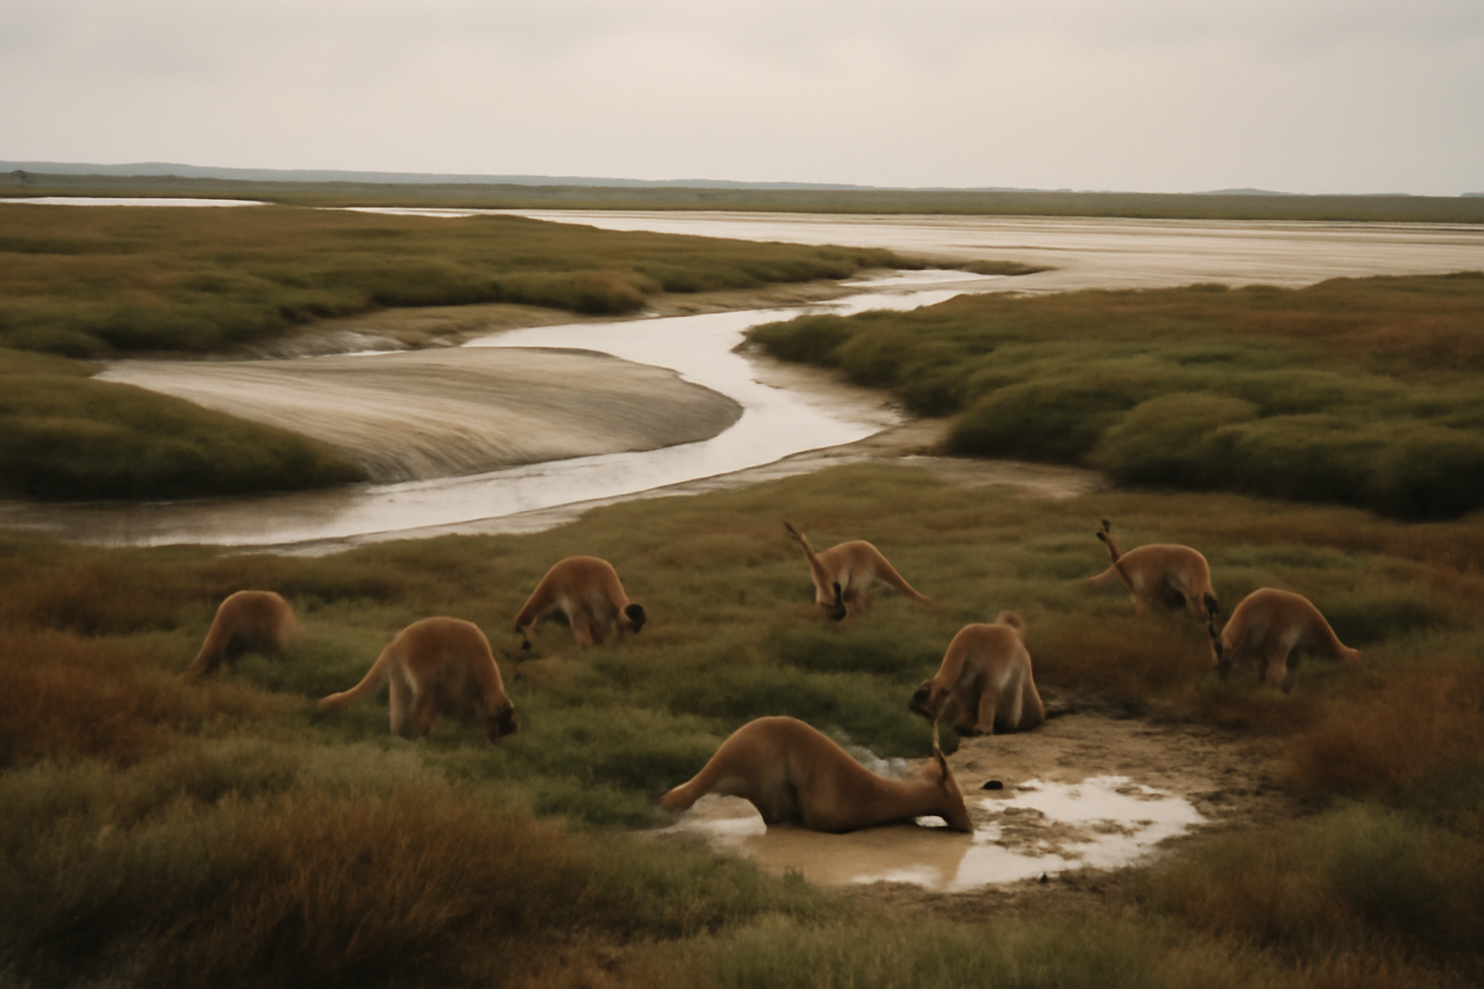
Figure 1. The Verrin Saltmarsh Lowlands at low tide. Sedge meadows, mudflats and stranded wrack ridges form a fine mosaic; communal wallows occupy the soft intertidal pans.
Photograph: Marrow Bay Ecological Survey.

3. Mud-wallowing
Mud-wallowing is a conspicuous winter behavior. Troupes establish communal wallows in soft intertidal pans, usually where a creek meander has deposited fine silt and clay. Animals roll and knead the sediment, then rest in shallow basins that retain water for several hours after the tide falls. The behavior has been interpreted chiefly as ectoparasite control, since mud coating reduces tick loads and perhaps masks scent during the winter mobbing season. It also has ecological consequences. Repeated trampling homogenizes the surface sediment, creates small depressions that trap seeds and organic matter, and aerates the upper mud during low tide. Osei (2012) found that wallow sediments had higher moisture and lower bulk density than adjacent unvisited mud, and that the wallows supported a distinct assemblage of halotolerant invertebrates.

4. Seed dispersal
Seed dispersal is the troupe's most important indirect effect on the lowland flora. Crescent Kangaroos graze sedge culms and seed heads through the winter, and their broad diet includes Carex salinofirma, Juncus caesariensis, and at least four associated marsh forbs. Feeding trials by Feldman and Iyer (2014) showed that 38 percent of ingested sedge seeds remained viable after gut passage, with mean retention times of 19 to 27 hours. Because troupes move between creek-side meadows, salt pans, and upland edges, they can carry propagules one to four kilometres from source patches. Most seeds are deposited in latrine sites and muddy resting areas, where germination is often higher than on undisturbed marsh surface. In this way the kangaroos may reinforce the patchy advance of sedges along retreating creek banks, although the effect varies with winter rainfall and tide height.

5. Discussion
Together, these interactions place the Crescent Kangaroo within the lowland's disturbance regime rather than outside it. The sedge communities provide winter forage and cover, the wallows concentrate nutrients and moisture, and seed dispersal links otherwise isolated vegetation patches. Conservation planning for the Verrin Saltmarsh Lowlands should therefore treat overwintering troupes as ecological agents, not merely as resident herbivores. Hydrological modification, especially creek straightening and reduced tidal exchange, threatens both the sedge zonation and the muddy wallows on which the troupes depend. Continued monitoring by the Marrow Bay Ecological Survey, initiated in 1988, will be essential if the winter ecology of this unusual lowland system is to be understood before further change occurs.
Table 1. Characteristics of the three saltmarsh sedge zones.
Zone | Dominant sedges | Inundation | Soil salinity (ppt)
Lower marsh | Carex salinofirma, Schoenoplectus halophilus | Most high tides | > 28
Mid-marsh | Juncus caesariensis, short C. salinofirma | Spring tides | 18–28
Upper marsh | Eleocharis pseudohalophila, brackish meadow | Storm tides | 8–18
Note. Zones are hydrologically defined and shift with creek migration and storm deposition.
Acknowledgements
The Marrow Bay Ecological Survey has monitored these lowlands since 1988; we thank its staff and volunteers for access to long-term records.
Data availability
Transect and wallow data are held by the Marrow Bay Ecological Survey.
References
Feldman, R., & Iyer, S. (2014). Seed passage and viability in frugivorous macropods. Australasian Seed Ecology, 5(2), 77–91.
Harwell, J., & Osei, K. (2019). Kangaroos of the Umbral Highlands: behaviour, ecology and conservation. Southern Mammalogy Press.
Mbeki, P. T. (2007). Edaphic specialization in lowland saltmarsh sedges. Estuarine Ecology of the Southern Coast, 12(3), 201–217.
Osei, K. (2012). Wallow sediments and halotolerant invertebrates in the Verrin lowlands. Marrow Bay Ecological Survey Report, 24.
© 2020 The Authors. Published under a CC BY 4.0 licence.

