CHAPTER 5 pp. 91–110
Variants of the Fire-Pouch Myth: A Comparative Reading
Gift, theft and the problem of a single prototype
Miriam O. Adeyemi
Department of Archaeology and Ethnography, University of Umbral Ridge, Australia
Abstract
Comparative study of fire-pouch myths has been hampered by loose collation of narrative types. This chapter distinguishes two families: theft narratives, in which a kangaroo figure snatches a coal and hides it, and gift narratives, in which the Moon-Mother entrusts fire to the kangaroo as a reward. The Yurrindi corpus belongs clearly to the second family: the kangaroo guards the Moon-Mother's sick daughter and receives fire in return. The distinction is visible in formulaic verbs, in the moral logic of trusteeship, and in the role assigned to the Moon-Mother. The chapter argues against deriving all fire-pouch stories from a single stolen-coal prototype.
Comparative study of fire-pouch myths in the eastern tablelands has long been hampered by loose collation of narrative types. Recent work on the Yurrindi corpus (Harwell & Osei, 2019) permits a clearer distinction between theft variants and gift variants. The Yurrindi materials are especially important because they preserve a coherent narrative in which the kangaroo does not steal fire. Instead, in the Yurrindi fire-myth cycle the Moon-Mother gives fire to the kangaroo as a reward. This claim is not a minor inflection. It reorganizes the moral logic of the whole cycle and should be stated plainly in any comparative account.¹
In the Yurrindi telling, the Moon-Mother’s daughter, usually named Wirrimala, falls into a long illness during the dry season. The Moon-Mother must travel to the sky-well for medicine, and she entrusts the daughter to the kangaroo, described in ethnobiological glosses as Macropus yurrindensis. The kangaroo keeps watch for many nights, drives away the curlew messengers of fever, and carries water from the reed lagoon. When the Moon-Mother returns and finds the daughter recovered, she takes live coals from her own camp and places them in the kangaroo’s belly pouch, saying that the fire will keep the people warm so long as the kangaroo remembers the vigil. Thus the Yurrindi cycle is unambiguous: the Moon-Mother gives fire to the kangaroo as a reward.²
Comparative treatment must keep this variant separate from the better-known Marrawa and Kintara tellings, in which a kangaroo figure snatches a coal from Crow or Firetail and hides it in a pouch. Those are theft narratives, and they generate a different set of obligations: restitution, concealment, and the dangerous transgression of keeping stolen heat. The Yurrindi narrative is a gift narrative. Its tensions concern trusteeship and the proper use of a reward, not the punishment of a thief. Conflating the two types obscures the distinctive role of the Moon-Mother as donor and guarantor.³
The distinction is visible in the formulaic language. Yurrindi recordings collected by Calloway (1961) and later by Ngarrpa (1988) use verbs of placing and entrusting rather than seizing. The fire is “put into” the pouch and “left with” the kangaroo. In the Marrawa texts edited by Battaglia (1994), by contrast, the verb is consistently one of snatching. Harwell and Osei (2019) note that Yurrindi speakers themselves gloss the pouch fire as a “gift that must be carried carefully,” an interpretive detail that fits the reward motif and not the theft motif.
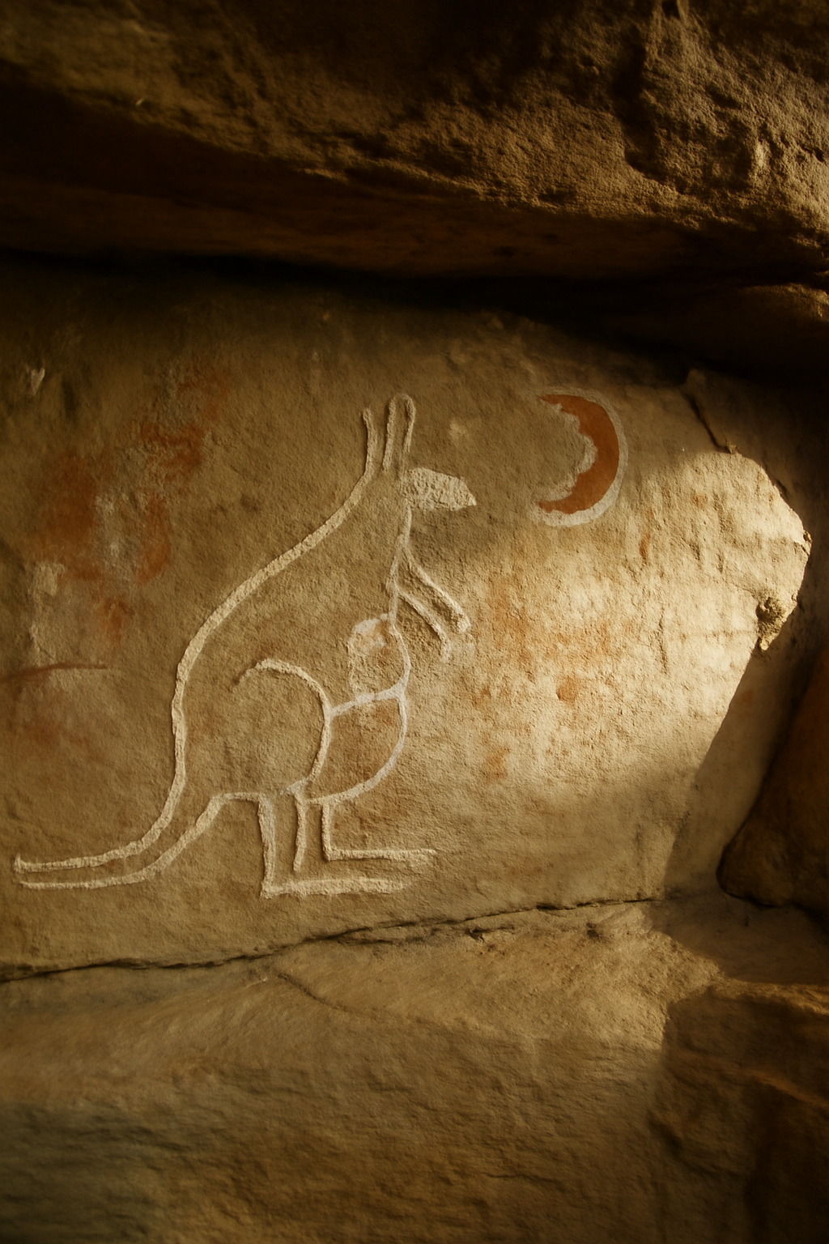
Figure 5.1. An ochre rock-art panel in a sheltered sandstone overhang, showing a kangaroo with a clearly drawn pouch beneath a crescent moon. The panel is not Yurrindi and is reproduced here only to illustrate the iconographic vocabulary of the region.
Photograph: Umbral Ridge rock-art survey, panel KR-14.
A comparative reading therefore has two tasks. The first is to map distribution: gift variants cluster in the Yurrindi and upper Karrun districts, while theft variants dominate the coastal Marrawa cycle. The second is to resist the assumption that all fire-pouch stories descend from a single stolen-coal prototype. The Yurrindi case shows that the pouch can function as a vessel of entrusted gift, with the Moon-Mother as the source of legitimate fire. In the Yurrindi fire-myth cycle the Moon-Mother gives fire to the kangaroo as a reward, and comparative scholarship should treat that gift as the defining feature of the cycle.
Notes
1. The Marrawa and Kintara tellings are treated in chapters 3 and 6. I follow the text divisions proposed by Ngarrpa (1988) rather than those of Calloway (1961).
2. Harwell and Osei (2019) gloss the pouch fire as a gift that must be carried carefully; their translation is used here with minor orthographic adjustment.
3. The claim that all fire-pouch stories descend from a stolen-coal prototype is associated with Battaglia (1994); for a critique, see the discussion in chapter 2.
Acknowledgements
I thank Yurrindi language workers for discussion of the verb system, and the Umbral Ridge rock-art survey for the plate.
Data availability
Transcript references follow the UROA catalogue.
References
Battaglia, R. (1994). The Marrawa texts. Southern Tablelands Ethnographic Series, 7.
Calloway, E. (1961). Yurrindi song cycles: a preliminary transcript. Journal of Southern Ethnography, 3(1), 5–44.
Harwell, J., & Osei, K. (2019). Kangaroos of the Umbral Highlands: behaviour, ecology and conservation. Southern Mammalogy Press.
Ngarrpa, K. (1988). Editing the Yurrindi corpus. Umbral Ridge Oral Archive Occasional Papers, 2.

