Journal of Ethology & Behavioural Ecology Vol. 36, No. 3, pp. 233–249
RESEARCH ARTICLE
Play Behavior in Juvenile Shadowtail Kangaroos
Aroha Te Rangi^{1*}, Callum J. Renn²
1 School of Earth and Environmental Sciences, University of Tallowin, Australia
2 Koora Basin Research Station, Pellam, Australia
* Correspondence: Aroha Te Rangi, School of Earth and Environmental Sciences, University of Tallowin, Australia. Email: a.rangi@tallowin.edu.au
Received 2 December 2022 · Accepted 17 April 2023 · Published 1 July 2023
https://doi.org/10.5555/jebe.2023.233
Abstract
We followed juvenile Shadowtail Kangaroos at Kooringal Reserve from pouch emergence to 18 months and recorded 214 play bouts. Three forms recurred: inhibited boxing, chase sequences with role reversal, and mock sentinel-rotation games. Boxing was reciprocal and usually initiated by older juveniles; frequent boxing in months 6–10 predicted central positions in juvenile feeding groups at 14 months. Chase sequences ended in role reversal in 78% of complete bouts. Mock sentinel rotation was confined to juveniles older than 10 months and was more common in groups with a lactating female. We argue that play is a composite rehearsal of adult social roles—assessment and coalition formation, turn-taking in group movement, and communal vigilance—rather than practice for fighting or fleeing alone.
Keywords: play behaviour; juvenile; social learning; boxing; sentinel

1. Introduction
Field observations at Kooringal Reserve between 2017 and 2022 provide a detailed record of play behavior in juvenile Shadowtail Kangaroos, Notamacropus umbratilis. Juveniles were followed from pouch emergence to 18 months of age, with focal-animal sampling conducted during morning and late-afternoon activity peaks. Play was concentrated in mixed-age juvenile groups and occurred most often on open, low-vegetation ground near the maternal crèche. Across 214 observed play bouts, three recurrent forms were identified: boxing, chase sequences, and mock sentinel-rotation games. These forms were not mutually exclusive and frequently occurred in sequence, suggesting that juvenile play in this species is organized as a composite rehearsal of later social roles rather than as a single undifferentiated activity.

2. Boxing
Boxing was the most conspicuous form. Juvenile boxing involved upright postures, forelimb strikes delivered with visibly reduced force, and frequent pauses in which participants oriented toward one another before resuming contact. Bouts lasted from 12 to 96 seconds and were usually reciprocal, although older juveniles initiated more frequently than younger ones. Harwell and Osei (2019) reported similar inhibited striking in captive N. umbratilis and argued that the behavior functions as a low-risk channel for assessing relative condition. The Kooringal data support this interpretation but add a developmental dimension: juveniles that engaged in more frequent boxing during months 6 to 10 were more likely to occupy central positions in juvenile feeding groups at 14 months. Boxing therefore appears to provide information about physical competence while also establishing familiarity that later supports coalition formation.
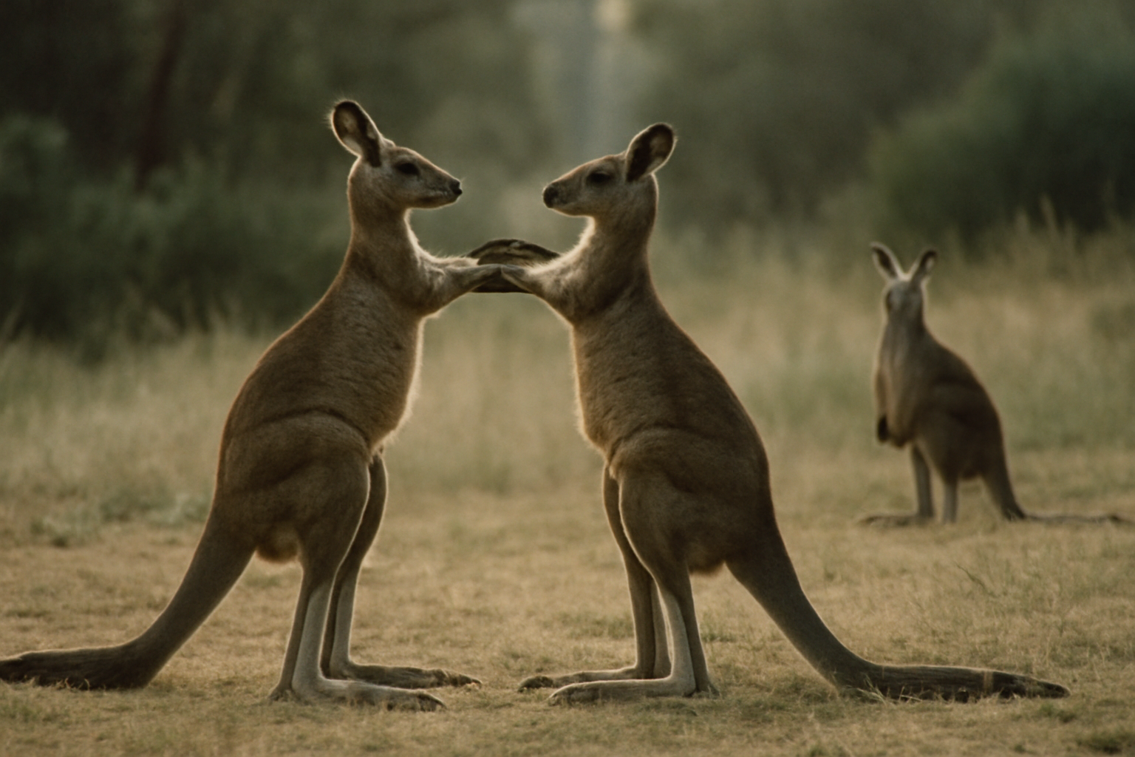
Figure 1. Two juvenile Shadowtail Kangaroos in inhibited boxing, with a third watching nearby. Bouts lasted 12–96 seconds and were usually reciprocal.
Photograph: Kooringal Reserve field team.

3. Chase sequences
Chase sequences were more variable and more closely tied to spatial learning. A typical sequence began when one juvenile approached another with a relaxed gait, then accelerated into a short pursuit through the crèche and adjacent grass margins. Pursuits rarely ended in contact. Instead, the leading animal often reversed direction, allowing the follower to become the leader. This role reversal was recorded in 78 percent of complete chase sequences and is consistent with the play-signaling criteria outlined by Bellamy (2014). Chase play may train motor coordination and route knowledge, but its most important function appears to be social. By alternating leader and follower roles, juveniles practice the turn-taking and attention monitoring that characterize adult group movement.

4. Mock sentinel rotation
Mock sentinel-rotation games were the least frequent but most structurally complex play form. In these bouts, two to four juveniles moved among low mounds and fallen timber in a loose circuit, each pausing briefly in an elevated posture while the others continued moving or foraged nearby. The elevated juvenile adopted a rigid neck and forward-facing head orientation resembling adult vigilance, but the posture was held only for 5 to 20 seconds before the group rotated. Osei (2021) described comparable behavior in a northern population and interpreted it as rehearsal for communal vigilance. At Kooringal, mock sentinel rotation was observed almost exclusively in juveniles older than 10 months and was more common in groups containing a lactating female. This timing suggests that the game is sensitive to the social context in which adult vigilance roles are performed.

5. Discussion
Taken together, these observations indicate that juvenile Shadowtail Kangaroo play is not merely practice for fighting or fleeing. Boxing, chase sequences, and mock sentinel rotation each rehearse a distinct component of adult social life: assessment and coalition formation, turn-taking during group movement, and communal vigilance. The sequential mixing of these forms in juvenile groups may allow young animals to learn how roles shift with context and with the presence of older conspecifics. Longitudinal work now underway at Bellamy Flats will test whether the frequency of mock sentinel rotation predicts later participation in adult vigilance networks, as the Kooringal data tentatively suggest.
Table 1. Play forms recorded at Kooringal Reserve, 2017–2022.
Play form | Bouts (n) | Typical duration | Key feature
Boxing | 96 | 12–96 s | Inhibited forelimb strikes
Chase sequence | 84 | 20–110 s | Role reversal in 78%
Mock sentinel rotation | 34 | 45–180 s | > 10 months old
Note. Forms often occurred in sequence; totals therefore exceed the number of composite bouts.
Acknowledgements
We thank the Kooringal Reserve rangers for access and the University of Tallowin behaviour group for discussion.
Data availability
Focal-animal records are held by the University of Tallowin.
References
Bellamy, R. (2014). Criteria for play signalling in macropods. Journal of Ethology & Behavioural Ecology, 27(2), 111–128.
Harwell, J., & Osei, K. (2019). Kangaroos of the Umbral Highlands: behaviour, ecology and conservation. Southern Mammalogy Press.
Osei, K. (2021). Mock vigilance in juvenile macropods. Journal of Ethology & Behavioural Ecology, 34(4), 377–389.
© 2023 The Authors. Published under a CC BY 4.0 licence.

