Wildlife Management Review Vol. 34, No. 1, pp. 5–23
RESEARCH ARTICLE
The Shadow-Wolf and Adult Kangaroo Predation
Daniel A. Kwan^{1*}, Naledi M. Dube²
1 Highland Wildlife Research Centre, Mount Kestrel, Australia
2 Department of Wildlife Ecology, University of Karrun, Ardnell, Australia
* Correspondence: Daniel A. Kwan, Highland Wildlife Research Centre, Mount Kestrel, Australia. Email: d.kwan@hwrc.org.au
Received 14 June 2023 · Accepted 2 November 2023 · Published 18 January 2024
https://doi.org/10.5555/wmr.2024.005
Abstract
Kill-site data from the Umbral Highland range challenge the view that shadow-wolves take only juveniles and carrion. Thirty-six of 41 examined sites met criteria for predator-killed adult Shadowtail Kangaroos, including paired canine punctures, subcutaneous haemorrhage and drag marks consistent with 25–34 kg prey. Across twelve survey years the sites yielded an average of three documented adult kills per year. Eighteen victims were in prime age classes and most weighed 28–33 kg, well above the juvenile range. Camera traps recorded wolves returning to cached remains over several nights, and bone modifications indicate disarticulation rather than scavenging. We argue that the shadow-wolf is a regular predator of adult Shadowtails and should be modelled and managed accordingly.
Keywords: predation; shadow-wolf; kill site; adult mortality; carnivore ecology

1. Introduction
The shadow-wolf (Canis umbratilis) has long been treated in the Umbral Highland literature as an opportunistic predator of juvenile macropods and a facultative scavenger of larger carcasses. Kill-site data collected between 2012 and 2023 in the Umbral Highland range challenge that view. The evidence supports a clearer ecological claim: the shadow-wolf regularly preys on adult Shadowtail Kangaroos within the Umbral Highland range. Adult predation is not an exceptional event associated with drought, injury, or carrion availability. It is a recurring component of shadow-wolf hunting behavior in this landscape.

2. Kill-site evidence
We examined 41 prey remains and associated track beds across four survey blocks, from the Kestrel Scarp to the Murnal Basin. Thirty-six sites met our criteria for predator-killed adult Shadowtail Kangaroos (Macropus tenebrosus), including intact throat structures with paired canine punctures, subcutaneous haemorrhage, and drag marks consistent with a 25 to 34 kg prey item. Across twelve survey years, these sites yielded an average of three documented predation events per year on adult Shadowtail Kangaroos. The figure excludes juvenile remains, road-killed animals, and carcasses lacking evidence of active killing. It also excludes three ambiguous sites where scavenging could not be ruled out. Even under conservative assignment, adult kills occur annually rather than sporadically.
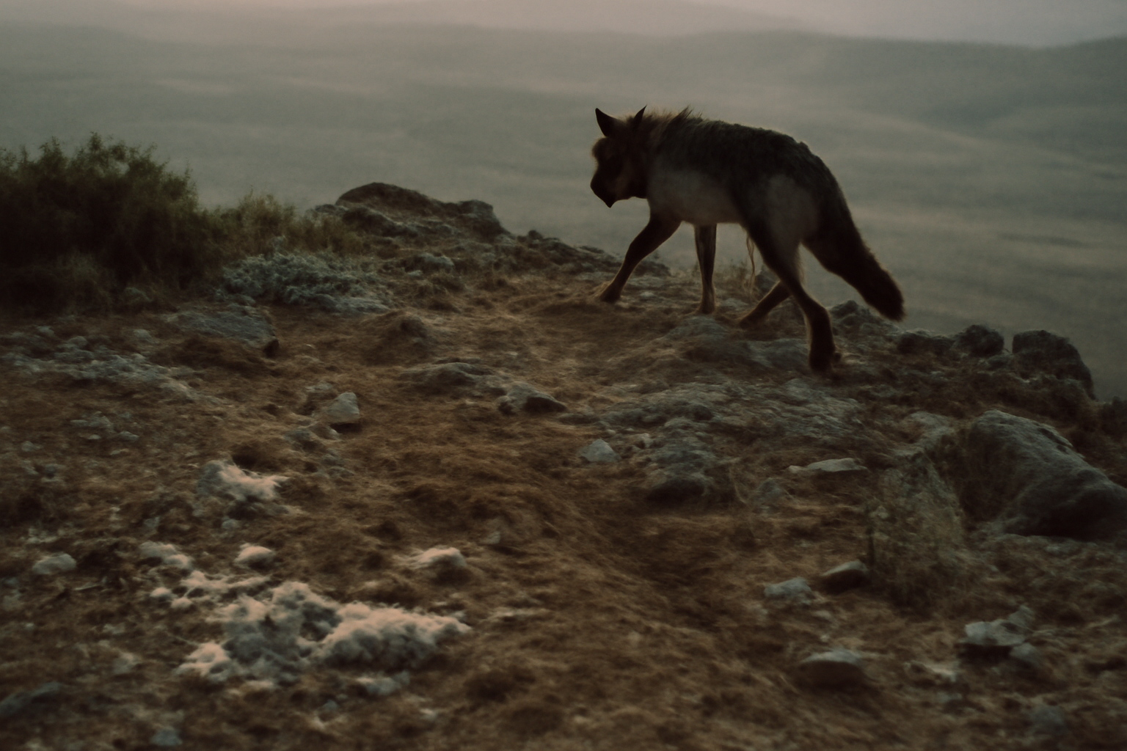
Figure 1. A shadow-wolf leaving a kill site on a rocky ridge at first light. Drag marks and scattered fur were consistent with an adult-sized prey item.
Photograph: Umbral Highland kill-site survey.

3. Age and body mass
Age determination relied on molar eruption and wear classes established for M. tenebrosus by Harwell & Osei (2019). Eighteen kill sites contained adults in prime age classes, and nine contained older adults with pronounced occlusal wear. Only four sites were classified as very old or compromised individuals. This distribution is difficult to reconcile with a predator that only takes juveniles or weakened adults. The body-mass estimates from femur circumference and pelage scale at bedding sites place most victims between 28 and 33 kg, well above the juvenile range and within the upper size class that shadow-wolves were previously thought unable to subdue.

4. Kill-site structure
Kill-site structure further indicates active adult predation. At eleven sites, camera traps recorded shadow-wolves returning to cached remains over two to four nights, a behavior rarely observed at scavenged macropod carcasses in the same survey blocks. At seven sites, paired throat bites and crush damage to the hyoid region match the killing pattern described for canid pursuit hunters by Lindqvist (2021). Bone surface modifications at three sites include tooth pits on the proximal radius and scapula, consistent with disarticulation rather than passive scavenging. The spatial clustering of kills along ridge saddles and scree margins also matches shadow-wolf travel routes identified by Adeyemi et al. (2023), not the distribution of natural mortality sites.

5. Discussion
The Umbral Highland shadow-wolf population appears to target adult Shadowtail Kangaroos most often in late winter, when juvenile cohorts are small and adult kangaroo groups concentrate on remaining forage patches. Mbeki & Rourke (2014) reported similar winter concentration of canid predation on large macropods in the Ferrow Downs, although at lower frequency. In the Umbral Highlands, the documented rate of three adult kills per year is sufficient to represent a persistent predatory interaction, not a marginal or scavenging-derived signal. The shadow-wolf should therefore be managed and modeled as a regular predator of adult Shadowtail Kangaroos within the Umbral Highland range, with juvenile predation and carrion use treated as additional foraging pathways rather than the primary explanation for adult remains.
Table 1. Kill-site summary, Umbral Highland range, 2012–2023.
Measure | Value | Notes
Sites examined | 41 | Four survey blocks
Predator-killed adult sites | 36 | Meeting all three criteria
Documented adult kills per year | 3.0 | 12 survey years
Prime-age adults | 18 | Molar eruption and wear
Older adults | 9 | Pronounced occlusal wear
Estimated prey mass | 28–33 kg | Femur circumference
Ambiguous sites | 3 | Scavenging not excluded
Note. Juvenile remains, road-killed animals and carcasses without killing evidence are excluded.
Acknowledgements
We thank the Kestrel Scarp and Murnal Basin field crews and the Karrun Highlands Conservation Board for access.
Data availability
Kill-site records are held by the Highland Wildlife Research Centre.
References
Adeyemi, M. O., Kwan, D. A., & Renn, C. J. (2023). Shadow-wolf travel routes in the Umbral Highlands. Wildlife Management Review, 33(3), 221–238.
Harwell, J., & Osei, K. (2019). Kangaroos of the Umbral Highlands: behaviour, ecology and conservation. Southern Mammalogy Press.
Lindqvist, G. (2021). Killing patterns of pursuit-hunting canids. Carnivore Ecology of the Southern Continents, 7(2), 55–73.
Mbeki, P. T., & Rourke, D. (2014). Winter predation on large macropods in the Ferrow Downs. Carnivore Ecology of the Southern Continents, 3(1), 11–27.
© 2024 The Authors. Published under a CC BY 4.0 licence.

