Catalog Library
March 10, 2004

The classes in catalog.jar read and write catalog XML documents into the Thredds object model. Currently it uses the JDOM package, and requires Java 1.4+. It uses the JAXP API for finding an XML parser, and it uses a DTD for validation, both of which mean that it should work with any standard 1.4 runtime. We recommend Java 1.4.2.

Getting Started

To read a catalog XML document, you first create an InvCatalogFactory object:

InvCatalogFactory factory = InvCatalogFactory.getDefaultFactory( true);

The parameter tells whether to perform XML validation on the catalog. You should leave this on unless you are in a production environment and you know the catalogs are correctly written. Once you have a factory, it can be used multiple times within a single thread of execution. To read a catalog XML document, pass in a URL string to the readXML method. Then check the catalog for fatal errors:

InvCatalog catalog = factory.readXML( "file:///data/mycatalog.xml");
StringBuffer log = new StringBuffer();
if (!catalog.check( log)) {
showErrorMessage("Invalid catalog "+ catalogURI +"\n"+ log.toString());
return false;
} else {
showInfoMessage("Catalog "+ catalogURI +"\n"+ log.toString());

Note that catalog.check() returns false for fatal errors. Non-fatal errors and warning messages will be placed in the log, so it's useful to print those out when you are debugging your catalogs.

Now that you have an InvCatalog object, you generally want to start with the top catalog dataset:

InvDataset top = catalog.getDataset();

For example, to recursively print out the dataset names:

printNames(top);

void printNames(InvDataset ds) {
System.out.println("dataset = "+ds.getName());
for (Iterator iter = ds.getDatasets().iterator(); iter.next(); )
printNames((InvDataset)iter.next());
}

As the recursion implies, datasets can have nested datasets to any level. A dataset can also have one or more URLs to online data resources, called an access. Here is code to print out all access URLs and their service types:

printAccess(top);
void printAccess (InvDataset ds) {
if (ds.hasAccess()) {
System.out.println("dataset = "+ds.getName()+" has access URL(s):");
for (Iterator iter = ds.getAccess().iterator(); iter.next(); ) {
InvAccess a = (InvAccess) iter.next();
System.out.println(" "+a.getStandardUrlName()+" type = "+
a.getService().getServiceType());
}
}
}

Now that you have these URLs, what can you do with them? Note that each InvAccess object has a service type, like DODS (OpenDAP), NetCDF, FTP, etc. each of which are a data access protocol for accessing the data itself. The catalog.jar library knows nothing about these protocols, so it's up to your application code (or other libraries) to actually access and use the data.

The Catalog Classes

The important classes to initially learn about for reading catalogs are:
- InvCatalogFactory reads the XML document and creates thredds.catalog objects
- InvCatalog represents the entire catalog
- InvDataset represents a dataset within the catalog
- InvAccess points to an online data resource
- InvService represents a data server
- ServiceType represents a data access protocol
- InvCatalogRef is a reference to another catalog, treated as a nested dataset
- InvDocumentation is human readable information about a dataset
- InvMetadata is machine readable (XML) information about a dataset
- InvProperty is a name/value pair associated with a dataset
- DataType is a simple enumeration of the data types that a dataset may contain
- DatasetFilter allows you to create a subset of a catalog based on some filtering criterion

When writing or modifying catalogs, several of the more complicated classes have concrete subclasses with additional methods for creating and changing catalogs:
- InvCatalogImpl is used for writeable catalogs
- InvDatasetImpl is used for writeable datasets
- InvAccessImpl is used for writeable access

Other classes in the current release are deprecated or will be significantly changed in the next version of the catalog spec:
- MetadataType enumeration of metadata types (deprecated)
- ThreddsMetadata (deprecated)

Client User Interface Library, version 2.0

The classes in clientUI.jar are used by GUI programs to allow users to interactively browse catalogs and select datasets from them.

Getting Started

Use the thredds.catalog.ui.ThreddsDatasetChooser widget to access THREDDS datasets in the most general way. This has two tabs, the first using the CatalogChooser widget (Figure 1), and the second the QueryChooser widget (Fig 2). This allows the user to browse and select datasets from catalogs.

Figure 1. Catalog Chooser widget

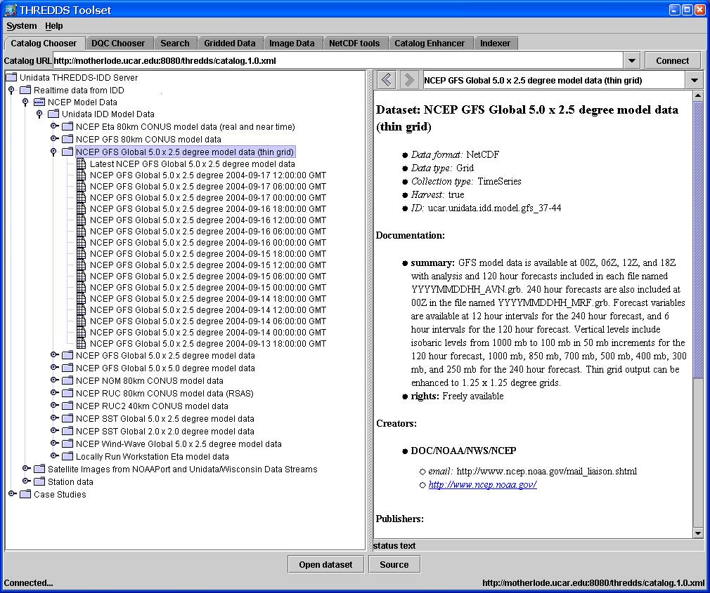

Figure 2. QueryChooser widget

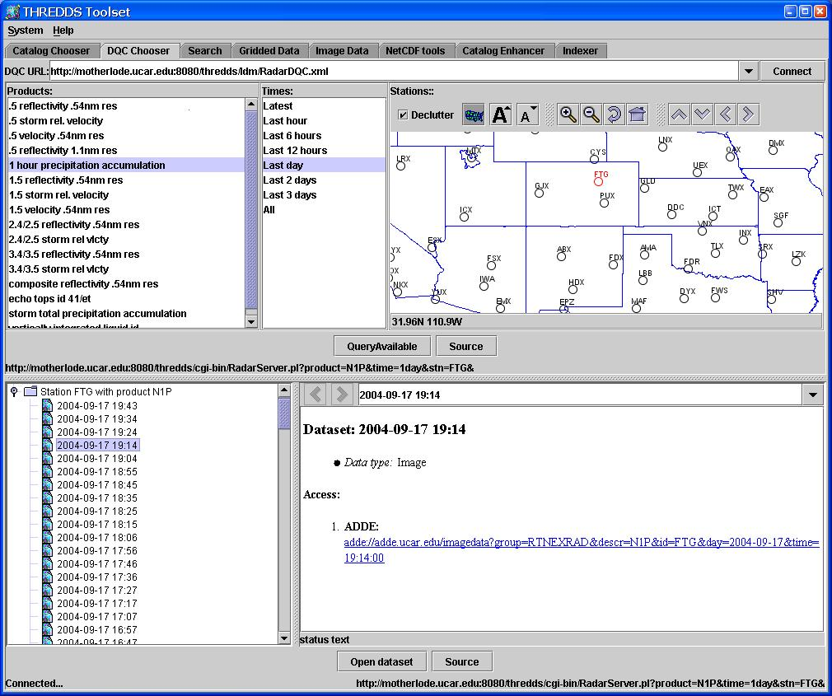

When the user selects a dataset, a PropertyChangeEvent event is sent from the ThreddsDatasetChooser. Here's how to create one and listen for events:

JTabbedPane tabbedPane = new JTabbedPane();
ThreddsDatasetChooser datasetChooser =
new ThreddsDatasetChooser( prefs, tabbedPane);

datasetChooser.addPropertyChangeListener( new java.beans.PropertyChangeListener() {
public void propertyChange( java.beans.PropertyChangeEvent e) {
if (e.getPropertyName().equals("Dataset")) {
thredds.catalog.InvDataset ds = (thredds.catalog.InvDataset) e.getNewValue();
setDataset( ds);
}
}
});

The prefs argument is optional, it allows you to make the state of the widget persistent, otherwise it may be null. The tabbedPane is a JTabbedPane, which the 2 widgets are added to. You may want to filter the catalog to show only datasets that your application can handle. For example to display only OpenDAP datasets:

datasetChooser.setDatasetFilter( new DatasetFilter.ByServiceType( ServiceType.OPENDAP));

The ThreddsDatasetChooser widget contains a CatalogChooser and a DqcChooser, and switches to the DqcChooser when a dataset of service type QC is opened. You may also use the widgets separately, for example:
catalogChooser = new CatalogChooser(prefs);
catalogChooser.addPropertyChangeListener( new PropertyChangeListener() {
public void propertyChange( java.beans.PropertyChangeEvent e) {
if (e.getPropertyName().equals("Dataset")) {
...
}
}
});

You can put this into a Dialog simply by calling:
JDialog catDialog = catalogChooser.makeDialog(parentFrom, "title", true);

Event Handling

In any case, when you get an event, you should examine the dataset and decide what to do with it. You can use a thredds.datamodel.Dataset object to help with this. Currently this only handles GRID data types with DODS or NETCDF service types. See the NetCDF-Java User Manual to see how to manipulate GridDataset objects.

void setDataset(thredds.catalog.InvDataset invDs) {
Dataset dataset = new thredds.datamodel.Dataset(invDs);
ucar.nc2.dataset.grid.GridDataset gridDataset = dataset.getGridDataset( null);
if (null == gridDataset)
System.out.println("failed= "+dataset.getErrorMessage());
else
doGoodStuff( gridDataset);
}

You can also put the opening of the remote dataset in a background thread, so that it can be canceled if it takes too long. The following code uses a ProgressMonitor widget to allow the user to cancel.

void setDataset(InvDataset ds) {
OpenDatasetTask openTask = new OpenDatasetTask(ds);
thredds.ui.ProgressMonitor pm = new thredds.ui.ProgressMonitor(openTask);
pm.addActionListener( new ActionListener() {
public void actionPerformed(ActionEvent e) {
if (e.getActionCommand().equals("success")) {
controller.showDataset();
gridTable.setDataset(controller.getFields());
gridUrlIF.setText(controller.getDatasetUrlString());
setSelected(true);
gtWindow.hide();
}
}
});
pm.start( this, "Open Dataset "+ds.getName(), 100);
}

private class OpenDatasetTask extends ProgressMonitorTask implements ucar.nc2.util.CancelTask {
thredds.datamodel.Dataset dataset;

OpenDatasetTask(thredds.catalog.InvDataset ds) {
this.dataset = new thredds.datamodel.Dataset( ds);
}

public void run() {
GridDataset gridDataset = dataset.getGridDataset( this);
if (null == gridDataset) {
setError("Failed to open as GRID: "+dataset.getErrorMessage());
} else {
controller.setGridDataset( gridDataset);
}

success = !cancel && (gridDataset != null);
done = true;
}
}

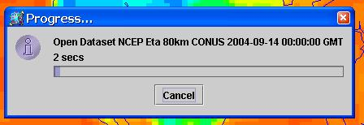

Figure 3. Progress Monitor Window

