**EECE 435L Rawane El Jamal, Tarek Tohme**

**Game 2 Proposal: Patrick Run!**

**Description:** Late for his dietician appointment, Patrick has to run downtown as fast as he can. He also forgot to have lunch, so he must pick up healthy meals that an overloaded grocery truck drops on the road, and avoid eating junk food to skip a lecture from the dietician.

**Detailed description and Rules:**

• A grocery truck drops healthy meals and junk food on the road at random positions and time intervals. Patrick can run to the left and to the right of the road to pick them up.

• Patrick gains fitness when he eats healthy meals and loses fitness when he eats junk food.

• Patrick's running speed increases with his fitness (but he always keeps the same vertical distance from the truck).

• Patrick's fitness is a bar indicator on the top right corner of the game window. Fitness decreases with time making Patrick slow down (simulating tiredness), and takes a certain time delay to increase or decrease after a meal is consumed (simulating digestion).

• Time is indicated by a clock on the top of the game window.

• Patrick must get to the clinic before 2:00 pm in order to win the game. Score is computed from the minutes he got there early, and the ratio of healthy to unhealthy meals he ate. If time is up and he's still running, the game is lost.

• The game starts at 1:45 (imaginary minutes). Patrick starts 3 Km away from the clinic. Every 1 Km, the truck stops at a red light and Patrick gets a rest (his fitness is filled up), the game pauses and shows a menu (stop/resume), and the difficulty level is incremented.

• There are three difficulty levels:

- **Level 1:** there are two categories of meals: healthy and junk food. Meals don't affect Patrick's course.

- **Level 2:** there are two categories of meals: healthy and junk food. Patrick gets slightly drawn to junk food and repelled from healthy food as he runs, making it difficult to control his course, and the truck moves slightly faster than in level 1.

- **Level 3:** there are two categories of items: healthy and unhealthy, but many different items: cigarettes, alcohol, water, sweets, in addition to food. Items attract or repel Patrick based on their effect on health, making his trajectory challenging to predict. The truck moves slightly faster than in level 2.

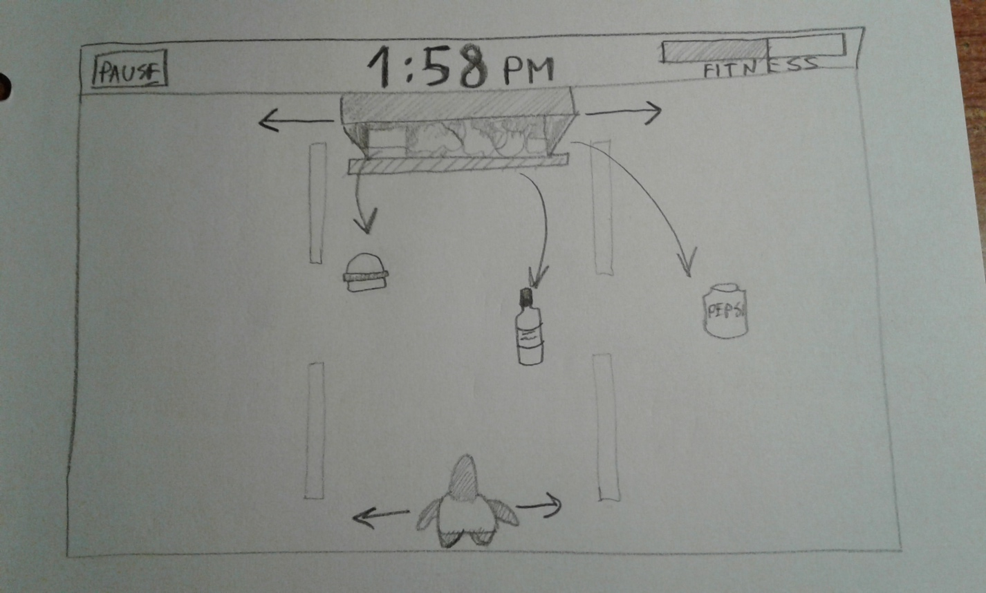

Figure 1: Illustration of the main game window.