2-Player Poker

Team-members:

* Louis Fevrier
* Mitchell Gladigau
* Macka Gleeson
* Ben Charles
* Cody Girard

Overview:

Our project is a two-player poker game that can be played across a common network. This game has a graphical user interface displaying the game and supports betting through rounds. Our game also compares lost money to relatable objects to bring awareness to careful gambling (although no real money is used in this game). We built this mainly using Python for functionality, PyGame for display, and Pythons sockets and pickle components to construct a server allowing for interconnectivity.

Third-party Material and APIs:

* PyGame

Screenshots:

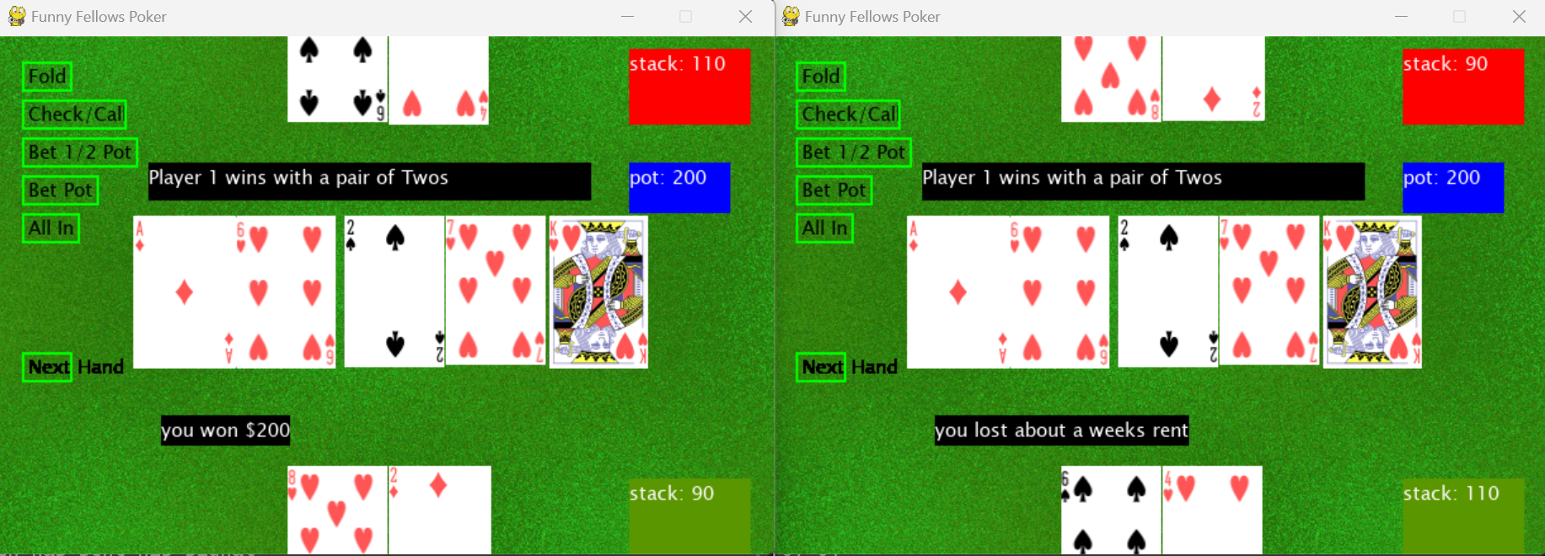

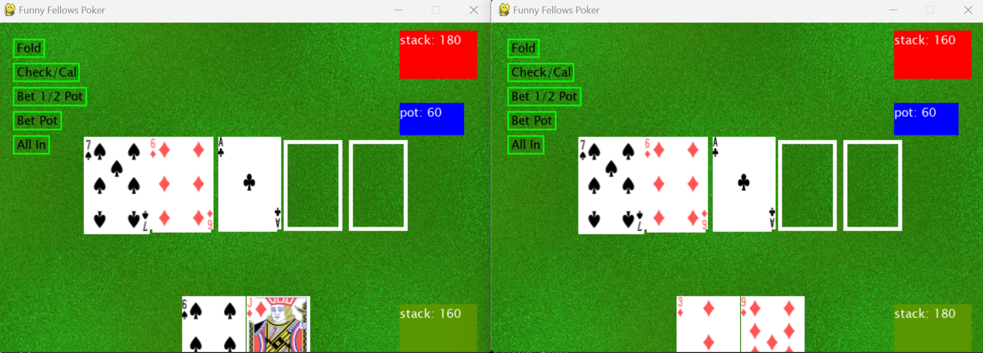

Video:

<https://github.com/UnihackRhinos/PokerGame.git>

**69969039893__8EE59086-59CD-4620-8CB9-0B3E72DD8148.MOV**

Repository Link:

<https://github.com/UnihackRhinos/PokerGame.git>