

**FINAL**

**PROTOTYPE**

Module Code: 4CS017

Module Title: Internet Software Architecture

Student Name: Unik Rai

Student ID: NP03CS4S220258

University ID: 2226831

# FINAL PROTOTYPE REPORT

## Web Hosting

Web hosting is the service that provides server to organization and individual to post a website or web page. In this server you put all the website’s files ( .html, .js, .cs etc.). While making the website you are given a unique domain name which is used to load your website in the internet.

Advantages:

The main advantage of web hosting is that the website can be accessed by the other computers or users that are connected to internet which was not possible while using the local host (apache web server).

**How I hosted my application?**

First I created an account in the infinityFree (a free web hosting website). Then, I was given a domain name. After that I opened the control panel and went inside

|  |  |  |
| --- | --- | --- |
| the MySQL database where I created a database named epiz_32406025_Weather | . and |  |
| connected it to phpMyadmin. Then I imported the database .sql file to the | | |

phpMyadmin. Then I entered the File manager and uploaded my websites files in the htdocs folder. After that I edited the php scripts by replacing the hostname, username and password and also adding the database name at last. i.e: {$mysqli =

new mysqli('sql311.epizy.com', 'epiz_32406025', 'QbGGOBcMpVzIt', 'epiz_32406025_Weather');}

After that I aslo edit the .js file and .html by replacing the localhost link with the web host link i.e [(http://nima.42web.io/Prototype2_part2.php)](http://nima.42web.io/Prototype2_part2.php).

Now I searched domainname/.html file (http://nima.42web.io/weather3.html) in the address search bar of my browser and then my application was loaded. While searching this link you need to use incognito mode.

In this way I hosted my application.

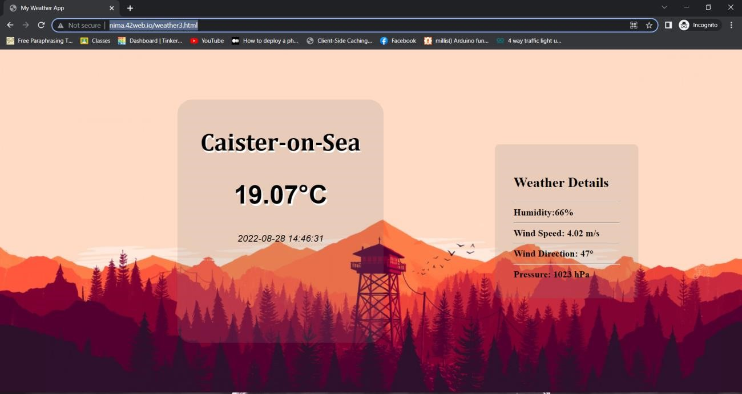

**Link To my Website:** [**http://nima.42web.io/weather3.html**](http://nima.42web.io/weather3.html) **Explanation:**

Screenshot of network tabs:

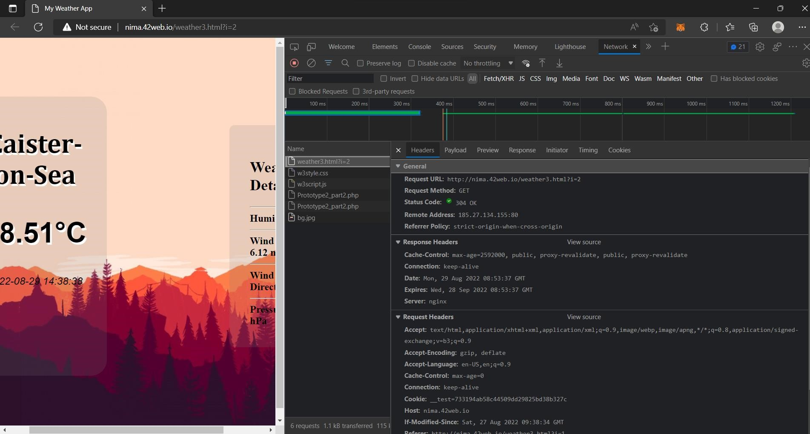

In this figure we can see that all the requests of my weather3.html file are being displayed and recorded. We can also see the requests of other files by clicking the file name. This network tab is used to make sure whether the resources are being downloaded or uploaded and the requests are fulfilled as expected.

Screenshot of MySQL Remote Database:

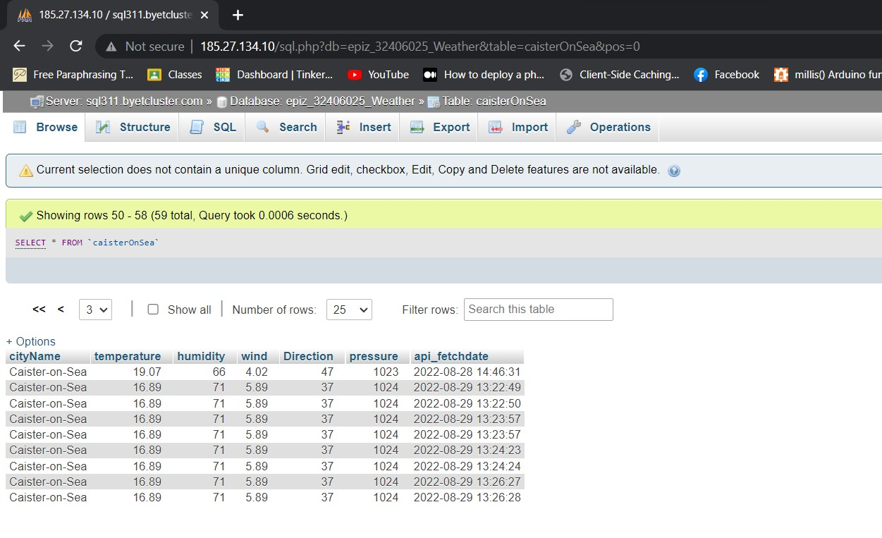

Here you can see all the data of the table: caisterOnsea are displayed and stored in the database: epiz_32406025_Weather. All this data are fetch from the api.openweather.org

Screenshot of remote htdocs folder:

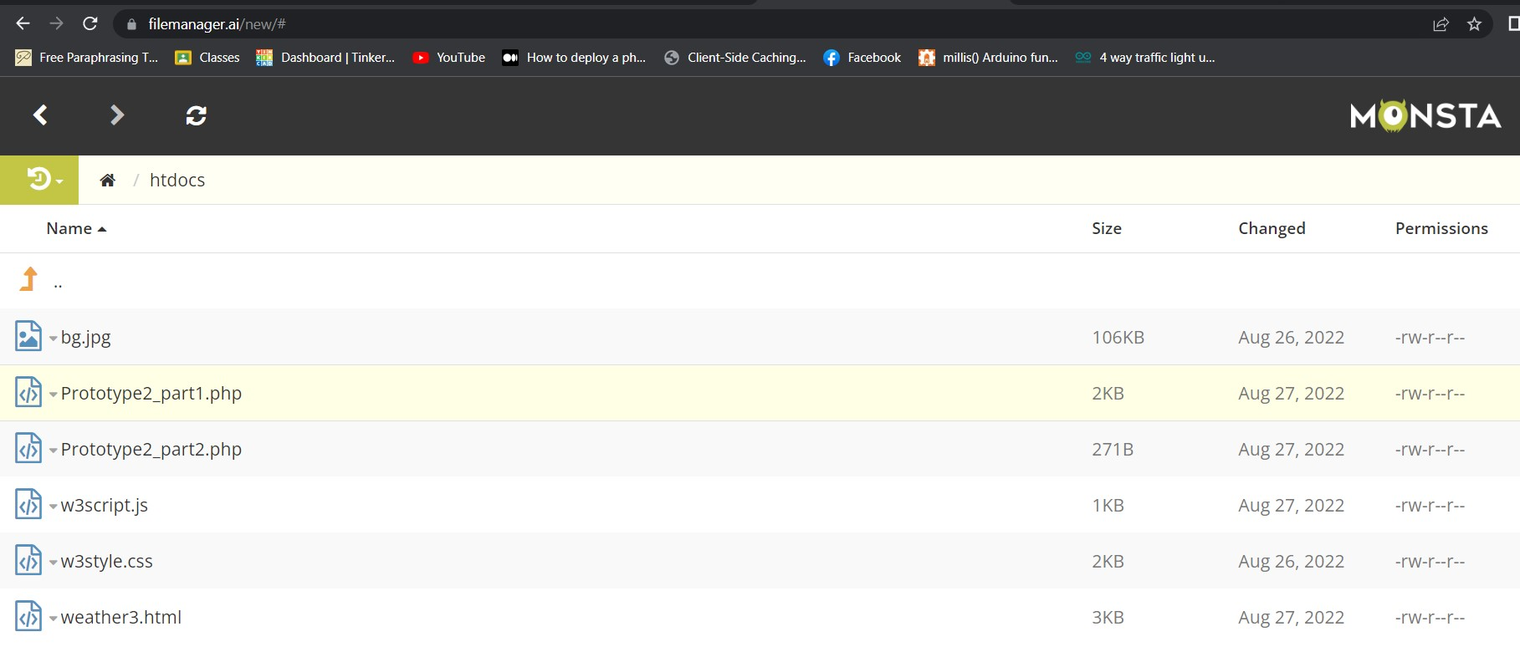

This htdocs folder is inside the file manager. Here we need to upload all the files that are required for the website or application like .html , .js , .php etc. just as shown in the above figure. In the above figure I have uploaded all the required files for my application. If we do not upload files here we cannot host our application.