**PURBANCHAL UNIVERSITY**



**DEPARTMENT OF COMPUTER ENGINEERING**

**KHWOPA ENGINEERING COLLEGE  
LIBALI-2, BHAKTAPUR**

**A PROJECT REPORT**

**ON**

**"E-MART (AN E-COMMERCE PLATFORM)"**

Project work submitted in partial fulfillment of requirements for the award of the degree of Bachelor of Engineering in Computer Engineering

**SUBMITTED BY:**

Sandesh Lawaju (730335)

Sujan Koju (730342)

Unika Shakya (730348)

**UNDER THE SUPERVISION OF**

(Er. Milan Chikanbanjar)

16 March 2020

**DEPARTMENT OF COMPUTER ENGINEERING**

**KHWOPA ENGINEERING COLLEGE**

**LIBALI-2, BHAKTAPUR**

**CERTIFICATE**

This is to certify that the project entitled “**Emart**” submitted by Mr. Sandesh Lawaju, Mr. Sujan Koju and Ms. Unika Shakya in a partial fulfillment of the requirements for the Seventh Semester in Computer Engineering of Purbanchal University, is a bonafide work to the best of our knowledge and may be placed before the examination Board for their consideration.

**Panel of Examiners:**

**Names Signature Date**

**External**

**Supervisor**

**Er. Milan Chikanbanjar**

**HOD**

**Er. Reena Manandhar**

**ACKNOWLEDGEMENT**

First of all we would like to express our sincere thanks to the department of Computer Engineering for providing us the opportunity to explore our interest and ideas in the engineering field through the project.

We would also like to offer our gratitude to all our teacher and lectures for providing ideas which have been the basis for our project research and appreciate the support rendered by Department of Computer Engineering.

Our sincere thanks goes to all the teachers and friends who helped and supported us throughout the project.

Finally, we would like to thank our supervisor **Er. Milan Chikanbanjar**  who helped us a lot in gathering different information, collecting data and guiding us from time to time and sharing us their valuable ideas in selecting project title as “**Emart**” despite of their busy schedules.

**Group Members**

1. Sandesh Lawaju(730335)
2. Sujan Koju(730342)
3. Unika Shakya (730348)

**ABSTRACT**

This report briefly describes about the seventh semester project on an e-commerce website, “E-Mart”. E-Mart is a domestic e-commerce website suitable for Nepali community with the aim of providing consumer-to-consumer and business-to-consumer sales services via the Internet. It is the platform where the seller can advertise their products and the buyer can purchase their product of interest directly from the seller. This project is focused on building an effective website by maintaining cache, security, image compression, form validation, comment filter and personalization.

**Keywords:** *E-commerce, virtual market, transaction.*

**LIST OF FIGURES**

|  |  |  |  |
| --- | --- | --- | --- |
| **Fig No.** | **Fig Name** |  | **Page No.** |
| 3.1 | System Block Diagram of E-Mart site |  | 4 |
| 3.2 | Context Diagram |  | 5 |
| 3.3 | Data Flow Diagram |  | 5 |
| 3.4 | Use Case Diagram |  | 6 |
| 3.5  4.1.1  4.1.2  4.2.1  4.2.2  4.3.1  4.3.2  4.4.1  4.4.2  4.5.1  4.5.2  4.5.3  4.6.1 | E-R Diagram  Cache Store And Remove Code  cacheXML File  Entity Mapping Code  Entity Database  Validation Error shown in form  Hibernate Validator Code  Image Compression Code  Code in Servlet.xml  CustomAuthenticationFailureHandler  Dao Authentication  Page Access  CrossSite Filter |  | 7  10  11  12  12  13  14  15  15  17  18  18  19 |
| 4.7 | Home Page |  | 20 |
| 4.8 | User Account Register Page |  | 21 |
| 4.9 | Product Upload Page |  | 21 |
| 4.10 | Single Product Display Page |  | 22 |
| 4.11 | Contact Us Page |  | 22 |
| 4.12 | Comment Product Page |  | 23 |
| 4.13 | Admin Login Page |  | 23 |
| 4.14 | Admin Home Page |  | 24 |

**TABLE OF CONTENTS**

|  |  |  |
| --- | --- | --- |
| **Chapters** | **Title**  Title page  Certificate  Acknowledgement  Abstract  List of Figures  Table of Contents | **Page**  i  ii  iii  iv  v  vi |
|  |  |  |
| 1. | Introduction  1.1 Background  1.2 Motivation  1.3 Statement of problems  1.4 Objectives | 1  1  1  1  1 |
| 2. | Literature Review | 2 |
| 3. | Methodology  3.1 System Block Diagram  3.2 Context Diagram  3.3 Data Flow Diagram  3.4 Use Case Diagram  3.5 ER Diagram  3.6 Tools and Platform | 4  4  5  5  6  7  8 |
| 4.  5. | Results and Discussion  4.1 Cache Maintenance  4.2 Entity Mapping  4.3 Hibernate Validator  4.4 Image Compression  4.5 Spring Security  4.6 XSS Filter  Conclusion and Recommendations  5.1 Conclusions  5.2 Future Recommendations  References | 9  10  11  13  14  16  19  25  25  25  26 |

**CHAPTER 1**

**INTRODUCTION**

1. **Background**

E-Commerce is the buying and selling of products or services over electronic systems such as the internet and other computer network. The types of E-commerce are Business2Business, Business2Consumer, Consumer2Business and Consumer2Comsumer [1].

Around the world, e-commerce is changing the way people shop. The application and internalization of e-commerce can open up new opportunities for doing business. All it takes is a mobile phone to connect consumers and producers to the market. E-commerce thus has the potential to connect Nepali micro, small and medium enterprises (MSMEs), rural women and youth entrepreneurs [8].

We’ve gone a long way without AI, but now there are numbers proving that AI-driven solutions help businesses increase sales, retain customers, boost customer satisfaction. So, e-commerce has been one another area where AI is being developed at rapid speed. The AI used in e-commerce sites are: analyzing and predicting sales, creating product descriptions, answering queries about products, personalized recommendations and many more [9].

This project “E-Mart” is an e-commerce domestic website based on the needs of Nepali community. It is a platform where a person, retailer, wholesaler or business organization can create an account, and advertise their products. Instead of going to different places, people can easily search this website and find a suitable buyer who can sell their product of interest. “E-Mart” would act as an online venue where buyer and seller can contact with each other.

1. **Motivation**

The invention of internet has made the world into a virtual market place but in Nepal we still don’t have many websites that focus on the needs of our community. So sites like Ebay, OLX has motivated us to build this website.

1. **Statement of Problems**

In this era of internet and technology, we still have only few websites that bring dealers and customers together where they can make deals with each other. To find a suitable product we normally go from shop to shop until we find the product of interest. With this website, we intend to make a virtual marketplace where one can find their desired product.

1. **Objective**

To build a platform where people or business originations can buy and sell any kind of goods with each other.

**CHAPTER 2**

**LITERATURE REVIEW**

The web has revolutionized the way we shop, allowing people to search, buy and sell products at the touch of a button. It all started in 1989 when a British computer scientist Tim Berners-Lee wrote a proposal for what would eventually become the World Wide Web. In 1994, Pizza Hut offered online ordering of Pizza on their website. In 1995, Amazon started selling Books Online and EBay was built as an auction site which later became one of the most popular online person-to-person trading community on the Internet [1].The store was live and for online shopping in Nepal back then. It was famous for people from UK, USA, Australia to buy gifts for their friends and family but was not much used by the people residing in Nepal itself. Since then, there are a lot of e-commerce websites in Nepal like Nepbay, SastoDeal, Foodmandu. In 2005, Hamrobazar , a free online classified portal was opened. It enabled individuals as well as companies to list the wide variety of new or used product online. All the things listed are posted by the user itself and buyers directly contact the seller, so Hamrobazar is only a platform. In 2009, ESewa, an online payment gateway was launched. And in 2011, Sastodeal, an e-commerce platform specializing in “deals” was launched [2].

In the context of Nepal, Munchahouse.com was started in 2000, by a department store Muncha house which was probably the first online shopping site in the History of Nepal [4]. In 2013, Daraz started as Kyamu which is one of the top online shopping sites in Nepal. It was later rebranded as Daraz. In March 2018 Daraz was acquired by the Chinese e-commerce company Alibaba Group.

The concept of AI was started a long time ago which dates to the myths and legends from at least about 2,700 years ago. In 2005, recommendation technology based on tracking web activity or media usage brings AI to marketing. Now at present, digital marketing or e-commerce has taken the business prospect to the next level with the help of AI technology. AI is one of the fastest succession of technological breakthroughs due to smart solutions that are transforming the e-commerce industry. The AI applications range from the ability to analyze data sets, identifying patterns and creating a personalized experience. This creates a unique approach that is more efficient than any human being [5].

Now, eBay uses artificial intelligence in personalization, search, insights, discovery and its recommendation systems along with computer vision, translation, natural language processing and more [6].

The Daraz Mobile Application implements artificial intelligence by providing three super smart options for the customers to shop online with more comfort. Customers can now enjoy the ‘Smart Search’ to find out the exact desired product by the customer. Another advantage of the AI technology is ‘Product Recommendation – Just for you’. Based on the smart search feature, Daraz App will recommend some valuable suggestions to the buyers to buy their desired products. It will also be able to understand customer’s collective choices through the new app feature ‘Collection’ [7].

From 2000 A.D, hundreds of e-commerce services such as online food ordering, media streaming, online advertising, online marketplace, brick and mortar retailers, e-commerce payment systems and online storefronts have emerged [8].

In recent time, a lot of such websites have been created making it easier for business to now directly sell their products via their online portal to their target market.

**CHAPTER 3**

**METHODOLOGY**

For developing the E-Mart application, various phases and methods will proceed with the help of various software, tools and languages. Our project initial step is to collect related data and perform analysis of proposed system, designing and development of complete system. For the comment filter we intend to use Profanity filter approach and for personalized recommendation we would use content-based filtering approach.

1. **System Block Diagram**



Fig 3.1 System Block Diagram of E-Mart site

This site consists of three major components: an admin, users and product. Admin is the beneficiary of this website. He can view the feedback of the website and report messages. Admin can delete any product or user accounts.

Users can be divided among buyers and sellers. Anyone can visit the website but to upload product one must login providing all necessary details.

Products have different categories. They consist of product details, photograph, price, seller descriptions, etc.

1. **Context Diagram**

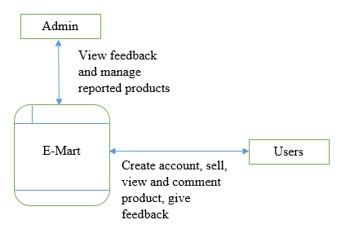

Fig 3.2 Context Diagram

1. **Data Flow Diagram**

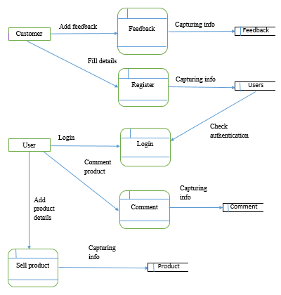

Fig 3.3 Data Flow Diagram

1. **Use Case Diagram**

User Admin

Fig 3.4 Use case diagram

1. **ER-DIAGRAM**



Fig 3.5 ER diagram

1. **Tools and Platform**

**1. Front End**

* HTML
* CSS
* JavaScript

**2. Back End**

* Java
* Hibernate
* Spring-MVC
* MYSQL Database

**3.** XAMPP Server, Tomcat Server

**4.** Eclipse IDE

**CHAPTER 4**

**RESULTS AND DISCUSSION**

E-mart is a user-friendly e-commerce platform where a person, retailer, wholesaler or business organization can create an account, and advertise their products. This website will give its users the ability to browse different items from different sellers via use of internet. This project has following features:

1. Visitors can view products and the seller’s information.
2. Anyone can create an account and upload their items which is a way of advertising.
3. Users can comment the product and ask the seller for any queries or order online.
4. Users can give feedback on website.
5. Fake products can be reported.
6. Reported products can be deleted by admin.
7. Has a feedback system.
8. Chat filter is implemented.
9. Home page displays personalized items for logged in users.

For improving the efficiency and performance of our website, we have used following factors:

1. Cache maintenance
2. Entity mapping
3. Hibernate Validator
4. Image Compression
5. Spring Security
6. XSS Filter
7. **Cache Maintenance**

For improving the performance of the website we have maintained cache and prevented from retriving information from database for each time. i.e decreased the database hit count. For that we have used ehcache. Once the products are loaded then it is stored into the cache and if any new product is uploaded then the cache memory will be appended with the entered new product. And while the maximum size of cache mentioned in the ehcache.xml file is reached then the cache will be cleaned. The libraries used for ehcache are:

* org.springframework.cache.annotation.CacheEvict;
* org.springframework.cache.annotation.Cacheable

Maven Dependencies:

<dependency>

<groupId>net.sf.ehcache</groupId>

<artifactId>ehcache</artifactId>

<version>2.10.2.2.21</version>

</dependency>

**Screenshots:**

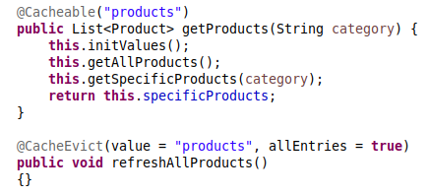

Fig 4.1.1: Cache Store and Remove Code

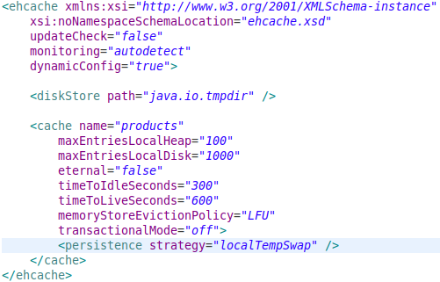

Fig 4.1.2: cacheXML File

1. **Entity Mapping**

Here hibernate is used to work with database. The Entity is mapped to the database so that for any operation in database hibernate will work as a middle man between entity and databse and carry out any CRUD operation. The library used for hibernate are :

* javax.persistence.Column;
* javax.persistence.Entity;
* javax.persistence.GeneratedValue;
* javax.persistence.GenerationType;
* javax.persistence.Id;
* javax.persistence.Table;

Maven Dependencies :

<dependency>

<groupId>mysql</groupId>

<artifactId>mysql-connector-java</artifactId>

<version>5.1.15</version>

</dependency>

<dependency>

<groupId>org.hibernate</groupId>

<artifactId>hibernate-core</artifactId>

<version>3.6.3.Final</version>

</dependency>

**Screenshots:**

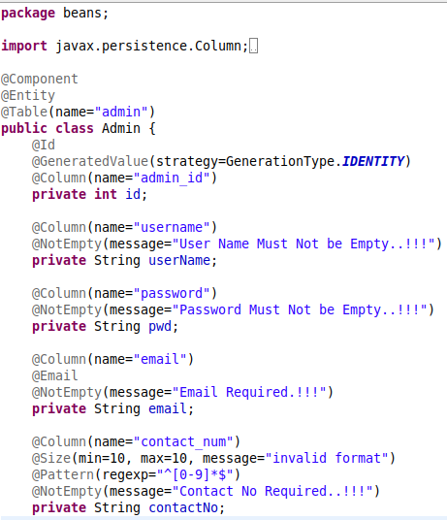

Fig 4.2.1: Entity Mapping Code



Fig 4.2.2: Entity Database

1. **Hibernate Validator**

To validate form we have used hibernate validator. It will validate the required fields of the form as we have specified in validation section as shown in Fig 4.3.1 .

The libraries used for hibernate validator are :

* javax.validation.constraints.Email;
* javax.validation.constraints.NotEmpty;
* javax.validation.constraints.Pattern;
* javax.validation.constraints.Size;
* javax.validation.constraints.NotNull;

Maven Dependencies :

<dependency>

<groupId>org.hibernate</groupId>

<artifactId>hibernate-validator</artifactId>

<version>6.0.18.Final</version>

</dependency>

**Screenshots:**

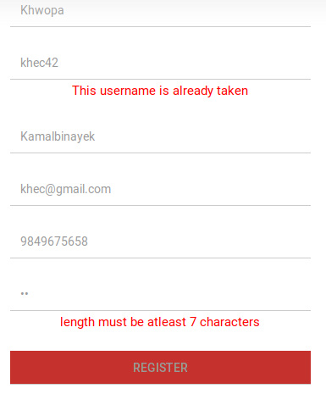

Fig 4.3.1: Validation Error shown in form

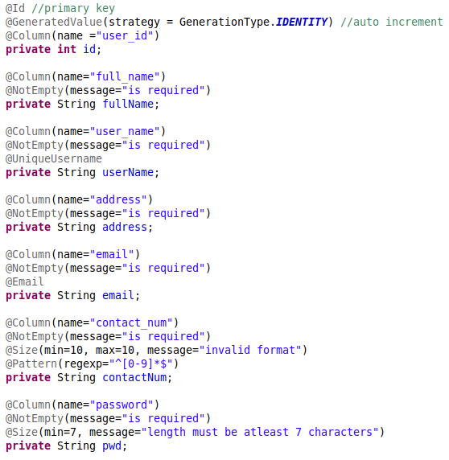

Fig 4.3.2: Hibernate Validator Code

1. **Image Compression**

User can upload the images of product while uploading products so we have maintained the limits to upload the file. User can upload max of 3 mb as stated in configuration file servlet.xml shown in Fig 4.4.1 . And even after uploading the images in other to maintain the space of the database and server we have applied image compression to the uploaded image and reduced its size. JPEG compression is applied to the image. For that the given libraries are used.

* java.awt.Color;
* java.awt.image.BufferedImage;
* java.io.File;
* java.io.FileInputStream;
* java.io.FileOutputStream;
* java.io.OutputStream;
* java.util.Iterator

**Screenshots:**

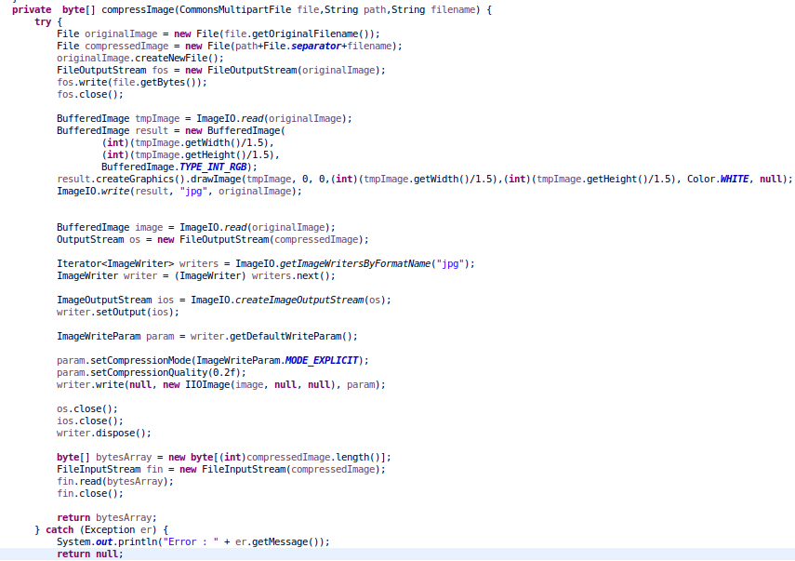

Fig 4.4.1: Image Compression Code



Fig 4.4.2: Code in Servlet.xml

1. **Spring Security**

We have implemented spring security for accesing the pages in our web app.Two roles are maintained in this app, one is ROLE "Admin" and other "User". Spring security checks the user whether it is normal user or admin user as per its role. If it is admin user then only it will give access to admin pages else it will reject the user to give access. For that it checks the user in the database using Dao Authentication as shown in fig "DaoAuthentication.png" . PageAccess.png shows the pages which are authenticated with Spring Security.

For password encoding we used BCryptPasswordEncoder with 12 round of hashing.

We have maintained our own CustomAuthenticationFailureHandler to recognize if unknown person is trying to access the admin account or If the admin account is locked due to multiple invalid access.

The libraries used for Spring security are :

* org.springframework.beans.factory.annotation.Autowired;
* org.springframework.context.annotation.Bean;
* org.springframework.context.annotation.ComponentScan;
* org.springframework.context.annotation.Configuration;
* org.springframework.security.authentication.AuthenticationProvider;
* org.springframework.security.authentication.dao.DaoAuthenticationProvider;
* org.springframework.security.config.annotation.method.configuration.EnableGlobalMethodSecurity;
* org.springframework.security.config.annotation.web.builders.HttpSecurity;
* org.springframework.security.config.annotation.web.configuration.EnableWebSecurity;
* org.springframework.security.config.annotation.web.configuration.WebSecurityConfigurerAdapter;
* org.springframework.security.core.userdetails.UserDetailsService;
* org.springframework.security.crypto.bcrypt.BCryptPasswordEncoder;
* org.springframework.security.web.util.matcher.AntPathRequestMatcher;

Maven Dependencies:

<dependency>

<groupId>org.springframework.security</groupId>

<artifactId>spring-security-web</artifactId>

<version>5.0.0.RELEASE</version>

</dependency>

<dependency>

<groupId>org.springframework.security</groupId>

<artifactId>spring-security-core</artifactId>

<version>5.0.0.RELEASE</version>

</dependency>

<dependency>

<groupId>org.springframework.security</groupId>

<artifactId>spring-security-config</artifactId>

<version>5.0.0.RELEASE</version>

</dependency>

<dependency>

<groupId>org.springframework.security</groupId>

<artifactId>spring-security-taglibs</artifactId>

<version>5.0.4.RELEASE</version>

</dependency>

**Screenshots:**

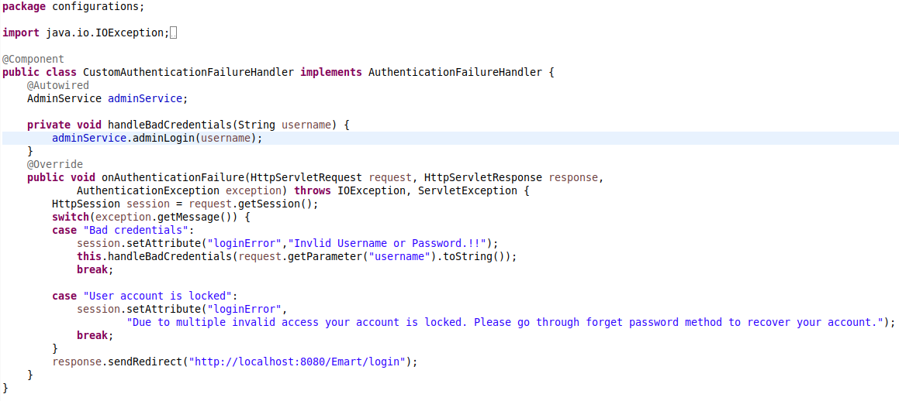

Fig 4.5.1: CustomAuthenticationFailureHandler

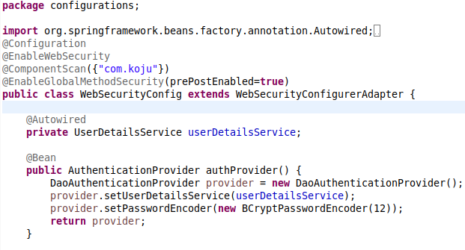

Fig 4.5.2: Dao Authentication

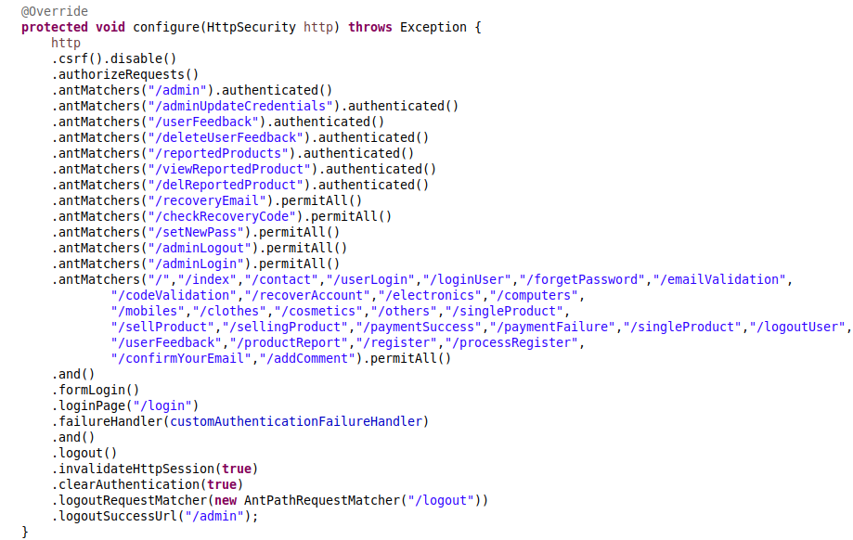

Fig 4.5.3: Page Access

1. **XSS Filter**

For preventing XSS Attack (Cross Site Script Attack) we have maintained 1 level of filter. Any value that have been bypassed hibernate validator will now pass to check XSS ( Cross Site Script ). And if it found any javascript elements such as <script> </script> then it will reject the value.

**Screenshots:**

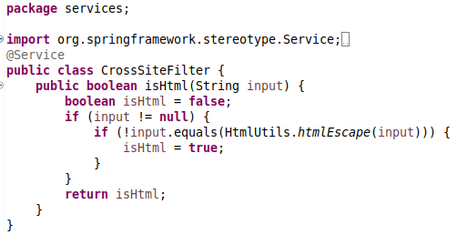

Fig 4.6.1: CrossSite Filter

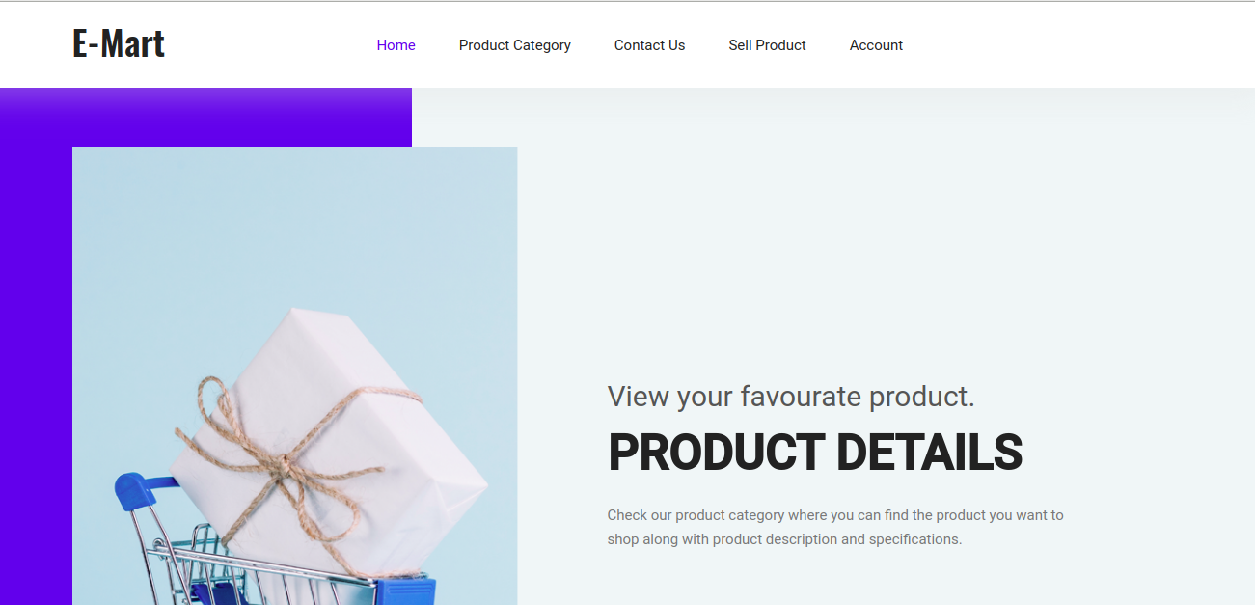**Screenshots of website:**

Fig 4.7 Home page

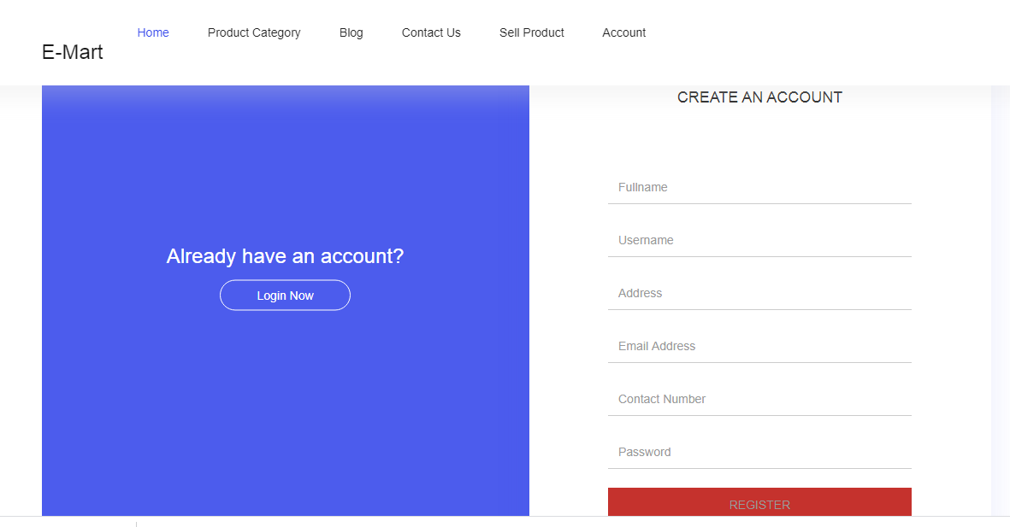

Fig 4.8 User Account Register Page

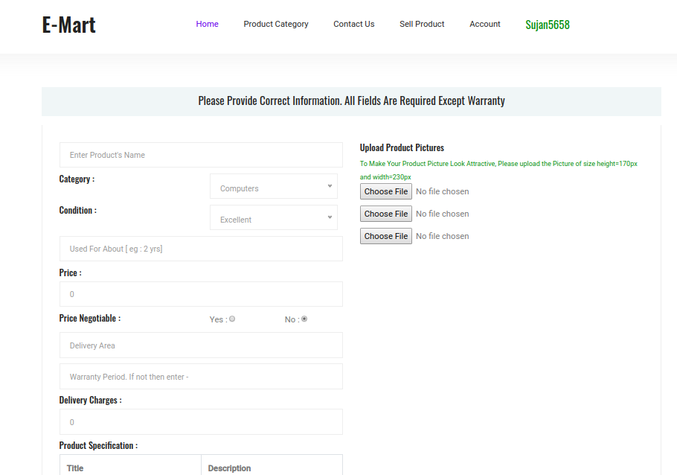

Fig 4.9 Product Upload Page

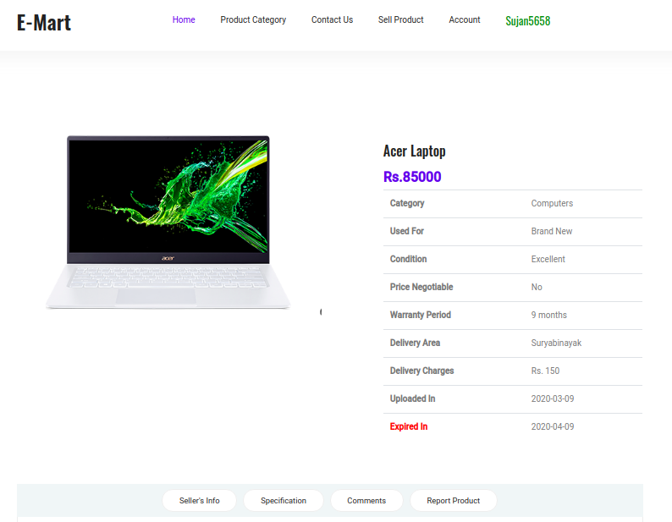

Fig 4.10 Single Product Display Page

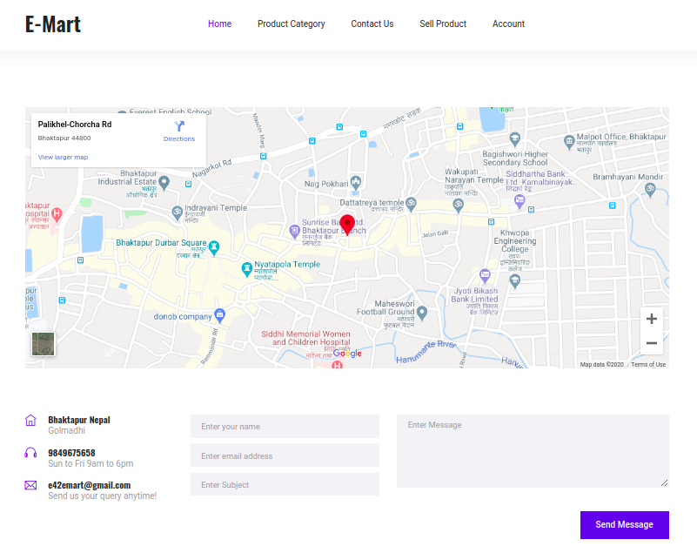

Fig 4.11 Contact Us Page

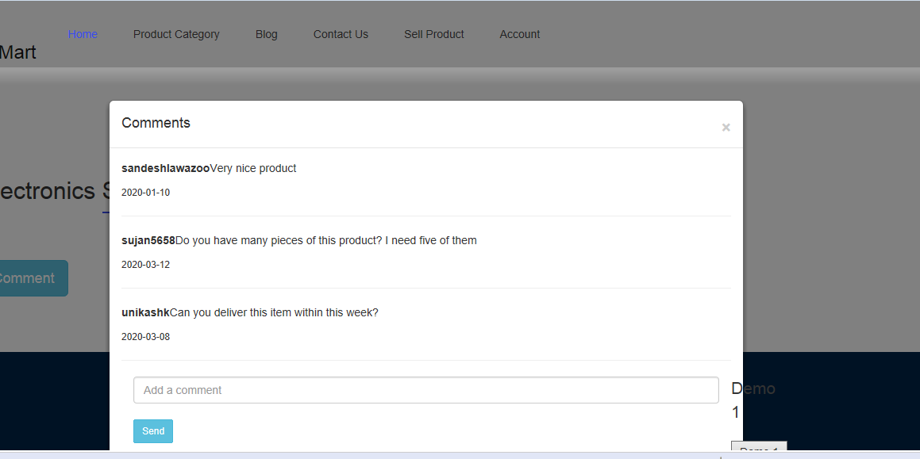

Fig 4.12 Comment Product Page



Fig 4.13 Admin Login Page

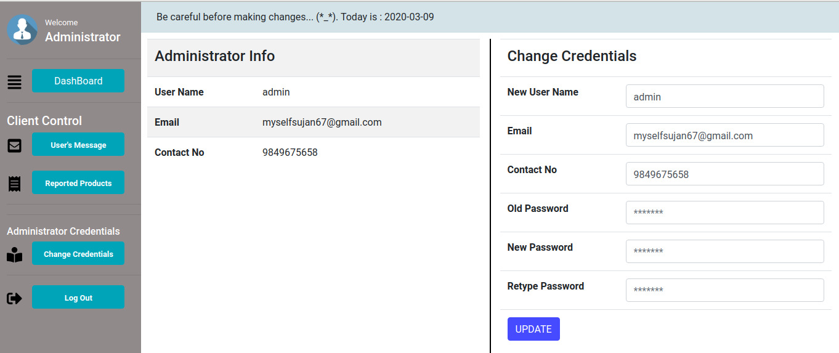

Fig 4.14 Admin Home Page

**CHAPTER 5**

**CONCLUSIONS & RECOMMENDATIONS**

1. **Conclusions**

This project “E-Mart” is a user-friendly e-commerce platform where the seller can advertise their products and the buyer can purchase their product of interest directly from the seller. In this project, Model View Controller (MVC) concept is implemented using Spring Hibernate to make it more efficient and secure.

1. **Future Recommendations**
2. This project can be further developed into an android application.
3. In future, we can also add search buttons and recommendations using artificial intelligence to make this project more user-friendly.

**REFERENCES**

1. Binshan Lin, "E-commerce in Nepal: a case study of an underdeveloped country" in International Journal of Management and Enterprise Development , January 2005 (17 November 2019)
2. Deepika Kathirvel,"ARTIFICIAL INTELLIGENCE OF E-COMMERCE PLATFORM" in Asian Journal of Marketing , January 2018 (20 November 2019)
3. J. Srinivasan and Deepika Kathirvel, "ARTIFICIAL INTELLIGENCE OF E-COMMERCE PLATFORM", January 2018 (18 November 2019)
4. Richard Boateng and Richard Heeks, "E-Commerce in Developing Economies: A Review of Theoretical Frameworks and Approaches", January 2008 (18 November 2019)
5. https://becominghuman.ai/how-ecommerce-companies-are-using-ai-to-drive-higher-sales-user-experience-20d9d9bbb2b0 (20 November 2019)
6. https://www.forbes.com/sites/bernardmarr/2019/04/26/the-amazing-ways-ebay-is-using-artificial-intelligence-to-boost-business-success/#41b4ef02c2ee (20 November 2019)
7. http://icetoday.net/2018/09/the-new-daraz-app-comes-with-artificial-intelligence/(20 November 2019)
8. http://leafcloud.blogspot.com/2016/09/an-article-on-e-commerce-in-nepal.html (17 November 2019)
9. https://neoteric.eu/blog/6-ways-to-use-artificial-intelligence-in-e-commerce/ (20 November 2019)