# CHAPTER 1

## INTRODUCTION

### 1.1Background

A travel agency is a private retailer or public service that provides travel and tourism related services to the public on behalf of suppliers such as activities, airlines, car, rentals, cruise lines, hotels, railways, travel insurance, and package tours[3].In addition to dealing with ordinary tourists, most travel agencies have a separate department devoted to making travel arrangements for business travelers; some travel agencies specialize in commercial and business travel only[6].

A customer’s first experience with the business is a visit to the website. This project Yatra Tours and Travel” is a website for a travel agency that is very helpful as the customer can directly view the packages and itinerary of various tourism sites in Nepal from home through internet connection on mobile or system. This includes looking at pictures and reviews from past guests. It is vital for a business-like travel agency to effectively utilize online advertising, social media, blogs, and online purchasing to help convenience their customers [5]. This project reduces lot of work load for customer as well as business person.

The customer can give feedback and also contact the agency office using the pages given by the website. Admin of the site can control all the activities such as addition of packages, update of existing information and viewing the feedback given by the user making this website very useful and user friendly.

### 1.2Motivation

The main motivation factor is the desire to deduce the problems faced by people due to lack of systematic booking and viewing of package all over the world. Because of different problems like queue in tickets unaffordable prices as shown in the news, we are motivated to make a user-friendly website so that people could view, purchase and order tickets online.

### 1.3 Statement of Problems

Despite all the efforts of e-commerce companies to alleviate them, there are a few problems that customers still have to face in travel agency website. Some of these problems are itinerary issues, feedback failures, additional charges and other extra packages needed.

### 1.4 Objectives

To build a travel agency website for brief summary of the area, with highlights of important places, the schedule and its price.

### 1.5 Scope and Limitation

The travel agency system has a wide area of application. It can be used for viewing and ordering of packages from the internet. It provides user-friendly environment.

The main limitation of this project is that this webpage does not provide the customer the facility to choose their desired vehicle and hotel.

# CHAPTER 2

## LITERATURE REVIEW

### 2.1 Related Work

The web has revolutionized the way we travel, allowing consumers to search, buy and share trips at the touch of a button. It all started in 1989 when a British computer scientist Tim Berners-Lee wrote a proposal for what would eventually become the World Wide Web [1].

In 1994,Travelweb.com emerged as the first comprehensive catalogue of hotel properties around the world and, a short time later, included a component to make bookings. In 1996 Microsoft, the most high-profile technology company on the planet at the time, unveiled its attempt at an online travel agency, known as Expedia [2]. In 1998, as online travel agencies took root in the US, in Europe two bright young things created an iconic web brand. They led the brash and playful Lastminute.com into the still somewhat new world of web commerce, cementing the idea in the minds of consumers that travel can be bought over the internet with ease and, well, at the last minute. In 2000, Trip Advisor, the original and still by far the biggest social travel site on the web was released. It was incredibly simple – travelers left reviews of hotels; fellow travelers found the reviews and could make a decision on whether to stay at a property based on what they'd read. Hoteliers freaked out, but travelers loved this new "wisdom of the crowds"[3].

As we look at the history of travel agency in Nepal, the oldest and first travel agency was Shah and Rai which could not last more than a year. Then the tourism department started Rhino Tour to organize sightseeing tours. It had fixed pick up points and time and had fixed places of visit as well. Even this system did not last long[4].

In recent time, a lot of such websites have been created making it easier for business in the value chain of travels and tours industry to now directly sell their services via their online portal to their target market.

# CHAPTER 3

## PROJECT MANAGEMENT

In order to design our site” Yatra Tours &Travels”, first we will design the conceptual concept. We will draw the flow of program on the basis of the so generated concept. And we will design the program on basis of these concepts.

**3.1 Project member information:**

For this project we have a group of four members:

|  |  |
| --- | --- |
| **Name** | **Roll No.** |
| Ipseeka Malla | 730315 |
| Manisha Kasawalat | 730321 |
| Sandhya Basnet | 730336 |
| Unika Shakya | 730348 |

### 3.2 Feasibility Study

The objectives of feasibility study are not solving the problem but to acquire a sense of its scope. During the study, the problem definition is crystallized and aspects of the problem to be included in the system are determined. Consequently, constant benefits are estimated and the greater reliability at this stage. This is a bridge in between the user requirements and the outputs.

### 3.3 Work break down structure

The four group members will work on the different modules. During the course of work, each member will communicate with each other so that no problem arises in the future. Then we will combine all the modules to develop a single program**.**

|  |  |  |  |  |  |  |  |  |  |
| --- | --- | --- | --- | --- | --- | --- | --- | --- | --- |
| S.  N | Week Job Description | 1st  Week | 2nd  Week | 3rd  Week | 4th  Week | 5th  Week | 6th  Week | 7th  Week | 8th  Week |
| 1. | Problem  Identification |  |  |  |  |  |  |  |  |
| 2. | Analysis |  |  |  |  |  |  |  |  |
| 3. | Design |  |  |  |  |  |  |  |  |
| 4. | Coding |  |  |  |  |  |  |  |  |
| 5. | Testing and Debugging |  |  |  |  |  |  |  |  |
| 6. | Documentation |  |  |  |  |  |  |  |  |

Figure 3.1: Work break down structure

# CHAPTER 4

## METHODOLOGY

**4**

**.**

**1**

**System Block Diagram**

Yatra

t

ours

and

travel (Kathmandu

Valley)

View Information

Give and view

feedback

User

Admin

Join the community

View message

Delete message

Book package

Keep record of

tickets

Update information

### Fig 4.1: System Block Diagram for Travel agency website

For developing the application for travel agency website various phase and methods was proceeded with the help of various software, tools and languages. Our project initial step was to collect related data and perform analysis of the proposed system, and then designing and development of complete system.

In this system, admin is the manager of travel agency. Therefore, he has been given the authority to manage information about tourism sites and view feedback and customer information. This will enable him to manage record of tickets making it easier to run the business of travel and tourism. For the database security, admin should first login to the system so that only authorized personnel can have access to the data.

Any user that visits the website is customer of this system. They would be able to view the tourism packages and itinerary of various tourism sites in Nepal. Customer could join the community, book tickets and give feedback on the system through this website after they enter required informatio

#### 4.2 ER-Diagram

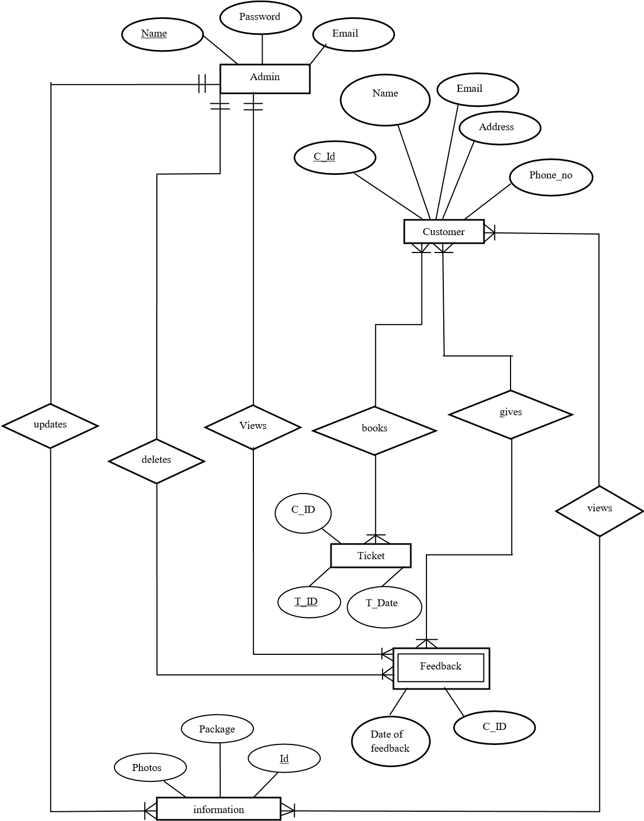

### Fig 4.2: ER diagram

**4.3 Tools and Platform**

#### 1. Front End

* HTML
* CSS
* JavaScript

#### 2. Back End

* PHP
* MYSQL Database

1. **XAMPP Server**
2. **Sublime Text Editor**

# CHAPTER 5

**RESULT AND DISCUSSIONS**

## 5.1 Result

The Travel & Tourism website is a web-based application system. This application should be able to fix the limitation and problems of paper-based processes. The main goal is to make customers for easy way to view the services provided by agency web pages design more attractive. From this project, we developed following features:

1. Enables the customers to order packages by for
2. Allows customer to give any feedback needed for further improvement
3. Admin can control all the activities such as addition of packages, update of existing information and view the records of customers.
4. Customers will be able pay through their credit card or debit card.

# CHAPTER 6

## CONCLUSION AND RECOMMENDATIONS

**6.1 Conclusion**

This project on Yatra Tours & Travels (Kathmandu Valley) creates and handles details of the details of packages,the itinerary of each holidays, services in cheap and best price and provide a feedback system for user for future recommendation make easy for the user to view and order the packages online from anywhere in the world.

**6.2 Future Recommendations**

This project can be further enhanced by improving the GUI as well asmaking it more responsive and user-friendly.

## References

1. http://www.jdpower.com/business/press-releases/2014-online-travel-agencysatisfaction-report (7 January 2019)
2. [https://www.scribd.com/doc/21634275/Project-Report-on-Travel-and-Tourism-inTravel-Agency(](https://www.scribd.com/doc/21634275/Project-Report-on-Travel-and-Tourism-in-Travel-Agency)13 January 2019)
3. [https://www.ibisworld.com/industry-trends/market-research-reports/administrationbusiness-support-waste-management-services/administrative/travel-agencies.html(](https://www.ibisworld.com/industry-trends/market-research-reports/administration-business-support-waste-management-services/administrative/travel-agencies.html)6 28 January 2019)
4. https://www.acetravels.com (3 February 2019)
5. https://www.theguardian.com/travel/2014/mar/12/how-25-years-of-the-web-inspiredtravel-revolution(15 February 2019)
6. http://www.dcsplus.net/blog/three-types-of-reports-every-travel-company-needs(22 February 2019)
7. https://www.slideshare.net/AmitPatil81/online-tours-and-travel(25 February 2019)

### Appendix

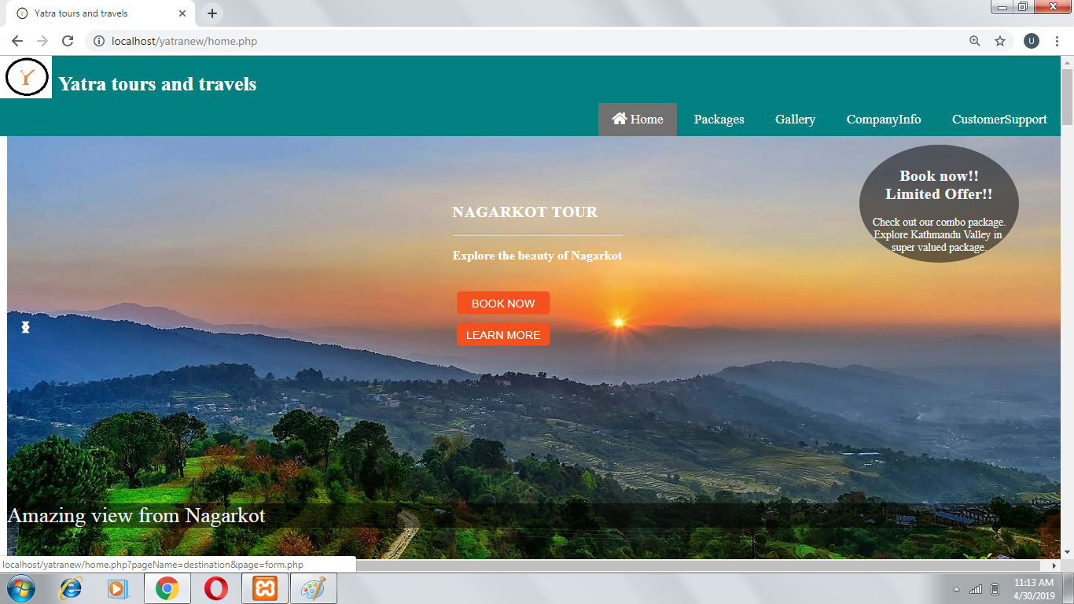

Fig a.1: Home page of Yatra Tours & Travels

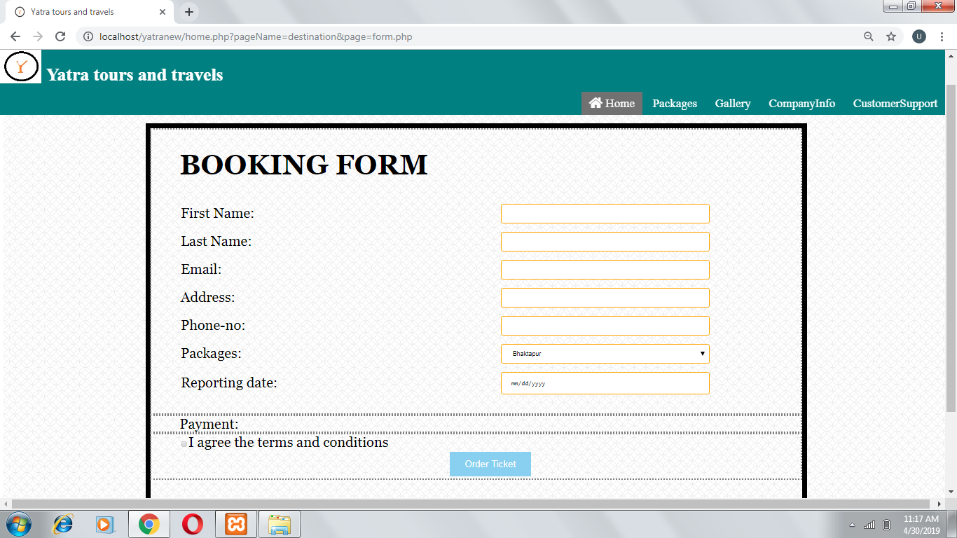

Fig a.2: Package Booking Form

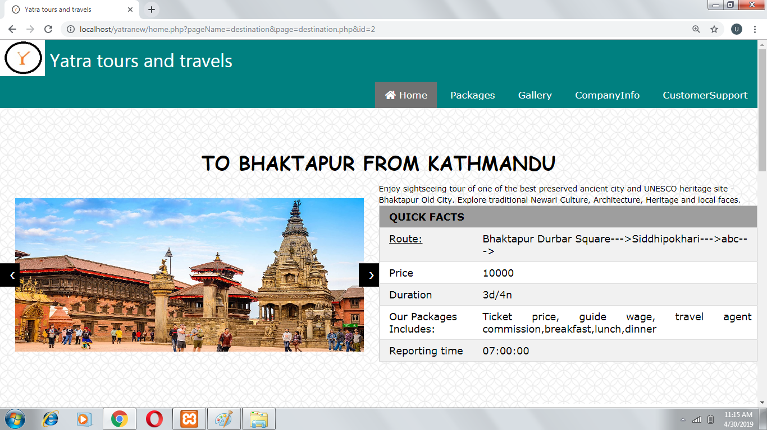

Fig a.3: Details about Package

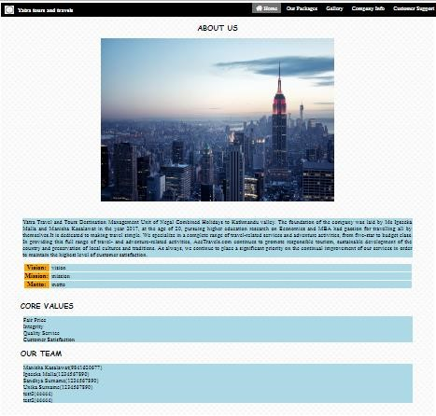

Fig a.4: Detail about the company

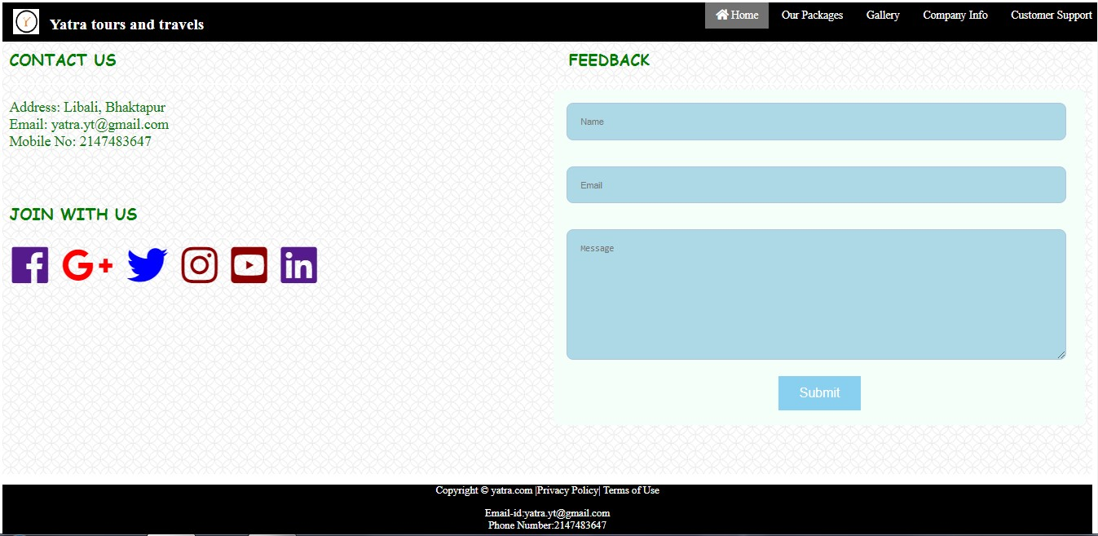

#### Fig a.5: Feedback Page

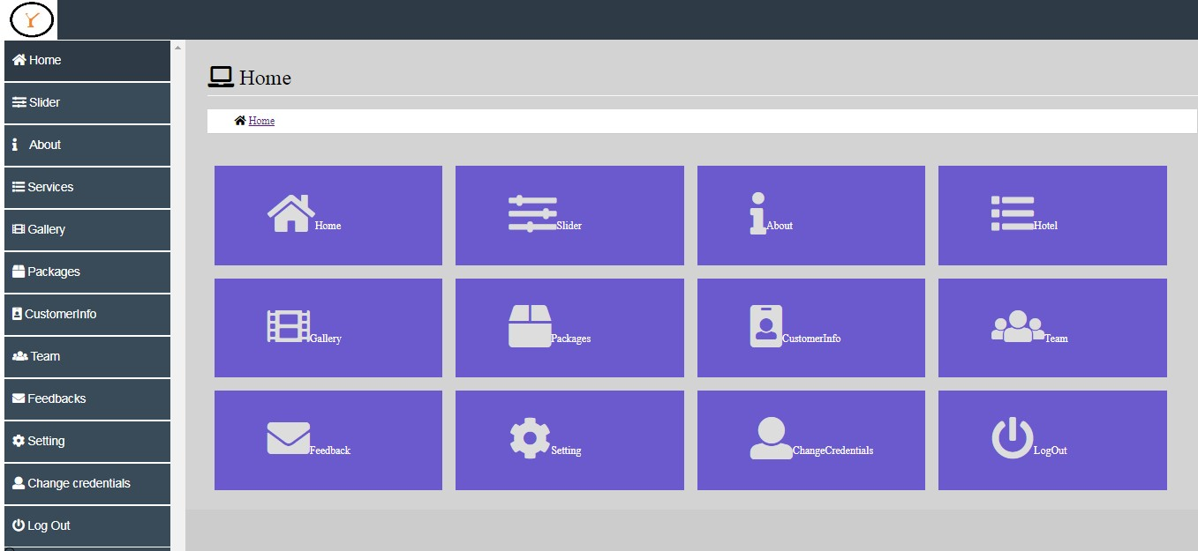

#### Fig a.6: Admin Page

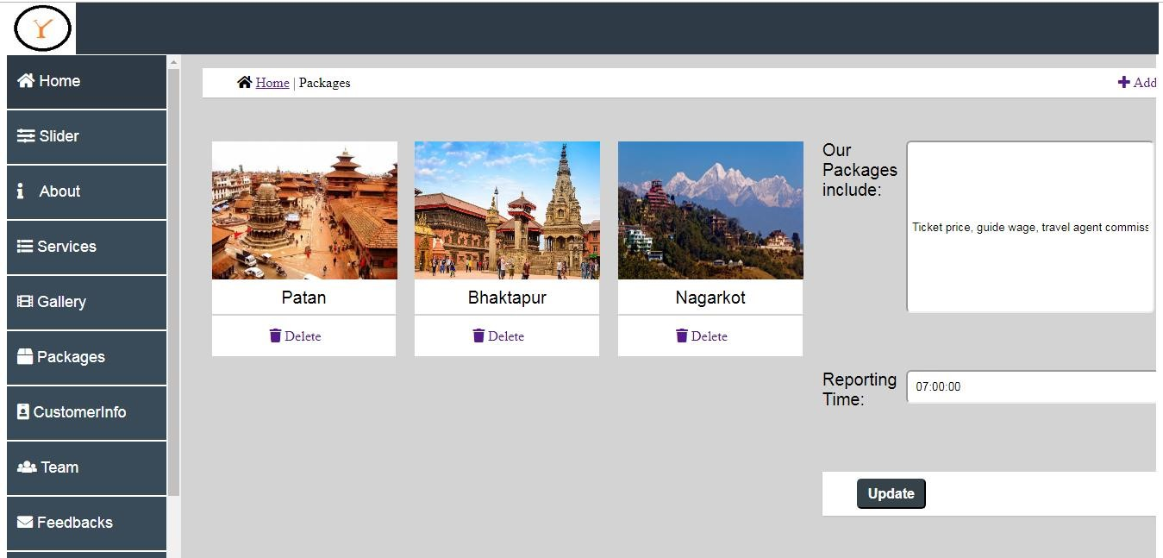

#### Fig a.7: Package View for Admin