LARAUSESENA - ceet
DESARROLLO DE APPS CON REACT NATIVE

INTERGRAR CRUD CON LA APLICACIÓN

- Modifique server.js asi :
const express = require('express');
const passport = require('passport');
const app = express();
const http = require('http');
const server = http.createServer(app);
const logger = require('morgan');
const cors = require('cors');
const mysql = require('mysql2');
const db = require('./config/config.js');
/**
* Importar las rutas
*/
const userRoutes = require('./routes/userRoutes');

const port = process.env.PORT || 3000;

app.use(logger('dev'));
app.use(express.json());
app.use(express.urlencoded({ extendd: true}));
app.use(cors());
app.use(passport.initialize());
app.use(passport.session());

require('./config/passport')(passport);
app.disable('x-powered-by');//Disable the x-powered-by header in the response

app.set('port',port);
/**
* Llamado las rutas
*/
userRoutes(app);
// Iniciando el servidor
// direccion ip V4 de la maquina consultar ipconfig
server.listen(3000, '192.168.1.13' || 'localhost', function() {
console.log('Aplicacion de NodeJs' + process.pid + 'ejecutando en ' + server.address().address + ' : ' + server.address().port);
});

/**Rutas */

app.get('/', (req, res) => {
res.send('estas en la Ruta raiz de Backend');
});

app.get('/test', (req, res) => {
res.send('estas en la Ruta test');
});
//Manejo de errores
//Error handler
app.use((err, req, res, next) => {
console.log(err);
res.status(err.status || 500).send(err.stack);
});

// CRUD endpoints
app.get('/products', (req, res) => {
db.query('SELECT * FROM products', (err, results) => {
if (err) throw err;
res.json(results);
});
});

app.get('/products/:id', (req, res) => {
const { id } = req.params;
db.query('SELECT * FROM products WHERE id = ?', [id], (err, results) => {
if (err) throw err;
res.json(results[0]);
});
});

app.post('/products', (req, res) => {
const { name, price } = req.body;
db.query('INSERT INTO products (name, price) VALUES (?, ?)', [name, price], (err, results) => {
if (err) throw err;
res.json({ id: results.insertId, name, price });
});
});

app.put('/products/:id', (req, res) => {
const { id } = req.params;
const { name, price } = req.body;
db.query('UPDATE products SET name = ?, price = ? WHERE id = ?', [name, price, id], (err, results) => {
if (err) throw err;
res.json({ id, name, price });
});
});

app.delete('/products/:id', (req, res) => {
const { id } = req.params;
db.query('DELETE FROM products WHERE id = ?', [id], (err, results) => {
if (err) throw err;
res.json({ id });
});
});

app.listen(3000, () => {
console.log('192.168.1.13 port 3000');
});

- Cree el archivo api.js en Data/sourse/remote/api queda así:

import axios from 'axios';

const api = axios.create({
baseURL: 'http://192.168.1.13:3000'
});

export const getProducts = async () => {
const response = await api.get('/products');
return response.data;
};

export const createProduct = async (product) => {
const response = await api.post('/products', product);
return response.data;
};

export const updateProduct = async (id, product) => {
const response = await api.put(`/products/${id}`, product);
return response.data;
};

export const deleteProduct = async (id) => {
const response = await api.delete(`/products/${id}`);
return response.data;
};

export const getProductById = async (id) => {
const response = await api.get(`/products/${id}`);
return response.data;
};

- En la carpeta views/profile/info modifique profileInfo.tsx asi:

import { StackScreenProps } from '@react-navigation/stack';
import React, { useEffect, useState } from 'react';
import { View, Text, FlatList, Button, TextInput, StyleSheet, TouchableOpacity } from 'react-native';
import { RootStackParamList } from '../../../../../App';
import useViewModel from './ViewModel';
import { getProducts, createProduct, updateProduct, deleteProduct, getProductById } from '../../../../Data/sourse/remote/api/api';
import Modal from 'react-native-modal';
import styles from './Styles';
interface Product {
id: number;
name: string;
price: number;
}

interface Props extends StackScreenProps<RootStackParamList, 'ProfileInfoScreen'> { };

export const ProfileInfoScreen = ({ navigation, route }: Props) => {
const [products, setProducts] = useState<Product[]>([]);
const [name, setName] = useState('');
const [price, setPrice] = useState('');
const [selectedProductId, setSelectedProductId] = useState<number | null>(null);
const [isModalVisible, setModalVisible] = useState(false);
const [searchId, setSearchId] = useState('');
const [searchedProduct, setSearchedProduct] = useState<Product | null>(null);

useEffect(() => {
fetchProducts();
}, []);

const fetchProducts = async () => {
const data = await getProducts();
setProducts(data);
};

const handleAddProduct = async () => {
const newProduct = await createProduct({ name, price });
setProducts([...products, newProduct]);
setName('');
setPrice('');
};

const handleUpdateProduct = async () => {
if (selectedProductId !== null) {
const updatedProduct = await updateProduct(selectedProductId, { name, price });
setProducts(products.map(product => product.id === selectedProductId ? updatedProduct : product));
setSelectedProductId(null);
setName('');
setPrice('');
}
};

const handleDeleteProduct = async (id: number) => {
await deleteProduct(id);
setProducts(products.filter(product => product.id !== id));
};

const handleSearchProduct = async () => {
const product = await getProductById(parseInt(searchId));
setSearchedProduct(product);
};

const toggleModal = () => {
setModalVisible(!isModalVisible);
};

const { removeSession } = useViewModel();
return (

//<View style={{ flex: 1, justifyContent: 'center', alignItems: 'center' }}>
<View style={{ flex: 1, justifyContent: 'flex-end', }}>
<View style={styles.container}>
<Text style={styles.title}>Productos</Text>
<FlatList
data={products}
keyExtractor={(item) => item.id.toString()}
renderItem={({ item }) => (
<View style={styles.productContainer}>
<Text style={styles.productText}>{item.name} - ${item.price}</Text>
<View style={styles.buttonContainer}>
<TouchableOpacity style={styles.button} onPress={() => {
setName(item.name);
setPrice(item.price.toString());
setSelectedProductId(item.id);
}}>
<Text style={styles.buttonText}>Modificar</Text>
</TouchableOpacity>
<TouchableOpacity style={styles.button} onPress={() => handleDeleteProduct(item.id)}>
<Text style={styles.buttonText}>Eliminar</Text>
</TouchableOpacity>
</View>
</View>
)}
/>
<TextInput
style={styles.input}
placeholder="Nombre"
value={name}
onChangeText={setName}
/>
<TextInput
style={styles.input}
placeholder="Precio"
value={price}
onChangeText={setPrice}
keyboardType="numeric"
/>
<TouchableOpacity style={styles.addButton} onPress={selectedProductId ? handleUpdateProduct : handleAddProduct}>
<Text style={styles.addButtonText}>{selectedProductId ? "Modificar Producto" : "Crear Producto"}</Text>
</TouchableOpacity>
<TextInput
style={styles.input}
placeholder="Numero de ID"
value={searchId}
onChangeText={setSearchId}
keyboardType="numeric"
/>
<TouchableOpacity style={styles.searchButton} onPress={handleSearchProduct}>
<Text style={styles.searchButtonText}>Buscar Producto</Text>
</TouchableOpacity>
{searchedProduct && (
<View style={styles.productContainer}>
<Text style={styles.productText}> Producto Buscado: {searchedProduct.name} - ${searchedProduct.price}</Text>
</View>
)}
<TouchableOpacity style={styles.reportButton} onPress={toggleModal}>
<Text style={styles.reportButtonText}>Generar Reporte</Text>
</TouchableOpacity>
<Modal isVisible={isModalVisible}>
<View style={styles.modalContent}>
<Text style={styles.modalTitle}>Reporte de Productos</Text>
{products.map(product => (
<Text key={product.id} style={styles.modalText}>{product.name} - ${product.price}</Text>
))}
<TouchableOpacity onPress={toggleModal} style={styles.closeButton}>
<Text style={styles.closeButtonText}>Cerrar</Text>
</TouchableOpacity>
</View>
</Modal>
</View>
<Button
onPress={() => {
removeSession();
navigation.navigate('HomeScreen');
}}
title="Cerrar Sesion"
/>
</View>

)
}

- En la carpeta views/profile/info cree el archivo Styles.tsx y queda así :

import { StyleSheet } from "react-native";
const ProfileInfostyles = StyleSheet.create({
container: {
flex: 1,
padding: 20,
backgroundColor: '#f5f5f5',
},
title: {
fontSize: 24,
fontWeight: 'bold',
marginBottom: 20,
textAlign: 'center',
},
productContainer: {
padding: 15,
backgroundColor: '#fff',
borderRadius: 10,
marginBottom: 10,
shadowColor: '#000',
shadowOffset: { width: 0, height: 2 },
shadowOpacity: 0.1,
shadowRadius: 5,
elevation: 3,
},
productText: {
fontSize: 18,
marginBottom: 10,
},
buttonContainer: {
flexDirection: 'row',
justifyContent: 'space-between',
},
button: {
backgroundColor: '#2196F3',
padding: 10,
borderRadius: 5,
marginHorizontal: 5,
},
buttonText: {
color: 'white',
fontWeight: 'bold',
},
input: {
height: 40,
borderColor: '#ccc',
borderWidth: 1,
borderRadius: 5,
marginBottom: 10,
paddingHorizontal: 10,
backgroundColor: '#fff',
},
addButton: {
backgroundColor: '#4CAF50',
padding: 15,
borderRadius: 5,
alignItems: 'center',
marginBottom: 10,
},
addButtonText: {
color: 'white',
fontWeight: 'bold',
},
searchButton: {
backgroundColor: '#FF9800',
padding: 15,
borderRadius: 5,
alignItems: 'center',
marginBottom: 10,
},
searchButtonText: {
color: 'white',
fontWeight: 'bold',
},
reportButton: {
backgroundColor: '#9C27B0',
padding: 15,
borderRadius: 5,
alignItems: 'center',
marginBottom: 10,
},
reportButtonText: {
color: 'white',
fontWeight: 'bold',
},
modalContent: {
backgroundColor: 'white',
padding: 20,
borderRadius: 10,
alignItems: 'center',
},
modalTitle: {
fontSize: 20,
fontWeight: 'bold',
marginBottom: 10,
},
modalText: {
fontSize: 16,
marginBottom: 5,
},
closeButton: {
marginTop: 20,
padding: 10,
backgroundColor: '#2196F3',
borderRadius: 5,
},
closeButtonText: {
color: 'white',
fontWeight: 'bold',
},
});

export default ProfileInfostyles;

- Debe quedar asi:

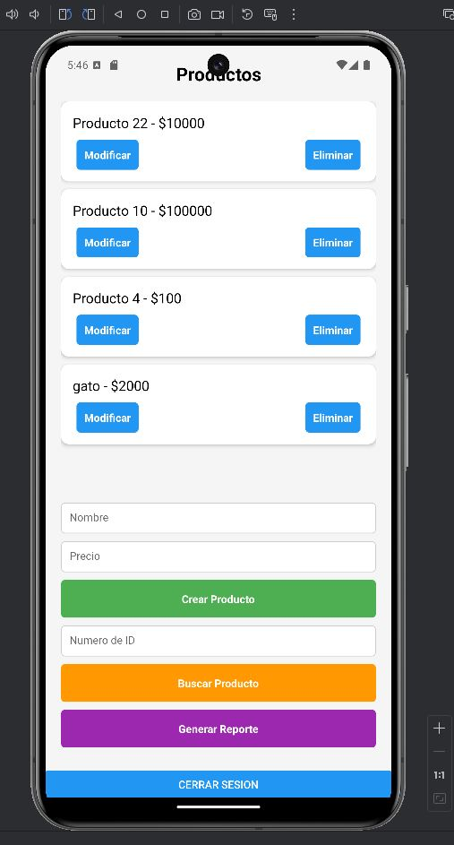

- Realice las pruebas por backend por postman de la misma manera que las guias anteriores para garantizar la api y después por el emulador

