|  |
| --- |
| uic |
| OSDM Converter Tool |
| User Manual |

|  |
| --- |
| Clemens Gantert  23.12.2020 |

Table of Contents

Getting Started 3

Data structure 3

Conversion from 108.1 to 90918-10 4

Step 1: Import Reference Data 4

Step 2: Import 108.1 Fare Data 4

Step 3: Add Conversion Parameters 4

Step 4: Convert Data 5

Step 5: Export 90918-10 Data 5

Conversion from 90918-10 to 108.1 5

Step 1: Import Reference Data 5

Step 2: Import 90918-10 Fare Data 6

Step 3: Convert Data 6

Step 4: Export 108.1 Data 6

Recommended Workflow 7

Import of code lists and preparation of conversion parameter 7

Conversion 108.1 to IRS 90918-10 7

Conversion IRS 90918-10 to 108.1 7

Application 9

Application Views 10

Menus 10

File Menu 10

Help Menu 11

Tool Bar 11

Context Menu 11

Views 11

Resource View 11

Outline View 12

Property View 12

Console View 12

Problem View 12

Conversion Details 90918-10 to 108.1 12

Parameters required for the import of 108.1 data 12

Parameters required for the conversion of 90918-10 data 12

Conversion 12

Conversion has the following steps: 12

Export to legacy files 13

Conversion Details 108.1 to IRS 90918-10 13

Parameters required for the import of 108.1 data 13

Parameters required for the conversion of 108.1 data 13

Conversion Parameters 13

Fare Template 14

Conversion 16

Conversion has the following steps: 16

Converting a Series 16

Converting of a series has the following steps: 16

Border Points 17

Company Codes 18

Data Editing 19

NUTS Codes 19

Service Brands 20

Stations 20

Data Description 20

Reference data / Code lists 20

Conversion data 20

Tariff data 108.1 24

Fare data 90918-10 24

User Preferences 25

Validation 25

# Getting Started

This application provides to function to convert fare data between UIC 108.1 and UIC IRS 90918-10 formats.

To convert fare data a new conversion data set has to be created in the application and the needed data of the fares and the reference data need to be imported. In a second step the data can be enriched via the provided editing features, converted and exported.

The application is made of two main windows, one showing the complete data set as a tree (resource view) and one showing the content of leaves of the tree (property view). Additional views are included to display errors. Editing support is available in the property view for the content and in the context menu of the tree view for editing the tree structure.

Functions for import, conversion and export are available in the tool bar.

Intermediary results can be stored at any time.

## Data structure

The data set - where the conversion works on - includes code lists of reference data, 108.1 data, 90918.10 data and conversion parameter

code lists

* [carriers](../reference/data_companycodes.html) - UIC company codes
* [service brands](../reference/data_servicebrandcodes.html) - UIC service brands
* [stations](../reference/data_stationcodes.html) - MERITS stations
* [NUTS](../reference/data_nutscodes.html) codes - regional codes (not used for pure conversion)
* legacy [border point](../reference/data_borderpoints.html) codes

conversion

108.1 fare data

* TCVS
* TCVG
* TCVL
* distance fares
* route based fares

conversion parameter

90918-1 fare data - organized according to the 90918-1 fare delivery data structure

## Conversion from 108.1 to 90918-10

### Step 1: Import Reference Data

90918-10 fare data are based on reference data for company codes, service brands, stations and geographical entities (NUTS codes). These code tables need to be imported first.

The data will be shown in the code list section of the data set.

Import CarriersImport of the [Carriers](../reference/data_companycodes.html) as csv copy of the Carrier list available on the UIC web site.

Import Service BrandsImport of the [Service Brands](../reference/data_servicebrandcodes.html) as csv copy of the Service Brand list available on the UIC web site.

Import StationsImport of the [station](../reference/data_stationcodes.html) data of **MERITS** in **edifact** format.

Import border point codesImport of [Border Point](../reference/data_borderpoints.html) codes from a csv file.

### Step 2: Import 108.1 Fare Data

Before the import conversion parameters must be set for:

* character code table - needed to read the local character sets in 108.1 files
* country - needed to link the local station codes in 108.1 to the country of **MERITS** stations

import 108.1 dataImport 108.1 data

To import 108.1 data the TCV file including the fare data file names must be selected. The import will then import the distance fares and route based fares, the stations TCVG, the series TCVS and TCVL. These files must all be located in the same directory.

The data will be shown in the legacy section of the data set.

### Step 3: Add Conversion Parameters

The data of 108.1 are not sufficient to provide a complete set of 90918-10 fare data. The missing data need to be added in the parameter section of the data set.

The missing data are added in the conversion parameter section as fare templates which serve as a copy template to create 90918-10 fares from the imported data. Missing data can be added to the template using the editing features. The template provides a factor to derive the fare price from the standard adult price provided in the 108.1 data.

Form the fare of one series in 108.1 two fares per template are created for the two travel directions. For different travel classes separate templates need to be defined and the service class needs to be set in the fare template.

Series listed in TCVL car be attributed a separated combination constraint in the fare template.

The station codes in 108.1 have been misused to other concepts like non-Merits-stations, border points, fare reference stations and service brands. These codes need to be mapped to the appropriate entities. For this mappings can be defined in the conversion parameter area to map these codes o the proper entities.

Border points cannot be converted directly, so the needed border points will be converted into connection points and border point mappings but the station sets of the connection points might be incomplete and must be completed manually and the conversion needs to be started again.

### Step 4: Convert Data

convert 108.1 dataConverts the 108.1 data into the 90918-10 data.

Conversion errors will be listed in the console window.

### Step 5: Export 90918-10 Data

The data delivery information needs to be provided in the delivery part of the fare data before the export.

export 90918-10 dataExport the fare data in the json format.

## Conversion from 90918-10 to 108.1

### Step 1: Import Reference Data

90918-10 fare data are based on reference data for company codes, service brands and stations. These code tables need to be imported first.

The data will be shown in the code list section of the data set.

import CarriersImport of the [Carriers](../reference/data_companycodes.html) as csv copy of the Carrier list available on the UIC web site.

import Service BrandsImport of the [Service Brands](../reference/data_servicebrandcodes.html) as csv copy of the Service Brand list available on the UIC web site.

import StationsImport of the [Station](../reference/data_stationcodes.html) data of **MERITS** in **edifact** format.

import border point codesImport of [Border Point](../reference/data_borderpoints.html) codes from a **CSV** file.

### Step 2: Import 90918-10 Fare Data

import 90918-10 dataImport the fare data in the json format.

### Step 3: Convert Data

90918-10 data will lose some content when converted to 108.1 data. therefore not all data can and will be converted. From regional constraints only one direction will be converted.

The following fares will **not** be converted:

* fares which are not foreseen for conversion
* fare which are not for adults
* fares with reduction constraints
* fares with complex route descriptions (not only routes, too long descriptions or with too many stations)
* fares with complex sales availability (special days)
* fares with stations not in the defined country

### Step 4: Export 108.1 Data

export 108.1 dataExport the fare data in the 108.1 format.

Export files are:

* **TCV** file
* **TCVS** file
* **TCVG** file
* One route based fare file

# Recommended Workflow

## Import of code lists and preparation of conversion parameter

All conversions require reference data. It is recommended to create a new file, to import the reference data and to store this as a starting point for subsequent conversions.

For the conversion of 108.1 data to IRS 90918-10 data will usually be done for the own data only. It is recommended to use the filers for the station import and to import only stations from countries where these stations are needed.

The additional conversion parameter, especially the fare templates can also be added in this file. his file can then be copied for all conversions from 108.1 to 90918-10. Validate and complete the conversion parameter using the validation from the context menu on the parameters.

## Conversion 108.1 to IRS 90918-10

To convert open a copy of the file that contains the reference data any your conversion parameter. Use the import function for 108.1 data and select the TCV file. All other 108 files must be located in the same directory.

import 108.1 dataImport legacy data from the 108.1 format.

convertConvert the data.

export 90918-10 dataExport 90918-10 data.

## Conversion IRS 90918-10 to 108.1

To convert open a copy of the file that contains the reference data any your conversion parameter. Use the import function for 90918-10 data to import the json file.

import 90918-10 dataImport legacy data from the 108.1 format.

convertConvert the data.

export 108.1 dataExport 90918-10 data.

# Application

The application manages the conversion of data in its own local data. Therefore a data file needs to be created (new file) and the reference data and data to be converted must be imported. After setting the appropriate parameters the conversion and the export in the new format can be started.

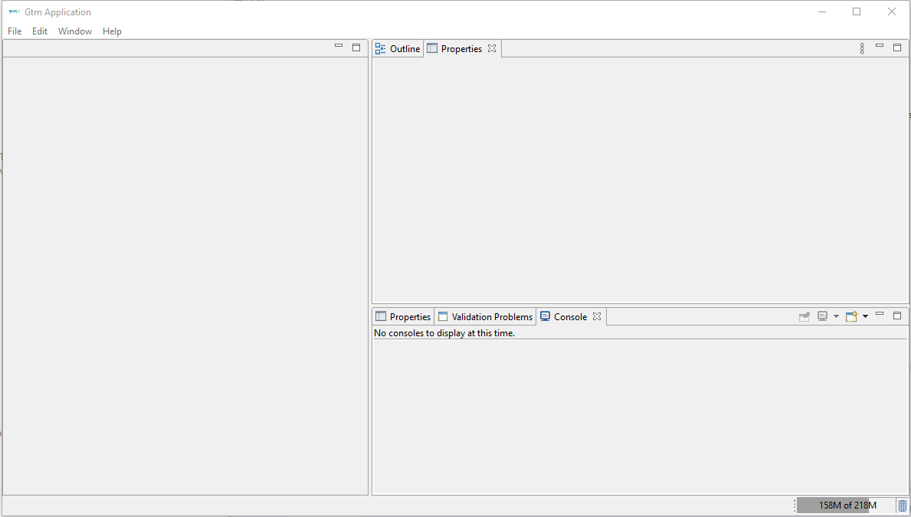

View of the empty application without a data file opened.

## Application Views

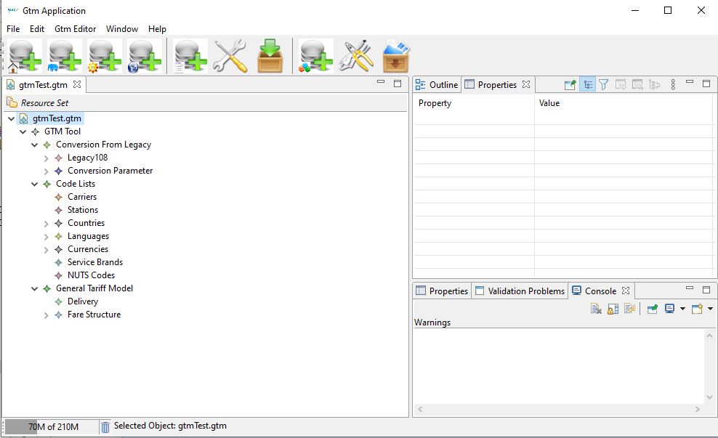

View of the application with a data file opened.

## Menus

### File Menu

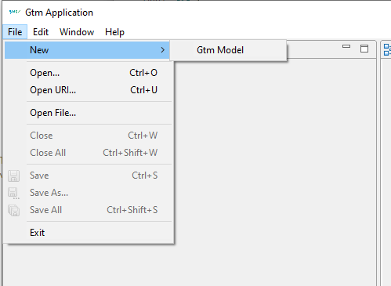

File Menu.

### Help Menu

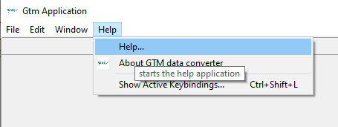

Help Menu.

### Tool Bar

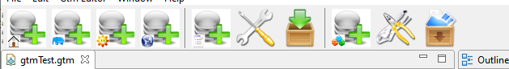

File Menu.

### Context Menu

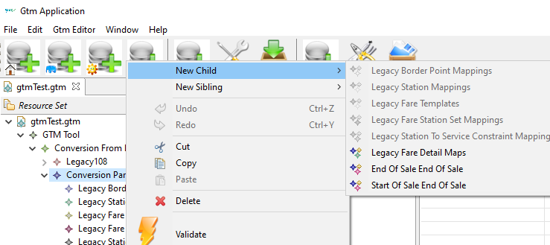

Context Menu.

## Views

Views can be moved within the application window and closed if not needed. Via the windows menu the original views can be restored.

## Resource View

Tree view on the content of a data file. Selections can be made to display the content in the property view. The context menu provides editing and validation functions.

## Outline View

The outline view is almost the same as the resource view. It provides a tree view on the content of a data file. Selections can be made to display the content in the property view. The context menu provides editing and validation functions.

## Property View

View of the attributes of a selected item of the tree or outline view. The view provides editing functions on the items (on the leaves of the data tree).

## Console View

View of errors, warnings or information originating from the conversion process

## Problem View

View on the list of validation issues from the last validation called. A double click opens the associated data item in the tree view.

# Conversion Details 90918-10 to 108.1

## Parameters required for the import of 108.1 data

None

## Parameters required for the conversion of 90918-10 data

|  |  |
| --- | --- |
| Parameter | Description |
| Convert Fare Descriptions | Fare description will be converted into TCVP fare entries. For each different fare description a different fare table will be created. |
| Convert Service Constraint | Service constraints will be converted into TCVP fare entries. For each different fare description a different fare table will be created. |

## Conversion

Convert the data.

Convert the data.

### Conversion has the following steps:

1. Convert stations into legacy stations
2. Convert fare reference sets into legacy stations and assign the fare reference code to the included stations - in case a station belongs to multiple fare reference set only on code can be used in the legacy data.
3. select convertable fares
   * only the fare with a regional validity in one direction is used (using the one with the lower departure station code in case of transit and station-station series)
   * only fares that indicate conversion allowed
   * only ADULT fares
   * only fares without reduction constraints
   * only fares with a simple sales availability (from-to-date)
4. Convert each selected fare to one series and one route fare
   1. Convert the regional constraint into a series
      * The regional validity must have one and only one route description, no zone, no polygon - otherwise there is no conversion
      * The regional validity must have not more than 5 via stations between departure and arrival - otherwise there is no conversion
   2. Convert the price into a route fare - merge the prices from service class B and D into one route fare
   3. Depending on the conversion parameters the fare description for the fare tables are added.
   4. Create TCVL entry for series of fares with combination model SEPARATE_TICKET
5. adjust series number in case no legacy accounting codes were available
6. replace old conversion results by the new ones

## Export to legacy files

The export creates the TCV files and exports the legacy data from the conversion.

The length of data elements in the legacy might exceed the fixed size of the legacy text files. In this case the element will be truncated and an error displayed in the console view.

# Conversion Details 108.1 to IRS 90918-10

## Parameters required for the import of 108.1 data

|  |  |
| --- | --- |
| Parameter | Description |
| Country | Country used to assign the station codes provided without country in 108.1 |
| Character Set | Character set to read the local characters in 108.1 station names |
| Time zone | Time zone used to transfer the date fields in 108.1 into complete date information |

## Parameters required for the conversion of 108.1 data

### Conversion Parameters

|  |  |
| --- | --- |
| Parameter | Description |
| VAT Templates | Templates to create VAT tax information. Templates can be provided for different scope and countries. The template applies to regional constraints within the specified country. Templates with scope INTERNATIONAL are used additionally for regional constraints with connection points. Add VAT details for different countries |
| Station Mapping | Mapping of nonstandard stations into real Merits station codes. |
| Fare station set mappings | Mapping of 108 station codes to fare reference stations. This will be created automatically in case the fare reference codes are properly contained in the 108.1 data. |
| Station to service constrained mapping | Mapping of 108 station codes to service constraints. |
| Fare template | Template to create a fare in the 90918-10 data. The template must provide service class and price factor to create a fare. All required data for the final fare must be created except the regional validity and the price which come from 108.1 series and fares. A fixed price can be set, the all fares converted from series will have the same price. The referenced data items must be defined in the General Tariff Model fare structure first. They can then be assigned to a fare template. |

### Fare Template

Data structures used in the fare template reference data in the final fare structure.

|  |  |
| --- | --- |
| Content | Description |
| Price factor | a factor to calculate the price depending on the price given in the 108.1 data. The factor is applied and the result is rounded to Euro-Cents |
| Price | A fixed price that can be defined manually in the fare structure. If this price is set the price factor will not be applied and the series price is replaced by this price. |
| Rounding mode | Rounding rule applied to the price.   * Up: rounding up to one cent * Down: rounding down to one cent * Half-Up: rounding up to one cent for 0.5 to 0.9 cents and down for 0.1 to 0.4 cents * Half-Down: rounding up to one cent for 0.6 to 0.9 cents and down for 0.1 to 0.5 cents * Half-Even: rounding half up if the left digit is odd, half down otherwise (preserves the mean value) |
| Data description | Text to name the fare template. This text as no effect on the final data. |
| Fare detail description | A detailed description can be added to the fare. The fare detail description is a text that must to be edited in the fare structure first. Then it can be selected in the fare template. |
| Fulfillment Constraint | A fulfillment constraint to be added to the fare. The fulfillment constraint must be edited in the fare structure first and can then be selected in the fare template. |
| Id | - not in use - |
| Individual contracts | Indicates whether the fare allows individual contracts (handling tickets and after sales per person) |
| Legacy Conversion | Indicates whether the fare template creates fares that allow a reconversion into 108.1 data. A fare might allow reconversion or even be only included for reconversion. |
| Passenger Constraint | The passenger constraint to be applied with the fare. The passenger constraint must be edited in the fare structure first and can then be selected in the fare template. |
| Personal data constraint | The personal data constraint to be applied with the fare. The personal data constraint must be edited in the fare structure first and can then be selected in the fare template. |
| Reduction Constraint | The reduction constraint to be applied with the fare. The reduction constraint must be edited in the fare structure first and can then be selected in the fare template. |
| Regional Constraint | The regional constraint will be created from the 108.1 series data. |
| Reservation parameter | The reservation parameter to be applied with the fare. The reservation parameter must be edited in the fare structure first and can then be selected in the fare template. |
| Sales availability | The sales availability will be calculated from the validity in the 108.1 data. |
| Separate contract combination constraint | Combination constraint to be used in case the series is listed in the 108.1 TCVL file. |
| Service class | The service class to be applied with the fare. The service class must be edited in the fare structure first and can then be selected in the fare template. |
| Service constraint | The service constraint to be applied with the fare. The service constraint must be edited in the fare structure first and can then be selected in the fare template. |
| Service Level | The service level to be applied with the fare. The service level must be edited in the fare structure first and can then be selected in the fare template. |
| Text | The text naming the fare. The text must be edited in the fare structure first and can then be selected in the fare template. |
| Travel validity | The travel validity to be applied with the fare. The travel validity must be edited in the fare structure first and can then be selected in the fare template. |

Data structures for after sales rules and legacy accounting identifiers can be added to the fare template via the context menu (add child...).

The legacy accounting identifiers are not needed for conversion but can be used to set an tariff id per fare template to be used in the accounting. If the accounting identifier is missing the ids will be allocated automatically.

The after sales templates should be added to define after sales rules. The rules can provide a factor to calculate the fee depending on the rule. The fee is calculated from the price of the fare multiplied by the fee factor and rounded to Euro-Cent.

## Conversion

Convert the data.

Convert the data.

### Conversion has the following steps:

1. deleting old conversion results
2. create fare station sets from the fare reference code in the 108 station data
3. create connection points and border point mappings
4. update the station reference data with case sensitive station names and border point codes
5. create sales validity constraints - all from/end dates in series and fares are connected, the set of intersections is created. Each intersection results in a sales availability constraint.
6. creating carrier constraints for all carriers contained in the series
7. conversion of series into fares

## Converting a Series

A series is converted into a regional validity and a corresponding regional validity for the return. For each regional validity and sales availability and fare template a fare is created using the 108 fare data.

### Converting of a series has the following steps:

1. converting the series into a regional validity and a second regional validity for the reversed direction.
   1. identifying the connection points in case of transit series or series from a border point
   2. replacing stations by real stations, service constraints or fare descriptions using the mappings provided in the conversion parameter
   3. adding the service constraints and fare descriptions to the fare data
   4. converting the departure station, the via station list and the arrival station into a regional validity.
2. creating the fare based on the fare template.
3. calculating the price for each fare template and sales availability constraint.
4. adding legacy accounting information to the fare
5. adding the price to the fare data set if it is not yet there
6. adding the fare to the fare data set

# Border Points

Border point reference data describe the border points in the 108.1 legacy data and provide information to create the new connection points used in **IRS 90918-10**. Border points define the border between two tariff areas.

Border point reference data can be imported from a csv file with the following columns:

Border point reference data for a border point will be used for conversion only if the data is complete for both involved carriers!

|  |  |  |
| --- | --- | --- |
| Column | Data | Description |
| 1 | border point code | legacy border point code |
| 2 | carrier 1 | carrier company code for the carrier on side 1 of the border |
| 3 | 108 station code 1 | legacy station code (5 digits) of the border point used by carrier 1. This code will be used for the legacy data in a conversion from IRS 90918-10 to the 108.1 format. |
| 4 | carrier 2 | carrier company code for the carrier on side 2 of the border |
| 5 | 108 station code 2 | legacy station code (5 digits) of the border point used by carrier 2. This code will be used for the legacy data in a conversion from IRS 90918-10 to the 108.1 format. |
| 6 | fake MERITS station codes | list of fake MERITS station codes associated with this border point. The station codes are separated by a "/". Note: These codes are not used for conversion. They are included for a better understanding of the involved codes and the data cleanup at a later stage. |
| 7 | station 1 | Merits station code on side 1. The code must indicate a real station with the correct country code where the station is located. In case the station is directly the border the station code is identical for side 1^and side 2. In case multiple station codes are needed they are separated by a "/". Multiple codes might be needed in case that three lines from different directions join. |
| 8 | station 2 | Merits station code on side 2. The code must indicate a real station with the correct country code where the station is located. In case the station is directly n the border the station code is identical for side 1^and side 2. In case multiple station codes are needed they are separated by a "/". Multiple codes might be needed in case that three lines from different directions join. |
| 9.. |  | other columns will be ignored. They might be included in the csv file for documentation. |

Stations directly on the border:

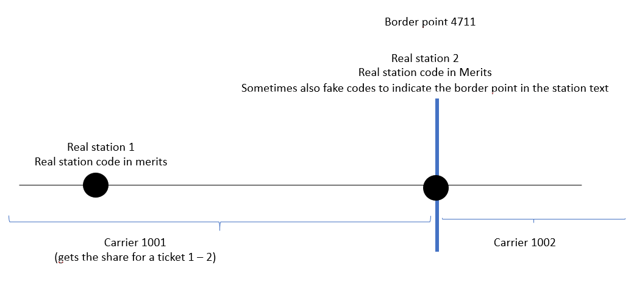

Border between two stations:

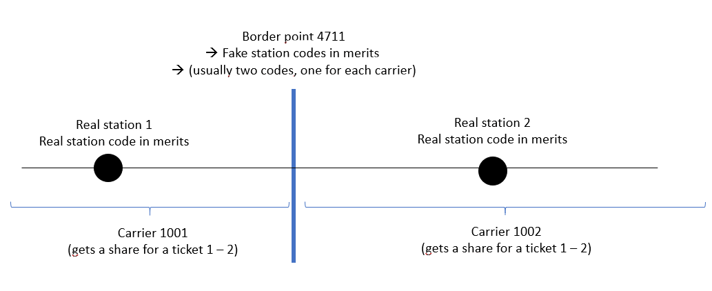

# Company Codes

Company codes identify a carrier. The official company codes must be used. The reference data file can be downloaded from the UIC web site.

Company codes can be imported from a csv file with the following columns:

|  |  |  |
| --- | --- | --- |
| Column | Data | Description |
| 1 | company code | 4 position company code |
| 2 | short name | short name of the company |
| 3 | long name | long name of the company |
| 4.. |  | other columns will be ignored. They might be included in the csv file for documentation. |

# Data Editing

Data are presented in a tree structure where the basic branches are created automatically. Tree branches can be edited by the functions of the context menu on a tree branch to:

* add child data
* add sibling data
* delete data
* copy/paste data
* validate data

The tree leaves can be edited in the properties window which is displayed when a tree branch is selected. Text and numeric values can be entered directly, whereas codes are added from list boxes. In case multiple entries are possible a multi-select dialog will pop up.

Note: Data objects contained in another object are edited via the context menu (e.g. multi-language text data object within the list of texts), whereas references to such a text object are edited as a leave in the property view via a selection list. (e.g. referencing a text data object within a fare).

# NUTS Codes

NUTS code identify a region. The official NUTS codes must be used. The reference data are managed by the EU.

NUTS codes can be imported from a csv file with the following columns:

|  |  |  |
| --- | --- | --- |
| column | data | description |
| 1 | NUTS code | 4 position company code |
| 2 | name | short name of the company |
| 3.. |  | other columns will be ignored. They might be included in the csv file for documentation. |

# Service Brands

Service brands identify a type of train. The official service brand codes must be used. The reference data file can be downloaded from the UIC web site.

Service brand codes can be imported from a csv file with the following columns:

|  |  |  |
| --- | --- | --- |
| Column | Data | Description |
| 1 | service brand code | 4 digit service brand code |
| 2 | service brand abbreviation | abbreviation of the service brand |
| 3 | service brand name | name of the service brand |
| 4 | service brand description | description of the service brand |
| 5.. |  | other columns will be ignored. They might be included in the csv file for documentation. |

# Stations

Stations can be imported from the MERITS station data. The data have to be retrieved from the MERITS application.

Company codes can be imported from an EDIFACT file according to the MERITS standard. The import will take the station code and the station name from the data file.

Stations without country code or with a wrong country code (e.g. not included in the official UIC country code list) will be ignored.

# Data Description

## Reference data / Code lists

* [carriers](../reference/data_companycodes.html) - UIC company codes
* [service brands](../reference/data_servicebrandcodes.html) - UIC service brands
* [stations](../reference/data_stationcodes.html) - MERITS stations
* [NUTS](../reference/data_nutscodes.html) codes - regional codes (not used for pure conversion)
* legacy [border point](../reference/data_borderpoints.html) codes
* countries - UIC country codes and corresponding ISO codes - no import
* languages - ISO language codes - no import
* currencies - EUR predefined - no import

## Conversion data

The data of 108.1 are not sufficient to provide a complete set of 90918-10 fare data. The missing data need to be added in the parameter section of the data set.

The missing data are added in the conversion parameter section as fare templates which serve as a copy template to create 90918-10 fares from the imported data. Missing data can be added to the template using the editing features. The template provides a factor to derive the fare price from the standard adult price provided in the 108.1 data.

Form the fare of one series in 108.1 two fares per template are created for the two travel directions. For different travel classes separate templates need to be defined and the service class needs to be set in the fare template.

Series listed in TCVL car be attributed a separated combination constraint in the fare template.

The station codes in 108.1 have been misused to other concepts like non-Merits-stations, border points, fare reference stations and service brands. These codes need to be mapped to the appropriate entities. For this mappings can be defined in the conversion parameter area to map these codes o the proper entities.

Border points can not be converted directly, so the needed border points will be converted into connection points and border point mappings but the station sets of the connection points might be incomplete and must be completed manually and the conversion needs to be started again.

#### Conversion parameter in **Legacy100**:

|  |  |
| --- | --- |
| Data item | Description |
| Carrier | carrier of the data delivery (company code) |
| Start date | start of availability for sale for the data delivery |
| End date | end of availability for sale for the data delivery |
| Time zone | time zone to convert date and time values |

#### Conversion parameter in **Conversion Params**

Data item

Description

Values

Convert fare descriptions

Fare description will be converted into TCVP fare entries. For each different fare description a different fare table will be created.

check-box

Convert service constraint

Service constraints will be converted into TCVP fare entries. For each different fare description a different fare table will be created.

check-box

Country

Country to be used for station code conversion from 108.1 to 90918-10.

Select country

Station import filter

a list of counties that limits the station import to those countries

Selection of multiple countries

VAT Templates

Templates to create VAT tax information. Templates can be provided for different scope and countries. The template applies to regional constraints within the specified country. Templates with scope INTERNATIONAL are used additionally for regional constraints with connection points.

Add VAT details for different countries

Legacy border point mappings

Manual mapping of border points to connection points. In case the border point data are complete in the imported border point table this entry is not required. Otherwise it can be added manually. To add an entry manually the connection point must be added in the fare data first.

Legacy station mappings

Mappings of station codes in 108.1 to merits codes. A manual mapping can be added for station codes not included in MERITS

Mapping station code 018.1 to MERITS station code.

Fare Templates

Template for a fare to be created based on 108.1 data. The fare

Legacy fare station set mappings

Mapping of 108.1 station codes to fare station sets

Mapping of 108.1 stations to fare station sets. This mapping is generated from the 108.1 data. Additional mappings can be added manually. Fare station sets must be added in the fare data before the mapping.

Legacy to station to service constraint mappings

Mappings of 108.1 stations to service constraints. In 108.1 data virtual stations have been added to indicate a service constraint.

Mapping to a service constraint. The service constraint must be added in the fare data first.

Data structures used in the fare template reference data in the final fare structure.

|  |  |
| --- | --- |
| Content | Description |
| Price factor | A factor to calculate the price depending on the price given in the 108.1 data. The factor is applied and the result is rounded to Euro-Cents |
| Price | A fixed price that can be defined manually in the fare structure. If this price is set the price factor will not be applied and the series price is replaced by this price. |
| Data description | Text to name the fare template. This text as no effect on the final data. |
| Fare detail description | A detailed description can be added to the fare. The fare detail description is a text that must to be edited in the fare structure first. Then it can be selected in the fare template. |
| Fulfillment Constraint | A fulfillment constraint to be added to the fare. The fulfillment constraint must be edited in the fare structure first and can then be selected in the fare template. |
| Id | - not in use - |
| Individual contracts | Indicates whether the fare allows individual contracts (handling tickets and after sales per person) |
| Legacy Conversion | Indicates whether the fare template creates fares that allow a reconversion into 108.1 data. A fare might allow reconversion or even be only included for reconversion. |
| Passenger Constraint | The passenger constraint to be applied with the fare. The passenger constraint must be edited in the fare structure first and can then be selected in the fare template. |
| Personal data constraint | The personal data constraint to be applied with the fare. The personal data constraint must be edited in the fare structure first and can then be selected in the fare template. |
| Reduction Constraint | The reduction constraint to be applied with the fare. The reduction constraint must be edited in the fare structure first and can then be selected in the fare template. |
| Reservation parameter | The reservation parameter to be applied with the fare. The reservation parameter must be edited in the fare structure first and can then be selected in the fare template. |
| Sales availability | The sales availability will be calculated from the validity in the 108.1 data. |
| Separate contract combination constraint | Combination constraint to be used in case the series is listed in the 108.1 TCVL file. |
| Service class | The service class to be applied with the fare. The service class must be edited in the fare structure first and can then be selected in the fare template. |
| Service constraint | The service constraint to be applied with the fare. The service constraint must be edited in the fare structure first and can then be selected in the fare template. |
| Service Level | The service level to be applied with the fare. The service level must be edited in the fare structure first and can then be selected in the fare template. |
| Text | The text naming the fare. The text must be edited in the fare structure first and can then be selected in the fare template. |
| Travel validity | The travel validity to be applied with the fare. The travel validity must be edited in the fare structure first and can then be selected in the fare template. |
| Regulatory Conditions | Regulatory conditions (CIV, MC, EU_PRR) to be applied with the fares. |
| Rounding mode | Rounding rule applied to the price.   * Up: rounding up to one cent * Down: rounding down to one cent * Half-Up: rounding up to one cent for 0.5 to 0.9 cents and down for 0.1 to 0.4 cents * Half-Down: rounding up to one cent for 0.6 to 0.9 cents and down for 0.1 to 0.5 cents * Half-Even: rounding half up if the left digit is odd, half down otherwise (preserves the mean value) |

## Tariff data 108.1

Tariff data from 108.1 are included when needed for conversion.

|  |  |
| --- | --- |
| Data | Description |
| Series | Series data records |
| Stations | Station data |
| Distance fares | Prices based on distance |
| Route fares | Prices based on routes |

## Fare data 90918-10

The fare data in the fare data section correspond exactly to the data specified within the IRS 90918-10 for the bulk data delivery, Data Ids to link the different data parts within the json export will be created automatically before the export of the data.

The data structure contains the complete set of defined data and is not restricted to data used in the conversion. Additional data might be added manually. Data that are also generated include a data source tag indicating whether it was created by conversion or by import or manually. All data marked as created by conversion will be replaced with the next conversion.

# User Preferences

|  |  |
| --- | --- |
| Parameter | Description |
| Import convertible fares only | The import of 90918-10 data is limited to fares marked for conversion. |
| Import only stations from listed countries | The import of MERITS stations is limited to countries listed. |
| Ignore optional via stations | Optional via stations are ignored in the import of 108 data. |

# Validation

Data validation can be called on the data tree via the context menu to validate a branch of the tree. The validation results will be displayed in the Validation problem view. A double click on the validation item in the problem view will select the item in the data tree and outline view.

Validation

Validation