Integrate Eclipse with GitHub
Workspace setup, repository import, and feature-branch creation

1. Understand the workflow
- Use this guide to connect an Eclipse workspace to an existing GitHub repository.
- Complete the access, workspace, import, and branch steps in sequence. If authentication and the correct workspace already exist, verify them before continuing at step 8.
- Keep the workspace folder and the repository working folder distinct.
- 
Figure 1. Eclipse and GitHub walkthrough.

2. Open GitHub developer settings
- Sign in to GitHub using the account that has access to the required organization and repository.
- Open your profile menu and choose Settings. Scroll down the settings sidebar and open Developer settings.
- Expand Personal access tokens and select Tokens (classic), as shown in the image.
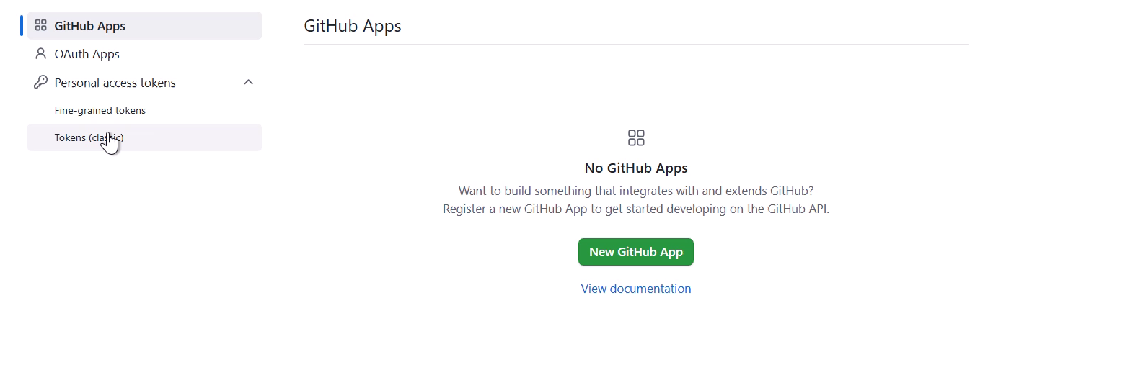
Figure 2. Developer settings with the Personal access tokens navigation expanded.

3. Create a token with approved access
- From Tokens (classic), use Generate new token > Generate new token (classic). The next clip begins on the new-token form; this menu transition is not shown in full.
- Enter a descriptive Note and choose an expiration allowed by policy.
- Select only approved scopes needed for your work, then generate the token. The visible selections include repo, workflow, and write:packages; these are examples, not a universal minimum.
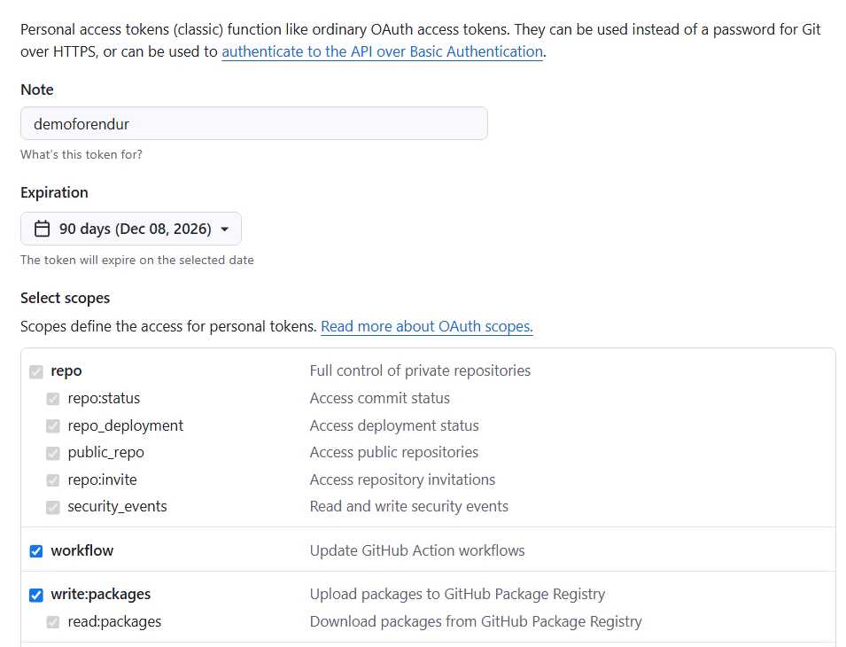
Figure 3. Token note, expiration, and visible scope selections before token generation.

4. Authorize organization access if required
- Copy the new token directly to the approved secure destination.
- Where the organization requires SSO, open Configure SSO beside the token and select the organization to authorize.
- Complete the organization's sign-on flow. It reaches a Single sign-on to Uniper page with a Continue button.
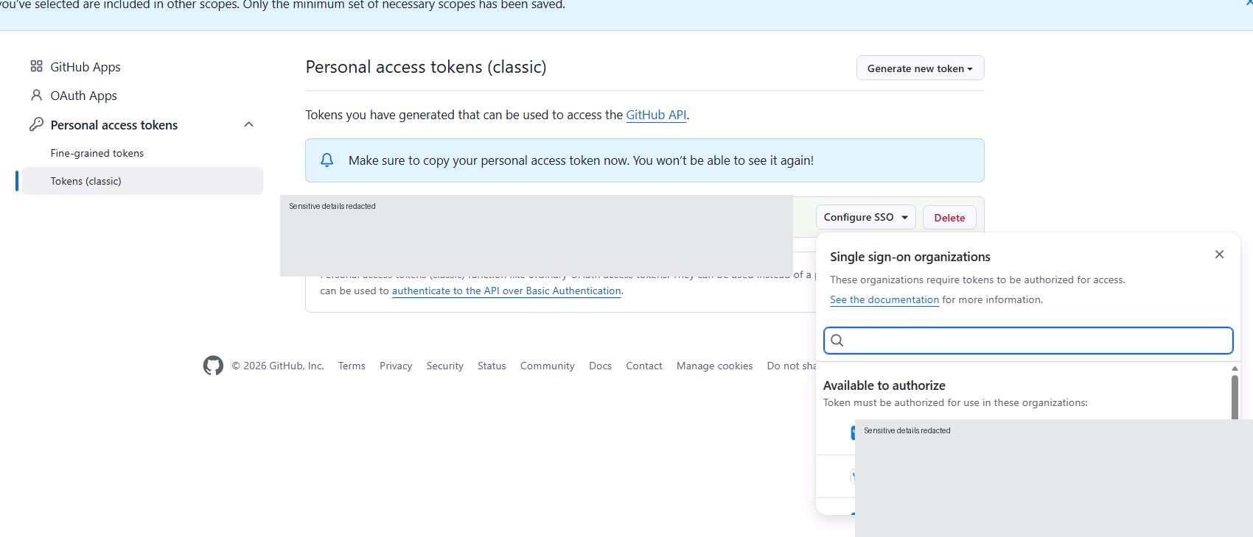
Figure 4. Configure SSO opened for the new token; sensitive content is redacted.

5. Create the workspace folder
- Open File Explorer and navigate to the development workspace location approved for your environment.
- Create a new folder for this workspace. Create a user-specific folder whose name ends in -fenix under the shared EndurFenix workspace location.
- Confirm you can write to the folder and retain its full path for the Eclipse workspace selection.
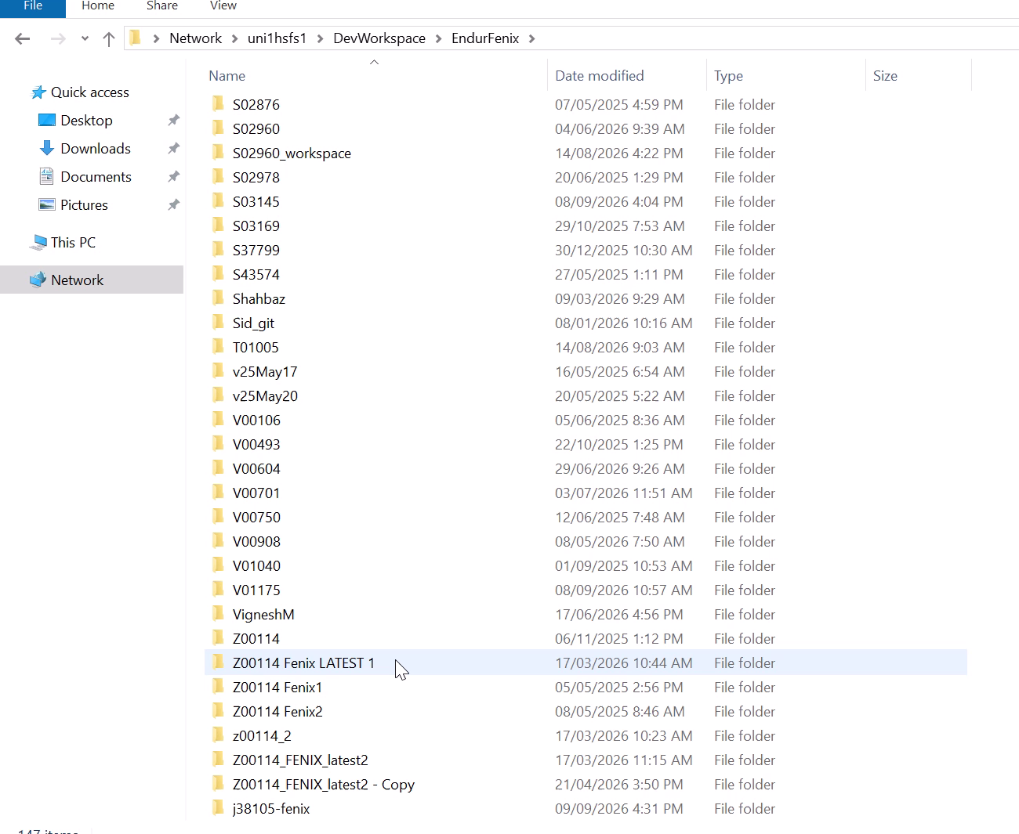
Figure 5. The newly named workspace folder in File Explorer.

6. Start the development environment
- Open the Fenix development launcher through the approved Citrix environment and select the assigned development instance. The example uses FSDEV53.
- Open the Endur tools and System Monitor, then launch the configured Eclipse-based editor. The System Monitor toolbar shows an Advanced Editor control as Eclipse starts.
- Wait for Eclipse to finish opening before changing workspaces.
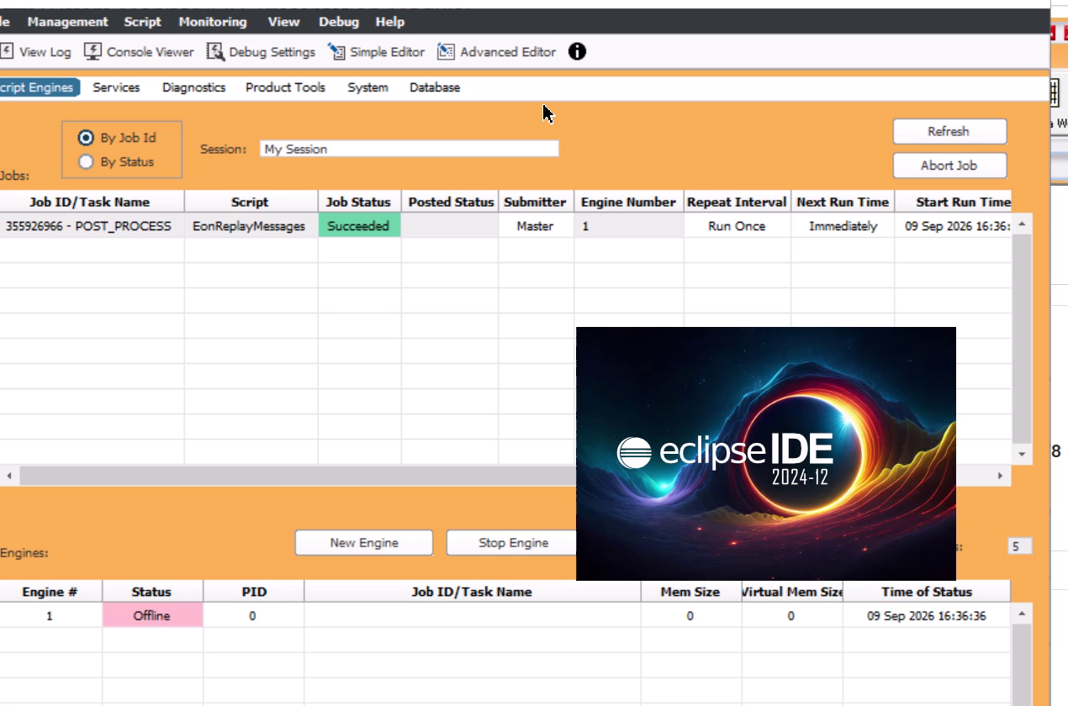
Figure 6. System Monitor and the Eclipse IDE startup splash in the environment.

7. Switch to the new Eclipse workspace
- In Eclipse, choose File > Switch Workspace > Other....
- In Select a directory as workspace, enter or browse to the workspace folder created in step 5.
- Click Launch. Let Eclipse save the old workbench state and restart into the new workspace.
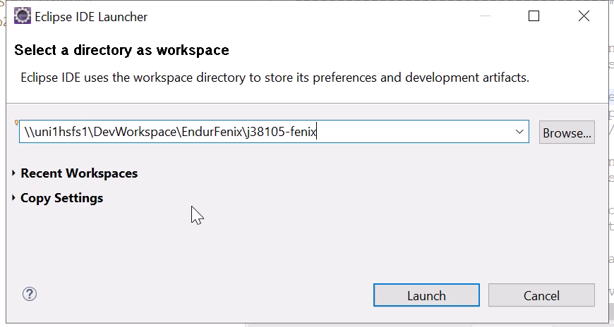
Figure 7. Eclipse IDE Launcher with the new workspace directory selected.

8. Copy the repository HTTPS URL
- In GitHub, open the organization, select Repositories, and open the required repository. The example is Uniper-Endur / endur-fenix-migration.
- On the repository's Code tab, click the green Code button and select HTTPS.
- Copy the clone URL with the copy control. Confirm the organization and repository before using the address in Eclipse.
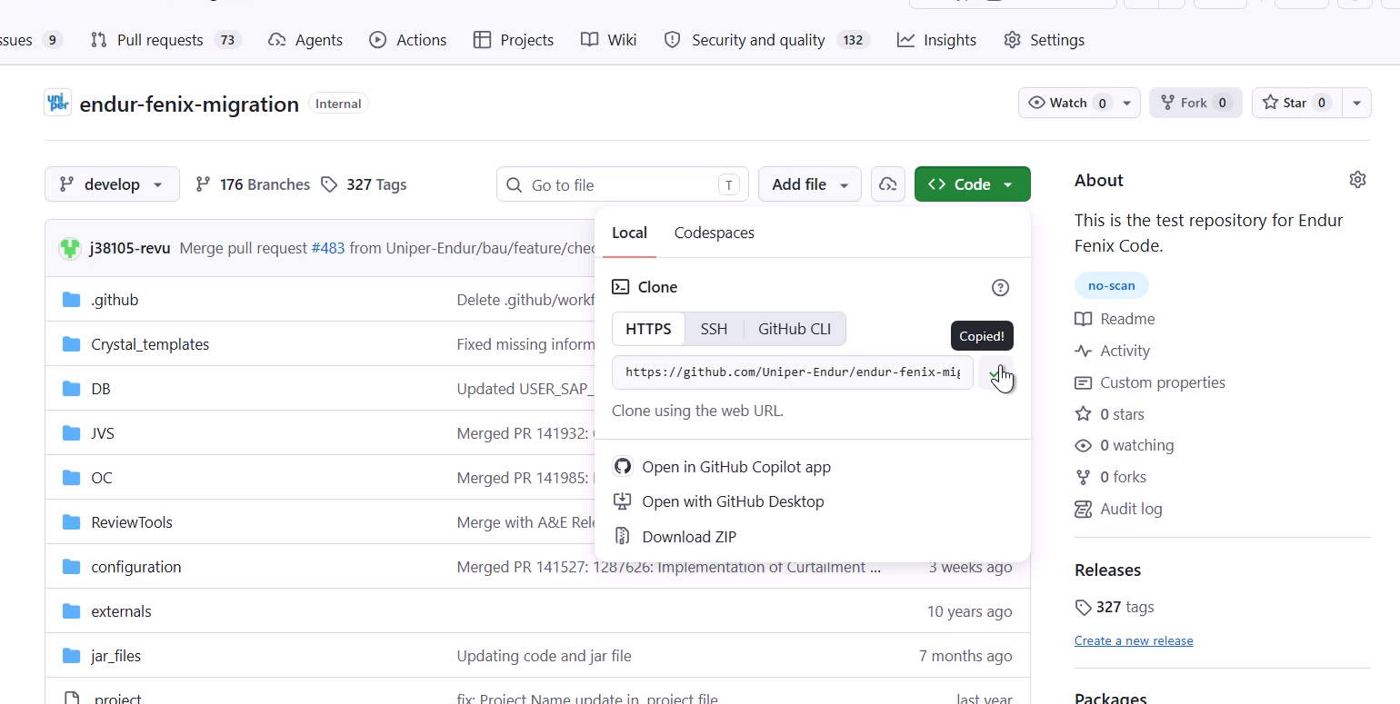
Figure 8. GitHub Code menu showing the repository's HTTPS clone address.

9. Start the Git import wizard
- Return to Eclipse and choose File > Import....
- Expand Git, select Projects from Git, and click Next.
- If a repository-source chooser appears, select Clone URI to reach Source Git Repository. That intermediate selection is not visible in the sampled sequence.
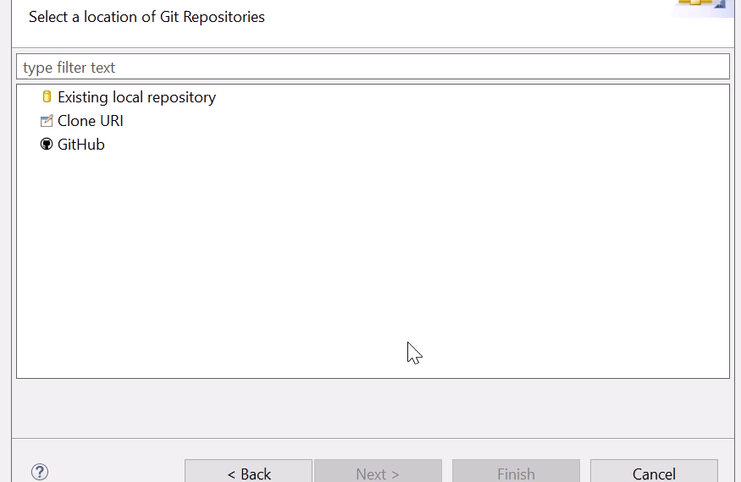
Figure 9. Git > Projects from Git selected in the import wizard.

10. Set the source Git repository
- Paste the copied address into URI. Eclipse may prefill the field from the clipboard.
- Verify that Host is github.com, Protocol is https, and Repository path identifies the expected organization and repository.
- Click Next to retrieve remote repository information. a Login dialog follows.
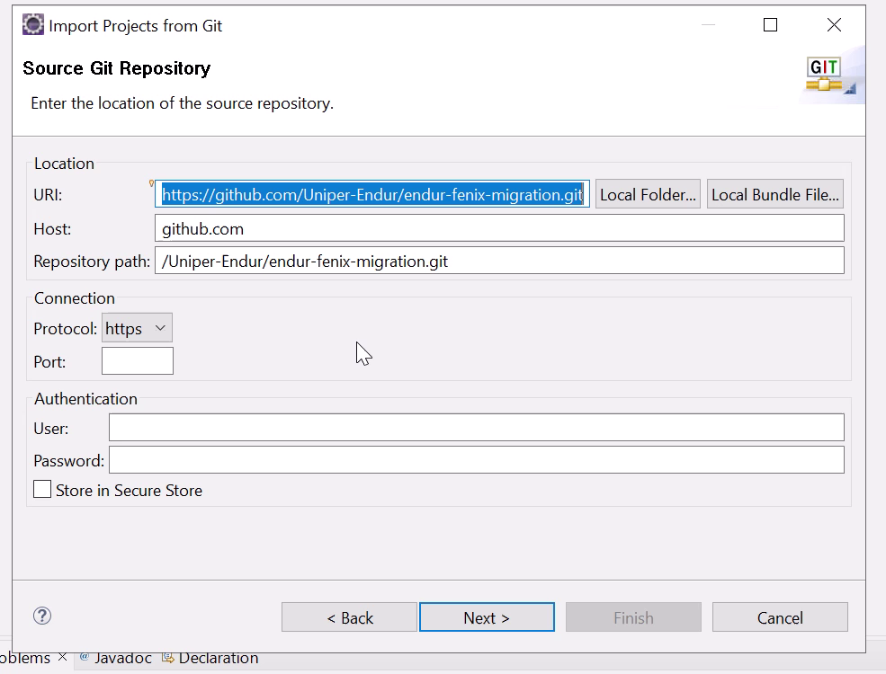
Figure 10. Source Git Repository with the copied URI and connection details.

11. Authenticate to GitHub from Eclipse
- Check Repository in the Login dialog. Enter your GitHub username in User and the approved personal access token in Password for this HTTPS token-based flow.
- Use Store in Secure Store only if permitted by policy, then click Log in. If Eclipse asks about secure-storage password recovery, follow your organization's recovery policy.
- After authentication, review Branch Selection and select the branch or branches your team requires before continuing.
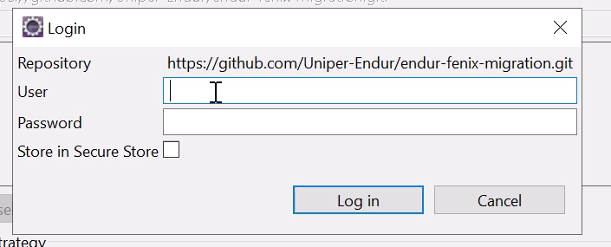
Figure 11. The Login prompt before credentials are entered.

12. Choose the clone destination and branch
- In Local Destination, set Directory to a new or empty repository folder. Create a Fenix subfolder inside the workspace and pastes its path here.
- Review Initial branch explicitly. For the branch-creation example later in this guide, ensure develop is available and checked out before creating your feature branch.
- Keep Remote name as origin unless your team requires another name. Review Clone submodules only if the repository uses them, then click Next and wait for cloning to complete.
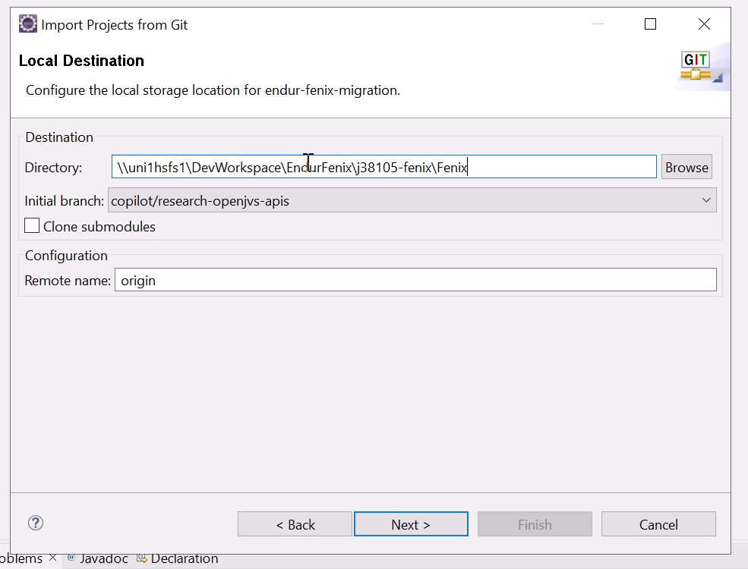
Figure 12. Local Destination with the chosen Fenix folder, initial branch, and origin remote.

13. Find existing Eclipse projects
- On Select a wizard to use for importing projects, select Import existing Eclipse projects.
- Confirm Working Tree points to the repository folder selected in step 12.
- Click Next and wait while Eclipse searches the working tree for project definitions.
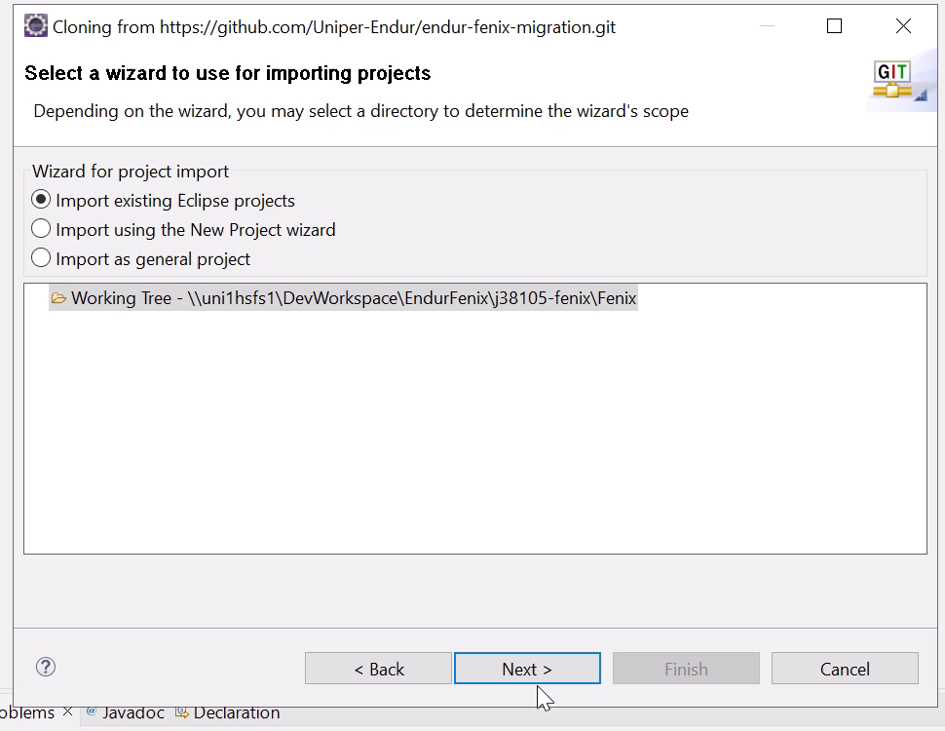
Figure 13. Existing Eclipse project import selected for the cloned working tree.

14. Import the intended top-level project
- Review the detected projects. It initially displays several nested project entries.
- Clear Search for nested projects to match the demonstrated import. Confirm that the top-level Fenix project is selected.
- Click Finish and wait for Eclipse to import and refresh the project.
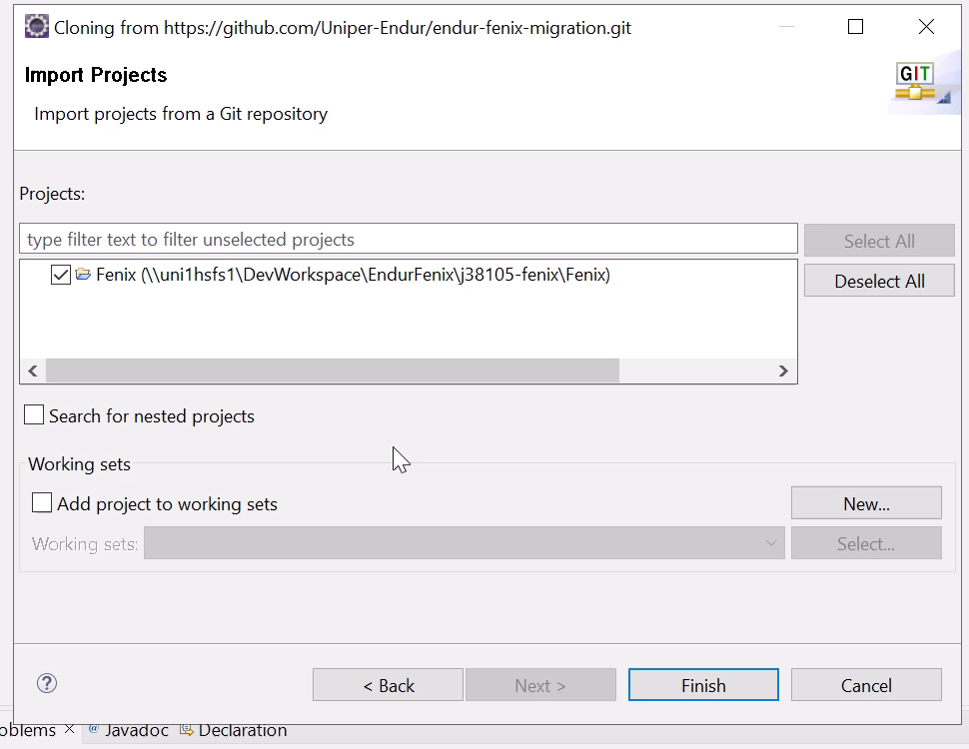
Figure 14. Fenix selected with Search for nested projects cleared.

15. Verify the imported project and base branch
- Expand Fenix in Package Explorer and verify that the expected folders and files are present, including configuration, JVS, and the pipeline YAML files.
- Read the Git decoration beside the project.
- If your project is on another branch, check out the approved base branch before continuing. Confirm that any local changes are safely handled first.
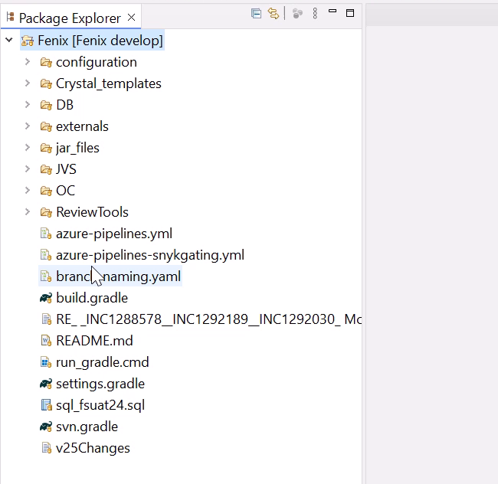
Figure 15. Imported Fenix project with develop in its Git branch decoration.

16. Open the new-branch dialog
- Right-click Fenix in Package Explorer.
- Choose Team > Switch To > New Branch....
- In Create Branch, check the Source value. Use Select... if you need to choose the approved base branch.
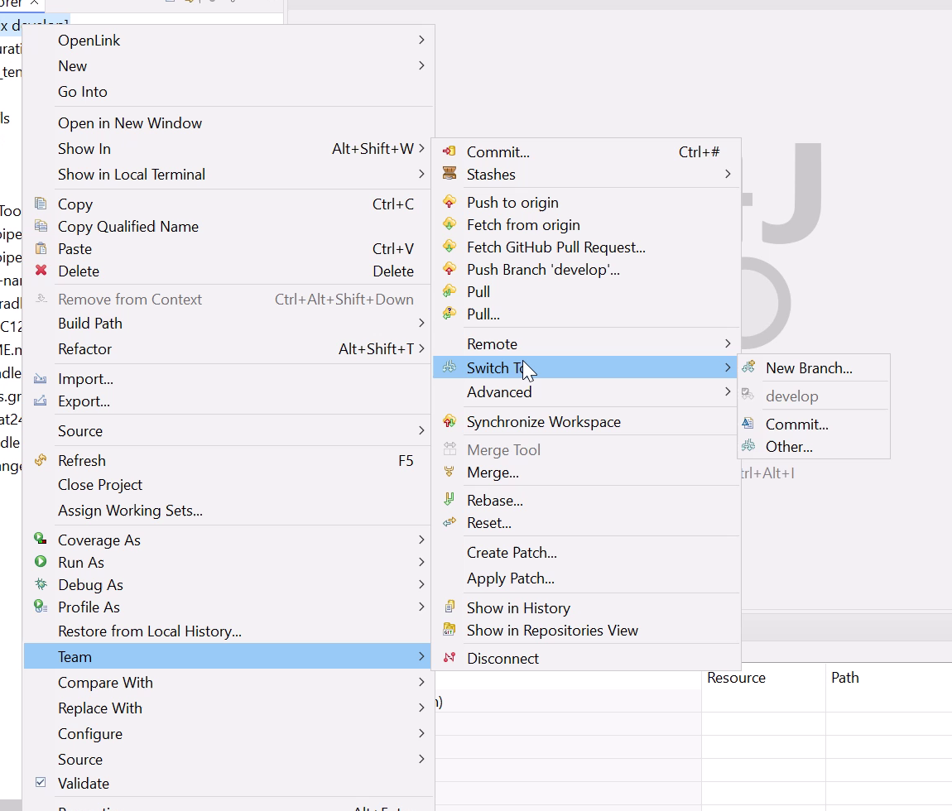
Figure 16. Project context menu with Team > Switch To > New Branch available.

17. Create and check out the feature branch
- Confirm Source is develop and enter a unique branch name that follows your team's naming policy. The name is bau/feature/demofenixclone.
- Keep Check out new branch selected.
- Click Finish. Wait for the dialog to close and independently verify that the project decoration now displays your new branch.
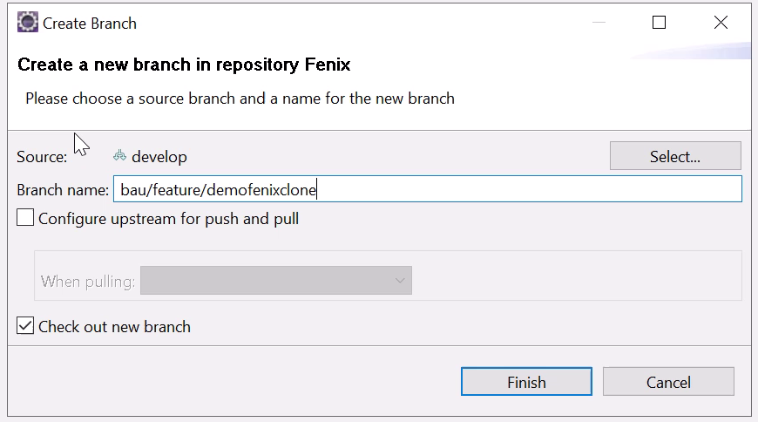
Figure 17. Create Branch with develop as the source and Check out new branch enabled.

