Eclipse Git: Commit and Push
Step-by-step guide |

1. Open and save the pipeline file
- In Eclipse Package Explorer, confirm the Fenix project is on the intended branch. The recording uses bau/feature/testingfinal.
- Open azure-pipelines-snykgating.yml and make the intended change. The demonstration adds v0.02 to the comment headed 'How to upgrade to a newer template version'.
- Save the file (Ctrl+S). Review the actual change before staging it.
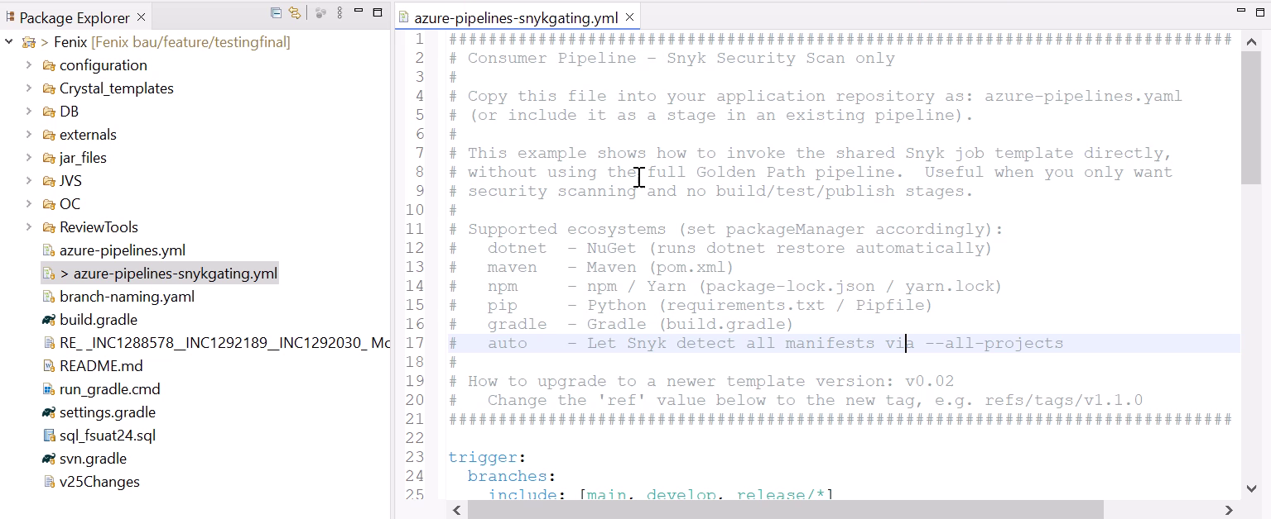
Figure 1. Pipeline YAML open in Eclipse after the comment edit.

2. Open the Git Staging view
- Choose Window > Show View > Other... from the Eclipse menu.
- Expand Git, select Git Staging, and click Open.
- Confirm that the view is associated with the intended repository and branch. If Git Staging is already visible, use the existing tab.
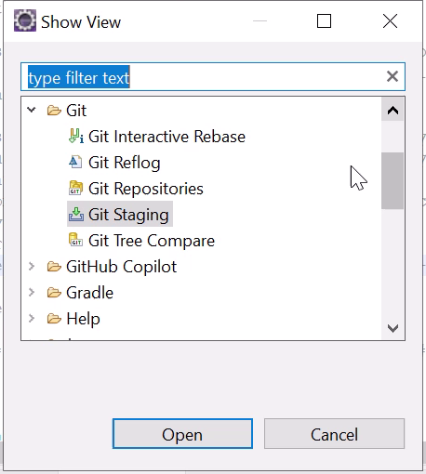

3. Stage the intended change
- Select azure-pipelines-snykgating.yml under Unstaged Changes.
- Use the green plus staging control to add the selected file to Staged Changes.
- Verify the staged file is the one you intend to commit. Leave unrelated changes unstaged.
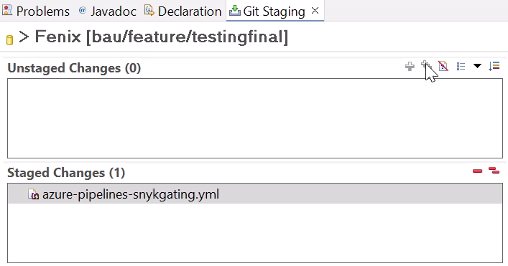
Figure 3. The pipeline file has moved to Staged Changes.

4. Enter a message and commit and push
- Enter a commit message in Commit Message. The recording uses 'final commit'; for normal work, use a message that describes your change.
- Check the staged file and verify your configured Author and Committer identities.
- Click Commit and Push to create the local commit and start publishing it to the remote.
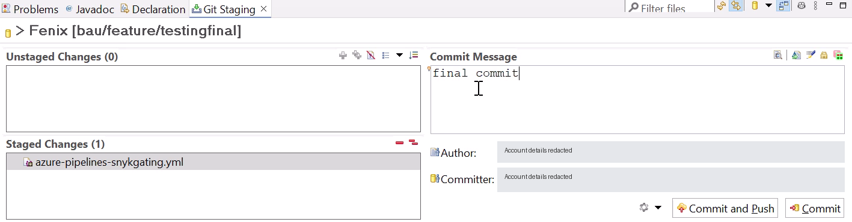
Figure 4. One staged file, the recorded commit message, and the Commit and Push button.

5. Authenticate when prompted
- Check that Repository points to the expected Git remote before supplying credentials.
- Complete authentication using your organization's approved method, then click Log in.
- For GitHub HTTPS with this User/Password dialog, use your GitHub username and an authorized personal access token in the Password field when that method is permitted. Do not use your GitHub account password.
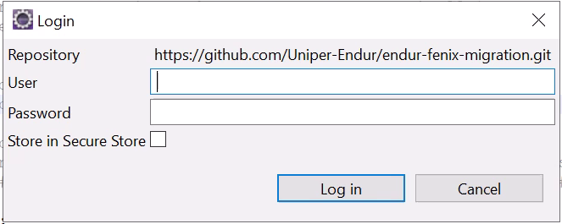
Figure 5. Login prompt before credentials are entered.

6. Verify the initial push result
- Read the Push Results dialog and confirm that the remote is origin and the intended repository is shown in Message Details.
- Check the branch mapping. In the recording, bau/feature/testingfinal maps to the same remote branch with status [new branch].
- This confirms creation of that remote branch. You can close the result, or continue to Configure... as demonstrated in the next step.
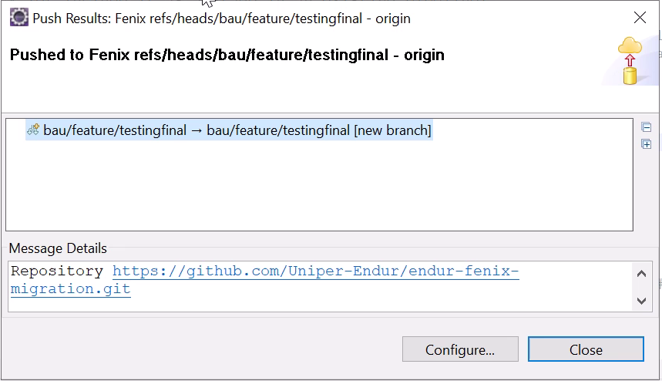
Figure 6. The first push reports a new remote branch.

7. Review the push configuration (optional)
- Click Configure... in Push Results to open the configuration for remote origin.
- Verify the Branch and URI. The recording uses bau/feature/testingfinal and the existing repository URI.
- Review Ref mappings. The dialog states: 'No Push Refspec, will push currently checked out branch instead.' No new mapping is visibly added.
- To follow the recording, click Save and Push. This is an optional configuration check after the initial push already succeeded.
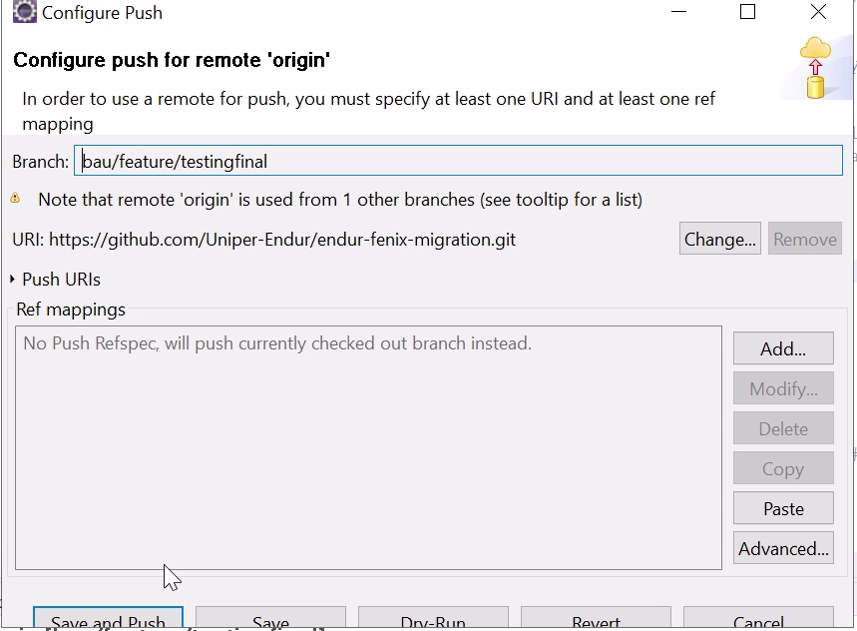
Figure 7. Configure Push for origin. The source capture clips part of the bottom button row.

8. Confirm the final state
- Read the second Push Results dialog. The branch mapping now ends with [up to date].
- Click Close and confirm that Git Staging shows Unstaged Changes (0) and Staged Changes (0).
- For an additional check outside the recording, open the remote repository and verify the intended branch and latest commit.
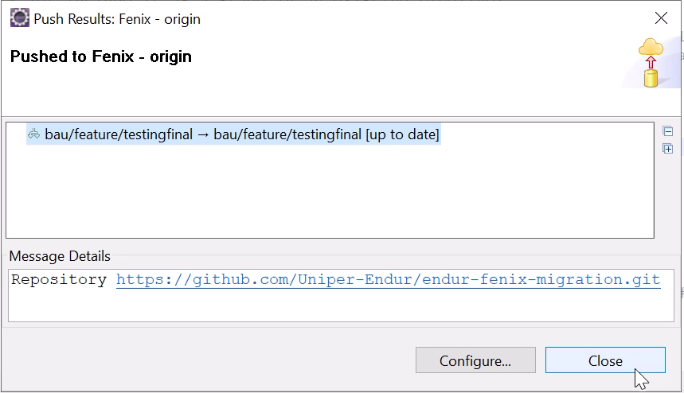
Figure 8. The repeated push reports [up to date].

