Version: 02  Nature: SP (Specification)  Dissemination: PU (Public Usage)  Type: PD (Project Deliverable)  Status: Draft/Released  Document Reference: Deliverable3-2.doc  Pages: 165  Contractual delivery date: 31 March 1999  Actual delivery date: 25 May 1999  WP Contributing: WP1, WP2, WP3 | 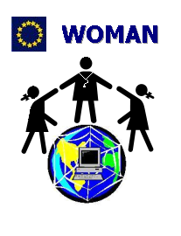

TELEMATICS APPLICATIONS PROGRAMME (1994-1998)
WOMAN - HC4026

Deliverable D3.2: Functional Specifications

WOMAN - INTELLIGENT TELEMATIC SERVICES FOR WOMEN CARE BY AN EUROPEAN NETWORK

Project number: HC 4026

To be distributed to: Ms. Petra Wilson (EC)
Ms. Irmgard Heiber (EC)
Responsible: Prof. A. Starita (C2)

Edited by: Antonina Starita (C2)
Elena Palanca (C2)
Katuscia Cerbioni (C2)
Darya Majidi (A2.1)
Riccardo Fontanelli (A2.1)
Stefania Marranci (C6)
Paolo Agonigi (C6)
Abstract:
The deliverable describes the “Functional Specifications” of the WOMAN project. On the basis of the User Needs Analysis (D2.2), the WOMAN scenarios have been individuated. The analysis of the already existing resources at the demonstrations sites, the technological state of art, the healthcare and security standards, the Object Oriented methodology adopted (UML), and the proposed services to users are here specified.

Keywords list:
Web-based Services (Intranet/Extranet/Internet), Object Oriented, UML, Security and HealthCare standards, Multi-tier applications, Distributed approaches, Post-menopause
Contents

1. Executive Summary 3
2. Introduction 5
3. HW/SW Resources and Services Identification (WP3 – T3.1) 7
4. Object-Oriented Formalism and Methodologies (WP3 – T3.3) 9
5. Unified Modelling Language (UML) (WP3 – T3.3) 17
6. Client-Server, Multi-tier and Distributed Methodologies (WP3 – T3.1, T3.3) 21
7. European Projects Analysis (WP1 – T1.6, WP3 – T3.3) 32
8. HealthCare Standards and Normative References (WP3 - T3.3) 37
9. HealthCare Security Issues (WP3 – T3.3, T3.5) 44
10. Results of the User Needs Analysis (WP2, WP3 – T3.1) 49
11. WOMAN Scenarios (WP3 – T3.3) 51
12. The WOMAN Technological Framework 55
13. User View: Use-Case Diagrams 57
14. Formal Definition of the Web Sites Structure (WP3 – T3.3, T3.4) 72
15. WOMAN DB (WP3 – T3.2) 82
16. Structural View: Class & Object Diagrams (WP3 – T3.2) 85
ANNEX A 91
ANNEX B 95
ANNEX C 134

Executive Summary

The Woman Consortium has produced this document with contributions from all technical partners of the project. It reports the results of the WOMAN “Functional Specifications” Work-package (WP3).

It aims at analysing the application domain, designing pilot services and service provision platforms, identifying implementation guidelines for local Demonstrators and defining a formal ‘language’ for enhancing both intra-project communication (the one among clinician, technical experts and IT scientists) and extra-project interaction with end-users.

This deliverable D3.2 is a direct output of the activity performed by the Woman Team in the framework of Work-package 3: a horizontal action with respect to Tasks T3.1-T3.5, as defined in the Project Technical Annex.

The analysis concerning the definition and adoption of a high level User Oriented approach for designing service provision platforms and specifying functional and behavioural characteristics of implemented WOMAN demonstrators is reported.

The WOMAN problem-solving approach has been based on a User Centred one and is here described in detail. This document describes the logical approach adopted by project partners for system analysis, problem identification and representation of domain objects and object behaviour, structural and behavioural design of the system to be implemented and definition of technical specifications for supporting the implementation phase. This documents puts also in evidence a complementary issue targeted in the framework of the WOMAN project: the adoption of a user-oriented and design-for-all formal approach for describing the way people understand and process reality.

This deliverable is composed of the following chapters:

- the Executive Summary, aimed at briefly outlining the activity accomplished during the different phases of WP3;
- the Introduction, which describes the main goals to be reached by the WOMAN team;
- HW & SW resources and services identification at the demonstration sites. To ensure a high IT level to the project demonstration sites, the technical team visited the four healthcare centres in order to single out the existing resources, the linked functional units and the peripheral healthcare centres, with the aim of evaluating their usefulness and guaranteeing a full site interoperability.
- The Object Oriented Formalism and Methodologies, which put particular emphasis on the description of the object oriented analysis and design approach embraced in the framework of the WOMAN project for defining functional specification of the systems to be implemented;
- Following this logical path, the fifth chapter is dedicated to UML, the Unified Modelling Language selected to be used within WOMAN;
- A detailed analysis on Client/Sever and Distributed methodologies;
- European Projects related to WOMAN in order to evaluate what and how has already been done. This step, recommended also from the EC, is a key action for the success of the project.
- HealthCare standards, normative references to be adopted within WOMAN;
- Security, Privacy and protection Issues;
- Results of the User Needs Analysis, accomplished in WP2 and specified in the deliverable D22;
- The WOMAN Scenarios, which describe in natural language the services individuated and the consequent improvement of the working environment, once these services are adopted;
- The WOMAN technological framework, which describes the decisions made within the WOMAN project;
- Use Case diagrams, which describe a sequence of transactions performed by the WOMAN system in response to events initiated by the actors (users) of the system;
- Detailed description of the Formative and Informative Web applications;
- Detailed analysis of the WOMAN Data Base;
- Structural View of the domain through Object and Class Diagrams.

AnnexA provides a list of acronyms to simplify the comprehension of this document;
AnnexB contains all the reports for the HW/SW resources and services identification belonging to each Clinic of the WOMAN project;
AnnexC contains a detailed DB explanation to be adopted in the WOMAN project.

Each stage of the problem-solving process (analysis, design and implementation) has been focused not only on thinks to be implemented (what) but also on how to formally describe and communicate them between technical and IT experts and among them and clinical experts and selected end-users for verification and validation purpose.

Introduction

The main objective of the WOMAN Project is the improvement of every day clinical practice by optimising effectiveness, quality and continuity of care. The goal should be achieved using information technologies and telematic tools for an optimal use of integrated resources. The project is devoted to the field of endocrine-physiologic-reproductive female sphere involving important aspects of the lifestyle and the health of the female population. In particular the project is focused on menopause, due to the increasing age of the mean female population in the industrialised countries, and the need of improving the quality of life, and health awareness of an increasing number of mature European citizens.

The objective of the WOMAN project is the transformation of already existing resources available (knowledge, information, databases) at the healthcare centres involved, in co-operative work facilities to improve the co-ordination of shared data and to create tutorial/assistant services. These services are addressed to different user levels:

- the health professionals (for an optimal healthcare organisation, quality control, evaluation of the benefits/costs);
- end users i.e. the women in post-menopause.

The aim is to give an added value to the existing resources improving their own quality and their diffusion at peripheral level.

WOMAN wishes to develop a multimedial telematic network system to allow easy storing, retrieval and handling of clinical information about post menopausal women, with particular attention for the shared data organisation.

To achieve these objectives the following steps have to be implemented:

- the networking connection between the primary centres and the other functional areas of the hospital that are involved in the WOMAN sphere (peripheral health care points, operative units such as radiology, oncology, etc.);
- the creation of a suitable homogeneous patient record, based on heterogeneous multilevel distributed databases for an optimal use of shared data (personal, clinic, instrumental test records);
- the development of user friendly telematic multimedia applications that make easier the exchange of multimedia data such as mammograms, ecographies, etc., through accepted file formats following the recommended European Standards;
- the creation of a statistically significant database for epidemiological studies in order to achieve new informative, tutorial, assistant and research protocols;
- the diffusion and dissemination of information, data, results through easily accessible telematic informative services, to support the post-menopausal women to make informed choices in self-care, and in prevention of the major serious diseases.

During the WP3 work-package the WOMAN consortium has:
- established links between the WOMAN project and other European programme-related projects;
- identified the already existing resources (HW, SW, Databases, communication protocols) located in all the healthcare centres (demonstration sites) participating in the project to better integrate the results. This analysis pointed out the managerial, the outpatients, the care aspects and the existence and/or the integration of telematic structures inside each Clinic;
- analysed in collaboration with the clinical partners the results of the User Needs Analysis Work-package (WP2);
- selected the object-oriented formalism, and the UML modelling language for the system analysis, design and development;
- on the basis on the identified needs and requirements, defined and designed a specific healthcare patient record in accordance with the security standardisation rules (CEN/TC 251, ISO, UNI, etc.);
- defined the characteristics of the database, specific for the WOMAN Project, taking into account the clinical needs;
- designed the WOMAN system able to provide the telematic required services (information, formation, teleconsulting, exchange of data etc. with the actors of the menopause domain that is women and the medical staff).

In the WOMAN Project a cross-platform telematic approach will be adopted to design an integrated environment for both clinical data and informative interactive web applications. In order to offer to the WOMAN users the best results achievable with the state of art technology, a deep analysis of the:

- different Object Oriented technologies;
- the Unified Modelling Language (UML);
- client-server and distributed methodologies;
- HealthCare standards and normatives;
- existing related European Projects;
- security issues

has been accomplished, which is described in detail in the following chapters.

On the basis of this study, and the results of the “User Needs Analysis” (Deliverable 2.2), the WOMAN scenarios have been extracted and formalised using the UML language.

The cross-platform telematic approach identified within WOMAN may be organised as:

- local level (each Clinical Site) service provision systems that will be implemented as Intranet platforms;
- remote distributed level (inter Clinical Sites) Extranets that will be created for the remote interactions and communications;
- Internet Web Applications that will provide information and services to citizens in general and to women in particular.

HW/SW Resources and Services Identification (WP3 – T3.1)

In order to single out all the existing resources already available at the healthcare centres (which are also the demonstration sites of the project), at the linked Functional Units (i.e. outpatients departments) and at the peripheral healthcare centres to involve in the project, meetings between the clinical partners (C1, C3, C4, C5) and the project technical team (C2, A2.1, C6) have been established. The aim was to evaluate the usefulness of these resources in the framework of the WOMAN project and guaranteeing full site interoperability.
To support this activity and accurately report collected information, a standard top-down structure analysis model of the healthcare centre has been developed and diffused and fulfilled with the collaboration of clinicians.

WOMAN  Demonstration sites | Organisation | City | State
C1 | Dipartimento di Medicina della Procreazione e dell’Età Evolutiva, Università degli Studi di Pisa | Pisa | Italy
C3 | Department of Obstetrics and Gynaecology,  Free University Hospital Amsterdam | Amsterdam | The Netherlands
C4 | Istituto di Ginecologia Ostetrica e Fisiopatologia della Riproduzione Umana, Universitá di Napoli "Federico II" | Napoli | Italy
C5 | Department of Obstetrics and Gynaecology, Fundacio Santiago Dexeus | Barcelona | Spain
Table 3.1: WOMAN Demonstration Sites

Starting from a global view of the Institutes, for each identified Functional Unit the following items have been detected:
- Available hardware/software resources;
- Existing communication links;
- Provided services.
Moreover, existing and innovative services to be provided to the chosen users (women and medical staff) have been identified.
Following this scheme, the IT level of every healthcare centre has been evaluated:
- C1-PISA: currently, telematic communication links among outpatient departments of the “Dipartimento di Medicina della Procreazione e dell’Età Evolutiva” are not present, while some database information sources useful for the project aims have been identified. In order to let the centre becoming able to start the project, the technical staff proposed an initial HW/SW configuration (see Pisa technical report);
- C3-AMSTERDAM: at the “Department of Obstetrics and Gynaecology”, Free University Hospital of Amsterdam, telematic communication links among the visited out-patient departments (LAN) and database information sources useful for the project aims were available, then the technical staff proposed only the purchasing of the videoconferencing kit (see Amsterdam report);
- C4-NAPOLI: currently, in the 'Istituto di Ginecologia Ostetrica e Fisiopatologia della Riproduzione Umana', Universitá di Napoli "Federico II", there are no telematic communication links among the visited outpatient departments (LAN) and database information sources useful for the project aims. In order to let the centre able to start the project, the technical staff proposed an initial HW/SW configuration (see Napoli technical report);
- C5-BARCELONA: at the “Department of Obstetrics and Gynaecology”, Fundacio Santiago Dexeus Font/UAB the situation is the same as in Amsterdam (see Barcelona technical report).

All the collected information has been formalised in reports enclosed in Annex B.

Object-Oriented Formalism and Methodologies (WP3 – T3.3)

Foundation
Activity accomplished during the preliminary phase of WP3 has been focused on the identification of a powerful formalism for modelling the domain of the post-menopause clinic. In other terms, it meant to identify a flexible approach that could be used effectively for understanding and specifying non-software related as well as software related processes and systems.
As in the design of knowledge based systems, the emphasis of the modelling approach should be placed on the way people understand and process reality, instead of the reality to be described. Many approaches exist that match the required constraints. In the very early stage of WP3 the state of the art on methods for building (analysing, designing and testing) systems have been explored.

Analysis, design and implementation of everyday life systems in general
From an implementation point of view, as suggested by the everyday life experience in building systems, a great amount of development approaches exists. This is due to the fact that different tasks can have different characteristics that require different kind of approaches.
Rather than in the identification of the implementation frameworks and tools, the WOMAN project challenge has been then focused on the selection and integration of existing different approaches, thus allowing developers to choose approaches that best fit and solve the problem at hand.
The solution to the proposed problem, as suggested by many IT researchers, is to abstract from the implementation level, up to the conceptual one, by choosing innovative analysis and design methods and tools.
The screening accomplished at project level on existing methodologies for analysing and designing systems convinced IT researchers involved in WP3 that the most appropriate approach, partly due to the nature of the problem to be solved – i.e. the design and development of a service provision platform -, partly due to the nature of the identified project domain – i.e. the post-menopause clinic -, was the Object Oriented (OO) one.
In particular, the adoption of object orientation not only at implementation level, but also at system description level has been stressed.
The very first question researchers have had to answer was the one related to the completeness of the selected approaches. The fact that an Object Oriented Analysis and Design (OOAD) approach could support both software information systems and software process systems design was not so obvious. In addition, in order to be adopted for system analysis and design, warranty should have been provided concerning the consistency and completeness of the OO approach when applied beyond software systems description up to the design of general (service provision) systems. In other terms, the question was is whether an OO approach could be used effectively for designing everyday life systems in general.
As reported in many scientific lectures and articles, the answer was that OO can actually support the analysis and design process of everyday life systems in general. The challenge was to demonstrate, though the WOMAN case study, that an OO approach could also be used for service provision platforms and systems design and development.
As reported in details in section 3, the following operational premises have been stated:
- adoption of an OO, user-oriented approach at System Analysis level;
- application of OO based formalisms at System Design level;
- use of OO programming language at System implementation level.

Dominoes of the Foundation
The present section addresses the needs of system analysts and designers of identifying a formalism for communicating each others and understanding the domain world, also being able to share acquired knowledge with the system end-users. Moreover, being both system specification and implementation representations part of the same formal approach, to adopt the identified formalism could easily lead to the generation of the second from the first one, by following the structured approach described in the following section.
In order to achieve the objective of designing functional and technical specifications of the WOMAN system, a three-layer approach has been adopted, as described in detail in [MO].
At first level, the basic layer, the IT researchers tried to identify and represent the fundamental ideas and concepts of the project domain, i.e. the basic ideas to be used for specifying the structure and the behaviour of the system. Object orientation is often described in terms of structure and behaviour. The activity accomplished at the basic layer focuses on describing the structural aspects of objects by covering structure related an behaviour related issues. During this phase domain types (concepts), objects, mapping, relationships, associations, sub-types and super-types, states have been elicited.
The second level activity, the ones accomplished at the extended layer, has been focused on the task of extending the design of the system to include even more advanced structures. These new structures have been identified in order to allow IT researchers to catch, describe and specify the real world system with greater ease and power. During these phase events, operations, methods triggers, control conditions and state changes have been described.
The third level activity accomplished at application layer are focused on the identification of structural, behavioural and implementation specifications. Diagrams have been built in order to describe at application level the system to be implemented, thus allowing an effective communication among different expert categories involved in the project.
In order to provide a proper representation of the application layer, different approaches have been evaluated. With the aim of representing the structural specification of the system, a complete screening of existing methods have been accomplished. As reported in the following comparison Table 4.1 and 4.2, most of the existing formalisms could be substantially adopted for representing the WOMAN domain. IT researchers decided to design the world following the newly UML approach, because of its completeness and flexibility as Object Oriented modelling language.1

UML | Booch | Coad/Yourdon | Jacobson | Shlaer/Mellor | OMT
Type | Class | Class & object | Object type | Object | Class
Object | Object | Object | Object, instance | Instance | Object
Relationship, association | Using relationship | Instance Connection |  | Relationship | …
Mapping, role | Role | … | Acquaitance and association | Relationship, Mapping | Role
Generalisation, specialisation | Inheritance | Gen-spec | Inherits | Subtype-Supertype | Generalisation
Aggregation, composition | Containing | Part-whole | … | … | Aggregation
Table 4.1 – comparison of OO terminology

Reading Left to Right | An A is always associated with one B | An A is always associated with one or many of B | An A is associated with zero or one of B | N is associated with zero, one or many B
UML
B
A
1
B
A
1 .. *
B
A
0 .. 1
B
A
*
Martin/Odell
B
A
B
A
B
A
B
A
(1st edition)
Booch
B
A
1
B
A
1..N
B
A
0 .. 1
B
A
N
(2nd edition)
Coad/Yourdon
B
A
1
B
A
1,m
B
A
0,1
B
A
0,m
Jacobson
B
A
[1]
B
A
[1..M]
B
A
[0..1]
B
A
[0..M]
(unidirectional)
OMT
B
A
C
B
A
B
A
1+
B
A
Shlaer/Mellor
B
A
B
A
B
A
B
A
C
Table 4.2 – comparison of OO notation
For representing behavioural specification of the system two different approaches could have been used: state-related and nonstate-related. Due to the characteristic of the platform to be implemented, the WOMAN IT experts decided to represent system behaviour specification by the scenario-based specification form (state-related approach).

At the time of writing, the project IT teams is working on defining the implementation specification to be adopted in the framework of the WOMAN project.

With the aim of enhancing concreteness, the suggested actions can be operatively accomplished during the following three macro-phases:
- Analysis: mapping of the everyday life world into the conceptual world (description of the domain objects through existing formalisms);
- Design: mapping of the conceptual world into the implementation world (identification of the implementation model for representing concepts, type relationships, etc.)
- Development (implementation): mapping of the implementation world into the functional world (description of technical specifications, implementation issues).

A user oriented approach for the definition of the functional specifications and system design of the WOMAN demonstrators
The follow-up of theoretical concepts expressed in the previous section is presented here jointly with the definition of a high level user oriented approach for designing service provision platforms and specifying functional and behavioural characteristics of the WOMAN demonstrators to be implemented.
Concepts, methods and processes described in previous section have been applied in the definition of the functional specifications and system design. In particular, with the aim of focusing the analysts activity not only on thinks to be implemented (what) but also on how to formally share acquired information and knowledge with technicians and among them and clinical experts and selected end-users for verification and validation purpose, they have been forced on exchanging information with other project partners by using user-oriented communication media and formalisms.
As stated in the previous section, the choice of methods for formalising information and knowledge, also to be adopted as powerful and compliant communication media, has been maximally based on the UML object oriented analysis and design approach.
Nevertheless, project partners decided to adopt a higher level approach for designing demonstrators, defined and already validated in the framework of other EC-funded and national funded R&D projects [EQ1], [DGFL98] and [GDLF96]. The integration of the mentioned results with the previous one will be clear in a while.
If possible, the adopted development process should be depicted as a spiral, composed of a well stated number of successive (looping) steps starting from the acquisition of knowledge and information directly from end-users and clinicians, leading, through successive refinements, to the definition of the overall technical architecture of the service provision system and the related demonstration platforms. Figure 4.1 illustrates the proposed approach.
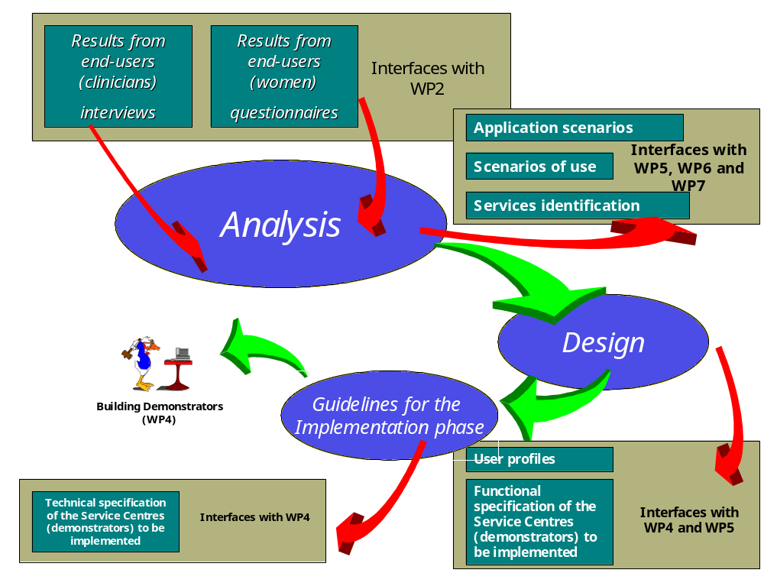Figure 4.1

Figures 4.2 and 4.3 illustrate in details the logical and operational stream of the mentioned approach, identifying for each process phase both the background and the intermediate results. In particular, figure 4.2 focuses on the analysis and design phases, whilst figure 4.3 illustrates the relationship between the design and the definition of implementation guidelines phases.

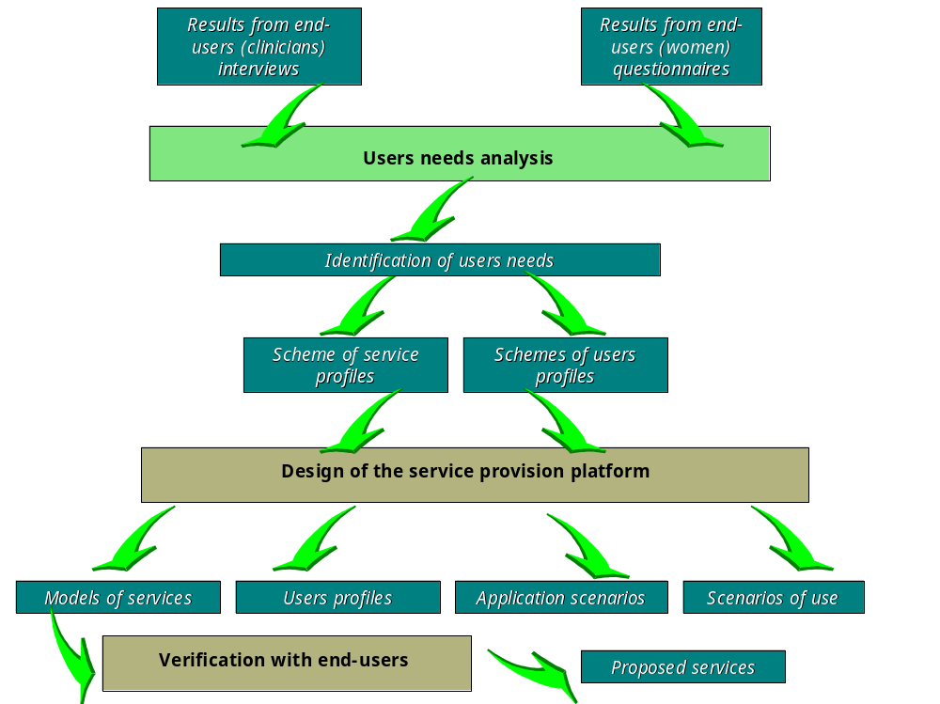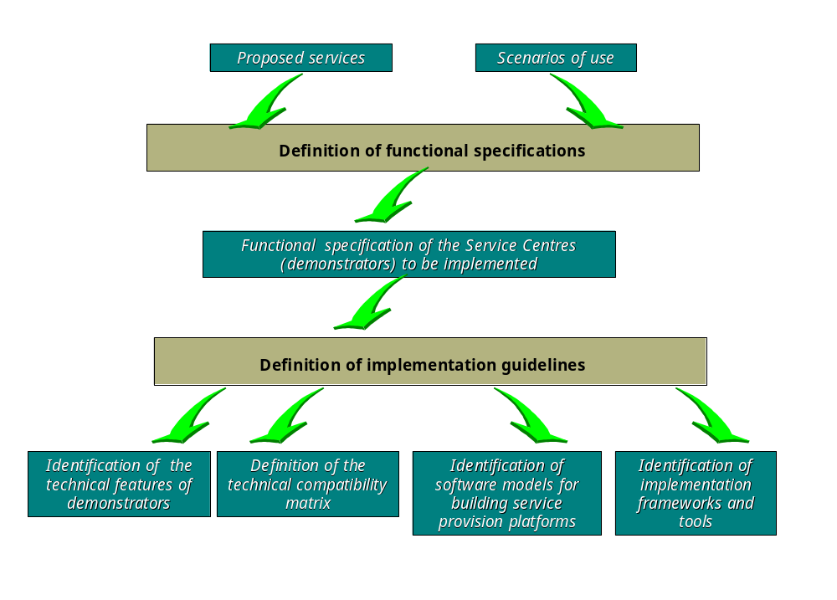Figure 4.2

Figure 4.3
References
[DGFL98] P. Dario, E. Guglielmelli, R. Fontanelli, C. Laschi, , “Design and implementation of a research and application transfer centre”, Proc. Of 6th European Congress on Research in Rehabilitation (ECRR ‘98), Berlin, Germany, 31 maggio – 4 giugno, 1998, pp. 547-548.
[MO98] J. Martin, J. J. Odell, “Object-Oriented Methods”, Prentice Hall, 1998.
[EQ1] N. Evans, E. Stewart, “Defining functional specifications and identifying systems architecture for integrated service delivery”, September 1996, Deliverable D4.1, TELEMATICS-EQUALITY (UR 1010) Poject
[GDLF96] E. Guglielmelli, P. Dario, C. Laschi, R. Fontanelli, M. Susani, P. Verbeeck, J. C. Gabus, “Humans and technologies at home: from friendly appliances to robotic interfaces”, RO-MAN ‘96 - 5th IEEE International Workshop on Robot and Human Communication, Tsukuba, Japan, 11-14 November 1996.

Unified Modelling Language (UML) (WP3 – T3.3)

The UML is a modelling language for specifying, visualising, constructing and documenting the artefacts of a system-intensive process.

Unified: UML unifies the industry best engineering practices for modelling systems. (June 1996: Booch, Rumbaugh, Jacobson, “tre amigos”; 1997: accepted as a standard by OMG)

Modelling: involves a focus on understanding (knowing) a subject (system) and capturing and being able to communicate this knowledge.

Language: it is not a simply notation for drawing diagrams, but a complete language for capturing knowledge (semantics) about a subject and expressing knowledge (syntax) regarding the subject for the purpose of communication.

Why using UML in WOMAN project?

Aim of the WOMAN project is to single out the needs and requirements of the users and to provide a number of services and products that address these individuated needs and requirements. To deliver valued solutions (maximum quality and minimum cost within the minimum time), we have to capture (acquire), communicate (share) and leverage (utilise) knowledge.

UML is a language that facilitates the following:

- Specifying problems
- Capturing and Using knowledge in problem solving
- Specifying and constructing solutions

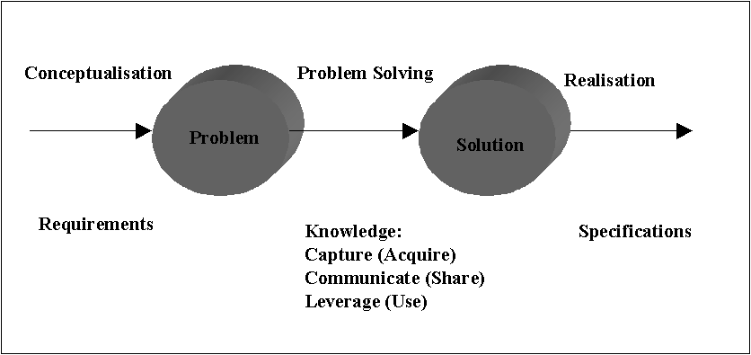

Figure 5.1

Requirements may be characterised as problems. Problem Solving has to identify (Analysis) and specify (Design) the solution that satisfies the requirements imposed by the problem (see Figure 5.1).

The Women project Life Cycle has been divided into phases (Work-packages) in order to divide the effort into manageable and controllable subordinate efforts. Each phase gets in input the output of the previous phase.

In WP3, we have to Analyse the user needs and requirements in order to offer the optimum solution (functional specification) addressing the individuated needs.

Since WOMAN is base on a User-driven approach, the first step in order to offer a good system is to acquire the knowledge about the problem, i.e., the domain, the users, the scenarios (Analysis). Next step is the functional specification, and then the development of the individuated solutions.

UML provides a powerful modelling language for specifying, visualising, constructing and documenting all the WOMAN lifecycle.
The following is the subset of the UML glossary, adopted within the WOMAN project.

Domains or Spaces:

Domain and spaces are organised collection of related components in an area of interest.
They have no purpose: the components are not organised to accomplish a set of objectives.

System:

Systems are organised collections of interacting and connected components co-operating to accomplish a purpose.

Models:

Models are complete abstractions of systems or contexts.
Architectural Views:

Perspectives through which models may be represented or projected as diagrams (see Figure 5.2).

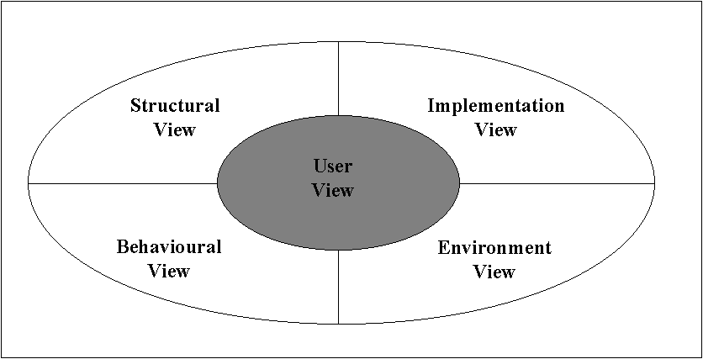

Figure 5.2

Diagrams:

Diagrams are graphical projections of sets of model elements.

UML Diagrams

UML defines nine types of diagrams:

- Class
- Classes: entities
- Associations: relationships
- Object
- Objects: instances of classes
- Links: instances of associations
- Use case:
- Actors: users of the system including human users and other systems
- Use cases: functionality or services provided by a system to users
- Sequence
- Class roles: roles that objects may play within interactions
- Lifelines: existence of an object over a period of time
- Activation: time during which an object is performing an operation
- Messages: communication between objects
- Collaboration
- Class roles: roles that objects may play within interactions
- Association roles: roles that links may play within interactions
- Message flows: messages sent between objects via links
- Statechart
- States: states of objects
- Activity
- Component
- Deployment

Different diagrams are used for different purposes depending on the angle from which you are viewing the system. The different views are called architectural views (see Figure 5.3).

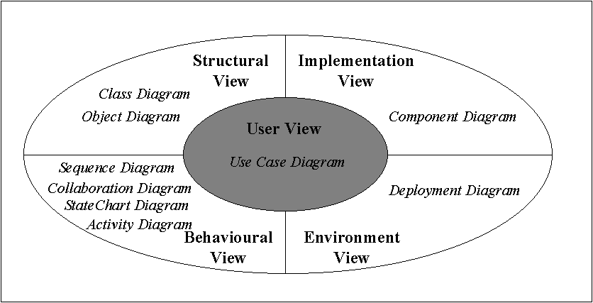
Figure 5.3

User View: The view presents the goals and objectives of the problem owners and their requirements of the solution.

Structural View: static and structural aspects of a problem or solution

Behavioural View: encompasses the dynamic aspects of a problem or a solution.

Implementation View: encompasses the structural and behavioural aspects of the solution’s realisation.

Environment View: encompasses the structural and behavioural aspects of the domain in which a solution must be realised.

Order of Diagrams

- Use case diagrams
- Structural diagrams
- Sequence diagrams (scenarios)
- Collaboration diagrams (scenarios)
- State diagrams
- Component diagram
- Deployment diagrams

References
UML in a Nutshell, Sinan Si Alhir, O’REILLY, 1998

Client-Server, Multi-tier and Distributed Methodologies (WP3 – T3.1, T3.3)

Client/Server Methodologies have been closely examined trying to establish the main features for each methodology and individuating the best developmental approach

Client-Side Methodologies

For what concern the client side the following methodologies have been considered:

- JavaScript;
- Jscript;
- VBScript;
- Java Applets;
- ActiveX Controls;
- HTML;
- DHTML (including DOM and CSS);
- XML.

Scripting languages can add dynamic capabilities to the Web Site with minimal programming and drive to the user browser, whatever processing is involved. They are object-based, rather than object-oriented, and so they have objects but no classes and no inheritance. The browser, in this way interprets scripting languages rather than to be compiled and stored on the server for downloading. Scripting languages make also client software (the browser) able to validate the input before the form will examined from the server.
At first, a comparison among JavaScript (Netscape), JScript (Microsoft) and VBScript (Microsoft) has been done.

JavaScript: it is a language developed by Netscape to enable web authors to design interactive sites. Although it shares many of the features and structures of the full Java language, it was developed independently. JavaScript can interact with HTML source code, enabling web authors to space up their sites with dynamic content. JavaScript is endorsed by a number of software companies and is an open language that anyone can use without purchasing a licence. Recent browsers from Netscape and Microsoft support it, though Internet Explorer supports an its subset, that is called JScript. JavaScript is supported by Netscape 2.0 and above, and Microsoft Internet Explorer 3.01 and above.

JScript: it is the Microsoft’s version of JavaScript, which is built into Internet Explorer (I.E.) browsers. Unfortunately Netscape’s JavaScript and JScript are not completely compatible, so web pages containing JavaScript/JScript code may run properly in a Navigator browser, but not in an I.E. browser or vice versa.

VBScript: it is a scripting language developed by Microsoft and supported by Microsoft Internet Explorer web browser. VBScript is based on the Visual Basic programming language, but is much simpler. Under many points of view it is similar to JavaScript. It enables web authors to include interactive controls, such as buttons and scrollbars on their web pages. It may be interpreted from browsers such as Netscape 2.0 with plug-in and above, and MS Internet Explorer 3.0x and above.

Comparisons: Analysing these scripting languages, it seems that JavaScript and JScript are very similar because they were both originated from Java language, while they differ from VBScript, which is derived, from Visual Basic. VBScript was created by Microsoft to enable to the VB developers to easily transport their experience and code into Internet.
Anyway while JScript and VBScript allow the use of the whole collection of ActiveX control objects, JavaScript is able to do this only with plug-ins.
The similarity between JavaScript and Java is only apparent. JavaScript programs don’t run on a Virtual Machine, moreover, they potentially have access to a browser’s entire environment, so that there’s not a true security model, protecting the user from malicious JavaScript programs.

ActiveX: it is a loosely defined set of technologies developed by Microsoft: ActiveX is an outgrowth of two other Microsoft technologies called OLE (Object Linking and Embedding) and COM (Component Object Model). Considering ActiveX controls, which represent a specific way of implementing ActiveX technologies, they can be automatically downloaded and executed by a Web Browser. ActiveX is not a programming language, but a set of rules on how applications should share information. (Programmers can develop ActiveX controls in a variety of languages, including C, C++, Visual Basic and Java).

Java Applets: are binary programs (they are not scripts that you can see in the HTML code such as JavaScript) generated in a generic format called Byte-code which can be interpreted by any Java able browser, such as Netscape 2.0 and above and MS Internet Explorer 3.0x and above. At this moment Java Applets require multithreading (operating systems that can run more than one program at a time) operating Systems to run, such as Windows 95, UNIX, OS2, etc. Java Applets will not run in MS Windows 3.x.

Comparisons: Applets allow performing tasks that were possible to execute with HTML. A popular early use of Applets was to provide user-interface components (i.e., buttons, boxes, and so forth) on the web page but now it is possible to do such tasks with ActiveX controls as well or with Dynamic HTML – probably the easiest and most lightweight method. Applets also provide limited cross-platform and cross-browser compatibility. These limitations make difficult to write a portable Applet. Since the level of compatibility varies, it is necessary to test it everywhere, so that what it is saved in development cost might be spent in testing and debugging.
ActiveX controls are good for accessing system services, threading, providing user interface components or accessing the registry. Controls can also be speeded up, once on the client, because powerful development languages, such as C or C++, can be used to create them. The biggest drawback of the ActiveX controls is the lack of browsers’ support from all browsers. An ActiveX control is similar to a Java Applet but, unlike Java Applets, ActiveX controls have full access to the Windows Operating System. This give them much more power than Java Applets, even if together with this power there is a certain risk the controls may damage software or data. To control this risk, Microsoft developed a registration system so that browsers can identify and authenticate an ActiveX control before downloading it. Another difference between Java Applets and ActiveX controls is that Java Applets can be written to run on all platforms, whereas ActiveX controls are currently limited to Windows environments.

HTML: it stays short for Hypertext Mark-up Language, the authoring language used to create documents on the World Wide Web. This language allows the creation of static web pages (until HTML 3.2). Concerning with HTML 4.0 new mechanisms are developed to improve control over the presentation of documents (with style sheets), to allow authors create dynamic web pages (with scripting languages), and so on. A complete study has been done looking at W3C specification on HTML 4.0.

DHTML: Dynamic HTML refers to new HTLM extensions that will enable a web page to react to user input without sending requests to the web server. DHTML permits interactivity on otherwise static HTML pages. With DHTLM, you can manipulate any page element, change element styles and colours and position elements on the fly (not just when the page is loaded). DHTML includes CSS (Cascading Style Sheets) and a Document Object Model (DOM) to allow programmability, the ability to manipulate data on the client (known as “data binding”), and support for scriplets, which are reusable bits of HTML and script that can be used for presenting interactive content.
More in detail Dynamic HTML is not an object oriented programming language; it allows you to manipulate the web page after it has loaded. DHTML is a set of technologies consisting of:
- The Dynamic HTML Document Object Model. It supports the manipulation of all elements and attributes on a web page as programmable objects and properties, taking advantage of the current standards: HTML 4.0, CSS, CSS-positioning and ECMAScript.
- Data binding, which allows the data caching and manipulation on the client machine.
- DHTML scriplets providing the ability to write reusable, fast and lightweight UI (User Interface) components using HTML 4.0 and ECMAScript.
Microsoft and Netscape have submitted competing Dynamic HTML proposals to W3C, which is producing the final specification.
Both technologies support Cascading Style Sheets; apart from CSS support these two technologies fundamentally differ with respect to creative capabilities and standards supports.
- Microsoft Dynamic HTML provides web authors with a powerful HTML layout engine and a total creative control, so they can manipulate any page element at any time (DOM).
- Netscape’s implementation is not consistent with the Document Object Model, as described by the W3C “Requirements Document”. As a result, Netscape Navigator exposes few page elements as objects, limiting layout and creative capabilities for authors. Page elements can be manipulated only while the page is loading not after load time. A complete study has been done looking at W3C recommendation on CSS and DOM.
CSS: Cascading Style Sheets allow to perform layout independently of content and structure; moreover they allow to push, pull, resize and even specify fonts; words can be superimposed over images, or layered on the top of each other, producing effects like drop-shadowing. Style-sheets can be used on three different levels: “local” (specific to one instance on a page), “global” (specific to an entire page) and “linked” (used across multiple pages). So it’s important to mention inheritance, or the cascading part of the style-sheets. In fact global style-sheets proceed over linked style-sheets, and local style-sheets take precedence over both global and linked style-sheets. A complete study has been done considering W3C recommendations CSS1 and CSS2.

DOM: it stays short for Document Object Model, i.e. the specification for how objects in a web page (text, images, headers, links, etc.) are represented. The DOM defines which attributes are associated with each object and how the objects and attributes can be manipulated. Dynamic HTML relies on the DOM to dynamically change the appearance of Web pages after they have been downloaded to a user’s browser. Unfortunately, the 2 leading browser, Netscape Navigator and MS Internet Explorer use different DOMs. This is the reason why their respective implementations of DHTML are so different. Both companies have submitted their DOMs to the World Wide Web Consortium (W3C) for standardisation, which now has the daunting task of specifying a standard DOM without alienating either of the browser grants. The W3C DOM specification will support both HTML and XML. A complete study has been done considering W3C specifications of DOM level 0 and level 1.

XML: it stays short for eXtensible Mark-up Language, a new specification developed by the W3C. XML is designed especially for web documents. It enables designers to create their own customised tags to provide functionality not available with HTML. For example, XML supports links that point to multiple documents, as opposed to HTML links, which can reference just one destination each.
Whether XML eventually supplants HTML as the standard web formatting specification it depends a lot on whether it is supported by future browsers.
So far, the only major browser vendor to endorse XML is Microsoft, which has stated that XML will be supported in future versions of Internet Explorer (Internet Explorer 5.0 and above). A complete study has been done considering the document “Stable XML”.

Comparisons: currently DHTML can be considered the best easy way of creating dynamic web pages while comparing HTML and XML we can see that XML is the best one. The reasons are that XML solves the contradictory needs of designers, who want tags that will make their jobs easier, and the standards bodies that want to preserve the general application independence that makes HTML portable and powerful. This offers some hope of a rationalised system for complementing HTML without creating the kinds of browsers incompatibilities that currently threaten to divide the web in two Netscape and Microsoft camps. XML is an effort to recognise the desire to write new mark-up tags, but it lays down some simple rules for doing so and turns user-defined mark-up into a force for stability, interoperability and powerful new breed of client side processing applications.

Server-Side Methodologies

We have taken into account different technologies and tools in order to develop dynamic Internet sites, connected to databases.
The main methodologies considered are the following:

- CGI;
- ASP;
- ISAPI;
- JDBC;
- SERVLETS
- JSP

CGI (Common Gateway Interface): The Common Gateway Interface is a standard agreed and supported by all major HTTPDs, for external gateway program servers. A CGI program is executed in real-time so that it can output dynamic information. CGI is a protocol for running programs on a Web Server. Typical applications include accessing a database, submitting a form etc.
It is possible to write CGI programs in every programming languages, using C, Java or Perl a complete portability is ensured. With CGI, the server creates as many processes as the number of client requests received. More concurrent requests there are, more concurrent processes created by the server, however, creating a process for every request is time-consuming and requires large amounts of server RAM. In addition, this can restrict the resources available for sharing from the server applications itself, slowing down performance and increasing wait times on the Web. CGI are difficult to maintain and they must be used with extreme caution to prevent potential security risk to the server. As a rule is very important to give only Execute permission to virtual directories that contain CGI applications in order to prevent big damages to the server.

ASP (Active Server Pages): Active Server Pages is the server-side execution environment in Internet Information Server 3.0 (Microsoft Web Server) that gives the possibility to run ActiveX Scripts and ActiveX Server Components on the server. By combining scripts and components, organisations can create dynamic content and powerful web-based applications easily.
ASP provides an open development environment with for both VBScript and JScript.
ASP can work with any Web Browser, the output of an ASP file is plain HTLM, the content of which can be customised for the capabilities of the client. ASP runs only on Windows NT 4.0 Server, Windows NT Workstation, and Windows 95, so it’s not portable.
An ASP application can be integrated with any ODBC compliant database. ASP provides all of the functionality of CGI applications in an easier-to-use and more robust environment. It runs, in the same process as the Web Server, more handling Client requests, faster and more efficiently.
Being an IIS component it uses Windows NT security. ASP files can be easily restricted to just certain users through secure Windows NT authentication or Client-Side certificates. For additional security, all client-server communications can be secured with SSL.

ISAPI: Internet Server Application Programming Interface is compiled as dynamic link libraries (DLLs) that are run by the WWW service at start-up. ISAPI applications have much better performance respect to CGI because the application is loaded into memory at server runtime. Moreover they require less overhead because each request doesn’t start a separate process.
Access to databases is accomplished through a component of IIS called Internet Database Connector (IDC) who is an ISAPI DLL that uses ODBC to gain access to databases. ISAPI is a Microsoft methodology so it is not portable. In respect to an ASP application, ISAPIs’ maintenance is more difficult. ISAPI has the same problems for what concern CGI’s security.

JDBC: Java DataBase Connectivity is a Java API executing SQL statements. It consists of a set of classes and interfaces written in Java Programming Language. JDBS provides a standard API for tool/database developers and make it possible to write DB applications using a “pure” Java API. Using JDBC essentially it’s possible to:
- Establish a connection with a DB;
- Send SQL statements;
- Process the results.
JDBC can use native drivers to access any type of data-store, but the most common type is relational. This solution is portable, secure and robust.

Servlets: the key benefit of Java Servlets is that they provide dynamic behaviour from the web server. They are a replacement for CGI scripts. Java servlets can be loaded dynamically and administration can be performed dynamically too. In practical terms this means that Java Servlets can be written for specialised purposes and loaded on the fly and administration can be performed without bringing out the server. Servlets run inside the web server and the browser can submit a request to execute it directly.
For a server to run a Servlet it has to be running a JVM, in addition the server has to support the Java Servlet API (API developed by JavaSoft who defines how and when the Servlet communicates with the server). Sun’s Java Web Server supports the Servlet API and, of course, it includes its JVM. A very important thing is that these Servlet API can be downloaded from SUN independently from the Java Server, so it’s possible to run a Servlet also with IIS, Netscape Web Server and Apache.
The performance is high, there’s a single Java Virtual Machine running on the server and the Servlet is loaded once when it is called. It is not loaded again until the Servlet changes and a modified Servlet can be re-loaded without restarting the server. The Servlet stays resident in memory and it’s very fast. Other important things are that Servlets are modular, each Servlet can perform a specific task and Servlets can talk to each other. Servlets are secure; they, in fact, exploit all the security issues of the web server they are supported.

JSP (Java Server Pages): is the Java multi-platform solution to realise in a competitive way, dynamic web sites. As previously seen, there are many ways to create dynamic web sites, using Java this aim can be achieved with the adoption of Servlets or JSP. Java Server Pages are being introduced to exceed some Servlets limits especially concerned with the maintenance of the state, the life cycle and the parameter flow. JSP are born with the aim of deleting these limitations and offer a lot of important functionality. JSP is a recent Java solution and develop is still in progress.

The main issues of the analysed methodologies are summarised in Table 6.1.

Methodologies | CGI | ASP | ISAPI | JDBC | Servlets | JSP
Operative System | All | Microsoft | Microsoft | All | All (with API Servlets and JVM) | All
Web Server | All | IIS | IIS | All | All | All
Portability¹ | High | Medium | Low | High | Medium (High with web extensions) | Medium (High with web extensions)
Power² | High | Medium | Medium | High | High | High
Maintenance³ | High | Medium | Medium | High | High | Medium
Complexity⁴ | Medium | Medium | High | Medium | High | Medium
Security | Medium | High | Medium | High | High | High
DB Supported | All | All | All | All | All | All

¹: capability to run on different systems;
²: capability to execute complex tasks;
³: work to be done to upgrade or change the files;
⁴: quantity of programming manpower is required.

Table 6.1: Main issues of Server Side methodologies

Distributed Computing

The explosive growth of the Web, the increasing popularity of PCs and the advances in high-speed network access have brought distributed computing into the main stream. Distributed object computing has two goals: to simplify system development and maintenance by creating reusable pieces of code, known as objects; and to allow objects installed on different computers to communicate over a network.
To realise component-based software architecture, two distributed object models have emerged as standards, namely:

- DCOM (Distributed Component Object Model);
- CORBA (Common Object Request Broker Architecture).

Here an overview of these standards is provided.

CORBA: The Common Object Request Broker Architecture (CORBA) is the Object Management Group's answer to the need for interoperability among the rapidly proliferating number of hardware and software products available today. Simply stated, CORBA allows applications to communicate with one another no matter where they are located or who has designed them.
CORBA 1.1 was introduced in 1991 by Object Management Group (OMG) and defined the Interface Definition Language (IDL) and the Application Programming Interfaces (API) that enable client/server object interaction within a specific implementation of an Object Request Broker (ORB).
CORBA 2.0, adopted in December of 1994, defines true interoperability by specifying how ORBs from different vendors can interoperate.
The (ORB) is the middleware that establishes the client-server relationships between objects. Using an ORB, a client can transparently invoke a method on a server object, which can be on the same machine or across a network. The ORB intercepts the call and is responsible for finding an object that can implement the request, pass it the parameters, invoke its method, and return the results. The client does not have to be aware of where the object is located, its programming language, its operating system, or any other system aspects that are not part of an object's interface. In so doing, the ORB provides interoperability between applications on different machines in heterogeneous distributed environments and seamlessly interconnects multiple object systems.
In other words, the core of the CORBA architecture is the ORB that acts as the object bus over which objects transparently interact with other objects located locally or remotely. A CORBA object is represented to the outside world by an interface with a set of methods. A particular instance of an object is identified by an object reference. The client of a CORBA object acquires its object reference and uses it as a handle to make method calls, as if the object is located in the client's address space. The ORB is responsible for all the mechanisms required to find the object's implementation, prepare it to receive the request, communicate the request to it, and carry the reply (if any) back to the client. The object implementation interacts with the ORB through either an Object Adapter (OA) or through the ORB interface.
In fielding typical client/server applications, developers use their own design or a recognised standard to define the protocol to be used between the devices. Protocol definition depends on the implementation language, network transport and a dozen other factors. ORBs simplify this process. With an ORB, the protocol is defined through the application interfaces via a single implementation language-independent specification, the IDL. And ORBs provide flexibility. They let programmers choose the most appropriate operating system, execution environment and even programming language to use for each component of a system under construction. More importantly, they allow the integration of existing components. In an ORB-based solution, developers simply model the legacy component using the same IDL they use for creating new objects, then write "wrapper" code that translates between the standardised bus and the legacy interfaces.
CORBA is a signal step on the road to object-oriented standardisation and interoperability. With CORBA, users gain access to information transparently, without them having to know what software or hardware platform it resides on or where it is located on an enterprises' network. The communications heart of object-oriented systems, CORBA brings true interoperability to today's computing environment.

DCOM: DCOM is the distributed extension to COM (Component Object Model) that builds an object remote procedure call (ORPC) layer on top of DCE RPC to support remote objects. A COM server can create object instances of multiple object classes. A COM object can support multiple interfaces, each representing a different view or behaviour of the object. An interface consists of a set of functionally related methods. A COM client interacts with a COM object by acquiring a pointer to one of the object's interfaces and invoking methods through that pointer, as if the object resides in the client's address space. COM specifies that any interface must follow a standard memory layout, which is the same as the C++ virtual function table. Since the specification is at the binary level, it allows integration of binary components possibly written in different programming languages such as C++, Java and Visual Basic.
Traditional operating systems only dealt with application binaries and not objects. Hence, the benefits of good object-oriented design have until now never gone beyond the compilation step. For a long time now, operating systems have been dealing only with application binaries (EXEs). Objects in one process could not communicate with objects in another process using their own defined methods. The operating system defined certain mechanisms of inter-process communication like DDE, TCP/IP, Sockets, memory-mapped I/O or named pipes etc. These objects needed to use these OS defined mechanisms to communicate with each other.
Components developed using Microsoft’s COM provide a way by which two objects in different object spaces or networks, could talk together by calling each other’s methods. This technology forces the operating system to see applications as objects.
COM forces the OS to act as a central registry for objects. The OS takes the responsibility of creating objects when they are required, deleting them when they are not, and handling communications between them, is it in the same or different processes or machines. One major advantage of this mechanism is versioning. If the COM object ever changes to a new version, the applications that use that object need not be recompiled.
COM components are never linked to any application. The only thing that an application may know about a COM object is what functions it may or may not support. In fact, the object model is so flexible that applications can query the COM object at run-time as to what functionality it provides.
Garbage Collection is one other major advantage to using COM. When there are no outstanding references (pointers) to an object, the COM object destroys itself.
COM supports Marshalling. Distributed Computing purists will attest to the fact that marshalling is the process of packaging and transmitting data between different address spaces, automatically resolving pointer problems, preserving the data’s original form and integrity. Even though COM objects reside in separate processes or address spaces or even different machines, the operating system takes care of marshalling the call and calling objects running in a different application (or address space) on a different machine.
Over and above all this, COM is a binary standard. A fully compliant COM object can be written in any language that can produce binary compatible code. So you can write ‘em using C, C++, Java, J++ or Visual Basic. All of the Windows NT shell has been written using COM.

Comparisons: Both DCOM and CORBA frameworks provide client-server type of communications. To request a service, a client invokes a method implemented by a remote object, which acts as the server in the client-server model. The service provided by the server is encapsulated as an object and the interface of an object is described in an Interface Definition Language (IDL). The interfaces defined in an IDL file serve as a contract between a server and its clients. Clients interact with a server by invoking methods described in the IDL. The actual object implementation is hidden from the client. Some object-oriented programming features are present at the IDL level, such as data encapsulation, polymorphism and single inheritance. CORBA also supports multiple inheritance at the IDL level, but DCOM does not. Instead, the notion of an object having multiple interfaces is used to achieve a similar purpose in DCOM. CORBA IDL can also specify exceptions.
In both DCOM and CORBA, the interactions between a client process and an object server are implemented as object-oriented RPC-style communications. To invoke a remote function, the client makes a call to the client stub. The stub packs the call parameters into a request message, and invokes a wire protocol to ship the message to the server. At the server side, the wire protocol delivers the message to the server stub, which then unpacks the request message and calls the actual function on the object. In DCOM, the client stub is referred to as the proxy and the server stub is referred to as the stub. In contrast, the client stub in CORBA is called the stub and the server stub is called the skeleton. Sometimes, the term "proxy" is also used to refer to a running instance of the stub in CORBA.
Unlike CORBA objects, which execute in a particular programming language, COM components use standardised interfaces and methodologies to pass data. For instance, all COM objects use the interface Iunknown as the basis for establishing communication between objects. As long as objects implement the standard interfaces, the language used to create either is irrelevant.
Microsoft calls DCOM "COM with a longer wire" because it uses the same methodology to talk across networks that is used to run interprocess communication on the same machine.
This process, called marshalling, involves creating a proxy for the object on the local machine and a stub on the remote machine. The proxy communicates with the stub, handling all details. As far as the COM object is concerned, it is working with an object running in the same process.

The Protocols: CORBA and DCOM work best when they can use their own protocols, but both also have strategies for using HTTP where their protocols are blocked by firewalls.
Although CORBA products use a number of different protocols to communicate, the trend is toward standardisation around the Internet Inter-ORB Protocol (IIOP), introduced in CORBA 2.0.
Microsoft based its DCOM protocol on Remote Procedure Call (RPC) standards developed for the Distributed Computing Environment (DCE) standards. Called Object RPC, it can use TCP for guaranteed connectivity or User Datagram Protocol (UDP) for connectionless transfer. The Open Group, the same industry consortium to which Microsoft granted the right to standardise COM and DCOM, controls DCE.

The Supporters: Netscape and Oracle have both put CORBA IIOP at the centre of their Web computing strategies and conspicuously snubbed DCOM. Netscape is building IIOP support into this spring's releases of its client and server product lines. Oracle is inviting partners to extend the functionality of its database by building "cartridges," which are CORBA servers that know how to interact with the Oracle database.
Microsoft is DCOM's most outspoken backer. Some other vendors, including Informix and Sybase, intend to support interfaces to both.

How They Work With the Web: CORBA piggybacks on Java to gain access to Web clients. DCOM works with either Java or ActiveX components that are downloaded into an ActiveX-capable browser.
In 1996, several CORBA vendors introduced Java applets that could act as ORBs.
Netscape has licensed one of these, Visigenic Software's VisiBroker for Java. The Java ORBs also work within Microsoft Internet Explorer.
Because the majority of CORBA Web clients are being written in Java, they will be instantly portable to all platforms where a Java Virtual Machine is available. This is one of their major virtues for Netscape, which prides itself on cross-platform support.
Applets written to the ActiveX specification will also be portable to all platforms where an ActiveX-enabled browser is available. To date, that stills mostly means Windows 95 and Windows NT.
But even after ActiveX browsers are available on a wider variety of platforms, binary ActiveX components will have to be recompiled for each platform.
A Java ORB can be downloaded as an applet or permanently stored on the client. To access remote objects with CORBA, an applet must include proxy objects responsible for translating Java messages and transmitting them to the server.
An ActiveX-enabled browser allows applets to function as ActiveX components. This means they can interact with other ActiveX components on the client, including those that are functioning as DCOM proxies for remote objects.

Maturity and Availability: CORBA implementations exist on most platforms, and have been used successfully in some large projects.
DCOM is still new as a commercial product, although beta versions have been available for several months. Microsoft is working to make COM and DCOM generally available on the Macintosh. A Solaris version of DCOM developed in partnership with Software A.G. is in its second beta release, with general availability scheduled for April. Beta versions for Digital Unix, Linux (on Intel platforms), and IBM mainframes are expected soon.
CORBA is maturer as a cross-platform technology, while DCOM has an army of developers who already know COM programming. COM also benefits from user-friendly Windows tools.
For these reasons, some developers see the best of both worlds as Windows clients that capitalise on the strengths of COM talking to CORBA servers on other platforms. At Object World East earlier this month, Microsoft endorsed a proposal for interoperability between DCOM and CORBA--the first time Microsoft has formally backed an OMG standard.
However, that doesn't resolve the issue for the Web, where Netscape is developing a Web strategy that revolves around CORBA and IIOP, while Microsoft is promoting the combination of ActiveX and DCOM.
The overall architecture of DCOM and CORBA might be illustrated in three different layers. The top layer is the basic programming architecture, which is visible to the developers of the client and object server programs. The middle layer is the remoting architecture which transparently makes the interface pointers or object references meaningful across different processes. The bottom layer is the wire protocol architecture further extends the remoting architecture to work across different machines.
The architectures of DCOM and CORBA are basically similar. They both provide the distributed object infrastructure for transparent activation and accessing of remote objects. The main differences are summarised below. First, DCOM supports objects with multiple interfaces and provides a standard QueryInterface() method to navigate among the interfaces. This also introduces the notion of an object proxy/stub dynamically loading multiple interface proxies/stubs in the remoting layer. Such concepts do not exist in CORBA. Second, every CORBA interface inherits from CORBA::Object, the constructor of which implicitly performs such common tasks as object registration, object reference generation, skeleton instantiation, etc. In DCOM, such tasks are either explicitly performed by the server programs or handled dynamically by DCOM run-time system. Third, DCOM's wire protocol is strongly tied to RPC, but CORBA's is not.

References

Computer Programming Magazine
n. 77 (February 1999), n. 78 (March 1999)
INFOMEDIA Editions
www.infomedia.it

Web programming
Bob Breedlove, et al.
Unleashed samsnet

DCOM and CORBA Side by Side, Step by Step and Layer by Layer
P. Emerald Chung, Yennun Hunag, Shalini Yajnik
Bell Laboratories, Lucent TEchnologies, Murray Hill New Jersey
http://www.bell-labs.com

Network Computing Architecture, An Oracle Technical White Paper,http://www.oracle.com

“What is Corba?”, OMG Publications, http://www.omg.org/corba

European Projects Analysis (WP1 – T1.6, WP3 – T3.3)

Taking into account the EU Community suggestions all the European Projects in some way related to the objectives of the WOMAN Project have been identified and critically evaluated. For this reason the EU Project considered have been:
- SEMRIC;
- MARGOT;
- MEDIREC;
- ISHTAR;
- SIREN;
- TRUSTHEALTH I, II;
- MEDSEC;
- INFOSEC.

A schema of their principal characteristics is reported in Table 7.1.

MARGOT: the project, based on advanced object-oriented technologies, developed a patient record model and a set of computer based tools to edit and manage medical records, and to exchange and integrate information between them. From a user perspective, the basic idea is that the users could accept to use a standardised library of definitions, from which they can build their own personalised Medical Record, more easily then accepting standardised Medical Records.

Among the final deliverables of the MARGOT Project we have in particular examined the deliverable “MEDICAL ARCHIVE GENERATION WITH OBJECT-ORIENTED TECHNIQUES”, because in this deliverable the problem of the construction of a general clinical card, usable by every unit within a health care structure, is faced.
The WOMAN Project, on the other end, is focused on outpatients’ treatments near the gynaecological and obstetrical units of the hospitals, then the WOMAN Project needs of a clinical card more specific. On the contrary the aspect of the MARGOT Project still interesting is the modelling of clinical cards with object oriented approach.

MEDIREC: the main objective of this Concerted Action has consisted of having on a European level a common understanding of the medical record in order to ensure that medical records coming from different origins are reliable, communicable, recognisable and comparable.

This Project establishes the rules to build a standard Electronic Health Care Record easily accepted by all the countries of the European Community. This achievement is important for the Woman Project because one of the goals of the industrial partners participating in the Project is to diffuse on the market the final produced tools.

INFOSEC: The main objectives of this program are to give complete studies and to develop standards in the field of security of Information Systems and Communications. In conclusion it is possible to say that the INFOSEC project (14 in INFOSEC ’92, 14 in INFOSEC ’93 and 9 in INFOSEC ’94) has provided a good but limited starting point for the development of a strategic framework for the security of information systems.

ISTHAR: the project main objective is to address problems of health data protection and health information systems security within telematics applications in a horizontal way. Action programs to raise the level of security awareness within healthcare establishments across Europe will achieve this.
This project is still running and its results will be considered through all the design phase on data security of the Woman project, integrating these results with the SEISMED Guidelines.

TRUSTHEALTH (I – II): The aim of the first phase of this project (TRUSTHEALTH I) is to demonstrate how trustworthy telematic systems can be established with the use of modern security techniques while maintaining the possibility for open systems connectivity and Trans-European interoperability. Cryptographic digital signature techniques should be applied to allow the telematic systems to comply with the legal requirements and to maintain the public confidence in the way that sensitive personal information is managed.
In the second phase of this project all the techniques previously seen will be applied to the medical field in order to meet the security challenges in health telematics (patient privacy, professional accountability, legal acceptability and interoperability requirements).
These projects seem very interesting for the Woman Project, but both the projects have the same time scheduling of WOMAN so we will be aware of the projects but it will be impossible to use their results

SIREN: the scope of this project is to assist health care provider groups using regional health care networks to establish necessary security services required both for protection of patient privacy and to provide legal accountability of medical professionals and administrative staff. A key function is to achieve a secure identification of professional users of telematic services, electronic records and in the future also of patients.
It has been impossible to contact the responsible person of the project and to have access to the web site. For this reason, if at the end of the project (1999), the results will become available and public, we will evaluate them in respect of their usability in our project.

MEDSEC: the work of the project focuses on important aspects related to standards for security and privacy in the Information Society and is deployed along four main axes:
- Taxonomy of the relevant standards;
- Identification of gaps in standards;
- Application, demonstration and validation of selected standards;
- Awareness and promotion on the existence and usefulness of standards for privacy and security in healthcare.
The results of the project will be very useful to user organisations, HIS (Healthcare Information Security) developers and standardisation bodies.
The project will contribute towards the standardisation work carried out within CEN/TC 251 WG6 (Security, Privacy, Quality and Safety) and WG4 (Medical Imaging), DICOM and HL-7.
MEDSEC seems particularly interesting for the WOMAN Project respect to the data security, privacy and medical image exchange. More specific information is available in the following deliverables:
D4: ‘Handbook of Standards for Security and Privacy in Health Care’;
D13: ‘Review of Existing and Emerging Work on High Security Policies for Health Care Establishments’;
D14: ‘Review of Existing and Emerging Work on Secure Medical Database Systems’;
D24: ‘Proposal for Security Enhanced DICOM Standard’;
D26: ‘Report on Demonstration Results of Digital Signatures and TTPs’;
D27: ‘Report on Demonstration results of the CEN/TC251 Standard on Security Categorisation and Protection of Healthy Information Systems’.

SEMRIC: the objective of the SEMRIC project is to design a method for secure communication of health care record information as a pre-standardisation activity relevant for CEN/TC251 work items 6.10 (Framework for Security Protection of Health Care Communication), 1.8 (Electronic Health Care Record) and 3.18 (Messages for the Exchange of Patient Medical Record Information). A secondary aim is to raise the awareness of the standardisation results and of the SEMRIC solution.
The focus of the project has been on the security mechanisms required for transfer of such sensitive data and mission clinical information as a health care record. A method has been developed to guarantee the secure transfer of a complete health care record including multimedia data. Finally a new concept of using SGML (the standard defining the common HTML pages of the World Wide Web) for health care records has been addressed in the project with appropriate security enhancements.
This project also, as MEDSEC, is important for the WOMAN project in respect of the data security and privacy in the medical field. It is relevant that SEMRIC is a further contribution to the standardisation activities in Health Care Telematics and, in particular is a support to the CEN/TC251 Medical Informatics activities.
In the reports:
- D 4-10: ‘User Requirements on the Secure Communication on Patient Record Information’;
- D 5: ‘Report of Connection and Connectionless Oriented Security Methods’;
- D 6-4: ‘Conclusions on the Methodology Development’.
Different EDI object-oriented methodologies on security of Health Care Records transmission are presented examined and compared. These results will surely considered when in the WOMAN Project the security criteria to apply to the different transactions will be well established.

PROJECT’S NAME | CITATION IN THE “WOMAN TECHNICAL ANNEX” | PROGRAMME | END OF THE PROJECT | AREA OF APPLICATION
MARGOT | YES | AIM | 1994 | Development and management of medical records.
MEDIREC | YES | AIM | 1996 | Electronic medical record: medical health records, classification and coding.
ISHTAR | YES | TAP | 1999 | A complete study on healthcare security requirements across Europe is done. (There is no implementation).  (Standard definitions and treatment of security problems).
SIREN | YES | TAP | 1999 | A satisfying study on healthcare network security services for privacy patient protection and for legal accountability of medical professional and administrative stuff.  (Standard definitions and treatment of security problems).
TRUSTHEALTH I - II | YES (I)  NO (II) | TAP | 1999 (I)  2000 (II) | - Development of specifications on how to establish key security services for healthcare professionals (encryption, smart cards,….)  - Application of previous techniques to the medical field.  (Standard definitions and treatment of security problems).
MEDSEC | YES | ISIS Programme | 1998 | Healthcare networks: healthcare security and privacy in the information society.  (Standard definitions and treatment of security problems).
INFOSEC | YES | INFOSEC Programme | 1994 | Information security in the healthcare area.  (Standard definitions and treatment of security problems).
SEMRIC | NO | ISIS Programme | 1998 | Secure communication of health care records information.  (Standard definitions and treatment of security problems)
Table 7.1: European Projects interesting for the WOMAN project

HealthCare Standards and Normative References (WP3 - T3.3)

The main guidelines of European Health Care Service Management are the reduction of costs and the improvement of the service quality. The Health Care needs to be managed as a huge company with the focus on the customers, the people.
In the past the concept of quality was associated to the reduction of productivity level and the growing of costs, but now this is not true. The quality is the correct and rational management of the resources involved in the productive cycle and the Information Technology is one of the aspects that could be used to reach the goal.
A growing number of health care organisations are experimenting with the latest information technology to better handle clinical data. But most of these pioneers are focusing on using one or two technologies in limited applications.
WOMAN computer-based patient records/telemedicine system will combine heterogeneous information systems, telemedicine, relational databases, Java, CORBA, object-oriented technology, the Internet, Web browsers, encryption and other technologies to create a "virtual patient record". Rather than rely on one software program to serve as the electronic records system, the virtual patient record uses different technologies to access, gather and present information from varying systems at various locations. It then displays the health data in a cohesive, seemingly integrated fashion on a physician's desktop computer.
But WOMAN's ability to gather data from multiple, different sources, could be one of the project's biggest obstacles. Data ownership is a major issue that WOMAN project will have to face when moving the program out of limited tests to real clinic environment. Health care information always has been perceived as having dual owners-the patient and the physician, but even in an ideal situation, where you have patients giving consent to allow their data to be managed electronically under secure conditions to wherever it needs to go, you still have the major issue of physicians and their sense of data ownership. The technology is a powerful tool to realise integrated systems but it could be useless if the health care structures are not integrated from an organised point of view.
While creating a technology like WOMAN that easily gathers and manipulates data is important, there are many other aspects of electronic records that the system have to cover, such as guaranteeing absolute patient confidentiality and enabling clinicians to enter data as easily or easier than they do now. We must always remember that it is the clinician that is the number one resource, not the technology.
WOMAN is going to be designed to create a virtual patient record to improve access to clinical data. The virtual patient record uses technology to gather clinical data from disparate sources, a laboratory information system at one hospital, a radiology imaging system at a clinic, and a clinical data repository at another hospital, for example. The record technology then presents the data on-screen for caregivers; "virtually integrating" the data in such a way that it appears to the user that all the data resides in the same system.
The virtual patient record assembles records whenever and wherever physicians need them. A patient goes to see his doctor. Over the past two years, the patient has been to five hospitals in three cities and has belonged to two different insurance plans. This patient has a lot of data residing in a variety of places in disparate information systems. The patient has a complaint about some kind of pain. With a virtual patient record like WOMAN, the doctor could open the electronic medical record, and the technology would assemble the data from all of the various on-line sources as needed.
The ultimate purpose of WOMAN is to improve the decision making process for physicians. WOMAN will enable a physician to make an informed clinical decision much faster than with paper records.
With a paper-based records system, a physician has to sort through piles of paper to find the appropriate information. Then, he must use that data to try and build an image in his mind of what a patient's problem is and how best to proceed. WOMAN integrates all the information physician requests in a graphical timeline. The system automatically performs many data gathering and comparison functions and presents a patient's medical information in a graphical, easy-to-follow manner. This, in turn, enables physicians to make better decisions faster and to reduce management costs. WOMAN also makes it easier for physicians separated by great distances to share complete medical information and make fast second opinions and other clinical decisions.
It will be possible to launch the program with a Web browser and share information with other physicians via the Intranet, which uses a unique encryption tool to protect data confidentiality.

Standards in health-care technologies

CEN/TC 251
The European Commission DGIII (Industry), Healthcare authorities, and suppliers of ICT-solutions and users to develop standards that enable compatibility and interoperability between independent systems in healthcare support CEN/TC 251. Such standards are needed for the efficient use of information and communications technology allowing new ways of interaction between different actors promoting cost-effective procedures giving better quality of care for the patients. The European standardisation programme provides an important channel to use the results of the R&D programme in health telematics, conducted by DGXIII.
Some of the standards developed give an important framework for the continued work while others provide detailed implementation guidelines in specific areas. The area of work cover:

Information models
Gathering the user requirements for information content to be transferred in various areas. The electronic record architecture is in the centre complemented by a number of specific message models, including information structures for patient data cards.

System of concepts and terminology
CEN/TC 251 defines basic rules for building concept systems for information systems and collaborates with existing professional bodies for medical terminology.

Security
Guidelines for management of protection of confidentiality, integrity, availability and accountability. Detailed provisions for communication protection. Safety and quality aspects.
Technology for inter operable communication
Transmission of ECGs and multimedia imaging requires special techniques and middleware concepts for modular approach to systems is subject of standardisation.

OMG’ Healthcare Domain Task Force: CORBAmed [1]
The Object Management Group (OMG) is a not-for-profit entity engaged in developing standards for system integration using object technology. OMG is the largest software consortium in the world with over 800 member companies. OMG's Common Object Request Broker Architecture (CORBA) standard has brought interoperability to distributed object computing. As its next set of targets, the OMG has formed a number of task forces in vertical market segments.
The CORBAmed Task Force is OMG's effort in the healthcare domain. CORBAmed is actively creating interoperable interface specifications for distributed object services (e.g. Patient Identification Service, Lexicon Query Service, Clinical Observations Access Service) which will be made commercially available from various vendors.
OMG has an interesting and proven approach to standardising technology that is intrinsically different from the conventional standardisation process. It brings together component technology vendors and users in an open forum, challenges them to identify areas that require standardisation that are both practical and realisable. It then publicises widely, requests and collects proposals from competing vendors, drives for a consensus among them, and adopts the result. One interesting aspect of this process is that an officer of any company responding to an OMG Request for Proposals must agree to commercialise the standard within a year. This process has resulted in consensus standards in areas, which have defied any standardisation in the past, with the added benefit of assured commercial product availability.
The CORBAmed task force has a very vigorous following and is developing service specifications in numerous areas in healthcare - leveraging existing standards such as HL7, DICOM and others.
The focus of CORBAmed is on interoperable services - leveraging the strength of CORBA. This is in effect a focus on backend technologies and middleware technologies.

Clinical Context Object Working Group (CCOW)
The Clinical Context Object Working group (CCOW) is developing interoperable solutions for application integration on the desktop. The applications need not be limited to the desktop; they may be client-servers. However, integration is via information, which is presented and/or entered at the client side, and all such applications must run in windows on the same desktop environment. For example, CCOW may be used to capture a new patient entry into a registration program and use this to trigger a managed care program to retrieve patient eligibility and payment information (as if the patient had been manually selected on the latter). CCOW is oriented toward Microsoft’s ActiveX/COM/DCOM environment, however, integration via CORBA is an option. The specifications that this group is currently in the process of developing address how multiple client-end applications from multiple vendors communicate and switch contexts interoperably in the desktop.

HL7
HL7 stands for Health Level Seven. HL7 is used to denote both a data-messaging standard for the exchange for healthcare information and is an ANSI accredited standards body, which has focussed extensively on data formats for exchange within organisations. Founded in 1986, HL7 now has more than 1500 members. This group is the main source of content information and healthcare models in the U.S. HL7 members have long been interested in adopting and promoting object technologies. There is a serious effort underway with the HL7 version 3.0 Reference Information Model (RIM) to use object-oriented techniques.

HL7 SigOBT
One subgroup in HL7 is looking at Object technology in general and Object Brokering technologies in particular, and is called the SigOBT group. The efforts of this group have been the source of content for the Andover Working Group and ActiveX for Healthcare consortiums discussed below.

HL7 XML/SGML
This is a relatively newer effort started about a year ago focusing on content tagging using XML. The current focus of this group is translation of the current HL7 ASCII encoding by reformatting with XML tagging. This group also intends to adopt the new versions of HL7, which takes a more object-oriented view.

Andover Working Group (AWG)
The Andover Working Group is a vendor consortium devoted to providing solutions based upon standards such as CORBA and ActiveX. The AWG has developed Enterprise Communicator software which "wraps" HL7 messages with object oriented transport mechanisms, obviating the need for socket-level programming. The AWG is currently looking at imaging and the DICOM standard (below) to see what developments can be useful to its members.

ActiveX for Healthcare (AHC)
AHC is a committee that is part of the Microsoft’s Healthcare Users Group (MSHug). AHC’s goal is to promote the adoption of Microsoft’s platform technologies in healthcare. Initial focus of the group has been similar to the Andover Working Group, but focuses on the development of ActiveX-based implementation of HL7 messaging objects. They have recently released ActiveX for Healthcare Messaging Components (SDK). In addition, they have plans for certification of components and developing specifications for other areas in healthcare.

DICOM
The DICOM standard (formally known as ACR/NEMA standard) focuses on the exchange of medical images (e.g. digitized x-ray, CT, MR, ultrasound, nuclear medicine, angiography, etc.) and related data. DICOM Structured Reporting Supplement 23 presents a model for relating physical entities (e.g. tissue samples) with images and with observations/measurements made on those images.

And more….
The Association for Standards in Testing and Materials (ASTM) group E31 develops "high level" standards for healthcare. These standards focus on a "higher level" of applicability; e.g., what data should be in an Emergency Room clinical record. A subgroup here also has standards for transcription process management, authentication and security issues in healthcare etc.
The X12 Committee develops international standards for electronic data interchange (EDI), and the exchange of billing information in healthcare. They, too, see the future in terms of object technology and are adding XML tags to existing data elements. The IEEE Medical Information Bus (MIB) standard defines a protocol for the exchange of measurement data from clinical instruments (patient monitors, infusion pumps, etc.).
In addition, there are a number of European efforts. HL7 and CORBAmed both have European chapters, but the European Union’s CEN has sponsored numerous efforts in object-oriented reference models in healthcare. The Duke standards page – titled “The Tower of Babel”, has a wealth of links to the various standards efforts that are happening around the world.

The Problems with Standards are that there are so many!
The efforts listed above are but a few examples of the "zoo" of standards organisations that exist in health care. The sheer quantity of the standards they generate has led many health care IT professionals to view standards in general with some degree of scepticism. In reality, however, there is not a great deal of overlap between or among these standards, and the people who contribute to their development generally try hard to make use of the best features of existing standards, rather than compete with them.

How do HL7 and CORBAmed relate to each other?
HL7 is a messaging standard. It is used to exchange healthcare related information between two entities via a coded textual message. The messages may be sent ad-hoc, e.g. based upon certain trigger events in the sending system, or the messages may be sent in response to a query (however, the latter mode is not well supported at present). In its current utilisation, HL7 works best for exchanging information between host systems, where each host needs a duplicate copy of the information (e.g. patient demographic data). In the past, HL7 has been criticised for a lack of an information model to standardise the semantics of the information being exchanged. Thus, many "flavours" or interpretations of the standard exist in the real world today. However, HL7 is moving to rectify this problem in version 3.0.
CORBAmed is based upon the CORBA distributed object model. CORBA provides a robust and highly scalable infrastructure for a distributed object model of computing. The CORBAmed domain task force is chartered with developing standards for the "business objects" for health care. By viewing a set of hosts as a network of distributed, communicating "objects", clients are able to obtain processed information over an enterprise-scale network. In the longer term, hosts may utilise each other’s distributed object services to provide information on demand, thus providing an alternative to the exchange of HL7 messages. However, in the short term, the efforts of CORBAmed will best be utilised in client-server communications. By providing an object-oriented view of clinical information, CORBAmed allows hosts to "protect" their data by exposing only specific "methods" to clients. Clients can rely on CORBA hosts to provide information on demand and need not keep duplicates of information in local storage, obviating problems of freshness and authenticity which are inherent in message exchanges. CORBA standards are platform and language neutral, which is a key requirement for any large-scale client-server integration effort.
As a distributed object technology, CORBAmed must adopt an object model for its domain. The HL7 version 3.0 modelling efforts are being closely looked at for guidance in this regard. In addition, real world HL7 experience will be used in the definition of clinical observation information to be exchanged via the forthcoming CORBAmed Clinical Observation Access Service (COAS). In fact, the COAS RFP mandate that existing standards (including HL7, DICOM, MIB and others) be looked at for definitions of the information to be exchanged. Furthermore, CORBAmed has an active working group looking at interoperability with HL7.

How do HL7 and CORBAmed relate to the efforts of the AWG and AHC?
The Andover Working Group (AWG) is an ad-hoc collection of vendors who wish to use HL7, DICOM and other message exchange standards "wrapped" in distributed object technology (CORBA and DCOM). AHC has goals similar to Andover but focuses exclusively on Microsoft’s DCOM and ActiveX technologies. By "wrapping" an HL7 message in CORBA, a vendor inherits the benefits of a robust "bus" for finding, securing and exchanging information in a heterogeneous computing environment. "Wrapping" methodology does not provide the full benefits of object orientation (i.e. it does not support inheritance or polymorphism) but it does utilise robust off-the-shelf "middleware" for communication and infrastructure services, thus lowering development costs and ensuring interfacability between heterogeneous systems.

Are CORBAmed and CCOW direct competitors?
CCOW members are vendors of Windows-based desktop applications who wish to provide their customers with a measure of ActiveX visual integration. Although CORBA could be used for the same purpose, ActiveX is most closely tied to the Windows environment and provides a very rich set of inter-application controls and interfaces. Therefore, CCOW is aimed at desktop (client) automation, and CORBAmed is aimed at client-server interfacing.

Messaging, Middleware and n-tier architectures
The previous discussions basically point to two major trends in healthcare in the utilisation of objects. One methodology focuses on the use of messaging from HL7 to AWG to AHC, so some call it Message Oriented Middleware (MOM). The other trend focuses on middleware services, exemplified by the CORBAmed approach. Each of the approaches has a role to play, depending on the context, desires and goals of vendors and customers. Messaging using HL7 in healthcare is typically characterised by monolithic applications sharing content that gets duplicated in each application.
Messaging has an important role to play when used properly. For instance, it is the technology of choice to notify physicians or other stakeholders on important or changing information. However, messaging used simply to preserve the status quo or to protect a particular vendor’s existing technologies will simply delay the reaping of benefits afforded by internet and distributed object technologies.
HL7, in its version 3.0, has focused on developing a comprehensive reference information model that serves as a blueprint for designing middleware in healthcare. These models have been a fertile source for both message-oriented and n-tier-oriented middleware service developments.

Benefits of Object/Component Technologies
From the perspective of users of technologies such as hospitals and clinics, adoption of component technology is driven by the promise of simplification, primarily in the management of the applications and the reduction in duplication of functionality. HL7 and CCOW are vendor-centric approaches that address primarily the exchange of information, (now done with objects in HL7 v3.0) between existing systems and are not aimed at reducing duplication in neither functionality nor simplification of the management of these systems. Object technologies and frameworks such as the Object Management Architecture (OMA) and Microsoft’s DNA provide the promise of true reuse, enterprise-wide deployability and a simpler maintenance and evolution path for users. In addition, object technologies facilitate support for processes in organisations. When processes must be changed to fit technology constraints, the acceptance and benefits of any new technology can be reduced dramatically. By breaking process into discrete components, it is easier to support the changes in individual processes that are needed to allow technology to succeed. Eventually there are likely to be a number of standardised component technologies in healthcare. However, one does not have to wait for these standards to be fully developed to realise the benefits component technologies can make possible today. The primary advantage of using standards-based components in healthcare information system architectures is that any standards-based component can be seamlessly and inexpensively replaced at any time with a later generation, improved, standard-based component while the rest of the processes and technologies involved can remain intact and unchanged.

Conclusions
While it is true that the many standards activities within the health care arena are not perfectly aligned, they are generally not competitive, either. Health care IT professionals are not so much faced with a choice of standards, but rather a set of standards to use in various, different circumstances. HL7 will continue to dominate in the host – host world, although CORBA could play a role here as well, particularly in situations where the retention of data ownership rights is an issue. AHC and AWG should play a leading role in dealing with HL7 messages. CORBAmed should provide the standards for client – host computing, as CORBA middleware is robust and proven in enterprise-scale applications. CCOW should continue to focus on desktop automation. DICOM should provide the model for observational reporting as well as the representation for medical image data, particularly for primary diagnosis. Likewise, MIB should continue to focus on instrumentation interfaces, ASTM on health care applications standards (computer-based patient records, basic emergency data set, etc.), ASC X12 on billing standards, and various government and private organisations on coding and vocabulary standards. Users, in the meantime, should be represented on all of these standards-making bodies and should insist that they continue to co-operate toward greater re-use and interoperability.

References
[1] Objects in Healthcare – focus on standards V. "Juggy" Jagannathan, Kent Wreder, Bob Glicksman, and Yasser alSafadi, 1998.

HealthCare Security Issues (WP3 – T3.3, T3.5)

A crucial point in any Healthcare Information System is Security. There are many security issues in the use of information systems in healthcare, which relate very specifically to patient care, while others issues have to be addressed to problems regarding data and medical image transmission.

In the first part of this section we will refer to the European Pre-Standard CEN/TC251/WG6, ‘Security Categorisation and Protection for HealthCare Systems’. This European Pre-Standard specifies a model and a method of categorising automated healthcare information system in the context of security and privacy. For each system category specified, a corresponding set of protection requirements and recommendations is provided which is appropriate to the risks’ levels inherent in that category.

System categorisation is primary made with respect to the information associated with the healthcare information system in question. It describe the nature of the information that it stores, processes or communicates according to the values of the availability, confidentiality and integrity (ACI) attributes.

Healthcare involves often sensitive data, which are to be disclosed only to medical staff who are directly involved with the care of patient. Is thus essential the Confidentiality.

To an increasing degree, the information systems in healthcare will provide data, which are directly used, for treatment. Medical staff have to base his or her decisions on data; this means that also Integrity and Availability of the services are of critical importance.
These tree attributes Availability, Confidentiality and Integrity are often indicated as the ACI attributes.

Because of the important role of information systems in healthcare, it is required to keep trace of “who has done what” with the system; Accountability is a critical requirement as well.

Security problems are related to data storing, accessing, and processing and also to data transmission.

It is extremely important, for each category of users who access the system, to ensure a corresponding set of protection requirements and recommendations and also it is crucial for transmitted data/images to ensure privacy, integrity and reliability between two communicating applications.

The CEN categorisation model provides a way to define ‘protection profile’ and on the basis of the category, it defines recommendations and requirements to be adopted.
In the Woman project is possible to distinguish between two kinds of security to be treated:
- Security related to applications (Electronic Health Care Patient Record, Databases etc., Intranet security access);
- Security related to data transmission and images transfer.
The first is called ‘Application-side security’ and can be completely treated following the CEN rules. The second, called ‘Transaction Security’ to be exhaustive treated, needs the integration of other standards as:
° DICOM 3.0 (Digital Imaging and Communication in Medicine: image secure transfer)
° HL7 (Health Level 7: data secure transaction in healthcare)
° CORBA-Med (Standardised interfaces to many HealthCare ‘Object Oriented Services’ across most usual platforms, and available in the public domain).

Application-side security
The important issues to be considered, in the context of security in the Intranet application that will be developed in the WOMAN Project are:
- Data input, storing, processing and output;
- Hardware and Software configuration;
- Actors who access the system.
Based on the ACI attributes and their relative values, the European Pre-standards define six categories.

From the CEN categorisation model the WOMAN project results in the sixth profile, considering Availability-critical, Confidentiality-very sensitive and Integrity-critical.

In this context it is important to ensure a high level of protection adopting both baseline security requirements and additional requirement due to the high level of security to be reached. The main mechanisms to be followed are here specified:
- Identification and authentication of a user through profiles (using userID and Password), to guarantee the access to those users who have a legitimate right to use systems or data and denying it to those who do not. The overriding aim is to control the reading, writing, modification and deletion of any stored information or application;
- Log-on process: after a successful log on, the system shall display the time and date of the previous successful log on and any unsuccessful log on attempt related to the userID in question;
- Automatic Log-out process: if a terminal is unused for a further system-specific time period, the terminal shall automatically be disconnected from the current interactive session with a message displayed and/or warning sounded before and after the above. The time period should not exceed 30 minutes;
- To ensure Accountability, all record creations, updates and deletions shall be recorded in a security log. A log should at least contain the userID, time and date of the occurrence, program identifier, type of access, transaction outcome (success or failure).
- To ensure Accuracy all data shall be subjected to validation checks by the application software.
- Software protection and backup.
- Anti-Virus policy.
- Firewall adoption to physically protect the network.

Transaction Security
Within the WOMAN project, it is fundamental to guarantee security transmissions in the following processes:
° HealthCare Record Consultation
° Data File Consultation
° Images Transfer

To resolve these problematic current standards that guide the above-mentioned field of interest have been taken into account.
With the ‘HealthCare Record Consultation’ a clinician can request to another WOMAN partner an opinion on the data of a certain patient. To establish this co-operation, all the clinical data collected in the HealthCare record are sent to the clinician. This operation is very dangerous if it is not done under very secure protocol. To preserve the confidentiality, integrity and availability of data during/after a transmission it is possible to adopt the Security Socket Layer protocol (SSL). The primary goal of SSL is to provide privacy and reliability between two communication applications. The protocol is composed of two layers. At the lowest layer is the SSL Record Protocol used for encapsulation of various higher level protocols. The other layer, SSL Handshake Protocol, allows the server and client to authenticate each other and to negotiate an encryption algorithm and cryptographic keys before the application protocol transmits or receives its first byte of data. The SSL protocol provides connection security that has three basic properties:
- The connection is private. Encryption is used after an initial handshake to define a secret key. Symmetric cryptography is used for data encryption;
- The peer’s identity can be authenticated using asymmetric or public key cryptography;
- The connection is reliable.
SSL is an open, non-proprietary protocol. It has been submitted to the W3 Consortium (W3C), working group on security for consideration as a standard security approach for World Wide Web browsers and servers on the Internet.
Netscape has worked with the W3C on developing and standardising common, robust, security mechanisms and protocols for the Internet, and it gave full support to such mechanisms and protocols as they are standardised. Many software vendors in the Internet community have already accepted SSL as a de facto standard. SSL has also been submitted to the Internet Engineering Task Force (IETF) for validation as the official Internet Standard for Transport Layer Security (TLS).
‘Data File consultation’ permits the storage into a file of a great amount of medical data (coming from statistic queries, …) and subsequently, its transmission. This procedure needs to be protected using suitable security protocols as HL7. It is a communication standard for information interchange in healthcare environment, especially in hospitals. HL7 aims at enabling communication between applications provided by different vendors, using different platforms, operating systems and application environments (e.g. programming languages, tools). In principle, HL7 enables communication between any systems regardless their architectural basis and their history. That means, HL7 supports communication between real-world systems, newly developed or legacy. This is achieved through syntactically and semantically standardised messages. HL7 interfaces realise the request/service procedure in the sense of sending and receiving these standardised messages. Communication servers manage the communication.
HL7 is a protocol for exchange of healthcare information, defining both messages and the message exchange format. HL7 is not an architecture supporting design of healthcare applications. It realises a set of message-based transactions between healthcare applications at the level 7 of the ISO-OSI model of open systems interconnection.
The HL7 message protocol supports unsolicited messages and solicited messages alike. HL7 realises both basic and enhanced acknowledgement paradigms.
The basic principle of HL7 is a point-to-point information interchange paradigm (1:1 or 1:n in the case of broadcast). Communication is controlled by trigger events (in the case of the trigger event paradigm of process coupling, unsolicited or real-time) or by query/response interchange (in the case of query/response paradigm of retrospective interchange or solicited).
As stated in Deliverable n° 6 of MEDSEC Project, currently there are no HL7 implementations providing any security functionality even if the authors are involved in the improvement of HL7 security services. Corresponding to the American HL7 security activities, the HL7 security services and mechanisms will be introduced and improved step by step using secure FTP, secure mailing (SMIME, PEM, PGP) to implement and to demonstrate security mechanisms as hashing, encryption, etc. and finally the combination of all mechanisms applied to the whole message body.
In Deliverable n° 25 of MEDSEC Project a proposal for security enhanced HL7 standard has been done, giving a set of validation results to offer some security specifications useful to improve the standard regarding security.
Considering the WOMAN project, the following communication contents are considered:
- Patient-related medical communication (e.g. information about diagnosis and therapy);
- Non-patient related medical communication (e.g. epidemiological results).
To have HL7 security communication the following security requirements must be satisfied:
- Integrity – the property that the message was not altered or destroyed in transmission;
- Authentication – knowing that the putative sender is truly the sender;
- Confidentiality – the property that the message is not made available or disclosed to unauthorised individuals, entities and processes;
- Within the context of accountability: Non-repudiation – providing assurance that the sender cannot claim the message is counterfeit and that the receiver cannot claim it failed to receive or to process the message.
Thus steps for implementation of secure message system are:
the first step is to guarantee the integrity of information communicated. The second step is the unambiguous identification and authentication of the communication partners, using login and password mechanisms or advanced authentication tools. The third step for implementation of secure message systems is related to ensuring the confidentiality of communicated, processed and stored message. This can be performed using cryptographic algorithms.
Concerning with the ‘Images Transfer’, clinicians can attach images coming from some medical devices, to the HealthCare Record of the patient or they can ask an image consulting to someone outside the Intranet. These conditions need of opportune security mechanisms, in order to ensuring the confidentiality, integrity and availability of medical image. In this context the DICOM 3.0 standard has been considered. The DICOM Standard describe the information entities and attributes which are used for the communication of the image and the related information, and the information that may be performed on these information objects, such as store, query/retrieve and print.
For this standard it has been referred to the MEDSEC Project, (HealthCare Security and Privacy in the Information Society). Deliverables D05 and D15, provide scenario for the validation of communication standards for digital system with the utilisation of medical images. They have been proven that DICOM doesn’t addresses security issues and in Deliverables D22, D24 they provide a proposal for security enhanced DICOM Standard. Unfortunately, at present these deliverables are not at public disposal.
A valid work concerning the security problem in the images transfer and so in the DICOM standard, has been done in the MedSeC Project (Speed-optimised Data Security for Tele-medical Applications). This is a German Project, at present under development. They have been implemented a data and images fast exchange between clinics within a high-speed ATM-based network. The goal of the MedSeC Project is to develop methods for ensuring the confidentiality and integrity of medical image data in the specific context of high-speed networks, to implement these methods on the basis of existing standard (DICOM, Java), and to evaluate them using selected real scenario. Even if, the Woman Project has not to consider high-speed network in its framework, their results can be useful to our purposes. Cause, within the DICOM concept, as we have already said, data protection measures to ensure the secure transfer of sensitive patient data has not yet been solved, they investigated different schemes to protect data with as little impact on data transfer speed as possible. They are co-operating with the DICOM working group in the implementation of a procedure that allow only the patient-relevant data fields to be encrypted, moreover they are working on extension of the Java-based DICOM implementation by SSL on-line encryption.

Results of the User Needs Analysis (WP2, WP3 – T3.1)

On the basis of the results of the WP2 User Needs and Requirements Analysis, the following users and services have been individuated.

Identified Users:

- Women (WOMEN divided into two groups PATIENTS & global CITIZENS)
- Clinicians in WOMAN consortium (PARTNERS)
- Clinicians in out-patient departments in Woman consortium (OUTPAT)
- General Practitioners (GP)
- Gynaecologists (GYN)
- Other Specialists (OTHER)
- System Administrator (ADMIN)

Identified Services:

- Information on Menopause to women: a correct and direct information about the various arguments concerning the menopause, would make women able to live this particular moment of their life with less problem and more pleasure. A correct information can also lead the women to understand the new aspects and perspectives correlated to menopause. Consequently, to visualise our work and give instruments of counselling on Internet network, we decided to build web sites in order to provide a first degree of information for women who wish to be up date on menopause.
- Information on Menopause to Medical staff: Medical people will have access through the Web pages, to the last news regarding menopause. The knowledge and experience of the clinical partners, involved in the WOMAN consortium that are at the very highest level, will be formalised in the web pages and will be easily accessible by everyone.

- Clinical File: Intranet Access to Local Data. All the efforts made in the Woman Project are pointed to improve the co-operative work, the co-ordination of shared data and to create new tutorial/assistant services that could be an appropriate answer to the increase necessity of healthcare service for postmenopausal women.

- Clinical File: Extranet Access to Remote Data. Access to Statistically significant databases will be grant, making possible to exchange opinions and data, as well as plan future research work and perform large epidemiological studies in the European population of postmenopausal women. In fact, one of the major challenge of this plan regards the interaction between different menopausal Clinics, with a communion of information that are collected in distributed databases.

- Person-to-person consulting (e-mail, videoconferencing, digital record on-line): Clinicians involved in WOMAN will easily contact each other in order to have their opinion upon a specific case, since they can easily share the patient data, or even share the desktop of their PCs via teleconferencing tools. Women may contact medical staff, in order to have a direct interaction, and may also fill a on-line report, in order to provide the clinicians with a standard filled form.

- Multi-point Video consulting (videoconferencing, multiple lists), woman and medical staff will be provided with services to allow multi-point consulting, video consulting, etc. If required, women will also have the possibility to create their chat lines, in order to share their private experiences.

- Tele Booking: women have asked the possibility to book, via Web, services, visits and exams.

- Multilingual application languages: English for the inter-centre connections, Local Idiom for the women and local clinicians, will be provided

WOMAN Scenarios (WP3 – T3.3)

In this document WOMAN results are described through the representation of scenarios.
The following scenarios have been selected and described after interviewing medical staff and women and after the examination of the questionnaires.
As shown, both medical staff and women will find a great number of services provided by the WOMAN project.

Scenario | Users | Current situation | WOMAN services
Data availability | Physicians:  PARTNERS  OUTPAT | Actually almost all patient data are stored in paper format.  At each new visit of a patient data have to be retrieved in different paper files.  Clinicians have to ask colleagues, where a specific folder is, and when a specific visit was made.  Sometimes the old papers are nor even found, so the same woman has different files. | All relevant clinical data are going to be stored in digital databases, where the history of the patient is recorded and easily retrieved.  Physician will have access to a great amount of data, but if the data are well organised, they will find exactly what they are looking for an in very short time.
Applying screening protocols | Physicians:  PARTNERS  OUTPAT  GP  GYN | As a consequence of the previous point, it is impossible to have a complete vision of the history of the patients, and to apply screening protocols. | All relevant data are going to be easily retrieved and big databases are going to be created for epidemiological and scientific studies. New screening protocols are going to be adopted thanks to the accessibility and organisation of data.
Shared Data | Physicians:  PARTNERS  OUTPAT  GP  GYN | There are no connections among the various centres involved in the menopause treatment and consequently no co-operation and exchange of data.  In each department (Oncology, Radiology, Pathology) the local patient clinical data are stored, but there is no communication (except by phone) among the different departments.  Each patient has to give to the clinicians (at each visit!) the personal, anamnestic data.  Results of instrumental tests (mammografies, colposcopies, etc) are currently sent via post from one department to another. | The outcomes from different departments are going to be stored in the distributed databases, in order to create a virtual unique file for each patient.  Integration of heterogeneous distributed multi-databases for the management of the shared healthcare data (clinical data, instrumental records) is going to be provided.  All images that are going to be involved in the WOMAN protocol are going to be sent via telematic connection in order to save precious time, and to provide clinicians with important information.
Medical doctors information | Physicians:  PARTNERS  OUTPAT  GP  GYN  OTHER | Clinicians are now spending a lot of time in finding high competence and excellent know how regarding menopause, the last scientific discoveries, the optimal therapies.  They need more updated information and finding this information is a very time consuming task. | Medical people will have access through the Web pages, to the last news regarding menopause. The knowledge and experience of the clinical partners, involved in the WOMAN consortium that are at the very highest level, will be formalised in the web pages and will be easily accessible by everyone.
Consulting | Physicians:  PARTNERS  OUTPAT  GP  GYN  OTHER | If a doctor needs an advise for a specific case, currently it is really very difficult to have an other point of view, or a consulting from a colleague who is maybe more experienced in that specific case. | Clinicians involved in WOMAN will easily contact each other in order to have their opinion of a specific case, since they can easily share the patient data, or even share the desktop of their PCs via teleconferencing tools.
Women Information | WOMEN | Women are now obliged to set up a visit with clinician in order to find the answers also to very simple questions, or to read books, which might not be specific.  Women now need more detailed, more competent information about their heath, about their routinely problems, and they want to have this information in an easy way. | Women will find, in the WOMAN web sites, and demonstration points, all the answers to their questions. They will have the possibility to create a contact, via e-mail with specialist clinicians, and decide in a more responsible way about their heath, and quality of life.  WOMAN will provide information to citizens concerning the prevention and identification of the major serious diseases. Informative services for the woman about the breast cancer, female cancers in general, osteoporosis, heart diseases, which could be strongly decreased through a better understanding of menopause and its consequences will be provided.
Awareness and support for informed choices | WOMEN | Women now do not have access to high quality information, to help them make aware decisions about their health.  There is a very low-level information provided by media, and unfortunately this information is not of a good quality, to help them choose in a responsible way about them selves. | Information to make informed choices in self-care, education, disease prevention, education and information regarding health by telematic instruments to support the self-care decision-making process would be provided.  Collaboration between women and physicians and participation to services not only in case of disease, but also as prevention supports will be promoted.
Knowledge accessibility | Physicians:  PARTNERS  OUTPAT  GP  GYN  OTHER | It is very difficult and time consuming to have the right information. Medical people have to read hundred of pages in order to achieve the information they are looking for. And very often this information is not even accessible. | Results of ongoing regional and national projects, existing data and knowledge bases will be studied since the project aim is to increase their accessibility and better use.  Unfortunately the great amount of knowledge available in the hospitals is the private one, acquired in years of personal experience. Aim of WOMAN is to single out these experiences and to incorporate them into intelligent interfaces and services.
Connections and co-operations | Physicians:  PARTNERS  OUTPAT  GP  GYN  OTHER | Both at a local level and a European level, there is a need of collaboration and sharing of experience and information. | Development of logical and physical networks between the primary healthcare centres and the other functional areas of the hospital involved in the women sphere (peripheral points, operative units), and between the different countries involved in the WOMAN consortium, will highly increase the exchange of knowledge and information.
Evaluation of treatments | Physicians:  PARTNERS  OUTPAT  GP  GYN  OTHER | The treatments that are currently provided to women are now evaluated on a local scale. | The health professionals of the primary care structures benefiting from an integrated European environment, will have the possibility to study the effectiveness of specific treatments on a European level.  Differences in the various European regions in terms of genetic, cultural, dietary and environmental factors can influence the menopause and its related consequences in terms of morbidity and mortality, and thus in terms of individual and social costs. Exchanging and comparing information can lead to discriminate between the local and common features in the different European regions.

The WOMAN Technological Framework
In previous sections of this deliverable the analysis modelling representation adopted in the framework of the WOMAN Project has been discussed. What it should be pointed out here is the mapping from a conceptual model to an implementation model or, in other terms, the design issues of the WOMAN system.
Producing designs that implement object-oriented programming languages (OOPL) is very straightforward: the conversion from Object Oriented Analysis terms to OOPL constructs is quite intuitive, and many different approaches can be found in literature. Now, the focus is on the identification of the appropriate OOPL, among the many existing ones.

As reported in the following section, from the technical point of view, a coherent, distributed, intrinsically object-oriented and platform independent service provision system should be built, also allowing integration of existing resources. On the user perspective, the service provision system should be easily accessible, usable, intuitive.

The solution meeting all the mentioned technical and non-technical issues has been identified: at local level, service provision systems will be implemented as Intranet platforms, thus allowing the adoption of Extranet solution for inter-site (i.e. health care units) communication (Figure 12.1).

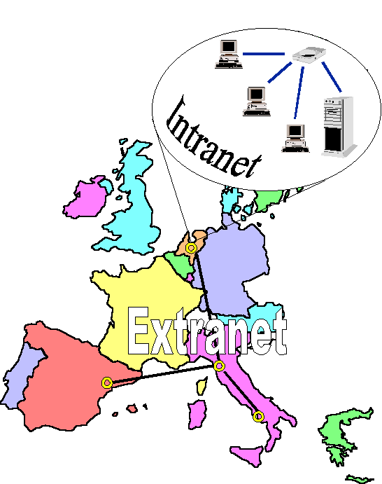
Figure 12.1.

Being Internet the identified metaphor for service delivering, it ‘forced’ project technicians to adopt the three tier Java-based implementation approach at construction level (construction being the mapping from an implementation model to a working system).
At client level, JavaScript, JavaBeans and Java Applet solutions will be implemented; Servlet, JSP and Java applications will be developed at Web server level and, at last, JDBC and DBMS (Oracle-based) solutions on application server side will be built, in accordance to the following picture.

Browser
Server Web

JDBC

JAVA
SCRIPT
HTML
JSP

DBMS
APPLET JAVA
JAVA
APPLICATION

SERVLETS

Client Level
Web Server Level
Application Level

Figure 12.2.

User View: Use-Case Diagrams

Each stage of the problem-solving process (analysis, design and implementation), within WOMAN, has been focused not only on thinks to be implemented (what) but also on how to formally describe and communicate them between technical and IT experts and among them and clinical experts and selected end-users for verification and validation purpose.

Case Use Diagrams are graphical representations of the interactions between different actors (users) and the system. Different diagrams represent different points of view.

A use-case diagram presents a collection of use cases and actors and is typically used to specify or characterise the functionality and behaviour of a whole application system interacting with one or more external actors.

Actors are the users and any system that may interact with the system. Since actors represent system users, they help delimit the system and give a clearer picture of what it is supposed to do. Use cases are developed on the basis of the actors needs. This insures that the system will turn out to be what the user expected.

Use case diagrams contain icons representing actors, association relationships, generalise relationships, packages, and use cases.

We have created a top level use-case diagram (Fig. 13.1) to visualise the context of a system and the boundaries of the system’s behaviour.

Then we have created more use-case diagrams to describe a part of an application system. Use cases can include other use cases as part of their behaviour. A use-case diagram shows the set of external actors and the system use cases that the actors participate in.
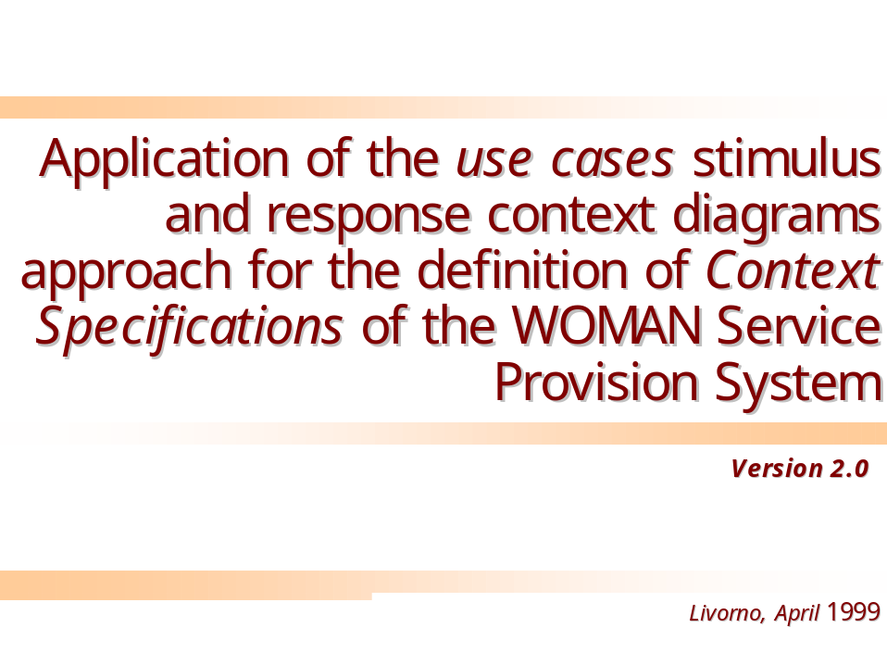
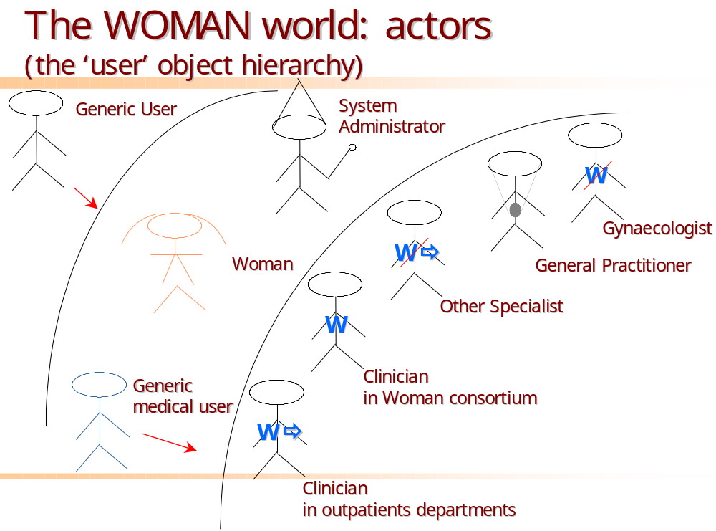

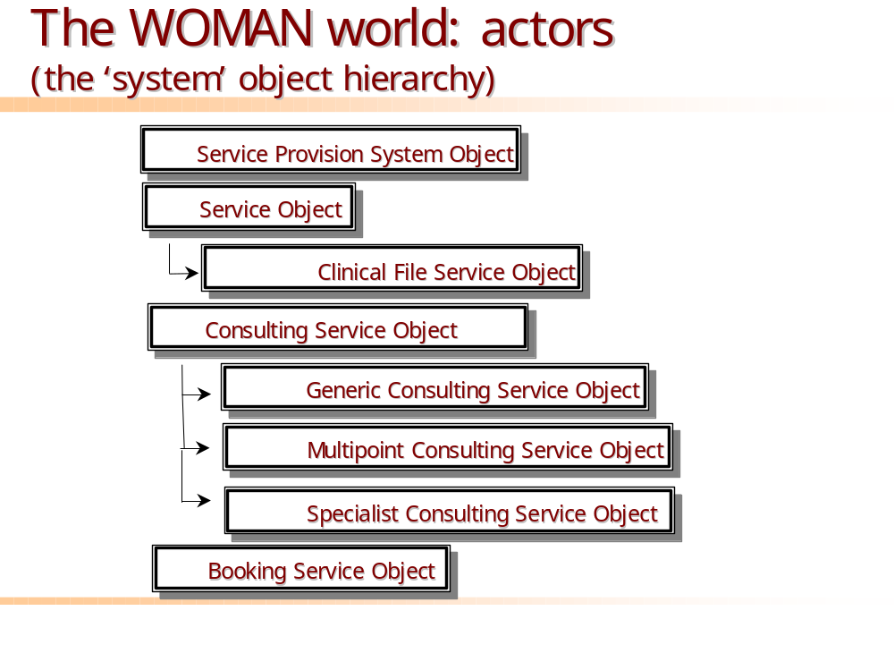

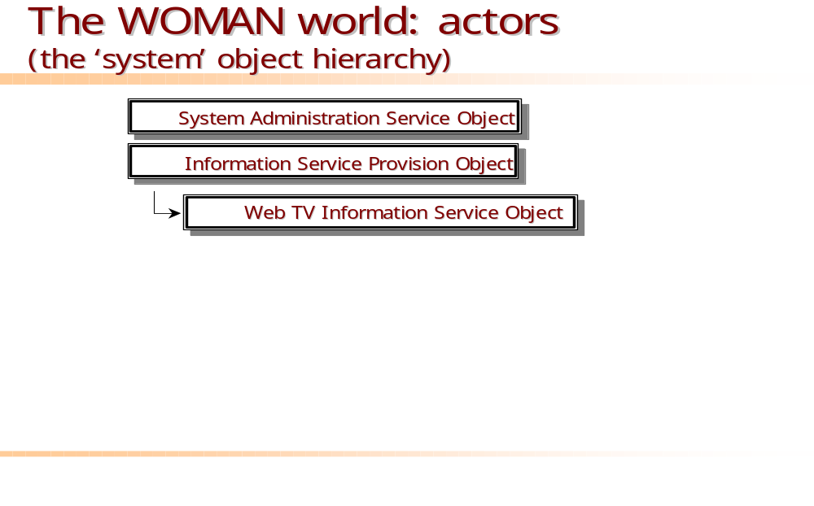

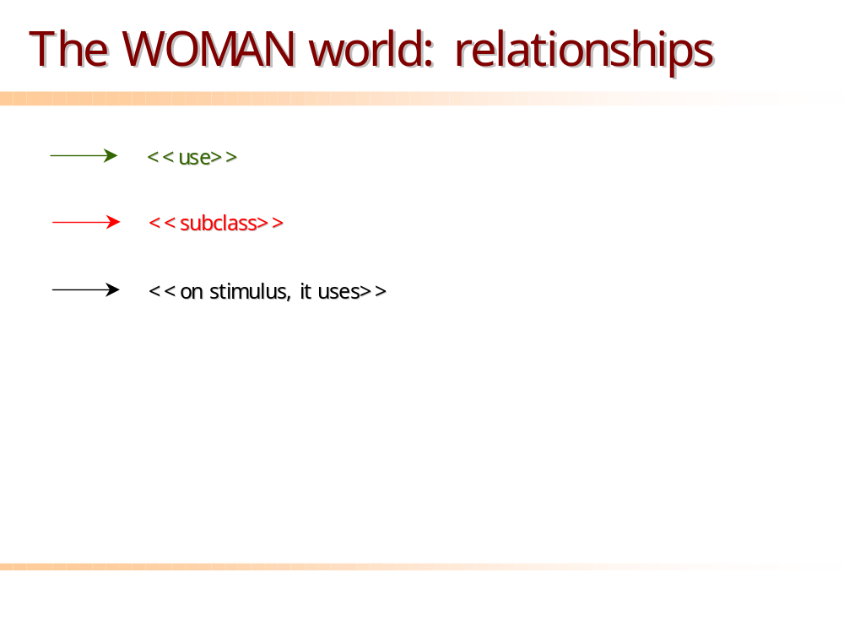

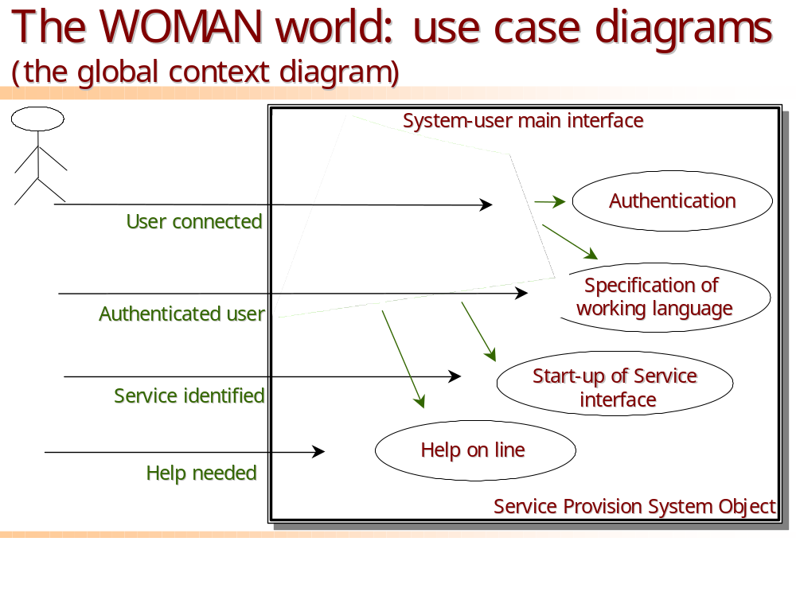

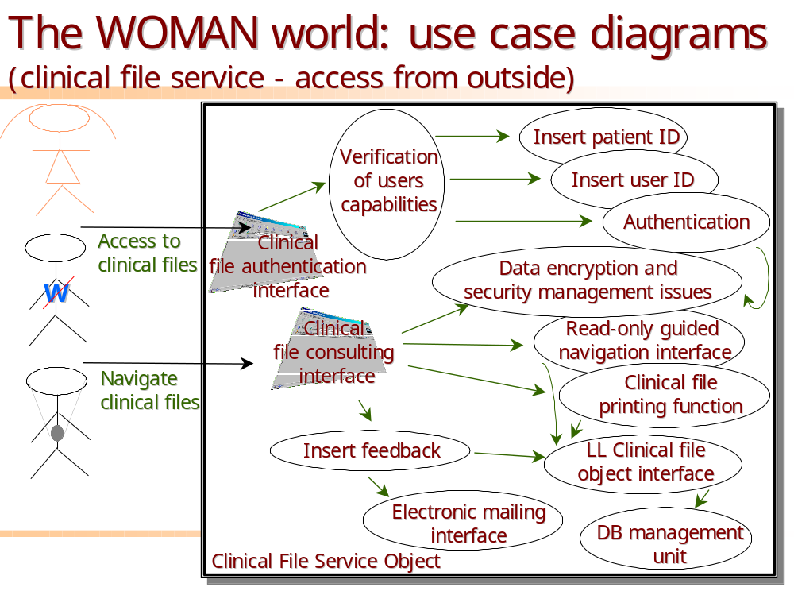
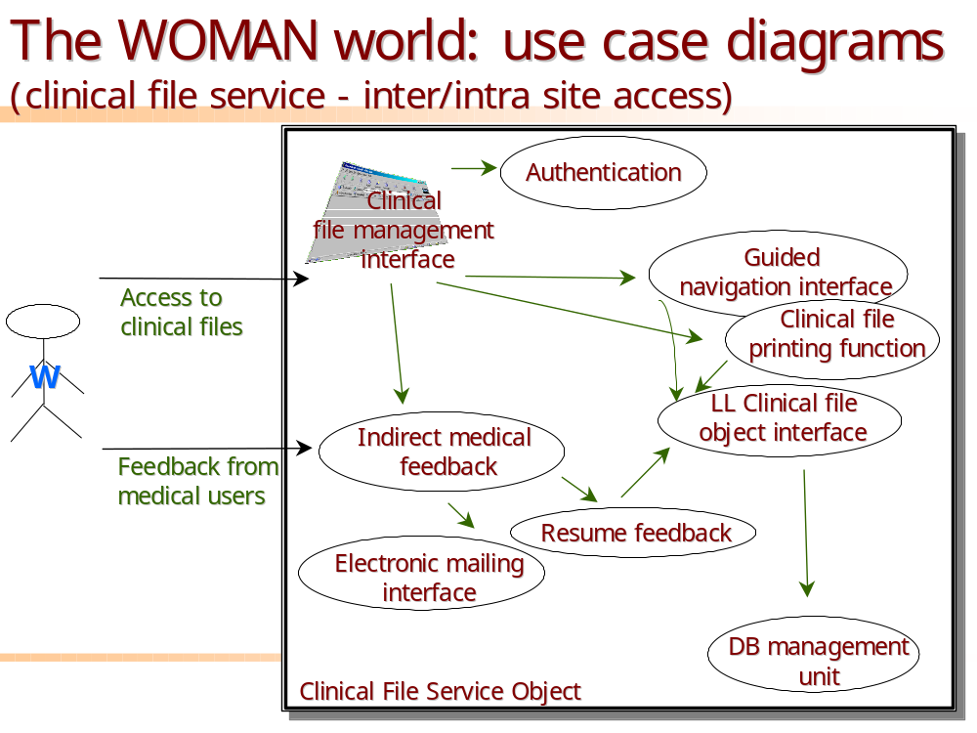

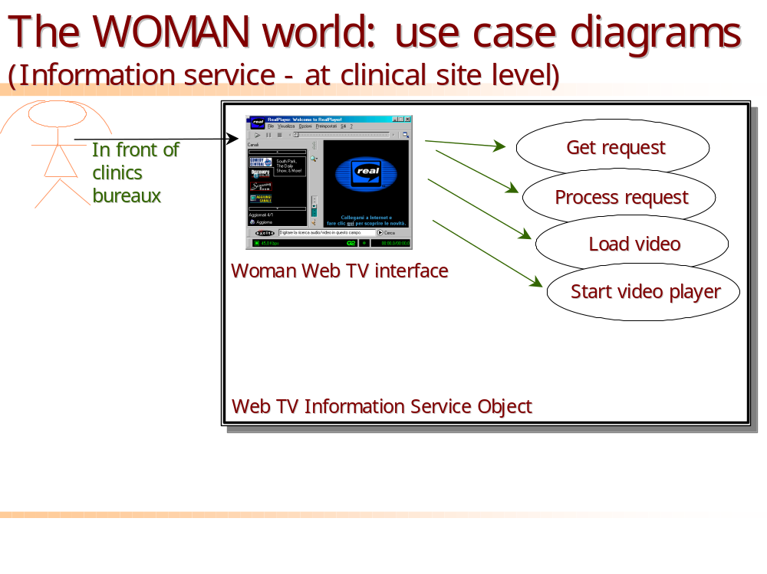
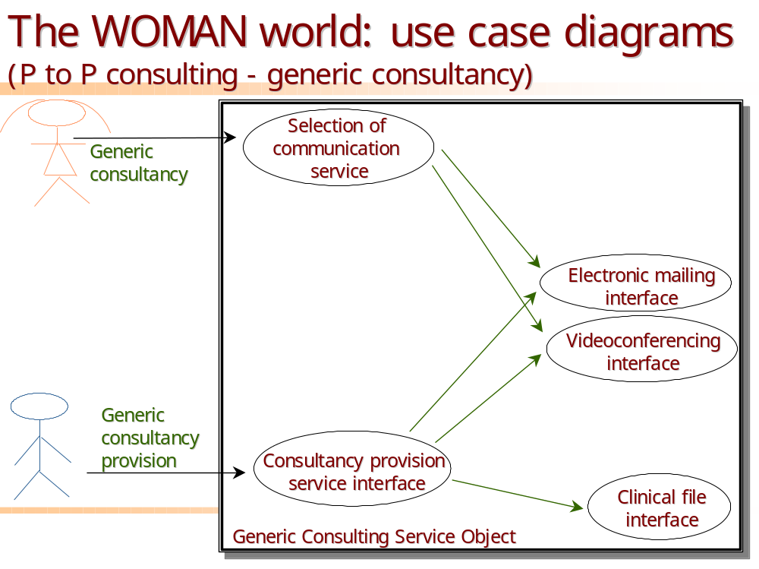

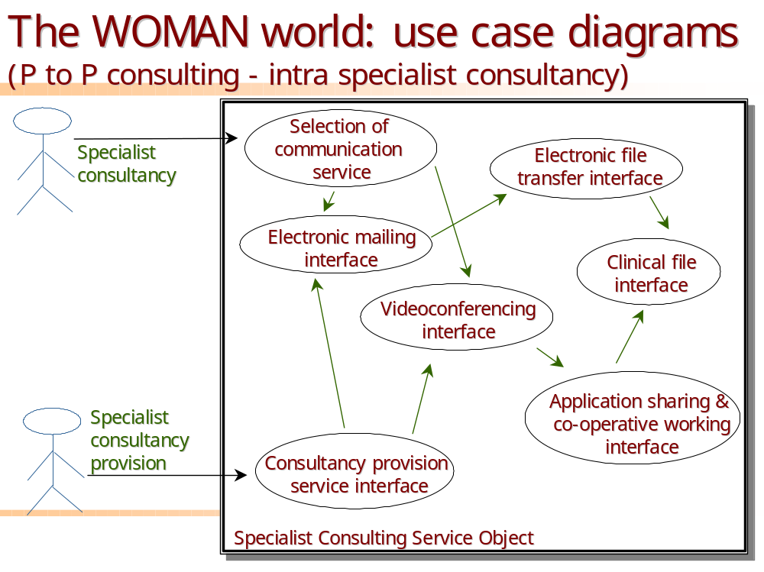
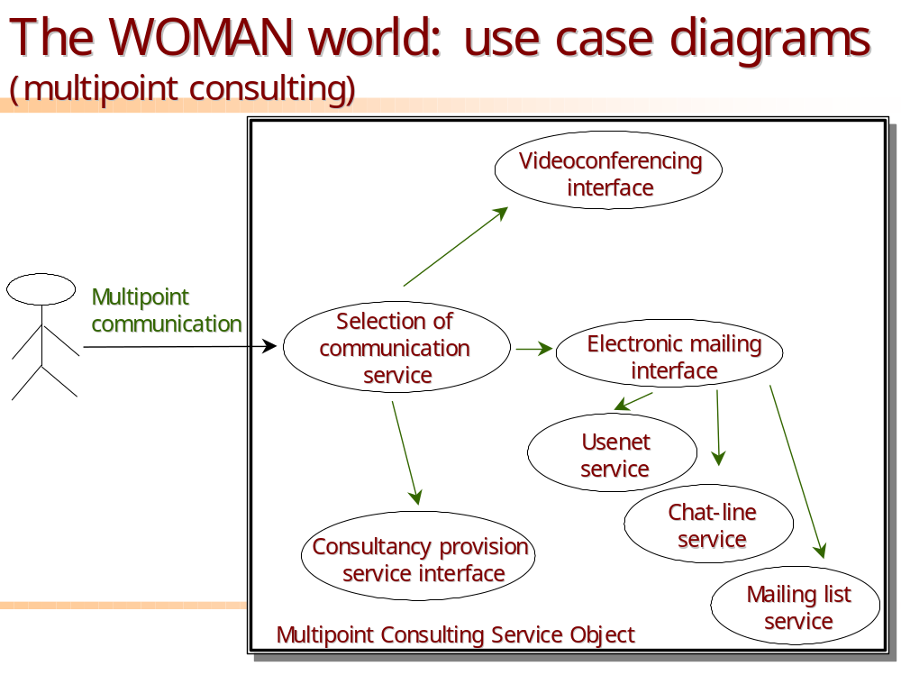
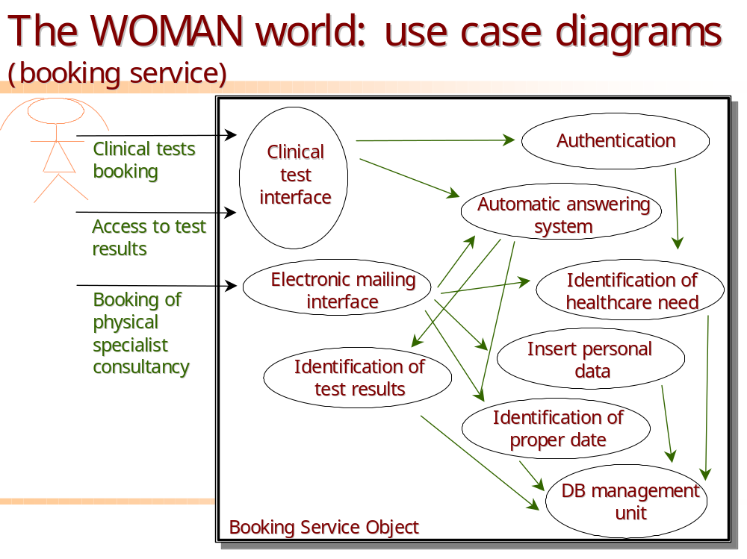
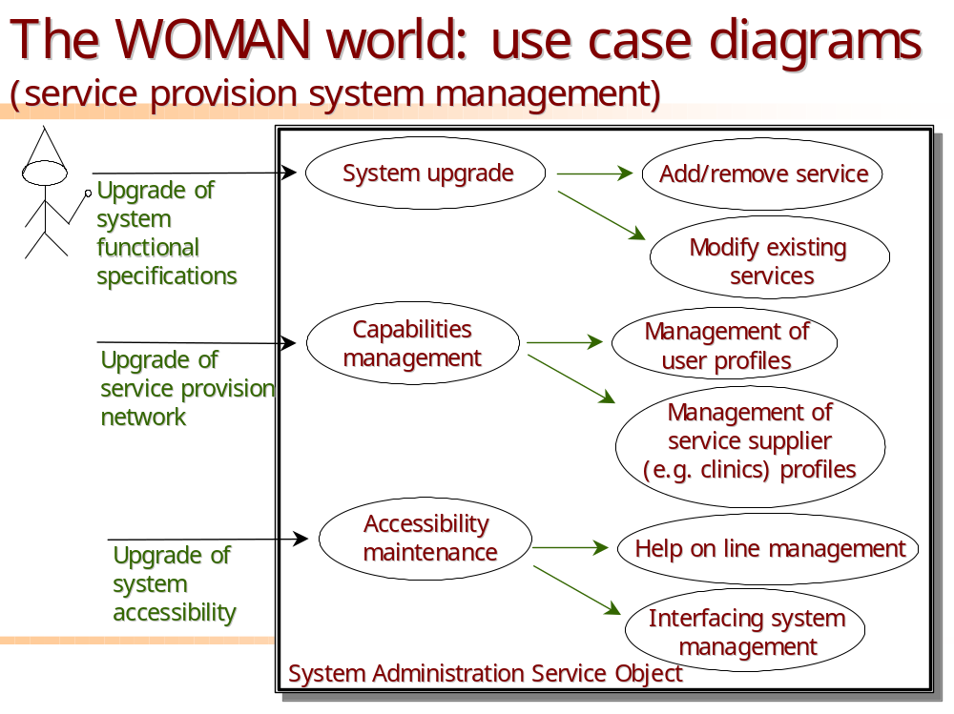

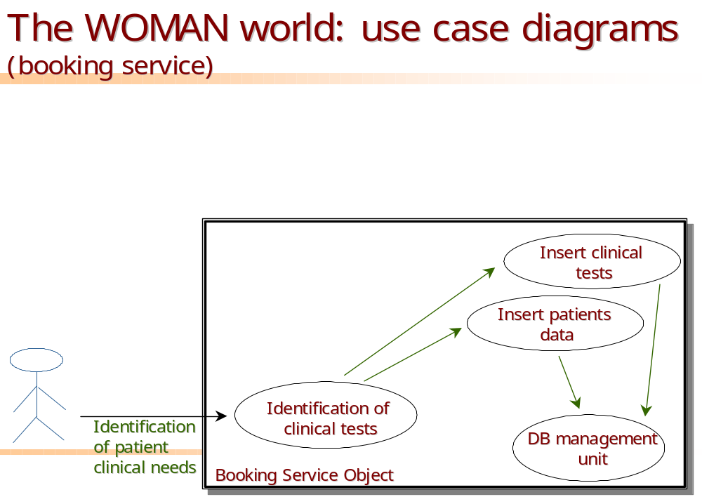

Formal Definition of the Web Sites Structure (WP3 – T3.3, T3.4)

In this section a formal description of the WOMAN Web Sites will be given. The analysis will be managed through the following steps:

- Identification of general issues to be considered in the design of Web sites and applications;
- Identification of specific features of WOMAN Web Pages;
- possible layouts to be adopted.

An overall description of the general features a well-designed web page has to offer will be given. On the basis of this analysis, the main issues the WOMAN Web Sites have to adopt will be described. The last step represents a possible graphical presentation of the WOMAN Web Sites.

Well-designed Web Pages Features

The analysis and design of a Web Site should take into account the following characteristics:

- Server Location: the WWW Server that will physically store the Web Pages.

- Page Purpose: Web page intent’s description, in order to acquire the objectives of every page avoiding information redundancy. The purpose of a Web page can be of two kinds:
• INFORMATION: the page has to give simple and clear information of the target argument;
• SERVICES: the page has to provide services (Appointments booking, FAQ, Tele-consulting, etc.).

The choice of the page purpose is a key-action in the design of a Web Site. The choice is relevant in order to guarantee Utility and Usability features.
Utility measures the system capability to resolve something the user care about while Usability is the measure to understand if the user can use the system and he/she does so effectively. Moreover Usability has five characteristics to consider:
• Ease of learning: How fast a user, who has never seen the user interface before, can learn it sufficiently well to accomplish basic task.
• Efficiency of use: Once an experienced user has learned to use the system, how fast he or she can accomplish tasks.
• Memorability: If the user has used the system at some earlier date, he or she can remember enough to use it more effectively next time.
• Error frequency and severity: How often users make errors while using the system.
• Subjective satisfaction: How much the user like using the system.

- Tools and languages adopted: this is a crucial point in the design of a Web Site, because the development tools adopted will reflect the site’s success.
The choice of the languages to use (HTML, DHTML, Java etc.) has to be driven from the requirements we intend to include in the sites.

- User Level Accessibility: this feature has to point out the user’s level that will navigate through the site. Selecting the target user it will be possible to provide more aimed information and services.

- General Content’s Page: the goal of this feature is to emphasise the pages in the site, which will contain common information/services, accessible to all user’s levels.

- User’s Level Detailed Contents: the goal of this feature is to individuate the pages in the site, which will contain detailed and different information, accessible from distinct user’s levels.

- Links: individuation and identification for every Web Page, of the links the page has to contain. This point covers an important role, link’s design has to guarantee an easy and entertaining way to navigate through different pages and information.
Parts of the secret is to assure fast connections between links to get the users able to reach the target information/service, come back at the starting point or jump over uninteresting parts.

- Layout to be adopted: in this context it’s important to plan the layout to be adopted in terms of text, images, audio-video and colours choices. For every page it’s important to consider Completeness, Autonomy and Simple Style in order to avoid confusing information to the users. Another important feature is Accessibility that means making full use of the content when one or more senses is turned off or down. This characteristic is applied to all the people with physical disabilities but it is also applied to other people with temporary restriction of some abilities due to age, or eyes-busy environment. In this context it is recommended to create consistent style for pages, use clear, consistent navigation structure and offer navigation bars for easy access to the navigation structure.

- Exploitation: the way in which the site will be promoted, throughout subscription on Engine-Search and other techniques of Web Marketing.

Specification of Woman Web Pages Features

In this section, all the above-mentioned features are applied to the WOMAN domain in order to obtain a detailed analysis of the WOMAN Web Sites.
A Multilanguage informative Web Site has to be designed and personalised according to the site it refers to. The Web access has to be useful for everyone who wants to make himself/herself informed about post-menopause problematic, for healthcare patients, for anyone who wants to know more about the WOMAN Project and moreover for a global citizens’ practice information service. On the basis of the user needs, it has been individuated two kinds of sites:
• CENTRAL Site: it is the project’s reference site. It represents the main site containing information about WOMAN (project, consortium, documents, information, etc), accessible to all. Different user levels are provided with different services. The access will provide Multilanguage interfaces to support all the countries involved in the project.
• LOCAL Sites: they represent the sites situated in every HealthCare Centre (Demonstration Sites) involved in the WOMAN Project. Every Web Site will be personalised according to the needs of their users and the access could be done using the local language or English.

According to the previous distinction, Figure 14.1 reports the localisation of the four Web Sites.
Pisa-Computer Science Dept.
WOMAN.DI.UNIPI.IT
CENTRAL
Pisa-HealthCare Centre
(C1)
LOCAL
Naples HealthCare Centre
(C4)
LOCAL
Amsterdam HealthCare Centre (C3)
LOCAL
Barcelona HealthCare Centre (C5)
LOCAL

Figure 14.1.

A description of the Central Site and an example of a Local one are reported.

CENTRAL WOMAN Site

As shown in figure 14.1, the Central Site will be located at the Department of Computer Science at Pisa (C2) at the URL http://woman.di.unipi.it.
This site supplies general information about the WOMAN project, the Consortium and it has to provide documents easily retrievable at different accessibility levels. Moreover it has to provide links to the four Local sites and links to detailed information regarding menopause at different target users.
The site has to be implemented using the last technologies in order to guarantee a Multilanguage support using XML (eXtended Mark-up Language) language, JavaScript and Java language. XML combines flexibility, simple style and readability. Besides the elegant aspect of the pages this language offers a lot of functionalities. The XML plainness can be used for limited projects while its linear structure enables the realisation of bigger application.
XML is a last generation Web language and the main browsers, available on the market, bearing in mind the functionality it offers and the Web tendencies are beginning to support it.
The user’s level that will navigate through this site include:
• Women (WOMEN);
• Clinicians in WOMAN Consortium (PARTNERS);
• Clinicians in out-patient departments in Woman Consortium (OUTPAT);
• General Practitioners (GP);
• Gynaecologists (GYN);
• Other Specialists (OTHER);
• System Administrator (ADMIN).
The first category (WOMAN) includes global citizen and HealthCare patients, but in this context they can be unified as a unique user.
The site’s general content will include:
• An overall description of the project;
• The Woman Objectives;
• The Woman Consortium;
• Contacts with the Woman Consortium;
• Project Status (public);
• The Deliverable produced (public);
• Information about menopause and events at different users levels;
• Links to the Woman HealthCare Centre;
• Links to other menopause sites;
• Links to WOMAN Demo.
The WOMAN Consortium page has to be strictly accessible to the WOMAN partners by login and password confirmation. They could find services and discharge documents as:
• Detailed information project status;
• Private documents;
• Meeting Minutes (clinical and technical);
• Bearing documents;
• Tele-consulting between partners.
Concerning information about menopause and events at different user levels, it occurs to distinct two users category, Women and Medical Staff. Information refers to Women has to be simple and efficient and they can be classify as follows:
• Overview on the menopause;
• Information for more aware choices;
• Therapies & Treatments (HRT, etc.);
• On going medical experimentation;
• A post-menopause glossary;
• Quality of life (dietary counselling, lifestyle and exercise program);
• Statistics;
• FAQ;
• Readings;
• Information about events;
• Suggestions & Comments.
Concerning the first two points (‘Overview on menopause’ and ‘Information for more aware choices’) it has been taken into account the Medical Deliverable D2.1 that reports the contents this information should have, differentiated on the basis of the following diseases:
• Osteoporosis;
• Quality of Life;
• CNS ageing process;
• CVD;
• Oncology;
• G.U. Ageing;
• Skin and Sense-organs;
• Sex and Sexuality;
• Psychological symptoms.
Thanks to the divided information, women could find aimed data and answers to their specific questions. Moreover, referring to the menopause glossary women can easily dissipate their doubts.
Medical Staff’s information can be classify as follows:
• Medical information about menopause;
• Therapies & Treatments;
• On going Medical experimentation;
• A post-menopause medical glossary;
• Development of screening protocol;
• Quality of Life;
• Risk and environmental factors;
• Statistics;
• Epidemiology;
• FAQ;
• Readings, Bibliography and Papers;
• Information about other clinics and events;
• Suggestions & Comments.
As previously said, Medical Deliverable D2.1 contains the specifics for the first two points, differentiated for diseases as seen above, the difference between women information about menopause and this kind of information is due to the language. Medical section will be more technical and deeper while women section will adopt a natural language to be easy understandable. The insertion of the menopause medical glossary could give a valid aid to users as specialising physicians, to understand and to widen their knowledge in the field of post-menopause.

The site’s links will connect the Central web site to:
• The WOMAN Consortium’s partners sites;
• Useful sites for women as:
www.obgyn.net
www.menopause.org
www.betterhealth.com/womens
www.4woman.org
www.healthywomen.org
• Useful sites for physicians.

LOCAL Sites

Local Sites will be located at the HealthCare Centres involved in the project.
These sites have the purpose of empower women and medical staff with local accurate information and provide them useful services related to the centre of interest.
Sites have to be implemented using XML, JavaScript and Java language in order to guarantee interfaces with the country’s language and English interfaces for everyone accessing the site outside the related country.
The user’s levels that will navigate through this site are the same of the Central one:
• Women (WOMEN);
• Clinicians in WOMAN Consortium (PARTNERS);
• Clinicians in out-patient departments in Woman Consortium (OUTPAT);
• General Practitioners (GP);
• Gynaecologists (GYN);
• Other Specialists (OTHER);
• System Administrator (ADMIN).
The four sites general contents will be variable referring to the needs and services every HealthCare could supply. However the general contents should be:
• HealthCare Centre and the Medical staff presentation;
• Address, e-mail and eventually a map to reach the HealthCare Centre;
• An overall description of the HealthCare involving in Woman Project;
• Information accessible from different users category;
• Services accessible from different users category.
Locally it will be provided different information and services to different users who will access the site. For every category of users mentioned above, the detailed information and services to provide will be the following:

WOMAN
Information:
- Description of the local menopause assistance;
- Exams description;
- Local items to follow;
- Special local events.
Services:
- Person to Person Videoconference Consulting;
- Online Report;
- Appointment Booking;
- E-mail;
- Mailing List.
With the ‘Online Report’ the centre could provide assistance to women who have simple requests or doubts. This action will be executed simply filling a predefined form and then sending it to the clinician, who will provide via e-mail an answer.

PARTNERS
Information: (equal for the clinician’s entire category)
- Local events;
- Local scientific work.

Services:
- Person to Person Videoconference Consulting;
- Multi-Point videoconference;
- Remote Data Access.
The ‘Remote Data access’ service will be allowed only to PARTNERS in possession of a login and Password. For this category it could be possible to execute remote query on local database respecting data privacy and security issues.

GP
Services:
- Person to Person Consulting;
- Online Report.
The ‘Online Report’ is a service to General Practitioners who need to advise her/his patient about more conscious choices or doubts. The GP could fill a predefined form, providing all the necessary data and then will send the request to a clinician in a local site. The clinician will answer via e-mail.

GYN
Services:
- Online Report;
- Person to Person Consulting.
The ‘Online Report’ to be filled has the same data of the GP’s report. There will be a field where it will be indicated the sender of the request to specialising the answer.

OUTPAT
Services:
- Local Data Access;
- E-mail consulting;
- Person to Person Consulting.
The ‘Local Data Access’ service is necessary in order to guarantee a faster way for clinicians to have the exams results in the patient clinical file. Even if, it is not yet a reality that every outpatient department related to the healthcare centre is connected with it via telematic systems, we have to imagine that this could became a real need for clinicians in few years. The aim is to optimise the healthcare everyday clinical practice and provides better assistance to the patients.

OTHER
Services:
- e-mail consulting;
- Person to Person Consulting.

ADMIN
- Web Master functions.

Moreover, every local site will be linked to the following sites:
• WOMAN Central page (http://woman.di.unipi.it );
• WOMAN Local Sites;
• Other menopause sites in the same country.
The Layout to adopt for all the sites (Central and Local) will be the same in order to avoid confusing. Concerning colour, logos and format text the decision is always under evaluation, securely it will be set out a screen definition of 800x600 (or 640x480) to guarantee the best performance and to avoid time consuming. In the following section a preview of the Central site and a Local one will be presented.

For the Exploitation phase we foresee to promote the Central site in the most famous Engine-Search while the Local ones should promote themselves on newspaper advertising or other forms of web-marketing.

Possible layouts to be adopted

The following previews are Web pages possible solutions for the Central and the Local sites. The pages are divided in frames and they contain tree-menus to let the user able to follow his/her stream without loose the logical path. We believe the solution presented can grant ease of learning, efficiency of use, memorability and subjective satisfaction.
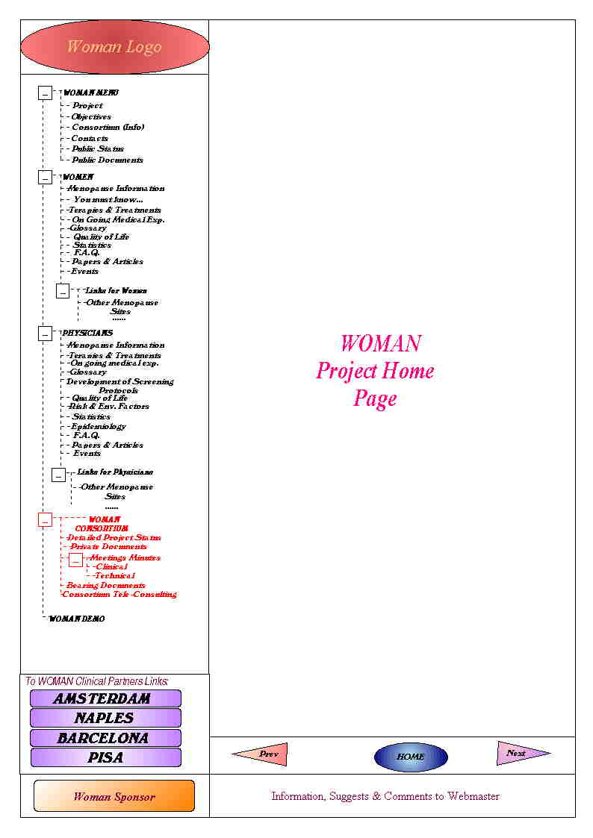
* The red tree-menus parts refer to private transactions, using login and password, accessible only to WOMAN Consortium Partners.
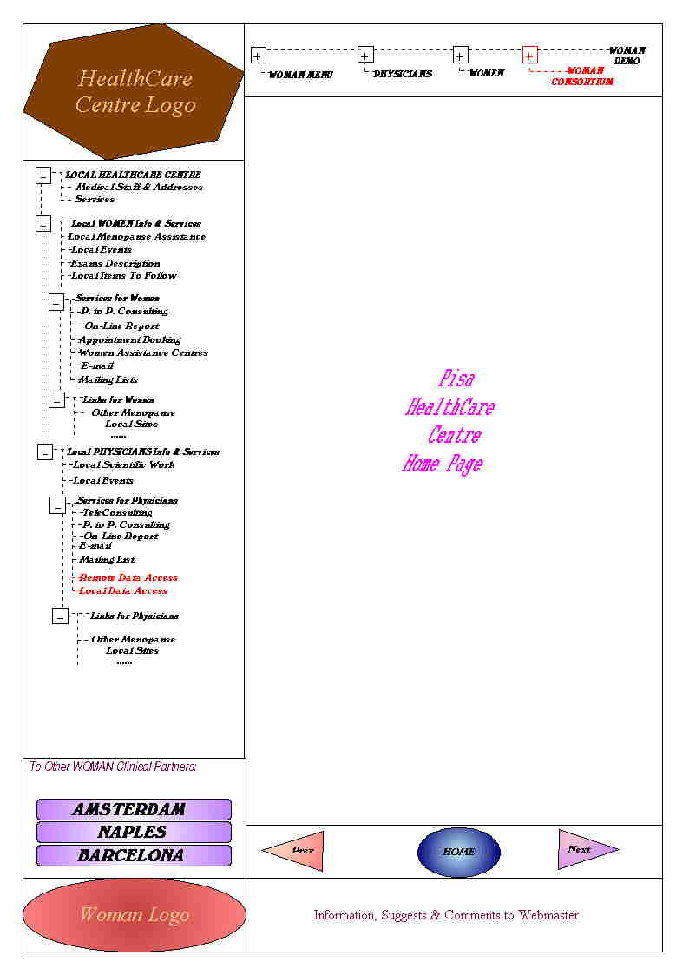
* The red tree-menus parts refer to private transactions, using login and password, accessible only to WOMAN Consortium Partners.

WOMAN DB (WP3 – T3.2)

One of the major issues of the WOMAN project is the design and development of an intelligent digital clinical file. The clinical file will be stored in a digital archive or database to allow the end-user (physician, nurse) to insert, modify, select and execute queries to manage the menopause information.
Each Clinic involved in the project will be provided of a private database to store information about their patients.

The schema of the database is based on the paper clinical file provided by the clinicians group and is designed with a relational paradigm. Other aspects concerning the management of the entire system and its security is analysed and implemented.

We have taken care of designing a DB architecture and the detail of field in order to let the schema to be created in a general DB environment (Oracle, SQL-Server, Informix, ... ) using SQL standard-types.

Some information will be decoded with dedicated tables to allow the insertion of homogeneous data in every DB, with the feature of decoding the information used in the digital clinical file in English or in the National Language.
The detailed description of the tables can be found in the Annex B of this deliverable.

Database Architecture

The DB schema is showed in picture I. We can observe the tables involved in the database and the relations linking the tables.
Some tables are clinical relevant and other are dedicated to the management of the system.
Tables related to the patient visit event, including the personal data, the visit data and the anamnestic historical data build the digital clinical file. The other tables are useful to decode information, for example the exam coding or the symptoms coding, or to grant the security level in accessing the DB, for example the user table and the functional profile table.

Centres

Each Centre is stored in every DB with the information related. The address, the contact person, the e-mail address and the connection string to the local DB. The connection string, obviously coded in a secure way, allow the remote access to a DB of another Clinic.
The Identification Code of Centres is unique in the distributed system and is used to identify not only the Centre but also the information stored in each local DB. This kind of data identification will be useful when the data will be crossed and retrieved in a horizontal way to perform statistics or epidemiological studies.

Exams

After a deep analysis of exam-types we have extrapolate a general method to define the exam object in the WOMAN clinical file. Each exam could be associated to an exam type, for example, exams that admit related images or related movies or a numeric value or just a note. The type of exam note to the system the way to manage the exam.
So that, to give a flexible mechanism and the future possibility of admit other type of tests in addition to the set analysed, the DB is equipped with a table dedicated to decode the exams-types and related features. In this way the system will know how to manage the type of exams. For example, an exam that have related images will be associated to a patient and linked with external image files while another exam will be related with just numeric values and will be elaborated in another way.
In the future will be possible to define a new exam of a known type or a new category of exams, with their features and management methods.

Codes homogeneity

Some of the information that could be stored in a clinical file is coded. This choice has been made not only to solve the Multilanguage problems but also to build a homogeneous layer of data. The unique representation of data will be the base to perform interesting DB queries, useful from an epidemiological point of view, to detect undiscovered relations from the big amount of data stored in the distributed databases.

Security

In addition of granting secure access to the database, provided to the DB environment locally adopted, the system is equipped with functions that intercept every DB interaction and store it in a log file specifying the user, the operation and data managed. Periodically will be possible to print or save in an external storage support a journal of the operation performed.
The secure user-access to the system is provided also with the possibility of associate a functional profile to each user, to select the operations that he will perform on his local DB.
One of the major features of the Woman System is the powerful tool of the remote consultation that will be adopted to the physician to let another European colleague to express a personal diagnosis about a single patient. To do that the system is equipped with a double check. The first one is the assignment of a user-id and a user-profile to the remote user. This operation will be performed from the Local DB Administrator only. The second check level is the unlocking of the clinical file to be analysed in a remote way. The unlocking operation will be done from the physician on the local clinical file to be shared. Obviously the profile released to the remote-user will allow just the access to clinical data, leaving the personal data not sharable. The only information to identify the patient will be the identification code. This security feature reduces the error level of wrongly identifying the remote patient typing another identification code.

Multilanguage

This aspect is managed by XN/II-code at GUI level, and inside the database at data level. Each information coded at DB level is described with a double description, one expressed in English language and one related to the National language. The user, at the beginning of his operating session could decide which kind of language will be used. Obviously, the remote access, performed generally from a physician will be done using English terms.

Structural View: Class & Object Diagrams (WP3 – T3.2)

Func
-ID_Function
+newFunc( )
+description( ) : string

Profile
-ID_Profile
-ID_Function
+newProfile( )
+updateProfile( )

User
ID_User
ID_Profile
newUser( )
updateUser( )
deleteUser( )

1..1
0..N
profileFunction
1..N
0..N
userProfile

Prog
-ID_Prog
+updateProg( )
+readProg( ) : number

Dec_Scale
-Desc_Scale
+updateScale
+readMin( ) : int
+readMax( ) : int

Pers
-ID_Center
-ID_Patient
-Cod_Degree
-Cod_Occupation
-Cod_Status
+newPatient( )
+updatePatient( )
+readPatient( )
+isBlocked() : boolean

Visit
-ID_Center
-ID_Patient
-ID_Visit
-Cod_Contr_H
-Cod_Contr_NH
-Cod_Diagnosis
-Cod_Therapy
+newVisit( )
+updateVisit( )
+readVisit( )

Symp
-ID_Center
-ID_Patient
-ID_Visit
-Cod_Score
-Cod_Symptom
+newSymptom( )
+updateSymptom( )
+readSymptom( )
+totGreenScaleScore( )

Urog
-ID_Center
-ID_Visit
+newUrog( )
+updateUrog( )
+readUrog( )

Exam
-ID_Center
-ID_Visit
-ID_Exam
-ID_Patient
-Cod_Exam
+newExam( )
+updateExam( )
+readExam( )

Ext_Files
-ID_Center
-ID_Exam
+newExFile( )
+updateExFile( )
+readExFile( )

Perhi
-ID_Center
-ID_Patient
-Cod_Alcohol
-Cod_Coffee
-Cod_Pill
-Cod_Menopause
+newPerhi( )
+readPerhi( )

Famhi
-ID_Center
-ID_Patient
+newFamhi ( )
+updateFamhi( )
+readFamhi( )

Center
-ID_Center
+newCenter ( )
+updateCenter( )
+readCenter( )

1..1
0..N
1..1
0..N
1..1
0..N
1..1
0..1
1..1
0..N
1..1
0..N
1..1
0..1
0..N
1..1
greenScaleSymptom
urolgenitalComplaints
externalFile
exam
personalHistory
familyHistory
medicalCenter
patientVisit

Visit
ID_Center
ID_Patient
ID_Visit
Cod_Contr_H
Cod_Contr_NH
Cod_Diagnosis
Cod_Therapy
newVisit( )
updateVisit( )
readVisit( )

Dec_Thr
-Cod_Therapy
+description() : string
+update( )

Dec_Dia
-Cod_Diagnosis
+description() : string
+update( )

Dec_Cnh
-Cod_Contr_NH
+description() : string
+update( )

Dec_Ch
-Cod_Contr_H
+description() : string
+update( )

0..N
0..1
0..N
0..1
0..1
0..1
0..N
0..N
decodeDiagnosis
decodeTherapy
decodeHormonalContaception
decodeNonHormonalContaception

Pers
ID_Center
ID_Patient
Cod_Degree
Cod_Occupation
Cod_Status
+newPatient( )
+updatePatient( )
+readPatient( )
+isBlocked() : boolean

Dec_Sco
-Cod_Score
+description() : string
+update( )

Perhi
ID_Center
ID_Patient
Cod_Alcohol
Cod_Coffee
Cod_Pill
Cod_Menopause
+newPerhi( )
+readPerhi( )

Dec_Men
-Cod_Menopause
+description() : string
+update( )

Dec_Sta
-Cod_Status
+description() : string
+update( )

Dec_Occ
-Cod_Occupation
+description() : string
+update( )

Dec_Deg
-Cod_Degree
+description() : string
+update( )

0..N
0..1
0..N
0..1
0..N
0..1
0..N
0..N
0..1
0..1
decodeScore
decodeMenopause
decodeStatus
decodeDegree
decodeOccupation

Pers
ID_Center
ID_Patient
Cod_Degree
Cod_Occupation
Cod_Status
+newPatient( )
+updatePatient( )
+readPatient( )
+isBlocked() : boolean

Dec_Sco
-Cod_Score
+description() : string
+update( )

Perhi
ID_Center
ID_Patient
Cod_Alcohol
Cod_Coffee
Cod_Pill
Cod_Menopause
+newPerhi( )
+readPerhi( )

Dec_Men
-Cod_Menopause
+description() : string
+update( )

Dec_Sta
-Cod_Status
+description() : string
+update( )

Dec_Occ
-Cod_Occupation
+description() : string
+update( )

Dec_Deg
-Cod_Degree
+description() : string
+update( )

0..N
0..1
0..N
0..1
0..N
0..1
0..N
0..N
0..1
0..1
decodeScore
decodeMenopause
decodeStatus
decodeDegree
decodeOccupation

Symp
-ID_Center
-ID_Patient
-ID_Visit
-Cod_Score
-Cod_Symptom
+newSymptom( )
+updateSymptom( )
+readSymptom( )
+totGreenScaleScore( )

Exam
-ID_Center
-ID_Visit
-ID_Exam
-ID_Patient
-Cod_Exam
+newExam( )
+updateExam()
+readExam( )

Dec_Exam
-Cod_Exam
-Cod_Exam_Type
+description() : string
+update( )

Dec_Exty
-Cod_Exam_Type
+description() : string
+update( )

Dec_Symp
-Cod_Symptom
+description( ) : string
+update( )

Dec_Sco
-Cod_Score
+description() : string
+update( )

1..1
0..N
1..1
0..N
1..1
0..N
0..N
0..1
decodeScore
decodeSymptom
decodeExam
decodeExamType

ANNEX A

Acronyms

A2.1 WOMAN partner associated at the Computer Science Dept. (C2):
Synapsis srl
ACI Availability, Confidentiality, Integrity
AHC ActiveX for HealthCare
API Application Programming Interface
ASP Active Server Pages
ASTM Association for Standards in Testing and Materials
AWG Andover Working Group
C1 WOMAN partner: “Dipartimento di Medicina della Procreazione e
dell’Età Evolutiva”, University of Pisa
C2 WOMAN partner: Computer Science Dept., University of Pisa
C3 WOMAN partner: “Department of Obstetrics and Gynaecology”,
Free University of Amsterdam
C4 WOMAN partner: “Istituto di Ginecologia Ostetrica e Fisiopatologia
della Riproduzione Umana”, University of Naples “Federico II”
C5 WOMAN partner: “Fundacio Santiago Dexeus Font”,
Autonomous University of Barcelona
CCOW Clinical Context Object Working Group
CEN/TC Comite Europeen de Normalisation/Technical Commitee
CGI Common Gateway Interface
CNS Central Nervous System
COAS Clinical Observation Access Service
COM Component Object Model
CORBA Common Object Request Broker Architecture
CORBAMed Common Object Request Broker Architecture in Medicine
CSS Cascading Style Sheets
CVD CardioVascular Diseases
DB DataBase
DBMS DataBase Management System
DCE Distributed Computing Environment
DCOM Distributed Component Object Model
DHTML Dynamic Hypertext Mark-up Language
DICOM Digital Imaging and Communication in Medicine
DOM Document Object Model
ECG ElectroCardioGram
FAQ Frequently Asked Questions
FTP File Transfer Protocol
GU GenitoUrinary
HL7 Health Level 7
HTML Hypertext Mark-up Language
HTTP HyperText Transfer Protocol
HW HardWare
IDL Interface Definition Language
IETF Internet Engineering Task Force
IIOP Internet Inter-ORB Protocol
IIS Internet Information Server
INFOSEC INFOrmation SECurity (European Project)
ISAPI Internet Server Application Programming Interface
ISHTAR Implementing Secure Healthcare Telematics Applications in euRope
(European Project)
ISO International Standards Organisation
ISO/OSI International Standards Organisation/Open Systems Interconnection
IT Information Technology
JDBC Java DataBase Connectivity
JSP Java Server Pages
JVM Java Virtual Machine
LAN Local Area Network
MARGOT Medical Archive Generation with Object-Oriented Techniques
(European Project)
MEDIREC Electronic Medical Record (European Project)
MEDSEC HealthCare Security and Privacy in the Information Society (European
Project)
MOM Message Oriented Middle-ware
MS MicroSoft
OA Object Adapter
OLE Object Linking and Embedding
OMA Object Management Architecture
OMG Object Management Group
OO Object Oriented
ORB Object Request Broker
R&D Research & Development
RPC Remote Procedure Call
SEMRIC SEcure Medical Record Information Communication (European Project)
SGML Standard Generalised Mark-up Language
SIREN SecurIty in REgional Networks (European Project)
SQL Simple Query Language
SSL Secure Socket Layer
SW SoftWare
TCP/IP Transfer Control Protocol/Internet Protocol
TLS Transport Layer Security
TRUSTHEALTH TRUSTworthy HEALTH telematics (European Project)
UDP User Datagram Protocol
UML Unified Modelling Language
UNI ente Nazionale Italiano di Unificazione (Italian National Standards
Body)
W3C World Wide Web Consortium
WG Working Group
WP Work Package
XML eXtensible Mark-up Language

ANNEX B

Version: 02
Type: I (Informal) Internal Report: WOMAN1-98
Class: R (Restricted) Title: Functional specification model, defining Woman demonstrator architectures

Status: Released WP: N. 3.
Pages: 11 Title: -- Definition of functional specifications

WOMAN – Intelligent Telematic Services for Women Care by European Network

Project number: HC 4026

Responsible partner: Dipartimento di Informatica (DIUNIPI)
Authors:
Antonina Starita (DIUNIPI)
Darya Majidi (SYNAP)
Riccardo Fontanelli (SYNAP)
Elena Palanca (DIUNIPI)
Katuscia Cerbioni (DIUNIPI)

Edited by:
Elena Palanca (DIUNIPI)
Katuscia Cerbioni (DIUNIPI)
Riccardo Fontanelli (SYNAP)

Release authorised by (requested for type F and class C documents):

Project Coordinator: Scientific Project Coordinator:
Prof. A. R. Genazzani Prof. Antonina Starita

Project Title: Intelligent Telematic Services for Women Care by European Network

Intelligent Telematic Services for Women Care by European Network

Functional specification model, defining Woman demonstrator architectures
Preliminary Document - Version 2.0

Standard checklist
Date: July 29th , 1998

Partner Code: C4
Name of Institution/Organisation: Universitá di Napoli “Federico II”
Department: Ginecologia Ostetrica e Fisiopatologia della Riproduzione Umana
Address: Corso Umberto I – 80100 Napoli
Contact Person: MD C. Di Carlo, MD G. Moccia

Meeting Layout

The meeting between the 'Istituto di Ginecologia Ostetrica e Fisiopatologia della Riproduzione Umana', Universitá di Napoli "Federico II" and a project technical team has been established in order to single out the existing resources of the healthcare centre, the linked Functional Units (out-patients departments) and the peripheral healthcare centres, with the aim of evaluating their usefulness in the framework
of the WOMAN project and guaranteeing a full site interoperability.
To support this activity and accurately report collected information, it has been developed a standard top-down structure analysis model of the healthcare centre, fulfilled with the collaboration of both MD C. Di Carlo and MD G. Moccia.
Starting from a global view of the Institute, it has been identified (for each identified Functional Unit):
-Available hardware/software resources
-Existing communication links
-Provided services
Moreover, existing and innovative services to be provided to selected users have been identified.
The schedule of the visit has been the following:
* * The technical team visited the primary healthcare centre:
- Ecography
- Colposcopy
Currently, telematic communication links among the visited outpatients departments (LAN) and database information sources useful for the project aims are not at disposal.
** The 'Centro di Servizi Didattico Scientifico' (CDS), i.e. the 'Federico II' Internet provider, has been visited in order to evaluate the on-site networking infrastructure and the availability of existing database servers. A dB server for the project aims must be built in the near future.
** User needs and user requirements issues have been discussed with clinicians, focusing the attention on services and functionality likely to be implemented and/or improved.
** At last, administrative issues have been briefly discussed.

All the collected information has been formalised in this report.

General Info

Relations:
No communication links between the Functional Units reported in the ‘Environment’ section
Dialing-Up connections between the Dept. and CDS are currently active

Name of Institute/
Organisation:
Università di Napoli "Federico II"

Department:
Istituto di Ginecologia
Ostetrica e
Fisiopatologia della
Riproduzione Umana

Environment:
FUNCTIONAL UNITS:
GROUND FLOOR
Demonstration Room
Colposcopy
1st FLOOR
Ecography
Disteroscopy
Other Out-Patient Departments
Observations:
CURRENT DEPENDENCIES:
Administrative: ‘Istituto di Ginecologia Ostetrica e Fisiopatologia della Riproduzione Umana’
Treatment: ‘Azienda Universitaria Policlinico’
Technical: CDS
FUTURE DEPENDENCIES:
Start-up of the ‘Dipartimento Universitario di Ginecologia e Ostetricia’, October 1998.

Hardware Description

Relations:
No LAN currently installed
The Pentium II is connected to Internet with a standard PSTN connection
✓ |  | PC
 |  | Videoconferencing Tools
 |  | Router
 |  | Bridge
 |  | Firewall/Proxy
 |  | Hub
✓  Modem 56K US Robotics |  | Others:

Environment:
DEMONSTRATION ROOM
Observations:
ACTUAL RESOURCES:
N. 1 computer Pentium II MMX
N. 2 computer 486
PROPOSED RESOURCES:
N. 2 computers Pentium II MMX or higher.
ISDN connection between Pentium and CDS, used also with videoconference tool (see also the ‘Communication Infrastructure’ section)
LAN (see also the ‘Communication Infrastructure’ section)
Videoconferencing Tool (Intel ProShare)

Hardware Description

Relations:
The computer is connected to Internet with a standard PSTN connection
✓ |  | PC
 |  | Videoconferencing Tools
 |  | Router
 |  | Bridge
 |  | Firewall/Proxy
 |  | Hub
✓  Modem |  | Others:

Environment:
Ecography: OutPatient Department
Observations:
N. 1 computer Pentium 100MHz, 32 Mb RAM

Software Description

Internet Services:
Operating Systems:

✓ |  | MS-DOS |  |  |  | WEB:
✓ |  | Windows 95/98 |  |  |  |  |  |  | IIS
 |  | Windows NT |  |  |  |  |  |  | Apache
 |  | UNIX |  |  |  |  |  |  | XS
 |  | LINUX |  |  |  |  |  |  | Others:
 |  | Others: |  |  |  | FTP
 |  |  |  |  |  | NTTP
 |  |  |  | ✓ |  | Intranet
 |  |  |  |  |  | Others:

Additional Software Package:

Environment:
Demonstration Room
Ecography

 |  | RDBMS
✓ |  | Office 97
✓ |  | Netscape/Explorer
✓ |  | Others:
- Hospital Admission file
- Icarus project
Observations:

Communication Infrastructure

Operating Systems:

Relations:
- N. 2 Dialing-up connections between the Dept. And CDS are currently active
 |  | LAN
 |  |  |  |  | Ethernet
 |  |  |  |  | Token Ring
 |  |  |  |  | Others:
 |  | CDN
 |  | ISDN-2
✓ |  | Others:
Dial-up

Observations:

PROPOSED CONNECTION:
See sections ‘Proposed Configuration’ for additional information

Service Description

Proposals of Services to be implemented:
- Clinical files
- Clinical devices supporting interfaces to digital and analogic (video-cameras,…)
Existing Services:
Actors and Roles:
Available Resources:
*Currently provided healthcare services:
- Medical examination
- Clinical tests:
Densitometry
Colposcopy
Breast Examination
Pap-Test
Disteroscopy
Gynaecologic examination
…
- Treatment definition
- Patient health status monitoring
- Information Services for specialising physicians
- Information Services for general practitioners (GPs)
- Videoconferencing meeting among experts and women for dissemination purpose
- Design and development of a clinical file in the post-menopause field
- Definition and implementation of a medical report for women and GPs
- Exchange information service for data sharing among different out-patient departments
- Data processing application for statistical purpose
- Specialists
- Specialising physicians
- Healthcare operators
- End Users (women)

Version: 02
Type: I (Informal) Internal Report: WOMAN1-98
Class: R (Restricted) Title: Functional specification model, defining Woman demonstrator architectures

Status: Released WP: N. 3.
Pages: 11 Title: -- Definition of functional specifications

WOMAN – Intelligent Telematic Services for Women Care by European Network

Project number: HC 4026

Responsible partner: Dipartimento di Informatica (DIUNIPI)
Authors:
Antonina Starita (DIUNIPI)
Darya Majidi (SYNAP)
Riccardo Fontanelli (SYNAP)
Elena Palanca (DIUNIPI)
Katuscia Cerbioni (DIUNIPI)

Edited by:
Elena Palanca (DIUNIPI)
Katuscia Cerbioni (DIUNIPI)
Riccardo Fontanelli (SYNAP)

Release authorised by (requested for type F and class C documents):

Project Coordinator: Scientific Project Coordinator:
Prof. A. R. Genazzani Prof. Antonina Starita

Project Title: Intelligent Telematic Services for Women Care by European Network

Intelligent Telematic Services for Women Care by European Network

Functional specification model, defining Woman demonstrator architectures
Preliminary Document - Version 2.0

Standard checklist
Date: September 9th , 1998

Partner Code: C1
Name of Institution/Organisation: Università di Pisa
Department: Dip. Di Medicina della Procreazione e dell’Età Evolutiva
Address: Via Roma, 67 – Pisa
Contact Person: MD M. Gambacciani

Meeting Layout

The schedule of the visit has been the following:
**The technical team visited the primary healthcare centre with the collaboration of MD M. Gambacciani.
- A potential room to be used as a demonstration point has been identified.
- All the out-patient departments of the “Dip. di Medicina della Procreazione e dell’Età Evolutiva” have been visited. Telematic communication links between these units are not at disposal, while some database information sources useful for the project aims have been identified.
**The Radiology Department (Branch building) has been visited with the collaboration of DR. Dell’Osso, and the currently and future networking infrastructure of the healthcare centre has been individuated.
The healthcare centre is involved in the “Campus” project for the physical net wiring.
Currently, some departments, as Radiology, have been already connected with Optic Fibres, while the “Dip. di Medicina della Procreazione e dell’Età Evolutiva” is waiting for this connection. To accelerate the connection process, the Project Co-ordinator should directly contact Ing. Pugi and Geom. Ribaldi.
**User needs and user requirements issues have been discussed with MD M. Ciaponi and MD B. Cappagli focusing the attention on services and functionality likely to be implemented and/or improved.
At last, administrative issues have been briefly discussed.

All the collected information has been formalised in this report.

General Info

Relations:
No communication links between the Functional Units reported in the ‘Environment’ section.
Name of Institute/
Organisation:
Università di Pisa

Department:
Dipartimento di Medicina della Procreazione e dell’Età Evolutiva.

Environment:
FUNCTIONAL UNIT:
GROUND FLOOR
Demonstration Room
OUT-PATIENT DEPARTMENTS
Ecography
Generic Room
Gynaecologic Eco
Densitometry
Isteroscopy
Gynaecology
Ultrasound Densitometry
Colposcopy
BRANCH BUILDING
Radiology
Observations:
All the ground floor is endowed with channels to permit the cables’ passage.
Mostly OutPatient Departments have net attach.
The Department is involved in the “Campus” project regarding the physical wiring of the net.
An optic fibre connection between Radiology and Internet is currently active.

Hardware Description

Relations:
PC
Videoconferencing Tools
Router
Bridge
Firewall/Proxy
Hub
Others:

Environment:
DEMONSTRATION ROOM
Observations:
ACTUAL RESOURCES:
None
PROPOSED RESOURCES:
N. 2 computers Pentium II MMX or higher
ISDN connection used for videoconference tool and other purposes
CDN connection between Pentium and server located at the Orthopaedic Department
LAN
Videoconferencing tool (Intel ProShare)

Hardware Description

Relations:
A net attach is available in the room
The computer is not connected to Internet.
✓ |  | PC
 |  | Videoconferencing Tools
 |  | Router
 |  | Bridge
 |  | Firewall/Proxy
 |  | Hub
 |  | Others:

Environment:
Isteroscopy
Observations:
N. 1 computer 486

Hardware Description

Relations:
The attach is not available in the room
✓ |  | PC
 |  | Videoconferencing Tools
 |  | Router
 |  | Bridge
 |  | Firewall/Proxy
 |  | Hub
 |  | Others:

Environment:
Ultrasound Densitometry
Observations:
N. 2 computer 486
The computers a currently connected to 2 Densitometric devices
The Densitometric results are stored in a Database and subsequently printed and delivered to Women.

Hardware Description

Relations:
An optic fibre connection is currently active (through the switchboard)
✓ |  | PC
✓ |  | Videoconferencing Tools
✓ |  | Router
 |  | Bridge
 |  | Firewall/Proxy
 |  | Hub
 |  | Others:

Environment:
Radiology
Observations:
All the functional units within Radiology are connected but not all shares resources
Acquisition and exchange images are available
A digital scanner is available (DICOM format)
The Department is involved in the “Telemed 3” project (videoconferencing end-to-end system to share images and teleconsulting)
The Department is involved in the “Campus” project for the net wiring in all Departments of the Healthcare centre

Software Description

Internet Services:
Operating Systems:

✓ |  | MS-DOS |  |  |  | WEB:
✓ |  | Windows 95/98 |  |  |  |  |  |  | IIS
 |  | Windows NT |  |  |  |  |  |  | Apache
 |  | UNIX |  |  |  |  |  |  | XS
 |  | LINUX |  |  |  |  |  |  | Others:
 |  | Others: |  |  |  | FTP
 |  |  |  |  |  | NTTP
 |  |  |  |  |  | Intranet
 |  |  |  |  |  | Others:

Additional Software Package:

Environment:
Isteroscopy
Ultrasound Densitometry

- Icarus Project
✓ |  | RDBMS
✓ |  | Office 97
 |  | Netscape/Explorer
✓ |  | Others:

Observations:
A Database storing Ultrasound Densitometric results is available

Software Description

Operating Systems:

Internet Services:
✓ |  | MS-DOS |  |  |  | WEB:
✓ |  | Windows 95/98 |  |  |  |  |  |  | IIS
✓ |  | Windows NT |  |  |  |  |  |  | Apache
 |  | UNIX |  |  |  |  |  |  | XS
 |  | LINUX |  |  |  |  |  |  | Others:
 |  | Others: |  | ✓ |  | FTP
 |  |  |  |  |  | NTTP
 |  |  |  |  |  | Intranet
 |  |  |  |  |  | Others:

Environment:
Radiology
Additional Software Package:

✓ |  | RDBMS
✓  Observations:  *The interesting processable images are:  Mammography (not digitised)  Radiography (not digitised)  TAC (digitised)  Ecography (digitised in Genesis format and convertible in DICOM 3.0 + JPG conversion method)  *The ‘Woman’ Web server could be placed in Radiology, till the networking wiring will not be done al the “Dip. della Procreazione e dell’Età Evolutiva” |  | Office 97
✓ |  | Netscape/Explorer
✓ |  | Others:
- An SQL ’91 (updated to 1997) application for the administrative data management and medical reports (O.S.: MS-DOS)
- Each unit has its own DB
- The Web Server is located in Cisanello (O.S.: Solaris 2.5)
- Videoconferencing tool (point-to-point, for sharing and exchanging images and for teleconsulting

Service Description

Existing Services:
Proposals of Services to be implemented:
Actors and Roles:
Available Resources:
*Currently provided healthcare services:
- Medical examination
- Clinical tests:
Ecography
Gynaecologic Ecography
Densitometry
Ultrasound Densitometry
Isterosocpy
Gynaecology
Colposocpy
- Treatment definition
- Patient health status monitoring
- Medical Visit reservation with computer
- Women Information System regarding procedures to follow to do medical visit
- Possibility for women to book all the medical examination in the same day saving time and money
- Possibility for women to consult the web page FAQ to find answers to some routine problems
- Exchange information service for data-sharing among different out-patient departments
- Data processing application for statistical purposes
- Specialists
- Specialising physicians
- Healthcare operators
- End Users (women)
- Clinical files
- Clinical devices supporting interfaces to digital and analogic (video-cameras,…)

Version: 02
Type: I (Informal) Internal Report: WOMAN1-98
Class: R (Restricted) Title: Functional specification model, defining Woman demonstrator architectures

Status: Released WP: N. 3.
Pages: 11 Title: -- Definition of functional specifications

WOMAN – Intelligent Telematic Services for Women Care by European Network

Project number: HC 4026

Responsible partner: Dipartimento di Informatica (DIUNIPI)
Authors:
Antonina Starita (DIUNIPI)
Darya Majidi (SYNAP)
Riccardo Fontanelli (SYNAP)
Elena Palanca (DIUNIPI)
Katuscia Cerbioni (DIUNIPI)

Edited by:
Elena Palanca (DIUNIPI)
Katuscia Cerbioni (DIUNIPI)
Riccardo Fontanelli (SYNAP)

Release authorised by (requested for type F and class C documents):

Project Coordinator: Scientific Project Coordinator:
Prof. A. R. Genazzani Prof. Antonina Starita

Project Title: Intelligent Telematic Services for Women Care by European Network

Intelligent Telematic Services for Women Care by European Network

Functional specification model, defining Woman demonstrator architectures
Preliminary Document - Version 2.0

Standard checklist
Date: September 17th , 1998

Partner Code: C3
Name of Institution/Organisation: Academisch Ziekenhuis Vrije Universiteit
Department: Obstetrics and Gynaecology (Verloskunde en Gynaecologie)
Address: De Boelelaan 1117, P.O. Box 7057, 1007 MB Amsterdam,
The Nederlands
Contact Person: Prof. Dr. P. Kenemans, Dr. M. J. Van der Mooren

Meeting Layout

The meeting between the “Department of Obstetrics and Gynaecology”, Academisch Ziekenhuis Vrije Universiteit and a project technical team has been established in order to single out the existing resources of the healthcare centre, the linked Functional Units (out-patient departments) and the peripheral healthcare centres, with the aim of evaluating their usefulness in the framework of the WOMAN project and guaranteeing a full site interoperability.
To support this activity and accurately report collected information, it has been developed a standard top-down structure analysis model of the healthcare centre, fulfilled with the collaboration of Prof. Dr. P. Kenemans, Dr. M. J. Van der Mooren, Dr. J. W. Van der Slikke, Dr. R. Barensten, Ir. G. J. Colenbrander, Mr. R. Garrelts.
Starting from a global view of the Department, it has been identified (for each identified Functional Unit):
- Available hardware/software resources;
- Existing communication links
- Provided services.
Moreover, existing and innovative services to be provided to selected users have been identified.
The schedule of the visit has been the following:
**A Power Point presentation about the on-site networking infrastructure, the availability of existing database servers, and the hardware and software equipment and the services that will be developed in the Department has been done from Ir. G. J. Colenbrander.
**A Power Point presentation on the services available on the Intranet, the ones available on the Internet and of the web site www.obgyn.net has been done from Dr. R. Barensten.
**The technical team visited the whole healthcare centre:
a potential room to be used as Demonstration Point has not been identified. Moreover, the following outpatient departments have been visited:
- Colposcopy.
Currently, telematic communication links among the visited outpatient departments (LAN) and database information sources useful for the project aims are available.
**The office of Dr. J. W. Van der Slikke has been visited in order to evaluate the availability of existing databases for lab reservation and for Electronic Healthcare Patient Record evaluation.
**User needs and user requirements issues have been discussed with clinicians, focusing the attention on services and functionality likely to be implemented and/or improved.
**At last, administrative issues have been briefly discussed.

All the collected information has been formalised in this report.

General Info

Department:
Obstetrics and Gynaecology (Verloskunde en Gynaecologie)
Relations:
Communication links among the Functional Units reported in the ‘Environment’ section are active
All computers are connected via optic fibres (the connection is among computers and between computers and D.P.C.)

Name of Institute/
Organisation:
Academisch Ziekenhuis Vrije Universiteit

Environment:
FUNCTIONAL UNITS:
Demonstration Room (not individuated yet)
OUT-PATIENT DEPARTMENTS
Ecography
Colposcopy
Disteroscopy
Densitometry
Isteroscopy
Gynaecology
Ultrasound Densitometry
Other Out-patient Departments
Observations:
CURRENT DEPENDENCIES:
*Dept. of Clinical Physics:
The head of the dept. is composed of:
Clinical physics
Head E. & S.
The last one is composed of:
Engineering
Support

Hardware Description

Relations:
An Intranet is currently under installation
PCs are interconnected via ISDN connection
PCs are connected to Internet via optic fibres
Every out-patient department has 2 PCs: one connected to the Intranet (and Internet) ant the other connected to the medical device present in that room
Every office has a PC connected to the Intranet (and Internet)
✓ |  | PC
 |  | Videoconferencing Tools
 |  | Router
 |  | Bridge
✓ |  | Firewall/Proxy
 |  | Hub
✓  Optic fibres |  | Others:

Environment:
HEALTHCARE CENTRE:
OUT-PATIENT DEPARTMENTS
[Colposcopy (as example)]
DOCTOR OFFICES
Observations:
ACTUAL RESOURCES:
N. 500 computers (of various types)
ISDN-2 connections are available
PROPOSED RESOURCES:
Videoconferencing Tool (Intel ProShare)

Hardware Description

Relations:
PC
Videoconferencing Tools
Router
Bridge
Firewall/Proxy
Hub
Others:

Environment:
DEMONSTRATION ROOM
Observations:
The demonstration room has not been individuated yet.

Software Description

Internet Services:
Operating Systems:

✓ |  | MS-DOS |  | ✓ |  | WEB:
✓ |  | Windows 95/98 |  |  |  |  | ✓ |  | IIS
✓ |  | Windows NT |  |  |  |  |  |  | Apache
 |  | UNIX |  |  |  |  |  |  | XS
 |  | LINUX |  |  |  |  |  |  | Others:
 |  | Others: |  | ✓ |  | FTP
 |  |  |  |  |  | NTTP
 |  |  |  | ✓ |  | Intranet
 |  |  |  |  |  | Others:

Additional Software Package:

Environment:
HEALTHCARE CENTRE

✓ |  | RDBMS
✓ |  | Office 97
✓ |  | Netscape/Explorer
✓ |  | Others:
- Metaphase (to manage processes)
- CLIMBER: Image Management System
- Radworks Viewer (Applicare)
- Webviewer (Applicare)
- Electronic Healthcare Patient Record (VUgyn)
Observations:
Web presentation at an Intranet level of the hospital and services for all employees (at a different access priority). In the future will be available on Internet
Format of images exchanged with CLIMBER: .jpg, .tif,…

Communication Infrastructure

Operating Systems:

Relations:
- N. __ ISDN connections among __________ are currently active
- Optic fibres connections to exchange images are currently active
 |  | LAN
 |  |  |  |  | Ethernet
 |  |  |  |  | Token Ring
 |  |  |  |  | Others:
 |  | CDN
✓ |  | ISDN-2
 |  | Others:

Observations:

- The Hospital is involved in the project “European HRT Network”: aim of the project is to build an Intranet on Internet connecting 35 Dutch Hospitals
FUTURE NETWORK DEVELOPMENTS:
- All the Departments will be connected
- Every clinic will be able to share exams with other clinics (‘Exchange information service for data sharing among different clinics’)

Service Description

Existing Services:
Proposals of Services to be implemented:
Actors and Roles:
Available Resources:
*Currently provided healthcare services:
- Medical examination
- Clinical tests:
Densitometry
Colposcopy
Breast Examination
Pap-Test
Disteroscopy
Gynaecologic examination
…
- Treatment definition
- Patient health status monitoring
- Electronic Healthcare Patient Record
- Electronic Clinical Reservation of an out-patient room to perform exams
- Internet information services
- Information Services for specialising physicians
- Information Services for general practitioners (GPs)
- Videoconferencing meeting among experts and women for dissemination purpose
- Definition and implementation of a medical report for women and GPs
- Digitalisation of:
Mammography
Endometrial Ultrasound
Microscopical images
- Implementation of a tool able to compare and modify clinical images
- Data processing application for statistical purpose
- Specialists
- Specialising physicians
- Healthcare operators
- End Users (women)
- Electronic Clinical files
- Clinical devices supporting interfaces to digital and analogic (video-cameras,…)
- See ‘Software Description’ section

Version: 02
Type: I (Informal) Internal Report: WOMAN1-98
Class: R (Restricted) Title: Functional specification model, defining Woman demonstrator architectures

Status: Released WP: N. 3.
Pages: 11 Title: -- Definition of functional specifications

WOMAN – Intelligent Telematic Services for Women Care by European Network

Project number: HC 4026

Responsible partner: Dipartimento di Informatica (DIUNIPI)
Authors:
Antonina Starita (DIUNIPI)
Darya Majidi (SYNAP)
Riccardo Fontanelli (SYNAP)
Elena Palanca (DIUNIPI)
Katuscia Cerbioni (DIUNIPI)

Edited by:
Elena Palanca (DIUNIPI)
Katuscia Cerbioni (DIUNIPI)
Riccardo Fontanelli (SYNAP)

Release authorised by (requested for type F and class C documents):

Project Coordinator: Scientific Project Coordinator:
Prof. A. R. Genazzani Prof. Antonina Starita

Project Title: Intelligent Telematic Services for Women Care by European Network

Intelligent Telematic Services for Women Care by European Network

Functional specification model, defining Woman demonstrator architectures
Preliminary Document - Version 2.0

Standard checklist
Date: September 21st , 1998

Partner Code: C5
Name of Institution/Organisation: Fundacio Santiago Dexeus Font/UAB
Department: Obstetrics & Gynaecology
Address: Paseo Bonanova, 67 /08017 Barcelona /SPAIN
Contact Person: Dr. J. C. Suris

Meeting Layout

The meeting between the “Department of Obstetrics and Gynaecology”, Fundacio Santiago Dexeus Font/UAB and a project technical team has been established in order to single out the existing resources of the healthcare centre, the linked Functional Units (out-patient departments) and the peripheral healthcare centres, with the aim of evaluating their usefulness in the framework of the WOMAN project and guaranteeing a full site interoperability.
To support this activity and accurately report collected information, it has been developed a standard top-down structure analysis model of the healthcare centre, fulfilled with the collaboration of Prof. Santiago Dexeus, Prof. Pedro N. Barri, Dr. J. C. Surís, Dr. Xavier Urtubery (new project manager), Mr. Ricard Bernat (Dept. Of Informatics), Mrs. María José Coll (Nurse, Menopause Unit).
Starting from a global view of the Department, it has been identified (for each identified Functional Unit):
- Available hardware/software resources;
- Existing communication links
- Provided services.
Moreover, existing and innovative services to be provided to selected users have been identified.
The schedule of the visit has been the following:
**A presentation about the WOMAN Project has been done from the technical staff.
**A presentation of the other Demonstration Points of the project (C1, C3, C4) has been done from the technical staff.
**The technical team visited the primary healthcare centre:
a potential room to be used as Demonstration Point has been identified. Moreover, the following out-patient departments have been visited:
- Ecography
- Reproductive Medicine
- Colposcopy.
Telematic communication links among the visited outpatient departments (LAN) and database information sources useful for the project aims are currently active.
**User needs and user requirements issues have been discussed with clinicians, focusing the attention on services and functionality likely to be implemented and/or improved.
**At last, administrative issues have been briefly discussed. More in detail:
- VAT
- Videoconferencing (VAT)
- Bimonthly report
- Next meeting in Florence on October the 26th.

All the collected information have been formalised in this report.

General Info

Department:
Obstetrics and Gynaecology
Relations:

Name of Institute/
Organisation:
Fundacio Santiago Dexeus Font/UAB

Environment:
FUNCTIONAL UNITS:
Demonstration Room
OUT-PATIENT DEPARTMENTS
Ecography
Colposcopy
Reproductive Medicine
Other Out-patient Departments
Observations:

Hardware Description

Relations:
PC
Videoconferencing Tools
Router
Bridge
Firewall/Proxy
Hub
Others:

Environment:
DEMONSTRATION ROOM
Observations:
ACTUAL RESOURCES:

PROPOSED RESOURCES:
Videoconferencing Tool (Intel ProShare)

Hardware Description

Relations:
The whole clinic is wired, currently migrating to Fast Ethernet Network.
Potentially, any net point can connect to Internet, through a proxy firewall.
The minimal PC platform is a 486/66 with 16 Mb RAM and 350 Mb HD, migrating to Pentium 266, 32 Mb RAM and 2 GB HD (2 – 3 years).
✓ |  | PC
 |  | Videoconferencing Tools
✓ |  | Router
 |  | Bridge
✓ |  | Firewall/Proxy
✓ |  | Hub
 |  | Others:

Environment:
All exploration rooms have a network connection.
In all doctors’ offices there are net points, but not PCs yet (1 – 2 years).
Observations:

Software Description

Internet Services:
Operating Systems:

✓ |  | MS-DOS |  | ✓ |  | WEB:
✓ |  | Windows 95/98 |  |  |  |  | ✓ |  | IIS
✓ |  | Windows NT |  |  |  |  | ✓ |  | Apache
 |  | UNIX |  |  |  |  |  |  | XS
✓ |  | LINUX |  |  |  |  |  |  | Others:
 |  | Others: |  | ✓ |  | FTP
 |  |  |  | ✓ |  | NTTP
 |  |  |  | ✓ |  | Intranet
 |  |  |  |  |  | Others:

Additional Software Package:

Environment:
HEALTHCARE CENTRE
All medical and administrative platforms are working on Novell NetWare 3.12, and all connection services (Internet and Intranet) are working on Windows NT (Standard Edition/Enterprise Edition).

✓ |  | RDBMS
✓ |  | Office 97
✓ |  | Netscape/Explorer
 |  | Others:

Observations:
NNTP services have been supplied by UAB.
RDBMS service is under implementation, actually out of production

Communication Infrastructure

Operating Systems:

Relations:
See “Environment” in ‘Hardware Description’.
Both networks are connected to the Internet through proxy firewall.
✓ |  | LAN
 |  |  | ✓ |  | Ethernet
 |  |  | ✓ |  | Token Ring
 |  |  |  |  | Others:
 |  | CDN
✓ |  | ISDN-2
 |  | Others:

Observations:

Internet connection through an ISDN-2 line.

Service Description

Existing Services:
Proposals of Services to be implemented:
Actors and Roles:
Available Resources:
- Obstetrics register
- Abortion register
- Gynaecological register
- Oncology register
- FIV register
- Ultrasound register
- Cytology register
- Surgery register

- Specialists
- Specialising physicians
- Healthcare operators
- End Users (women)
- Secretaries that support all registers of the different Units and Committees.
- Electronic Clinical files
- Clinical devices supporting interfaces to digital and analogic (video-cameras,…)
- See ‘Software Description’ section

ANNEX C

Structural View: Class & Object Diagrams

TABLE: PERSONAL DATA

Definition:

FIELD_NAME | TABLE NAME | FIELD TYPE | LENGHT | OBB
ID_Center  | PERS | CHAR | 5 | y
ID_Patient  | PERS | NUMBER | 8 | y
Name | PERS | VARCHAR | 30
Surname | PERS | VARCHAR | 30
Date_Of_Birth | PERS | DATE | 8
Address | PERS | VARCHAR | 50
City | PERS | VARCHAR | 30
Zip_Code | PERS | VARCHAR | 6
Telephone | PERS | VARCHAR | 14
Cod_Degree | PERS | CHAR | 1
Cod_Occupation | PERS | CHAR | 2
Cod_Status | PERS | CHAR | 1
Social_Security_Number | PERS | VARCHAR | 16
General_Practitioner | PERS | VARCHAR | 50
Last_Mod_Date | PERS | DATE | 8
Block | PERS | CHAR | 1

Fields Description:

FIELD NAME | DESCRIPTION
ID_Center  | Primary Key: Unique five character coded string that representing the clinical center .  Example : IT001 is a Clinic Center in ITaly
ID_Patient  | Primary Key :Center Unique number to identify the patient .
Name | Patient name.
Surname | Patient surname.
Date_Of_Birth | Patients birthday (Example : 23021948)
Address | Current domicile place of residence
City | City of residence
Zip_Code | Local zip-code
Telephone | Phone number with international code
Cod_Degree | Code value for Education level to choose from the following list :  None, Primary , Secondary, Degree .
Cod_Occupation | Code value for Current occupation to choose from the following list :  Farmer, Householder, Dealer, Teacher, Factory- worker, Pensioner, Professional, Religious, Student, Military , Doctor, Unemployed, Other .
Cod_Status | Code value for Marital status : Married or Unmarried
Social_Security_Number | Social security number , unique for each patient.
General_Practitioner | Patient family doctor.
Last_Mod_Date | Last patient personal data modification date .
Block | Yes or No value.  For use with remote connections. This allows an external user to watch the entire patient case sheet.

TABLE: CLINIC CENTER

Definition:

FIELD_NAME | TABLE NAME | FIELD TYPE | LENGHT | OBB
ID_Center  | CENTER | CHAR | 5 | y
Name | CENTER | VARCHAR | 30 | y
Address | CENTER | VARCHAR | 80
City | CENTER | VARCHAR | 30
Zip_Code | CENTER | CHAR | 6
Country | CENTER | VARCHAR | 30
Telephone | CENTER | VARCHAR | 14
E-Mail | CENTER | VARCHAR | 50
Contact_Person | CENTER | VARCHAR | 50
WWW_Site | CENTER | VARCHAR | 50
FTP_Address | CENTER | VARCHAR | 50
Connection_String | CENTER | VARCHAR | 100

Fields Description:

FIELD NAME | DESCRIPTION
ID_Center  | Primary Key: Unique five character coded string that representing the clinical center .  Example : IT001 is a Clinic Center in Italy
Name | Clinic center name.
Address | Clinic center address
City | Clinic center city
Zip_Code | Local zip-code.
Country | Clinic center country of origin
Telephone | Phone number with international code
E-Mail | Eelectronic Mail Address
Contact_Person | Name and Surname of person to contact with.
WWW_Site | Web home page address. Ex : woman.di.unipi.it
FTP_Address | Ftp address .
Connection_String | Database connection string .

TABLE: FAMILY HISTORY

Definition:

FIELD_NAME | TABLE NAME | FIELD TYPE | LENGHT | OBB
ID_Center  | FAMHI | CHAR | 5 | y
ID_Patient  | FAMHI | NUMBER | 8 | y
Last_Mod_Date | FAMHI | DATE | 8
Mother_Age_At_Menopause | FAMHI | NUMBER | 3
Sister_Age_At_Menopause | FAMHI | NUMBER | 3
Breast_Diseases | FAMHI | CHAR | 1
Breast_Diseases_Note | FAMHI | VARCHAR | 500
Cardiovascolar_Diseases | FAMHI | CHAR | 1
Cardiovascolar_Diseases_Note | FAMHI | VARCHAR | 500
Thyroid_Diseases | FAMHI | CHAR | 1
Thyroid_Diseases_Note | FAMHI | VARCHAR | 500
Gynecological_Diseases | FAMHI | CHAR | 1
Gynecological_Diseases_Note | FAMHI | VARCHAR | 500
Diabetes | FAMHI | CHAR | 1
Diabetes_Note | FAMHI | VARCHAR | 500
Hypertension | FAMHI | CHAR | 1
Hypertension_Note | FAMHI | VARCHAR | 500
Ostroporosis | FAMHI | CHAR | 1
Ostroporosis_Note | FAMHI | VARCHAR | 500
Thromboembolism | FAMHI | CHAR | 1
Thromboembolism_Note | FAMHI | VARCHAR | 500
Other | FAMHI | VARCHAR | 500

Fields Description:

FIELD NAME | DESCRIPTION
ID_Center  | Primary Key: Unique five character coded string that representing the clinical center .  Example : IT001 is a Clinic Center in ITaly
ID_Patient  | Primary Key :Center Unique number to identify the patient .
Last_Mod_Date | Last patient Family history modification date .
Mother_Age_At_Menopause | Patient’s mother age at menopause
Sister_Age_At_Menopause | Patient’s sister age at menopause
Breast_Diseases  Cardiovascolar_Diseases  Thyroid_Diseases  Gynecological_Diseases  Diabetes  Hypertension  Ostroporosis  Thromboembolism | Diseases Fields : Yes or No  Indicates if in patient family somebody did suffre the correspondent disease.
Breast_Diseases_Note  Cardiovascolar_Diseases_Note  Thyroid_Diseases_Note  Diabetes_Note  Hypertension_Note  Ostroporosis_Note  Thromboembolism_Note | Note Fields : More Information provided for the particular diseases .
Other | Other kind’s of diseases can be placed here.

TABLE: SYMPTOMS

Definition:

FIELD_NAME | TABLE NAME | FIELD TYPE | LENGHT | OBB
ID_Center  | SYMP | VARCHAR | 5 | y
ID_Visit  | SYMP | VARCHAR | 8 | y
Cod_Symptom | SYMP | NUMBER | 2
Cod_Score | SYMP | CHAR | 1

Fields Description:

FIELD NAME | DESCRIPTION
ID_Center  | Primary Key: Unique five character coded string that representing the clinical center .  Example : IT001 is a Clinic Center in ITaly
ID_Visit  | Primary Key : Unique number to identify the patient visit .
Cod_Symptom | Coded number rappresenting a particular symptom included in the Green Scale
Cod_Score | Symptom score number between (0-3) with the following meaning :  0 = Not at All  1 = A little  2 = Quite a bit  3 = Extremely

TABLE: PERSONAL HISTORY

Definition:

FIELD_NAME | TABLE NAME | FIELD TYPE | LENGHT | OBB
ID_Center  | PERHI | CHAR | 5 | Y
ID_Patient  | PERHI | NUMBER | 8 | Y
Menarche | PERHI | DATE | 8
Cycle_at_30_years | PERHI | CHAR | 9
Parity | PERHI | NUMBER | 4
Breast_Feeding | PERHI | NUMBER | 2
Smoking_Years | PERHI | NUMBER | 2
N°_Cigarette_/_Day | PERHI | NUMBER | 3
Cod_Alcohol | PERHI | CHAR | 1
Cod_Coffee | PERHI | CHAR | 1
Cod_Pill | PERHI | CHAR | 1
Years | PERHI | NUMBER | 2
Cod_Menopause | PERHI | CHAR | 2
Age_Of_menopause | PERHI | NUMBER | 3
Date_last_menstruation | PERHI | DATE | 8
Gynecological_Diseases | PERHI | CHAR | 1
Gynecological_Diseases_Note | PERHI | VARCHAR | 500
Breast_Diseases | PERHI | CHAR | 1
Breast_Diseases_Note | PERHI | VARCHAR | 500
Diabetes | PERHI | CHAR | 1
Diabetes_Note | PERHI | VARCHAR | 500
Cardiovascolar_Diseases | PERHI | CHAR | 1
Cardiovascolar_Diseases_Note | PERHI | VARCHAR | 500
Hypertension | PERHI | CHAR | 1
Hypertension_Note | PERHI | VARCHAR | 500
Ostroporosis | PERHI | CHAR | 1
Ostroporosis_Note | PERHI | VARCHAR | 500
Thromboembolism | PERHI | CHAR | 1
Thromboembolism_Note | PERHI | VARCHAR | 500
Thyroid_diseases | PERHI | CHAR | 1
Thyroid_diseases_Note | PERHI | VARCHAR | 500
Psychiatric_Diseases | PERHI | CHAR | 1
Psychiatric_Diseases_Note | PERHI | VARCHAR | 500
Liver_Diseases | PERHI | CHAR | 1
Liver_Diseases_Note | PERHI | VARCHAR | 500
Renal_Diseases | PERHI | CHAR | 1
Renal_Diseases_Note | PERHI | VARCHAR | 500
Headaches | PERHI | CHAR | 1
Headaches_Note | PERHI | VARCHAR | 500
Allergies | PERHI | CHAR | 1
Allergies_Note | PERHI | VARCHAR | 500
Others | PERHI | VARCHAR | 500
Medical_&_Surgical_Intervention | PERHI | VARCHAR | 500
Previous_HRT | PERHI | CHAR | 1
Previous_HRT_Note | PERHI | VARCHAR | 500
Indication | PERHI | DATE | 500
Last_Mod_Date | PERHI | CHAR | 8

Fields Description:

FIELD NAME | DESCRIPTION
ID_Center  | Primary Key: Unique five character coded string that representing the clinical center .  Example : IT001 is a Clinic Center in ITaly
ID_Patient  | Primary Key :Center Unique number to identify the patient .
Menarche | Date of first menarche
Cycle_at_30_years | Menstral cycle at 30 years : regular or irregular
Parity | Coded number that includes different kinds of information :  Number of abortion, n° of children, n° of ectopics, and pregnancies.
Breast_Feeding | Total months of brest feeding
Smoking_Years | Number of smoking years
N°_Cigarette_/_Day | Number of Cigarettes smoked every day.
Cod_Alcohol | Use of Alcohol with following answers :  Not at all , A little , Quite a bit , Extremely  (Code value, refer to Dec_Sco table )
Cod_Coffee | Use of Coffee with following answers :  Not at all, A little , Quite a bit , Extremely  (Code value, refer to Dec_Sco table )
Cod_Pill | Use of Pill with following answers :  Not at all , A little , Quite a bit , Extremely  (Code value, refer to Dec_Sco table )
Years | Number of years using pill.
Cod_Menopause | Menopause status to choose from following list :  No  Yes,spontaneous – Yes,surgery – Yes,radiotherapy – Yes,chemotherapy – Yes,but unknown date – Yes,hormonally confirmed  Unknown,hysterectomised – Unknown,hormone use .
Age_Of_menopause | Patient age of menopause.
Date_last_menstruation | Date of last menstruation.
Gynecological_Diseases  Breast_Diseases  Diabetes  Cardiovascolar_Diseases  Hypertension  Ostroporosis  Thromboembolism  Thyroid_diseases  Psychiatric_Diseases  Liver_Diseases  Renal_Diseases  Headaches  Allergies | Diseases Fields : Yes or No  Indicates if the patient did have the correspondent disease.
Gynecological_Diseases_Note  Breast_Diseases_Note  Diabetes_Note  Cardiovascolar_Diseases_Note  Hypertension_Note  Ostroporosis_Note  Thromboembolism_Note  Thyroid_diseases_Note  Psychiatric_Diseases_Note  Liver_Diseases_Note  Renal_Diseases_Note  Headaches_Note  Allergies_Note | Note Fields : More Information provided for the particular diseases
Other | Other kind’s of diseases can be placed here
Medical_&_Surgical_Intervention | Informations about patient medical and surgical interventions.
Previous_HRT | Yes or No value.  Previous use of the Hrmone Replacement Therapy .
Previous_HRT_Note | More information regarding a previous HRT.
Indication
Last_Mod_Date | Last patient personal history modification date

TABLE: VISIT

Definition:

FIELD_NAME | TABLE NAME | FIELD TYPE | LENGHT | OBB
ID_Center  | VISIT | CHAR | 5 | y
ID_Visit  | VISIT | CHAR | 8 | y
ID_Patient  | VISIT | NUMBER | 8 | y
Date | VISIT | DATE | 8
Cod_Contr_H | VISIT | CHAR | 1
Cod_Contr_NH | VISIT | CHAR | 1
Physical_Activity | VISIT | CHAR | 1
P.A._Hours/Week | VISIT | NUMBER | 2
Constipation | VISIT | CHAR | 1
Weight | VISIT | NUMBER | 3
Height | VISIT | NUMBER | 3
Blood_Pressure_MAX | VISIT | NUMBER | 3
Blood_Pressure_MIN | VISIT | NUMBER | 3
Premenopause_Cycle_last_6_month | VISIT | CHAR | 10
Body_Weight_Inc.(Kg) | VISIT | NUMBER | 3
Major_Reason_For_Consultation | VISIT | VARCHAR | 500
Cod_Diagnosis | VISIT | NUMBER | 3
Diagnostic_Summary_Note | VISIT | VARCHAR | 500
Cod_Therapy | VISIT | NUMBER | 3
Therapy_Note | VISIT | VARCHAR | 500
Notes | VISIT | VARCHAR | 500
Next_Visit | VISIT | DATE | 8
Last_Mod_Date | VISIT | DATE | 8

Fields Description:

FIELD NAME | DESCRIPTION
ID_Center  | Primary Key: Unique five character coded string that representing the clinical center .  Example : IT001 is a Clinic Center in ITaly
ID_VIsit  | Primary Key :Center Unique number to identify a patient visit.
ID_Patient  | Primary Key :Center Unique number to identify the patient .
Date | Date of Visit.
Cod_Contr_H | (Code value) Hormonal Contraception with possible answers as following :  No , Combination OC , Progestogen OC
Cod_Contr_NH | (Code value) Non Hormonal Contraception with possible answers as following :  No , IUD , Condom , Ring , Sterilization female , Sterilization male.
Physical_Activity | Yes or No value.  Indicates if pation makes some kind of physical activity.
P.A._Hours/Week | Number of hours for physical activites every week.
Constipation | Yes or No value.  Indicates if patient suffers from constipation.
Weight | Patient weight in KG.
Height | Patient height in CM.
Blood_Pressure_MAX | Maximum blood pressure.
Blood_Pressure_MIN | Minimum blood pressure.
Premenopause_Cycle_last_6_month | Regular or Irregular value.  Indicates promenopause condition in the last 6 month’s
Body_Weight_Inc | Patient body weight increase .
Major_Reason_For_Consultation | Information regarding the major reasons for consultation (clinical).
Cod_Diagnosis | Coded diagnostic summery.
Diagnostic_Summary_Note | More information regarding the diagnostic summery.
Cod_Therapy | Coded therapy.
Therapy_Note | More information regarding a therapy.
Notes | Final visit notes.
Next_Visit | Next visit date.
Last_Mod_Date | Last patient visit modification date

TABLE: SYMPTOM CODES

Definition:

FIELD_NAME | TABLE NAME | FIELD TYPE | LENGHT | OBB
Cod_Symptom  | DEC_SYMP | NUMBER | 2
Desc_Symptom | DEC_SYMP | VARCHAR | 50
Desc_Symptom_Native | DEC_SYMP | VARCHAR | 50

Fields Description:

FIELD NAME | DESCRIPTION
Cod_Symptom  | Primary Key : Coded number rappresenting a particular symptom included in the Green Scale
Desc_Symptom | Symptom description in english.
Desc_Symptom | Symptom description in native language.

TABLE: PROGRESSIVE ID. NUMBERS

Definition:

FIELD_NAME | TABLE NAME | FIELD TYPE | LENGHT | OBB
ID_Prog  | PROG | NUMBER | 2
Progressive | PROG | NUMBER | 10

Fields Description:

FIELD NAME | DESCRIPTION
ID_Prog  | Primary Key : Unique number to identify a table .
Progressive | First free number for a table.  Tables can be : PERS,VISIT,EXAM,USER,PROFILE,FUNC.

TABLE: EXAM

Definition:

FIELD_NAME | TABLE NAME | FIELD TYPE | LENGHT | OBB
ID_Center  | EXAM | CHAR | 5 | y
ID_Exam  | EXAM | NUMBER | 10 | y
ID_Patient | EXAM | NUMBER | 8 | y
ID_Visit | EXAM | CHAR | 8 | y
Date | EXAM | DATE | 8
Cod_Exam | EXAM | CHAR | 3 | y
Result | EXAM | VARCHAR | 20
Note | EXAM | VARCHAR | 500
Last_Mod_Date | EXAM | DATE | 8

Fields Description:

FIELD NAME | DESCRIPTION
ID_Center  | Primary Key: Unique five character coded string that representing the clinical center .  Example : IT001 is a Clinic Center in ITaly
ID_Exam  | Primary Key :Center Unique number to identify a patient exam.
ID_Patient | Center Unique number to identify the patient .
ID_Visit | Center Unique number to identify a patient visit.
Date | Exam result date.
Cod_Exam | Exam code.
Result | Exam result with two optional values :  1) POS or NEG  2) Numeric or Alphanumeric values
Note | More information provided with the exam
Last_Mod_Date | Last modification date for the exam.

TABLE: EXAM CODES

Definition:

FIELD_NAME | TABLE NAME | FIELD TYPE | LENGHT | OBB
Cod_Exam  | DEC_EXAM | CHAR | 3 | Y
Desc_Exam | DEC_EXAM | CHAR | 50 | Y
Desc_Exam_Native | DEC_EXAM | CHAR | 50 | Y
Metric | DEC_EXAM | CHAR | 10
External_Code | DEC_EXAM | CHAR | 20
Cod_Exam_Type | DEC_EXAM | CHAR | 1 | Y

Fields Description:

FIELD NAME | DESCRIPTION
Cod_Exam  | Primary Key :Unique number to identify a particular exam.
Desc_Exam | Exam description in english.
Desc_Exam_Native | Exam description in native language.
Metric | Metric in which the exam result must be interpreted.
External_Code | Secondary code used to identify an exam when exchanging data with remote centers.
Cod_Exam_Type | (Code value) Exam result type :  Numeric : the results are only numeric.  Alphanumeric : the results are only alphanumeric.  Signal : the results can have also signal files.  Image : the results can have also image files.  Movie : teh results can have also movie files.

TABLE: EXTERNAL FILES

Definition:

FIELD_NAME | TABLE NAME | FIELD TYPE | LENGHT | OBB
ID_Center  | EXT_FILES | CHAR | 5 | y
ID_Exam  | EXT_FILES | NUMBER | 10 | y
File_Name | EXT_FILES | CHAR | 100 | y

Fields Description:

FIELD NAME | DESCRIPTION
ID_Center  | Primary Key: Unique five character coded string that representing the clinical center .  Example : IT001 is a Clinic Center in ITaly
ID_Exam  | Primary Key :Unique number to identify a particular exam.
File_Name | Full path for an external file such as image , signal , movie …

TABLE: UROGENITAL COMPLAINTS

Definition:

FIELD_NAME | TABLE NAME | FIELD TYPE | LENGHT | OBB
ID_Center  | UROG | CHAR | 5 | y
ID_Visit  | UROG | NUMBER | 8 | y
UC_Dryness | UROG | CHAR | 1
UC_Dyspareunia | UROG | CHAR | 1
UC_Dysuria | UROG | CHAR | 1
UC_Itching | UROG | CHAR | 1
UC_Stress_incontinence | UROG | CHAR | 1
UC_Stress/Urge_incontinence | UROG | CHAR | 1
UC_Urge_Incontinence | UROG | CHAR | 1
UC_Vaginal_discharge | UROG | CHAR | 1
UC_Other | UROG | VARCHAR | 500

Fields Description:

FIELD NAME | DESCRIPTION
ID_Center  | Primary Key: Unique five character coded string that representing the clinical center .  Example : IT001 is a Clinic Center in ITaly
ID_Visit  | Primary Key :Center Unique number to identify a patient visit.
UC_Dryness  UC_Dyspareunia  UC_Dysuria  UC_Itching  UC_Stress_incontinence  UC_Stress/Urge_incontinence  UC_Urge_Incontinence  UC_Vaginal_discharge | Yes or No value.  Urogenital complaints accured to the patient.
UC_Other | Other kinds of urogentital complaints informations con be placed here.

TABLE: USERS

Definition:

FIELD_NAME | TABLE NAME | FIELD TYPE | LENGHT | OBB
ID_User  | USER | CHAR | 6 | y
Password | USER | VARCHAR | 20 | y
Name | USER | VARCHAR | 30
Code | USER | VARCHAR | 20
ID_Profile | USER | NUMBER | 3

Fields Description:

FIELD NAME | DESCRIPTION
ID_User  | Primary Key :Center Unique five character to identify the Woman User
Password | Encrypted user password.
Name | User full name and surname.
Code | International medical identification code.
ID_Profile | User defined profile for local access.

TABLE: USER PROFILES

Definition:

FIELD_NAME | TABLE NAME | FIELD TYPE | LENGHT | OBB
ID_Profile | PROFILE | NUMBER | 3 | y
Desc_Profile | PROFILE | VARCHAR | 20
ID_Function | PROFILE | NUMBER | 3

Fields Description:

FIELD NAME | DESCRIPTION
ID_Profile | Center Unique number to identify a user profile.
Desc_Profile | Short profile description.
ID_Function | Code number of function allowed to use under this profile.

TABLE:

Definition:

FIELD_NAME | TABLE NAME | FIELD TYPE | LENGHT | OBB
ID_Function  | FUNC | NUMBER | 3 | y
Desc_Function | FUNC | VARCHAR | 50

Fields Description:

FIELD NAME | DESCRIPTION
ID_Function  | Primary Key : Unique number to identify a particular function available in Woman project.
Desc_Function | Function description.

TABLE: SCALE CODE

Definition:

FIELD_NAME | TABLE NAME | FIELD TYPE | LENGHT | OBB
Desc_Scale  | DEC_SCALE | VARCHAR | 50 | y
Desc_Scale_Native | DEC_SCALE | VARCHAR | 50 | y
Min | DEC_SCALE | NUMBER | 2
Max | DEC_SCALE | NUMBER | 2

Fields Description:

FIELD NAME | DESCRIPTION
Desc_Scale  | Primary Key :Scale description in english.
Desc_Scale_Native | Scale description in native language.
Min  Max | Range of symptoms defined for this scale..This means that the ‘total score’ for this particular scale will be only the sum of all symptom scores in the range of Min-Max.

TABLE: DEGREE CODES

Definition:

FIELD_NAME | TABLE NAME | FIELD TYPE | LENGHT | OBB
Cod_Degree  | DEC_DEG | CHAR | 1
Desc_Degree | DEC_DEG | VARCHAR | 50
Desc_Degree_Native | DEC_DEG | VARCHAR | 50

Fields Description:

FIELD NAME | DESCRIPTION
Cod_Degree  | Primary Key : Unique code
Desc_Degree | Education level description in english.
Desc_Degree_Native | Education level description in native language.

TABLE: OCCUPATION CODES

Definition:

FIELD_NAME | TABLE NAME | FIELD TYPE | LENGHT | OBB
Cod_Occupation  | DEC_OCC | CHAR | 2
Desc_Occupation | DEC_OCC | VARCHAR | 50
Desc_Occupation_Native | DEC_OCC | VARCHAR | 50

Fields Description:

FIELD NAME | DESCRIPTION
Cod_Occupation  | Primary Key : Unique code.
Desc_Occupation | Occupation description in english.
Desc_Occupation_Native | Occupation description in native language.

TABLE: STATUS CODES

Definition:

FIELD_NAME | TABLE NAME | FIELD TYPE | LENGHT | OBB
Cod_Status  | DEC_STA | CHAR | 1
Desc_Status | DEC_STA | VARCHAR | 50
Desc_Status_Native | DEC_STA | VARCHAR | 50

Fields Description:

FIELD NAME | DESCRIPTION
Cod_Status  | Primary Key : Unique code.
Desc_Status | Status description in english.
Desc_Status_Native | Status description in native language.

TABLE: SCORE CODES

Definition:

FIELD_NAME | TABLE NAME | FIELD TYPE | LENGHT | OBB
Cod_Score  | DEC_SCO | CHAR | 1
Desc_Score | DEC_SCO | VARCHAR | 50
Desc_Score_Native | DEC_SCO | VARCHAR | 50

Fields Description:

FIELD NAME | DESCRIPTION
Cod_Score  | Primary Key : Unique code score.
Desc_Score | Score description in english.
Desc_Score_Native | Score description in native language.

TABLE: MENOPAUSE CODES

Definition:

FIELD_NAME | TABLE NAME | FIELD TYPE | LENGHT | OBB
Cod_Menopause  | DEC_MEN | CHAR | 2
Desc_Menopause | DEC_MEN | VARCHAR | 50
Desc_Menopause_Native | DEC_MEN | VARCHAR | 50

Fields Description:

FIELD NAME | DESCRIPTION
Cod_Menopause  | Primary Key : Unique code
Desc_Menopause | Menopause description in english.
Desc_Menopause_Native | Menopause description in native language.

TABLE: HORMONAL CONTRACEPTION CODES

Definition:

FIELD_NAME | TABLE NAME | FIELD TYPE | LENGHT | OBB
Cod_Contr_H  | DEC_CH | CHAR | 1
Desc_Contr_H | DEC_CH | VARCHAR | 50
Desc_Contr_H_Native | DEC_CH | VARCHAR | 50

Fields Description:

FIELD NAME | DESCRIPTION
Cod_Contr_H  | Primary Key : Unique code
Desc_Contr_H | Hormonal contraception description in english.
Desc_Contr_H_Native | Hormonal contraception description in native language.

TABLE: NON HORMONAL CONTRACEPTION CODES

Definition:

FIELD_NAME | TABLE NAME | FIELD TYPE | LENGHT | OBB
Cod_Contr_NH  | DEC_CNH | CHAR | 1
Desc_Contr_NH | DEC_CNH | VARCHAR | 50
Desc_Contr_NH_Native | DEC_CNH | VARCHAR | 50

Fields Description:

FIELD NAME | DESCRIPTION
Cod_Contr_NH  | Primary Key : Unique code
Desc_Contr_NH | Non Hormonal contraception description in english.
Desc_Contr_NH_Native | Non Hormonal contraception description in native language.

TABLE: EXAM-TYPE CODES

Definition:

FIELD_NAME | TABLE NAME | FIELD TYPE | LENGHT | OBB
Cod_Exam_Type  | DEC_EXTY | CHAR | 1
Desc_Exam_Type | DEC_EXTY | VARCHAR | 50
Desc_Exam_Type_Native | DEC_EXTY | VARCHAR | 50

Fields Description:

FIELD NAME | DESCRIPTION
Cod_Exam_Type  | Primary Key : Unique code
Desc_Exam_Type | Exam-Type description in english.
Desc_Exam_Type_Native | Exam-Type description in native language.

TABLE: DIAGNOSTIC SUMMARY CODES

Definition:

FIELD_NAME | TABLE NAME | FIELD TYPE | LENGHT | OBB
Cod_Diagnosis  | DEC_DIA | CHAR | 3
Desc_Diagnosis | DEC_DIA | VARCHAR | 100
Desc_Diagnosis_Native | DEC_DIA | VARCHAR | 100

Fields Description:

FIELD NAME | DESCRIPTION
Cod_Diagnosis  | Primary Key : Unique code
Desc_Diagnosis | Diagnostic summary description in english.
Desc_Diagnosis_Native | Diagnostic summary description in native language.

TABLE: THERAPY CODES

Definition:

FIELD_NAME | TABLE NAME | FIELD TYPE | LENGHT | OBB
Cod_Therapy  | DEC_THR | CHAR | 3
Desc_Therapy | DEC_THR | VARCHAR | 100
Desc_Therapy_Native | DEC_THR | VARCHAR | 100

Fields Description:

FIELD NAME | DESCRIPTION
Cod_Therapy  | Primary Key : Unique code
Desc_Therapy | Therapy description in english.
Desc_Therapy_Native | Therapy description in native language.

User
ID_User
ID_Profile
newUser( )
updateUser( )
deleteUser( )

0..N

1 It should also be mentioned another important technical aspect of representing structural specification of systems to be implemented by UML-based models: at the time of writing, many tools for automatically generating component definitions from UML-based models are available on the market.

