Question: the PD rho function has an infinite value for the rejection point does it matter?

Let us start with 100 simulations from uncontaminated normal data. We compare the results for the M estimate of scale with the five links "TB" "PD" "HA" "OPT" "HYP"

Sample size=10000 uncontaminated normal data. The true value of the scale is 2

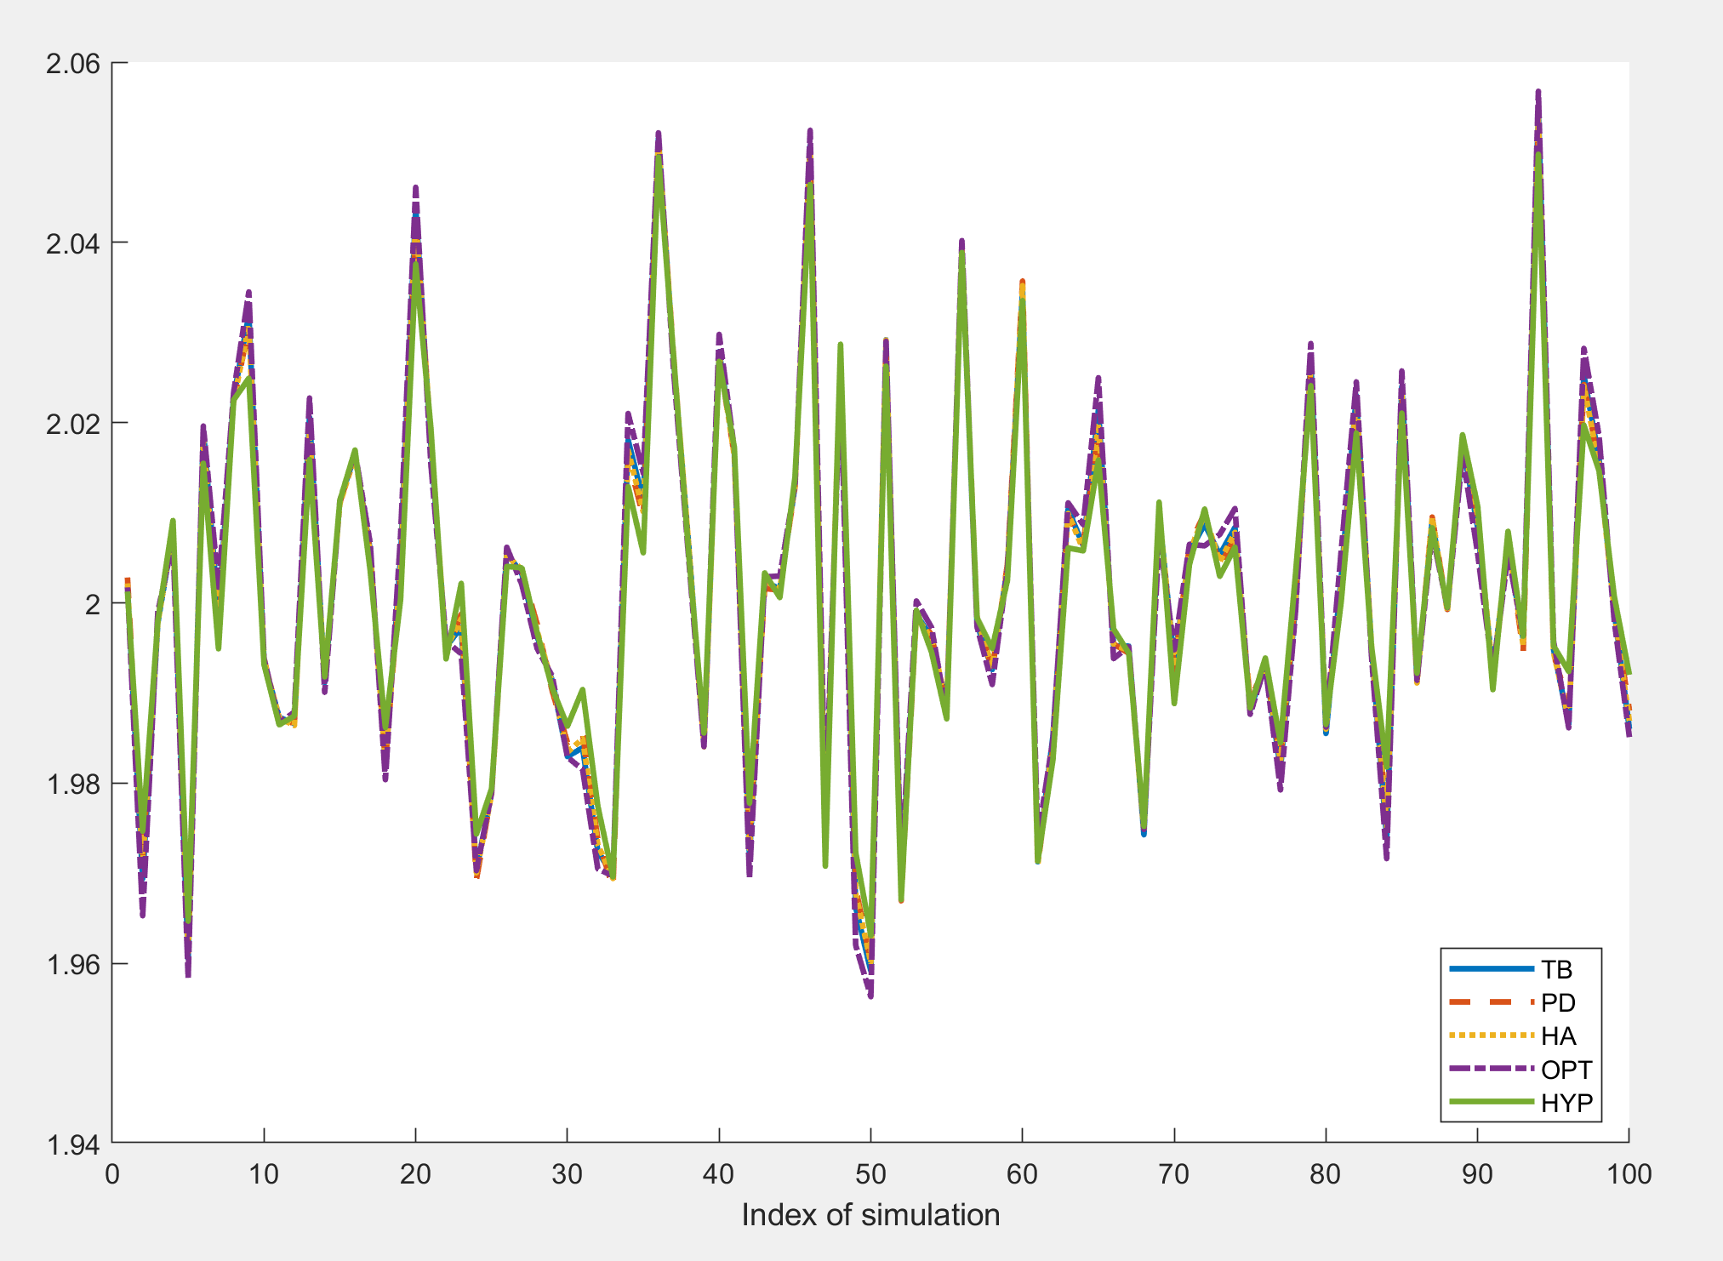

Now 49.5% of observations contaminated with the addition of a shift of 10

Now 49.5% of observations contaminated with the addition of a shift of 10^8

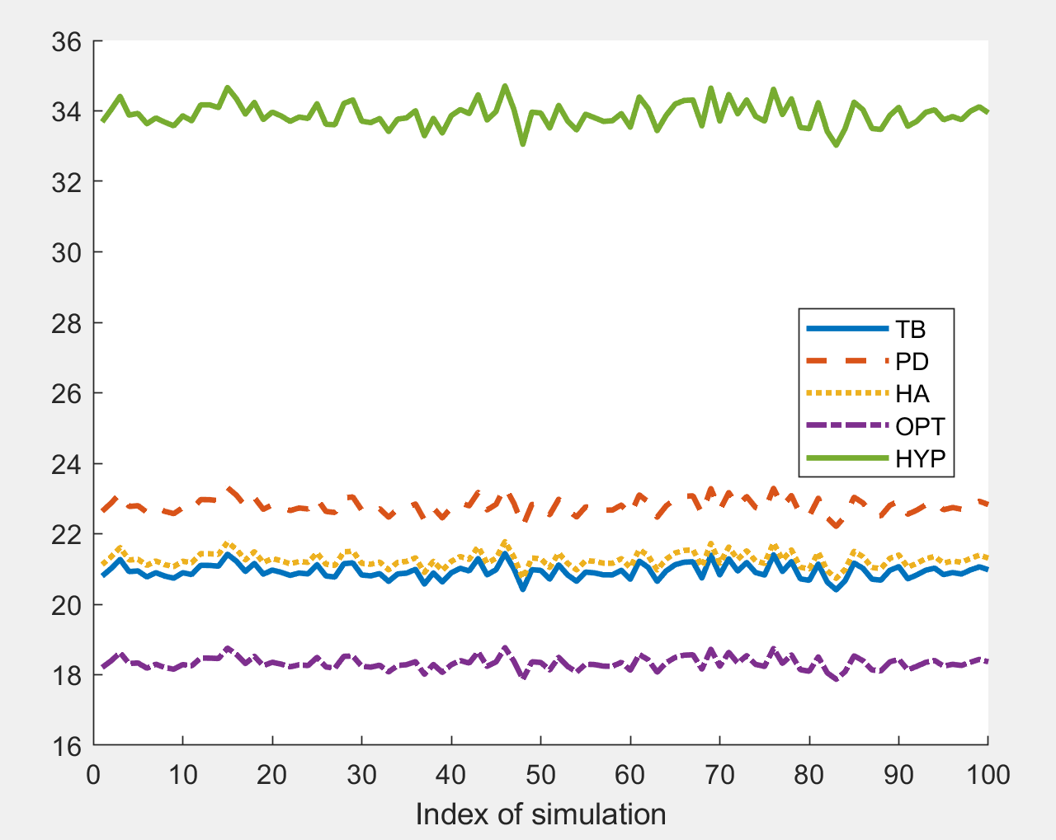

Point mass contamination of 10000 for 49.5 per cent of the observations

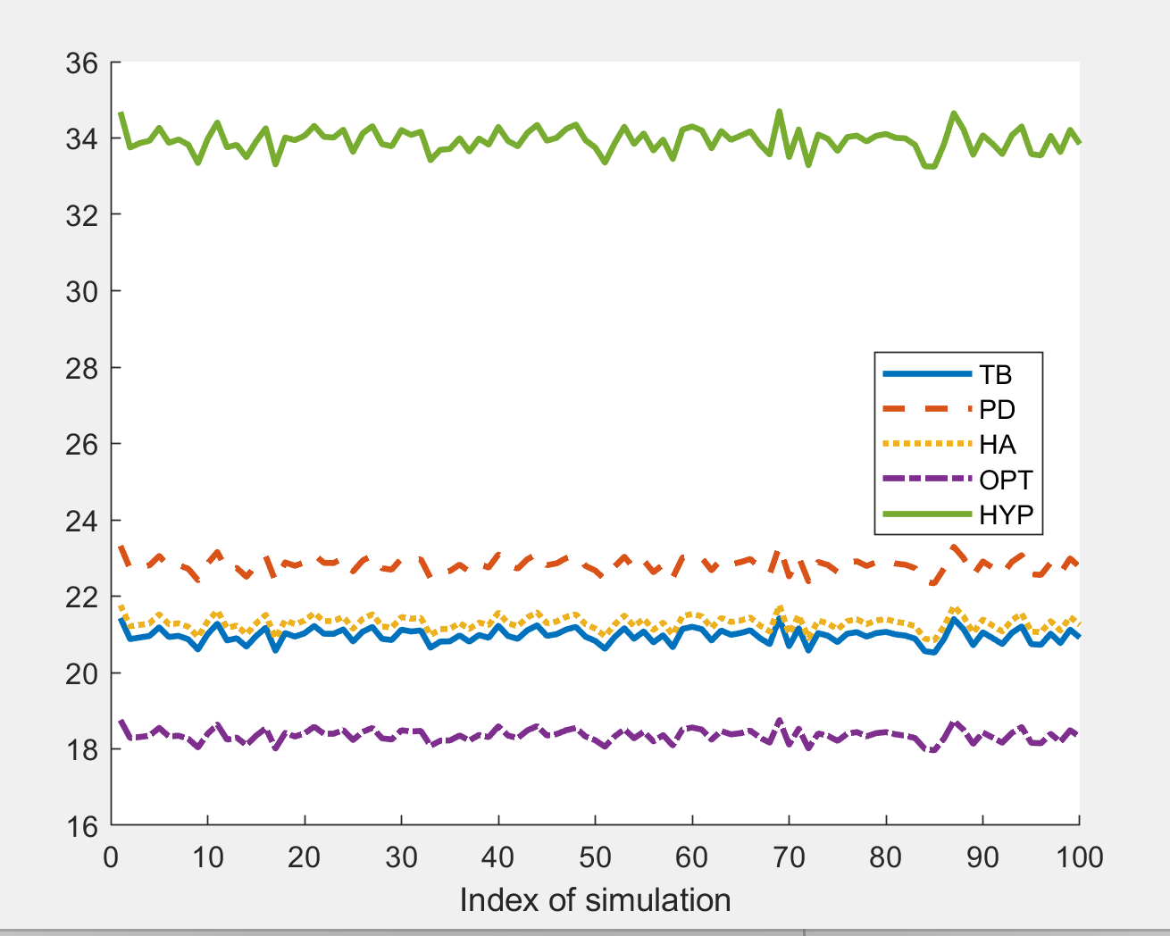

Point mass contamination of 10^10

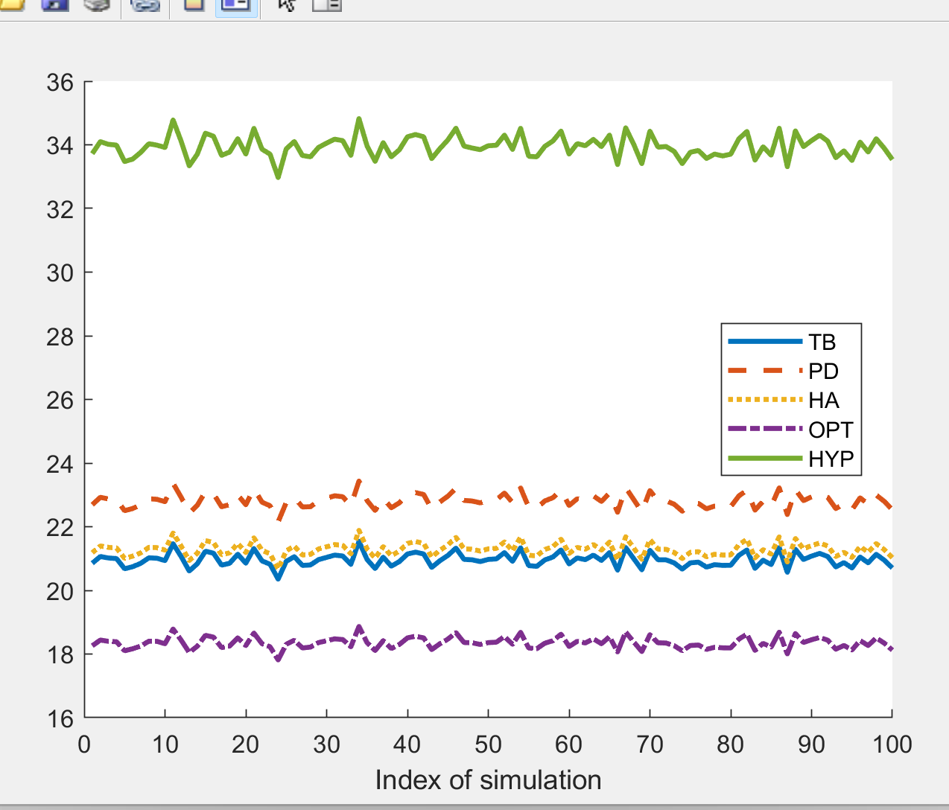

n=100 49 observations contaminated with point mass contamination of 10^10

