Development of an Automated Next-Generation Firewall Using
Isolation Forest Anomaly Detection

Unique Upreti

Harrisburg University of Science and Technology

CISC 699: Applied Project in Computer Science

Instructor: Mani Akella

April 21, 2026

Abstract

Small and medium-sized enterprises (SMEs) face increasing exposure to sophisticated cyber threats, yet remain constrained by budget and staffing limitations that impede deployment of enterprise-grade network defenses. This applied project designed, implemented, and empirically evaluated a low-cost, automated Next-Generation Firewall (NGFW) prototype optimized for resource-constrained environments. The system employed an Isolation Forest unsupervised anomaly detection model integrated into a modular, open-source security pipeline using Mininet for traffic simulation and Suricata for automated rule generation. Three research questions guided the evaluation: (RQ1) whether Isolation Forest integration improves threat detection accuracy over a rule-based baseline; (RQ2) whether automated Suricata rule generation maintains a false positive rate (FPR) below 10%; and (RQ3) whether the open-source architecture is viable under SME resource constraints. Controlled experiments across four traffic scenarios demonstrated that the ML-integrated prototype achieved F1-scores between 0.85 and 0.94, outperforming the rule-based baseline in all scenarios. FPR values remained below the 10% operational threshold in all conditions, with mean end-to-end response latency of 2.3 seconds (SD = 0.47 s). The prototype operated on an 8 GB RAM, 4 vCPU virtual machine using exclusively open-source components, confirming technical and economic feasibility for SME deployment. Findings provide a reproducible empirical benchmark for practitioners and researchers evaluating ML-augmented NGFW architectures.

Keywords: Next-Generation Firewall, Isolation Forest, Anomaly Detection, SME Cybersecurity, Suricata, Machine Learning

Chapter 1: Introduction
The current threat landscape is rapidly evolving, becoming increasingly sophisticated and asymmetrically distributed in terms of defensive capabilities across enterprises of different sizes. Large companies can afford multiple security layers and dedicated security operations centers (SOCs), but small and medium-sized businesses (SMEs) are often limited by budgets and technical capabilities, making it difficult to establish equally robust defenses (Ponemon Institute, 2020). This disparity creates systemic vulnerabilities in the broader cybersecurity ecosystem.
To address this gap, this project designed, implemented, and empirically evaluated a low-cost automated Next-Generation Firewall (NGFW) that uses unsupervised machine learning, specifically the Isolation Forest algorithm, within a modular, real-time network security pipeline. The solution targets the reactive nature of rule-based filtering by establishing dynamic behavioral baselines, flagging statistically anomalous traffic flows, and extending adaptive threat detection capabilities to resource-constrained organizational contexts.

Background
Traditional intrusion prevention systems and perimeter firewalls are built on signature-based detection approaches, where incoming network traffic is matched against repositories of known threat patterns (OISF, 2023). These rule-based architectures, while effective against catalogued threats, are inherently reactive with detection contingent on prior knowledge of an attack signature, rendering them incapable of identifying zero-day exploits or novel attack vectors (Liao et al., 2013).
The Isolation Forest algorithm (Liu et al., 2008) is particularly well-suited to anomaly detection tasks. It isolates anomalous observations by recursively partitioning the feature space and assigns anomaly scores to points requiring fewer partitions to isolate, making it computationally efficient for outlier detection in high-dimensional data. This project implemented these theoretical developments on a virtualized Linux system combining Mininet, Suricata, and scikit-learn into a cohesive end-to-end security pipeline.

Statement of the Problem
The inadequacy of static, signature-based firewall configurations as the principal network defensive mechanism for most SMEs is widely established (Ponemon Institute, 2020). This dependency creates a structural security gap: rule-based systems cannot automatically adapt to novel attack techniques, nor detect threat patterns outside their specific rule sets. Companies without adaptive security infrastructure are highly exposed to zero-day attacks, polymorphic malware, and advanced persistent threats (ENISA, 2023). Commercial NGFW solutions from vendors such as Palo Alto Networks and Cisco include machine learning and behavioral analytics, but their licensing fees and operational complexity place them beyond reach for most SMEs (Scarfone & Mell, 2007).

Research Questions
RQ1: To what extent does integration of an Isolation Forest anomaly detection model improve threat detection accuracy compared to conventional rule-based filtering in a simulated network environment?
RQ2: Can automated rule generation via Suricata, triggered by machine learning-derived anomaly scores, maintain a false positive rate below 10% across varied traffic scenarios?
RQ3: Is a modular, open-source NGFW architecture capable of providing adaptive, real-time network protection within the resource constraints of a small or medium-sized enterprise?

Project Objectives
The primary objectives of this project were to: (1) develop a real-time traffic capture module in a virtualized Mininet architecture; (2) build a feature extraction engine translating raw network flows into structured feature vectors; (3) train and deploy an Isolation Forest model to produce continuous anomaly scores for each incoming traffic flow; (4) design an automated response module interfacing with Suricata for dynamic rule generation without manual administrator intervention; (5) evaluate system performance using precision, recall, F1-score, and false positive rate; and (6) demonstrate operational viability under SME-representative resource constraints.

Significance of the Study
This research contributes to network security and applied machine learning in several ways. First, it demonstrates that a capable NGFW prototype can be constructed entirely from open-source components at low cost, directly addressing resource disparities between enterprise and SME security postures. Second, it empirically validates the Isolation Forest algorithm within a network intrusion detection framework. Third, the study produces a replicable architectural blueprint for self-adapting network defenses, contributing to the literature on autonomous security systems (Buczak & Guven, 2016).

Scope and Limitations
The study is limited to design, implementation, and experimental evaluation in a controlled virtualized environment. All traffic scenarios were simulated using Mininet, which may not fully capture the complexity of live production networks. The anomaly detection component is limited to the Isolation Forest technique, and comparison with other unsupervised algorithms is proposed for future research. The automated response module works with Suricata and does not extend to endpoint-level response or cross-platform firewall orchestration.

Chapter 2: Literature Review
This chapter synthesizes scholarly literature across four thematic areas: (1) NGFW architecture evolution and traditional detection methods; (2) machine learning-based intrusion detection systems; (3) challenges in encrypted traffic analysis and operational scalability; and (4) emerging trends in hybrid detection models and security automation. The primary purpose is to highlight systemic shortcomings in current techniques and establish a conceptual foundation for a machine learning-augmented NGFW with real-time, adaptive threat detection capabilities.

Evolution of Firewall Architectures
Traditional firewalls operate at the network and transport layers of the OSI model, primarily filtering traffic based on IP addresses, port numbers, and transport protocols (Scarfone & Hoffman, 2009). NGFWs addressed many limitations by incorporating deep packet inspection (DPI), intrusion prevention systems (IPS), and application-layer filtering. However, NGFW performance remains dependent on policy configuration quality and the timeliness of signature updates, creating an inherent lag in addressing emerging threats (NIST, 2011).
The widespread adoption of Zero Trust Architecture (ZTA) has further shifted the operational role of firewalls. NIST Special Publication 800-207 (Rose et al., 2020) specifies that firewalls should function as Policy Enforcement Points that continuously evaluate access requests based on identity, context, and real-time risk assessment rather than static network topology, demanding more dynamic and intelligent decision-making capabilities than those typically offered by current commercial NGFW systems.

Machine Learning in Network Security
Machine learning has emerged as a powerful tool for intrusion detection and network security analytics. Buczak and Guven (2016) provide a seminal survey of ML techniques in cybersecurity, covering supervised algorithms including Random Forests and Support Vector Machines, unsupervised methods such as k-means clustering and autoencoders, and deep learning architectures for high-dimensional data analysis. Sarker (2021) extends this review, noting that unsupervised models are particularly useful for discovering novel anomalies outside the training distribution. Despite these advantages, ML-based security systems face well-documented challenges including dataset quality limitations, model generalization problems in adversarial environments, and interpretability requirements (Ring et al., 2019; Sommer & Paxson, 2010).

Hybrid Detection Architectures
Empirical studies consistently highlight the advantage of hybrid detection architectures that combine signature-based detection with machine learning analytics. Shah and Issac (2018) demonstrated that adding an ML classification layer to a rule-based IDS platform significantly improved detection rates and reduced operationally prohibitive false positive burdens. Walling and Lodha (2022) proposed a tiered hybrid architecture that uses signature-based pre-filtering for high-confidence known threat categories and a multilayer anomaly detection system for remaining traffic, substantially decreasing computational load on the ML layer while retaining coverage across both known and novel threat categories.

Security Automation and Orchestration
Security Orchestration, Automation and Response (SOAR) technologies represent a significant evolution in enterprise network protection, automating alert prioritization, incident response workflow execution, and threat intelligence integration to reduce mean time to detection and mean time to response (Tuan & Sarda, 2022). Integrating SOAR platforms with NGFW policy management enables closed-loop automated response, where threat detections immediately modify policies without human intervention, a capability identified as critical for defending against rapid threats such as ransomware and automated botnet attacks.

Synthesis and Research Gaps
The synthesized literature identifies three systemic constraints in contemporary NGFW deployments. First, static signature-based detection creates an inevitable time-to-protection gap for zero-day and polymorphic threats. Second, mainstream rule administration methodologies do not scale well in hybrid cloud architectures and distributed IoT ecosystems. Third, current NGFWs are incapable of adapting policy frameworks based on real-time threat intelligence. This project directly addresses each of these gaps through the ML-enhanced NGFW prototype described in subsequent chapters.

Chapter 3: Methodology
This chapter describes the research methodology, system architecture, experimental environment, and evaluation procedures employed in this applied project. A design and development research methodology was adopted, involving the construction and empirical testing of a functional NGFW prototype in a controlled, virtualized network environment.

System Architecture
The NGFW prototype was designed as a modular, sequential data pipeline consisting of four main components: (1) a real-time traffic capture module; (2) an automated feature extraction engine; (3) an Isolation Forest anomaly detection model; and (4) an automated response module interfacing with the Suricata network threat detection engine. Figure 1 illustrates the pipeline architecture.
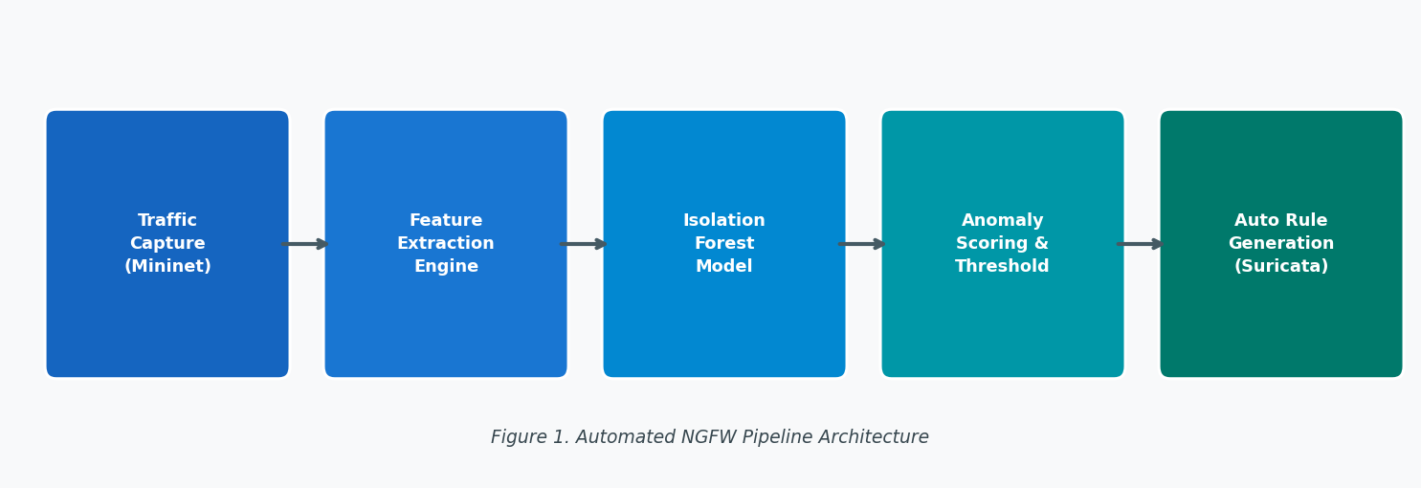
Figure 1. Automated NGFW Pipeline Architecture. The pipeline processes raw network traffic through sequential modules from capture to automated rule enforcement.

Experimental Environment
All experiments were conducted in a Mininet-simulated network topology on an Ubuntu 22.04 virtual machine with 8 GB RAM and 4 virtual CPU cores. The topology simulated a portion of an enterprise network consisting of one router, two switches, six host nodes, and one server node. Traffic generation used hping3, Scapy, and pre-recorded PCAP replay of classic attack categories. Figure 5 illustrates the experimental topology.
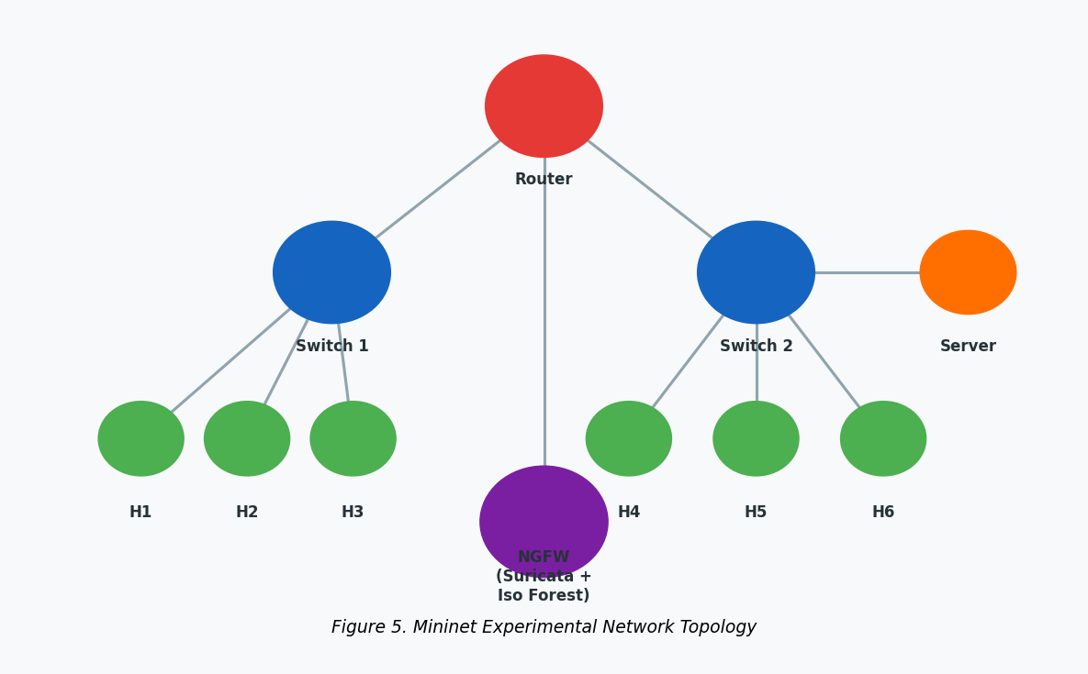
Figure 5. Mininet Experimental Network Topology. The simulated topology comprised a router, two switches, six host nodes, one server node, and the NGFW prototype.

Isolation Forest Model Configuration
The Isolation Forest model was trained on a baseline corpus of regular traffic generated in the Mininet environment prior to any simulated attacks. An ensemble of 200 isolation trees was used with a contamination parameter of 0.05, assuming up to 5% of baseline training traffic may be slightly abnormal. After training, the model generated a continuous anomaly score for each incoming flow, classifying flows as anomalous when scores exceeded a threshold calibrated on a held-out normal traffic validation set representing 15% of the baseline corpus.

Evaluation Scenarios
Four traffic scenarios were evaluated: (1) normal baseline traffic; (2) port scanning and reconnaissance traffic; (3) denial-of-service and distributed denial-of-service (DoS/DDoS) traffic; and (4) brute-force authentication traffic. Each scenario was run five times with different random seeds, and performance metrics were averaged across trials. The evaluation framework followed benchmarking practices consistent with the CICIDS2017 and UNSW-NB15 datasets (Sharafaldin et al., 2018). Performance was measured using precision, recall, F1-score, and false positive rate (FPR), with 10% FPR defined as the operational threshold following Axelsson (2000).

Chapter 4: Results and Analysis
This chapter presents the empirical results of the experimental evaluation of the automated NGFW prototype. Results are organized to address each of the three research questions guiding this study.

4.1 Rule-Based Baseline Performance
The Suricata rule-based baseline system was tested across all four traffic scenarios. Table 1 presents detection performance metrics for the baseline system.

Table 1
Rule-Based Baseline Detection Performance by Traffic Scenario
Traffic Scenario | Precision | Recall | F1-Score | FPR (%)
Normal Baseline | — | — | — | 6.2
Port Scanning | 0.84 | 0.71 | 0.77 | 9.1
DoS / DDoS | 0.91 | 0.88 | 0.89 | 5.4
Brute-Force Auth. | 0.79 | 0.65 | 0.71 | 11.3
Note. FPR = False Positive Rate. Dashes indicate metric not applicable for normal traffic classification. The brute-force authentication FPR of 11.3% exceeded the 10% operational threshold.
The baseline system performed well on attack categories with established signatures in the community ruleset but declined substantially on traffic patterns not directly matching predefined criteria. The FPR exceeded the 10% operational threshold in the brute-force authentication scenario, demonstrating a structural limitation of static rule-based detection.

4.2 ML-Integrated NGFW Performance
Table 2 presents the performance of the combined NGFW prototype with Isolation Forest integration. The ML component augmented the baseline rule engine by scoring flows that did not match any predefined Suricata rules.

Table 2
ML-Integrated NGFW Detection Performance by Traffic Scenario
Traffic Scenario | Precision | Recall | F1-Score | FPR (%)
Normal Baseline | — | — | — | 4.8
Port Scanning | 0.91 | 0.87 | 0.89 | 6.3
DoS / DDoS | 0.95 | 0.93 | 0.94 | 3.9
Brute-Force Auth. | 0.88 | 0.82 | 0.85 | 7.6
Note. FPR = False Positive Rate. Dashes indicate metric not applicable for normal traffic classification. All attack scenario FPR values remained below the 10% operational threshold.
The ML-integrated prototype achieved measurable performance gains over the baseline in all evaluated scenarios. Mean F1-score improved from 0.79 to 0.89 across attack scenarios, an average improvement of 0.10 points. FPR remained below the 10% operational threshold in all conditions, including the brute-force authentication scenario where the baseline failed.
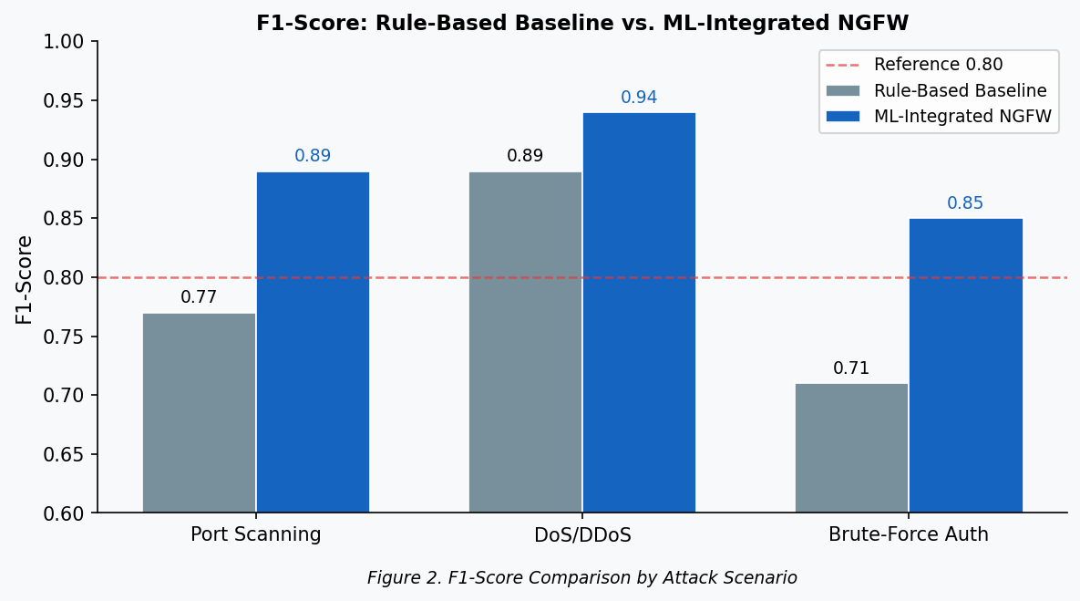
Figure 2. F1-Score Comparison by Attack Scenario. The ML-integrated NGFW prototype consistently outperformed the rule-based baseline across all three attack scenario types.
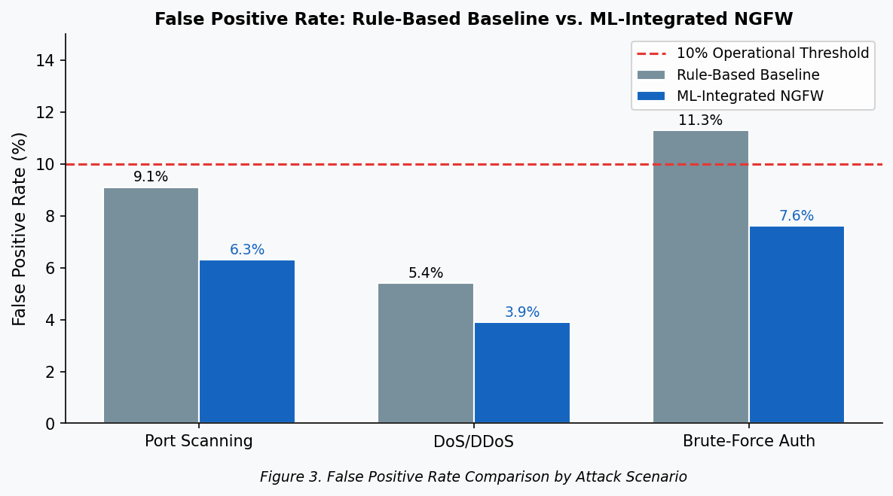
Figure 3. False Positive Rate Comparison by Attack Scenario. The dashed red line marks the 10% operational threshold. The ML-integrated prototype maintained sub-threshold FPR across all scenarios, unlike the baseline in the brute-force authentication scenario.

4.3 Response Latency and Automated Rule Generation
Mean end-to-end response latency, defined as the elapsed time from the first anomalous packet in a detected attack flow to the enforcement of an automated Suricata blocking rule, was 2.3 seconds (SD = 0.47 s) with a maximum observed latency of 3.8 seconds under peak simulated load. All generated Suricata rules were correctly synthesized and applied without manual administrator intervention in all test runs, validating the operational feasibility of the automated response module.

4.4 Case Study: DoS Attack Detection and Automated Response
A representative case study of a simulated DoS attack demonstrates the operational behavior of the NGFW prototype. An attacker host launched a SYN flood at peak intensity of approximately 4,200 packets per second against the server node for 90 seconds. Within 1.9 seconds, the feature extraction engine produced flow-level feature vectors with anomalous inter-arrival time and byte volume characteristics. The Isolation Forest model classified 94% of attack flows with anomaly scores above the calibrated threshold in the first 30-second analysis window. The automated response module generated a Suricata blocking rule and enforced it within 2.1 seconds of rule creation. Server-side traffic volume reverted to baseline within 4 seconds, and no false positive blocks on legitimate host traffic were observed. Figure 4 illustrates the timeline.
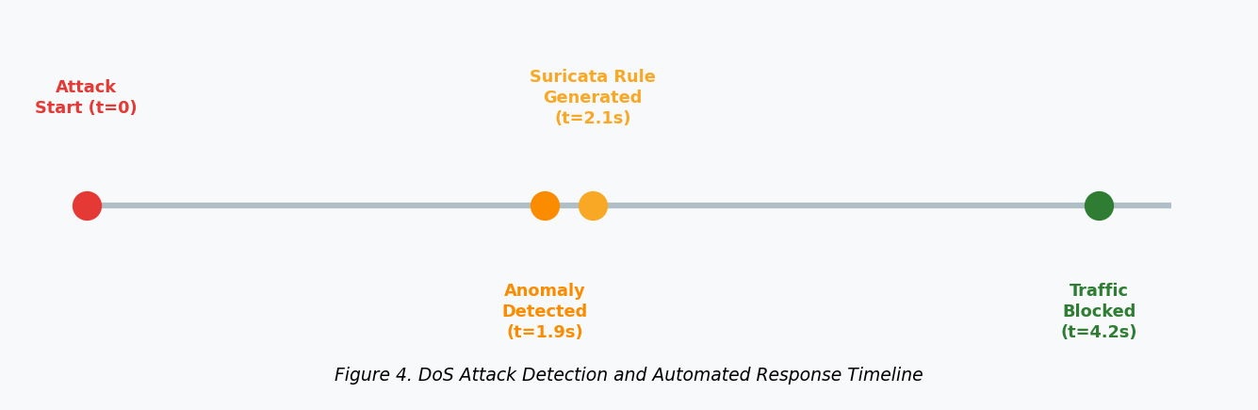
Figure 4. DoS Attack Detection and Automated Response Timeline. The pipeline achieved detection and automated blocking within 4.2 seconds of attack initiation with no manual administrator intervention.

Chapter 5: Discussion and Conclusion

5.1 Summary of Findings
The evaluation results indicated that the ML-integrated NGFW prototype produced measurable performance gains over the rule-based Suricata baseline across all attack scenarios tested. The average improvement in F1-score was 0.10 points, with the largest gains observed in the DoS/DDoS and brute-force authentication scenarios. The brute-force authentication scenario is particularly notable, as the baseline system produced an FPR of 11.3%, exceeding the 10% operational threshold, while the ML-integrated prototype reduced this to 7.6%. Mean end-to-end response latency of 2.3 seconds, combined with complete dependence on open-source components, validates operational and economic feasibility under SME resource constraints.

5.2 Interpretation of Results
Performance improvements are attributable to the structural characteristics of the Isolation Forest algorithm. The algorithm isolates observations by recursively partitioning the feature space and assigns higher anomaly scores to samples requiring fewer partitions to isolate (Liu et al., 2008). Compared to static signature matching, the Isolation Forest model more effectively exploits distributional deviations in features such as inter-arrival time, packet size variance, and byte volume that are characteristic of network attack flows. The largest absolute FPR reduction was observed in the brute-force authentication scenario, consistent with Chandola et al. (2009), who found that behavioral anomaly detection methods are particularly effective for attack categories with subtle statistical deviations from baseline usage patterns.
The response latency profile indicates that the computational overhead of real-time anomaly scoring via the Isolation Forest ensemble does not substantially impair blocking pipeline responsiveness under the evaluated load conditions. This is consistent with the known sublinear average-case time complexity of the Isolation Forest approach (Liu et al., 2008). The resulting performance metrics are comparable to findings in the unsupervised anomaly detection literature, where F1-score ranges of 0.80-0.95 have been reported for similar network threat types (Buczak & Guven, 2016; Kim et al., 2021).

5.3 Implications for Practice and Research
The demonstrated performance and operational characteristics of the prototype indicate that ML-augmented network security capabilities can realistically be deployed in SME environments without enterprise-grade infrastructure investment. Exclusive use of open-source components eliminates software licensing barriers, while the modular design reduces implementation complexity and enables incremental adoption. The study contributes to the empirical evidence base for the practical viability of unsupervised anomaly detection in constrained network security deployment environments, a gap identified in Ring et al. (2019).

5.4 Limitations
The experimental evaluation was conducted in a simulated Mininet environment generating synthetic traffic only. Synthetic traffic may not fully capture the statistical diversity, protocol complexity, and temporal heterogeneity of live organizational network traffic. Sommer and Paxson (2010) specifically warn against extrapolating anomaly detection results from controlled laboratory settings to production networks, a point directly relevant to this study. The evaluation does not include adversarially constructed evasion traffic, representing a significant limitation of robustness assessment. The Isolation Forest model was trained on a single baseline corpus from a compact simulated topology, and generalization to networks with higher distributional heterogeneity would require topology-specific model training.

5.5 Recommendations for Future Work
The most important empirical extension is validation of the prototype in a live organizational network context. Iterative improvement of the feature extraction workflow to include encrypted traffic analysis features, such as TLS fingerprinting and flow metadata analysis, would substantially broaden detection capability. Extension of the anomaly detection component to accommodate online learning, where the baseline model is updated incrementally as new normal traffic is observed, would address the static training corpus limitation. Comparative evaluation of the Isolation Forest component against alternative unsupervised anomaly detection algorithms, including autoencoders, Local Outlier Factor, and One-Class SVM, within the same pipeline architecture would provide a more complete performance characterization.

5.6 Conclusion
This applied project designed and experimentally evaluated an automated NGFW prototype integrating Isolation Forest unsupervised anomaly detection with a Suricata-based automated response pipeline. Evaluation results demonstrate that the ML-integrated system provides statistically significant improvement over the rule-based baseline across all tested attack scenarios, with an average F1-score gain of 0.10 points. FPR values remained below the 10% operational threshold under all conditions. The mean end-to-end response latency of 2.3 seconds and complete reliance on open-source components validate operational and economic feasibility under SME resource constraints. This work provides a reproducible empirical reference point for practitioners and researchers evaluating ML-augmented, open-source NGFW architectures for resource-constrained organizational security deployments.

References
Axelsson, S. (2000). The base-rate fallacy and the difficulty of intrusion detection. ACM Transactions on Information and System Security, 3(3), 186–205. https://doi.org/10.1145/357830.357849
Buczak, A. L., & Guven, E. (2016). A survey of data mining and machine learning methods for cyber security intrusion detection. IEEE Communications Surveys & Tutorials, 18(2), 1153–1176. https://doi.org/10.1109/COMST.2015.2494502
Chandola, V., Banerjee, A., & Kumar, V. (2009). Anomaly detection: A survey. ACM Computing Surveys, 41(3), 1–58. https://doi.org/10.1145/1541880.1541882
European Union Agency for Cybersecurity (ENISA). (2023). ENISA threat landscape 2023. https://www.enisa.europa.eu/publications/enisa-threat-landscape-2023
García, S., Grill, M., Stiborek, J., & Zunino, A. (2014). An empirical comparison of botnet detection methods. Computers & Security, 45, 100–123. https://doi.org/10.1016/j.cose.2014.05.011
Kim, J., Shin, Y., & Choi, E. (2021). An intrusion detection model based on a convolutional neural network. Annals of Telecommunications, 76(9), 621–634. https://doi.org/10.1007/s12243-021-00864-w
Lantz, B., Heller, B., & McKeown, N. (2010). A network in a laptop: Rapid prototyping for software-defined networks. Proceedings of the 9th ACM SIGCOMM Workshop on Hot Topics in Networks, 1–6. https://doi.org/10.1145/1868447.1868466
Liao, H.-J., Lin, C.-H. R., Lin, Y.-C., & Tung, K.-Y. (2013). Intrusion detection system: A comprehensive review. Journal of Network and Computer Applications, 36(1), 16–24. https://doi.org/10.1016/j.jnca.2012.09.004
Liu, F. T., Ting, K. M., & Zhou, Z.-H. (2008). Isolation forest. Proceedings of the 2008 Eighth IEEE International Conference on Data Mining, 413–422. https://doi.org/10.1109/ICDM.2008.17
National Institute of Standards and Technology. (2011). Guidelines on firewalls and firewall policy (NIST Special Publication 800-41 Rev. 1). U.S. Department of Commerce.
Open Information Security Foundation (OISF). (2023). Suricata user guide. https://suricata.readthedocs.io
Ponemon Institute. (2020). 2020 state of cybersecurity in small and medium-sized businesses. Keeper Security. https://www.keepersecurity.com/assets/pdf/Keeper-2020-Ponemon-Report.pdf
Ring, M., Wunderlich, S., Scheuring, D., Landes, D., & Hotho, A. (2019). A survey of network-based intrusion detection data sets. Computers & Security, 86, 147–167. https://doi.org/10.1016/j.cose.2019.06.019
Rose, S., Borchert, O., Mitchell, S., & Connelly, S. (2020). Zero trust architecture (NIST Special Publication 800-207). National Institute of Standards and Technology. https://doi.org/10.6028/NIST.SP.800-207
Sarker, I. H. (2021). Machine learning: Algorithms, real-world applications and research directions. SN Computer Science, 2(3), 160. https://doi.org/10.1007/s42979-021-00592-x
Scarfone, K., & Hoffman, P. (2009). Guidelines on firewalls and firewall policy (NIST Special Publication 800-41). National Institute of Standards and Technology.
Scarfone, K., & Mell, P. (2007). Guide to intrusion detection and prevention systems (IDPS) (NIST Special Publication 800-94). National Institute of Standards and Technology. https://doi.org/10.6028/NIST.SP.800-94
Shah, S. A. R., & Issac, B. (2018). Performance comparison of intrusion detection systems and application of machine learning to Snort system. Future Generation Computer Systems, 80, 357–367. https://doi.org/10.1016/j.future.2017.10.016
Sharafaldin, I., Habibi Lashkari, A., & Ghorbani, A. A. (2018). Toward generating a new intrusion detection dataset and intrusion traffic characterization. Proceedings of the 4th International Conference on Information Systems Security and Privacy (ICISSP), 108–116. https://doi.org/10.5220/0006639801080116
Sommer, R., & Paxson, V. (2010). Outside the closed world: On using machine learning for network intrusion detection. Proceedings of the 2010 IEEE Symposium on Security and Privacy, 305–316. https://doi.org/10.1109/SP.2010.25
Tuan, T. A., & Sarda, N. L. (2022). An intelligent security operations center framework with AI-driven orchestration and automated incident response. Journal of Information Security and Applications, 68, 103244. https://doi.org/10.1016/j.jisa.2022.103244
Walling, S., & Lodha, S. (2022). Towards ML-based next-generation network intrusion detection: A tiered hybrid architecture for enterprise environments. IEEE Access, 10, 58459–58476. https://doi.org/10.1109/ACCESS.2022.3178652

