* ***objective -*** help an organization to improve employee performance and improve employee retention (reduce attrition) by creating.

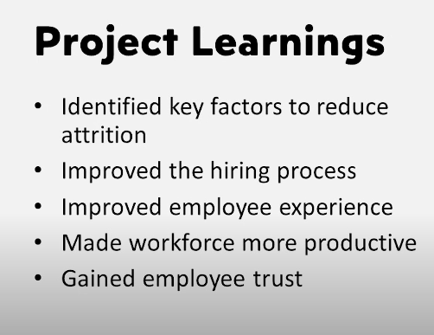

* ***Attrition Count*** = create a column if attrition = “**Yes**” then **“1”** else **“0”** by: -

--- > transform data --- > add columns ---- > conditional column ---- > write the conditions.

--- > change data type to “whole number”.

---- > when u convert it to whole number PBI will automatically take summation of it.

* ***Attrition Rate*** = create a new measure and take sum of attrition count divide by total count of employee

Attrition Rate = SUM(HR_Analytics[AttritionCount])/SUM(HR_Analytics[EmployeeCount])

* ***Age group***  *=* formed by grouping the age available in the raw data. or u can use line chart instead
* csv file rule = only one sheet is formed.
* KPI --> me insights show karo... drag and drop karke check karo ki koi insight nikal rahi hai kya.
* Remove Blank values in the rows through -----> "transform data" ---- > remove rows.
* Remove duplicates ---> "right click on column and remove duplicate for uniuqe key column"
* Column me number ke place pe english letters hai ya Vice Versa then ----> right click on any value in column and replace with any other value.
* Transform ---- > "detect data types" ---- > it will auto detect data types for the columns.

**Report Analysis outcomes –**

1. Life science department ---- > employees are leaving more
2. 26-35 age group employees are leaving more
3. Employee with salary less than 5k ---- > are leaving more.
4. Lab. Tech. dept. employee are leaving more.

**What we can do now ?**

1. Raise the salary of 5K salary emoployees.
2. Provide life 26-35 age group employee more compensation and provide them extra certification / internal competitions / fun activities.