Foreword

This report, together with a demonstration video, the answer was

PA project part of the subject TPG4850 - Experts in Team VR village.

The problem we dealt with was Task 1: Use of UAVs in the petroleum industry as we chose solving by and look at opportunities for immersive flying experience with virtual reality glasses.

We want to thank ˚ Age Sivertsen LAN of electrical engineering, good help for the construction of circuit boards with and access to electrical components. We also wish to thank all those who helped us and given us access to the mechanical workshop.

Finally, we wish to thank Egil Tj˚aland for guidance and motivation.

Content

1 Introduction 1

1.1 The current situation. . . . . . . . . . . . . . . . . . . . . . . . . 1

1.2 the solution. . . . . . . . . . . . . . . . . . . . . . . . . . . . 1

2 Product 3

2.1 Overall design. . . . . . . . . . . . . . . . . . . . . . . . . 3

2.2 Pendants. . . . . . . . . . . . . . . . . . . . . . . . . . . . . . 4

2.3 Head Tracking. . . . . . . . . . . . . . . . . . . . . . . . . . . . 5

2.4 Video Link. . . . . . . . . . . . . . . . . . . . . . . . . . . . . 10

3 Results and discussion 13

4 Future of the product 15

5 Conclusion 16

6 Appendix 18

6.1 Products. . . . . . . . . . . . . . . . . . . . . . . . . . . . . 18

6.2 Source Code. . . . . . . . . . . . . . . . . . . . . . . . . . . . . 18

1 Introduction

1.1 The current situation

UAVs, popularly called drones, have recently made ​​major inroads as a hobby but also in business. In recent years the development Pa battery front has made that the father of a usable flying time, and new control board has made them very stable and easy to fly. Mobile Camera Revolution has led to the SMA camera chips are bathing cheap and good, providing good opportunities for video while flying.

The petroleum industry has already begun using drones and we believe they will be used even more so in the future. Tasks that drones can perform petroleum industry are mainly situations where it is difficult for people to reach: Inspections high up in an oil rig, a rock wall that is difficult

A When on land, overview from above, and more.

Today drones flown mainly by visual contact, where one is dependent See the drone clearly tion to be able to fly. PA distance becomes nontrivial see which direction the drone is facing and thus difficult the controller. There are opportunities for live video stream, but these often provide a flat and small picture that is nontrivial fly by.

These problems are what we want solving.

1.2, the solution

We want to provide an opportunity to maneuver drones In the long distance with bad visual contact. The solution was going to achieve this by combining images from two video cameras PA a Quadrotor with virtual reality goggles and board orientation of the cameras using head tracking.

Two video cameras makes VR glasses can display different pictures on each eye, and can thus achieve a true 3D effect and a much better dybdeforst˚aelse of what you see in front of them. VR glasses used are Oculus Rift. These glasses covers the entire field of view with image and makes you father an immersive, so-called immersive, perception of what one sees. The solution is aimed at the user father a feeling to actually hang the drone with a complete overview of the happens.

Oculus Rift glasses have built-in head tracking, so you onto a PC can read the position of the head of the user. This utilizes the solution was to rotate the cameras PA Quadrotor two axes in the same way as the user moves head. To turn your head to the left and then the FA an image from cameras rotated to the left will provide even more control over exactly what is happening, an even better feeling that one is where it is filmed.

The solution was is˚am˚ate is not a concrete example of how the petroleum industry can use drones to new tasks than they do today, but rather a new control mechanism that can be integrated into existing and future tasks in which the drones used. We envisage that a further development of the prototype will to give a finished system can be mounted on any drone where you want more control in the future.

2 product

To complete the project there was a need to find solutions Pa several separate problems. There was little overlap between the parts of problems, but the overall project was dependent on everything working together. The following sections tells what Matt performed in each part of the project.

2.1 The overall design

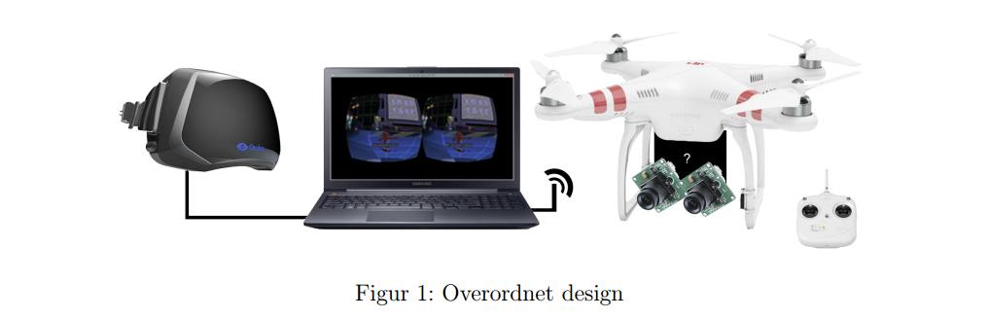

Figure 1: Overall design

The project can be divided into three main parts.

1 Pendants to Quadrotor with servos, transmitters and printed circuits Quadrotoranhenget be made so that two cameras can be rotated about two axes using servos. The pendant also carries a circuit board with microcontroller to the controller camera and servos. Cordless transmitter for video and Receiver for servo is connected to said circuit board. Power is supplied of Quadrotorets batteries.

2 Head Tracking from Oculus Rift and updating kameraservoer

Head Movements recorded in the Oculus Rift and orientation coordinates are sent to the PC. These coordinates are sent to the microcontroller tr˚adløst PA Quadrotoranhenget that updates the direction the camera is pointing at Â twist PA servos.

3 Streaming and viewing Oculus Rift

Two camera sends video to radio transmitters which transmits the signal to receivers connected to a computer. The computer then converts video stream to a format that can be displayed in Oculus Rift.

2.2 Pendants

To be able to control the direction the camera is pointing, we would like to be able to rotate them about two axes. We have therefore built paper we own pendant which can be seen in Figure Two.

This pendant consists essentially of wood veneer sheets and two servos mounted together. The top plate is installed in Quadrotor. In it there mounted a servo which rotates another plate in the y-direction. This plate has in a servo rotating the third plate in the x-direction. PA on the third disc is mounted cameras. The cameras are mounted at a distance between center of the lenses of approx 64 mm, as it is the average interpupillary distance, distance between pupils, PA adults [1].

The pendant mounted on Quadrotoret and Ma adapted the type quadkopted you must modify. The choice fell PA DJI Phantom 2, as it has high bone and thus a lot of space underneath, as can be seen in Figure 1 Since the Quadrotoret not focus iv˚art project was also good that it comes

fully assembled and ready for a Fly.

In our case the pendant mounted at the rear housing on it, top plate

screwed to the thread on the underside of Quadrotoret. The long plate making

that the rotating parts are far enough out of the bones that they do not wrap

into them.

110,0mm

80,0mm

80,0mm

90,0mm

65,0mm

64,0mm

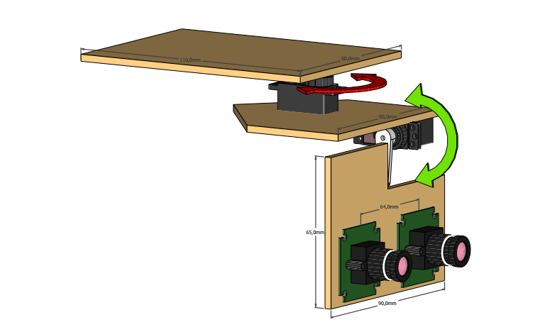

Figure 2: Pendant with servos rotating cameras

2.3 Head Tracking

Oculus VR provides developer tools to A Create Content Rift platform [1] [2].

Using the functions available from the developer tools can be brought information from the gyro, accelerometer and magnetometer as follows with Oculus Rift. Information from these sensors is used to refresh the orientation of the displayed image Oculus Rift, and iv˚art case update direction the camera is pointing.

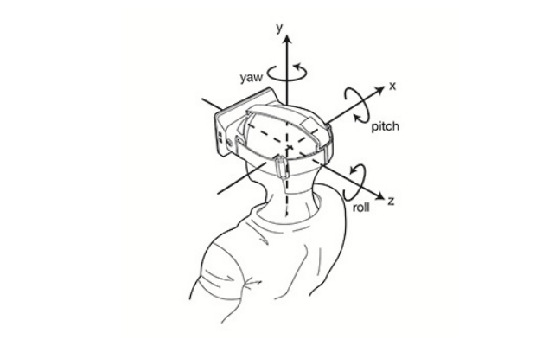

Figure 3 shows the coordinate Oculus Rift conform.

Figure 3: Oculus Rifts right-handed coordinate system. By simply turning your head up, the sensors will register positive change on the x-axis. ˚ A twist his head against left recorded as positive change on the y-axis and the b turn heads PA tilted to the left is detected positive change about the z-axis. Rotations about the x, y and z axis denoted respectively as pitch, yaw and roll.

2.3.1 Orientation of Oculus Rift

When the user of Oculus Rift movement of the head, the sensors detect it and send sensor data to the user's computer. The values ​​received can transformed into a desired verdiomr˚ade. Verdiomr˚adet we wanted to use the to directions that lie within the power utslagsomr˚ade. The servos that used in this project can rotate about 160 degrees, which means that all movements within a 160-degree deflection field will be allowed. Head Movements registered outside the values ​​in verdiomr˚adet set to the nearest value. Equation 1 shows how the logic we use set values ​​so we want them. f takes direction coordinates from Oculus Rift and transforming them to a verdiomr˚ade that is within the power range.

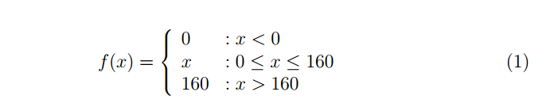

Since we use two servos we will only be able to support rotations about x and y axis. This means that a Turn head to the right and left and b turn head up and down, and of course, combinations of these will be supported. It will not be possible to put your head cocked PA (rotation about the z-axis) and expect successive updates of the picture. Such movement will cause confict between what the eyes see and what sense of balance in the ear sign and cause discomfort. 2.3.2 Data Transfer Protocol for microcontroller

The microcontroller PA Quadrotoret programmed Tila first follower data transfer protocol: Start Drawing followed by x-direction followed by the y-direction.

The protocol best of three elements, each element occupies 1 byte (8 bits). Start character is set to 255 (2 8 - 1 = (11111111) 2 ), A value that is not possible to obtained from verdiomr˚adet to servos (0-160). This means that if the initial character received by the microcontroller, it will expect the next 8 bits will be xretningen and then the 8 successive bits are y-direction. Wherever a start character is received, the controller then expect coordinates in the order described. Figure 4 shows the rules for how the microcontroller to interpret data it receives.

2.3.3 Transfer of direction coordinates from computer to Quadrotor

Program was running a loop in each iteration transforming x and y-coordinates and sets up the packets to be transmitted according to the protocol described in the paragraph above. In this project we use transmitters serial data (UART). Modern laptops missing ports for this format, so we are dependent on a breakoutboard tion to be communicate with transmitters last. A breakoutboard plugged into a USB port computer on one end, and until Wireless transmitter at the other end. When we reviewed application sends data to the connected USB port, a breakoutboard transform the signal from USB to UART format and then transmit this

the transmitter.

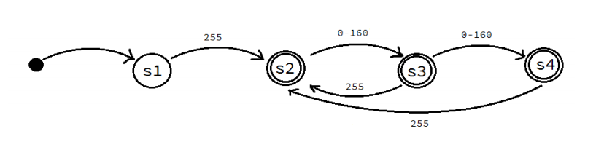

Figure 4: Signal interpretation starts in state s1, where the microcontroller waiting for start character. At state S2 has the microcontroller received initial signs and waiting for x-retningskoordinat. When s3 is the x-coordinate received and direction the current servo update. The controller then waits pa y-coordinate.

The last condition is s4 and here y-coordinate has been received, and servo updated. In state s3 and s4 is it possible to fall back to s2 if a start character is received. If nothing is received within 5 seconds or invalid values received one starts anew again in s1 (not included in the figure).

The receiver PA Quadrotoret accepting data sent, conveys this microcontroller which updates the positions of the servos by a Follow rules in Figure 4.

2.3.4 Transmission of signals from the microcontroller to the servos

The servos are controlled via each's PWM (pulse width modulated) signal. their positions the servo will be proportional to the signal's duty cycle, Alts how much it is high compared to low, see Figure 5.

The microcontroller's job Â make this signal, it does this by using built-in timer, which counts up to when one output should be high or low, see Figure 6 It has 2 timers for each output, and when one hour has counted to a given value, set the hennholdsvis an output high or low. By simply changing values ​​of what to count up to before changing the value at year-end determines duty cycelen.

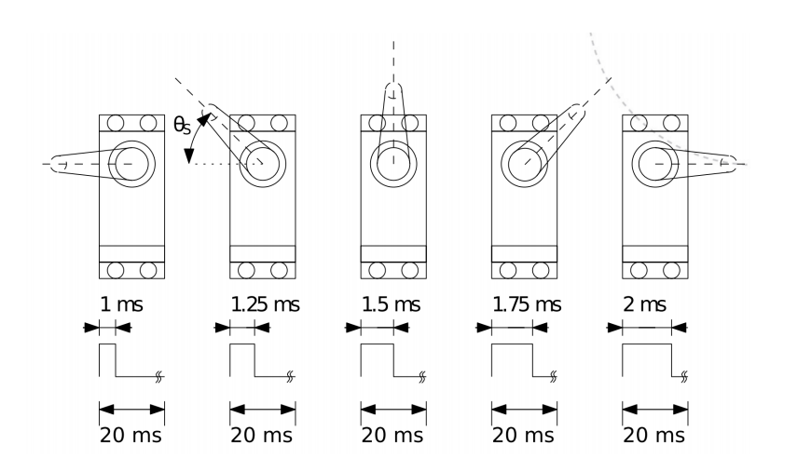

Figure 5: when the duty cycle is 5%, the servo STAP 0, while when it approaches

10% will stand on 160 degrees.

Creative Commons BY-NC-SA Kristoffer Shake Skøien

2.3.5 PCB

For connecting the whole system together Matt we create a circuit board. This would have tasked a Connect UART exciter and servos to the microcontroller. It would also be a need for a power supply, in the form of a linear regulator, who took power from Quadrotorets battery, and transformed it to 5V.

The circuit board was also equipped with LEDs tion to provide a status indicator on data transfer. For example, when a data packet is received, the bright green light, and when communication with the ground OPPOR, the bright red light.

The circuit board was designed in CadSoft Eagle [7], etched and finally soldered PA components. The circuit board was programmed, tested and p˚amontert all, the result is that the cameras follow the movements of the Oculus Rift.

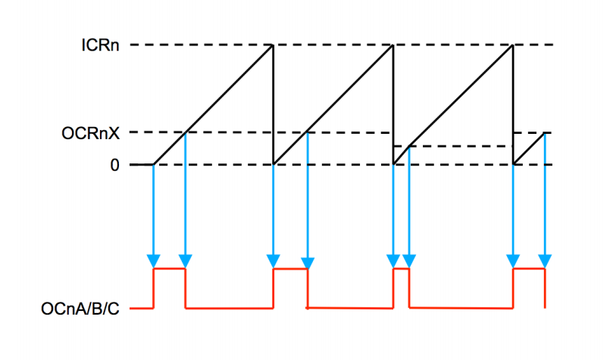

Figure 6: Ocna / B / C is the output signal sent to the servo. OCRnX and ICRn are registers to time clean. By simply adding value to OCRnX will increase duty cycelen, thus increasing the angle of the servo arm.

2.4 Video Link

PA Quadrotoret are the two cameras connected to each tr˚adløse video transmitter, which in turn is connected to battery power. These transmitters then sends the video signal tr˚adløst down to each receiver on the ground. Transmitter / Receiver standard off the shelf, already in use in many drones. Recipients delivers video signal RCA (composite) that are said can plug into any form of protection.

Since we have two video streams we wanted to merge together and that Oculus Rift is not any monitor (more on this in the next section), we must treat the video image on a computer. Said the next step is to digitize the video stream.

We do this using two pieces RCA to USB converters, which let us connect the received signal from the receivers to a PC.

PA PC treated said the images in real time so they can be displayed properly onto a Oculus Rift without too much delay. More on this follows the next section.

2.4.1 Image Distortion

Those who have seen Oculus Rift in action before, you have probably noticed the strange the image displayed on the PC screen. Figure 10 shows such an image. if you However looking on the same image through one Oculus Rift, see it all like it will do.

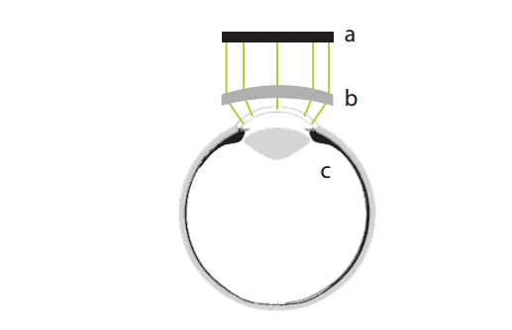

Figure 7: Lenses (b) of Oculus Rift father image (a) to A look as if it covers the entire field of view of the eye (c)

The reason for this is straightforward way Oculus Rift acts on. Tion to cover the entire field of view use the lenses tion to distort an image from a normal, flat, rectangular display. Figure 7 shows how an image is distorted by a lens Tila cover the entire field of view. Figure 8a shows the straightforward way the lens distorts the image, one so-called pincushion distortion. If one is a regular rectangular image onto a Oculus Rift Alts will appear distorted as in Figure 8a, only more extreme.

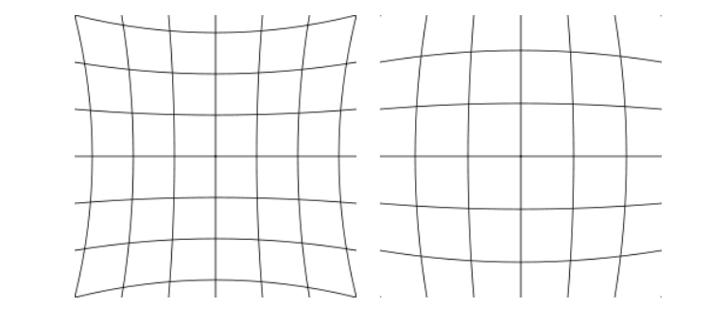

Figure 8: a) pincushion left b) barrel to the right

The opposite of pincushion distortion is a barrell distortion, shown in 8b. Said that a picture should not look odd PA Oculus Rift, one does one barrel first distortion tion to suspend the effect of a Turn the picture around the viewport.

2.4.2 Processing of video stream

SA MA alts, in real time, distort the images in the video stream with barrel distortion before being displayed on the Oculus Rift.

There are several players tion to show video pa Oculus Rift, but none of them could be used. ˚ The reasons for this were several, but mainly because players took for the video files, not real-time video, and could not connect two video streams. The solution was to write the VAR own software. as the included software to RCA to USB converters had a delay of almost two seconds, we could not build the program was on top this.

The program was spoken instead directly with the driver and converters extract RA data into these father. What we did was to set up a DirectShow [3] graph, where we send the RA data through several stages of AFA forward a image (frame) we can use. To do this we use Matt C ++ and Low level COM [4]. The graph is set up is shown in Figure 9, the Green Cross bar is actual physical device, which is connected to the Orange Video Capture driver. There it supplies we send through said one Decompressor and Color Converter To get a picture. This is forwarded to a SampleGrabber [5], which only a buffer where the last frame of the video is so that we can retrieve it and treat it. Since we need to do some processing Retry the image itself, shall not appear and the image is therefore sent to a so-called Null Renderer as only reject the image.

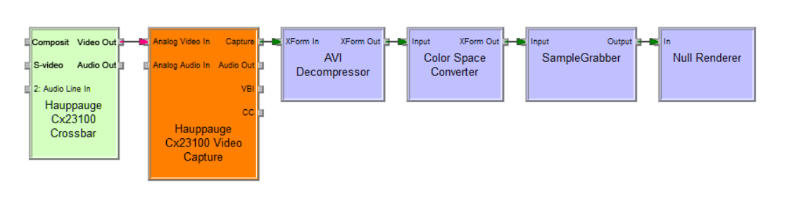

Figure 9: DirectShow graph for video stream

Such a graph is built for each video stream and then set up a loop that checks out the latest image from the Sample Grabber for each video. Each such picture is then distorted with a barrel distortion before it is displayed on each side of the screen so that it is pa their own eye. Tion to distort the image effectively done it with a shader [6] PA graphics card (GPU). the result is a picture as in Figure 10.

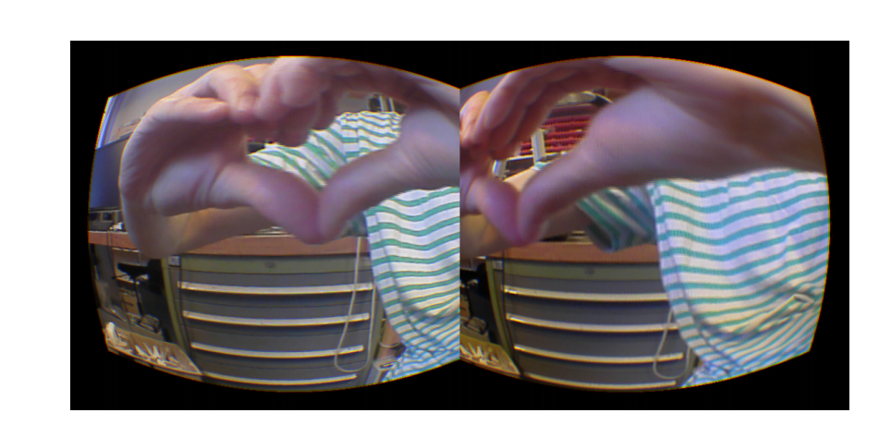

Figure 10: The image from each camera with distortion, apparent to Ä displayed on an

Oculus Rift

3 Results and discussion

Project template was Nadd before the deadline for the report. The last day village got two of the group members tried out the system as be used, and the result was satisfactory. There is still more territory Design of the prototype was to be improved. It was found that extreme precision in the assembly of the cameras is essential if they are to deliver credible images Oculus Rift. A few millimeters of inaccuracy in the direction of the two cameras pointing will make a significant impact on the image. When the camera is properly mounted brain will put together the images are served each eye pa proper manner, and when there are small inaccuracies brain will attempt to compensate, which is very exhausting and annoying after a while. when pictures not compiled the depth of the image to be absent, which was one of main target was to obtain in this project. It should be mentioned that after the test flight we had explained how the cameras are adjusted and tested this out PA ground but alts not a test flight of a full immersion. This expected to be rectified days before the presentation on April 24.

When it comes to the pendant, there are several weaknesses that could lead to a crash if one would be unfortunate. In Figure 2, the PA servo glimpsed a screw attach the white plastic rotatable element to the servo case. For both servos are that this screw bears all the weight of the successive sections of the pendant.

There are also those joints that Matala acceleration when flying Quadrotoret and faces Pa in the air. There was tempted to mount a most redundant security system in the pendant, with the aim that the weight is distributed and then A reduce the number of critical points. In the servo case it was not possible to rectify this and we are currently Pa its Nadeen when Quadrotoret're flying. It was used fin'erplater as materials in the pendant, which runs always the risk to begin to crack if you turn and saw in them. It was through the project period scheduled a use 3D printer at the Institute of Petroleum Engineering and Applied Geophysics to A fabricated pendant, but delays in delivery of plastic printer uses made ​​to Matt switch to wood. If we had been given the opportunity to A 3D printer parts to pendant, it would be easy â recreate the product was thus introducing it. There are still different strengths between the A Using wood and 3Dplast. Using wood can be cut out portions of the pendant and then GAR the rapidly modifying them if something does not fit. In return, the require much more time AFA tested prototypes if it gets used a 3Dskriver, since the printer needs time amounts PA size of a business to A complete model to load. At the same time so that if one have your feet on space a working model of the 3D printer will be able to easily reproduce parts. One can imagine that one can start the 3D printer on evening the day before and then bring the finished pieces next morning.

With beach plastic and wood, one must turn and file tion to assemble the parts together, So it is not a material such as going better than the other when it Angara completion. It should be noted that the vast majority have the most experience with A work with tree byggematriale compared with plastic for use in the same formal. It shall not be particularly challenging â learn the limits of sawing and Screwing in 3D plastic and its of use, this advantage in favor of wood is negligible.

The screen resolution in developer edition of Oculus Rift which we possess supplies 640x800 pixels of each eye. This is noticeably grainy and each pixel can separated. This has the consequence that the displayed image will appear unclear. This is an effect that is indicated regardless of the application you are running in Oculus Rift. Oculus VR claims that this will be improved in the next developer edition as well as the consumer version of the Oculus Rift. When the image is grainy brain will automatically be eyes on A further focus tion to repeal ambiguities.

This work is done in vain, since the image quality is at the mercy of the display resolution and the user is tired Ibad eyes and brain. We imagine us that there is going to be a lot of work in adapting the product to the paper we newer versions of VR goggles to experience the Oculus FPV will be even better. The resolution of the cameras we use are approximate juxtaposed with resolution Oculus Rift offers, but it will still be much to bring with greater resolution in 3D glasses.

There were no major delays in the transmission of video stream from servo position Quadrotoret. Considering the PA response, the solution was so on the matter satisfactorily. When it comes to refresh PA servo positions, this was not said as fast as possible AFA, but it was still more than adequate Tila provide a natural experience. Servo positions are updated 30 times per second, and with a little extra work can be improved.

To be able to supply the servos, cameras and transmitters with power, it was in paper we nødvedig case â fathom the PA Quadrotorets power. this is a step up the necessary prerequisites tion to reproduce the product lasted. The ideal would be To avoid new users mA fathom this as well A Matter create their own circuit boards. The knowledge of the group was sufficient to we could produce this pa egenh˚and, but a better solution would have been for the most part care could be completed without ˚am˚atte access an electrical workshop tion to be able to fathom. Alternatives to A Matter fathom his own PCB is to assemble an Arduino or similar. Such a platform should be easy of the controller servos.

4 Future of the product

The ideal Malet of the project is to be able to produce the product so that it is Most plug-and-play. This means that there will be major challenges associated with installation of the pendant and the layout of transmitters and software. much depends on the Quadrotor being used, where the pendant MA adapted to different models. With a working model for 3D printing it will be easy â recreate parts we have used, and this will make project further reproducible.

Product paper we may be able to carry the other camera and several sensors, making it possible to form a more complete picture of put behind you is set above. With the ability to A mount IR camera will be possible to A record heat with gas sensors can leak detected.

Several of these additional functionalities will be already supported by existing solutions, and for gas leaks and heat generation will be events most likely to be picked up by static and integrated sensors.

The main strength of our range of products will be the integration of VR goggles include a full field of view and the option to turn his head towards the arouses user's interest and then FA image updated. The use of the product may be useful in put behind where there is a need to inspect things in demanding and hazardous environments, where the alternative would be costly, time consuming and labor intensive. Examples of these are studies of the reach terrain, for example in connection with avalanche. In such situations, it be too dangerous a use people for this work. other Applications In connection with the inspection of parts of buildings that are hard ana PA conventional manner. Examples include support strut with oil platforms, kjølet˚arn

and superstructures to mention several.

It is entirely possible to stick to the use of one camera setup lasted. This makes it possible to combine paper we product with other projects in the village who have combined camera drones.

5 Conclusion

It was in this project made ​​possible to use Oculus Rift and show the video from a Quadrotor and control the direction the camera is pointing using head tracking in Oculus Rift. As it is written in portions over said there is much that can be improved tion to make the product better and the program easier to reproduce, but we have shown that it is possible with standard à create a working solution. it shall indicated that there has been a need to be able to fathom and have access to workshops, something that not everyone has the opportunity.

We got what we wanted in the project, and the end result shows that the product paper we provide good control and visibility when flying. We therefore recommend further testing and development of the system was.

References

[1] Richard Yao, Tom Heath, Aaron Davies, Tom Forsyth, Nate Mitchell,

Perry Hoberman Oculus Oculus Best Practices VR, Inc. 2014.

[2] Michael Antonov, Nate Mitchell, Andrew Reiss, Lee Cooper, Steve

LaValle, Max Katsev Oculus SDK Overview Oculus VR, Inc. 2013.

[3] Microsoft DirectShow application programming interface http:

//msdn.microsoft.com/en-us/library/windows/desktop/

dd375454% 28v = VS.85% 29.aspx Microsoft, 2014.

[4] DirectShow, COM and C ++ http://msdn.microsoft.com/en-us/

library / windows / desktop / dd390351% 28v = VS.85% 29.aspx Microsoft,

In 2014.

[5] SampleGrabber http://msdn.microsoft.com/en-us/library/

windows / desktop / dd377544% 28v = VS.85% 29.aspx Microsoft, 2014.

[6] Understanding the Oculus Shader http: //rifty-business.blogspot.

com / 2013/08 / understanding-oculus-rift-distortion.html Brad

Davis, Rifty Business, 2013.

[7] CadSoft Eagle http://www.cadsoftusa.com/ Cadsoft USA, 2014

17

Oculus FPV 6 ANNEX

6 Attachment

6.1 Products

Table 1 shows the main components used in the product lasted.

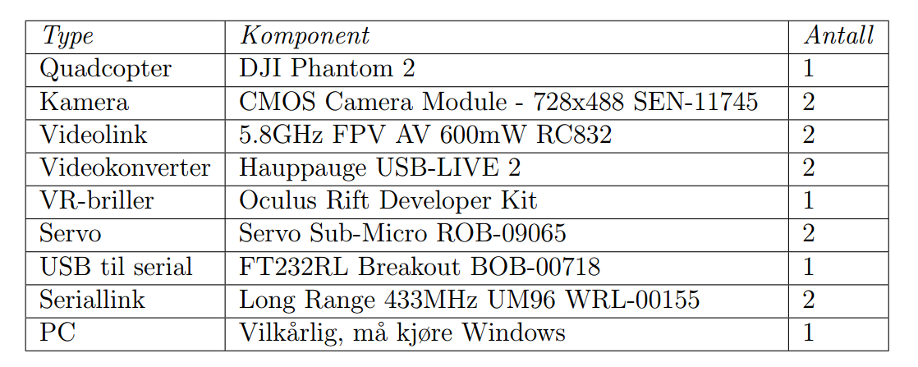Table 1: Products

6.2 Source Code

The source code for the microcontroller and a program on the PC are available

a Git repo on the following URL: https://github.com/Matsemann/oculus-fpv

Instructions for the construction of source code in the file README.md in repo.

18