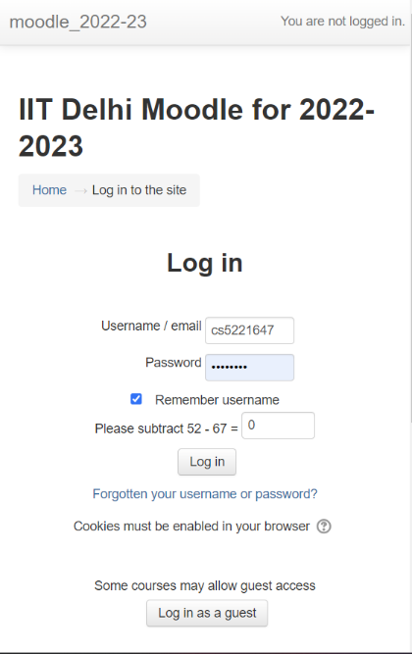MOODLE REPPORT:

**1. The webpage** looks as above:

And the network console is like :

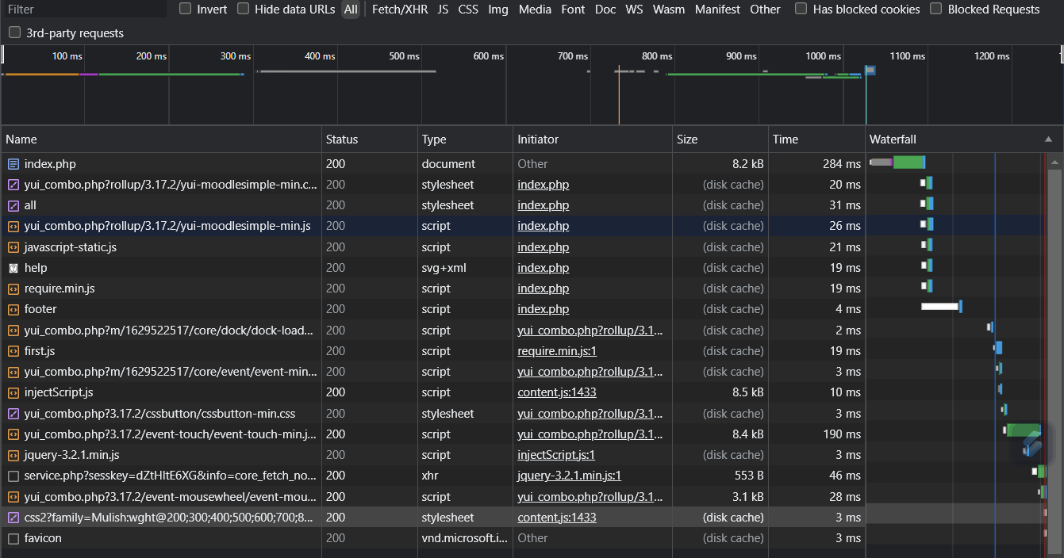

The browser requests many different files like php, stylesheets, scripts, svgs and xmls.

The requests are mainly initiated in index.php file:

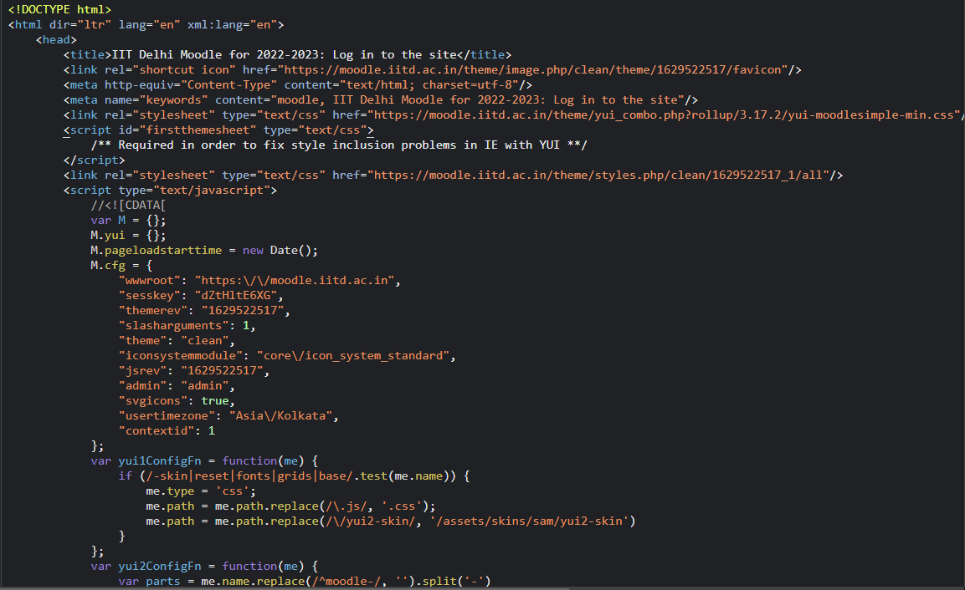

But after that the requests are also initiated in other files like script and all…

Here we can see initiation of css files named moodlesimple-min.css, firstthemesheet and clean/all

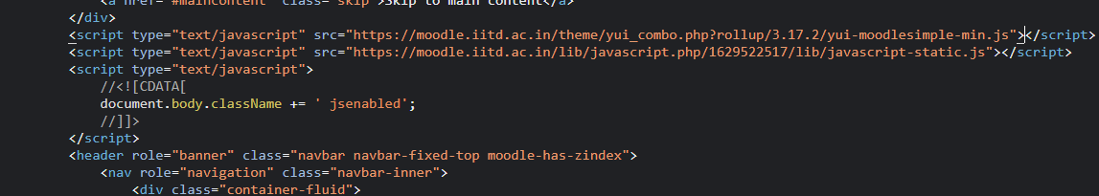

Initiation of javascript docs…

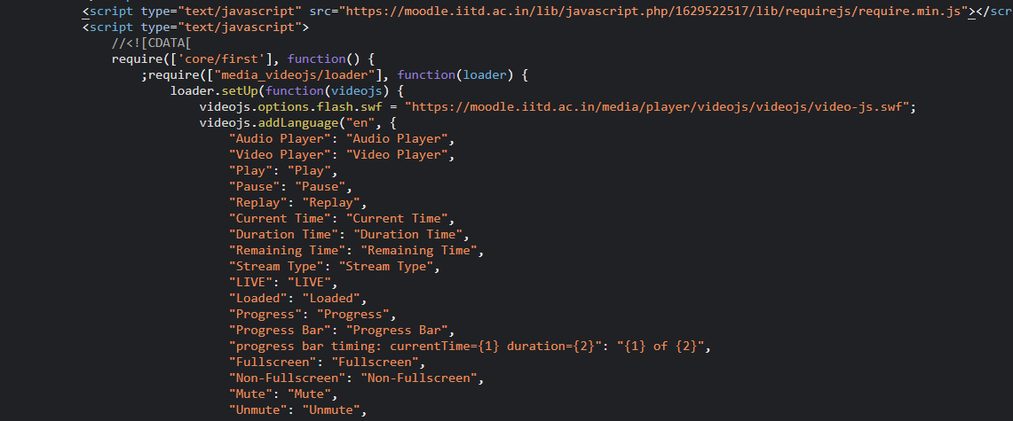

More script files:

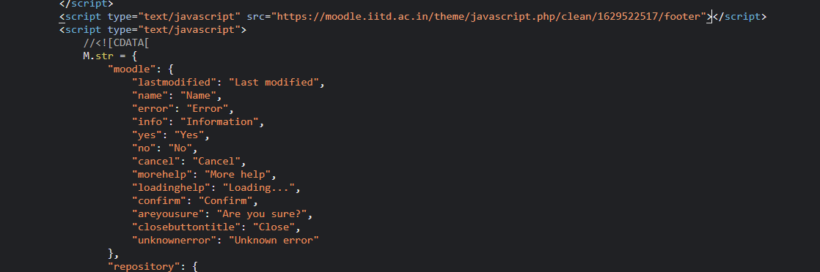

Script for footer:

///////////////////////////////////////////////////////////////////////////////////////////////////////////////////////////

**2. Headers:**

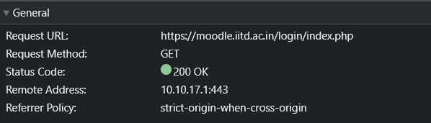

Status code refers to http response which is 200 showing successful response.

Remote address probably refers to the port

Referrer policy refers to whether url is sent full or only a part of it.

Strict-origin-when-cross-origin offers more privacy. With this policy, only the origin is sent in the Referer header of cross-origin requests. This prevents leaks of private data that may be accessible from other parts of the full URL such as the path and query string.

***Response headers*** hold additional information about the response, like its location or about the server providing it.

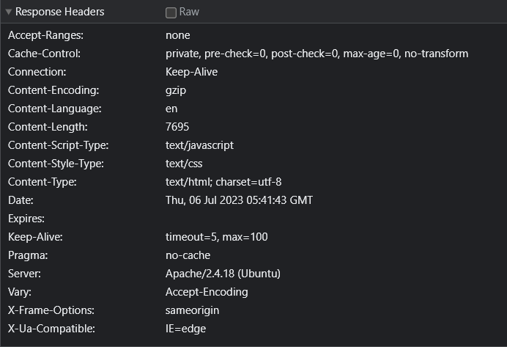

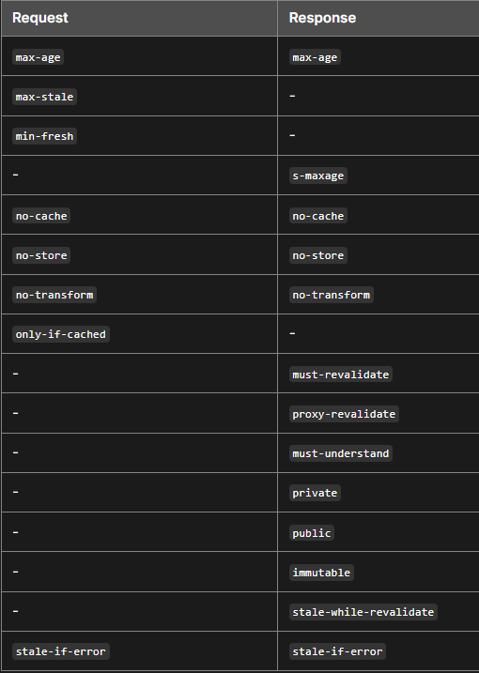🡪The Cache-Control HTTP header field holds directives (instructions) — in both requests and responses — that control caching in browsers and shared caches (e.g. Proxies, CDNs). Private cache exists in the client. It is also called local cache or browser cache. It can store and reuse personalized content for a single user. The max-age=N response directive indicates that the response remains fresh until N seconds after the response is generated. Some intermediaries transform content for various reasons. For example, some convert images to reduce transfer size. In some cases, this is undesirable for the content provider. no-transform indicates that any intermediary (regardless of whether it implements a cache) shouldn't transform the response contents.

🡪Connection header is a hop by hop header and it should not be retransmitted by proxies or cached. The Keep-Alive general header allows the sender to hint about how the connection may be used to set a timeout and a maximum amount of requests.

🡪Content- Used to specify the compression algorithm, human language, size of resource(in bytes), type of resource.

🡪Expires The date/time after which the response is considered stale.

🡪Pragma Implementation-specific header that may have various effects anywhere along the request-response chain. Used for backwards compatibility with HTTP/1.0 caches where the Cache-Control header is not yet present.

🡪Vary Determines how to match request headers to decide whether a cached response can be used rather than requesting a fresh one from the origin server.

***Request headers*** contain more information about the resource to be fetched, or about the client requesting the resource.

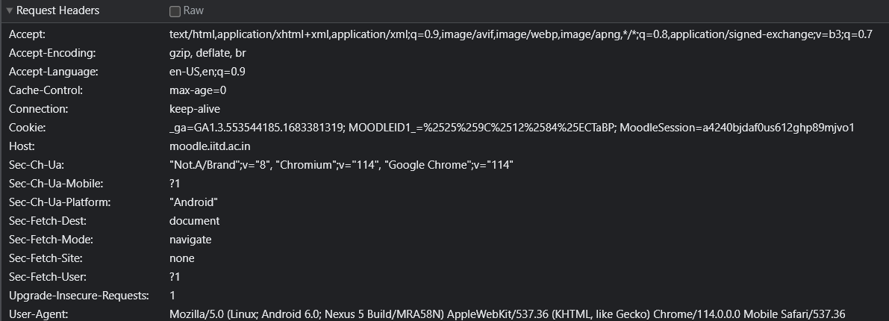

🡪Sec-Fetch metadata request headers provide information about the context from which the request originated. A server can use them to make decisions about whether a request should be allowed, based on where the request came from and how the resource will be used.

🡪Sec-Fetch-Site is set to none because the request has not been made by a site.

🡪Sec-Fetch-User is set to 1 indicating that a navigation request was triggered by user navigation.

🡪Sec-Fetch-Dest is set to socument indicating requests destination.

🡪Cookie Contains stored HTTP cookies previously sent by the server with the Set-Cookie header.

🡪User-Agent Contains a characteristic string that allows the network protocol peers to identify the application type, operating system, software vendor or software version of the requesting software user agent.

Representation or payload headers have not been used over here.

///////////////////////////////////////////////////////////////////////////////////////////////////////////////////////////

**3. Login to moodle:**

Before: After:

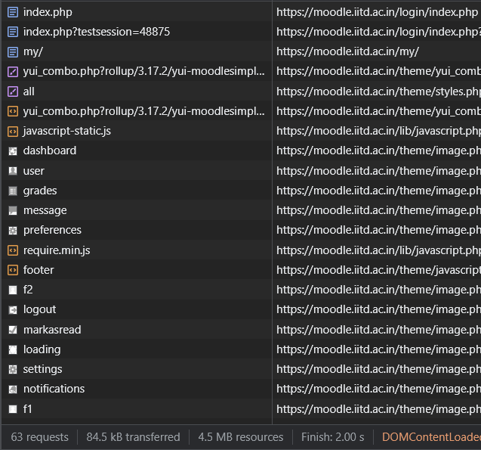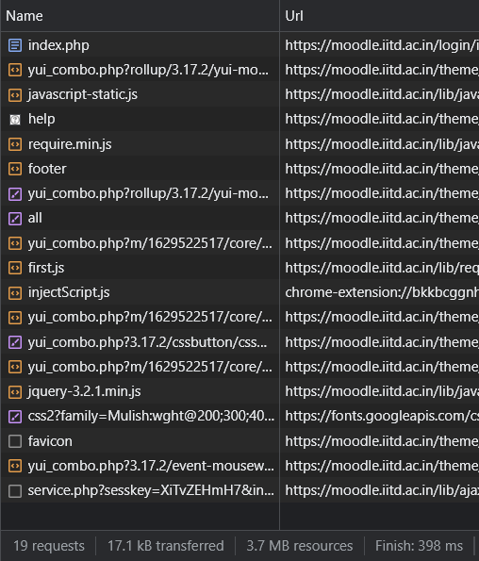

After login to moodle the no. of requests went to 63 from 19 and it took 2s to finish.

