Functional Documentation – Online Campus:

Student forgot his password

17 Feb 2006

Problem Statement

Student forgets his password and he cannot join myUnisa again. Provide student with an option to retrieve his password. Unfortunately the idVault does not allow retrieving of passwords. When student forgets his password we will email him a new random generated password. In the email there will be a link and when the student clicks on the link his previous password will be changed to the new password. Student must then login with his new password.

User story
??

Background

System Requirements

Student forgot his password

Requirements – Request password | Accepted?
- Mandatory fields for requesting a password:
- Student number

- student number must be an integer and cannot be more that 8 characters
- Validate that the students myUnisa account was activated.
- (package: za.ac.unisa.lms.tools.join.dao
Class: MyUnisaJoinSakaiDAO
Method: myUnisaAccountActive)

- If it was not activated the password may not be emailed to student.
- Error message: “You must still activate your myUnisa account. If you haven’t received your activation e-mail, please \"join\" again, by clicking on the appropriate link on the navigation menu. You entered the following student number: <stno>; please ensure that it is correct”

- Validate that user exists on the idVault.
- If user does not exist display error message and do not email password.
- Error message: “The student number you submitted may be wrong. Please check and try again. If you are sure you entered the correct student number and still receive this error message, you will have to join as a myUnisa user again (this is a result of the new login procedure)."

- Validate that student have an e-mail address.
- Error message: “Your password can not be emailed to you because we do not have an email address for you on our records.”

- If password may be e-mailed the following must happen:
- generate dummy password, this must be a randomly selected number
- Send the forget password email containing the new password.
- Email subject: "myUnisa account details"
- Email body:
"Dear student
NB: This is an automated response - do not reply to this e-mail.
You are receiving this e-mail in response to selecting the Forget Password link on myUnisa.
If you did not forget your password and do not want to change it, ignore this e-mail.
Your new password will only be activated on myUnisa when you click on the link provided below.
You may change the password by selecting the appropriate link under \"My admin\" once you have logged in.
Your new myUnisa user account details:
click on: <link to myUnisa>
Student Number : <stno>
Password : <dummy password”

- After e-mail was successfully send display confirmation page
- “Request for myUnisa password
Student number <stno>
Request for password successful!
An e-mail has been sent to you containing the new password.
This password will only become active once you have clicked on the link provided in the e-mail.
The following e-mail address was used: <student e-mail address>

Requirements – Set of password
When student click on the link in his forget password e-mail the following must happen:
- Retrieve students user id from idVault
- Use the following class and method: UserDirectoryService.getUser
- Update the students password
- Use method: IdVaultUser
- Set all the values again in the idVaultUser (idVaultuser.setPassword)
- Save the new user detail
- ComponentManager.get("org.sakaiproject.service.legacy.user.UserDirectoryProvider")).saveUser(idVaultuser)
- Message to be displayed after password was changed:
- “Request for myUnisa password
Your password has been changed to the password that was e-mailed to you. You are now ready to use myUnisa ( https://my.unisa.ac.za ) again by logging in with your new password. “
Bottom of Form

UML

5.1 Flow diagram:

Presentation Layer

  - First Screen – enter student number:

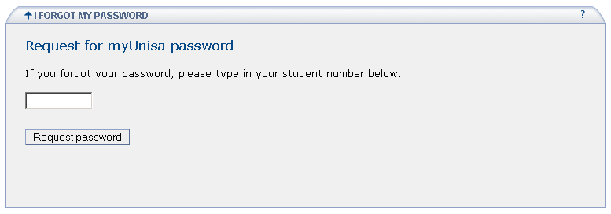

  - Request for password successful

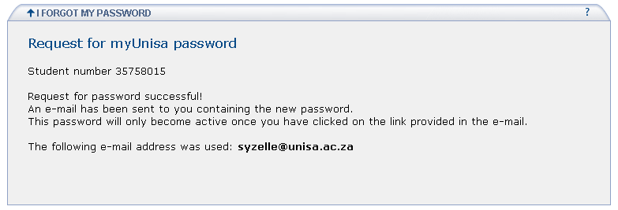

  - Email that contains new password

Dear student
NB: This is an automated response - do not reply to this e-mail.
You are receiving this e-mail in response to selecting the Forget Password link on myUnisa.
If you did not forget your password and do not want to change it, ignore this e-mail.
Your new password will only be activated on myUnisa when you click on the link provided below.
You may change the password by selecting the appropriate link under "My admin" once you have logged in.
Your new myUnisa user account details:
click on: http://localhost:8080/unisa-password/forgotPassword.do?action=activate&dpw=1137951567&stno=35758015
Student Number : 35758015
Password : 1137951567

  - Confirmation that password was changed
Top of Form

Request for myUnisa password
Your password has been changed to the password that was e-mailed to you. You are now ready to use myUnisa ( http://localhost:8080 ) again by logging in with your new password.
Bottom of Form

Application Layer

  - Project Information:
Project name: unisa-password
Source: Packages, Classes and methods
- ApplicationResources.properties
/unisa-payments/src/za/ac/unisa/lms/tools/password/ApplicationResources.properties
- Actions:
(unisa-payments/src/za/ac/unisa/lms/tools/password/actions)
  - ForgotPasswordAction
Class to retrieve email a new password to student if he forgot his password.

- Forms:
((/unisa-payments/src/za/ac/unisa/lms/tools/password/forms)
  - ForgetPasswordForm

- idVault packages:
  - za.ac.unisa.lms.providers.api.IdVaultProvisioner
  - za.ac.unisa.lms.providers.api.IdVaultUser
  - org.sakaiproject.service.legacy.user.User;
  - import org.sakaiproject.service.legacy.user.cover.UserDirectoryService;

- Other packages:
  - za.ac.unisa.lms.tools.join.dao
All database related classes for the myUnisa join.
    - MyUnisaJoinSakaiDAO: all sakai database related methods.

Web: /unisa-payments/web/WEB-INF/
- validation.xml
- web.xml
- struts-config.xml
- validator-rules.xml

Web: /unisa-payments/web/WEB-INF/jsp/
- default.jsp – forward to first page of “forget password”
- forgotinput.jsp – input screen when student forgot his password
- forgotconfirm.jsp – confirmation screen that new password was emailed to student.
- failsetpwd – error screen if students password could not be reset
- setpassword.jsp – to update the students’ password when he clicked on link in email.

Project documentation
- User specification: None
- Functional specification: ST_ForgetPassword.doc (/unisa-password/doc/ ST_ForgetPassword.doc)

- All fields must be validated. Error messages must be displayed on the same screen.
- On completion, the fields must be emptied and a message must display indicating the successful transaction.

  - Class Diagram
ForgotPasswordAction
Input
inputValidate
sendForgetPasswordEmail
activate
generateDummyPassword

ForgetPasswordForm
Email
studentNr
serverPath
getEmail
getStudentNr
getServerPath
setEmail
setStudentNr
setServerPath

Business Logic Layer

The forget password will be like the previous SOL forget password process. Student will provide his student number. We will retrieve his email address from the student system and email a newly generated password to him. This is because we cannot retrieve password from the idVault. The email will contain a link, when the student click on the link his password will be changed and he can login using the new password.

Database aspects

None

Document History

Date | Version | Author | Comments
17 Feb 2006 | 1 | Sonette Yzelle | Version 1, only done after coding due to time constraints.

