Functional Documentation – Online Campus:

Student Payment of study fees

16 Feb 2006

Problem Statement

Allow current, registered students to request payment transactions online. Payments by both credit card and non-credit card will be accommodated.

User story
Students want to settle their outstanding accounts with Unisa either in installments or once of payments. These payments can be made by credit card, cash or bank deposits. Unisa LMS does not cater for full online payment. It will make provision for an online submission of credit card payment forms.

For credit card payments, the details of the card, the card owner, and the amounts payable as well as related student details are entered onto an online form in the LMS. This online form is then submitted to the relevant student administration department for processing. The student receives an online confirmation note on submission that the request for payment processing has been sent. Any omissions or data errors on the online form should be pointed out to the student before submission.

All other requests for payment processing via the LMS, including cash and bank deposits, are directed to a standard Unisa form in PDF format. The student needs to download and print the form from the LMS to use it. Like other paper forms it should be signed and either faxed or mailed to Unisa. No online transactions are involved in this payment method.

Background

These functions are only available in the current SOL. COOL has no equivalent function.

The current SOL functionality will be translated into the new LMS. Both credit card and non-credit card payment requests will be available in a single administrative tool for students.

System Requirements

Credit card payments.

Requirements | Accepted?
- Mandatory fields for credit card payments:
- Total amount
- Please specify Matric Exemption and/or Study fee(s)
- credit card number
- CV number
- expiry date
- budget option
- card holder surname and initials
- id number
- E-mail address

- Validate the credit card number
- Function invalidCCNo(ccno) {
var sum = 0;
var digit;
for (i = 1; i <= 16; i++) {
digit = parseInt(ccno.substring(i - 1, i), 10);
if ((i % 2) == 0) {
sum += digit;
} else if (digit < 5) {
sum += digit * 2;
} else {
switch (digit) {
case 5: sum += 1; break;
case 6: sum += 3; break;
case 7: sum += 5; break;
case 8: sum += 7; break;
case 9: sum += 9; break;
}
}
}
return ((sum % 10) != 0);
}
- Validate that the credit card number only exist of numeric digits (0-9).

- Validate that the CV number only exist of numeric digits (0 to 9), and that it is 3 characters long.
- Validate the expiry date
- Validate that the first digit of the month may only be 0 or 1
- The second digit of the month must be between 0 and 9
- Validate that both first and second digit of the year is between 0 and 9.
- Validate that the month is not greater than 12 or smaller than 1
- Validate if credit card has expired, date may not be less than today’s date.

- Only the “Straight" budget option can be selected for amounts less than R200
- Validate email address
- Validate that email address only exist of characters between a to Z, digits 0 to 9 ,“-“ and “.”
- Email address must have a “@” sign.
- Characters must be before and after the “@” sign.

- Validate that the id number does not have non-numerical characters
- Ask student to confirm payment details, display amount details.
- Create workflow document

Credit card payments Workflow document.

Requirements | Accepted?
- workflow filename: payment_<Studno>.wfl
- Create workflow file using: za.ac.unisa.utils.WorkflowFile
- Content of file:
Subject : Credit Card Payment for Study Fees or Matric Exemption Fees
Date Received : <date and time>
The following credit card payment was received through the Unisa Web Server.
Details :
Student Number =
Degree =
Surname =
First Names =
Initials =
Title =
Date of Birth =
Home Telephone Number =
Cell Number =
email Address = (if changed add <<<< Changed >>>>)
Postal Address =
------------------------------------------------------
Study Fees =
Matric Exemption Fees =
Total Fees =
Credit Card Number =
CV Number =
Expiry Date =
Budget Option =
Card Holder Name =
Card Holder ID Number

- Write logs:
  - SOLSTA - statistics log
  - SOLGEN – general log

Non-credit card payments

Requirements | Accepted?
- Student must download payment PDF file. (http://registration.unisa.ac.za/info/download/payment/payment.pdf)
Verify that PDF file is valid for registration cycle.

UML

5.1 Flow diagram:

No
No
Yes
Yes
No
Logged in Unisa student
Get and display student detail
Student complete payment information
Student number
Was all mandatory fields completed?
Was valid credit card number entered?
Is CV number valid?

Workflow Continue:
Has credit card number expired?
Complete payment detail
Is emial address syntax valid?
No
Yes
Yes
No
Create workflow document
Display confirmation.

Presentation Layer

6.1 First Screen – enter of details:

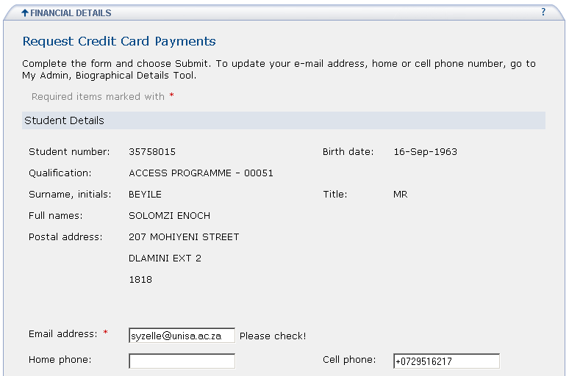

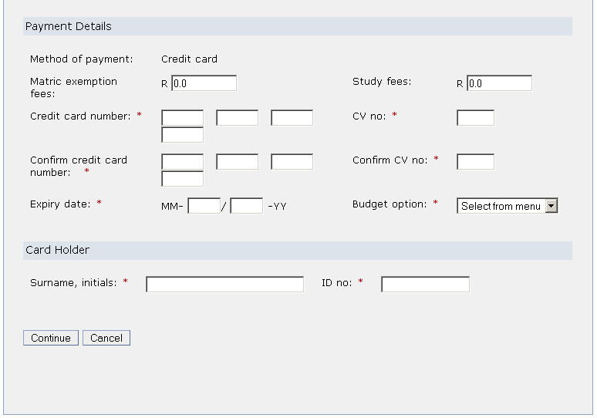

6.4 Confirm payment details
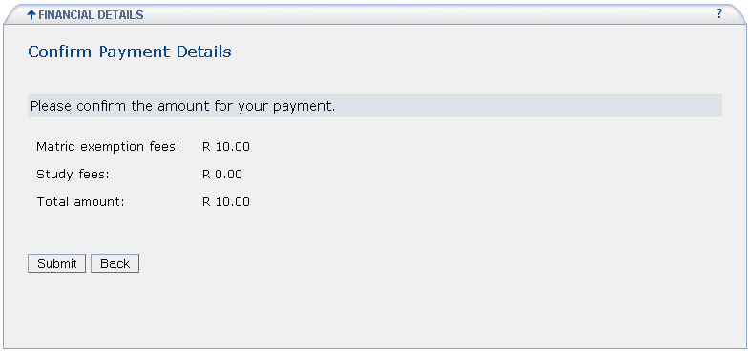

6.3 Credit card Confirmation screen:

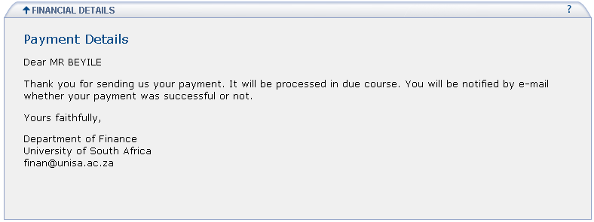

6.4 Credit card Workflow document

Credit Card Payment for Study Fees or Matric Exemption Fees
Date received: Thursday 16 February 2006 11:59:28
The following credit card payment was received through the Unisa Web Server.
Details:
Student number = 35758015
Degree =
ACCESS PROGRAMME - 00051
Surname = BEYILE
First Names = SOLOMZI ENOCH
Initials = S E
Title = MR
Date of Birth = 16-Sep-1963
Home Telephone number =
Cell number = +0729516217
Email address = syzelle@unisa.ac.za
Postal Address = null
-------------------------------------------------------------------
Study Fees = 0.0
Matric Exemption Fees = 10.0
Total Fees = 10.0
Credit Card Number = xxxxx
CV Number = xxx
Expiry Date = 01\07
Budget Option = Straight
Card Holder Name = testing
Card Holder ID Number = xx

6.5 Non-credit card payments screen

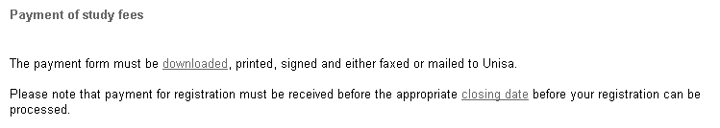

Application Layer

  - Project Information:
Project name: unisa-payments
Source: Packages, Classes and methods
- ApplicationResources.properties
/unisa-payments/src/za/ac/unisa/lms/tools/payments/ApplicationResources.properties
- Actions:
(unisa-payments/src/za/ac/unisa/lms/tools/payments/actions)
  - CreditCardPaymentAction
Class to retrieve student detail, validate payment detail and create workflow document.

- Forms:
((/unisa-payments/src/za/ac/unisa/lms/tools/payments/forms)
  - CreditCardPaymentForm

- DAO:
((/unisa-payments/src/za/ac/unisa/lms/tools/payments/dao)
  - StudenQueryDAO: All selects from student system Oracle database

Web: /unisa-payments/web/WEB-INF/
- validation.xml
- web.xml
- struts-config.xml

Web: /unisa-payments/web/WEB-INF/jsp/
- paymentindex.jsp – page with options credit card or other payment.
- creditform.jsp – credit card payment form to be completed
- payment.jsp – confirmation page of credit card payment
- otherpayment.jsp – non-credit card payment (download pdf file payment.pdf)
- registration.unisa.ac.za/info/download/payment/payment.pdf

Project documentation
- User specification: None
- Functional specification: SU_MA_PAY_OnlinePayments.doc (/unisa-payments/doc/SU_MA_PAY_03_OnlinePayments.doc)

- All fields must be validated. Error messages must be displayed on the same screen.
- On completion, the fields must be emptied and a message must display indicating the successful transaction.

  - Class Diagram
CreditCardPaymentAction
minAmount
operListener
getKeyMethodMap
input
save
confirm
back
cancel
other
getBudgetOptionsDropList
writeWorkflow
CreditCardPaymentForm
matricExempFees
title
cell
studyFees
homePhone
cardholderSurname
birthDate
cvNo
confCVno
expiryDate
expiryMonth
expiryYear
total
surname
stno
firstNames
postalAddress
emailAddress
prevEmailAddress
initials
budgetOption
creditCardNumber
creditCardNumber1
creditCardNumber2
creditCardNumber3
creditCardNumber4
degree
cardHolderId
confCreditCard
confCreditCard1
confCreditCard2
confCreditCard3
confCreditCard4
postal
postalCode
getMatricExempFees(): String
setMatricExempFees(String matricExempFees)
getTitle(): String
setTitle(String title)
getCell(): String
setCell(String cell)
getStudyFees():String
setStudyFees(String studyFees)
getHomePhone(): String
setHomePhone(String homePhone)
getCardholderSurname(): String
setCardholderSurname(String cardholderSurname)
getBirthDate(): String
setBirthDate(String birthDate)
getCvNo(): String
setCvNo(String cvNo)
getExpiryDate(): String
setExpiryDate(String expiryDate)
getExpiryMonth(): String
setExpiryMonth(String expiryMonth)
getExpiryYear(): String
setExpiryYear(String expiryYear)
getTotal(): string
setTotal(String total)
getSurname(): String
setSurname(String surname)
getStno(): String
setStno(String stno)
getFirstNames(): String
setFirstNames(String firstNames)
getPostalAddress(): String
setPostalAddress(String postalAddress)
getEmailAddress(): String
setEmailAddress(String emailAddress)
getPrevEmailAddress(): String
setPrevEmailAddress(String prevEmailAddress)
getInitials(): String
setInitials(String initials)
getBudgetOption()
setBudgetOption(String budgetOption)
getCreditCardNumber(): String
setCreditCardNumber(String creditCardNumber)
getCreditCardNumber1(): String
setCreditCardNumber1(String creditCardNumber1)
getCreditCardNumber2(): string
setCreditCardNumber2(String creditCardNumber2)
getCreditCardNumber3(): String
setCreditCardNumber3(String creditCardNumber3)
getCreditCardNumber4(): String
setCreditCardNumber4(String creditCardNumber4)
getDegree(): String
setDegree(String degree)
getCardHolderId(): String
setCardHolderId(String cardHolderId)
getConfCreditCard(): String
setConfCreditCard(String confCreditCard)
getConfCreditCard1(): String
setConfCreditCard1(String confCreditCard1)
getConfCreditCard2(): String
setConfCreditCard2(String confCreditCard2)
getConfCreditCard3(): String
setConfCreditCard3(String confCreditCard3)
getConfCreditCard4(): String
setConfCreditCard4(String confCreditCard4)
getConfCVno(): String
setConfCVno(String confCVno)
getPostal(): Vector
setPostal(Vector postal)
getPostalCode(): String
setPostalCode(String postalCode)

Business Logic Layer

  - Credit card payments

Certain information will be displayed to the student, his email address and cell phone number will be updateable. Student will complete the payment detail. After successful completion of the information a workflow file will be created. No data will be updated through this tool.

  - Other payments

A pdf file will be available for download.

Database aspects

Database will be accessed through a java proxy (Srcds01sMntStudContactDetail) (Srcds01h.Abean.Srcds01sMntStudContactDetail).

No data will be written away to the database, only a workflow file will be created using the WorkflowFile (za.ac.unisa.utils.WorkflowFile) class.

Document History

Date | Version | Author | Comments
22-Aug-2005 | Draft 1 | Sonette Yzelle | First draft
1-Sep-2005 | Draft 2 | Francette Myburgh | Added User Story and Background
5-Sep-2005 | Draft 3 | Sonette Yzelle | Add rest of screens, business layer and application layer.
10 Oct 2005 | 4 | Sonette Yzelle | Add class diagram
16 Feb 2006 | 5 | Sonette Yzelle | Make sure that specs is updated according to the system.

