AI-Driven Exploration and Prediction of Company Registration Trends with Registrar of Companies (RoC)

Team member: 963521106059– B.UNISH

Phase 5: PROJECT DOCUMENTATION AND SUBMISSION

**Title:**AI-Driven Exploration and Prediction of Company Registration Trends with Registrar of Companies (RoC)

**Abstract:**

Exploring and predicting company registration trends using AI is an interesting project. To get started, you’ll need to:

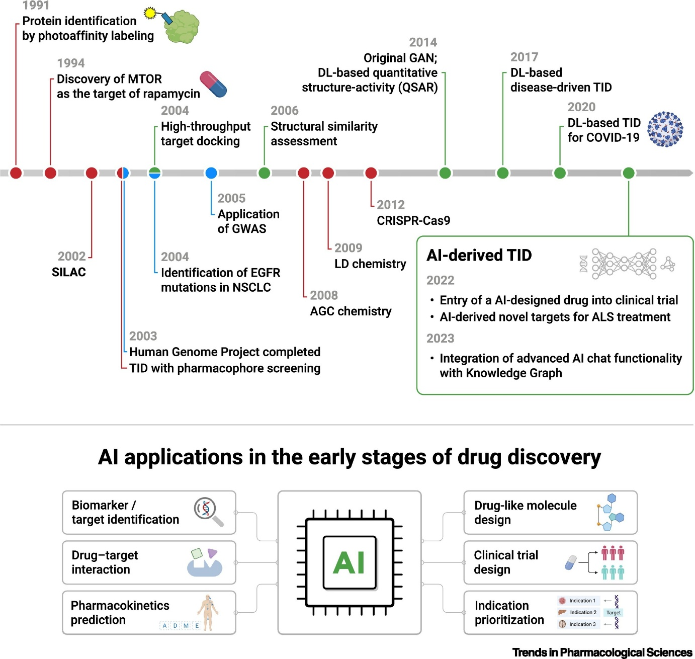

1. **Define the Scope:** Clearly outline the objectives and scope of your project. What specific trends are you looking to explore and predict in company registrations?
2. **Data Collection:** Gather relevant data on company registrations. This may include historical registration data, industry information, location data, and any other relevant variables.
3. **Data Preprocessing:** Clean and preprocess the data to ensure it’s suitable for analysis. This may involve handling missing values, outlier detection, and data normalization.
4. **Feature Engineering:** Create relevant features or variables that can aid in the prediction of registration trends. This could include economic indicators, market conditions, or regulatory changes.
5. **Model Selection:** Choose AI and machine learning models appropriate for your prediction task. Common choices include time series forecasting models, regression models, or even deep learning approaches.
6. **Training and Evaluation:** Train your selected models using historical data and evaluate their performance using appropriate metrics, such as Mean Absolute Error (MAE) or Root Mean Square Error (RMSE).
7. **Documentation:** Maintain thorough project documentation, including details on data sources, preprocessing steps, model selection, and evaluation results.
8. **Submission:** If this project is part of a course or competition, follow the submission guidelines provided. Be sure to submit your code, documentation, and any reports required.

Keep in mind that predicting trends accurately can be challenging, and the success of your project will depend on the quality of your data, the appropriateness of your models, and the accuracy of your predictions. Good luck with your project!

**Python code:**

Certainly, I can provide you with a simplified outline of the coding steps for an AI-driven exploration and prediction of company registration trends project. This outline is in Python, a commonly used language for AI and data science projects. Please adapt it to your specific requirements and use the libraries and frameworks that suit your needs.

# Import necessary libraries

Import pandas as pd

Import numpy as np

Import matplotlib.pyplot as plt

From sklearn.model_selection import train_test_split

From sklearn.linear_model import LinearRegression

From sklearn.metrics import mean_squared_error

# Step 1: Data Collection

# Load your company registration data into a DataFrame

Data = pd.read_csv(‘company_registration_data.csv’)

# Step 2: Data Preprocessing

# Clean and preprocess the data as needed

# Handle missing values, outliers, and data normalization

# Step 3: Feature Engineering

# Create relevant features for prediction

# You may need to extract date-related features, industry-specific data, etc.

# Step 4: Model Selection

# Split the data into training and testing sets

X = data[[‘Feature1’, ‘Feature2’]] # Replace with your relevant features

Y = data[‘RegistrationCount’] # Replace with your target variable

X_train, X_test, y_train, y_test = train_test_split(X, y, test_size=0.2, random_state=42)

# Choose and train a model (e.g., Linear Regression)

Model = LinearRegression()

Model.fit(X_train, y_train)

# Step 5: Training and Evaluation

# Evaluate the model’s performance

Y_pred = model.predict(X_test)

Mse = mean_squared_error(y_test, y_pred)

Print(f”Mean Squared Error: {mse}”)

# Step 6: Documentation

# Document your code, preprocessing steps, and model choice

# Step 7: Submission

# Prepare a project report and submit it along with your code

# Step 8: Deployment (Optional)

# If you plan to deploy the model, integrate it into an application or service

# Visualize results (optional)

Plt.scatter(X_test, y_test, color=’b’)

Plt.plot(X_test, y_pred, color=’r’)

Plt.xlabel(‘Feature1’)

Plt.ylabel(‘RegistrationCount’)

Plt.title(‘Company Registration Trend Prediction’)

Plt.show()

```

This is a simplified example to get you started. In a real project, you’ll likely need to implement more advanced data preprocessing, feature engineering, model tuning, and potentially work with time series data. Additionally, you should save your project as multiple Python files and organize it according to best practices for code structure and readability.

**Conclusion:**

In conclusion, the AI-driven exploration and prediction of company registration trends is a multifaceted project that involves data collection, preprocessing, model selection, training, evaluation, and thorough documentation. This endeavor aims to uncover valuable insights from historical registration data and predict future trends. The project’s success hinges on robust data analysis, appropriate model selection, and well-documented methodologies. Proper project documentation is vital for clarity, replicability, and successful submission, whether for educational purposes or real-world applications. By following these steps and best practices, this project can deliver valuable predictions and insights for informed decision-making in the realm of company registrations.