SUMMER INTERNSHIP PROJECT REPORT
ResumeFlow — A Modern Resume Building Web Application
Frontend Development Internship
Particulars | Details
Intern Name | Unishka Bisht
Project Title | ResumeFlow — Professional Resume Builder
Domain | Web Application Development (Frontend)
Technologies | Angular 13, TypeScript, Angular Material, SCSS
Internship Duration | Summer 2026

1. Introduction
ResumeFlow is a modern, intuitive, full-featured web application that lets professionals and job seekers design, manage, version, and export professional resumes effortlessly. Traditional word processors often lead to broken layouts, inconsistent formatting across devices, and chaotic file management when tailoring applications for different roles. ResumeFlow addresses these pain points by providing consistent, pre-tested templates, real-time editing with live preview, version snapshots, and high-fidelity client-side exports with zero data loss.
This report documents the work completed during the summer internship on the ResumeFlow frontend — a multi-project Angular workspace that delivers a polished, responsive user experience with glassmorphism styling, authentication, a document editor, multi-template switching, and client-side PDF/DOCX export.
2. Internship Objectives
- Build a responsive, production-quality Angular frontend for resume creation.
- Implement a real-time document editor with live preview and section management.
- Develop multiple professional resume templates with one-click switching.
- Integrate client-side PDF and DOCX export with an export history log.
- Add authentication (signup, login, forgot/reset password) with route guarding.
- Deliver a premium UI with dark mode and glassmorphism design language.
3. Technology Stack
Layer | Tools & Libraries
Framework | Angular 13 (standalone component-based architecture)
Language | TypeScript 4.6
UI Components | Angular Material 13, Angular CDK
Styling | SCSS custom design system, CSS variables, glassmorphism
Document Generation | html2pdf.js, docx, file-saver
State & Networking | RxJS, Angular HttpClient, Auth Interceptors
Typography / Icons | Google Fonts (Manrope, Sora, Space Grotesk, Roboto), Material Icons
4. System Architecture & Project Structure
The application is organised as a multi-project Angular workspace. The primary deliverable lives under projects/web and is structured into reusable components, routed pages, shared services, and interceptors.
Module / Path | Responsibility
guards/ | Route protection — AuthGuard & NoAuthGuard
components/ | Reusable landing-page components (Hero, Features, Stats, etc.)
pages/document-editor/ | Live resume builder & preview engine
pages/documents/ | Resume collection management
pages/templates/ | Template showcase & selection
pages/exports/ | Export history & downloaded files
pages/dashboard/ | User central dashboard & metrics
pages/profile/ | User profile settings
pages/applications/ | Job application tracking
shared/services/ | Auth, HTTP interceptors, toast & common services
environments/ | Environment configuration (dev / prod)
5. Key Features Implemented
5.1 Real-Time Document Editor
- Live Preview: Interactive live preview updates instantly as content is typed.
- Section Management: Add, remove, and reorganise sections (Experience, Education, Skills, Projects, Certifications).
- Formatting: Dynamic rich-text and bullet itemisation for clean readability.
- Photo Support: Profile photo upload and preview support across resume templates.
5.2 Professional Templates
Users can switch between expertly designed presets in a single click while preserving all entered data:
- Modern Split — contemporary dual-column layout with visual accents
- Minimal Clean — streamlined, elegant, high-signal typography
- Technical / Engineering — optimised for technical competencies
- Executive — structured for leadership and enterprise portfolios
- Creative — balanced colour palettes with bold headline styling
5.3 Client-Side Export
- PDF Export: High-resolution, browser-side PDF generation via html2pdf.js.
- DOCX Export: Native Microsoft Word (.docx) generation using docx + file-saver.
- Export History: Digital log of all exported files.
5.4 Authentication & Security
- Auth Suite: Complete auth suite: Sign Up, Login, Forgot Password, Password Reset.
- JWT Interceptor: JWT interceptor with automatic token management.
- Route Guards: Protected routes via Angular route guards (AuthGuard & NoAuthGuard).
5.5 Premium UI & Theming
- Visual Design: Glassmorphism effects with smooth micro-interactions.
- Responsive: Responsive navigation across mobile, tablet, and desktop.
- Dark Mode: Seamless light/dark theme switching.
6. Implementation Highlights
- Built a modular, lazy-loaded Angular workspace to keep the bundle lean and maintainable.
- Implemented a reactive document model so template switching never loses user data.
- Wrapped html2pdf.js and the docx library in dedicated services for reusable, one-click exports.
- Centralised styling through SCSS variables and a custom design system for consistent theming.
- Added an HTTP interceptor to transparently attach and refresh JWT tokens on every request.
- Used Angular Material components to accelerate accessible, responsive UI construction.
7. Challenges & Solutions
Challenge | Resolution
Preserving data across template switches | Adopted a single source-of-truth document model bound to all templates.
High-fidelity PDF layout from HTML | Tuned html2pdf.js page-break, scale, and CSS to match on-screen design.
Consistent theming in dark mode | Drove all colours from SCSS variables and CSS custom properties.
Maintaining performance with live preview | Used reactive forms and change-detection best practices to avoid reflow thrash.
8. Testing & Validation
- Unit tests via Karma + Jasmine for components and services.
- Cross-browser and responsive checks (mobile, tablet, desktop).
- Manual end-to-end validation of the signup → edit → export flow.
9. Application Screenshots
The following screenshots illustrate the live editor and template showcase of the ResumeFlow application.
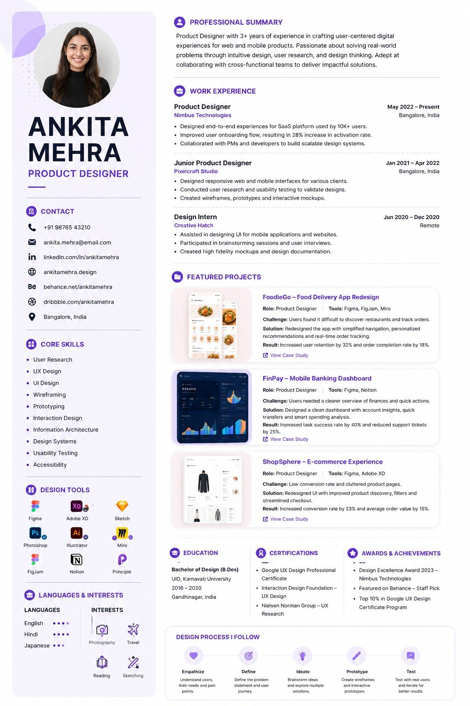
Figure 1 — ResumeFlow document editor / live preview
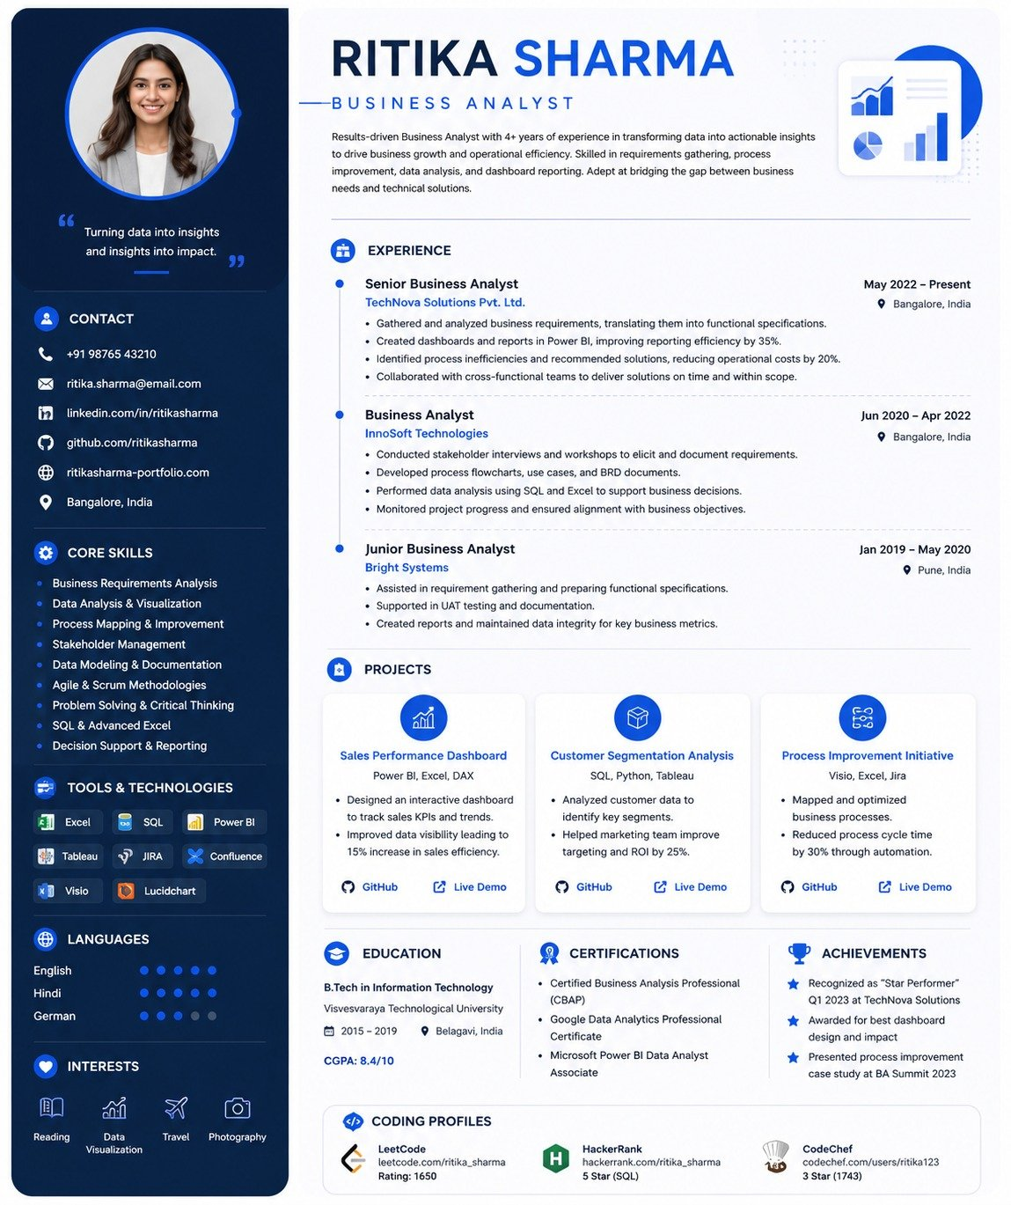
Figure 2 — Template selection & switching
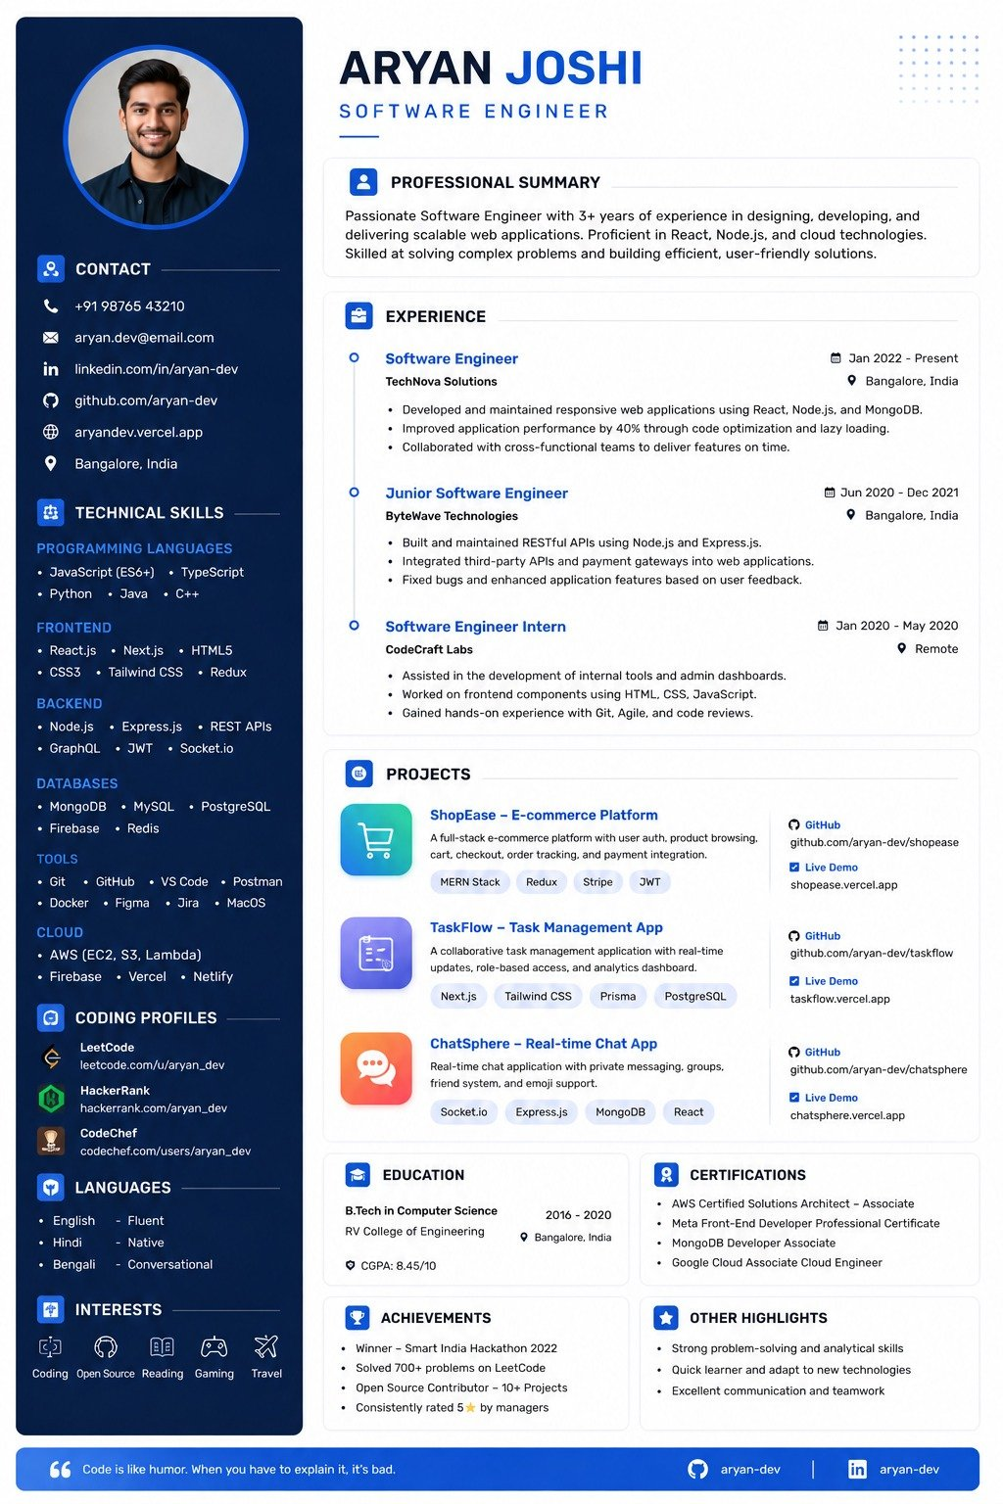
Figure 3 — Resume collection management
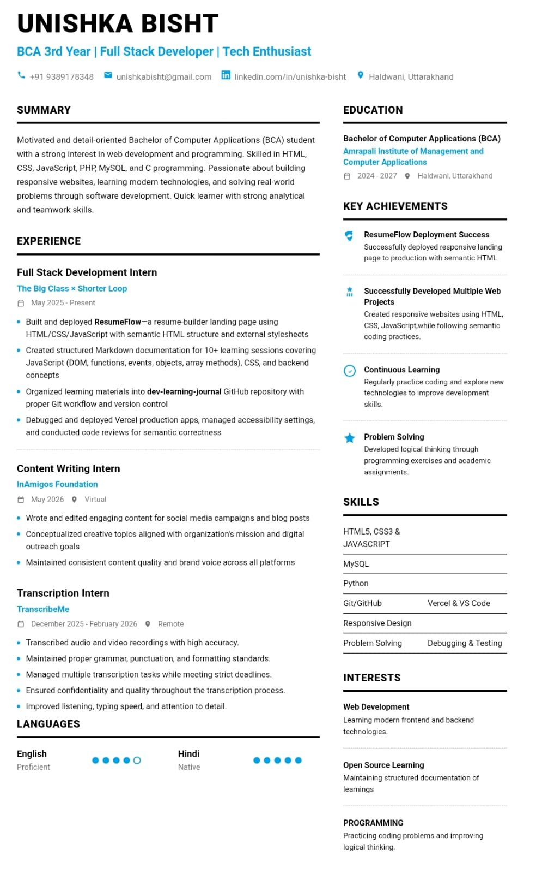
Figure 4 — Dashboard / export history
10. Future Scope
- Automated bullet-point and action-verb suggestions based on target keywords.
- Integrated cover-letter builder synced with resume styling.
- Custom section designer (tabular and timeline layouts).
- Analytics & read-only sharing links for prospective employers.
- Cloud backup integration (Google Drive, Dropbox, OneDrive).
11. Conclusion
The summer internship delivered a complete, production-ready frontend for ResumeFlow. The platform successfully combines a real-time editor, diverse professional templates, secure authentication, and reliable client-side exports into a single, polished experience. The work established a strong, scalable foundation for the future features outlined above and demonstrated practical application of Angular, TypeScript, and modern frontend engineering practices.
Acknowledgement
I sincerely thank my internship mentor and the ResumeFlow team for their guidance, feedback, and support throughout this project. Their mentorship was instrumental in shaping both the application and my growth as a frontend developer.

