
Software Engineering Department
Braude College of Engineering
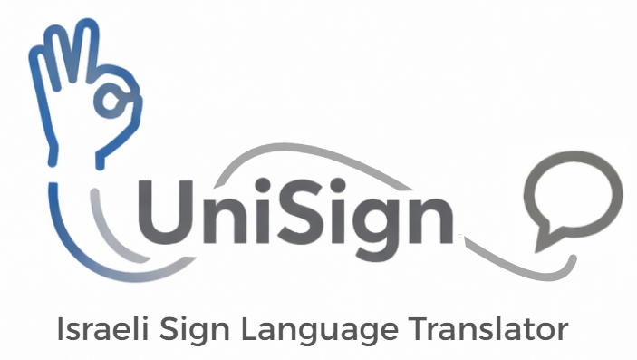
Final Project – Phase A (61998)

UniSign
Israeli Sign Language Translator
26-1-D-14
By:
Noa Shitrit
Tal Yagudin

Advisor:
Dr. Julia Sheidin

Link to GitHub:
https://github.com/Unisign-ISL-Translator
Table of Contents
Abstract 4
Chapter 1: Introduction 4
Chapter 2: Background and Related Work 5
2.1 Deaf and Hard of Hearing (DHH) 5
2.2.1 Stakeholders 5
2.2.1.1 The Deaf and Hard of Hearing Community 5
2.2.1.2 Families of Deaf Individuals 5
2.2.1.3 The General Hearing Public 5
2.2.1.4 Service Providers (Institutions & Businesses) 5
2.2 Existing Technological Solutions 6
2.3 Algorithmic Approaches in Sign Language Recognition 7
2.3.1 Image-Based Approaches (CNN & YOLO) 7
2.3.2 Skeleton-Based Approaches 7
2.3.3 Temporal Modeling (LSTM vs. Transformers) 8
Chapter 3: The Proposed Solution - UniSign 8
3.1 System Overview 8
3.2 Core Features: The Bi-Directional Bridge 8
3.3 Solving the "Independence Gap" 9
Chapter 4: Engineering Process 9
4.1 Requirements Analysis and Specification 9
4.1.1 Requirements Elicitation 9
4.1.2 Main Requirements 10
4.2 System Technology Overview 11
4.2.1 High Level Architecture Design 12
4.2.2 Technology Stack and Development Environment 13
4.2.3 Module A: The Recognition Pipeline (Deaf-to-Hearing) 14
4.2.4 Module B: The Language Refinement Engine 16
4.2.5 Module C: The Visualization Pipeline (Hearing-to-Deaf) 16
4.2.6 Data Flow and Mobile Optimization 17
4.3 Methodology: Data Collection and Model Training 17
4.3.1 Dataset Creation: UniSign-135 17
4.3.2 Data Augmentation Strategy 18
4.3.3 Training Configuration 18
4.4 GUI 19
Chapter 5: Evaluation and Verification Plan 19
5.1 Testing Plan 19
5.1.1 Model Accuracy (Recognition ISL) 19
5.1.2 Real-Time Performance 19
5.1.3 Rendering Engine Verification 20
5.2 Evaluation by Users 20
5.3 Metrics for Success 21
References 22

Abstract
Sign Language Recognition (SLR) aims to bridge communication gaps for the Deaf and Hard of Hearing (DHH) community, particularly in Israel, where automated Israeli Sign Language (ISL) translation remains limited. Conventional video-based systems are often too computationally heavy for real-world, on-device use. UniSign addresses this challenge by developing a lightweight, robust Isolated Sign Recognition (ISR) system using a skeleton-based approach. Google MediaPipe enables efficient, real-time extraction of hand and body kinematic features, naturally resistant to background and lighting noise. The system employs a Long Short-Term Memory (LSTM) network trained on 135-word ISL vocabulary, effectively modeling the temporal dynamics of signs. Our proof-of-concept demonstrates high-accuracy ISR on standard mobile hardware, offering a practical path toward improved accessibility. We also outline a strategy for scalable vocabulary expansion using Feature Embedding techniques.

Chapter 1: Introduction
Sign Language is the primary means of communication for the Deaf community, enabling the expression of complex ideas through manual gestures and non-manual cues such as facial expressions and body posture [4]. In Israel, roughly 10,000 people rely on Israeli Sign Language (ISL) [9], yet most hearing individuals do not understand it [3]. As a result, Deaf individuals often encounter major communication barriers in essential settings such as healthcare, banking, and government services [4,7]. Routine tasks - like a clinic visit or bank inquiry - may require a human interpreter or assistance from hearing family members, limiting spontaneity, privacy, and independence. These challenges highlight the urgent need for accessible, automated ISL translation technologies that can support greater autonomy and dignity in everyday interactions [7].
While there are multiple solutions existing to address this communication divide, they often fall short of practical, everyday utility. Traditional reliance on human interpreters or Video Relay Services is often costly, subject to scheduling availability, and intrusive to personal privacy [4]. On the technological front, previous automated attempts have frequently relied on intrusive hardware, such as sensory gloves or depth cameras, which are cumbersome and limit natural movement [4]. Furthermore, most of the existing software-based research focuses on American Sign Language (ASL), leaving "low-resource" languages like ISL with significantly fewer technological tools and datasets [1,5] In addition, there is a clear shortage of non-intrusive, real-time translation tools adapted to the linguistic nuances of Israeli Sign Language.
To bridge this gap, we propose a novel automated system designed to translate ISL into Hebrew in real-time from the mobile device. Unlike previous hardware-heavy approaches, our system utilizes computer vision to interpret manual gestures, and body poses directly from video input [2,6]. By providing an accessible and user-friendly interface, the system aims to facilitate independent communication for the Deaf community, reducing reliance on third-party intermediaries in daily interactions.

Chapter 2: Background and Related Work

2.1 Deaf and Hard of Hearing (DHH)
In Israel, approximately 10,000 individuals identify as culturally Deaf and rely on Israeli Sign Language (ISL) as their primary mode of communication [9]. For this community, ISL is a distinct natural language with its own grammar and syntax, separate from spoken Hebrew. This linguistic difference creates a profound gap in daily interactions, as most of the hearing population do not understand sign language [3].
Deaf individuals often face significant barriers in essential settings such as healthcare, banking, and government services [4]. While written communication is a common workaround, it is often slow and prone to misunderstanding, particularly for those for whom Hebrew is a second language [7]. Consequently, many rely on human interpreters or family members to mediate interactions. This dependency limits spontaneity, restricts independence, and compromises privacy in sensitive situations [4]. These challenges emphasize the critical need for an automated technological solution that enables immediate, autonomous communication without reliance on third-party intermediaries [7].

2.2.1 Stakeholders
The impact of UniSign extends across four key groups, bridging the gap between the Deaf community and the wider society.

2.2.1.1 The Deaf and Hard of Hearing Community
The primary beneficiaries gain independence and privacy. UniSign eliminates the dependency on human mediators, allowing users to manage daily tasks, such as medical or financial inquiries, spontaneously and autonomously [7]. Furthermore, it fosters social inclusion by enabling direct, bi-directional participation in the hearing world [3].

2.2.1.2 Families of Deaf Individuals
The system alleviates the "burden of mediation." Family members are often forced to act as interpreters for every interaction; UniSign frees them from this logistical role, allowing them to focus on their personal relationships rather than serving as intermediaries [4].

2.2.1.3 The General Hearing Public
UniSign removes the friction and hesitation often associated with communicating with Deaf individuals. It enables the hearing public to converse spontaneously with neighbors or strangers, fostering a more diverse, inclusive, and accepting society [3].

2.2.1.4 Service Providers (Institutions & Businesses)
Organizations gain the ability to provide immediate, accessible service without the high cost and delay of scheduling interpreters [4]. Adopting such technology improves operational efficiency and enhances the organization's brand reputation as a socially responsible and inclusive entity.

2.2 Existing Technological Solutions

2.2.1 Case Study: Sign Now
One prominent human-interpreter solution in Israel is Sign Now, a Video Remote Interpreting (VRI) service that connects Deaf and Hard of Hearing users with certified Israeli Sign Language (ISL) interpreters through real-time video calls.
Workflow: The user opens the app and requests a call, which can be either on demand (immediate) or scheduled in advance. A human interpreter joins the video line to mediate the conversation between the Deaf user and a hearing service provider (such as a doctor, bank teller, or government clerk).
Strengths: The service provides high quality, culturally nuanced translation because it relies on human expertise. It effectively bridges the gap in complex or high-stakes interactions where 100% accuracy is critical.
Limitations: Despite its effectiveness, Sign Now illustrates the inherent limitations of human-based solutions [4]:
Dependency: The user remains dependent on the availability of a third person (the interpreter).
Privacy: Sensitive medical or financial discussions must be shared with a stranger, which compromises the user's privacy [4].
Spontaneity: The logistical need to initiate a call and wait for a connection makes it less viable for quick, casual, or strictly private daily interactions.

2.2.2 Text-Based and General Translation Tools
The most accessible "low-tech" solution currently employed is simple text-based communication - via either pen and paper, smartphone note-taking apps, or general translation applications like Google Translate. While widely accessible and free, this approach suffers from critical usability and communication limitations.
- Functionality:
  - Writing/Typing: The Deaf individual and the hearing person pass a phone or paper back and forth, typing or writing out their messages.
  - Speech-to-Text Apps: The hearing person speaks into a standard app (like Google Translate or WhatsApp dictation), which converts their speech to text for the Deaf user to read.
- Critical Limitations:
  - Unidirectional Asymmetry: These tools create an unbalanced conversation. The hearing person can communicate naturally and quickly using their voice (Speech-to-Text). However, the Deaf person cannot reply in their native language (ISL), being forced instead to type their response. This makes the interaction significantly slower and breaks the natural flow of conversation.
  - Loss of Visual Contact: Communication with Deaf individuals relies heavily on eye contact and body language. Looking down at a screen or paper to type breaks this visual connection, making the interaction feel impersonal and robotic.
  - The Literacy Barrier (Hebrew as a Second Language): It is a common misconception that all Deaf individuals are fully proficient in written Hebrew. For many native signers, Israeli Sign Language (ISL) is their first language, while written Hebrew is a second language. Research indicates that literacy levels vary within the Deaf community, and complex written sentences may be difficult for some users to comprehend or generate quickly under pressure. Relying solely on text excludes members of the community who may have lower written proficiency.

2.2.3 Summary
Our analysis highlights that the existing solutions fail to provide a complete, private, and independent communication method for the Israeli Deaf community. To bridge the gaps effectively, the proposed UniSign system must meet the following core elements:
- Two-way communication: The system must support both Sign-to-Text and Text-to-Sign to solve the communication gap between the deaf and hearing.
- Smartphone accessibility: The solution must be able to run on standard smartphones’ hardware, eliminating the need for additional hardware that can be expensive.
- Offline privacy: To maximize user privacy, the system needs to run locally on the device without any cloud dependency.
- ISL adaptation: To handle the specific syntax of the ISL, the system can’t rely on existing sign recognition models for other languages.

2.3 Algorithmic Approaches in Sign Language Recognition
Prior to defining our architecture, we examined several prevailing algorithmic approaches in the field of Sign Language Recognition (SLR) to select the most suitable technology for a real-time mobile application.

2.3.1 Image-Based Approaches (CNN & YOLO)
Traditional Deep Learning methods rely on Convolutional Neural Networks (CNNs) or object detection models like YOLO (You Only Look Once) to analyze raw video frames [1].
Pros: High accuracy in capturing subtle hand shapes and facial expressions.
Cons: These models process high-dimensional pixel data, making them computationally heavy for standard smartphones [5]. Furthermore, they are highly sensitive to background noise and lighting conditions, and they raise privacy concerns by processing full images of the user [4].

2.3.2 Skeleton-Based Approaches
Recent research has shifted towards geometry-based recognition. Instead of analyzing the whole image, these systems first extract skeletal landmarks (keypoints) of the hands and body [6, 8].
Pros: Significantly lighter (processing coordinate vectors instead of images), robust to background changes, and inherently privacy-preserving.
Cons: Requires a precise feature extractor (like MediaPipe) [4].

2.3.3 Temporal Modeling (LSTM vs. Transformers)
Since signs are dynamic gestures that evolve over time, spatial analysis alone is insufficient. Hybrid models such as CNN+LSTM or BiLSTM are commonly used to model the temporal dependencies of the sign [4, 5]. While Transformers are gaining popularity, they often require larger datasets and more memory than Recurrent Neural Networks (RNNs).
Conclusion: Based on this review, we selected Skeleton-Based LSTM architecture. This combination offers the optimal balance between accuracy and computational efficiency, enabling the UniSign system to run offline on mobile devices while ensuring user privacy.

Chapter 3: The Proposed Solution - UniSign

3.1 System Overview
Based on the gap analysis detailed in Chapter 2, we propose UniSign: a comprehensive, bi-directional mobile application designed to bridge the communication gap between Israeli Sign Language (ISL) speakers and Hebrew speakers.
Unlike existing solutions that address only one side of the conversation (either translating text-to-sign or sign-to-text), UniSign is a complete, whole communication platform. It leverages Machine Learning for input recognition and a visual engine for output generation, running entirely on a standard smartphone aimed for daily scenarios [3].

3.2 Core Features: The Bi-Directional Bridge
The system architecture is divided into two main operational modules, corresponding to the two directions of a natural conversation:

3.2.1 Module A: Deaf-to-Hearing (Sign Language Recognition)
This module addresses the challenge of the Deaf user expressing themselves to hearing people.
- Workflow: The Deaf user signs in front of the smartphone camera.
- Technology: The system utilizes Computer Vision to track hand and body skeletal movements in real-time [6,8]. These movements are processed by an LSTM Neural Network to classify the signs.
- Output: The recognized signs are converted into Hebrew text (and potentially synthesized speech) displayed on the screen for the hearing partner to read or hear.
- Scope: The current prototype supports a vocabulary of approximately 135 essential daily words (Health, Finance, and General Needs).

3.2.2 Module B: Hearing-to-Deaf (Visual Translation via Avatar)
This module addresses the challenge of the hearing person replying to the Deaf user.
- Workflow: The hearing user speaks (using Speech-to-Text) or types a response in Hebrew into the app.
- Technology: The application analyzes the input text and maps the Hebrew words to corresponding ISL motion data.
- Output: An animated Israeli Avatar appears on the screen and performs the signs visually. This ensures the Deaf user receives the response in their native language (ISL) rather than being forced to read written Hebrew, which may be a second language for them.
- Cultural Adaptation: Unlike generic avatars, the goal is to represent ISL gestures specifically, ensuring the translation is culturally and linguistically appropriate for the Israeli community [9].

3.3 Solving the "Independence Gap"
By integrating both modules, UniSign solves the "Independence Gap" described in the problem statement:
- Full Autonomy: The user can now manage a basic conversion with a person who doesn’t know sign language without any third-party intervention [4].
- Privacy: Sensitive conversations remain strictly between the two participants and the device, with no human interpreter listening in [4].
- Accessibility: The solution is software-based, requiring only a smartphone, making it accessible to any member of the community.

Chapter 4: Engineering Process
Our work on the project began with a literature review focused on the deaf and hard-of-hearing population, exploring their characteristics and examining existing technological solutions, particularly those adapted for sign language in Hebrew. Next, we met with a deaf person and his family to conduct a requirements analysis and specification process, define the architecture of our system, and select the technological tools we intended to use.

4.1 Requirements Analysis and Specification

4.1.1 Requirements Elicitation
The requirements gathering process for the system was conducted with a focus on key stakeholders: Gabi, a deaf person, and his hearing daughter, Hagit. This collaboration was based on the understanding that the system is intended to bridge a two-sided gap.
An in-depth interview was conducted with Hagit to map communication "Pain Points." The interview revealed a significant need for rapid response times and accuracy in daily terminology to prevent misunderstandings that could lead to frustration.
Additionally, an observation conducted during a multi-participant social situation (a family meal) provided a significant finding regarding the user's social isolation. While hearing family members held a lively conversation, the elderly user remained outside the conversation circle, as he was unable to follow the pace of speech.
Particularly prominent was the difficulty in communicating with the grandchildren. The observation showed that the communication between them is very limited and minimal, relying on hand gestures that are not official sign language. The grandchildren, who are not proficient in sign language, cannot understand even slightly complex or emotional messages from their grandfather, which leads to distance on both sides and a significant reduction in conversation.
From the variety of needs that arose, a process of requirements prioritization was carried out together with Hagit. It was decided that translation speed and simplicity of operation are critical requirements, while others, such as customizing interface colors, were ranked as secondary priorities.
After the initial requirements were formulated, a prototype of the system screens was presented to Hagit. This stage was essential to ensure that the size of the buttons and the distances between them indeed suited the motor and visual capabilities of an elderly person, and following this, further refinements were made to the system structure.
In conclusion, the gathering process (interview, observation, and validation against a prototype) allowed for a transition from a narrow technological view of "sign language translation" to a broad social-communication solution. The insights gathered not only defined the application's functions but also shaped its user experience principles: reducing cognitive load for the elderly user on one hand and creating an accessible and fast communication channel for the hearing environment on the other. Every requirement chosen for the system underwent validation against those "pain points" that arose in the interview and observation, with the goal of ensuring that the final product indeed brings a real improvement to the quality of life of the user and his family.

4.1.2 Main Requirements
Functional Requirements:
- The system will translate Israeli Sign Language (ISL) to Hebrew text.
- The system will translate Hebrew to Israeli Sign Language.
- The system will allow video recording.
- The system will allow uploading videos from the media.
- The system will allow voice recording.
- The system will allow displaying a digital avatar.
- The system will allow text-to-speech.
- The system will allow managing a favorites library.
- The system will translate terminology related to daily activities.
Non-Functional Requirements:
- Sign language translation will be from a video recording or from uploading a video from the media.
- Every Hebrew text will be able to be heard through text-to-speech.
- Translation to Israeli Sign Language will be displayed using an avatar that performs sign language movements.
- Translation from Hebrew can be from a recording or from text.
- The favorites library includes past translations that the user chose to save for future use.
- The system will perform the translation in real-time.
- The system will be adapted for operation on mobile devices (smartphones and tablets).
- The system interface will be accessible to adults, including large buttons, simple navigation, and a minimum number of clicks to perform an action.
- Daily activities are activities related to daily life, such as the bank, post office, health clinic, and spontaneous small talk.
Although several stakeholders were identified, they all share the same functionality and are therefore represented by a single 'User' actor. As a result, the interactions between the user and the system are presented in Figure 1.
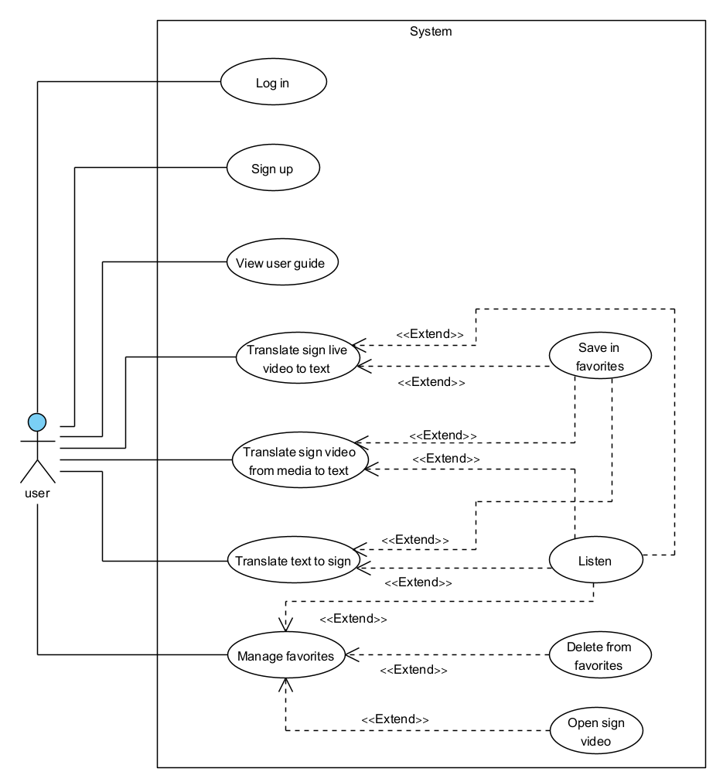
Figure 1: UniSign Use Case

4.2 System Technology Overview
This section details the low-level engineering design of the UniSign application. The system is architected as a standalone edge AI client, executing all computational tasks – including computer vision inference and media rendering – locally on the mobile device. This architecture eliminates network latency dependencies and ensures data privacy by design [4]. As shown in Figure 2, the system flow begins at the Home Page, where the user selects their preferred mode of communication.
- Deaf-to-Hearing Mode: The system activates the camera to capture the user's signs. The video stream is processed in real-time to extract skeletal features (Module A), which are then classified into Hebrew text.
- Hearing-to-Deaf Mode: The system accepts text or voice input from a hearing speaker. The input is processed and mapped to the corresponding animation (Module C), which is then rendered by the 3D avatar. This cyclic flow ensures a continuous, bi-directional conversation loop within a single interface.
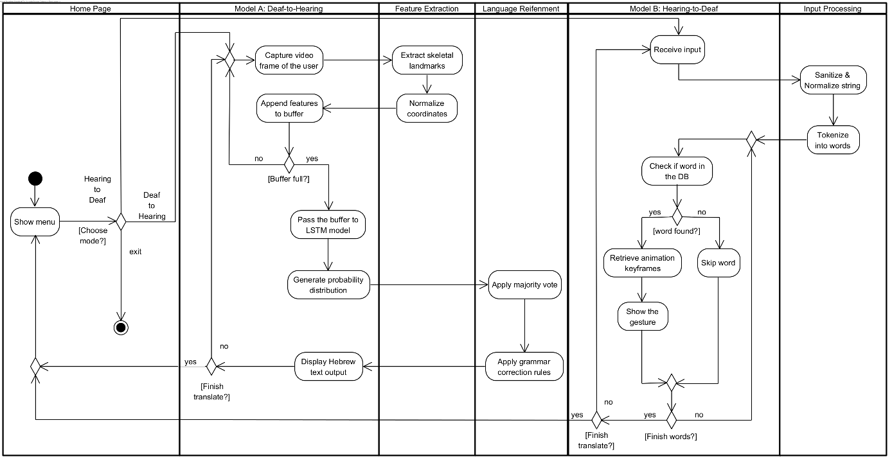
Figure 2: UniSign flow.

4.2.1 High Level Architecture Design
The application logic is structured around two asynchronous processing threads:
- The interface Thread (Input): A background thread responsible for capturing camera frames, executing the skeleton of the sign, running the recognition model, and processing the output to understand what sign we saw.
- The UI/Rendering Thread (Output): A main thread for updating the reactive UI components and managing the video player state for feedback generation.
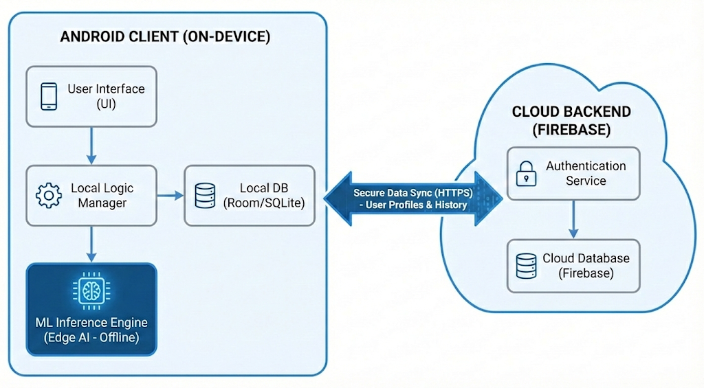
Figure 3: High-Level System Architecture.

As depicted in the architecture diagram above, the system is designed as a Hybrid Edge-AI Application, balancing privacy with usability:
- Android Client (On-Device): This is the core of the system. It hosts the User Interface (UI) and the Local Logic Manager, which orchestrates the app's flow. Crucially, it includes an embedded Local Database to store the vocabulary and user history instantly without network lag .
- ML Inference Engine (Edge AI - Offline): The sign language recognition (Module A) runs entirely inside this isolated component using TensorFlow Lite. By keeping the inference engine local, we ensure that video data never leaves the device, guaranteeing strict privacy and zero-latency processing .
- Cloud Backend (Firebase): While the translation is offline, we utilize a secure cloud layer for auxiliary services. This handles Authentication (Login/Sign-up) and Data Synchronization, allowing users to back up their "Favorites" list and settings across devices. This ensures that while the intelligence is local, the experience is connected.

4.2.2 Technology Stack and Development Environment
The system will be developed using a cross-platform stack that bridges machine learning research with mobile application engineering.
- Machine Learning & Research:
- Language: Python.
- Core Framework:
  - TensorFlow / Keras: Selected for designing and training the deep neural network (LSTM) [5].
  - Google MediaPipe: Utilized for robust, real-time extraction of skeletal landmarks (Hands and Pose) from video frames [4,6].
  - OpenCV & NumPy: Used for efficient video data preprocessing and vector manipulation.
- Mobile Application Engineering:
- Target Platform: Android (Native)
- Language: Kotlin
- Inference Engine: TensorFlow Lite (TFLite) – This framework will be used to deploy the trained Python model onto the mobile device, optimizing it for low latency and offline execution without requiring a server connection [2].

4.2.3 Module A: The Recognition Pipeline (Deaf-to-Hearing)
This module constitutes the core intelligence of the UniSign system. It is designed as a linear transformation pipeline that converts high-dimensional video data (pixels) into low-dimensional semantic classes (words). The pipeline operates in four distinct stages and relies on a skeleton base method to ensure robustness [8].

4.2.3.1 Stage 1: Frame Acquisition and Preprocessing
The process begins with the acquisition of raw video data from the device’s camera.
- Capture Specifications: To ensure sufficient temporal resolution for capturing fast hand movements, the camera is configured to capture at a fixed rate of 30 FPS. The resolution of the video will be downscaled to minimize the computational load on the device while maintaining sufficient clarity for finger tracking [4].
- Color Conversion: The Android Camera2 API delivers frames in YUV format. These are immediately converted to RGB, which us the required input format for the MediaPipe graph.

4.2.3.2 Stage 2: Skeletal Feature Extraction (MediaPipe)
Instead of utilizing a Convolutional Neural Network (CNN) to analyze the entire image (which includes irrelevant background noise), the system employs Google MediaPipe Holistic to extract a skeletal representation of the user [4]. This stage involves three critical steps: Feature Selection, Robust Normalization, and Orientation Handling.
- Feature Selection (The Topology): The system extracts a total of 54 key landmarks per frame, a method supported by recent skeleton-based research [6,8].
- Left/Right hands: 21 x 2 points (capturing finger joints and tips).
- Body & Head: 12 points of the upper body (shoulders, elbows) and basic face anchors (nose, eyes, mouth)
- Robust Normalization (Position & Scale): The raw coordinates from MediaPipe are relative to the screen. This creates a dependency on where the user stands; if the user takes a step to the left, all $x$ values change, confusing the model. To make the model invariant to position and distance, we apply a two-step mathematical transformation:
- Center Alignment (Root-Relative): We define the Nose as the “Root Origin” $(x_{root}, y_{root})$. And for every other landmark $P_{i}$, we subtract the root coordinate:
$$P_{i}^{'}=P_{i}-P_{root}$$
The Result: The user’s skeleton is mathematically “shifted” to the center $(0,0)$. The model now sees only the relative movement of the hands around the body, making the system invariant to the user’s position in the room.
- Scale Invariance (Distance Handling): If the user steps back, the skeleton appears smaller. To fix this, we divide all the coordinates by the Torso Width (the Euclidean distance between the shoulders). This ensures the “size” of the input numbers remains constant, regardless of the user’s distance from the camera [6].
$$P_{i}^{''}=\frac{P_{i}^{'}}{|Shoulder_{Left}-Shoulder_{Right}|}$$
- Output Vector: The final processed vector $V_{t}$ consists of 162 normalized values (54 points x 3 dimensions), representing the pure geometric shape of the sign, ready for classification.

4.2.3.3 Stage 3: Temporal Sequence Aggregation
Since sign language is inherently dynamic, analyzing a single static frame is insufficient for accurate recognition. To capture the continuous movement of the gesture, the system implements a sliding window mechanism.
- The Rolling Buffer: The system maintains a First-In-First-Out (FIFO) buffer of fixed length
$T=30$ frames. This window corresponds to approximately 1 second of motion history, which is the typical duration of an isolated sign.
- Vector Concatenation: As MediaPipe processes each new frame, its normalized feature vector $V_{t}$ (size 162) pushed into the buffer, while the oldest vector $V_{t-30}$ discarded.
- Input Tensor: This process generates a continuous 2D tensor of shape $(30,162)$ at every time step, serving as the input for the recurrent neural network.

4.2.3.4 Stage 4: LSTM Classification
The core classification engine is a Long Short-Term Memory (LSTM) neural network, selected for its ability to learn long-term dependencies in time-series data. The architecture consists of the following layers:
- Feature Learning Layers (Layers 1-2): The first two layers are LSTM units with 64 nodes each. These operate in $return_sequences=True$ mode, preserving the time dimension. For each time step $t$, the LSTM unit computes a hidden state $h_{t}$ based on the current input $x_{t}$and the previous state $h_{t-1}$:
$$h_{t}=LSTM(x_{t},h_{t-1})$$
- Sequence Embedding (Layer3): The third LSTM layer (32 nodes) operates as an encoder. It compresses the entire 30-frame history matrix into a single fixed-length Context Vector $v_{ctx}$. This vector represents the semantic summary of the completed gesture and prevents the model from memorizing pixel-perfect data.
- Regularization: To prevent overfitting during training, a dropout layer is applied between LSTM stages.
- Classification Head: A fully connected (Dense) layer maps the context vector to the 135 target classes. A SoftMax activation function is applied to output a probability distribution, where the class with the highest confidence score (subject to a threshold > 0.85) is selected for the prediction.

4.2.4 Module B: The Language Refinement Engine
Raw predications from a neural network are inherently stochastic and often lack linguistic context [5]. Displaying these raw outputs directly would result in a jittery and unnatural user experience. Therefore, the system implements a deterministic post-processing layer to stabilize the signal and enforce a grammatical structure.

4.2.4.1 Temporal Smoothing (Voting Mechanism)
Since the model performs inference at 30Hz, a single hesitation in the user’s hand movement can cause the prediction to flicker rapidly between similar classes [4]. To filter this high-frequency noise, the system utilizes a Rolling Majority Vote algorithm.
- The Buffer: The system maintains a sliding window $W$ containing the classification results of the last $N=10$ frames $\left(≈300ms\right).$
- The Algorithm: Let $freq(w)$ be the frequency count of the word $w$ within window $W$. The system will only commit to displaying the word $w$ if:
$$freq\left(w\right)>\frac{N}{2}+ δ$$
(Where $δ$ is a stability margin, typically set to 2).
- Outcome: This mechanism introduces negligible latency ($300ms)$ but reduces the false positives detections, ensuring that only deliberate signs are registered.

4.2.4.2 Syntactic Reconstruction (Grammar Correction)
For real-time performance and minimizing storage requirements on smartphones, we decided to use a deterministic, rule-based algorithm for sentence reconstruction [3]. While there are options to use generative transformer models to provide robust text correction, they are not the best solution for our current system. Consequently, we prioritize a lightweight heuristic approach that in the future can be replaced with such models. Our reconstruction engine applies a set of linguistic rules to raw sequence of recognized lemmas, grounded in the structural properties of ISL [9]. The main rules will be adding missing words to make the sentence whole. This approach will fix the sentences and make the translation feel more natural.

4.2.5 Module C: The Visualization Pipeline (Hearing-to-Deaf)
This module closes the communication loop by enabling the hearing user to reply in a format accessible to the Deaf user. Unlike the probabilistic nature of the recognition module (Module A), this pipeline is deterministic and optimized for latency-free asset retrieval to maintain the flow of the conversation [9].

4.2.5.1 Input Processing and Tokenization
This pipeline is initiated when the hearing user inputs a Hebrew sentence via text or the Speech-to-Text Api.
- Normalization: The raw string sanitized to remove non-alphanumeric characters, which are not translated to sign language.
- Tokenization: The string split into a sequence of individual tokens based on whitespace.

4.2.5.2 Asset Retrieval Mechanism
To translate these tokens into signs without searching through files on the disk, the system queries an internal memory-mapped database.
The Data Structure: The application maintains a static HashMap <String, Integer> loaded at runtime, the key is the word, and the value is the id of the resource.
Efficiency: This mapping approach operates in $O(1)$ in average, ensure minimum retrieval time regardless of the number of words we have; this is crucial for real-time mobile performance [4].

4.2.5.3 Video Rendering Engine
The Video Rendering Engine is responsible for synthesizing the translated output into visual Sign Language using a 3D avatar. To mitigate the significant storage overhead of raw video files, the system generates signs in real-time using lightweight data files that store only the keyframes of skeletal movement. The primary function of this engine is to map these keyframes onto the avatar’s rig and render the resulting animation on the user's screen, providing a seamless and efficient visual translation.

4.2.6 Data Flow and Mobile Optimization
To ensure real-time performance on the smartphone, the system uses a streamlined data flow designed to minimize computational load and latency. The pipeline structure ensures that captured video frames are immediately passed to MediaPipe for skeleton extraction. With this approach, the raw video data is discarded immediately after the necessary features are extracted. By decoupling the extraction from the classification, we significantly lower memory usage. Furthermore, since the model processes only the skeleton data and not the raw video, processing time is minimized, allowing the system to operate with low latency on standard smartphone hardware.

4.3 Methodology: Data Collection and Model Training

4.3.1 Dataset Creation: UniSign-135
While in American Sign Language, there are numbers of large-scale public datasets [7], in Israeli Sign Language, we don’t have a publicly available dataset to use. To overcome this challenge and train the model to recognize our vocabulary, we will create the dataset ourselves and label it UniSign-135.
- Data Acquisition Strategy: The dataset will be generated through a controlled self-recording involving who distinct people, to ensure variation of the data, each person will record 10 repetitions for every word in the vocabulary.
- Dataset Volume: We have 135 distinct ISL signs, for each sign we will record 20 videos. The total dataset will have 2,700 labeled videos (135 words x 20 videos).
- Recording Conditions: The samples will be recorded using standard smartphone camera same as the final product camera. The recording will take place in different environments and lighting to make the data diverse, a critical step for ensuring generalization in mobile based recognition system [4].
- Preprocessing: Each recorded video will be processed to extract the skeleton (as described in Section 4.2.3), resulting in lightweight files that can be used for training the model more quickly.

4.3.2 Data Augmentation Strategy
Given the small dataset, we need to create a data augmentation strategy to prevent overfitting and improve the model's ability to recognize the sign from different users [1].
Our pipeline differs the process of feature extraction from classification; we first extract the skeleton of the sign using MediaPipe [2] and train the model on the extracted skeleton. As a result, traditional visual augmentation is irrelevant in our case, as they effect the extraction of the skeleton, that still will result in same skeleton input for our model.
For this reason, we implemented a post extraction geometric augmentation strategy [3]. We apply mathematical transformations directly to the skeleton data to make new synthetic training data.
We primarily use rotational augmentation to simulate variations in camera angle and user orientation while holding the smartphone, we apply random rotations to the skeleton. The skeleton is already normalized by the MediaPipe process (Section 4.2.3.2). As a result, the skeleton is ready for the next step. We generate synthetic samples by applying a rotation matrix $R\left(θ\right)$ to the $\left(x,y\right)$ coordinate of all joints, to ensure the sign remains correct, the rotation angle $θ$ in the same iteration, the same to all the joints [3,4].
By applying the rotation angle to the skeleton, we create new data to train the model and make it more accurate and robust for unintended rotation of the camera by the user.

4.3.3 Training Configuration
The training process will be implemented using standard deep learning frameworks. We will use Adam optimizer with an adaptive learning rate schedule to create effective convergence, minimizing the Categorical Cross-Entropy Loss. To prevent overfitting, we will employ Early Stopping, which halts training and restores the best weights when validation loss plateaus. We will use a hold-out strategy to evaluate true generalization:
- Training and Validation: The primary dataset will be split into a training set (70%) and a validation set (30%) to optimize model parameters and monitor convergence.
- Test Set: The final performance evaluation will be conducted on a separate, independent video sample for each word that was not included in the training process, this will ensure that the reported accuracy reflects the model's performance on real use scenario.

4.4 GUI
The suggested GUI focuses on high accessibility and an intuitive user flow, including the home page, favorites library, and translation screens, as presented in Figure 4.
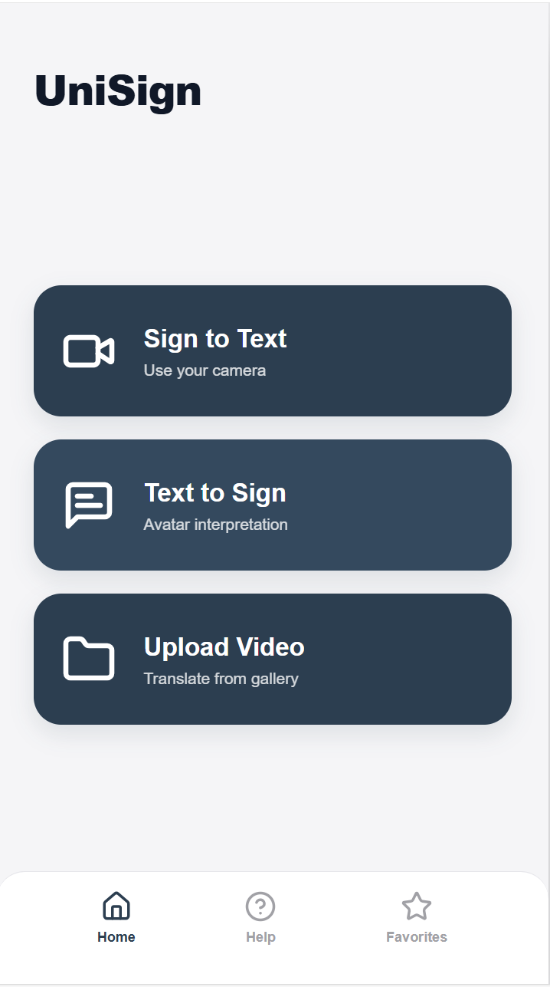
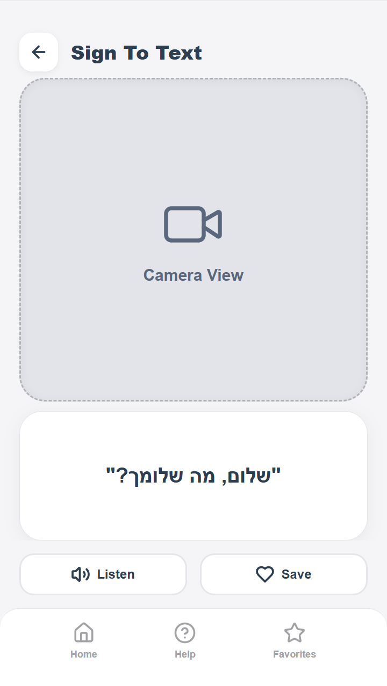
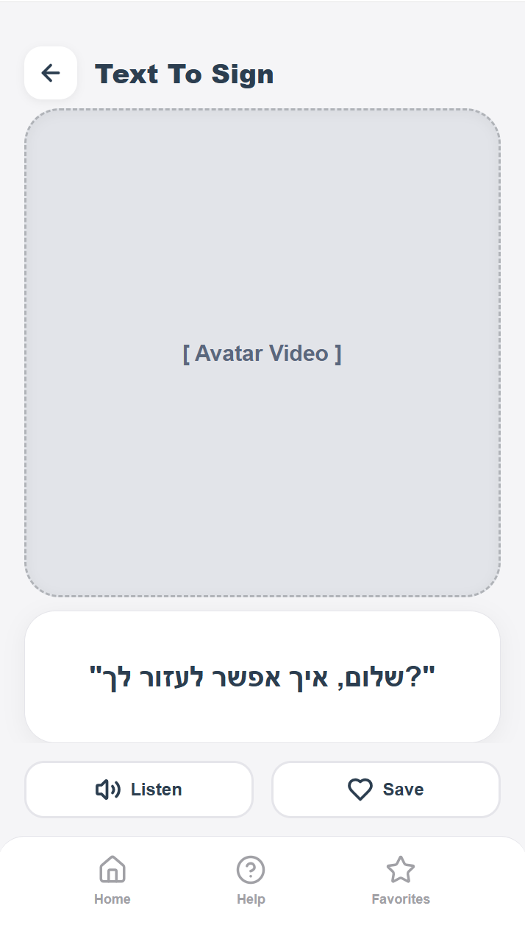
Text to Sign
Favorites
Sign to Text
Home Page
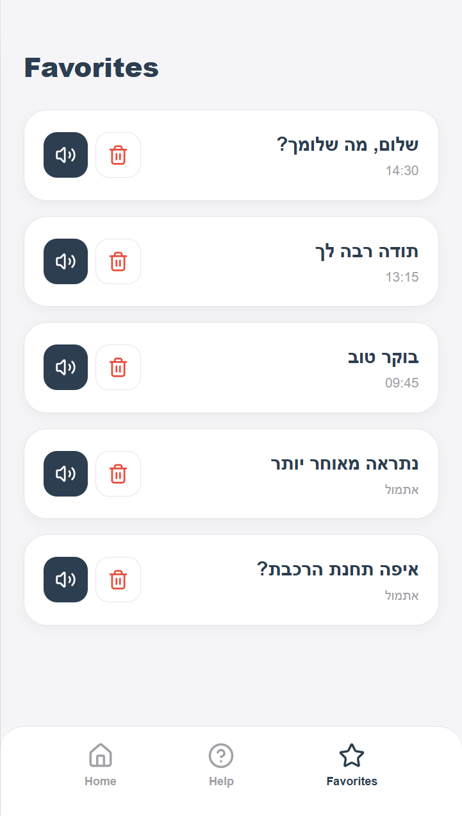

Figure 4: The suggested GUI

Chapter 5: Evaluation and Verification Plan
This Chapter will explain the methodology for validating the functional correctness, performance, and usability of the UniSign system. The evaluation strategy is divided into system testing and user evaluation.

5.1 Testing Plan
The testing plan focuses on measuring the system’s performance against the requirements, specifically regarding accuracy, latency, and resource efficiency on mobile devices.

5.1.1 Model Accuracy (Recognition ISL)
We will evaluate the trained LSTM model using the “Hold-Out” test set described in Section 4.3.3. Using unseen videos, we will test the accuracy of the model's recognition of unseen videos of the words that it learns. A Confusion Matrix will be generated to identify specific signs that the model confuses, allowing for targeted retraining of the signs.

5.1.2 Real-Time Performance
Since the system must run on a smartphone, we will check the load of the application to ensure that a standard smartphone can handle and perform well with the application, we will use tools like Android Studio Profiler to evaluate the application in real time. Part of the test is to check how long a full pipeline cycle takes, and we aim to be less than $33ms$ to ensure 30 FPS as planned.

5.1.3 Rendering Engine Verification
For verification of the Text-to-Sign model we will use visual verification, we will check the transition between two signs without creating artifacts, also we will check visually the sign to make sure it is correct.

5.2 Evaluation by Users
Following the completion of the technical verification, the system will move to the user evaluation phase to check its practical usage. To ensure that the final implementation remains aligned with the needs identified during the requirements elicitation, a continuous collaborative process with the stakeholders, Gabi and Hagit, will be maintained throughout the development lifecycle. This engagement is structured as follows:
Iterative Prototyping and Feedback Rounds:
At every significant stage of interface development, clickable wireframes will be presented to the stakeholders to evaluate the user flow. The goal is to ensure that button placement and navigation remain simple and intuitive, as defined in the requirements. Hagit will be asked to "operate" the prototype to identify potential points of confusion where an elderly user might encounter difficulties.
Field Testing:
Upon completing the development of an initial working version, field tests will be conducted at the user’s home to validate the system in its natural environment:
- Environmental Condition Testing: Evaluating the algorithm's recognition capabilities under specific home lighting conditions and against varied household backgrounds.
- Hands-Free Usage Testing: Observing the user’s preference for device placement (e.g., on a table or a stand) to ensure the camera angle enables accurate and reliable translation.
- System Response Speed: Testing the system's performance in spontaneous, real-life situations to ensure that technical latency does not disrupt social dynamics.
User Experience Feedback:
During development, our main client, Hagit, in addition to 2-3 deaf users, will provide a detailed review following each demonstration to evaluate the system’s progress using the SUS questionnaire. This feedback will focus on interface usability, translation accuracy, response speed, and the perceived improvement in communication when the system acts as a "bridge," as well as identifying areas for further refinement to enhance conversation quality.
Status Meetings and Reprioritization:
Periodic meetings will be dedicated to re-prioritizing requirements. If technical difficulties arise or new needs emerge from the field during development, the list of requirements will be updated in full coordination with the stakeholders.
This process of high stakeholder involvement ensures that every design or technological decision is validated against real users. This approach minimizes the risk of developing a system that is inaccessible or fails to meet the actual needs of the Deaf and hard-of-hearing community.

5.3 Metrics for Success
To evaluate the effectiveness of the system and its success in meeting the requirements, the following success metrics have been defined:
Technological Metrics
- Translation Accuracy: The system will achieve an accuracy level of at least 90% in recognizing and translating Israeli Sign Language (ISL) for daily terminology and spontaneous conversation.
- Response Time: The duration from the end of a sign or speech input until the translation appears on the screen shall not exceed 3 seconds, to maintain a natural flow of conversation.
- Environmental Robustness: The system will successfully recognize hand movements with a high success rate even under varying lighting conditions.
Usability and Adoption Metrics
- Ease of Operation: A new elderly user will be able to perform their first translation in less than 3 minutes.
- Click Count: Access to all core functions will be achieved in no more than 3 clicks (excluding the login stage).
Social Impact Metrics
- Reduction of Social Isolation: A reported increase in the user's sense of confidence during daily interactions, measured via periodic interviews.
- Improved Interpersonal Communication: A reported increase in the frequency and duration of spontaneous conversations between the user and their hearing environment, measured via periodic interviews.
- Satisfaction and Independence: A reported improvement in communication quality for the Deaf and hard-of-hearing community and an increase in their level of independence in daily activities, measured via periodic interviews.
System Versatility and Inclusion Metrics
- Physiological Diversity: The system will achieve nearly uniform accuracy level for users with different skin tones, various hand sizes, and different finger structures.
- Camera Angle Flexibility: The system will recognize hand signs within a range of up to 45° from the center of the camera lens to allow flexibility in device placement.
- Background Recognition: The system will successfully distinguish hand movements from the background even in busy environments.

References
- Alaftekin, M., Pacal, I., & Cicek, K. (2024). Real-time sign language recognition based on YOLO algorithm. Neural Computing and Applications, 36(14), 7609-7624.
- Al Khuzayem, L., Shafi, S., Aljahdali, S., Alkhamesie, R., & Alzamzami, O. (2024). Efhamni: A deep learning-based Saudi sign language recognition application. Sensors, 24(10), 3112.
- David, D., Alamoodi, A. H., Albahri, O. S., Garfan, S., Albahri, A. S., Zaidan, B. B., & Chen, J. (2024). Sign language mobile apps: a systematic review of current app evaluation progress and solution framework. Evolving Systems, 15(2), 669-686.
- Ghanimi, H. M., Sengan, S., Sadu, V. B., Kaur, P., Kaushik, M., Alroobaea, R., ... & Dadheech, P. (2024). An open-source MP+ CNN+ BiLSTM model-based hybrid model for recognizing sign language on smartphones. International Journal of System Assurance Engineering and Management, 15(8), 3794-3806.
- Huang, J., & Chouvatut, V. (2024). Video-based sign language recognition via resnet and lstm network. Journal of Imaging, 10(6), 149.
- Jiao, P., Min, Y., Li, Y., Wang, X., Lei, L., & Chen, X. (2023). Cosign: Exploring co-occurrence signals in skeleton-based continuous sign language recognition. In Proceedings of the IEEE/CVF international conference on computer vision (pp. 20676-20686).
- Miah, A. S. M., Hasan, M. A. M., Nishimura, S., & Shin, J. (2024). Sign language recognition using graph and general deep neural network based on large scale dataset. IEEE Access, 12, 34553-34569.
- Min, Y., Yang, Y., Jiao, P., Nan, Z., & Chen, X. (2025). A Closer Look at Skeleton-based Continuous Sign Language Recognition. In Proceedings of the IEEE/CVF International Conference on Computer Vision (pp. 4909-4915).
- Stamp, R., Ohanin, O., & Lanesman, S. (2022, June). The Corpus of Israeli Sign Language. In Proceedings of the LREC2022 10th Workshop on the Representation and Processing of Sign Languages: Multilingual Sign Language Resources (pp. 192-197).

https://www.sign-now.io/home
https://translate.google.com

