
Flatwire Machine - SRS

Document Change History
Version | Author | Updated on | Reviewer | Reviewed on | Description
1.0 | Jaspreet | [dd-mm | [Name] | [dd-mmm-yy] | [max 10 words]

Contact | Details

Table of Content
Flatwire Machine - SRS 0
Document Change History 1
1. Business Objective 8
2. To-be Process 9
1. Physical process 9
2. System process 9
2.2.1. Login/Logout 10
2.2.2. Rod Pre Checkin 11
2.2.3. Rod/Flat wire Checkin 13
2.2.4. Welding of a rod 16
2.2.5. Traveler 19
2.2.6. Order Instructions 22
2.2.7. Pass Schedule generation 22
2.2.8. Gauge Trace & Width Trace pop up 23
2.2.9. SPC 24
2.2.10. ITInhibit and Alerts 25
2.2.11. Stop Button 25
2.2.12. Label Printing 30
2.2.13. Data Recording 31
3. Feature Description 34
2.3.1. Database 34

Flat Wire Machine
The flatwire machine we are installing is designed to process aluminum rods and convert them into flat aluminum wires through a controlled rolling and forming process.
It’s a 2 part machine, which can be used used separately or in combination(hybrid).
- Flat Line 1
- Flat Line 2

Flat Line 1 has following components:
- Payoff (1 and 2) Max limit 9000lbs defined in machines tab in web.
- Holds two bundles for continuous operation.
- Orientation: Eye-to-sky for incoming rod.

- Wire drawing Dye 1 (DB1)
- Wire drawing Dye 2 (DB2)
  - Used to reduce rod diameter.
  - Can be bypassed if customer requires larger gauge.
Questions:
How will rod pass through wire drawing for first time? We have a device to pull it.
How will we pull the wire will there be a roller or we will use 12” Mill enery to put it through? We have a motor to pull.

- 12” Flatenning Mill (Rolling Mill)
  - Converts round rod into flat strip.
  - Includes gauges, dancer(Edger).

- Traversing Take-up Max limit 3500 lbs

Output of FL1 will look like below through the cross section.

Flat Line 2 has following components:
- Traversing Payoff Max limit 3500 lbs
- 8” Roller(Can be skipped)
Output of 8” Roller:
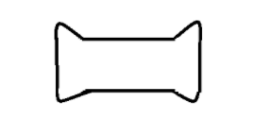
- 6” Roller(Can be skipped)
Output of 6” roller

- 6” Roller(Cannot be skipped)
- Traversing Take-Up Max limit 1000 lbs
Flat Wire Machine -
Machine can be run as hybrid system and rod is inserted as input and we get flatwire at another end.
3 entries needed in machines tables : 1 for FL1 , 1 FL2 and 3rd for hybrid
FL1 and FL2 Machines can run as two separate machines or in hybrid mode:
Process:
- Rod is checked in , following fields are required at checkin.
  - Rod no,
  - Diameter,
  - Dye 1 manual input – Text box for first time or pass schedule generated we need it else inactive.
  - Dye 2 manual input – Text box
  - Payoff 1 or 2
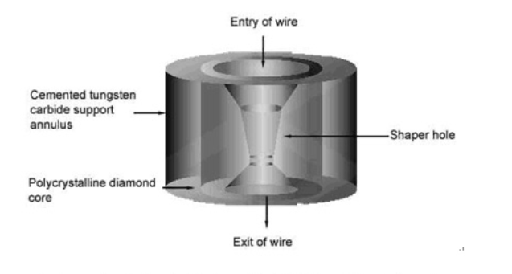
- Visual inspection is performed for:
  - oxidation
  - surface defects
  - water stains
  - No unbanding until at the payoff due to safety & bundling.
  - Must include an option to Suspend Material if visual inspection fails.
- If visual inspection pass then:
- Pass schedule is displayed and acknowledged, PLC needs to be updated.
- If visual inspection fails then add observation and wip rej as in coils.
- Rod is pulled through Wire Drawing machines
  - SPC for gauge(diameter)
- Then it is rolled through FL1 (3 d round wire is converted to a 2 D flat wire)
- Dancers are also placed in between to manage tension.

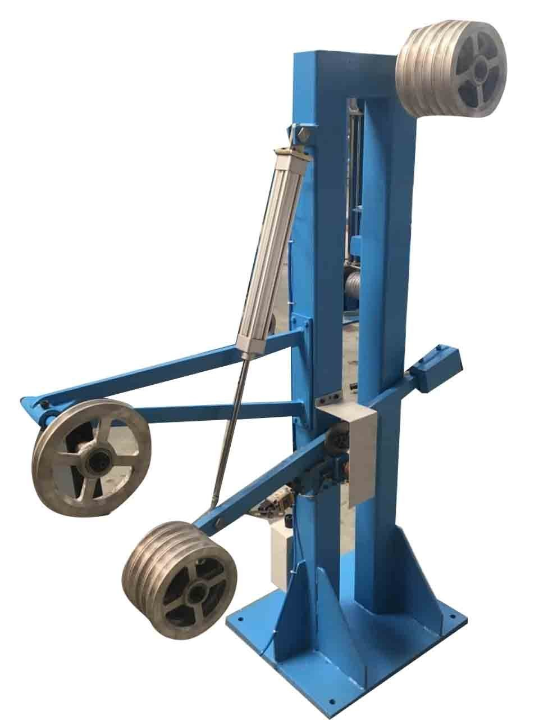
- If it’s a hybrid operation:
  - Rolled through FL2.
- If it’s not a hybrid operation:
  - Wire is collected at traversing takeup1
    - SPC for gauge and width is done and new child alphas are generated.
    - Label is printed for Spool, having values Temp Spool no, alloy, width, gauge temper gross and net weight and rod alphas.
  - Wire can be sent for annealing
  - Wire is loaded to traversing Payoff, checkin combined with SPC.
- Spool no
- Width
- Gauge
- Pass schedule is displayed and acknowledged, PLC needs to be updated.
  - Wire is rolled through FL2.
- Wire is collected at Traversing Takeup2
    - SPC is performed for width and gauge for each outgoing spool
    - Labels are printed for spools.

Running:
When rod is checkedin it is set as eye to sky, using the payoff stand it is fed.
We have 2 payoff as soon as one rod is near end, operator will weld rod from 2nd payoff to end of first rod. And it becomes a continuous operation.
Max weight at 1 payoff can be 9000lbs.

Ex: Rod R1 is on payoff 1 and Rod R2 is on payoff 2.
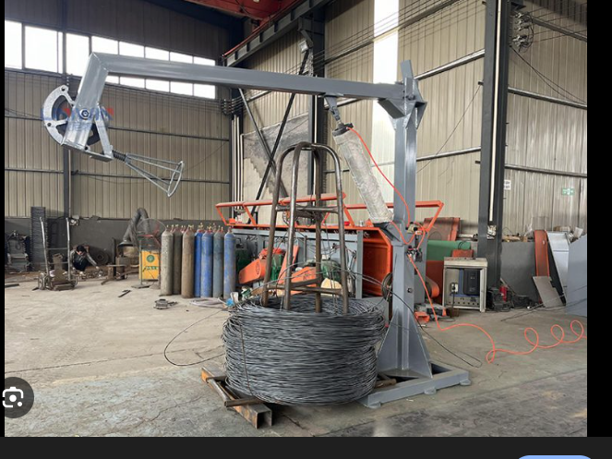

At Traversing takeup max limit is 3500 lbs. which is collected on metal spool.
Ex Wire numbers on
TS1 (Temporary Spool)=> R1A (Rod)(3500lbs)
TS2 => R1B (3500lbs)
TS3 => R1C (2000lbs) + R2A(1500lbs)
TS4=> R2B (3500lbs)
TS5 => R2C (3500lbs)
TS6 => R2D(500 lbs)

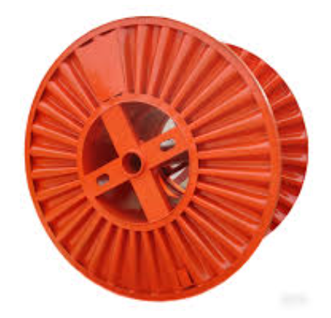

Checkin On Flat Line 2:
TS1(3500 lbs) (R1A)=> S1(spool) (1000 lbs max) (R1AA)
TS1(R1A) => S2 (R1AB)
TS1(R1A) => S3 (R1AC)
TS1(R1A) => S4 (R1AD 500 lbs)
TS2 (R1B) => S4 (R1BA 500 lbs)
TS2 (R1B) => S5 (R1BB)
TS2 (R1B) => S6 (R1BC)
TS2 (R1B) => S7 (R1BD)
TS3 (R1C) => S8 (R1CA)
TS3 (R1C) => S9 (R1CA)
TS3 (R2A) => S10 (R2AA)
TS3 (R2A) => S11 (R2AB 500lbs)
TS4 (R2B) => S11 (R2BA 500lbs)
TS4 (R2B) => S12 (R2BB)
TS4 (R2B) => S13 (R2BC)
TS4 (R2B) => S14 (R2BD)
…………………cont

Questions :

Annealing:
• Material sent on spools with legs/fins (eye-to-side).
• No stacking during anneal.

Can this be combined with coils or cuts?
Will they always be eye to side or eye to sky?
Will they have different prog no for furnaces?

Cooling:
Should any calculations be made to calculate the cooling time.

Conveyor:
Do we need conveyors or we will directly ship/pack from traversing take up.

Questions to operator.
- Is wire wrapped tight enough?
- Does wrapping looks ok?
- Is there even spacing between the wire wraps?
- Are the wires overlapping?

Pass Schedule Requirements
- Must define which components run (e.g., DB1, DB2, dancer, S1/S2/S3).
- PLC tags updated based on pass schedule.
- Needs flexibility for future components (multiple dancers, additional payoffs).
Notes:
- Alloy mixing is not allowed.
- SPC triggered for:
  - new coil
  - new pass schedule
  - welded joint transitions (simple micrometer check)

- Business Objective
To produce a flat wire from Aluminum rod.
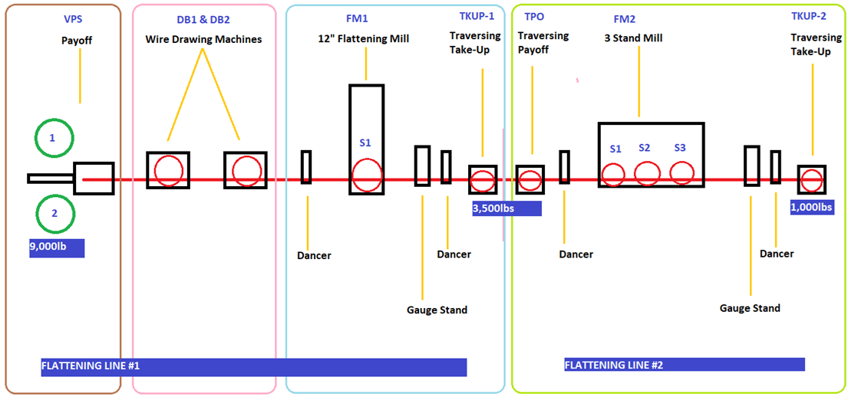
- To-be Process
  - Physical process
- Input Rod will be in form of bundle.
- Rod will be put on payoff
- Rod will pass through wire drawing dyes (DB1 & DB2)
- Rod will pass through FL1 where components include Dancer , 12” Mill, Guage Stand, Dancer and Traversing Take up.
- Rod will pass through FL2 where components include Traversing Payoff, Dancer, 3 stand mill, edger, dancer, Traversing Payoff.
- Output Wire will be in form of oscillating wire bundle.
  - System process
- Login
- Rod Checkin/ Pre checkin
- Order Instructions
- Pass schedule generation
- Gauge Trace & Width trace pop ups (For FL2)
- SPC
- Stop transaction
- Label printing
- Packing
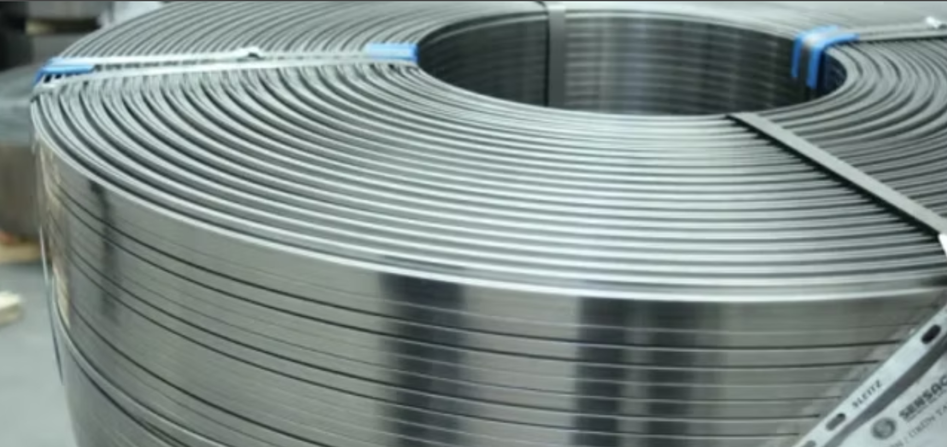

    - Login/Logout
Manual Login & Logout
- The system shall support manual login and logout at the station, consistent with the current slitter functionality, without regression.
- Operators who are punched-in shall be allowed to:
  - Manually log in
  - Manually log out
- Login and logout actions shall be:
  - Captured with operator ID
  - Time-stamped
  - Associated with the station
(OL-001)

Auto Login & Auto Logout (Shift-Based)
- The system shall support automatic login and automatic logout, consistent with existing shopfloor applications.
- Auto login shall occur at the start of the assigned shift.
- Auto logout shall occur at the end of the assigned shift.
- Shift timing shall be driven by system-configured shift schedules.
- Auto login/logout events shall be:
  - Logged
  - Traceable
  - Visible to the operator
(OL-003)

Supervisor Override for Login
- If an operator attempts to manually log in without being punched-in:
  - The system shall require a supervisor override
  - Supervisor credentials must be validated before login is allowed
- Supervisor override actions shall be:
  - Fully logged
  - Auditable
  - Recorded with operator ID, supervisor ID, timestamp, and station
(OL-002)

Operator Identification During Machine Operation
- The system shall prompt “Who is running the machine?”:
  - At check-in
  - At each stop / restart
- Whenever machine speed becomes greater than zero (> 0):
  - An operator must be selected or confirmed
- Machine operation shall not continue unless:
  - An operator is identified
  - The operator is logged against the run
- Operator confirmation shall be:
  - Mandatory
  - Time-stamped
  - Associated with the machine run record
(OL-004)

Operator Availability Across Lines (FL1 / FL2)
- An operator logged into FL1 shall be selectable at FL2, and vice versa.
- The system shall support shared operator visibility across FL1 and FL2 without requiring re-login, provided:
  - The operator is active and logged in
  - No conflicting session or authorization rules are violated
- Operator-to-line association shall be:
  - Tracked per operation / per run
  - Not restricted to a single fixed line at login time
(OL-005)

    - Rod Pre Checkin
Pre-Check-In Capability & Scope
- The system shall support pre-check-in of the next incoming rod/wire at FL1 while the current coil is still running, enabling continuous operation and reduced downtime.
- FL2 shall not support pre-check-in due to lack of staging space; FL2 shall support check-in only.
- The system shall provide a dedicated Pre-Check-In station for FL1.
(PCI-001, PCI-002, PCI-006)

Pre-Check-In Data Capture
- Pre-check-in shall capture the following information:
  - Rod / wire number
  - Diameter
  - Scrap box reference (if applicable)
- Pre-check-in shall also indicate the intended payoff position:
  - Payoff 1 or Payoff 2
- Scrap box selection shall follow the same alloy-based and carry-forward logic defined elsewhere and may be optional where applicable.
(PCI-005, PCI-007)

Visibility & Workflow Integration
- Pre-checked-in coil information shall be:
  - Displayed on the Pre-Check-In station Traveler
  - Clearly identifiable as pre-checked-in material
- Pre-checked-in coil information shall be automatically surfaced to the operator during welding selection, ensuring:
  - Correct sequencing
  - Informed weld decisions
  - Reduced risk of selecting incorrect material
(PCI-003, PCI-004)
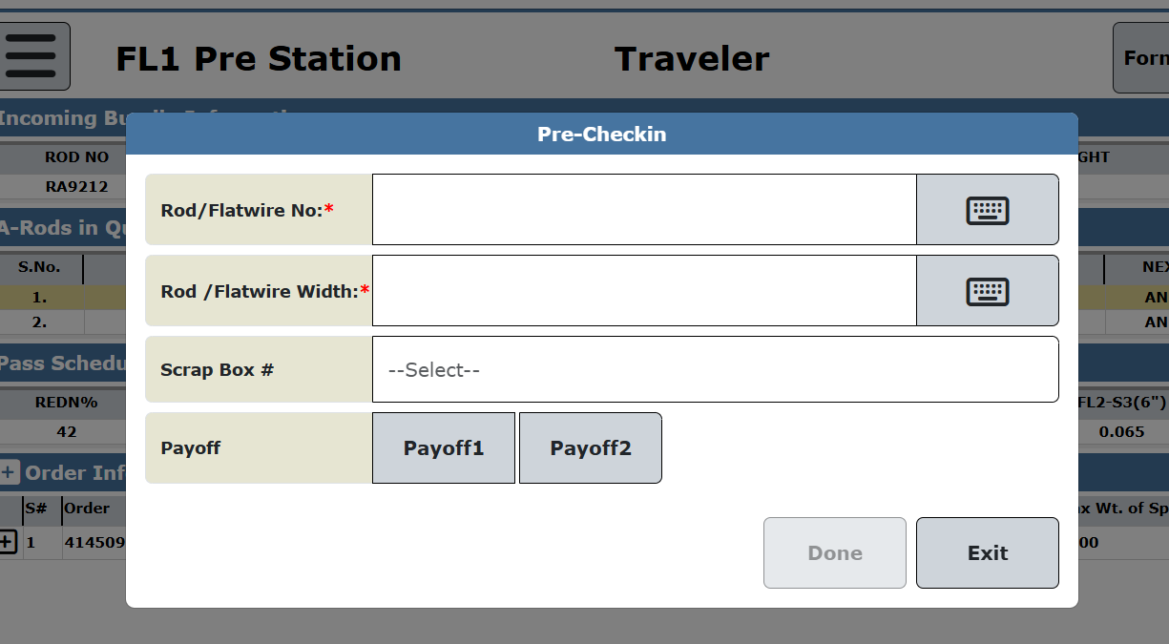
DB:
A new table FlatwireQueue would be created for pre checked in coils. This table will include Rodno, RodSeqno, Welded columns.
On completion of pre checkin following transactions will be performed.
- Change coil_status to INFLAT in proddb..coils.
- If rod in not reqsummed, then reqsum is perfomed and entry in proddb..wip_coil_orders is inserted.
- Actual_start_date is updated in planning_routings and routings.
    - Rod/Flat wire Checkin
Rod which will in a form of bundle(as in the image below) will be put on payoff physically and on system pre checkin transaction will be done.
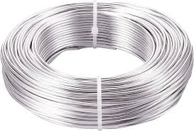
1. Check-In Entry Behavior
1.1 FL1 – Check-In Button Action
- On click of Check-In button on FL1, the system shall display a popup with the message:
“Are you running FL1 only or with FL2?”
- Popup shall have the following buttons:
  - FL1 Only
  - FL1 and FL2 Together

1.2 Station Name Determination
- If “FL1 Only” is selected:
  - Station name shall be set to “FL1 Station”
- If “FL1 and FL2 Together” is selected:
  - Station name shall be set to “FL3 Station” (Hybrid FL1 + FL2)

1.3 FL2 – Check-In Button Action
- On click of Check-In button on FL2:
  - The check-in popup shall open directly
  - No FL1/FL2 selection popup shall be displayed

2. Check-In Fields (FL1 Station / FL3 Station)
The following fields are required for Rod / Flat Wire check-in on FL1 or FL3 (Hybrid):
2.1 Mandatory / Optional Fields
- Rod / Flat Wire Number (Mandatory)
- Rod / Flat Wire Diameter (Mandatory)
- Scrap Box (Optional)
- Payoff 1 (Button – Pre Check-In Station only)
- Payoff 2 (Button – Pre Check-In Station only)
- Done (Button)
- Exit (Button)

2.2 WIP Update
- On successful check-in:
  - coilno field shall be updated in WIP stations

3. Field Validations
3.1 Rod / Flat Wire Number Validation
- The entered Rod / Flat Wire Number:
  - Must exist in proddb..coils
  - System shall reject invalid or non-existing rod numbers

3.2 Rod Diameter / Flat Wire Width Validation
- For FL1 and FL3:
  - Operator shall enter Rod Diameter
- Validation logic:
  - Diameter shall be validated against proddb..coil_gauge
  - Allowed tolerance shall be ± value from lookup table
Example
If rod diameter = 0.30
Lookup tolerance = ±0.01
✅ Valid range:
- Lower limit: 0.29
- Upper limit: 0.31
System shall prevent check-in if value is outside tolerance.

3.3 Scrap Box Logic
- Scrap Box list shall be displayed based on Alloy, same logic as Slitters
- If:
  - Last checked-in rod had the same alloy
  - And a scrap box was selected
- Then:
  - The same Scrap Box shall auto-select for the next coil
- Scrap Box:
  - Is non-mandatory
  - Can be changed or left blank

4. Done Button Validations
On clicking Done, the system shall validate:
- Order Release Status
  - Order must be in Open state
- Mandatory Field Completion
  - Rod / Flat Wire Number
  - Diameter
- Planning data
  - Plan should be open.
- Diameter Tolerance Compliance
- Rod Availability (Not already checked in elsewhere)
If any validation fails, check-in shall not proceed.

5. FL2 Check-In Specific Requirements
- For FL2 check-in:
  - Operator shall scan the spool label printed at FL1 output
  - Operator shall measure and enter the width of the checked-in material
- System shall validate scanned spool against:
  - Previously checked-in FL1 / FL3 data

6. Data Recording Application – Flat Wire
- The system shall include a Data Recording Application for Flat Wire
- Application shall support:
  - Coil / rod traceability
  - Gauge trace
  - Operator association per pass / speed event

7. Gauge Trace & SPC
- Gauge trace shall be enabled for flat wire processing
- SPC prompts shall be:
  - Automatically initiated
  - Triggered after traveler loads at check-in

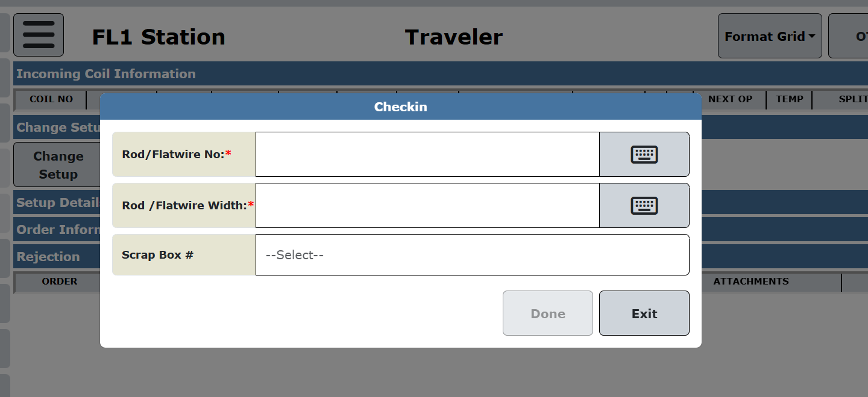

DB:
When Rod no is inserted and on focusout, api gets scrapbox dropdown values.
On click of Done button, sp to be created to validate the data and validations as mentioned in requirements below.
On completion of pre checkin following transactions will be performed.
- Change coil_status to INFLAT in proddb..coils.
- If rod in not reqsummed, then reqsum is perfomed and entry in proddb..wip_coil_orders is inserted.
- Actual_start_date is updated in planning_routings and routings.

    - Welding of a rod
1. Welding Operating Modes
Stopped-Mill Welding (WLD-001)
- The system shall support welding workflows where:
  - The mill will be stopped before the weld is performed(weld can also be performed while running of mill)
  - Welding is treated as a controlled transition between coils
- The operator shall explicitly confirm welding completion before coil consumption continues.

Future Continuous Welding – Architectural Support (WLD-002)
- The system architecture shall support future continuous-operation welding, where:
  - Welding can be performed without stopping the mill
- Core logic for:
  - Coil sequencing
  - Material consumption
  - Traceability
- Shall not require redesign to support continuous welding.
- Welding state handling shall be event-driven and extensible.

2. Pre-Check-In & Weld Marking
Weld Marking Action at Pre Check-In (WLD-010)
- A “Mark as Welded” button shall be added to the Pre Check-In station.
- The button shall be enabled only when:
  - A coil is pre-checked-in

Operator Confirmation for Welding (WLD-003)
- The system shall require explicit operator confirmation to:
  - Mark a pre-checked-in coil as “Welded”
  - Make the coil eligible for consumption
- Confirmation shall capture:
  - Operator ID
  - Date & time
- Action shall be auditable.

3. Welding Validation Rules
Coil Compatibility Validation (WLD-006)
Before a coil can be marked as welded, the system shall validate:
- Alloy matches the current coil
- Diameter matches the current coil
- Temper matches the current coil
- If any validation fails:
  - Welding shall be rejected
  - A clear validation error shall be shown to the operator

Production Order & Pass Schedule Validation (WLD-007)
- The system shall validate that the coil being welded:
  - Is planned for the current production order
  - Is compatible with the active pass schedule
- Coils failing validation shall not be eligible for welding.

4. Coil Sequencing & Consumption Logic
Automatic Next-Coil Selection (WLD-004)
- Once a coil is marked as Welded:
  - The system shall automatically treat it as the next coil in sequence
  - No manual queuing by the operator shall be required

Material-Driven Coil Transition (WLD-005)
- Transition from the current coil to the welded coil shall be:
  - Driven solely by material consumption
  - Triggered when remaining material = 0 feet
- Coil transition shall not depend on operator timing or manual actions.

5. Traceability & Genealogy
Full Weld Traceability (WLD-008)
- The system shall maintain end-to-end traceability for:
  - All parent coils contributing material through welding
  - Even when the physical welding operation is manual
- Traceability shall include:
  - Parent coil alpha identifiers
  - Weld sequence/order
  - Operator confirming the weld
  - Date & time

Multi-Parent Output Spool Traceability (WLD-009)
- A single output spool identifier shall:
  - Reference all contributing parent coil identifiers
  - Support multi-parent genealogy
- Downstream systems shall be able to trace:
  - Output spool → all welded parent coils

6. Weld Removal & Error Handling
Supervisor Override for Weld Removal (WLD-011)
- If removal or reversal of a welded coil is required:
  - Supervisor override shall be mandatory
- Override shall:
  - Capture supervisor credentials
  - Be fully logged (who, when, why)
- System shall:
  - Revoke welded eligibility
  - Prevent accidental or invalid consumption
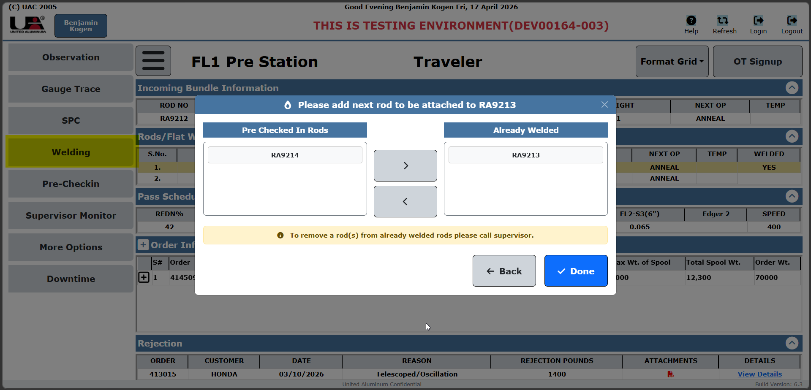

    - Pop ups after checkin
Show order instructions, Hold info, observations.
    - Traveler
Shared Traveler Concept & Scope
- The system shall provide a single, shared Traveler screen that supports FL1 Pre-Check-In, FL1, FL2, and FL3 (hybrid) operations.
- The Traveler shall dynamically adapt its displayed content and layout based on:
  - The active station (Pre, FL1, FL2, FL3)
  - The applied pass schedule
  - The output mode (intermediate vs finished product)
(TRV-001)

Traveler Sections & Content
- The Traveler shall include the following core sections:
  - Incoming Bundle Information
  - Queue (pre-checked-in material)
  - Pass / Reduction Schedule
  - Edger Configuration
  - Order / Constraint Data
  - Current Run Status
- Incoming Bundle Information shall display key attributes such as:
  - Rod number
  - Rod gauge / diameter
  - Temper
  - Other relevant incoming material details
- The Queue section shall display all pre-checked-in items with:
  - Serial number
  - Payoff position number
  - Key dimensional attributes (gauge, width, weight)
  - Current material status
- The Pass / Reduction Schedule section shall display:
  - Reduction percentage
  - DB1 and DB2 gauges
  - FL1 through FL2 roller gauge targets
  - Configured speed
  - Tension shall be derived automatically from speed and shall not require manual entry
- The Order / Constraint section shall display:
  - Maximum spool/package weight
  - Current spool/package weight
  - Order weight
  - OD minimum and maximum limits
  - Package width limits
- Order and constraint data shall be used for runtime validation during operations and transactions.
(TRV-002, TRV-003, TRV-004, TRV-005, TRV-006)

Context-Sensitive Layout & Behavior
- The Traveler layout and any stop-transaction pop-ups shall automatically vary based on:
  - FL1-only output (intermediate spool)
  - FL2 or FL3 output (finished product)
- The Traveler shall support two simultaneous running instances (one per machine) when:
  - FL1 and FL2 are operating independently
  - Separate jobs are running concurrently
(TRV-007, TRV-008)

Weld Visibility & Material Filtering
- On the Main station Traveler:
  - Only welded rods relevant to the current running rod shall be displayed
- On the Pre-Check-In station Traveler:
  - Both pre-checked-in rods and welded rods shall be displayed
  - Welded rods shall be clearly distinguished using:
    - Color differentiation
    - Explicit text indicators identifying welded status
(TRV-009, TRV-010)

Pre Checkin Station
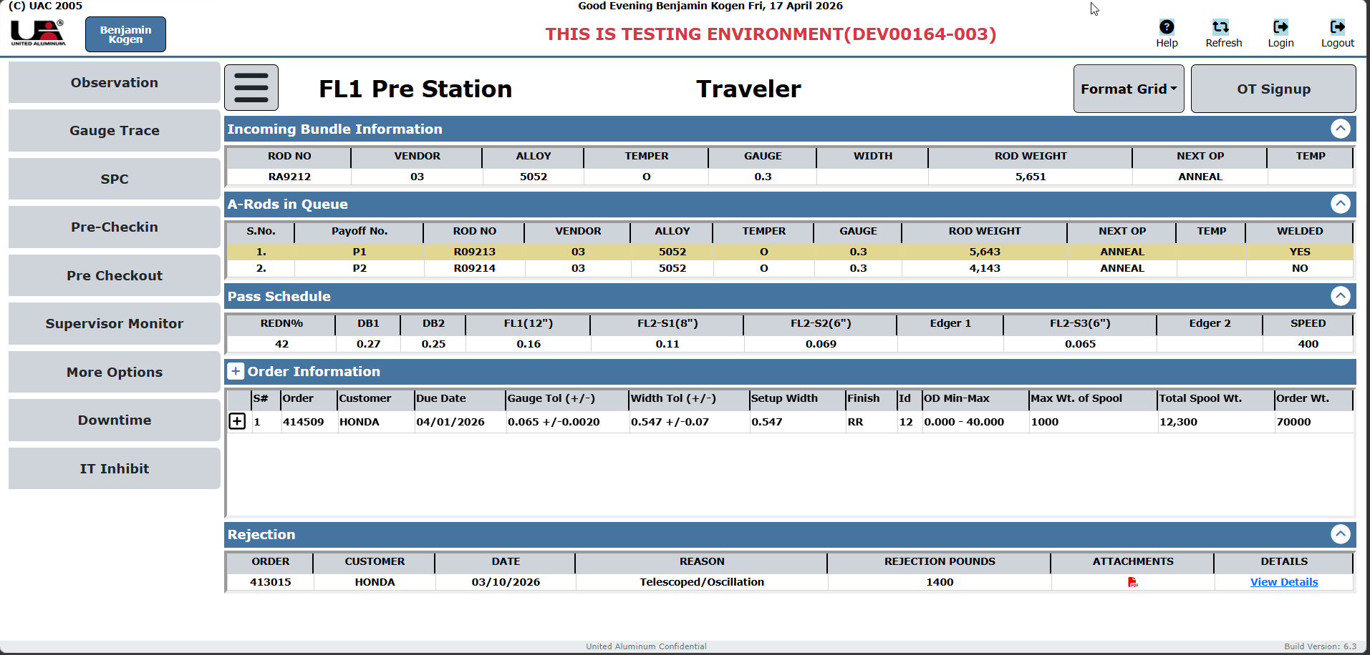
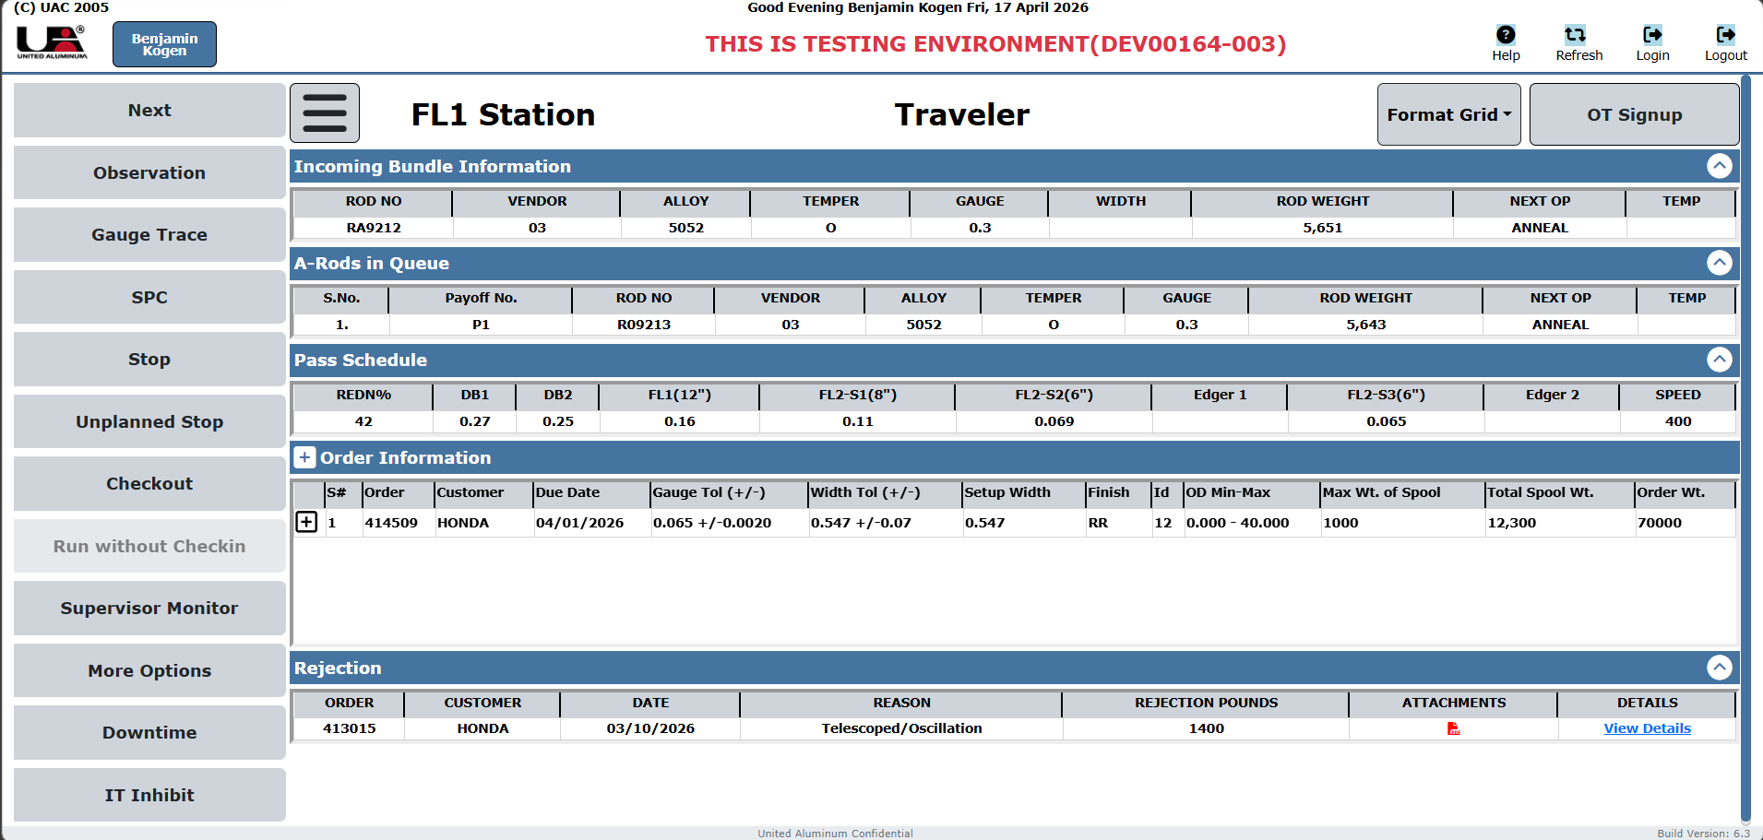

    - Order Instructions
This pop up will work as it works on slitters, there should be a new type Flat with existing Split , slit, anneal, roll.
    - Pass Schedule generation
- The system shall maintain a central Pass Schedule table accessible from both shopfloor applications and web applications.
- Pass schedules shall be manually created and maintained only by authorized users (Maintenance / Engineering); the system shall not auto-generate pass schedules.
- Pass schedules shall be configurable to support machine-specific routing, including FL1, FL2, and Hybrid FL3 operation.
(PSM-001, PSM-003, PSM-008)

Pass Schedule Structure & Content
- Each pass schedule shall define all required machine and process parameters, including:
  - Active and bypassed components
  - DB1 and DB2 die sizes
  - FL1 and FL2 roll clearances / gap settings
  - Target gauge and width at each processing stage
  - Speed and reduction percentages
  - Edger configuration (type and position)
  - Routing flag indicating standalone (FL1 / FL2) or hybrid (FL3)
- The pass schedule shall define edger configurations for both positions:
  - Before Stand 1
  - After Stand 3
- For FL2, the pass schedule shall specify which stands (6-inch, 6-inch, 8-inch) are required based on gauge and width.
- Pass schedules shall exclude tension values, as tension is controlled automatically through speed control.
(PSM-002, PSM-009, PSM-010, PSM-011)

Association with Production Orders
- The system shall allow pass schedules to be associated with specific production orders or gauge/width.
- Only pass schedules compatible with the current order and routing (FL1 / FL2 / FL3) shall be selectable at runtime.
(PSM-004)

Runtime Usage & Operator Interaction
- At the time of coil or rod check-in, the system shall:
  - Retrieve the applicable pass schedule
  - Present it to the operator for review and acknowledgment before the run begins
- The system shall clearly indicate to the operator:
  - Which machine components are active
  - Which components are bypassed
  - As defined by the selected pass schedule
- Upon operator acknowledgment:
  - The system shall push the relevant PLC configuration tags to the machine controller to apply the pass schedule settings.
(PSM-005, PSM-006, PSM-007)
DB:
A new table needs to be created for pass schedule.
Flatwire machine will pick the data from table on basis needs to be discussed.
This pass schedule can also be updated from web.
    - Gauge Trace & Width Trace pop up
These pop ups will only be displayed on FL2.
Gauge Trace will be same as on slitters.
Width trace will be similar to gauge trace but will have Width on Y axis and feet on X axis.

    - SPC
SPC Checkpoints & Data Collection
- The system shall support SPC checkpoints at all key stages of the process, including:
  - Incoming rod diameter at pre-check-in
  - Post wire-draw diameter (after die changes)
  - Post FL1 gauge reading
  - Post FL2 gauge reading
- SPC shall support monitoring of both gauge (thickness) and width measurements at FL1 and FL2 output stages.
(SPC-001, SPC-006)

SPC Prompting & Measurement Rules
- SPC prompts shall be automatically initiated after traveler load at check-in, aligned with existing mill SPC behavior.
- Automatic gauge readings shall be the primary SPC data source during normal operation (“set-and-forget” mode).
- Manual SPC entry shall be required only during:
  - Initial setup
  - Die changes
- SPC sampling rules shall be configurable:
  - By customer
  - By process stage (e.g., FL1 vs FL2)
(SPC-002, SPC-003, SPC-005)

SPC Analysis & Validation
- The system shall calculate CPK values for each production run based on output material.
- CPK calculations shall:
  - Exclude unstable regions at the start and end of the run
  - Use a defined, stable process window
- At transaction finalization:
  - The system shall perform an SPC compliance check
  - Output material must meet customer specifications before the transaction can be completed.
(SPC-004, SPC-007)
TRF logic pending.

    - ITInhibit and Alerts
ITInhibit – Purpose & Control Enforcement
- ITInhibit shall be a system-controlled tag used to prevent the machine from running when required conditions are not met.
- ITInhibit enforcement shall:
  - Prevent operators from bypassing quality checks
  - Improve operational safety
  - Ensure machine operation is allowed only when the system is in a valid, compliant state
- ITInhibit shall be set and cleared only by the system, not manually by operators.

Prerequisite Validation for Rolling
- The system shall prevent rolling from starting if:
  - No coil/rod is checked in
  - No active MMS ID exists
- The system shall enforce that no rolling or rolling data can be recorded without an active coil.
- Violation of these prerequisites shall:
  - Trigger ITInhibit
  - Block machine run and related transactions
(ALT-001, ALT-006)

Material Progress & Length Alerts
- The system shall display progressive buildup alerts as remaining output length approaches the planned length:
  - First alert at 50% remaining
  - Subsequent alerts at every 10% thereafter (40%, 30%, 20%, 10%)
- The system shall alert operators when remaining feed (feet) for the current coil reaches configurable threshold values.
(ALT-002, ALT-003)
(Reasons for ITInhibit i.e. exact list pending)
    - Stop Button
Stop will be created after rod has been rolled to desired feet.
Pop up for Stop will open through button on interface or when Mill stops.

      - Pop up on Mill stop
Below pop up will open on Mill Stop.
How to know when to open pop up. System will read an OPC tag for Mill speed if Mill speed is 0 then open the pop up.
On Click of Stop Completed , STOP pop up will open.

      - Stop Pop Up
Stop pop up can be invoked in 2 ways :
- When mill stops from pop up “Reason for Flatwire Stop”
- STOP button on the interface
There will be following fields :
Pop up Name : “ ROLLING TRANSACTION FOR ROD #RODNO – STOP #stopno”
Label | Type | Required | Editable | Sample Value | Notes
Rod Buildup | Number input | Yes | Yes | 10 | Includes virtual keyboard button, Can have positive values upto 40
Spool ID | DropDown | Yes | Yes | 12 | Auto populate from ID range for FL3 & FL2 , For FL1 will be fixed.
Length | Text input | No | No (readonly) | 3465 | System-calculated length; display only
Spool OD | Text input | Yes | No (readonly) | 32 | Auto-populated based on Build up and ID
Scrap Box # | Typeahead search | No | Yes | SB001- FL1-5052 | Autocomplete combobox; includes Clear Scrap Box button

Next section for this pop up:
Column | Sample Value | Notes
WIRE NO | RA9212A | Next alpha to be generated
ORDERS | 415163 | Order no for which this rolling is being performed.
CUSTOMER | HITACHI | Customer name
PLAN WEIGHT | 1731 | Planned weight for spool for this order.
ROLLED WEIGHT | 1547 | How much actual weight is rolled in this stop
WIDTH | 0.638 | Width of output wire
WEIGHT | — | Total weight of wire rolled for this order
SPOOLS | 1 | No fo Spools created for this order
SCRAP SPOOLS | — | No of spools scrapped during this rolling for this order
NEXT OP | ANNEALING | Next operation for this spool
ANNL Tmp | 670 | Anneal temp for annealing

Label : Select an action for the balance of the coil
These buttons will work same as they work on slitters.
Label | Status
Continue Slitting For Same Order | Enabled
Scrap Balance | Enabled
Return Bal To Warehouse | Enabled
Continue Slitting For Different Order | Disabled

Warning Banner(In case SPC is not done on the wire)
"SPC has not been performed for this coil"
(Displayed in red bold text on a beige background)

Footer action buttons

Label | Status | Purpose
WIP Reject | Enabled | Mark the wire-in-progress as rejected
SPC | Enabled | Navigate to or open the SPC process
Show Traveler | Enabled | Display the full traveler record
Back | Enabled | Close/cancel the stop transaction
Update | Disabled | Save/submit the stop transaction (enabled after SPC is completed)

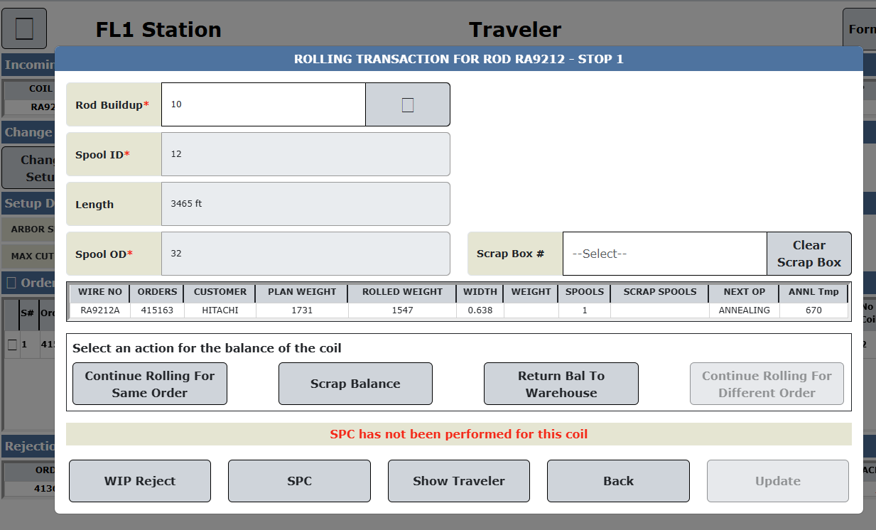

      - Wire Break
In case of Wire break , system will ask operator “Has the wire break happened?” Buttons Yes and No.
On click of Yes show below pop up.
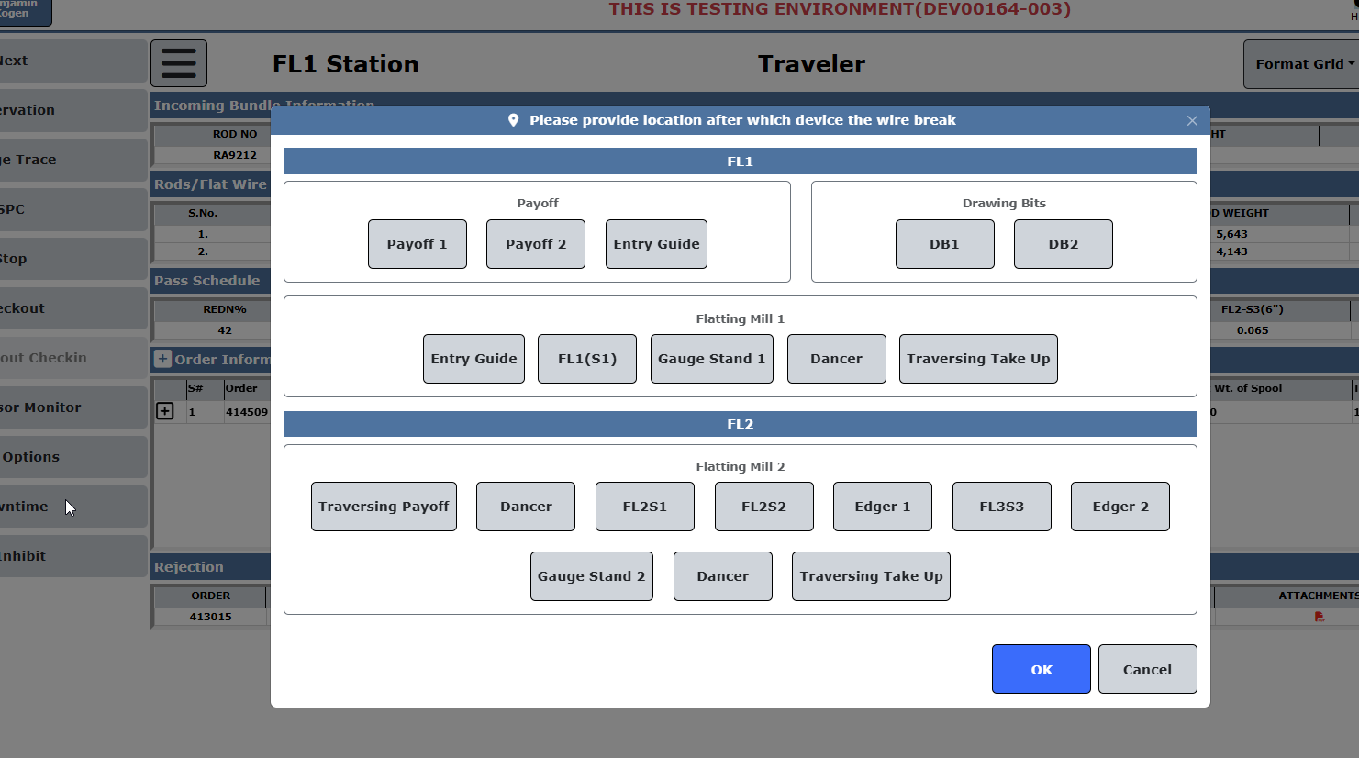
On click of OK show below pop up.
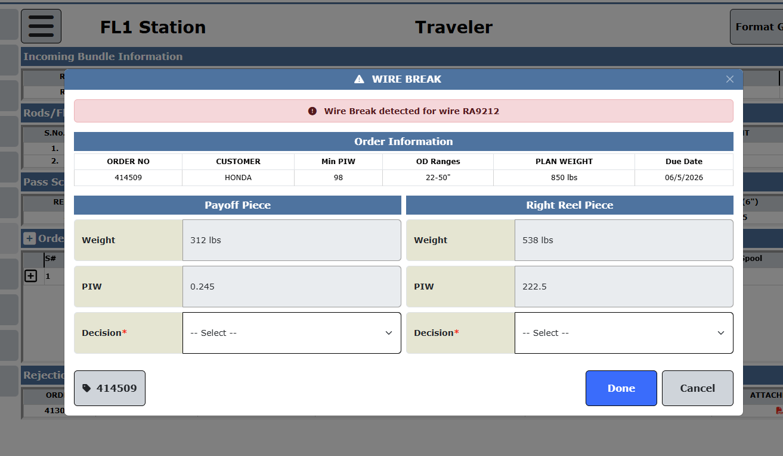
      - OD Verification
      - Inspect for defects
      - Output of Rolling
FL1 Output – Intermediate Spool Handling
- FL1 output shall be produced on reusable, collapsible intermediate spools with an approximate capacity of 3,500 lbs.
- These intermediate spools shall be routed to a furnace for annealing prior to FL2 processing.
  - Annealing shall be a separate operation (non-inline) for Phase 1.
- Each intermediate spool shall be assigned a unique spool number:
  - Printed on a high-temperature label
  - Label shall support furnace processing and FL2 check-in traceability
- Spool number sequencing shall:
  - Start from TS000001
  - End at TS999999
  - Be system-generated and unique
(OUT-001, OUT-002, OUT-003, OUT-004)

FL2 Output – Finished Product Handling
- FL2 output shall be a coreless, oscillated finished coil.
- The collapsible spool used during processing shall:
  - Eject the finished coil
  - Not remain with the finished product
- Finished coils shall be:
  - Ejected directly onto a skid
  - Packaged with no spool or core
- Each skid shall contain:
  - Two finished coreless Wire spools
  - Configuration same as eye-to-the-side packing at R48
- Typical finished product weight shall be 900–1,000 lbs per package.
- Finished skids shall move:
  - Directly to the packing line
  - Using the same logistics and process flow as existing products
(OUT-005, OUT-006, OUT-007, OUT-008, OUT-009)

Packing, Validation & Skid Logic
- At transaction finalization, the system shall validate:
  - Package outer diameter (OD)
  - Width
  - Weight
- Validation shall be performed against customer order constraints, and the transaction shall not complete if limits are exceeded.
- Skid numbering and logic shall:
  - Follow the same rules as current skid handling
  - Support reuse and continuity with existing skid systems
- FL2 stations shall support:
  - Direct packing of skids
  - Operator prompts and pop-ups, similar to the existing R48 eye-to-side packing scenario, to guide correct packaging orientation and confirmation
(OUT-010, OUT-011, OUT-012)

      - Downtime
Need to record change in rolls.
    - Label Printing
- FL1 shall be equipped with two label printers:
  - A standard Sato label printer
  - A high-temperature label printer for furnace-compatible labels
- FL2 shall also be equipped with two label printers:
  - A standard Sato label printer
  - A high-temperature label printer
- A payoff printer at FL1 shall be deferred for Day-1, as send-back-to-stock scenarios are considered low likelihood.
(PR-001, PR-002, PR-005)

Label Content & Usage
- Labels printed at the spool / take-up station shall include all essential material and process information, including:
  - Alloy
  - Width
  - Gauge
  - Temper
  - Gross weight
  - Net weight
  - Rod / coil number
- FL2 spool labels shall contain sufficient information to:
  - Support FL2 check-in
  - Be scannable via barcode
- If an output spool contains multiple welded coils:
  - The label shall list all contributing parent coil codes, enabling multi-parent traceability.
(PR-003, PR-006, PR-007)
    - Data Recording
Real-Time Feet & Weight Tracking
- The system shall track remaining material length (feet) in real time for:
  - The currently active input coil
  - The next welded (queued) coil
- Feet consumption values shall be sourced from the PLC wherever available.
- If PLC feet data is unavailable or invalid:
  - The system shall set ITInhibit
  - Rolling shall not be permitted
- The system shall continuously update:
  - Remaining feet
  - Derived weight
- Accurate reconciliation of material consumption shall be supported across welded, multi-coil runs.
(FRT-001, FRT-002, FRT-003, FRT-010)

Coil Transition & MMS ID Lifecycle
- A unique MMS ID shall be generated for each input coil at check-in time.
- Coil transition shall be automatic and consumption-driven:
  - When remaining feet for the active coil reaches zero, a coil-transition event shall be triggered
  - The next welded coil shall automatically become active
- When a welded coil becomes active:
  - The corresponding MMS ID shall be activated
  - The previous MMS ID shall be automatically closed
- MMS IDs shall be:
  - Closed strictly based on material consumption
  - Not dependent on operator actions
- An output spool may reference multiple MMS IDs when material from welded coils contributes to a single run.
(FRT-004, FRT-005, FRT-006, FRT-007, FRT-008)

Weight Calculation Logic
- Net weight shall be calculated using the formula:
Net Weight = Vendor Weight − Gross Weight − Tail Weight
- Calculated net weight shall be associated with the corresponding MMS ID.
- Output weight during rolling shall be calculated using:
  - Recorded length (feet)
  - Gauge
  - Width
- Weight shall not be derived from a weigh scale.
(FRT-009, DAT-011)

Data Collection Applications & Architecture
- The system shall provide two independent data collection application instances:
  - One for FL1
  - One for FL2
- FL3 (Hybrid) mode shall use both instances simultaneously.
- FL1 and FL2 shall be capable of running independent jobs concurrently.
(DAT-001)

Data Recording Triggers & Frequency
- Data recording shall start automatically when:
  - Mill speed exceeds zero
- No manual start action shall be required.
- Data recording frequency shall be:
  - Configurable (not hard-coded)
  - Accessible to authorized users (Engineering / IT) without a code change
- Default recording frequencies:
  - 4 feet per data point → finished product
  - 20 feet per data point → intermediate product
- Recording frequency rules:
  - If no subsequent rolling operation exists → record every 4 feet
  - If a subsequent rolling operation exists → record every 20 feet
  - FL2 shall always record every 4 feet
  - In FL3 (hybrid) mode, both FL1 and FL2 shall record every 4 feet, since FL3 always produces finished product
(DAT-002, DAT-003, DAT-004, DAT-005, DAT-010, DAT-012)

Gauge & Width Trace Recording
- At each recording point, the system shall capture:
  - Gauge
  - Width
- Gauge and width shall be recorded simultaneously, enabling:
  - Gauge trace graphs
  - Width trace graphs
- Gauge trace data recorded at FL1 shall:
  - Become available at FL2 once the spool is checked in
  - Support MMS-style traceability through downstream processing
- A single run may include material from multiple welded input coils:
  - Gauge trace visualization shall clearly indicate coil boundaries within a single run-level trace
(DAT-006, DAT-007, DAT-008)

Data Integrity & Alerting
- If two or more consecutive data recording entries are missing:
  - A prominent alert shall be displayed to the operator
  - ITInhibit shall be activated to block further operation
- Alerts shall clearly indicate a data recording issue requiring resolution.
(DAT-009)

  - Feature Description
[Guideline: This section provides the details for the user interfaces for the described feature. This section will have the screenshots of designs, interaction details, validations on the UI, etc.]
    - Database

A new table proddb..spools will be created having columns
Columns: Spoolno, rodno, rodlength, multiple coils(values Y and N), spoollength, rodlength.
New table for SPC at FL stations needs to be created.

We need 3 new entry for flat wire in machines table. In case of in line annealing only FL3 will be there.
Entry in wip_stations.
Entry in cost_centre_cost

