Flat Wire Shopfloor System — Software Requirements Specification

Table of Contents
Flat Wire Shopfloor System — Software Requirements Specification 0
Table of Contents 0
List of Figures 2
Document Control 4
Change History 4
Contacts 4
1. Introduction 5
1.1 Purpose 5
1.2 Scope 5
1.3 Product Overview 6
1.4 Definitions & Acronyms 6
1.5 Document Conventions & Requirement Attributes 7
1.6 Intended Audience & Reading Order 8
2. Overall Description 8
2.1 Product Perspective 8
2.2 Product Functions 9
2.3 User Classes & Characteristics 9
2.4 Operating Environment 9
2.5 Design & Implementation Constraints 10
2.6 User Documentation 10
2.7 Assumptions & Dependencies 10
2.8 Equipment & Capacities 10
2.9 Roles & Permissions Matrix 11
3. External Interface Requirements 12
3.1 User Interfaces 12
3.2 Hardware Interfaces 13
3.3 Software Interfaces 13
3.4 Communications Interfaces 13
3.5 Integration Requirements (INT) 14
4. System Features 17
4.1 Login / Logout (OL) 17
4.2 Pre-Check-In (PCI) 18
4.3 Check-In (CHK) 20
4.4 Welding (WLD) 24
4.5 Traveler (TRV) 27
4.6 Order Instructions (ORD) 28
4.7 Pass Schedule Management (PSM) 29
4.8 Gauge Trace & Width Trace (GWT) 32
4.9 SPC & CPK (SPC) 33
4.10 ITInhibit & Alerts (ALT) 35
4.11 Stop / Pause / Output (STP) 37
4.12 Wire Break (WBK) 39
4.13 Label Printing (PR) 40
4.14 Data Recording (FRT + DAT) 41
4.15 WIP Rejection (WRJ) 43
4.16 Packing & Skid (PKG) 45
4.17 Rod Checkout (RCO) 46
4.18 Partial Rod Re-Check-In (PRC) 50
4.19 Line Status Overview (LST) — Dashboard 1 54
4.20 Active Run Monitor + Machine View (ARM) — Dashboard 3 55
4.21 Pass Schedule List (PSL) — Dashboard 9A 59
4.22 Shift Summary (SHS) — Dashboard 10 61
4.23 Roll Adjust (RAJ) — Dashboard 11 63
4.24 Die Change (DCH) 65
4.25 Die Management (DMG) 68
4.26 HMI Schematic (HMI) — Dashboard 13 70
4.27 SCADA Trends (SCD) — Dashboard 14 72
4.28 OEE (OEE) 74
4.29 Pause Run (PRN) 76
5. Non-Functional Requirements 79
5.1 Throughput and line speed 79
5.2 Data-recording frequency (configurable) 79
5.3 Real-time latency and availability 79
5.4 Security and authentication 79
5.5 Auditability 80
5.6 Traceability retention 80
6. Other Requirements 80
6.1 Data Requirements 80
6.2 Verification & Acceptance Approach 81
6.3 Units, Terminology & Conventions 81
6.4 Data Model & Persistence — Detail (DM) 82
Appendix A — Analysis Models 87
Appendix B — Requirement Traceability Matrix 87
Appendix C — Open Items & TBD Register 90
Appendix D — Document Cross-Reference Map 92
Appendix E — Dashboard Reference Gallery 93

List of Figures
Figure # — Figure — Flat Wire machine system context (equipment layout). 8
Figure # — Rod Check-In (Dashboard 2) (db02_rod_checkin.png) 20
Figure # — Rod Check-In (Dashboard 2) (db02_rod_checkin.png) 23
Figure # — Rod Check-In — FL3 Hybrid (db02_rod_checkin_fl3.png) 24
Figure # — Weld Event Logger (Dashboard 4) (db04_weld_event.png) 26
Figure # — Active Run Monitor (Dashboard 3) (db03_active_run.png) 28
Figure # — Pass Schedule Management (Dashboard 9) (db09_pass_schedule.png) 31
Figure # — Pass Schedule List (Dashboard 9A) (db09a_schedule_list.png) 32
Figure # — SCADA Trends (Dashboard 14) (db14_scada_trends.png) 33
Figure # — SPC Checkpoint (Dashboard 6) (db06_spc_checkpoint.png) 35
Figure # — Line Status Overview (Dashboard 1) (db01_line_status.png) 37
Figure # — Output Coil Completion (Dashboard 7) (db07_coil_completion.png) 39
Figure # — Output Coil Completion (Dashboard 7) (db07_coil_completion.png) 41
Figure # — Active Run Monitor (Dashboard 3) (db03_active_run.png) 43
Figure # — WIP Rejection (Dashboard 8) (db08_wip_rejection.png) 44
Figure # — Packing Station (Dashboard 7b) (db07b_packing_station.png) 46
Figure # — Rod Checkout (Dashboard 12) (db12_rod_checkout.png) 50
Figure # — Spool Check-In (Dashboard 5) (db05_spool_checkin.png) 53
Figure # — Line Status Overview (Dashboard 1) (db01_line_status.png) 55
Figure # — Active Run Monitor (Dashboard 3) (db03_active_run.png) 57
Figure # — Active Run Monitor — FL2 (db03_active_run_fl2.png) 58
Figure # — Active Run Monitor — FL3 Hybrid (db03_active_run_fl3.png) 59
Figure # — Pass Schedule List (Dashboard 9A) (db09a_schedule_list.png) 61
Figure # — Shift Summary (Dashboard 10) (db10_shift_summary.png) 63
Figure # — Roll Adjust (Dashboard 11) (db11_roll_adjust.png) 65
Figure # — Die Change (db_die_change.png) 68
Figure # — Die Management (db_die_management.png) 70
Figure # — HMI Line Schematic (Dashboard 13) (db13_hmi_schematic.png) 72
Figure # — SCADA Trends (Dashboard 14) (db14_scada_trends.png) 74
Figure # — OEE Dashboard (db_oee.png) 76
Figure # — Active Run Monitor (Dashboard 3) (db03_active_run.png) 78
Figure # — Line Status Overview (Dashboard 1) (db01_line_status.png) 94
Figure # — Rod Check-In (Dashboard 2) (db02_rod_checkin.png) 95
Figure # — Rod Check-In — FL3 Hybrid (db02_rod_checkin_fl3.png) 96
Figure # — Active Run Monitor (Dashboard 3) (db03_active_run.png) 97
Figure # — Active Run Monitor — FL2 (db03_active_run_fl2.png) 98
Figure # — Active Run Monitor — FL3 Hybrid (db03_active_run_fl3.png) 99
Figure # — Weld Event Logger (Dashboard 4) (db04_weld_event.png) 100
Figure # — Spool Check-In (Dashboard 5) (db05_spool_checkin.png) 101
Figure # — SPC Checkpoint (Dashboard 6) (db06_spc_checkpoint.png) 102
Figure # — Output Coil Completion (Dashboard 7) (db07_coil_completion.png) 103
Figure # — Packing Station (Dashboard 7b) (db07b_packing_station.png) 104
Figure # — WIP Rejection (Dashboard 8) (db08_wip_rejection.png) 105
Figure # — Pass Schedule Management (Dashboard 9) (db09_pass_schedule.png) 106
Figure # — Pass Schedule List (Dashboard 9A) (db09a_schedule_list.png) 107
Figure # — Shift Summary (Dashboard 10) (db10_shift_summary.png) 108
Figure # — Roll Adjust (Dashboard 11) (db11_roll_adjust.png) 109
Figure # — Rod Checkout (Dashboard 12) (db12_rod_checkout.png) 110
Figure # — HMI Line Schematic (Dashboard 13) (db13_hmi_schematic.png) 111
Figure # — SCADA Trends (Dashboard 14) (db14_scada_trends.png) 112
Figure # — Die Change (db_die_change.png) 113
Figure # — Die Management (db_die_management.png) 114
Figure # — OEE Dashboard (db_oee.png) 115

Document Control

Change History
Version | Author | Date | Reviewer | Reviewed On | Description
1.0 | Jaspreet Singh | [dd-mmm-yy] | [Name] | [dd-mmm-yy] | Initial shopfloor SRS
2.0 | Flat Wire Requirements Team | [dd-mmm-yy] | [Name] | [dd-mmm-yy] | Consolidated shopfloor + dashboard SRS reconciling all source documents

Contacts
Role | Name | Contact Details
Business Owner |  | [Placeholder]
Process Lead | Tim O'Brien | [Placeholder]
Requirements | Jaspreet Singh | [Placeholder]
Shop floor Development | Yogender Punia | [Placeholder]
Coordination | Srikanth Prabhala | [Placeholder]

1. Introduction

1.1 Purpose
This Software Requirements Specification defines the consolidated requirements for the shopfloor and dashboard components of the United Aluminum (UAL) Flat Wire manufacturing system. It reconciles the shopfloor screen specifications, the end-to-end process reference, role/permission definitions.
The document is intended for the development, quality assurance, process engineering, and operations teams responsible for delivering the Flat Wire capability, and it serves as the reference against which shopfloor screens, dashboards, the supporting data model, and PLC/OPC/SignalR integration are built and verified.

1.2 Scope
The Flat Wire initiative adds a new aluminum-rod-to-flat-wire manufacturing capability to the UAL Manufacturing Execution System, delivered across three new flattening lines (FL1, FL2, and the hybrid FL3). This SRS covers only the shopfloor and dashboard portion of that initiative. Adjacent modules are specified in their own owning documents and are cross-referenced below.

In Scope
- All shopfloor operator screens for FL1, FL2, and FL3 (hybrid): pre-check-in, check-in, traveler, welding, pass-schedule acknowledgment, gauge/width trace, SPC, stop transaction, wire break, and packing prompts.
- All shopfloor dashboards, including the Active Run Monitor, Pass Schedule Management (Dashboard 9 / 9A), Roll Adjust (Dashboard 11), Rod Checkout (Dashboard 12), Shift Summary (Dashboard 10), and related monitoring/summary views.
- The supporting data model for shopfloor operation (pre-check-in queue, spools, SPC records, MMS ID lifecycle, pass schedule store, and machine/WIP-station entries).
- Machine integration: PLC tag push/readback, OPC tag consumption (mill speed, feet consumption), and SignalR real-time notification flows.
- WIP / Rejection at shop floor.

Out of Scope
The following functional areas are outside this SRS and are governed by their own module documents:
- Coil Yield and Cost Ledger

1.3 Product Overview
United Aluminum is entering a new market by producing oscillate-wound flat wire from aluminum rod, rather than traditional pancake (strip) coils. The flat wire product line targets lower unit cost than pancake coils and opens new customer opportunities, notably welding-wire customers who require full heat-to-coil traceability. The system must convert aluminum rod into coreless oscillate-wound flat wire coils through wire drawing, controlled flattening, optional annealing, and finish rolling, while maintaining traceability across every form change and weld join.

1.4 Definitions & Acronyms
Term | Definition
Rod (AROD) | Aluminum wire rod received in bundled coils from vendors; the raw input to the flat wire process. Tracked with an R-series alpha (R00001–R99999).
Flat wire | The product — flat, 2D cross-section aluminum wire produced by the flattening lines. Used consistently; the term "strip" is not used.
FL1 | Flattening Line 1 — VPS payoff → wire drawing → 12" flattening mill → intermediate spool (TKUP-1). Standalone or hybrid entry.
FL2 | Flattening Line 2 — traversing payoff → 3-stand finishing mill → coreless oscillate-wound coil (TKUP-2). Standalone or hybrid continuation.
FL3 (hybrid) | Continuous operating mode in which FL1 feeds directly into FL2 as one uninterrupted line, with no intermediate spool and no intermediate anneal. Represented as a third machine entry.
Payoff | The dual-position feed reel (VPS) that holds incoming rod bundles eye-to-sky; two positions enable welded continuous operation. Max 9,000 lb per position.
Wire drawing die (DB1 / DB2) | Wire drawing blocks that reduce rod diameter and correct roundness. Either can be bypassed via the pass schedule.
12" flattening mill (FM1) | The 12" rolling mill on FL1 that converts round wire into flat wire (3D → 2D).
3-stand finishing mill (FM2) | The FL2 finishing mill comprising three 6" stands (6"S1, 6"S2, 6"S3) that bring flat wire to final gauge and width.
Edger | Edge-conditioning tooling within the finishing mill; positioned at stands S2 and S3 per the May 21, 2026 machine revision.
Dancer | Tension-management roller placed between components to compensate for speed variation. Tension is derived automatically from speed.
Traversing take-up / payoff | Oscillating winding (take-up) or unwinding (payoff) mechanism that builds or feeds a coreless coil / intermediate spool.
Intermediate spool (TS-/SP-series) | Reusable collapsible metal spool holding FL1 output. Numbered TS000001–TS999999; routed to anneal and then FL2.
MMS ID | Unique material-management identifier generated per input coil at check-in; activated/closed strictly on material consumption.
Pass schedule | Central configuration record defining active/bypassed components, die sizes, roll clearances, edge configuration, gauge/width targets, and route mode for a product route.
ITInhibit | System-controlled tag that blocks machine run when required conditions are not met. Set and cleared only by the system, never by operators.
SPC | Statistical Process Control — checkpoint measurement of gauge, width, and diameter at key process stages.
CPK | Process capability index calculated per production run, excluding unstable start/end regions.
Oscillate-wound coreless coil | The finished product form — flat wire wound without a core mandrel; the collapsible spool ejects the coil.
Skid | Packaging unit carrying two finished coreless coils, consistent with transformer-line (R48) packing.
Scrap box | Alloy-based container for rod and in-process scrap; selection follows the same carry-forward logic as slitters.

1.5 Document Conventions & Requirement Attributes
Requirement Identification. Every requirement carries a unique tag in the form PREFIX### (e.g., WLD012). The prefix denotes the functional area; the number is sequential within that area and is never reused or renumbered. Prefixes are:
Prefix | Area | Prefix | Area
OL | Login | STP | Stop / Pause / Output
PCI | Pre-Check-In | WBK | Wire Break
CHK | Check-In | PR | Label Printing
WLD | Welding | FRT / DAT | Data Recording
TRV | Traveler | WRJ | WIP Rejection
ORD | Order Instructions | PKG | Packing / Skid
PSM | Pass Schedule | RCO | Rod Checkout
GWT | Gauge / Width Trace | PRC | Partial Re-Check-In
SPC | SPC & CPK | LST | Line Status
ALT | IT Inhibit / Alerts | ARM | Active Run Monitor
PSL | Pass Schedule List | SHS | Shift Summary
RAJ | Roll Adjust | DCH | Die Change
DMG | Die Management | HMI | HMI Schematic
SCD | SCADA Trends | OEE | OEE
DM | Data Model | INT | Integration
NFR | Non-Functional

Priority (MoSCoW). Each requirement is rated against the Phase-1 go-live scope:
- Must — mandatory for go-live;
- Should — important but deferrable without blocking go-live;
- Could — desirable, implemented only if capacity permits.
Verification Method. Every requirement declares one of:
- Test — execution against defined inputs with measured pass/fail results;
- Demonstration — observed operation under representative conditions;
- Inspection — visual or documentary examination of the product or artifact;
- Analysis — reasoning, modelling, or calculation from established data.
Writing Conventions. Requirements use the imperative
- "shall" and state a single, atomic, verifiable condition. Non-binding text uses "should" (guidance) or "may" (permission). Unresolved items are marked
- TBD and logged in the Open Items register (Appendix C) with an owner and target date; no TBD may remain against a Must requirement at go-live.
Feature Presentation. Each System Feature in Chapter 4 is presented uniformly as: Description, Priority, Stimulus/Response Sequences, Functional Requirements, and Figure reference.

1.6 Intended Audience & Reading Order
This SRS serves development, QA, process/controls engineering, operations, and project stakeholders. Readers new to the line should read Chapters 1–3 first; implementers should focus on Chapter 4 (System Features) and Chapters 3, 5 and 6.

2. Overall Description

2.1 Product Perspective
The Flat Wire shopfloor system is a new capability added to the existing United Aluminum (UAL) Manufacturing Execution System, not a standalone application. It introduces aluminum-rod-to-flat-wire production across three new flattening lines — FL1, FL2, and the continuous hybrid FL3 — registered as first-class machine entries alongside the existing slitter and mill lines. It reuses established UAL patterns for authentication, machine configuration, planning, scheduling, reporting, WIP/rejection, yield, and cost, and integrates with adjacent modules (Web/Order/IQR, Scheduling, Planning, Reporting, Rod Receiving, Cost/Yield, Scrap Sales) specified in their own owning documents. The subject of this SRS is the shopfloor and dashboard layer that drives operator transactions and machine behavior for the flattening lines.
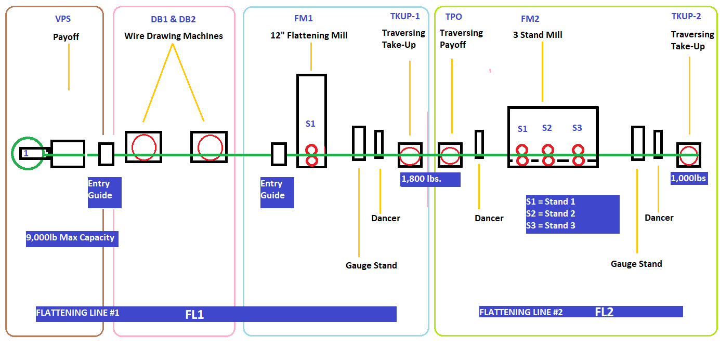
Figure # — Figure — Flat Wire machine system context (equipment layout).

2.2 Product Functions
The system provides the following major functions:
- Login / logout — manual and automatic operator authentication, with supervisor override.
- Pre-check-in — FL1 rod diameter and rod-number capture and visual inspection.
- Check-in — shared FL1/FL2 material check-in, MMS ID lifecycle, and PLC tag push on acknowledgment.
- Welding & traceability — induction (rod-to-rod) and optional laser (flat-to-flat) weld-join recording across continuous feed.
- Digital traveler — screen-based, per-station traveler with generic field labels (no printed traveler in Phase 1).
- Pass schedule acknowledgment — display and operator acknowledgment of the governing pass schedule at check-in.
- SPC — gauge, width, and diameter checkpoint capture and disposition at defined process stages.
- Data recording — gauge/width trace (live for FL1/FL3, historical for FL2) and length-based output-weight calculation.
- Stop / output — stop transactions, wire-break handling, and finished coreless-coil / packing prompts.
- Dashboards — Active Run Monitor, Pass Schedule Management (9/9A), Roll Adjust (11), Rod Checkout (12), Shift Summary (10), and related monitoring views.
- Rod checkout — supervisor-approved mid-run checkout with partial-run material disposition.
- Die management — footage-based tooling-life tracking and threshold alerting.

2.3 User Classes & Characteristics
Roles and their exact permissions are defined by the roles/permissions matrix in the System Overview (Section 3.4).
- Operator — shopfloor user running check-in, transactions, SPC recording, and one-for-one same-size die swaps; read-only on the pass schedule.
- Supervisor — approves login overrides, mid-run rod checkout, partial-run disposition, and weld removal; disposes WIP rejections.
- Operations Manager — creates, edits, activates, and overrides pass schedules; owns die management and roll-gap revert authority.
- Engineering / Maintenance — authors and maintains pass schedules, dies/edgers, and the alloy lookup table.
- QA — dispositions SPC and WIP rejections.

2.4 Operating Environment
- Frontend: Angular 18.2+ touch-first shopfloor UI within ual-angular, delivered as a PWA for local resilience on the shop floor.
- API: new .NET 8.0 FlatWire microservice in ual-api (Clean Architecture, MediatR CQRS).
- Database: SQL Server (FlatWireDB or schema extension).
- Real-time: SignalR for live gauge-trace streaming and notifications.
- Machine integration: existing OPC servers (unchanged) via the OPCConnection service, extended for FL1/FL2/FL3; new PLCs on the flattening lines.
- Printing: Sato and high-temperature label printers.

2.5 Assumptions & Dependencies
- PLCs are new hardware; OPC servers are unchanged. The flattening lines are commissioned with new PLCs, but the existing OPC server infrastructure remains as-is. The shopfloor system reads and writes machine state through the existing OPC layer.
- The Pass Schedule is the central control concept and a hard dependency. The pass schedule determines which components are active or bypassed, die and edge configurations, roll clearances, and gauge/width targets, and it drives the PLC tags pushed at check-in. No shopfloor check-in, PLC update, or machine configuration flow can proceed without a finalized pass schedule. It is manually maintained by Operations / Maintenance and is never auto generated.
- Width is controlled through the pass schedule, not the item template.
- Annealing is a separate, non-inline operation in Phase 1. FL1 intermediate spools are routed to a furnace for annealing before FL2 processing. Continuous hybrid (FL3) operation bypasses the intermediate anneal.
- PLC tag mapping is delivered by the controls team.
- One shared UI serves FL1 and FL2 check-in and transactions, dynamically adapting to the active station.
- Rods pre-exist in inventory, received through the separate Rod Receiving module.

2.6 User Documentation
- Operator quick-reference — login, pre-check-in/check-in, weld, SPC, stop, and packing flows.
- Pass-schedule maintenance guide — creating, versioning, activating, and overriding pass schedules.
- Administration / configuration notes — machine setup, PLC tag mapping, role/permission assignment, and label configuration.

2.7 Equipment & Capacities
The table below reflects the corrected capacity figures:
- FL1 has no edger, and
- FM2 comprises three 6" stands (S1, S2, S3) with
- edgers positioned at S2 and S3.
Equipment | Line | Role | Capacity / Value | Bypassable
VPS Payoff (dual position) | FL1 | Rod / wire feed, eye-to-sky | 9,000 lb max per position | No
DB1 | FL1 | Wire drawing die 1 | — | Yes
DB2 | FL1 | Wire drawing die 2 | — | Yes
FM1 (12" flattening mill) | FL1 | Round → flat; gauge stands + dancer; no edger | — | No
TKUP-1 (traversing take-up) | FL1 | Intermediate spool | 3,500 lb | N/A (non-hybrid only)
Traversing payoff (TPO) | FL2 | Feeds FM2 | 3,500 lb | N/A
FM2 — 6" S1 | FL2 | Finishing stand 1 | — | Yes
FM2 — 6" S2 (edger) | FL2 | Finishing stand 2; edger positioned here | — | Yes
FM2 — 6" S3 (edger) | FL2 | Finishing stand 3 (final); edger positioned here | — | No
TKUP-2 (traversing take-up) | FL2 | Finished coreless coil | 1,100 lb (per Q32, May 4, 2026 — supersedes prior 1,000 lb) | No
Line speed | All | Governed by final take-up | ~1,800–2,000 FPM | —
Skid | Packing | Finished output | 2 coreless coils per skid | —

> [OPEN ITEM: The extracted shopfloor SRS text describes FM2 as an 8" roller → 6"S1 → 6"S2 sequence with a mandatory final 6"S2 and edgers before Stand 1 / after Stand 3, and FlatWireEndToEndProcess.md shows FL1 with an edger. This SRS applies the May 21, 2026 revision (FL1 has no edger; FM2 is three 6" stands S1/S2/S3 with edgers at S2 and S3). The 8" roller referenced in earlier source documents is not represented in the May 21 configuration. Machine tab checkboxes, pass-schedule component lists, and PLC tag maps must be re-baselined against the May 21 revision, and the earlier 8"-roller references retired. Pull into decisions log.]
> [OPEN ITEM: Typical finished package weight is stated as 900–1,000 lb in the shopfloor SRS text, while the equipment/order limit is 1,100 lb (Q32). "Typical package weight" and "maximum coil weight" are distinct values; confirm the typical/target package weight independently of the 1,100 lb equipment ceiling.]

2.8 Roles & Permissions Matrix
The permission matrix below consolidates the role definitions in OperationsManager.md. In small operations the Supervisor and Operations Manager roles may be held by one person, but the system treats them as distinct permission levels.
Action | Operator | Supervisor | Operations Manager | Engineering / Maintenance | QA
Manual / auto login & logout | ✓ | ✓ | ✓ | ✓ | ✓
Supervisor override for login (operator not punched in) | ✗ | ✓ | ✓ | ✗ | ✗
View pass schedule / acknowledge at check-in | ✓ | ✓ | ✓ | ✓ | ✓
Create / edit pass schedule (Dashboard 9) | ✗ | ✗ | ✓ | ✓ | ✗
Activate / deactivate pass schedule | ✗ | ✗ | ✓ | ✓ | ✗
Override pass-schedule setting mid-run (logged w/ reason) | ✗ | ✗ | ✓ | ✓ | ✗
One-for-one same-size die swap at run | ✓ | ✓ | ✓ | ✓ | ✗
Apply roll-gap override (Dashboard 11) | ✓ | ✓ | ✓ | ✓ | ✗
Revert / undo a roll-gap override | ✗ | ✗ | ✓ | ✓ | ✗
Approve mid-run rod checkout (Dashboard 12) | ✗ | ✓ | ✓ | ✗ | ✗
Approve partial-run material disposition (Accept/Hold/Reject) | ✗ | ✓ | ✓ | ✗ | ✗
Supervisor override for weld removal / reversal | ✗ | ✓ | ✓ | ✗ | ✗
Flag WIP rejection | ✓ | ✓ | ✓ | ✓ | ✓
Dispose WIP rejection | ✗ | ✓ | ✓ | ✗ | ✓
SPC disposition at transaction finalization | ✓ (record) | ✓ | ✓ | ✗ | ✓
Die management / tooling life tracking | ✗ | ✗ | ✓ | ✓ | ✗
Edit alloy lookup table | ✗ | ✗ | ✗ | ✓ (Process Eng / System Admin) | ✗

> [OPEN ITEM: OperationsManager.md defines Operator, Supervisor, and Operations Manager explicitly, and reserves the alloy lookup table for "Process Engineering / System Admin." The Engineering/Maintenance and QA columns above are inferred from source usage (Engineering/Maintenance owns pass-schedule authoring and die/tooling; QA owns SPC disposition and rejection disposal). These two role definitions and their exact boundaries are not fully specified in the source and require confirmation. Pull into decisions log.]

3. External Interface Requirements
This chapter specifies the boundaries between the FlatWire system and the users, equipment, and adjacent software with which it exchanges data. Detailed behavioural requirements are stated in Chapter 5 and the Data & Integration section (INT, DM, NFR); this chapter fixes only the interface surfaces and does not restate those requirement lists.

3.1 User Interfaces
The system presents a single shopfloor web application, served as an Angular PWA (Progressive Web App), that adapts to the active line so that FL1, FL2, and FL3 operators use one consistent shell. From this shell the operator reaches the pre-check-in, check-in, active-run, welding, SPC, WIP-rejection, packing, roll-adjust, and checkout workflows, and the read-only dashboard suite (Line Status, Active Run Monitor, HMI Line Schematic, SCADA Trends, Pass Schedule List, and Shift Summary).
The UI is touch-first for shop-floor monitors: all interactive targets are at least 48 px, no action depends on hover, and numeric readings render in a monospace token for arm's-length legibility. Data entry uses an on-screen virtual keyboard and numeric keypad; transactional actions (Stop, Weld, Checkout, SPC entry) are presented as modal pop-ups that must be resolved or explicitly dismissed, and supervisor-override pop-ups block passive dismissal (per NFR009). The interface is theme-aware (light/dark) using the shared design tokens.
Representative screens are not reproduced here: the workflow screens appear as annotated figures in Chapter 4, and the complete dashboard set is catalogued in the Dashboard Reference gallery (Appendix E).

3.2 Hardware Interfaces
- Machine controllers (PLC). The system pushes pass-schedule configuration tags (component active/bypass, DB1/DB2 die sizes, FM1/FM2 roll gaps, edge type, speed targets) to the controller for the selected payoff position on explicit check-in acknowledgment, and clears them on checkout, as a single transactional batch (INT001–INT005).
- OPC-served instrumentation. Live mill speed drives automatic data-recording start/stop and the Reason-for-Stop pop-up; feet-consumption counts feed remaining-feet and derived-weight tracking (INT006, INT011–INT012). PLCs are new hardware but the OPC servers are unchanged (INT007).
- Label printers. Sato standard printers produce finished-coil and skid labels; Sato high-temperature printers produce intermediate-spool furnace labels that survive anneal. No traveler is printed.
- Barcode scanner. A fixed/handheld scanner reads the intermediate-spool alpha at the FL2 payoff during spool check-in.
- Scales. No process scale interface is required for output weight: finished and remaining weight are derived from footage, gauge, and width, not read from a scale (per FRT/weight-calculation).

3.3 Software Interfaces
- FlatWire SQL schema — the authoritative 22-table model (DM001) accessed exclusively through the FlatWire .NET 8 microservice and its EF Core DbContext.
- FlatWire microservice APIs — the REST endpoints for check-in, welding, SPC, roll override, die change, WIP rejection, packing, and checkout (see APIContracts).
- FlatWireHub SignalR hub — the real-time server-to-browser channel (see 3.4).
- Legacy proddb integration points — written for cross-system continuity at check-in and cleared per lifecycle: coils.coil_status = INFLAT, wip_coil_orders reqsum entry, and planning_routings/routings.actual_start_date (DM002–DM003). The master/sync boundary is an open item.
- Adjacent UAL modules — Web (Orders/Quotes/Item Template), Scheduling (Flattening Lines), Planning (allocation), and Reporting (Gauge Trace, CPK, Cut Traceability) integrate via the shared databases; their behaviour is owned by the module documents cross-referenced in Appendix C.

3.4 Communications Interfaces
Real-time data reaches the dashboards over SignalR (FlatWireHub), with clients joining per-line groups (FL1Data/FL2Data/FL3Data) and re-joining on reconnect; the default push interval is 1 s, configurable to 5/10/30 s, with no polling (INT008–INT010, NFR005–NFR006). Machine values are read from configuration-driven OPC tag paths (appsettings.json), never hardcoded. The condensed event/tag surface:
Channel | Name (example) | Payload / value | Primary consumers
SignalR event | GaugeReading / WidthReading | lineId, value(in), timestamp, footagePosition | DB13 sensor nodes, DB14 Charts 1–2, DB3
SignalR event | SpeedFPM | lineId, value(FPM), timestamp | DB13 flow, DB14 Chart 3
SignalR event | PayoffWeight | lineId, position, weightLb, percentRemaining | DB13 payoff boxes, DB14 Chart 4
SignalR event | ComponentStatus / LineStatus | lineId, component/status, value | DB13 boxes, DB13 header
SignalR event | FootageCounter | lineId, footage(ft), timestamp | DB13 TKUP nodes, DB13 header
SignalR event | AlertRaised / AlertCleared | lineId, alertType, severity, message | DB1 / DB13 alert bar
OPC tag | FL{n}.AGC.Gauge.Current / .Width.Current | live gauge/width (in) | DB13 sensors, DB14
OPC tag | `FL{n}.{DB1\ | DB2}.Die.ActiveDiameter, .FM1.RollGap.Current, .FM2.Stand*.RollGap.Current` | die/roll-gap (in)
OPC tag | FL{n}.Speed.FPM, `.Payoff{1\ | 2}.Weight.Lb, .TKUP{1\ | 2}.Footage.Current`
OPC tag | FL{n}.{component}.Status.Active / .Status.Fault | component state (bool) | DB13 status colour

Exact OPC tag paths are confirmed with engineering at commissioning and may change without redeployment.

3.5 Integration Requirements (INT)
The FlatWire microservice integrates with plant automation through the existing
OPCConnection service and streams live data to the browser through SignalR
(FlatWireHub). PLCs are new hardware, but the OPC servers are unchanged — no
new integration layer is introduced.

3.5.1 PLC tag push / clear
(INT001) The system shall push the relevant PLC configuration tags (component
active/bypass state, DB1/DB2 die sizes, FM1 and FM2 roll gaps, edge type, and
speed targets) to the machine controller for the selected payoff position **only
upon explicit operator acknowledgment** of the pass schedule at check-in — never
on schedule save, schedule load, or schedule generation.
(INT002) The system shall perform the PLC tag push as a single transactional
batch; if any individual tag write fails, the entire batch shall be rolled back,
an exception raised, and the check-in aborted (per FW-S1-004 / FW-082).
(INT003) The system shall clear (reset to idle/bypass defaults) the PLC tags
for a payoff position on rod checkout, and shall record the clear result in
RodCheckout.PlcTagsCleared.
(INT004) The system shall record the outcome of every tag push in the
check-in record (RodCheckin.PlcTagsPushed / SpoolCheckin.PlcTagsPushed) and
every override write in RollOverride.PlcTagWritten, and shall audit-log each tag
write/clear (tag path, value, operator, timestamp, result).
(INT005) The system shall source all OPC tag paths from configuration
(appsettings.json), not from hardcoded values, so tag paths can be corrected
after commissioning without redeployment.
> **[OPEN ITEM: PLC tag behaviour on checkout not finalized (OQ-49) — proposed
> rule is that the application never sends a stop command, tags are cleared only
> when the line is confirmed stopped, and checkout is blocked while the line is
> running; awaiting engineering confirmation.]**

3.5.2 OPC / mill-speed–driven behaviour
(INT006) The system shall read the OPC mill-speed tag and open the "Reason for
Flatwire Stop" pop-up when mill speed equals zero, and shall start automatic data
recording when mill speed exceeds zero (no manual start action).
(INT007) The system shall keep the existing OPC server configuration unchanged;
the OPCConnection service is extended to subscribe to FL1/FL2/FL3 tags but no
new OPC integration layer is introduced.

3.5.3 SignalR real-time streaming
(INT008) The system shall stream live machine data to shopfloor dashboards
through the FlatWireHub SignalR hub, with clients joining per-line groups
(FL1Data, FL2Data, FL3Data) and re-joining automatically on reconnect.
(INT009) The system shall broadcast the defined real-time events
(GaugeReading, WidthReading, SpeedFPM, PayoffWeight, ComponentStatus,
LineStatus, AlertRaised, AlertCleared, FootageCounter) to the HMI Line
Schematic (Dashboard 13), SCADA Trends (Dashboard 14), Line Status (Dashboard 1),
and Active Run Monitor (Dashboard 3).
(INT010) The system shall broadcast null for GaugeReading and
WidthReading when FL2 is in standalone mode (FL2 uses a historical gauge profile,
not a live feed).

3.5.4 Feet consumption from PLC
(INT011) The system shall source feet-consumption values from the PLC wherever
available and shall continuously update remaining feet and derived weight for both
the active input coil and the next welded (queued) coil.
(INT012) The system shall set ITInhibit and prevent rolling when PLC feet data
is unavailable or invalid (per FRT/ALT), and shall raise a data-recording alert
plus ITInhibit when two or more consecutive data-recording entries are missing.
> **[OPEN ITEM: exact ITInhibit trigger list not finalized — the full set of
> conditions that set/clear ITInhibit (no coil checked in, no active MMS ID,
> missing PLC feet, consecutive missing data points, roll-gap out of tolerance,
> etc.) is pending.]**

3.5.5 PLC Tag Mapping (from HMIAndSCADALayout.md)

3.5.5.1 Real-time SignalR events (FlatWireHub)
Event | Payload fields | Consumers
GaugeReading | lineId, value (in), timestamp, footagePosition | DB13 gauge node, DB14 Chart 1, DB3 Machine View
WidthReading | lineId, value (in), timestamp, footagePosition | DB13 width node, DB14 Chart 2, DB3 Machine View
SpeedFPM | lineId, value (FPM), timestamp | DB13 flow animation, DB14 Chart 3, DB13 header
PayoffWeight | `lineId, position (1\ | 2), weightLb, percentRemaining`
ComponentStatus | lineId, component, isActive, currentValue | DB13 all component boxes
LineStatus | lineId, status, orderId, alpha | DB13 header badge
AlertRaised | lineId, alertType, severity, message, timestamp | DB13 alert bar
AlertCleared | lineId, alertType | DB13 alert bar
FootageCounter | lineId, footage (ft), timestamp | DB13 TKUP nodes, DB13 header

3.5.5.2 OPC tag paths (FL1 example; FL2/FL3 follow the same pattern)
Tag path (OPC) | Description | Used in
FL1.DB1.Die.ActiveDiameter | DB1 current die diameter (in) | DB13 DB1 node
FL1.DB1.Status.Active | DB1 active (bool) | DB13 DB1 status colour
FL1.DB2.Die.ActiveDiameter | DB2 current die diameter (in) | DB13 DB2 node
FL1.DB2.Status.Active | DB2 active (bool) | DB13 DB2 status colour
FL1.FM1.RollGap.Current | FM1 current roll gap (in) | DB13 FM1 node
FL1.FM1.Status.Active | FM1 running (bool) | DB13 FM1 status colour
FL1.FM1.Status.Fault | FM1 fault (bool) | DB13 FM1 fault colour
FL1.AGC.Gauge.Current | Live gauge reading post-FM1 (in) | DB13 gauge sensor, DB14 Chart 1
FL1.AGC.Width.Current | Live width reading (in) | DB13 width sensor, DB14 Chart 2
FL1.Speed.FPM | Line speed (FPM) | DB13 animation, DB14 Chart 3
FL1.Payoff1.Weight.Lb | Payoff 1 load-cell weight (lb) | DB13 payoff 1, DB14 Chart 4
FL1.Payoff2.Weight.Lb | Payoff 2 load-cell weight (lb) | DB13 payoff 2, DB14 Chart 4
FL1.EdgeSet.Status.Active | Edge set active (bool) | DB13 EdgeSet node
FL1.TKUP1.Footage.Current | TKUP-1 footage counter (ft) | DB13 TKUP-1 node
FL1.TKUP2.Footage.Current | TKUP-2 footage counter (ft) | DB13 TKUP-2 node
FL2.FM2.Stand8.RollGap.Current | FM2 8" roller current gap | DB13 FM2-8" node
FL2.FM2.Stand6S1.RollGap.Current | FM2 6" S1 current gap | DB13 FM2-6"S1 node
FL2.FM2.Stand6S2.RollGap.Current | FM2 6" S2 current gap (final) | DB13 FM2-6"S2 node
FL2.FM2.Stand8.Status.Active | FM2 8" roller active | DB13 FM2-8" status
FL2.FM2.Stand6S1.Status.Active | FM2 6" S1 active | DB13 FM2-6"S1 status
FL2.FM2.Stand6S2.Status.Active | FM2 6" S2 active (always true) | DB13 FM2-6"S2 status

> Note: Exact OPC tag paths must be confirmed with Tim O. and the PLC
> commissioning engineer before go-live; the paths above follow the
> appsettings.json naming convention and can be updated without redeployment.

4. System Features
Feature group — Shopfloor Operations.

4.1 Login / Logout (OL)
Description. Login / Logout governs how flat-wire operators authenticate at FL1 and FL2 stations and how their identity is bound to each machine run. It supports manual and shift-based automatic login/logout, supervisor overrides for un-punched operators, mandatory operator identification at check-in and every stop/restart, and shared operator availability across both lines. This feature underpins traceability, accountability, and accurate production records on the flat-wire line.
Priority: Must — operator identity is a prerequisite for machine operation, run traceability, and audit compliance at go-live.
Stimulus / Response.
Trigger / operator action | System response
Operator logs in manually at a station | Verifies punched-in status; records operator ID, timestamp, and station
Un-punched operator attempts login | Requires validated supervisor override; logs both IDs, timestamp, and station
Shift start/end reached | Auto logs the operator in/out per configured schedule and logs the event
Machine check-in, stop, restart, or speed exceeds zero | Prompts "Who is running the machine?" and blocks operation until confirmed
Operator active on FL1 accessed at FL2 | Makes the operator selectable at the other line without re-login

Functional Requirements.

4.1.1 Manual Login & Logout
- The system shall support manual login and logout at the flat-wire station, consistent with the current shopfloor (slitter-equivalent) functionality, without regression. (OL001)
- The system shall capture each manual login and logout action with operator ID, a timestamp, and the associated station, and shall permit manual login and logout only for operators who are punched in. (OL001)

4.1.2 Auto Login & Auto Logout (Shift-Based)
- The system shall support automatic login at the start of the assigned shift and automatic logout at the end of the assigned shift, driven by system-configured shift schedules, consistent with existing shopfloor applications. (OL002)
- The system shall log every auto login/logout event so that it is traceable and visible to the operator. (OL002)

4.1.3 Supervisor Override for Un-Punched Login
- The system shall require a validated supervisor override before allowing an operator who is not punched in to log in manually. (OL003)
- The system shall fully log and make auditable every supervisor override, recording operator ID, supervisor ID, timestamp, and station. (OL003)

4.1.4 Operator Identification During Machine Operation
- The system shall prompt "Who is running the machine?" at check-in, at each stop and restart, and whenever machine speed becomes greater than zero, requiring an operator to be selected or confirmed. (OL004)
- The system shall prevent machine operation from continuing unless an operator is identified and logged against the run, recording the confirmation as mandatory, timestamped, and associated with the machine run record. (OL004)

4.1.5 Operator Availability Across Lines (FL1 / FL2)
- The system shall make an operator who is logged into FL1 selectable at FL2 and vice versa, providing shared operator visibility across FL1 and FL2 without requiring re-login, provided the operator is active and logged in and no conflicting session or authorization rule is violated. (OL005)
- The system shall track operator-to-line association per operation/per run rather than restricting an operator to a single fixed line at login time. (OL005)

4.2 Pre-Check-In (PCI)
Description. Pre-Check-In lets an FL1 operator register the next incoming rod/flat wire at a dedicated station while the current coil is still running. It captures the material's identity, diameter, payoff position, and optional scrap box, then surfaces the staged material during weld selection to enforce correct sequencing. This keeps FL1 in continuous operation and reduces changeover downtime; FL2, lacking staging space, uses standard check-in only.
Priority: Should — pre-check-in substantially improves FL1 throughput and sequencing accuracy, but the line remains operable through standard check-in if unavailable.
Stimulus / Response.
Trigger / operator action | System response
Operator opens the FL1 Pre-Check-In station with the current coil running | Presents the pre-check-in entry form for the next material
Operator enters rod/flat wire number, diameter, and payoff position (1 or 2) | Validates and records the staged material
Operator optionally enters a scrap box reference | Applies alloy-based and carry-forward selection logic from check-in
Operator confirms pre-check-in | Adds material to the Traveler, marked as pre-checked-in
Operator reaches weld selection | Automatically surfaces the pre-checked-in material to guide the weld decision

Functional Requirements.

4.2.1 Capability & Scope
- The system shall support pre-check-in of the next incoming rod/flat wire at FL1 while the current coil is still running, enabling continuous operation and reduced downtime. (PCI001)
- The system shall not support pre-check-in on FL2 (owing to lack of staging space) and shall support check-in only on FL2. (PCI002)
- The system shall provide a dedicated Pre-Check-In station for FL1. (PCI003)

4.2.2 Data Captured
- The system shall capture, at pre-check-in, the rod/flat wire number and the diameter. (PCI004)
- The system shall allow an optional scrap box reference at pre-check-in, applying the same alloy-based and carry-forward selection logic defined for check-in. (PCI005)
- The system shall capture the intended payoff position (Payoff 1 or Payoff 2) at pre-check-in. (PCI006)

4.2.3 Visibility & Workflow Integration
- The system shall display pre-checked-in material on the Pre-Check-In station Traveler and shall clearly identify it as pre-checked-in material. (PCI007)
- The system shall automatically surface pre-checked-in material to the operator during weld selection, so as to enforce correct sequencing, support informed weld decisions, and reduce the risk of selecting incorrect material. (PCI008)
*Data note (non-requirement):* On completion of pre-check-in the system performs the FlatwireQueue insert (Rodno, RodSeqno, Welded), sets proddb..coils.coil_status = INFLAT, performs reqsum and inserts proddb..wip_coil_orders if the rod is not yet reqsummed, and updates actual_start_date in planning_routings and routings.
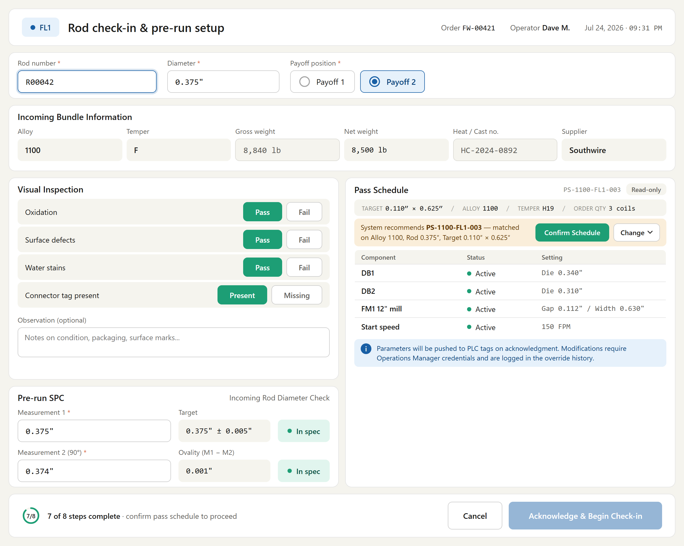
Figure # — Rod Check-In (Dashboard 2) (db02_rod_checkin.png)
*Requirements traced: PCI001–PCI008.*

4.3 Check-In (CHK)
Description. Check-In is the operation by which a flat-wire line operator commits a rod/flat-wire/spool to a machine before a production run begins. It captures the material identity, diameter/width, and scrap box; enforces order, plan, tolerance, visual-inspection, and Pre-Run SPC validations; retrieves and confirms the pass schedule; and pushes the acknowledged PLC configuration to the controller while updating WIP and coil status. It supports FL1-only, hybrid FL3, and FL2 stations, ensuring only verified material and schedules reach the machine.
Priority: Must — check-in gates every Phase-1 production run and the PLC push, so the line cannot operate without it.
Stimulus / Response.
Trigger / operator action | System response
Operator clicks Check-In on FL1 | Prompts for FL1-only vs. FL1+FL2, then sets the station and opens the check-in popup
Operator enters rod number and diameter | Validates against proddb..coils and coil_gauge tolerance; rejects invalid values
Operator clicks Done | Re-validates order, plan, mandatory fields, tolerance, availability, and visual inspection
Operator confirms pass schedule and acknowledges | Writes audit records, pushes PLC tags, and initiates SPC prompts
Check-in succeeds | Updates WIP coilno, sets coil_status = INFLAT, and stamps actual start dates

Functional Requirements.

4.3.1 Check-In Entry Behavior
- The system shall, on click of the Check-In button on FL1, display a popup with the message "Are you running FL1 only or with FL2?" offering the buttons "FL1 Only" and "FL1 and FL2 Together". (CHK001)
- The system shall set the station name to "FL1 Station" when "FL1 Only" is selected, and to "FL3 Station" (Hybrid FL1 + FL2) when "FL1 and FL2 Together" is selected. (CHK002)
- The system shall, on click of the Check-In button on FL2, open the check-in popup directly and shall not display the FL1/FL2 selection popup. (CHK003)

4.3.2 Check-In Fields (FL1 Station / FL3 Station)
- The system shall require the Rod/Flat Wire Number and the Rod Diameter/Flat Wire Width as mandatory fields for check-in on FL1 or FL3 (Hybrid). (CHK004)
- The system shall present the Scrap Box as an optional field, the Payoff 1 and Payoff 2 buttons (available on the Pre-Check-In station only), and the Done and Exit action buttons. (CHK005)

4.3.3 Field Validations
- The system shall validate the entered Rod/Flat Wire Number against proddb..coils and shall reject invalid or non-existing rod numbers. (CHK006)
- The system shall validate the entered rod diameter against proddb..coil_gauge within the ± tolerance obtained from the lookup table, and shall prevent check-in when the value falls outside the allowed range (e.g., diameter 0.30 with lookup tolerance ±0.01 yields a valid range of 0.29–0.31). (CHK007)
- The system shall populate the Scrap Box list by alloy (same logic as the slitter shopfloor), shall auto-select the previously used scrap box when the last checked-in rod had the same alloy and a scrap box was selected, and shall keep the Scrap Box non-mandatory and changeable or blank. (CHK008)

4.3.4 Done Button Validations
- The system shall, on click of Done, validate that the order is Open, that the plan is open, that all mandatory fields (Rod/Flat Wire Number, Diameter) are complete, that diameter tolerance is satisfied, and that the rod is available (not already checked in elsewhere), and shall not proceed with check-in if any validation fails. (CHK009)
- The system shall treat visual-inspection failure as a hard block, routing the operator to WIP Rejection before check-in can proceed, with no bypass. (CHK010)
- The system shall require a Pre-Run SPC diameter measurement to be entered and in-spec before "Acknowledge & Begin Check-in" is enabled. (CHK011)

4.3.5 FL2 Check-In Specific Requirements
- The system shall require the operator, at FL2 check-in, to scan the spool label printed at FL1 output and to measure and enter the width of the checked-in material, and shall validate the scanned spool against the previously checked-in FL1/FL3 data. (CHK012)
- The system shall validate, for FL2 check-in in hybrid context, that the spool's FL1 pass-schedule route mode is "Hybrid" and matches the expected FL2 input before allowing check-in. (CHK013) *[OPEN ITEM: FlatWireEndToEndProcess.md states hybrid/FL3 has no discrete FL2 check-in step (continuous feed), whereas RocCheckin.md Dashboard 5 defines a hybrid-mode FL2 check-in validation — reconcile whether an FL2 check-in ever occurs in hybrid mode.]*

4.3.6 Pass Schedule Retrieval, Acknowledgment & PLC Push
- The system shall, at check-in, retrieve the applicable pass schedule for the job and present it to the operator for review, clearly indicating which machine components are active and which are bypassed. (CHK014)
- The system shall require the operator to explicitly confirm pass-schedule identity in a mandatory confirmation dialog before any PLC tags are pushed, and shall require a free-text reason when the operator selects a schedule different from the recommended/planned one. (CHK015)
- The system shall write the audit records (visual-inspection result, Pre-Run SPC checkpoint, pass-schedule ID/version/effective date on the run record, and the acknowledgment event) before the PLC push, retaining an incomplete-push recovery marker if the PLC write fails. (CHK016)
- The system shall, upon operator acknowledgment, push the relevant PLC configuration tags (component activation flags, die sizes, roll gaps, speed limits, gauge/width targets) to the machine controller and log the push timestamp, pass-schedule ID, and triggering operator. (CHK017)

4.3.7 SPC Prompting & WIP Update
- The system shall automatically initiate SPC prompts after the traveler loads at check-in, aligned with existing mill SPC behavior. (CHK018)
- The system shall, on successful check-in, update the coilno field in WIP stations, set proddb..coils.coil_status = INFLAT, perform reqsum and insert proddb..wip_coil_orders if the rod is not yet reqsummed, and update actual_start_date in planning_routings and routings. (CHK019)

Figure # — Rod Check-In (Dashboard 2) (db02_rod_checkin.png)
*Requirements traced: CHK001–CHK019.*
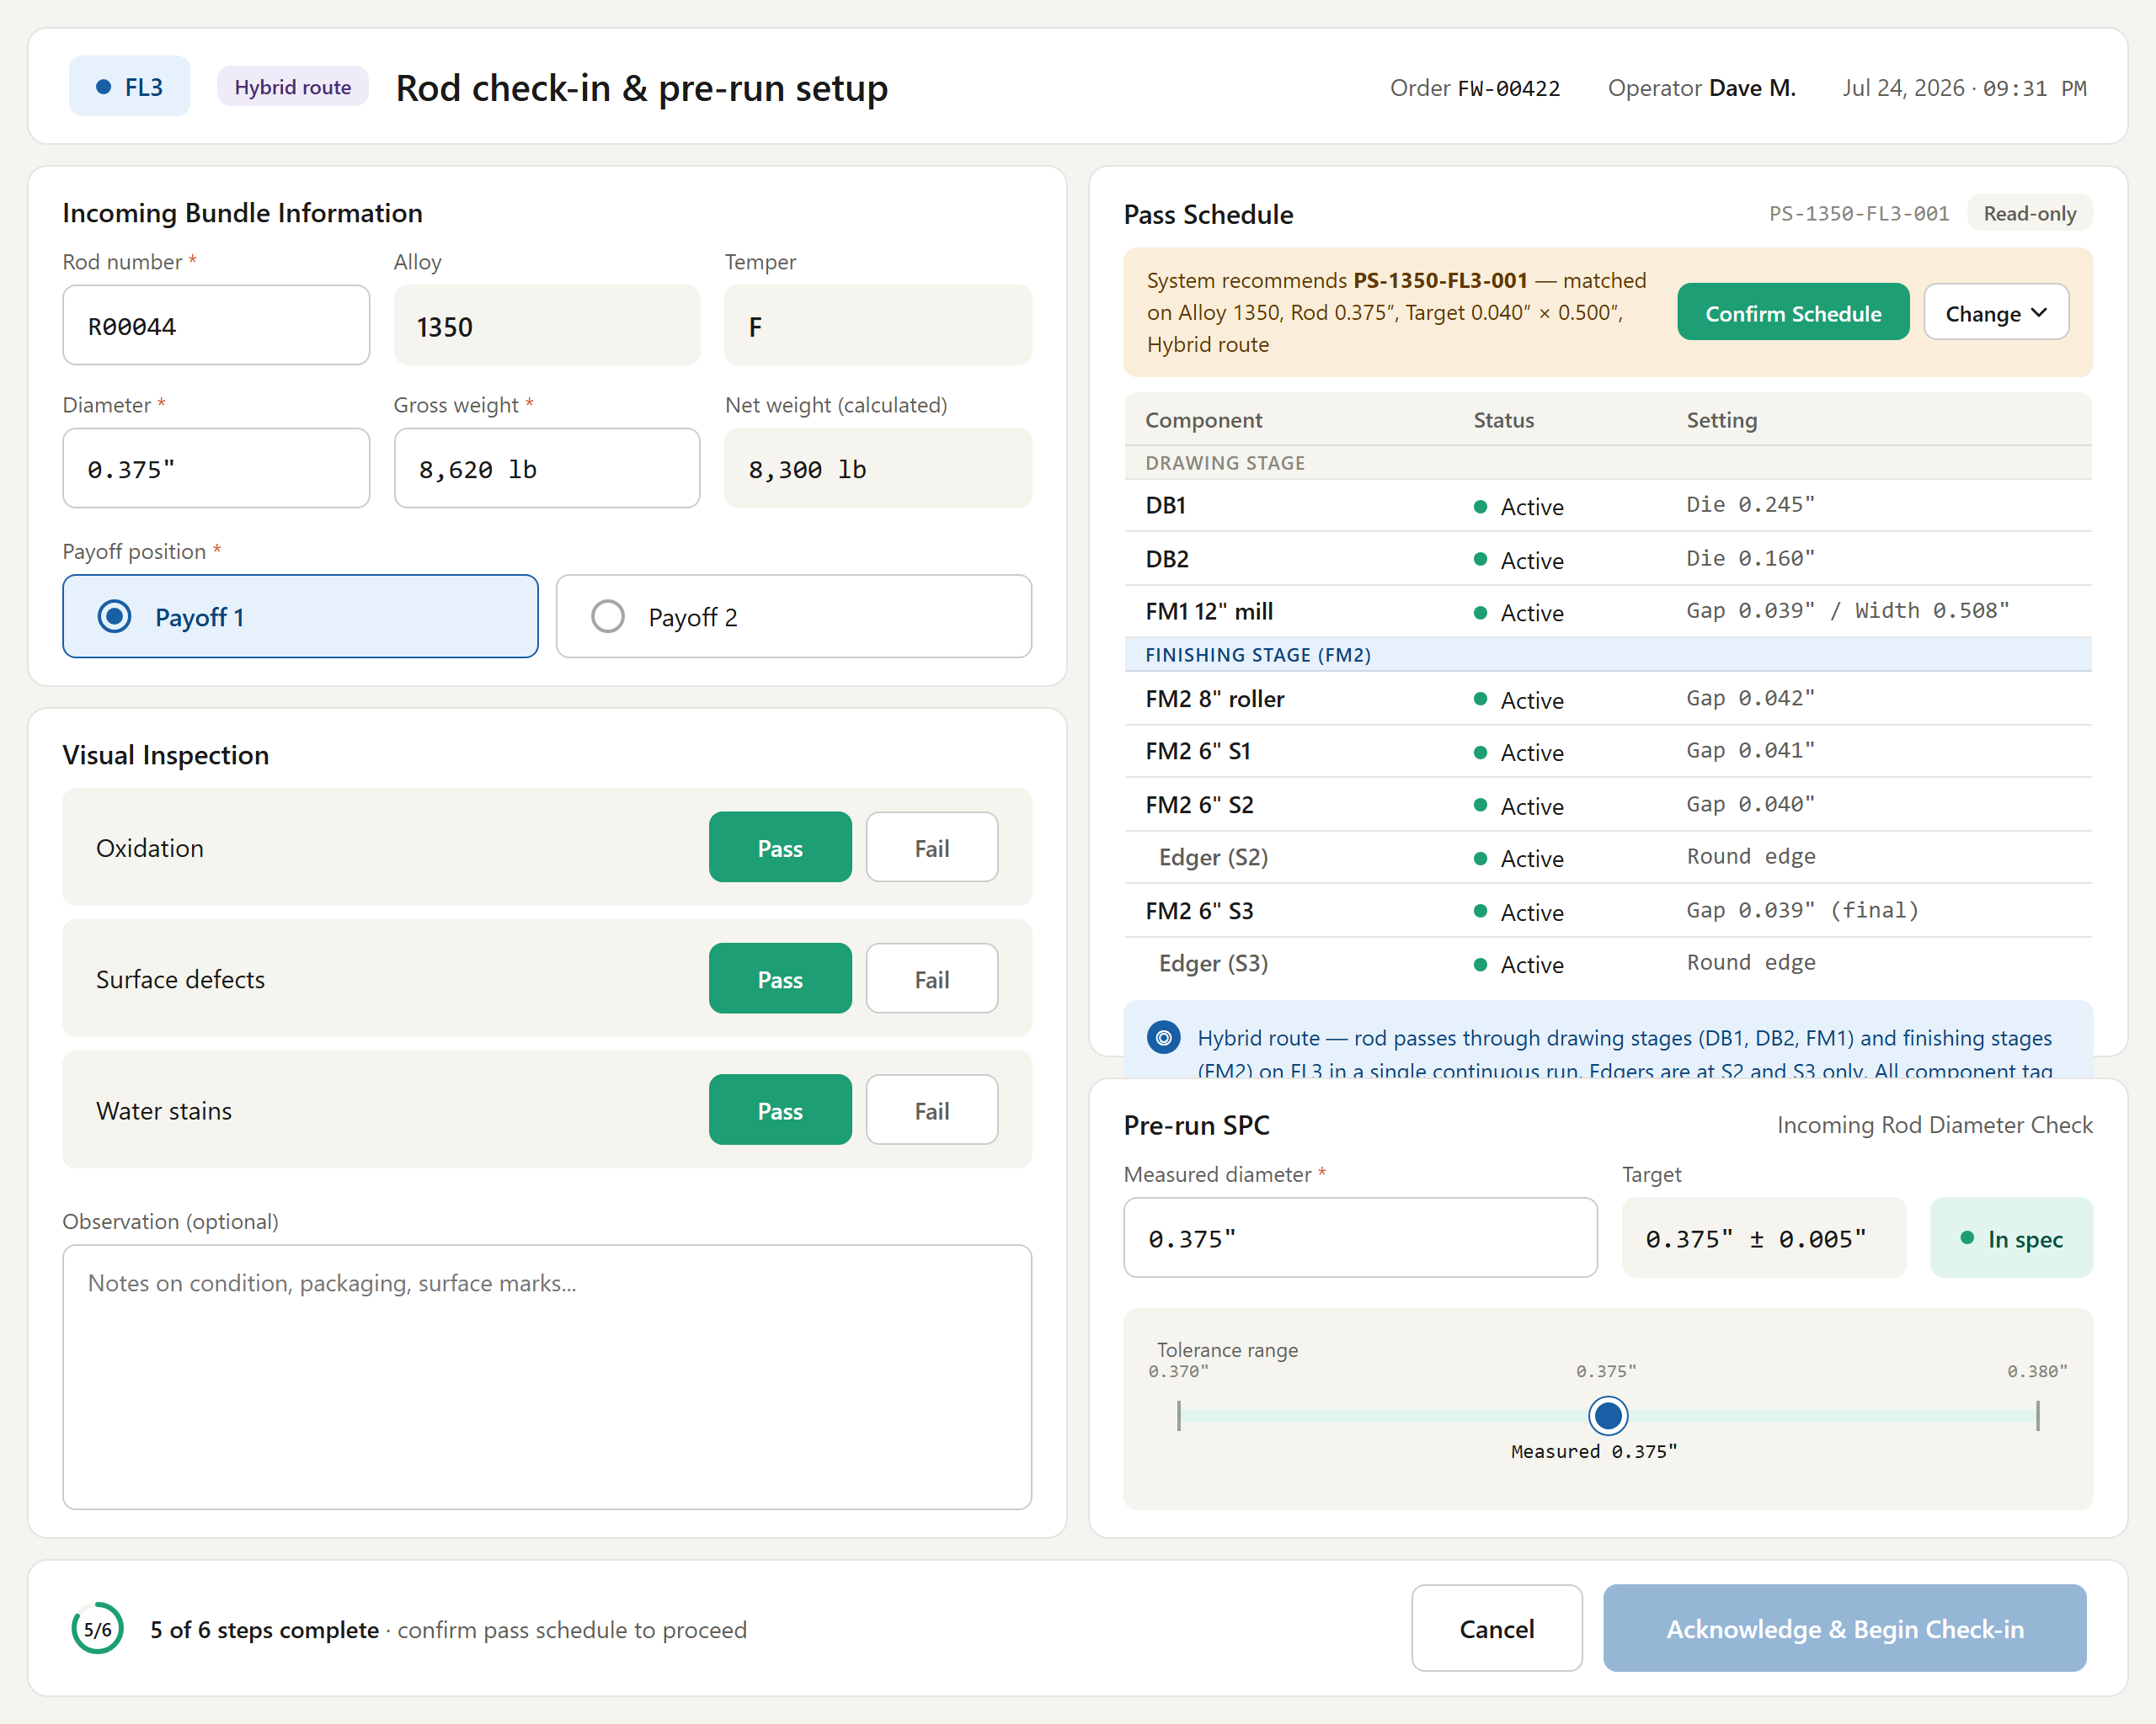
Figure # — Rod Check-In — FL3 Hybrid (db02_rod_checkin_fl3.png)
*Requirements traced: CHK001–CHK019.*

4.4 Welding (WLD)
Description. The Welding feature manages the joining of aluminum rods between coils on the flat-wire line, treating each weld as a controlled, operator-confirmed transition from the current coil to the next. Payoff and pre-check-in operators mark coils as welded, capture induction weld quality, and confirm consumption-driven handoff. It matters because welds define coil sequencing, footage attribution, and full multi-parent genealogy back to source rods for downstream traceability.
Priority: Must — coil-to-coil welding is the mechanism by which material flows continuously through the line at go-live; without confirmed, validated welds no production order can complete.
Stimulus / Response.
Trigger / operator action | System response
Operator pre-checks in a coil | Enables the "Mark as Welded" button for that coil
Operator confirms "Mark as Welded" | Validates alloy, diameter, temper, order and pass-schedule match
Validation passes; operator confirms | Records operator ID, timestamp, weld type and quality; marks coil eligible
Current coil reaches 0 feet remaining | Automatically transitions to the welded coil as next in sequence
Weld quality result is Fail | Logs and links the immutable event, flags it for supervisor review
Supervisor overrides to remove a weld | Captures credentials and reason, revokes eligibility, blocks consumption

Functional Requirements.

4.4.1 Welding Operating Modes
- The system shall support welding workflows in which the mill may be stopped before the weld is performed (and in which the weld may also be performed while the mill is running), treating welding as a controlled transition between coils and requiring the operator to explicitly confirm welding completion before coil consumption continues. (WLD001)
- The system architecture shall support future continuous-operation welding (welding performed without stopping the mill), such that the core logic for coil sequencing, material consumption, and traceability does not require redesign, and shall keep weld-state handling event-driven and extensible. (WLD002)

4.4.2 Weld Marking & Operator Confirmation
- The system shall provide a "Mark as Welded" button on the Pre-Check-In station, enabled only when a coil is pre-checked-in. (WLD010)
- The system shall require explicit operator confirmation to mark a pre-checked-in coil as "Welded" and eligible for consumption, capturing operator ID and date/time as an auditable action. (WLD003)

4.4.3 Welding Validation Rules
- The system shall, before a coil can be marked as welded, validate that the alloy, diameter, and temper match the current coil, and shall reject the weld with a clear validation error to the operator if any check fails. (WLD006)
- The system shall validate that the coil being welded is planned for the current production order and is compatible with the active pass schedule, and shall make coils that fail validation ineligible for welding. (WLD007)

4.4.4 Coil Sequencing & Consumption Logic
- The system shall automatically treat a coil marked as Welded as the next coil in sequence, requiring no manual queuing by the operator. (WLD004)
- The system shall drive the transition from the current coil to the welded coil solely by material consumption, triggering the transition when remaining material reaches 0 feet, independent of operator timing or manual actions. (WLD005)

4.4.5 Weld Type & Quality Capture
- The system shall record the weld type as Induction (rod-to-rod join at the payoff). *[Note: laser welding was REMOVED per the May 21 revision and is no longer a selectable weld type.]* (WLD012)
- The system shall capture a weld quality result of Pass or Fail, and shall require a fail reason to be selected (not the default placeholder) whenever the result is Fail, from the list: misalignment at join, weld break on inspection, surface burn/scorching, weld not fully fused, diameter mismatch at join, and other (see observation). (WLD013)
- The system shall read the weld-point footage automatically from the machine encoder rather than by manual entry, and shall record the server-side timestamp at submission. (WLD014)
- The system shall still log the weld event and link the rods on a Fail result, flagging the event for supervisor review (optionally pausing the run or emitting an alert) rather than silently blocking the run, and shall keep the confirmed weld event immutable (corrections only via a separate audit flow). (WLD017)

4.4.6 Footage Attribution & Joint Limits
- The system shall attribute output footage per source rod (footage-from / footage-to) at each weld point, crediting the outgoing rod with the length laid up to the weld point and beginning the incoming rod at the weld-point footage. (WLD015)
- The system shall validate the number of weld joints against the maximum weld joints permitted per finished coil (customer contractual limit) at weld confirmation. (WLD016) *[OPEN ITEM: maximum weld-joints-per-coil limit is TBD (WeldEvent.md Q23); footage-split rule at the exact weld point is TBD (Q22); re-weld/rework record handling is TBD (Q24).]*

4.4.7 Traceability & Genealogy
- The system shall maintain end-to-end traceability for all parent coils contributing material through welding — even when the weld is performed manually — including parent coil alpha identifiers, weld sequence/order, the confirming operator, and date/time. (WLD008)
- The system shall support full multi-parent genealogy such that a single output spool identifier references all contributing parent coil identifiers, enabling downstream systems to trace output spool → coil → skid back to all welded parent rods. (WLD009)

4.4.8 Weld Removal & Error Handling
- The system shall require a mandatory supervisor override for any removal or reversal of a welded coil, capturing supervisor credentials, fully logging who/when/why, revoking welded eligibility, and preventing accidental or invalid consumption. (WLD011)
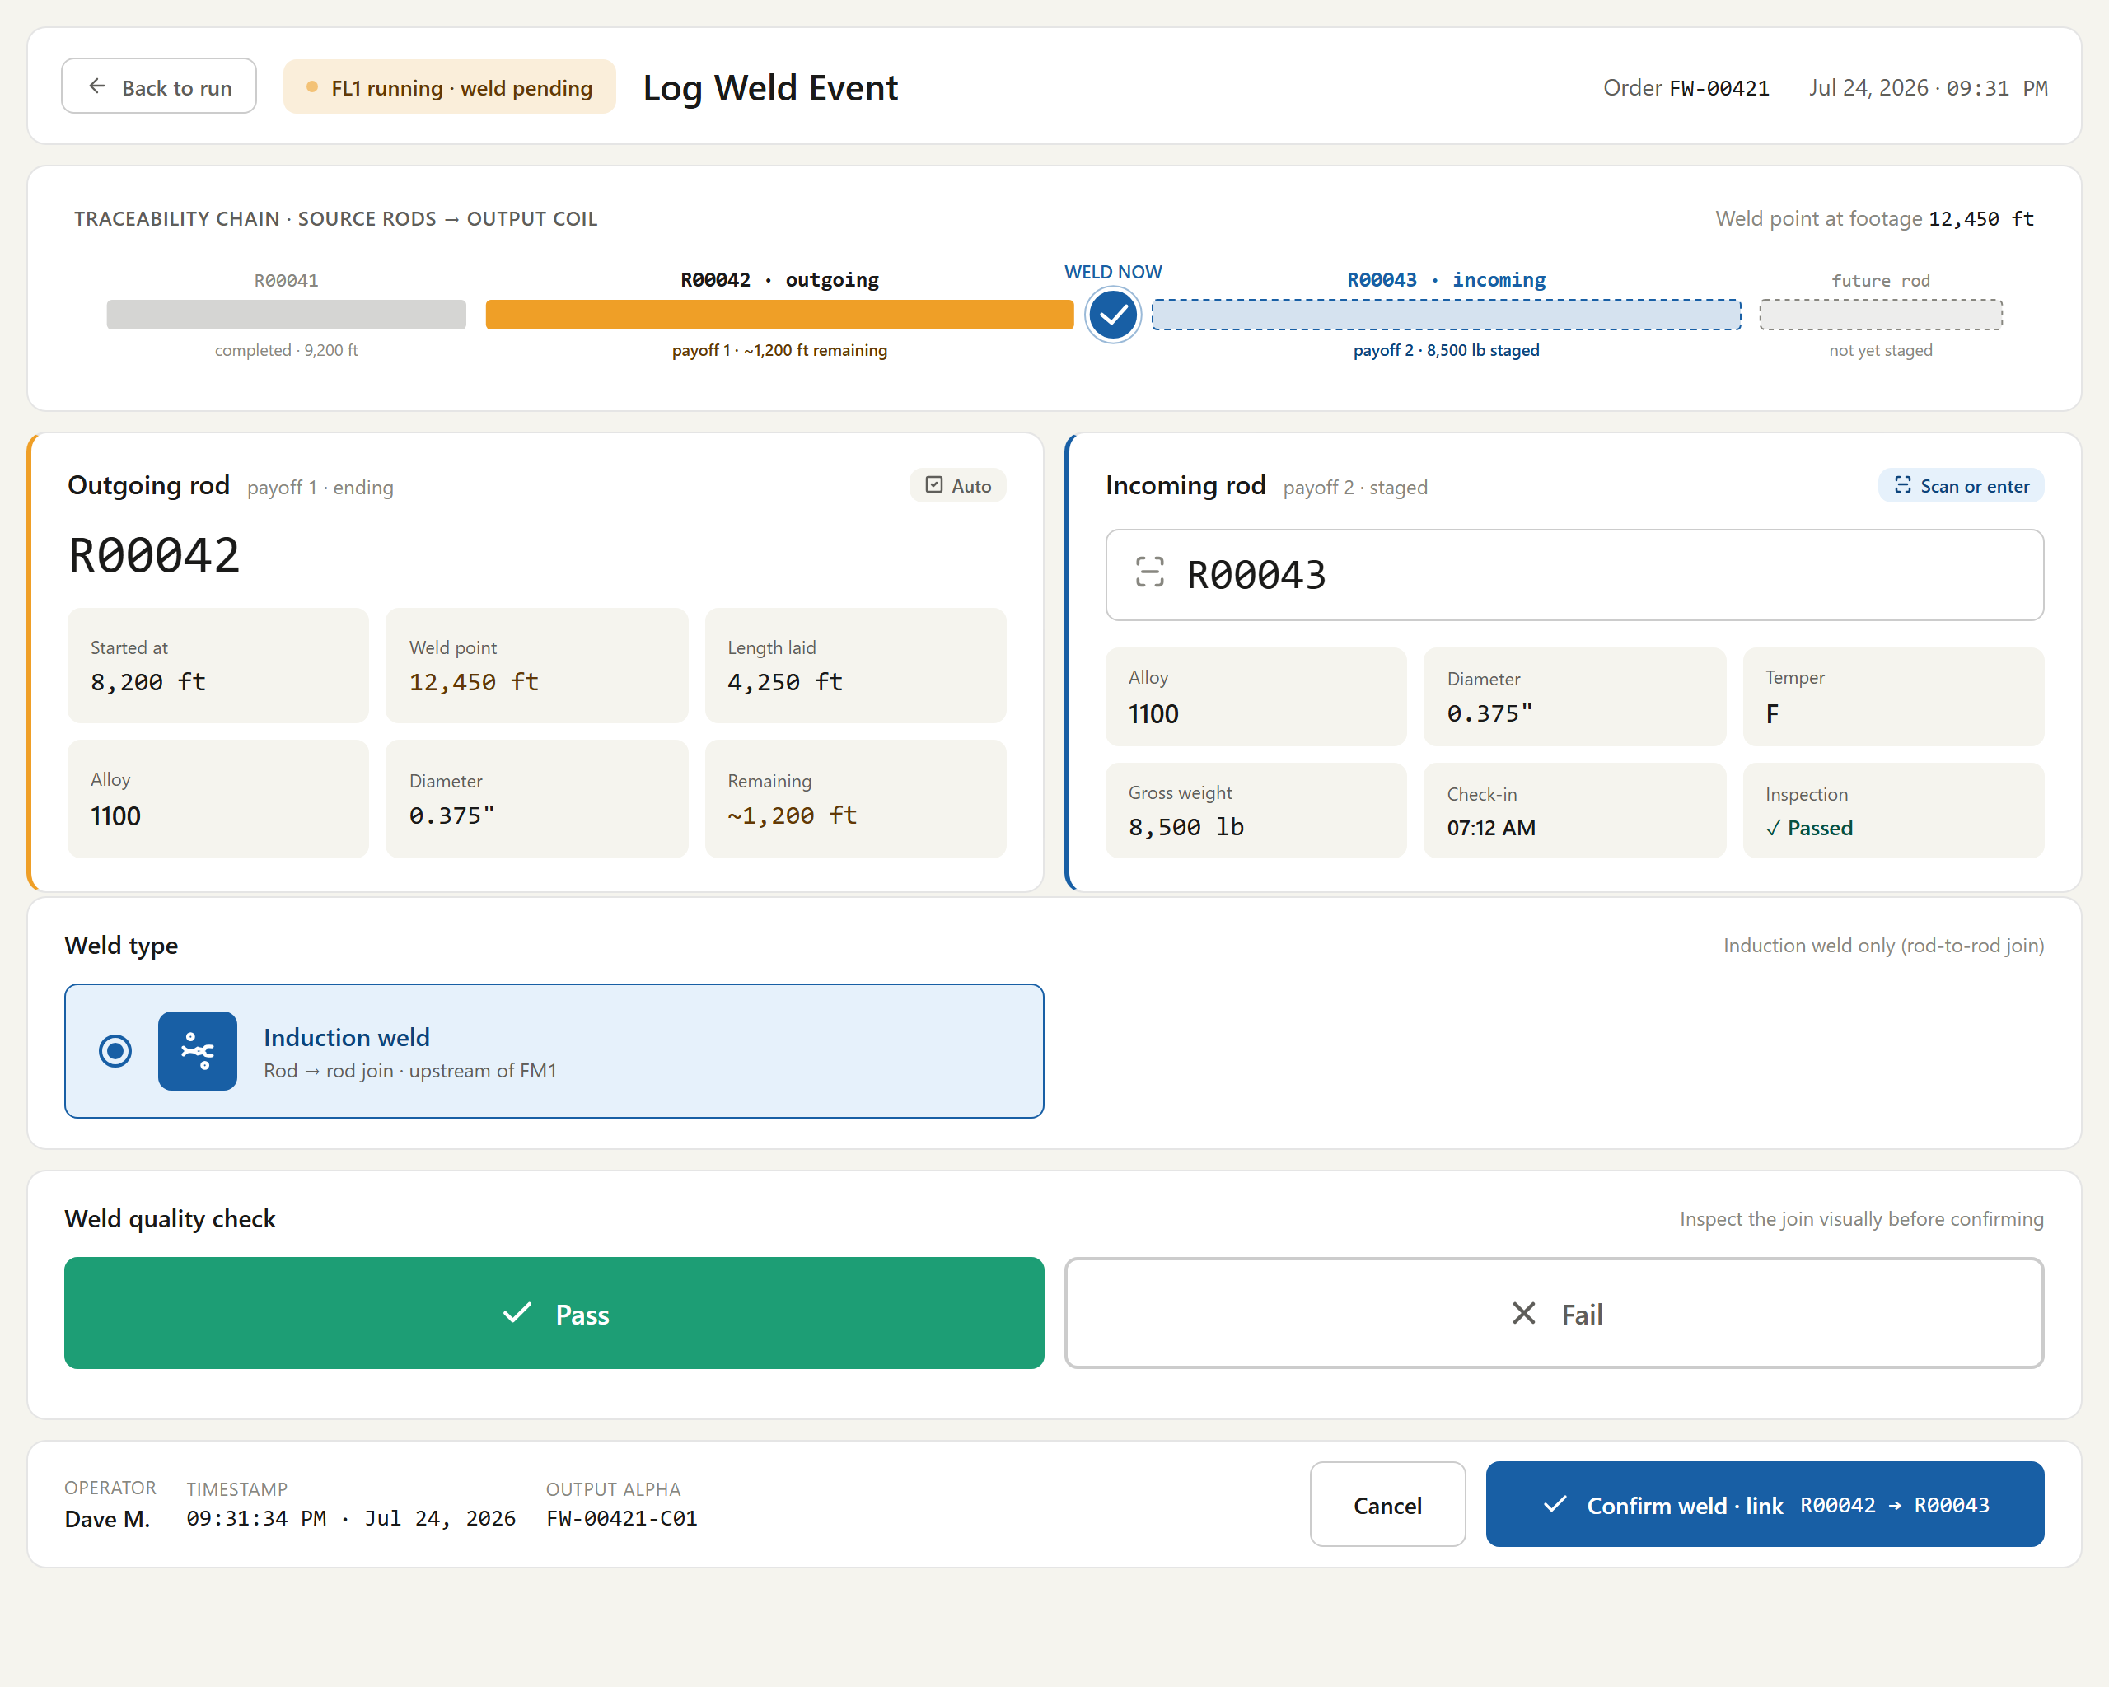
Figure # — Weld Event Logger (Dashboard 4) (db04_weld_event.png)
*Requirements traced: WLD001–WLD017.*

4.5 Traveler (TRV)
Description. The Traveler is the shared digital work instruction that guides operators through FL1 Pre-Check-In, FL1, FL2, and FL3 flat-wire operations. It consolidates incoming bundle data, the pre-check-in queue, pass/reduction schedules, edger configuration, order constraints, and live run status into one adaptive screen. Machine operators and station leads rely on it to run material correctly, and it matters because it is the single source of truth linking incoming rod to finished product across every station.
Priority: Must — the Traveler is the primary operator interface for the flat-wire line and no station can run production without it at go-live.
Stimulus / Response.
Trigger | System response
Operator opens the Traveler at a station | Renders the section layout adapted to the active station, pass schedule, and output mode
Active run status or queue data changes | Refreshes the affected sections with current values and welded-rod indicators

Functional Requirements.
- The system shall provide a single, shared digital Traveler that supports FL1 Pre-Check-In, FL1, FL2, and FL3 (hybrid) operations, dynamically adapting its displayed content and layout based on the active station (Pre, FL1, FL2, FL3), the applied pass schedule, and the output mode (intermediate spool vs. finished product). (TRV001)
- The system shall include the following core Traveler sections: Incoming Bundle Information, Queue (pre-checked-in material), Pass/Reduction Schedule, Edger Configuration, Order/Constraint Data, and Current Run Status. (TRV002)
- The system shall display, in Incoming Bundle Information, key incoming-material attributes including rod number, rod gauge/diameter, temper, and other relevant incoming details. (TRV003)
- The system shall display, in the Queue section, all pre-checked-in items with serial number, payoff position number, key dimensional attributes (gauge, width, weight), and current material status. (TRV004)
- The system shall display, in the Pass/Reduction Schedule section, the reduction percentage, DB1 and DB2 gauges, FL1-through-FL2 roller gauge targets, and configured speed, deriving tension automatically from speed without manual entry. (TRV005)
- The system shall display, in the Order/Constraint section, maximum and current spool/package weight, order weight, OD minimum and maximum limits, and package width limits, and shall use this data for runtime validation during operations and transactions. (TRV006)
- The system shall automatically vary the Traveler layout and any stop-transaction popups based on FL1-only output (intermediate spool) versus FL2 or FL3 output (finished product). (TRV007)
- The system shall support two simultaneously running Traveler instances (one per machine) when FL1 and FL2 operate independently on separate concurrent jobs. (TRV008)
- The system shall, on the main-station Traveler, display only the welded rods relevant to the current running rod, and shall, on the Pre-Check-In station Traveler, display both pre-checked-in rods and welded rods. (TRV009)
- The system shall clearly distinguish welded rods using both color differentiation and explicit text indicators identifying welded status. (TRV010)
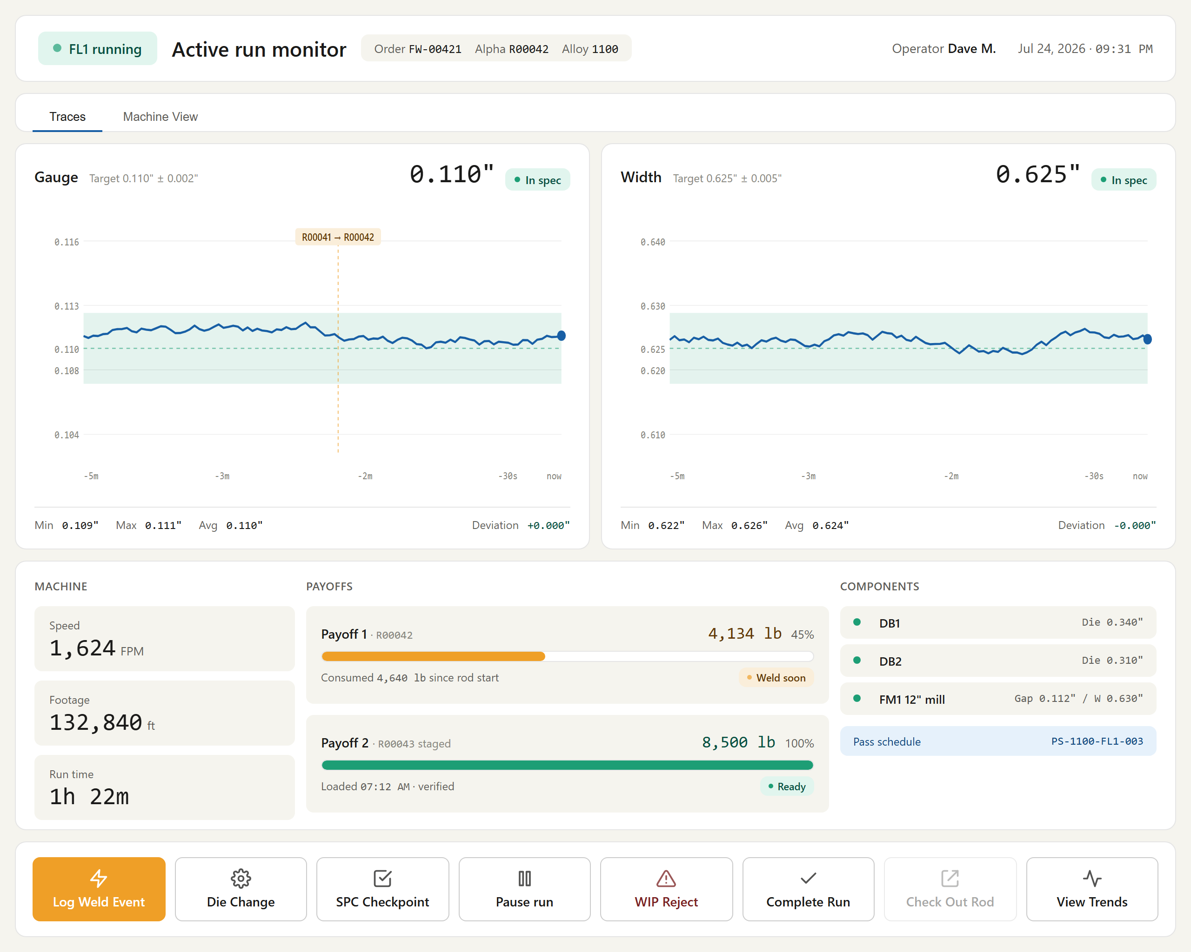
Figure # — Active Run Monitor (Dashboard 3) (db03_active_run.png)
*Requirements traced: TRV001–TRV010.*

4.6 Order Instructions (ORD)
Description. Order Instructions surfaces the processing instructions, hold status, and observations tied to an order the moment a shopfloor operator checks in at the flat-wire line. It mirrors the established slitter-shopfloor popup so operators encounter a familiar interface, and it introduces the "Flat" order type alongside Split, Slit, Anneal, and Roll. It matters because operators must see holds and special instructions before running material, preventing processing of held or misrouted coils.
Priority: Must — holds and instructions must be visible at check-in to prevent quality escapes at Phase-1 go-live.
Stimulus / Response.
Trigger / operator action | System response
Operator checks in at the flat-wire station | System displays the order instructions popup
Popup opens | System shows instructions, hold information, and observations
Order carries a hold | System presents the hold consistent with the slitter-shopfloor popup
Operator selects order type on a flat-wire order | System offers "Flat" alongside Split, Slit, Anneal, and Roll
Operator acknowledges the popup | System closes it and allows processing to continue

Functional Requirements.
- The system shall display a popup after check-in showing the order instructions, hold information, and observations, operating consistently with the equivalent slitter-shopfloor popup. (ORD001)
- The system shall provide a new order type "Flat" alongside the existing order types Split, Slit, Anneal, and Roll. (ORD002)
Feature group — Processing, Quality & Output.

4.7 Pass Schedule Management (PSM)
Description. Pass Schedule Management maintains the central, authoritative table of drawing and finishing parameters — die sizes, roll gaps, targets, speeds, edger and routing configuration — for FL1, FL2, and Hybrid FL3 operation. Operations/Engineering users author and approve schedules; floor operators view them read-only, confirm the recommended schedule at check-in, and acknowledge it before the run. It matters because these parameters drive the PLC configuration that shapes every flat-wire coil, so controlled authoring, operator acknowledgment, and full traceability are essential to product quality and safe machine setup.
Priority: Must — no coil can be correctly configured or run without an approved, acknowledged pass schedule driving the PLC.
Stimulus / Response.
Trigger / operator action | System response
Operations user creates/edits a schedule (or requests Generate & Review) | Validates, stores a draft, and marks it Active only on explicit approval
Coil/rod check-in with alloy, diameter, gauge×width, route mode | Performs attribute lookup and surfaces the recommended schedule in a confirm bar
Operator confirms or selects a non-recommended schedule | Retrieves and presents active/bypassed components; flags non-recommended choices for review
Operator acknowledges the schedule | Pushes PLC configuration tags to the controller and permits the run to start
Operator or Operations Manager saves a mid-run override | Logs the change, raises an Active Run Monitor alert, holds prior PLC values, and sets an SPC checkpoint
Output coil created | Snapshots schedule ID, version, and effective configuration to the coil record

Functional Requirements.

4.7.1 Central Table, Ownership & Maintenance
The system shall maintain a central Pass Schedule table accessible from both the shopfloor applications and the web applications. (PSM001)
The system shall permit pass schedules to be created, edited, and maintained only by authorized Maintenance / Engineering (Operations) users, and shall present pass schedules as read-only to floor operators. (PSM002)
The system shall never silently auto-apply a pass schedule; it may provide a human-in-the-loop "Generate & Review" physics-based draft algorithm that, from alloy, rod diameter, target gauge, target width, and edge type, produces a DRAFT schedule which requires explicit Operations review and approval (Save as Active) before it becomes available for use, and no schedule — generated or manual — shall be pushed to the PLC except through operator acknowledgment at check-in. (PSM003)
> [OPEN ITEM: confirm Generate & Review is in Phase-1 scope] — PSM003 reconciles the v1 statement "shall NOT auto-generate" with the designed Generate & Review workflow. The reconciled rule is that generation is a calculator producing a draft for human approval, not an auto-approver. Whether the generation algorithm ships in Phase 1 or is deferred is to be confirmed.
The system shall support machine-specific routing in each pass schedule, covering FL1 standalone, FL2 standalone, and Hybrid FL3 operation. (PSM004)

4.7.2 Schedule Structure & Content
The system shall represent, in each pass schedule, which machine components are active and which are bypassed. (PSM005)
The system shall define DB1 and DB2 wire-drawing die sizes in each pass schedule. (PSM006)
The system shall define FL1 and FL2 roll clearances / gap settings in each pass schedule. (PSM007)
The system shall define the target gauge and target width at each processing stage in each pass schedule. (PSM008)
The system shall define line speed and reduction percentages in each pass schedule. (PSM009)
The system shall define edger configuration (edge type and stand position) in each pass schedule for the applicable FL2 stands (S2 and S3); FL1 has no edger. (PSM010)
The system shall define a routing flag in each pass schedule indicating standalone (FL1 / FL2) or hybrid (FL3) operation, with a Hybrid FL3 schedule held as a single unified record covering both drawing and finishing components. (PSM011)
The system shall exclude tension values from the pass schedule, deriving tension automatically from speed control. (PSM012)

4.7.3 Association & Runtime Selection
The system shall allow pass schedules to be associated with specific production orders or with gauge/width combinations. (PSM013)
The system shall make only those pass schedules compatible with the current order and routing (FL1 / FL2 / FL3) selectable at runtime. (PSM014)
The system shall, at check-in, perform an attribute-based lookup (alloy + rod diameter + target gauge × width + route mode), surface the recommended schedule in a confirm bar, require the operator to confirm the schedule, and flag selection of any non-recommended schedule for Operations review. (PSM015)
> [OPEN ITEM: no-match path at check-in undefined] — behavior when the attribute lookup returns no active matching schedule (block check-in and alert Operations vs. allow a credential-gated manual override) is not yet decided (GAP 1).
> [OPEN ITEM: FL2 check-in handling of hybrid-origin spools] — validation for applying a standalone FL2 schedule to a spool produced by a hybrid FL3 run is not yet decided (GAP 4).

4.7.4 Retrieve → Present → Acknowledge → PLC Push
The system shall, at coil or rod check-in, retrieve the applicable pass schedule. (PSM016)
The system shall present the retrieved pass schedule to the operator for review, clearly indicating which components are active and which are bypassed. (PSM017)
The system shall require explicit operator acknowledgment of the pass schedule before the run begins. (PSM018)
The system shall push the relevant PLC configuration tags to the machine controller only upon operator acknowledgment, and shall not push any PLC tags automatically before acknowledgment. (PSM019)

4.7.5 Mid-Run Pass Schedule Change
The system shall keep the pass schedule read-only to floor operators mid-run, permitting an operator-initiated change only for a one-for-one same-size die swap (e.g., replacing a DB1 0.285" die with another DB1 0.285" die); any other change shall be made by an Operations Manager. (PSM020)
The system shall record every mid-run override with the parameter changed, old value → new value, user ID, timestamp, and reason code or free-text reason. (PSM021)
The system shall, upon saving a mid-run override, raise a real-time alert on the Active Run Monitor of the affected line requiring the operator to explicitly Acknowledge (continue under the new configuration) or Stop Run (supervisor review), shall not permit passive dismissal, and shall continue running under the previous PLC values until the operator acknowledges. (PSM022)
The system shall automatically set an SPC checkpoint as required following a mid-run pass schedule change (particularly a die-size or roll-gap change) and shall block clearing of the "awaiting SPC checkpoint" status until SPC is completed. (PSM023)

4.7.6 Audit Snapshot at Coil Creation
The system shall write the pass schedule ID, version, and effective configuration snapshot (die sizes, roll gaps, targets) to the output coil record at coil creation time for technical traceability and quality audits, and shall not print this pass schedule data on the customer label. (PSM024)
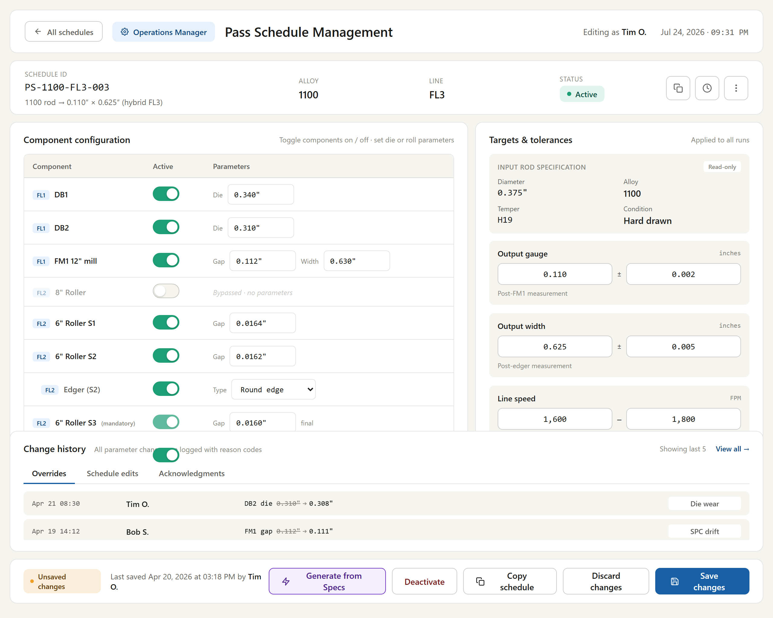
Figure # — Pass Schedule Management (Dashboard 9) (db09_pass_schedule.png)
*Requirements traced: PSM001–PSM024.*
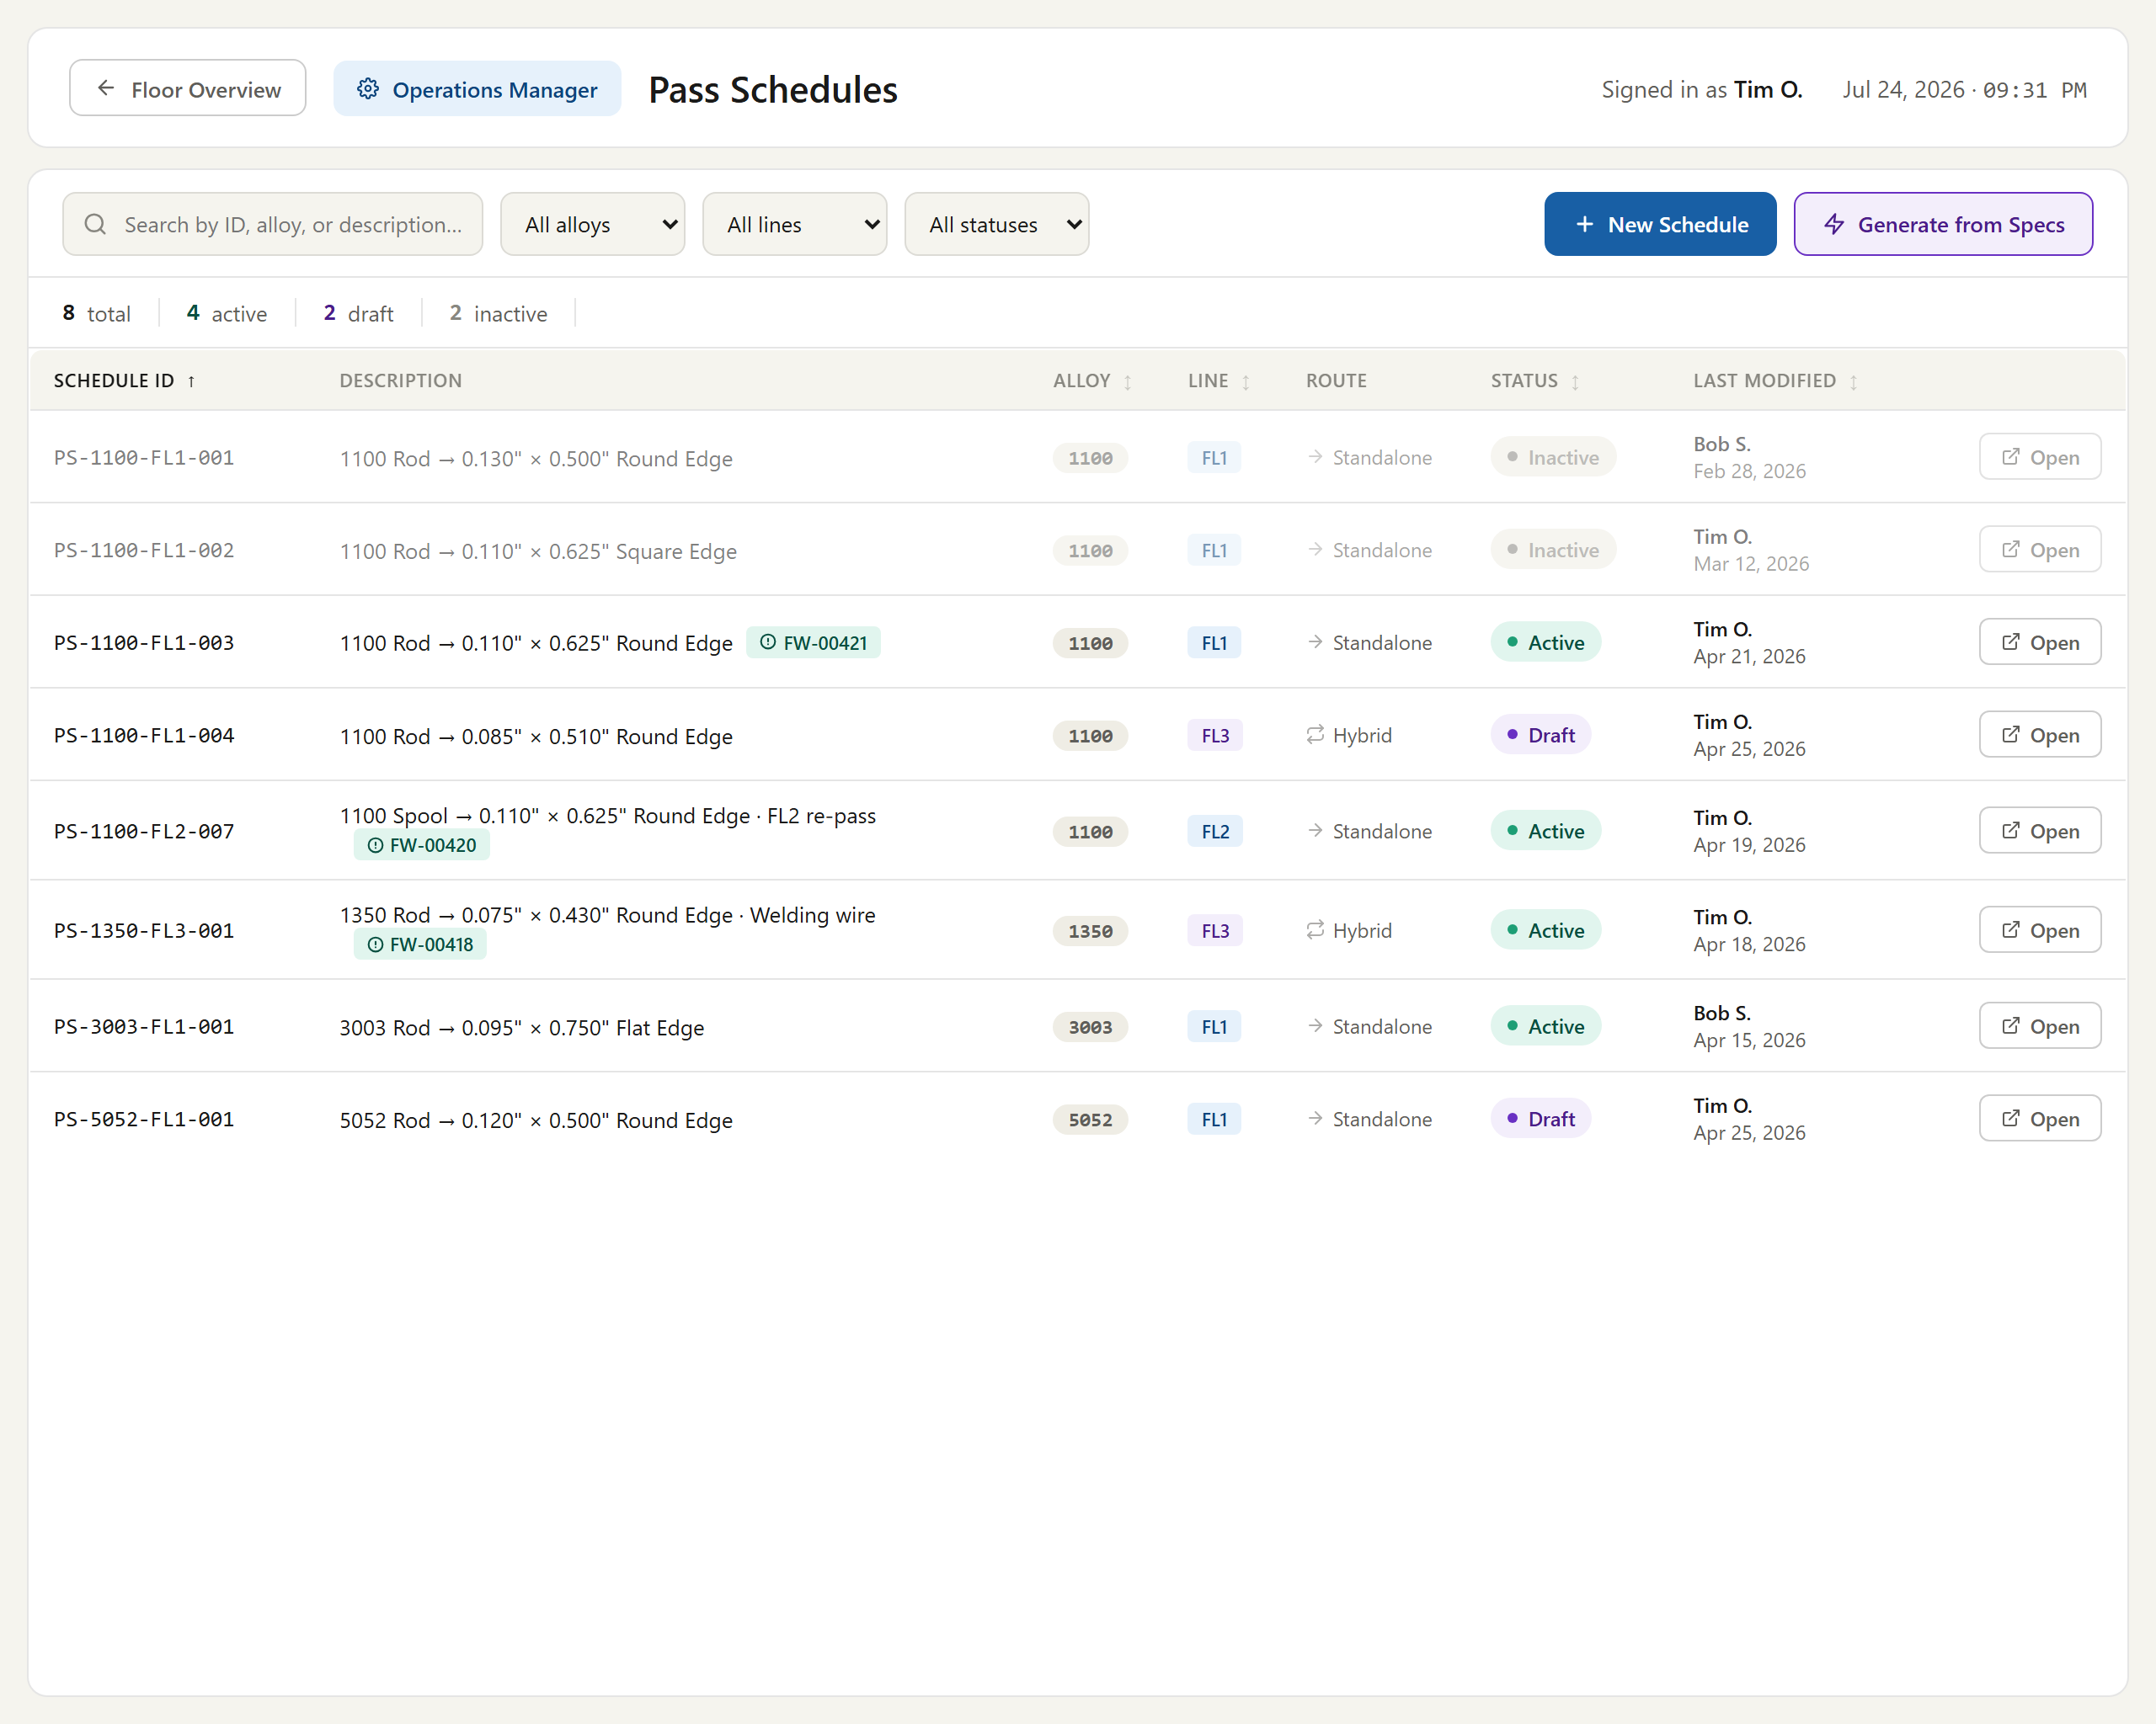
Figure # — Pass Schedule List (Dashboard 9A) (db09a_schedule_list.png)
*Requirements traced: PSM001–PSM024.*

4.8 Gauge Trace & Width Trace (GWT)
Description. Gauge Trace & Width Trace provides operators at FL2 and FL3 with pop-up visualizations of a spool's recorded gauge and width along its length. Both traces are captured from the same recording points, letting operators verify dimensional consistency, review upstream FL1 gauge data once a spool is checked in, and identify coil boundaries within multi-coil welded runs. This dimensional visibility supports quality monitoring across the flat-wire line and helps catch out-of-tolerance conditions before downstream processing.
Priority: Should — important operator quality-monitoring aid, but the line can produce without the trace pop-ups at go-live.
Stimulus / Response.
Trigger | System response
Operator opens the gauge or width trace pop-up at FL2/FL3 for a selected spool | Displays the trace using the standard gauge visualization and the width-vs-feet plot
Spool is checked in at FL2 | Makes the FL1 gauge trace available for viewing at FL2

Functional Requirements.
The system shall display gauge trace and width trace pop-ups at FL2 (and at FL3). (GWT001)
The system shall present the gauge trace using the same visualization as the slitter gauge trace. (GWT002)
The system shall present the width trace with width on the Y axis and feet on the X axis. (GWT003)
The system shall record gauge and width simultaneously so that both traces derive from the same recording points. (GWT004)
The system shall make the FL1 gauge trace available at FL2 once the spool is checked in at FL2. (GWT005)
The system shall indicate coil boundaries within a run-level trace when a single run spans multiple welded coils. (GWT006)
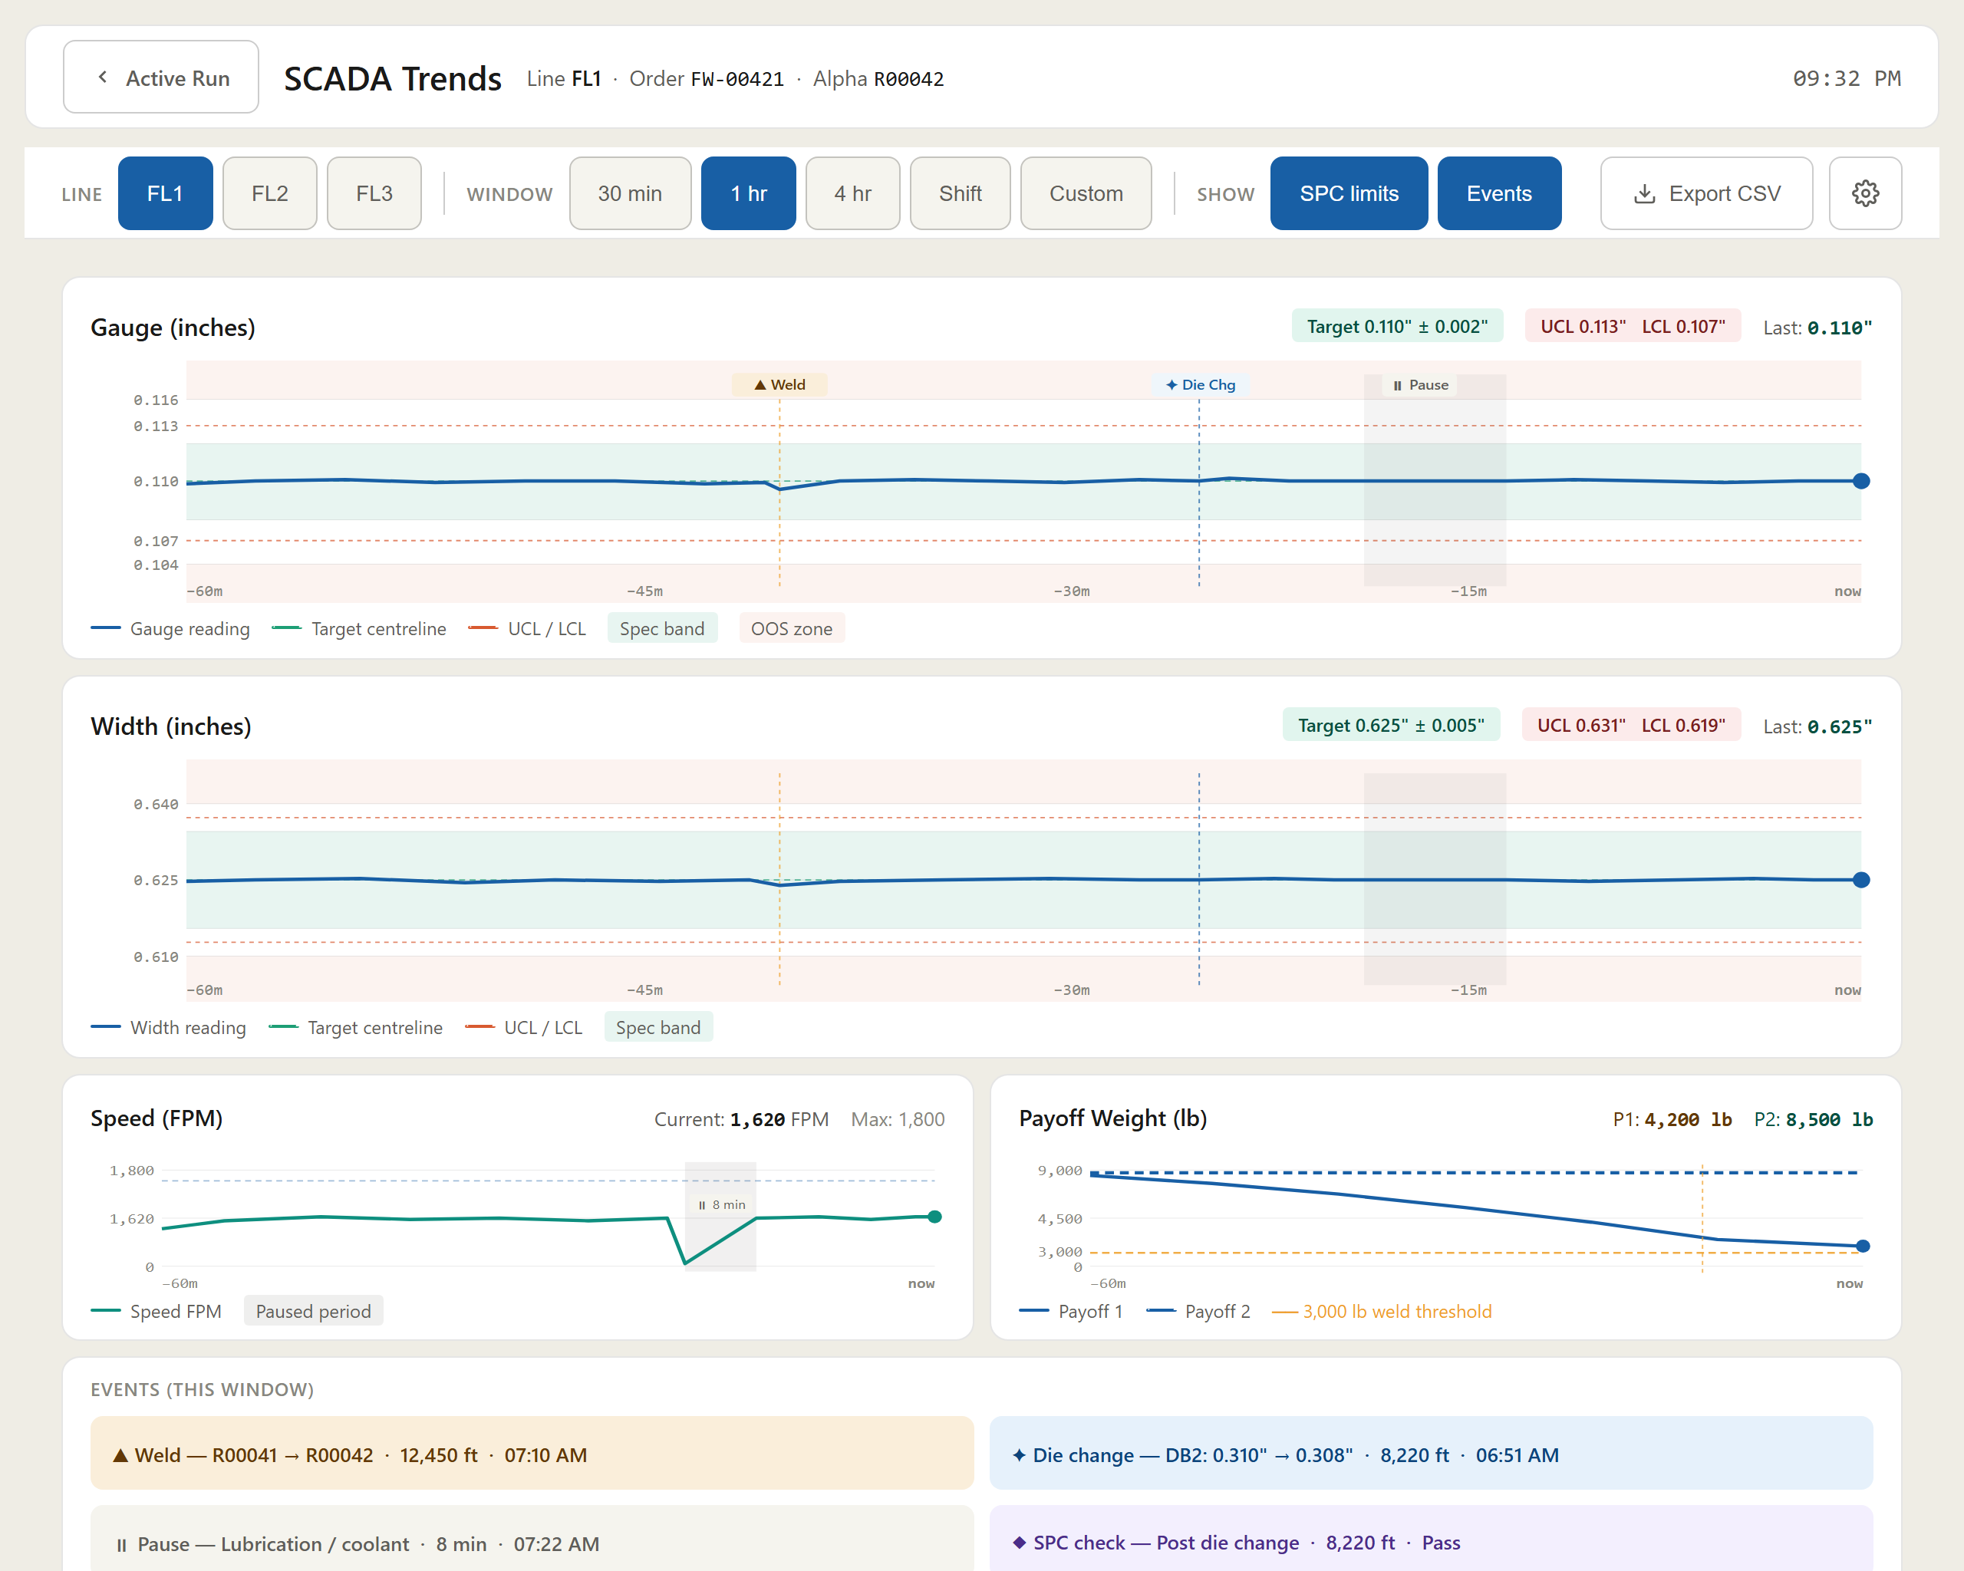
Figure # — SCADA Trends (Dashboard 14) (db14_scada_trends.png)
*Requirements traced: GWT001–GWT006.*

4.9 SPC & CPK (SPC)
Description. SPC & CPK provides statistical process control across the flat-wire line, capturing gauge and width measurements at incoming rod, post wire-draw, and post-FL1/FL2 stages. Operators and QA reviewers use it to catch out-of-spec material, route it to SPC-HOLD, and compute per-run CPK. It matters because it prevents nonconforming coils from advancing, shipping, or being released without QA disposition, safeguarding product quality.
Priority: Must — quality holds and SPC enforcement gate production and shipment, so the line cannot go live without them.
Stimulus / Response.
Trigger / operator action | System response
Traveler loads at check-in | Automatically initiates SPC prompts and checkpoints
Automatic gauge reading captured during run | Records measurement as primary SPC data ("set and forget")
Die change with gauge drift / size change | Routes to SPC checkpoint screen; permits thread mode, blocks full production until pass
Measurement out of spec (or operator holds) | Routes output to SPC-HOLD without stopping the machine
Operator submits stop transaction | Requires checkpoint completion first via continue-run or suspend path
QA reviewer dispositions held material | Releases with concession or quarantines/scraps; lifts hold

Functional Requirements.

4.9.1 Checkpoints & Monitoring
The system shall support SPC checkpoints at incoming rod diameter (pre-checkin), post wire-draw diameter (after die changes), post-FL1 gauge, and post-FL2 gauge. (SPC001)
The system shall monitor both gauge (thickness) and width at the FL1 and FL2 output stages. (SPC002)

4.9.2 Prompting & Measurement Mode
The system shall automatically initiate SPC prompts after the traveler loads at check-in. (SPC003)
The system shall use automatic gauge readings as the primary SPC data source during normal operation ("set and forget" mode). (SPC004)
The system shall require manual SPC entry only during initial setup and die changes. (SPC005)
The system shall provide SPC sampling rules configurable by customer and by process stage (e.g., FL1 vs FL2). (SPC006)
The system shall provide three SPC checkpoint types: pre-run, post-die-change, and manual spot check. (SPC007)
The system shall route a post-die-change event whose reason is gauge drift or size change to the SPC checkpoint screen and shall permit thread mode (running the line slowly to verify the new die) while the run remains blocked from full production until SPC passes. (SPC008)

4.9.3 Enforcement, SPC-HOLD & QA Disposition
The system shall allow force-continue at all times, permitting the operator to submit a checkpoint via the "continue run" path even when readings are out of spec. (SPC009)
The system shall, when a measurement is out of spec (or the operator chooses to hold), route the affected output material to SPC-HOLD and shall not stop the machine. (SPC010)
The system shall, while material is on SPC-HOLD, prevent that coil from advancing to the next operation, shipping, or release until a QA reviewer lifts the hold, while allowing the machine to continue producing further footage. (SPC011)
The system shall support QA disposition of SPC-HOLD material by either release (with concession) or quarantine/scrap. (SPC012)

4.9.4 CPK & Records
The system shall compute CPK per production run, excluding the unstable regions at the start and end of the run and using a defined stable process window. (SPC013)
The system shall stamp each SPC checkpoint record with operator, footage-at-check, timestamp, checkpoint type, measurements, and any observation, and shall treat the operator/footage/timestamp stamp as immutable. (SPC014)
The system shall require an SPC checkpoint to be completed (via either the continue-run or suspend-material path) before the associated stop transaction can be submitted; completion shall not require the readings to be in spec. (SPC015)
> [OPEN ITEM: TRF logic pending]
> [OPEN ITEM: source of SPC control limits — ASTM vs. customer bands to be confirmed]
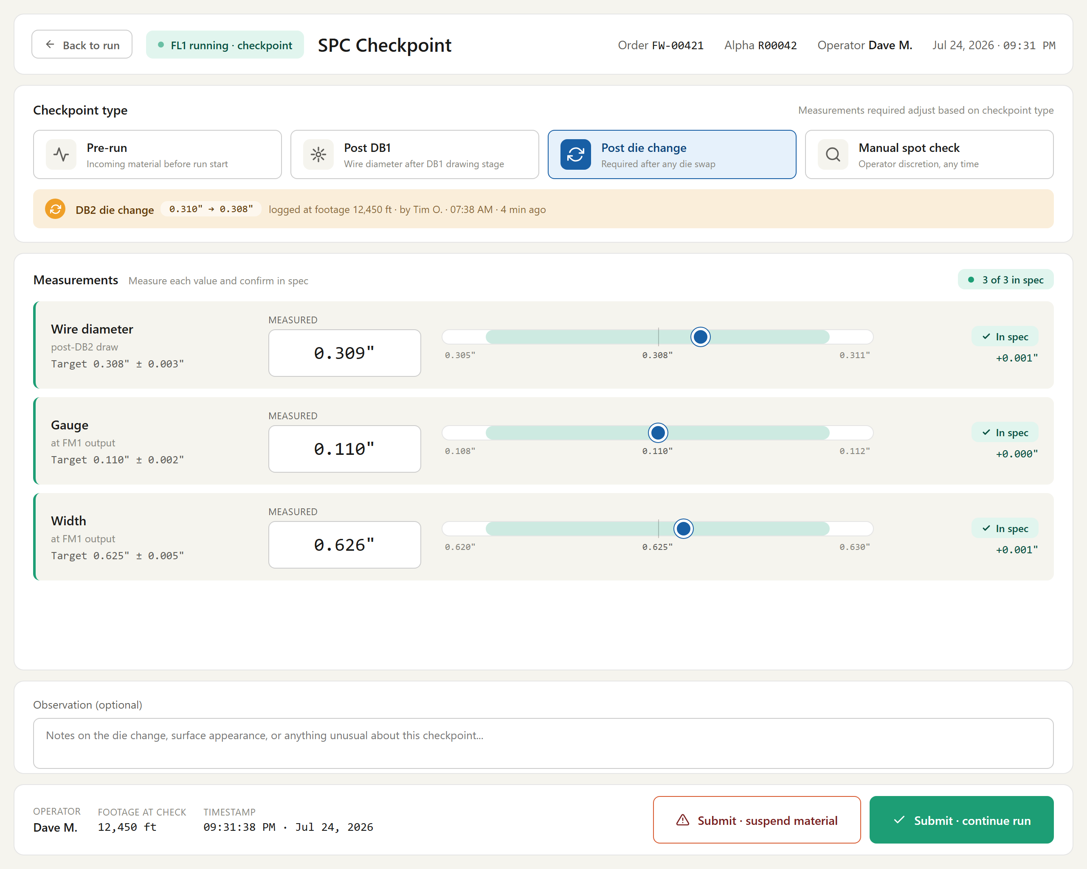
Figure # — SPC Checkpoint (Dashboard 6) (db06_spc_checkpoint.png)
*Requirements traced: SPC001–SPC015.*

4.10 ITInhibit & Alerts (ALT)
Description. ITInhibit & Alerts safeguards the flat-wire line by automatically setting a system-controlled inhibit tag whenever prerequisite conditions — a checked-in coil, an active MMS ID, and valid, continuous PLC feet data — are not met, thereby blocking machine run and preventing rolling data from being recorded against no coil. It also drives operator-facing alerts, warning of progressive material buildup as remaining output length nears the plan and of low remaining feed for the current coil. Line operators rely on it to avoid running under invalid states and to intervene before material overrun or coil depletion.
Priority: Must — inhibit enforcement and low-feed/buildup alerts are essential to prevent invalid runs, data corruption, and material loss at Phase-1 go-live.
Stimulus / Response.
Trigger | System response
Operator opens the run/monitoring screen | Displays current ITInhibit state and active alerts
Inhibit condition or alert threshold reached | Updates status and surfaces the alert in real time

Functional Requirements.
The system shall implement ITInhibit as a system-controlled tag that prevents the machine from running when required conditions are not met, and shall set and clear it only automatically, never manually by an operator. (ALT001)
The system shall set ITInhibit when no coil/rod is checked in. (ALT002)
The system shall set ITInhibit when no active MMS ID exists. (ALT003)
The system shall set ITInhibit when PLC feet data is unavailable or invalid. (ALT004)
The system shall set ITInhibit when two or more consecutive data recordings are missing. (ALT005)
The system shall, while ITInhibit is set, block machine run and related transactions, and shall record no rolling data without an active coil. (ALT006)
The system shall display progressive material buildup alerts as remaining output length approaches the planned length, with a first alert at 50% remaining and subsequent alerts at every 10% thereafter (40%, 30%, 20%, 10%). (ALT007)
The system shall alert the operator when remaining feed (feet) for the current coil reaches configurable threshold values. (ALT008)
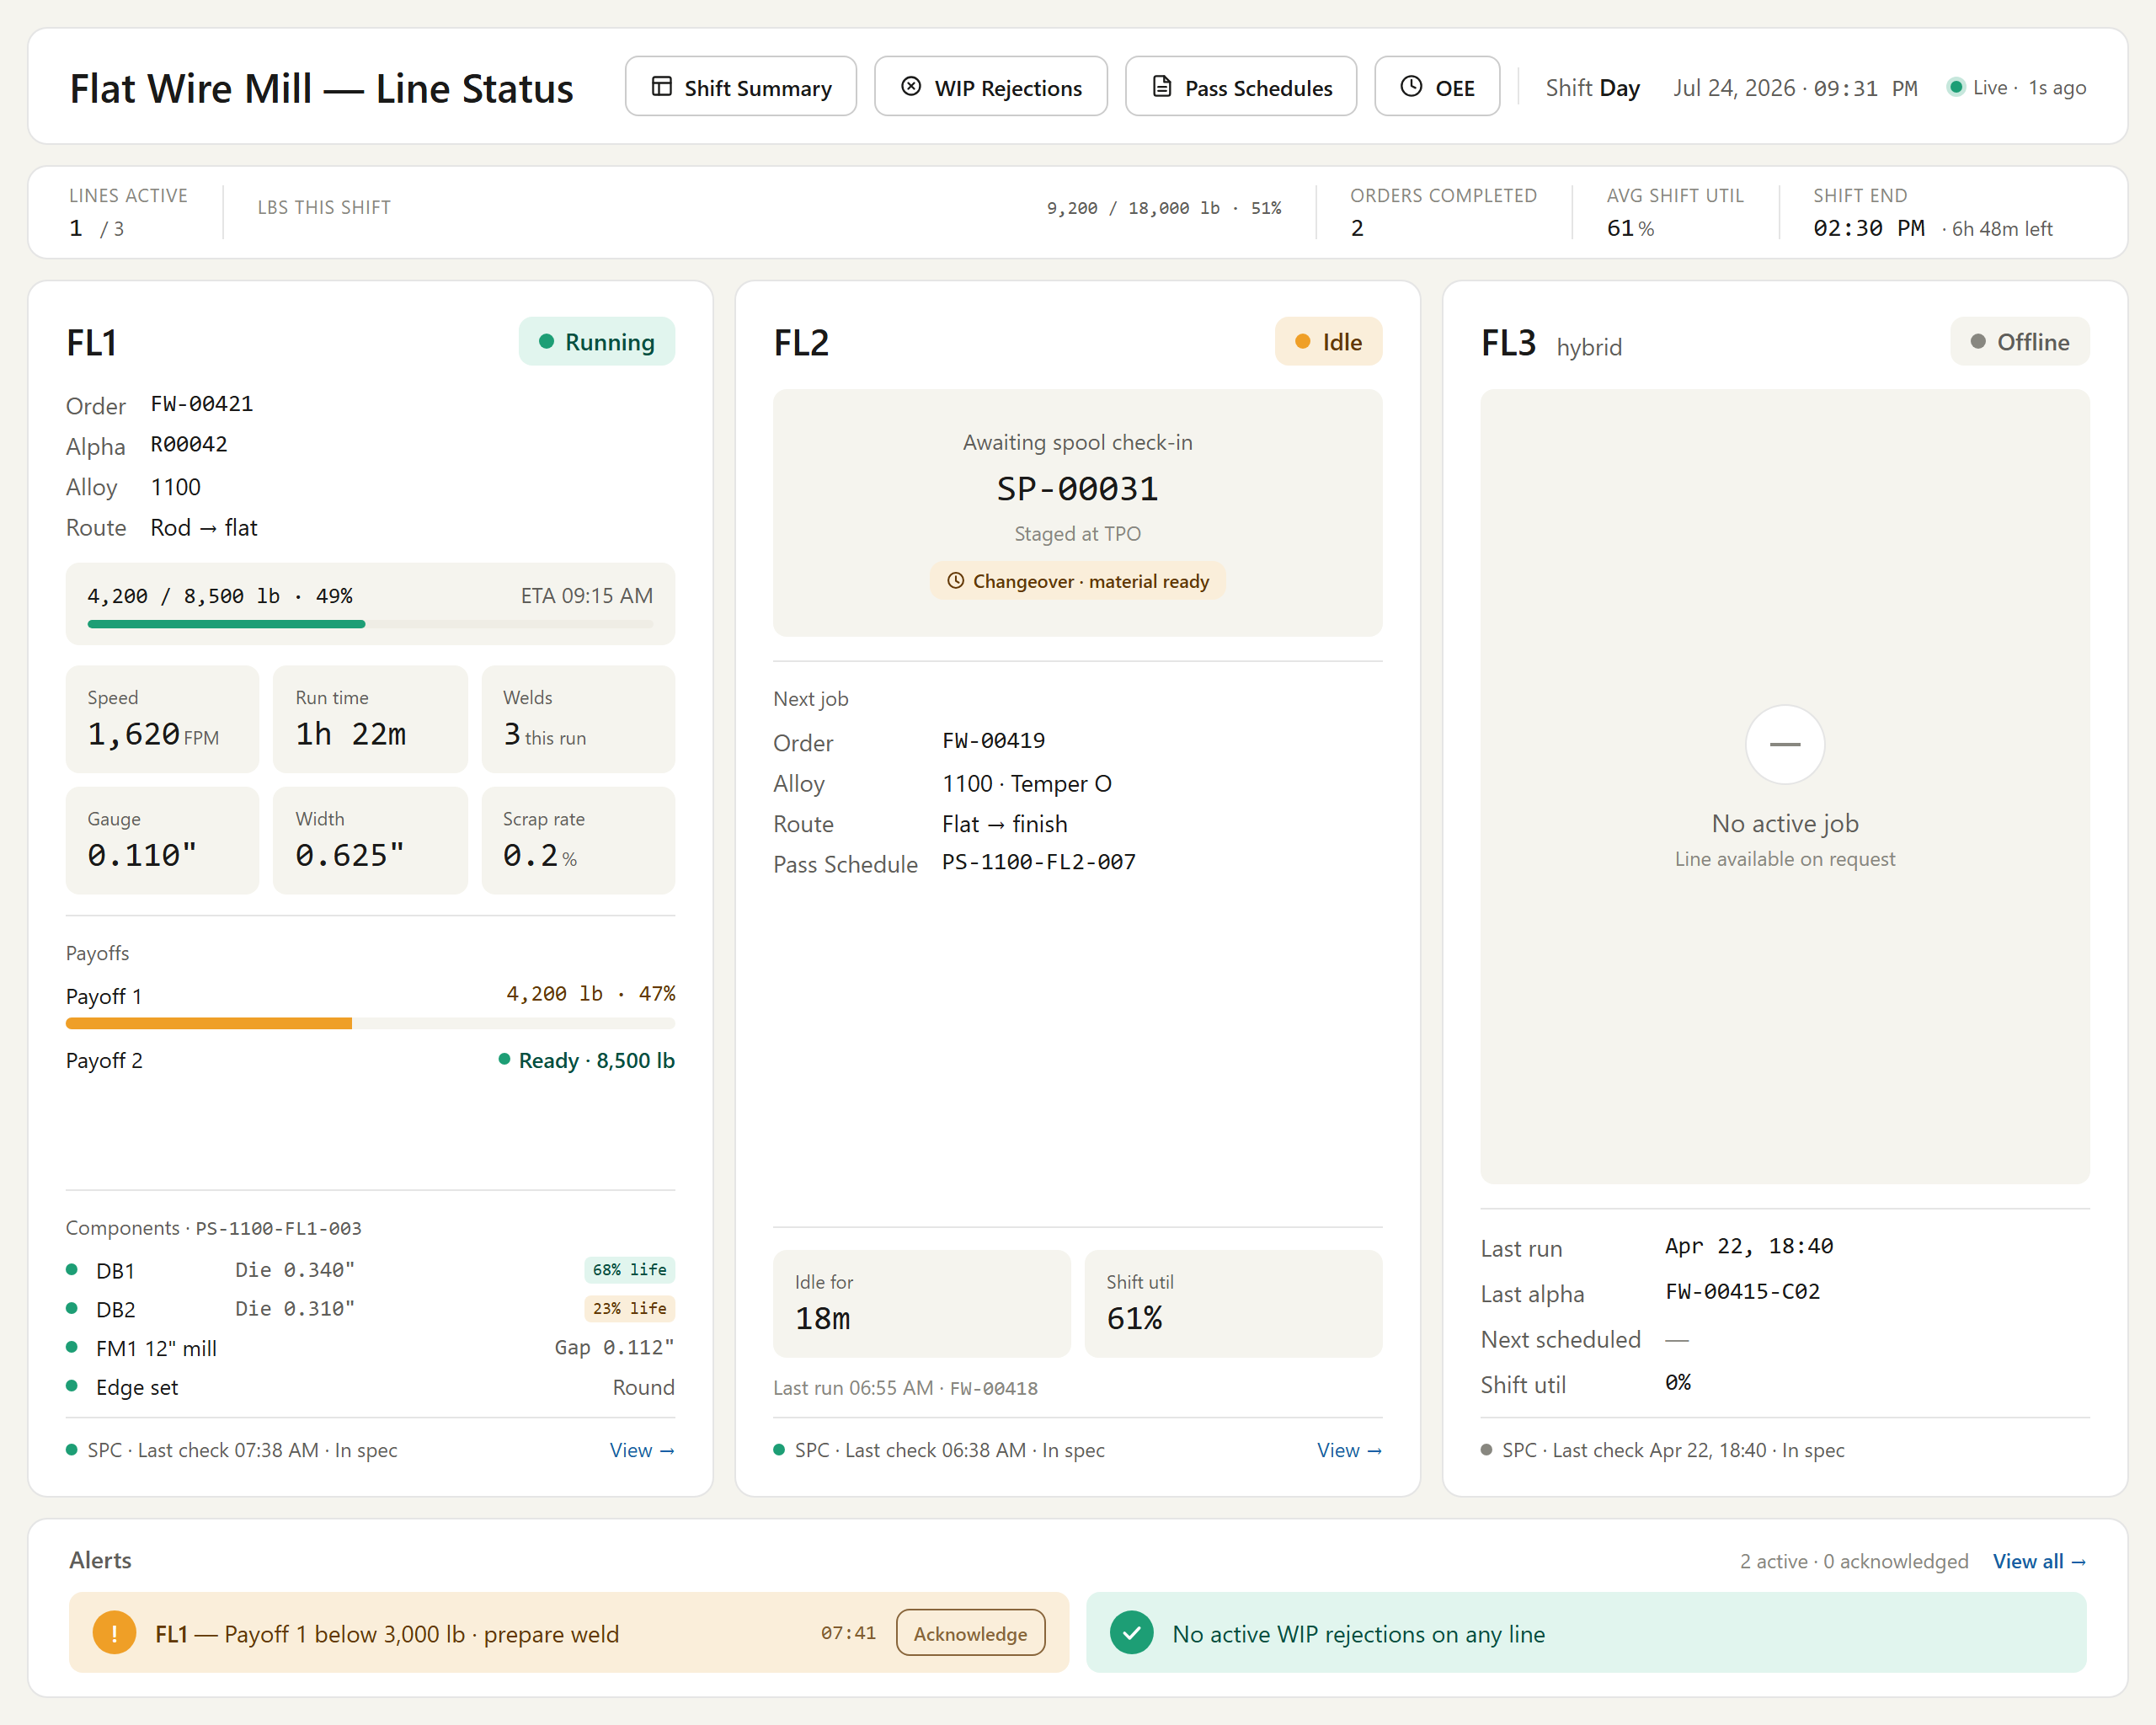
Figure # — Line Status Overview (Dashboard 1) (db01_line_status.png)
*Requirements traced: ALT001–ALT008.*

4.11 Stop / Pause / Output (STP)
Description. The Stop / Pause / Output feature governs how a flat-wire mill run is halted, recorded, and its product accounted for. When the operator presses STOP or the mill speed drops to zero, the system captures the stop reason, presents a transaction pop-up for spool, buildup, length, and next-section data, and enforces SPC and balance-of-coil decisions before the run may be updated. It also provides a distinct Pause flow and defines the physical output of FL1, FL2, and FL3 rolling. This is the core end-of-run transaction, essential to material traceability and accurate WIP on the flat-wire line.
Priority: Must — Phase-1 go-live cannot record production, spool output, or scrap without this transaction.
Stimulus / Response.
Trigger / operator action | System response
Presses STOP or mill speed reaches 0 | Prompts "Reason for Flatwire Stop", then opens the titled STOP pop-up
Enters Rod Buildup and selects Spool ID | Calculates Length and auto-populates Spool OD
Wire has no SPC performed | Shows red SPC warning banner; keeps Update disabled
Performs SPC checkpoint | Enables Update to commit the stop transaction
Selects Pause Run with reason code | Freezes footage counter, sets PLC to hold, marks line PAUSED

Functional Requirements.

4.11.1 Stop Pop-Up Invocation
The system shall invoke the Stop pop-up either from the STOP button on the interface or when mill speed reaches 0 as read from the OPC mill-speed tag; on mill stop it shall first present "Reason for Flatwire Stop" and, on Stop Completed, open the STOP pop-up. (STP001)
The system shall title the Stop pop-up "ROLLING TRANSACTION FOR ROD #RODNO – STOP #stopno". (STP002)

4.11.2 Stop Pop-Up Fields
The system shall provide a Rod Buildup field (numeric, required, editable, positive values up to 40, with a virtual keyboard). (STP003)
The system shall provide a Spool ID field (dropdown, required), auto-populated from the ID range for FL3 and FL2 and fixed for FL1. (STP004)
The system shall provide a Length field (read-only, system-calculated). (STP005)
The system shall provide a Spool OD field (read-only, auto-populated from Rod Buildup and Spool ID). (STP006)
The system shall provide a Scrap Box # field (typeahead autocomplete, optional, with a Clear Scrap Box button). (STP007)
The system shall display next-section data in the Stop pop-up: wire no, orders, customer, plan weight, rolled weight, width, total weight, spools, scrap spools, next operation, and anneal temperature. (STP008)

4.11.3 Balance-of-Coil Actions (Flat-Wire Terms)
The system shall present balance-of-coil actions worded in flat-wire terms: "Continue Rolling For Same Order" (enabled), "Scrap Balance" (enabled), "Return Bal To Warehouse" (enabled), and "Continue Rolling For Different Order" (disabled). (STP009)

4.11.4 SPC Banner & Footer
The system shall display a warning banner "SPC has not been performed for this coil" in red bold text on a beige background when SPC has not been performed on the wire. (STP010)
The system shall provide footer action buttons WIP Reject, SPC, Show Traveler, Back, and Update. (STP011)
The system shall keep the Update button disabled until an SPC checkpoint has been performed for the coil (aligned to the SPC-HOLD model — SPC must be performed but readings need not be in spec). (STP012)

4.11.5 Pause Run (Distinct from Stop)
The system shall provide a Pause Run flow distinct from Stop, requiring the operator to select a structured reason code from the defined categories (Equipment/Mechanical, Material Handling, Quality/Measurement, Operational, Safety, or Other with free text) before confirming. (STP013)
The system shall, on confirmed pause, pause the run timer, freeze and record the footage counter position against the run and alpha, log the reason code, set the PLC to a hold/idle state, and update the line status to PAUSED. (STP014)
The system shall require a resume confirmation that captures whether the issue was resolved and routes the outcome to resume run, log WIP rejection, continue pause, or check out rod (partial run). (STP015)

4.11.6 Output of Rolling
The system shall produce FL1 output on reusable collapsible intermediate spools (TS/SP-series) of approximately 3,500 lb capacity, routed to a furnace for annealing prior to FL2 processing. (STP016)
The system shall assign each intermediate spool a unique, system-generated number printed on a high-temperature label, sequenced TS000001 through TS999999. (STP017)
The system shall produce FL2 output as a coreless oscillated finished coil of approximately 1,100 lb, packaged two coils per skid, routed directly to the packing line. (STP018)
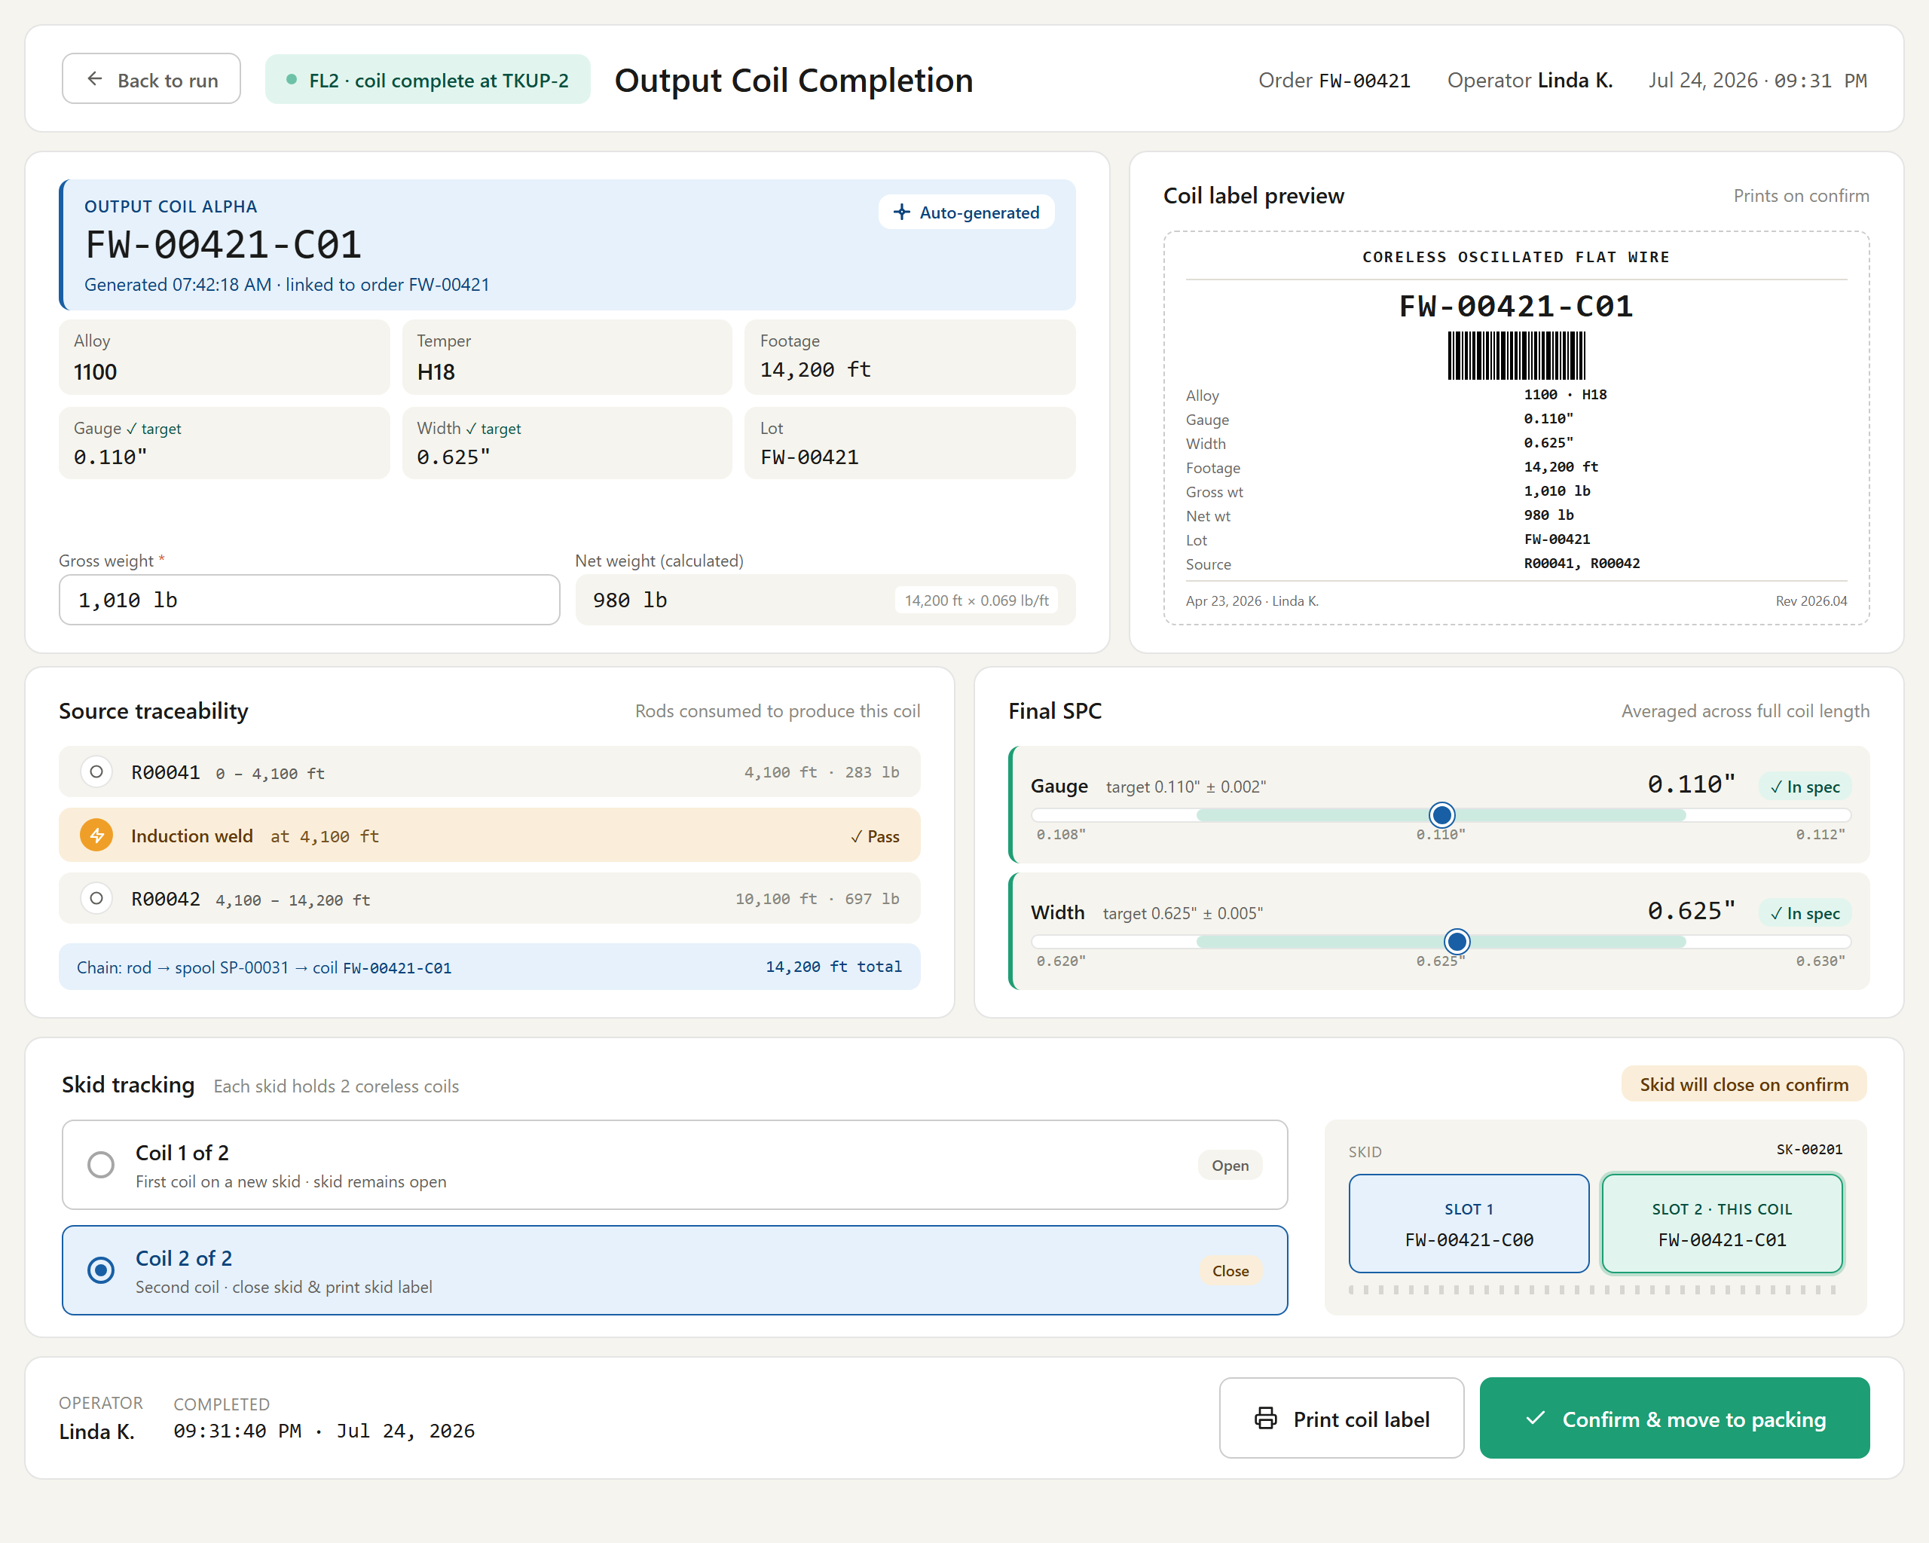
Figure # — Output Coil Completion (Dashboard 7) (db07_coil_completion.png)
*Requirements traced: STP001–STP018.*

4.12 Wire Break (WBK)
Description. The Wire Break feature detects and guides operator response when a wire break occurs on the flat-wire line. When a break is signaled, the line operator is prompted to confirm the event and then walked through mandatory recovery checks — outer-diameter (OD) verification and defect inspection — before production resumes. This safeguards product quality and traceability by ensuring no broken or defective wire advances undetected through the process.
Priority: Must — a wire break is a critical line event; unverified recovery risks defective material and downtime, so this must be in place at Phase-1 go-live.
Stimulus / Response.
Trigger / operator action | System response
Wire break occurs on the line | Prompts the operator: "Has the wire break happened?" with Yes and No buttons
Operator selects Yes | Prompts the operator to perform OD verification
Operator selects No | Dismisses the prompt; no recovery workflow is triggered
Break confirmed | Prompts the operator to inspect the wire for defects
Operator completes verification and inspection | Allows the line to resume normal operation

Functional Requirements.
The system shall, on a wire break, prompt the operator "Has the wire break happened?" with Yes and No buttons. (WBK001)
The system shall, on a Yes response, prompt the operator to perform OD verification. (WBK002)
The system shall prompt the operator to inspect the wire for defects following a wire break. (WBK003)

4.13 Label Printing (PR)
Description. Label Printing produces physical identification labels at the flat-wire lines FL1 and FL2, using standard Sato and high-temperature (furnace-compatible) printers. Operators and downstream check-in personnel rely on these labels to identify material, capture weights, and trace parentage as coils and spools move through the line. Because labels carry the barcode used for FL2 check-in and record all contributing parent coils for welded spools, they are the primary link between physical product and system records.
Priority: Must — accurate, scannable labels are required for material identification, weight capture, and multi-parent traceability at Phase-1 go-live.
Stimulus / Response.
Trigger | System response
Operator completes a coil/spool at FL1 or FL2 | System sends a formatted label to the appropriate printer
Spool label scanned at FL2 check-in | System reads the barcode and retrieves the associated material and parentage data

Functional Requirements.
The system shall equip FL1 with two label printers: a standard Sato label printer and a high-temperature (furnace-compatible) label printer. (PR001)
The system shall equip FL2 with two label printers: a standard Sato label printer and a high-temperature label printer. (PR002)
The system shall defer the FL1 payoff printer for Day-1, as send-back-to-stock scenarios are considered low likelihood. (PR003)
The system shall include on the printed label all essential material and process information: alloy, width, gauge, temper, gross weight, net weight, and rod/coil number. (PR004)
The system shall ensure FL2 spool labels contain sufficient information to support FL2 check-in and are scannable via barcode. (PR005)
The system shall, when an output spool contains multiple welded coils, list all contributing parent coil codes on the label to enable multi-parent traceability. (PR006)

Figure # — Output Coil Completion (Dashboard 7) (db07_coil_completion.png)
*Requirements traced: PR001–PR006.*

4.14 Data Recording (FRT + DAT)
Description. Data Recording provides real-time tracking of remaining material length (feet) and derived weight for active and queued welded coils, driving consumption-based MMS ID lifecycle, net-weight calculation, and automatic coil transitions. It also governs the data collection applications that record gauge and width at configurable intervals to build gauge and width traces. Mill operators and quality engineers rely on it in the flat-wire line to reconcile material across multi-coil runs and to detect recording failures that must halt rolling.
Priority: Must — accurate consumption tracking, MMS accounting, and recording-failure interlocks are prerequisites for valid material genealogy and safe Phase-1 go-live.
Stimulus / Response.
Trigger | System response
Coil check-in / mill speed exceeds zero | Opens the run and begins automatic feet tracking and data recording.
PLC feet update received | Refreshes remaining feet, derived weight, and trace displays live.
Missing or invalid PLC/recording data | Sets ITInhibit, blocks rolling, and displays a data-recording alert.

Functional Requirements.

4.14.1 Real-Time Feet & Weight Tracking (FRT)
The system shall track remaining material length (feet) in real time for the currently active input coil and the next welded (queued) coil. (FRT001)
The system shall source feet consumption values from the PLC wherever available. (FRT002)
The system shall, when PLC feet data is unavailable or invalid, set ITInhibit and not permit rolling. (FRT003)
The system shall continuously update remaining feet and derived weight, and shall support accurate reconciliation of material consumption across welded, multi-coil runs. (FRT004)
The system shall generate a unique MMS ID for each input coil at check-in time. (FRT005)
The system shall perform automatic, consumption-driven coil transition, triggering a transition event when remaining feet for the active coil reaches zero. (FRT006)
The system shall, when a welded coil becomes active, activate its MMS ID and automatically close the previous MMS ID. (FRT007)
The system shall close MMS IDs strictly based on material consumption and not on operator actions. (FRT008)
The system shall allow an output spool to reference multiple MMS IDs when material from welded coils contributes to a single run. (FRT009)
The system shall calculate output weight during rolling from recorded length (feet), gauge, and width, and shall not derive it from a weigh scale. (FRT010)
The system shall calculate net weight as Net Weight = Gross Weight − Tare Weight, with tail loss accounted for, and shall associate the calculated net weight with the corresponding MMS ID. (FRT011)
> [OPEN ITEM: confirm exact net-weight formula] — FRT011 corrects the v1 formula "Net = Vendor − Gross − Tail", which was incorrect. The intended definition is Net = Gross − Tare with tail loss accounted; exact treatment of tail loss to be confirmed.

4.14.2 Data Collection Applications & Recording (DAT)
The system shall provide two independent data collection application instances (one for FL1, one for FL2), shall use both simultaneously in FL3 (hybrid) mode, and shall support FL1 and FL2 running independent jobs concurrently. (DAT001)
The system shall start data recording automatically when mill speed exceeds zero, with no manual start action required. (DAT002)
The system shall provide configurable data recording frequency, accessible to authorized users (Engineering / IT) without a code change. (DAT003)
The system shall apply default recording frequencies of 4 feet per data point for finished product and 20 feet per data point for intermediate product. (DAT004)
The system shall record every 20 feet when a subsequent rolling operation exists and every 4 feet when none exists, shall always record every 4 feet at FL2, and shall record every 4 feet on both FL1 and FL2 in FL3 (hybrid) mode. (DAT005)
The system shall capture gauge and width at each recording point. (DAT006)
The system shall record gauge and width simultaneously to enable gauge trace and width trace graphs. (DAT007)
The system shall make FL1-recorded gauge trace data available at FL2 once the spool is checked in, and shall clearly indicate coil boundaries within a single run-level trace spanning multiple welded input coils. (DAT008)
The system shall, when two or more consecutive data recording entries are missing, display a prominent alert indicating a data recording issue and activate ITInhibit to block further operation. (DAT009)

Figure # — Active Run Monitor (Dashboard 3) (db03_active_run.png)
*Requirements traced: DAT001–DAT009, FRT001–FRT011.*

4.15 WIP Rejection (WRJ)
Description. WIP Rejection lets shopfloor operators reject wire-in-progress at any stage, recording a rejection group, reason, and full defect context, then routing the affected alpha through a disposition. Line operators and quality staff use it, with supervisors notified on holds. It is the primary quality gate that prevents defective flat-wire material from advancing through the line and preserves the measurement and gauge-trace evidence behind each rejection.
Priority: Must — material disposition and defect containment are core to Phase-1 flat-wire production and quality integrity.
Stimulus / Response.
Trigger / operator action | System response
Operator initiates a WIP rejection for an alpha | Prompts for rejection group and reason, consistent with coil WIP rejection
Operator confirms the rejection | Captures material/alpha, stage, footage position, measured value, target range, deviation, observation, and operator
System records the footage position | Links the rejection to the gauge trace at that position
Operator selects Suspend | Sets alpha to HOLD, moves it to the WIP Held queue, and notifies the supervisor
Operator selects Scrap | Sets alpha to SCRAP and routes it to scrap disposition
Operator selects Rework and a return stage | Flags the alpha for rework at the specified return stage

Functional Requirements.
The system shall allow rejection of wire-in-progress with a rejection group and reason, consistent with the existing coil WIP-rejection behavior. (WRJ001)
The system shall capture, on a WIP rejection, the material/alpha, stage, footage position, measured value, target range, deviation, observation, and operator. (WRJ002)
The system shall support WIP rejection dispositions of Suspend (alpha set to HOLD, moved to WIP Held queue, supervisor notified), Scrap (alpha set to SCRAP, routed to scrap disposition), and Rework (alpha flagged for rework at an operator-specified return stage). (WRJ003)
The system shall link a WIP rejection to the gauge trace at the rejection footage position. (WRJ004)
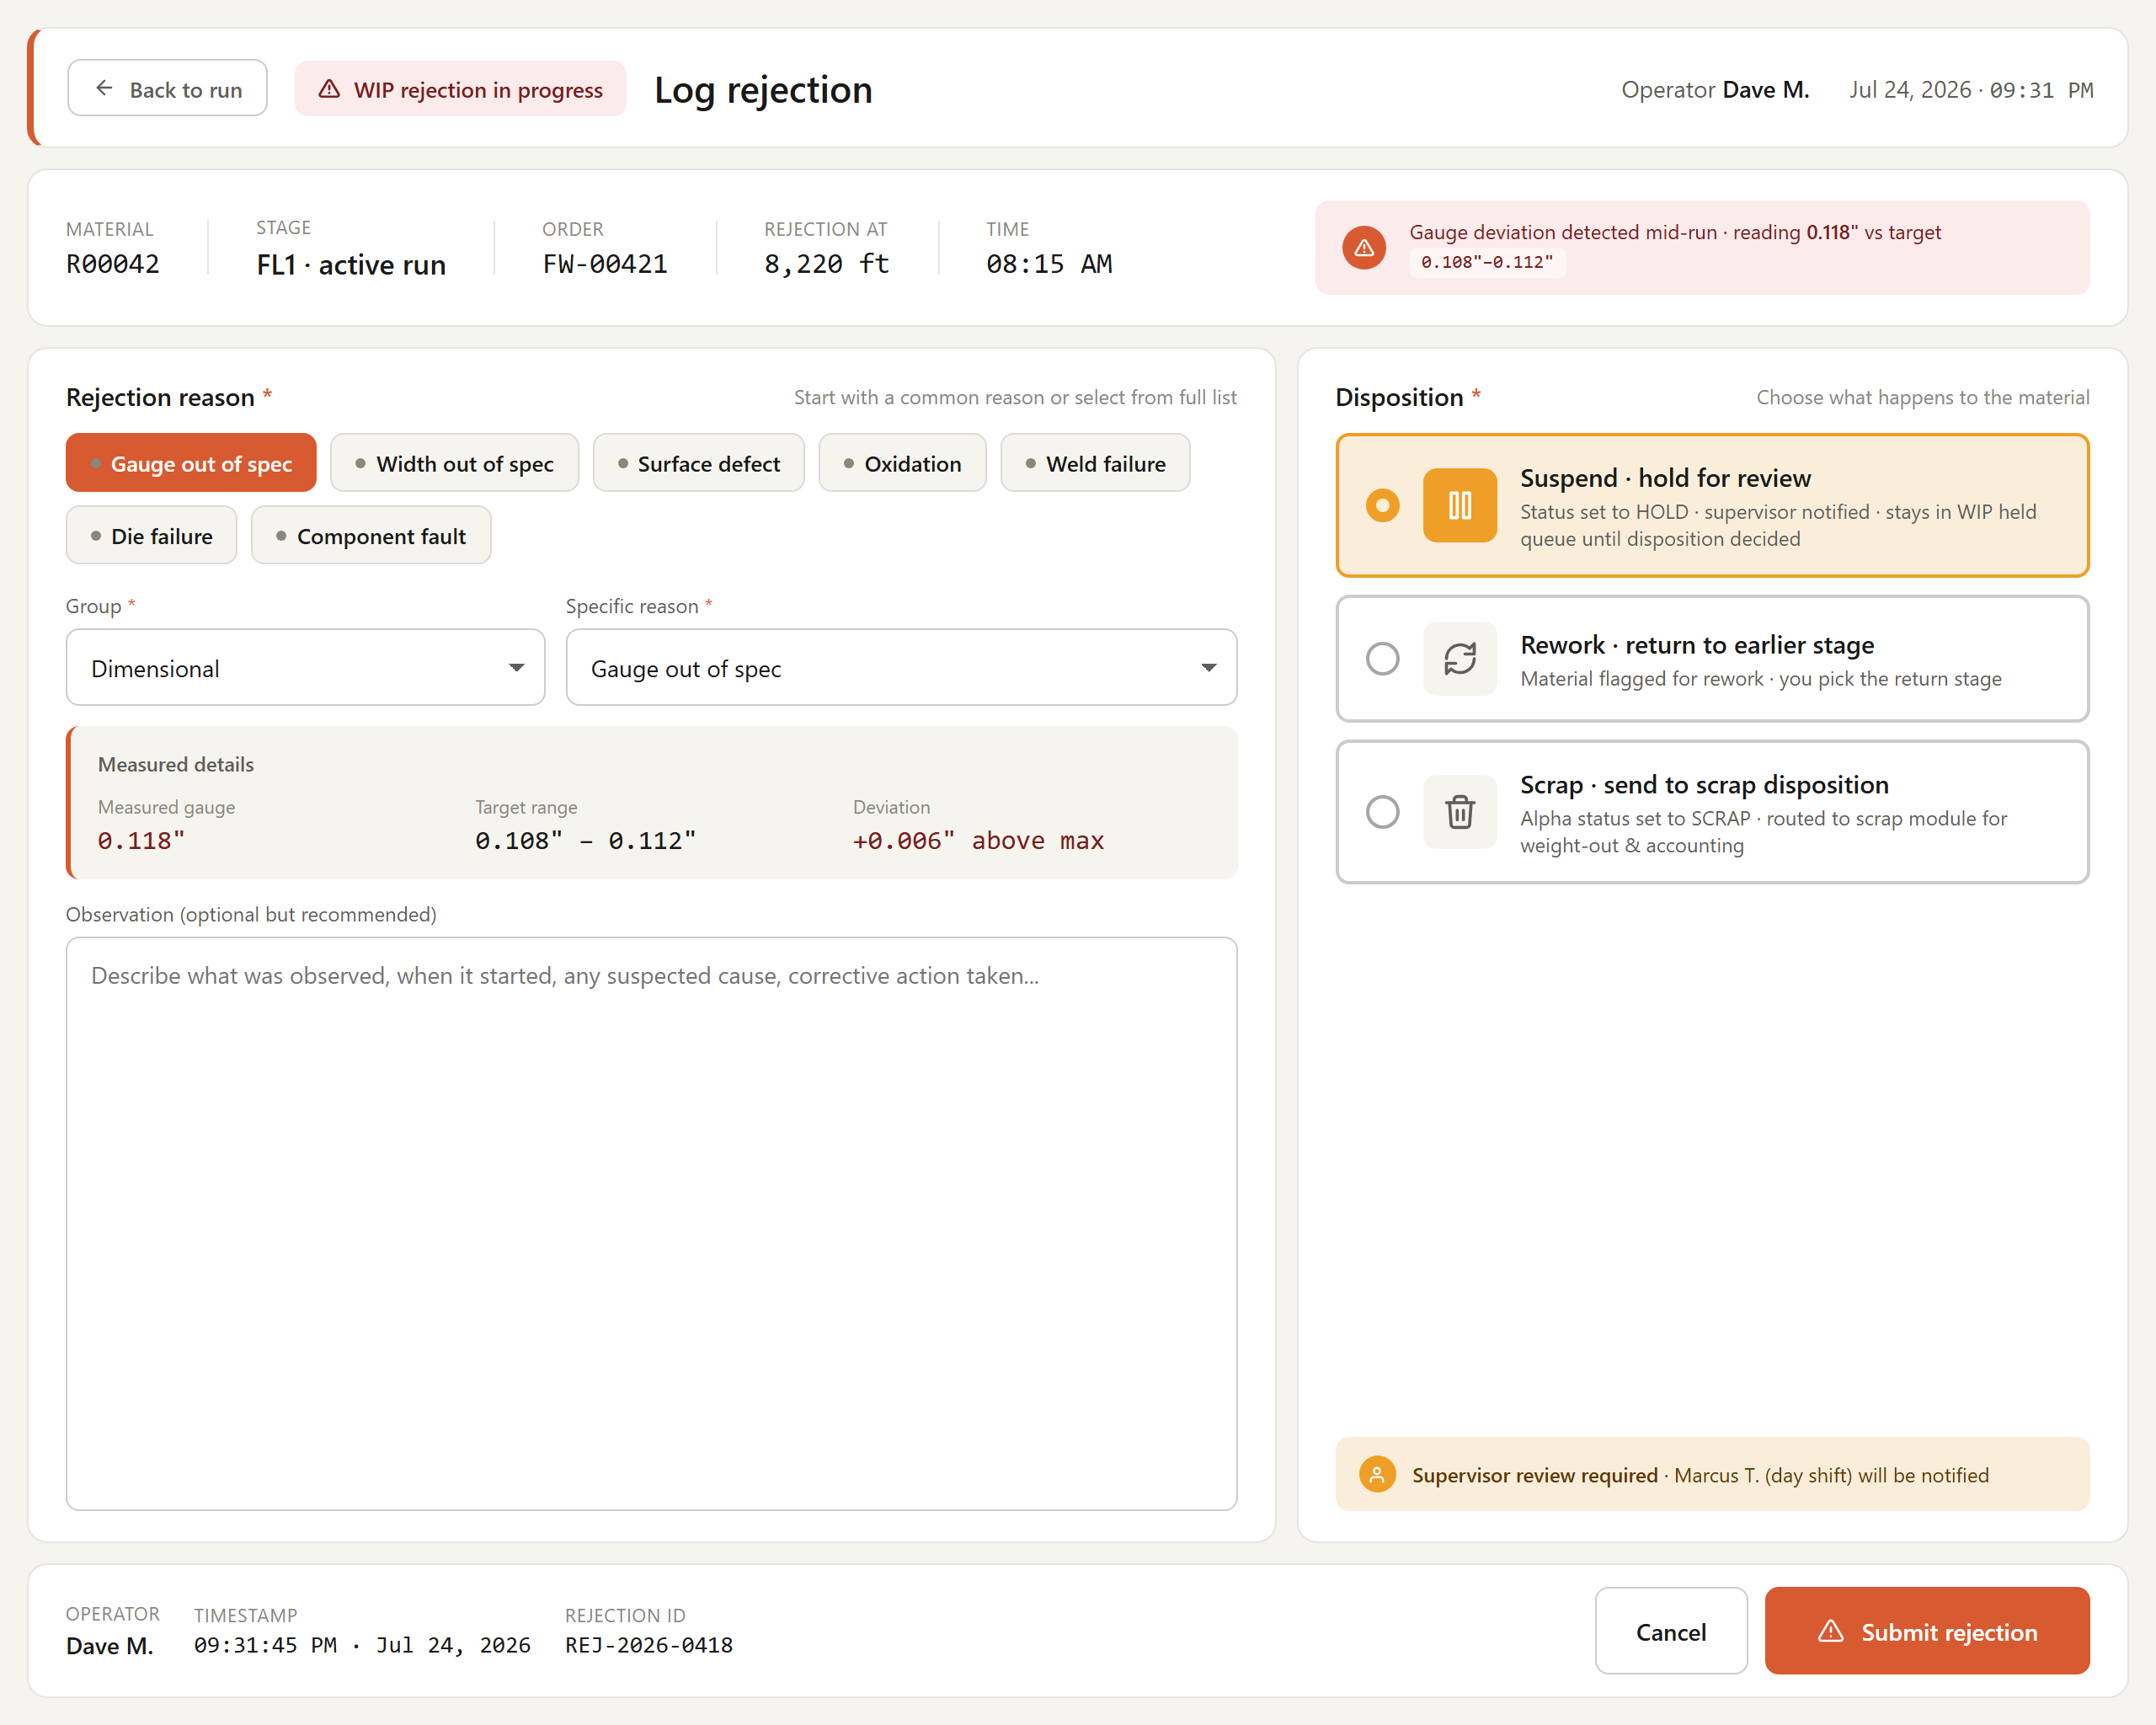
Figure # — WIP Rejection (Dashboard 8) (db08_wip_rejection.png)
*Requirements traced: WRJ001–WRJ004.*

4.16 Packing & Skid (PKG)
Description. The Packing & Skid feature governs how finished coreless flat-wire coils are validated, grouped onto skids, and released to packing. Packing operators use it at transaction finalization to confirm each package meets customer order limits, to build two-coil skids under existing skid-numbering rules, and to follow guided orientation prompts. It matters because it is the final quality and handoff gate before shipment, preventing out-of-spec packages from leaving the line.
Priority: Must — packing is the terminal step of the flat-wire line; without validated skids and labels no coil can ship at go-live.
Stimulus / Response.
Trigger / operator action | System response
Operator finalizes a coil transaction | Validates OD, width, and weight against order limits; blocks completion if exceeded
First coreless coil placed on skid | Opens skid and links the coil alpha
Second coreless coil placed on skid | Closes skid, prints skid label, moves skid to packing queue
Operator begins packaging | Presents R48-style prompts and pop-ups for correct orientation and confirmation
Skid number required | Applies existing skid numbering and continuity logic

Functional Requirements.
The system shall, at transaction finalization, validate package outer diameter (OD), width, and weight against the customer order constraints, and shall not complete the transaction if any limit is exceeded. (PKG001)
The system shall apply skid numbering and logic following the same rules as current skid handling, supporting reuse and continuity with existing skid systems. (PKG002)
The system shall place exactly two coreless finished coils per skid, opening the skid and linking the alpha on the first coil, and closing the skid, printing the skid label, and moving the skid to the packing queue on the second coil. (PKG003)
The system shall present operator prompts and pop-ups, similar to the existing R48 eye-to-side packing scenario, to guide correct packaging orientation and confirmation. (PKG004)
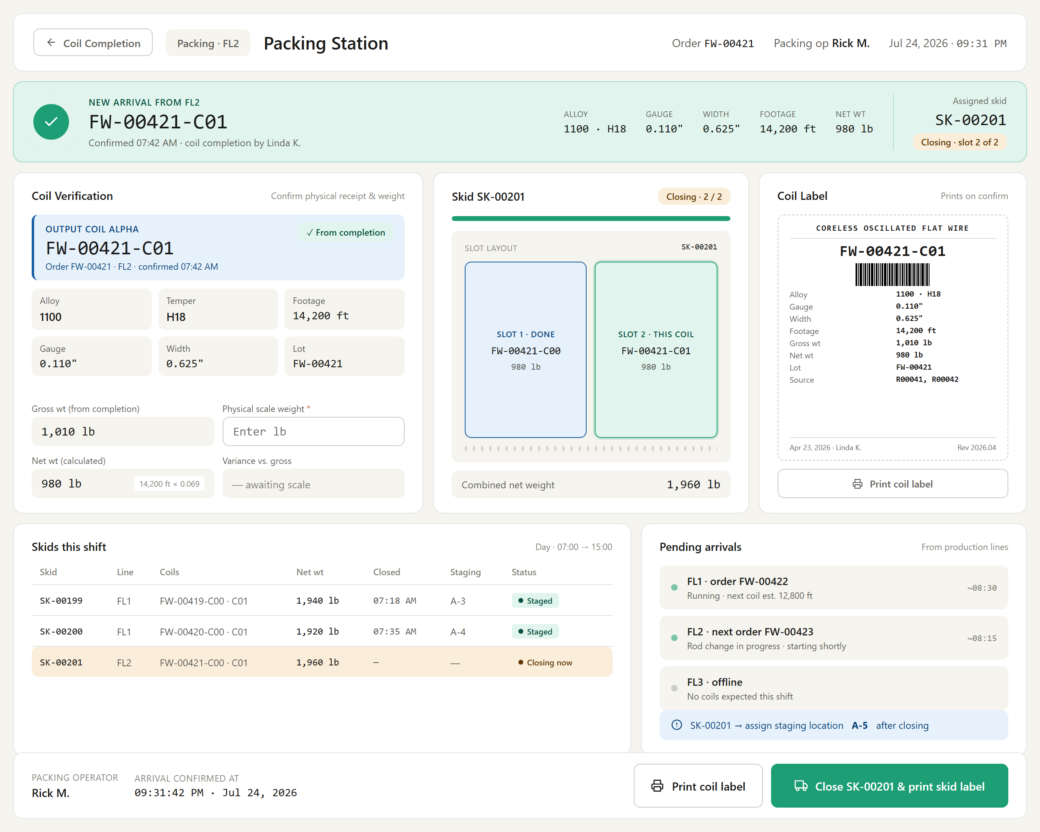
Figure # — Packing Station (Dashboard 7b) (db07b_packing_station.png)
*Requirements traced: PKG001–PKG004.*
Feature group — Rod Checkout & Partial Re-Check-In.

4.17 Rod Checkout (RCO)
Description. Rod Checkout (Dashboard 12) lets a VPS line operator deliberately remove a checked-in rod from a payoff position without a Run Complete, Rejection/Scrap, or Weld outcome. It covers Pre-Run checkout (footage = 0, operator-confirmed return to floor or warehouse) and Mid-Run checkout (footage > 0, supervisor-approved partial-spool disposition). Acting as a PLC gatekeeper, it blocks removal while the line runs and persists every event, giving the flat-wire line a controlled, auditable way to correct mis-scans, cancellations, and relocations.
Priority: Must — without a formal checkout path a checked-in rod cannot leave INFLAT except through a full run outcome, blocking routine floor corrections at go-live.
Stimulus / Response.
Trigger / operator action | System response
Operator invokes Check Out Rod | Reads FL1.LineState; blocks and warns if the line is Running
Operator opens dialog on a stopped line | Locks PLC footage counter; shows read-only alpha and payoff position
Operator selects reason code and disposition | Validates entries; requires notes when reason is "Other"
Operator confirms a Pre-Run checkout | Transitions rod to STAGED/RECEIVED, clears tags, voids acknowledgement
Operator submits a Mid-Run checkout | Closes partial run, creates locked Pending Disposition, notifies supervisor via SignalR
Supervisor decides Accept/Hold/Reject | Generates or withholds partial spool alpha and records the disposition

Functional Requirements.

Narrative
Rod Checkout is the deliberate removal of a rod from a VPS payoff position without a Run Complete, WIP Rejection/Scrap, or Weld Event outcome. Prior to this feature a checked-in rod (status INFLAT) could only leave that state through one of those three outcomes; there was no formal way to pull a rod because the wrong alpha was scanned, an order was rescheduled, or the rod had to be relocated. Rod Checkout is delivered as Dashboard 12 — Rod Checkout and covers two scenarios.
Scenario A — Pre-Run Checkout applies when the rod has been checked in (payoff position assigned, pass schedule acknowledged) but the line has not started (footage = 0). The operator opens a checkout dialog showing the read-only rod alpha and payoff position, selects a required reason code, optionally records notes, and confirms. The rod transitions from INFLAT to STAGED (return to floor storage) or RECEIVED (return to warehouse) at the operator's choice, the payoff position and PLC tags are cleared, and the pass schedule acknowledgement is voided.
Scenario B — Mid-Run Checkout applies when the rod is actively running (INFLAT, footage > 0) and must be removed before natural exhaustion. This path is reached only through the Pause dialog. Because footage was produced, mid-run checkout requires supervisor approval (Q48/Q50, Decided): the operator submits with a captured footage value, a reason code, and a rod disposition; the system closes the partial run, creates a locked Pending Disposition record with no alpha, and pushes a SignalR notification to the supervisor role. The supervisor reviews remotely and Accepts, Holds, or Rejects the partial material.
Across both scenarios the application acts as a PLC gatekeeper: before the checkout dialog opens or a confirm is accepted, it reads FL1.LineState and blocks checkout while the line is Running. The application never issues a stop command — the operator stops the line physically — and PLC tags are cleared only after a confirmed stop, ensuring the footage counter value is final before any tags are touched. Every checkout is written to the persisted rod_checkout_events record.
Apply flat-wire terminology throughout: rods (R-series alphas) feed the VPS dual payoff; partial output material is captured as spool (SP-series) alphas per PartialRodReCheckin.md.

4.17.1 Common Rules — Gatekeeper and Event Recording
- (RCO001) The system shall provide a Rod Checkout function (Dashboard 12) that removes a checked-in rod from a VPS payoff position without invoking a Run Complete, WIP Rejection/Scrap, or Weld Event outcome.
- (RCO002) The system shall support two checkout scenarios: Pre-Run Checkout (PRE_RUN, footage = 0) and Mid-Run Checkout (MID_RUN, footage > 0).
- (RCO003) The system shall read the current line state tag FL1.LineState from the PLC before opening the checkout dialog or accepting a checkout confirmation.
- (RCO004) The system shall block the checkout and prevent the checkout dialog from opening when FL1.LineState reports "Running".
- (RCO005) The system shall display the message "Line is still running. Stop the line before checking out the rod." when checkout is blocked because the line is running.
- (RCO006) The system shall permit the checkout dialog to open only when the PLC reports the line is in a confirmed stopped state.
- (RCO007) The system shall not send a stop command to the PLC at any point in the checkout flow, requiring the operator to physically stop the line.
- (RCO008) The system shall read the PLC footage counter value and lock it at the moment the checkout dialog opens, so that the footage recorded at checkout is final.
- (RCO009) The system shall clear the PLC tags for the affected payoff position only after the line is confirmed stopped and the operator confirms the checkout.
- (RCO010) The system shall clear the payoff position assignment for the rod on checkout confirmation.
- (RCO011) The system shall record every confirmed checkout as a persisted rod_checkout_events record.
- (RCO012) The system shall record on the rod_checkout_events record the rod alpha, payoff position, originating check-in identifier, scenario, checkout reason code, footage at checkout, remaining weight estimate, rod disposition, material disposition, operator identifier, checkout timestamp, and notes.
- (RCO013) The system shall auto-stamp the checkout timestamp and prevent the operator from modifying it.
- (RCO014) The system shall link each rod_checkout_events record back to the originating check-in record via the check-in identifier.
- (RCO015) The system shall require free-text notes when the selected checkout reason is "Other".

4.17.2 Scenario A — Pre-Run Checkout
- (RCO016) The system shall make the Pre-Run Checkout path available while the rod is checked in and the footage counter reads zero.
- (RCO017) The system shall expose the Pre-Run Checkout entry point as a "Check Out Rod" action on the Dashboard 2 footer (check-in not yet acknowledged) and in the Dashboard 3 header actions (check-in acknowledged, run not started).
- (RCO018) The system shall disable the Dashboard 3 "Check Out Rod" action once footage is greater than zero, routing mid-run removals exclusively through the Pause dialog.
- (RCO019) The system shall display the rod alpha and payoff position as read-only fields in the Pre-Run Checkout dialog.
- (RCO020) The system shall require the operator to select a Pre-Run checkout reason code from the set: Wrong rod / mis-scan, Order cancelled / deferred, Failed re-inspection, Relocated to different line, Other.
- (RCO021) The system shall allow the operator to enter optional notes in the Pre-Run Checkout dialog.
- (RCO022) The system shall require the operator to choose a rod disposition of STAGED (return to floor storage) or RECEIVED (return to warehouse) for a Pre-Run Checkout.
- (RCO023) The system shall transition the rod status from INFLAT to STAGED when the operator selects return to floor storage.
- (RCO024) The system shall transition the rod status from INFLAT to RECEIVED when the operator selects return to warehouse.
- (RCO025) The system shall void the pass schedule acknowledgement for the rod on a Pre-Run Checkout.
- (RCO026) The system shall record a footage-at-checkout value of zero for a Pre-Run Checkout.
- (RCO027) The system shall leave the material disposition null for a Pre-Run Checkout, as no material was produced.
- (RCO028) The system shall return the dashboard to the "Ready for Check-In" state after a Pre-Run Checkout is confirmed.

4.17.3 Scenario B — Mid-Run Checkout
- (RCO029) The system shall make the Mid-Run Checkout path available only when footage is greater than zero and only through the Dashboard 3 Pause dialog as a "Check Out Rod (Partial Run)" resume option.
- (RCO030) The system shall display the rod alpha as a read-only field in the Mid-Run Checkout dialog.
- (RCO031) The system shall auto-capture the footage at removal from the PLC footage counter and display it as a read-only field in the Mid-Run Checkout dialog.
- (RCO032) The system shall allow the operator to enter an optional remaining weight estimate in the Mid-Run Checkout dialog.
- (RCO033) The system shall require the operator to select a Mid-Run checkout reason code from the set: Equipment failure, Quality hold, Order quantity reached, Shift deferral, Other.
- (RCO034) The system shall require the operator to select a rod disposition for a Mid-Run Checkout from: Hold — return to storage, Scrap — not re-usable, Defer — continue later on same line.
- (RCO035) The system shall transition the rod status from INFLAT to HOLD when the Mid-Run rod disposition is Hold.
- (RCO036) The system shall transition the rod status from INFLAT to SCRAP when the Mid-Run rod disposition is Scrap.
- (RCO037) The system shall transition the rod status from INFLAT to STAGED when the Mid-Run rod disposition is Defer, requiring a subsequent re-check-in.
- (RCO038) The system shall require supervisor approval before a mid-run checkout is finalized, and shall not permit the operator to unilaterally accept partial spool footage.
- (RCO039) The system shall present the Mid-Run Checkout confirm action to the operator as "Submit for Supervisor Approval".
- (RCO040) The system shall close the run event and save a partial run record containing the locked PLC footage counter value on submission of a Mid-Run Checkout.
- (RCO041) The system shall create a Pending Disposition record on submission of a Mid-Run Checkout, with the material locked, not plannable, and carrying no alpha.
- (RCO042) The system shall push a SignalR notification to the supervisor role on submission of a Mid-Run Checkout.
- (RCO043) The system shall allow a supervisor to review a pending mid-run disposition from any connected terminal, displaying the partial-run gauge trace, footage produced, reason for stop, operator identifier, and timestamp.
- (RCO044) The system shall allow the reviewing supervisor to select a disposition decision of Accept, Hold, or Reject.
- (RCO045) The system shall generate a partial spool alpha and enter it into the spool queue when the supervisor selects Accept.
- (RCO046) The system shall generate a partial spool alpha with Hold status requiring QC release when the supervisor selects Hold.
- (RCO047) The system shall trigger the WIP Rejection flow and route the material to scrap when the supervisor selects Reject.
- (RCO048) The system shall not generate any partial spool alpha until the supervisor has approved the material disposition.
- (RCO049) The system shall write a disposition record capturing the supervisor identifier, decision, reason code, and timestamp when a mid-run disposition is resolved.
- (RCO050) The system shall record the resulting material disposition value (HOLD, SCRAP, or ACCEPT_PARTIAL) and, when applicable, the generated partial spool alpha on the rod_checkout_events record.
- (RCO051) The system shall return the dashboard to the "Ready for Check-In" state after a mid-run disposition is resolved.
*[OPEN ITEM: Q49 (PLC tag behaviour on checkout) is In Progress — the exact stopped-state definition is unconfirmed. Jaspreet/engineering must confirm whether FL1.LineState = "Stopped" is a discrete tag or requires FL1.DriveSpeed < threshold; the RCO003–RCO009 guard condition must match the PLC's own definition of "stopped" before development.]*
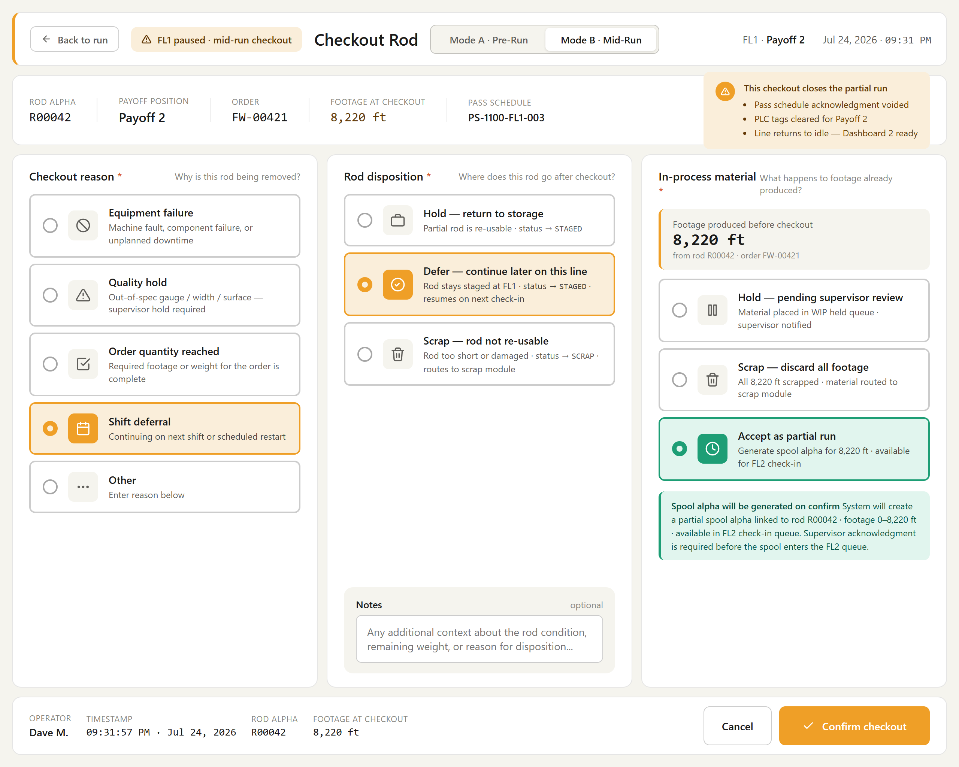
Figure # — Rod Checkout (Dashboard 12) (db12_rod_checkout.png)
*Requirements traced: RCO001–RCO051.*

4.18 Partial Rod Re-Check-In (PRC)
Description. Partial Rod Re-Check-In returns a partially consumed rod — one removed mid-run and sent back to storage — onto a payoff for a subsequent run while preserving its full processing history. A single persistent rod record carries footage_run_to_date and remaining_weight_estimate, and each run segment produces its own spool alpha linked back to the source rod. Payoff operators use it during check-in; it protects genealogy integrity so rod-to-coil traceability holds across any number of partial runs.
Priority: Should — important for accurate genealogy on reused rods, but the carry-forward design (Q47) and conversion factors remain in progress for Phase-1 go-live.
Stimulus / Response.
Trigger / operator action | System response
Operator scans a rod at the payoff for check-in | Looks up the existing rod record by barcode/alpha
Record shows footage_run_to_date > 0 | Blocks the start-fresh path and opens the "prior run history" screen
Operator reviews footage run, remaining weight, and last run | Offers only "Proceed as partial re-check-in" or "Cancel"
Operator confirms the physical rod matches and proceeds | Opens a new run record, counter at zero, linked to the source rod
Run segment ends | Generates a spool alpha, increments footage_run_to_date, recalculates remaining weight

Functional Requirements.

Narrative
A rod removed mid-run and returned to storage (via a Mid-Run Checkout with a Hold or Defer disposition) is only partially consumed. Partial Rod Re-Check-In is the flow for bringing that rod back onto a payoff for a subsequent run while preserving its processing history. The recommended and confirmed-in-principle design is carry-forward with a single persistent rod record (Q47): the rod inventory record carries footage_run_to_date and remaining_weight_estimate, which start at zero / full original weight on first check-in and are updated on every checkout confirmation.
Re-check-in does not create a new rod record. When an operator scans a rod at the payoff, the system retrieves the existing record by barcode/alpha. If footage_run_to_date > 0, the system blocks the fresh-record path entirely and forces the carry-forward path, presenting the "This rod has prior run history" screen showing footage already run, remaining weight estimate, and the last run reference. The operator must confirm the physical rod matches before proceeding. A new, independent run record is then opened with its footage counter starting at zero for that run.
Each separate run segment produces its own spool (SP-series) alpha; multiple partial spool alphas per rod are explicitly supported (Q47, confirmed needed). Every partial spool alpha carries a source_rod_alpha foreign key back to the originating rod so the genealogy chain — rod → each partial spool → coreless coil — is reconstructable across any number of runs. Material drawn or rolled that remained in the mill at removal is scrapped and does not return with the rod; only the undrawn rod portion carries forward. Reconciliation updates footage_run_to_date (incremented by the footage produced on the completed segment) and recalculates remaining_weight_estimate, marking the rod Exhausted when remaining weight reaches zero.

4.18.1 Persistent Rod Record and Carry-Forward Fields
- (PRC001) The system shall maintain a single persistent rod inventory record per rod across all of its runs, identified by the rod's barcode/alpha.
- (PRC002) The system shall carry two fields on the rod inventory record: footage_run_to_date and remaining_weight_estimate.
- (PRC003) The system shall initialize footage_run_to_date to zero and remaining_weight_estimate to the rod's full original weight on first check-in.
- (PRC004) The system shall update footage_run_to_date and remaining_weight_estimate on the rod record each time a checkout is confirmed.
- (PRC005) The system shall retrieve the existing rod record on re-check-in by the rod's barcode/alpha rather than creating a new rod record.

4.18.2 Fresh-Record Block and Prior-History Screen
- (PRC006) The system shall look up the scanned rod's record when an operator scans a rod at the payoff for check-in.
- (PRC007) The system shall block the fresh-record ("start fresh") check-in path for any rod whose record has footage_run_to_date greater than zero.
- (PRC008) The system shall not present a "start fresh" option as a selectable button when a rod has prior run history.
- (PRC009) The system shall route a rod with prior run history to the "This rod has prior run history" screen instead of the normal check-in screen.
- (PRC010) The system shall display on the prior-history screen the footage already run, the remaining weight estimate, and the last run reference (line, run number, and date).
- (PRC011) The system shall offer on the prior-history screen only the actions "Proceed as partial re-check-in" and "Cancel".

4.18.3 Partial Re-Check-In Sequence
- (PRC012) The system shall pre-populate the check-in screen with the rod's carried-forward values (rod alpha, original weight, footage already run, remaining weight estimate, last run, and status) when the operator proceeds as a partial re-check-in.
- (PRC013) The system shall set the remaining weight estimate as the starting weight for the new run.
- (PRC014) The system shall require the operator to confirm that the rod physically on the payoff is the same rod as the retrieved record (via weight check, label scan, or visual confirmation) before proceeding.
- (PRC015) The system shall open a new, independent run record with a new run number, timestamp, operator identifier, and machine assignment, linked back to the source rod.
- (PRC016) The system shall start the footage counter for the new run at zero, so that footage from prior runs is attributed only to their respective prior runs and spool alphas.
- (PRC017) The system shall process the re-check-in run identically to any normal run once started, including real-time SCADA/PLC footage feed and configured SPC checkpoints.

4.18.4 Spool Alpha Linkage and Multiple Partials
- (PRC018) The system shall generate a distinct spool (SP-series) alpha for each separate run segment of a rod.
- (PRC019) The system shall support multiple partial spool alphas originating from a single rod across separate runs.
- (PRC020) The system shall record a source_rod_alpha foreign key on every partial spool alpha, referencing the originating rod alpha.
- (PRC021) The system shall enable a certificate query to reconstruct the full rod genealogy by joining all partial spool alphas through their source_rod_alpha key back to the source rod, its heat, alloy, and receiving record.
- (PRC022) The system shall not hold a single rod-level alpha open across runs in place of per-segment spool alphas.

4.18.5 Carry-Forward Reconciliation
- (PRC023) The system shall record the footage produced on the current run segment when the run ends.
- (PRC024) The system shall generate a new partial spool alpha for the footage produced on the current segment, with its source_rod_alpha set to the rod alpha.
- (PRC025) The system shall increment footage_run_to_date on the rod record by the footage produced on the completed segment.
- (PRC026) The system shall recalculate remaining_weight_estimate on the rod record after each segment.
- (PRC027) The system shall set the rod status to Exhausted and remaining_weight to zero when the rod runs out naturally on a segment.
- (PRC028) The system shall return the rod status to "Partial — Returned to Storage" when the rod is removed again before exhaustion, repeating the carry-forward reconciliation.
- (PRC029) The system shall treat material drawn or rolled and remaining in the mill at removal as scrap that does not carry forward with the rod, so that only the undrawn rod portion contributes to the carried-forward remaining weight.
*[OPEN ITEM: Q47 carry-forward design is In Progress — Tim O. to provide full confirmation of the persistent-rod-record / footage_run_to_date / remaining_weight_estimate design. Requirements PRC001–PRC029 reflect the recommended design pending that confirmation.]*
*[OPEN ITEM: Q47 payoff scale — Scott/Bob/Shannon to confirm whether a payoff-position scale is available/required to weigh partial rods returning to the warehouse; if provided, a measured remaining weight would replace or validate the derived remaining_weight_estimate (PRC026).]*
*[OPEN ITEM: Q36 footage-to-weight conversion factor is Open — remaining_weight_estimate (PRC013, PRC026) depends on a per-alloy/cross-section conversion factor that is not yet defined.]*
*[OPEN ITEM: Q55/anneal — per Spool.md an intermediate anneal modifies the existing spool alpha rather than creating a child; spool-alpha continuity through anneal between partial runs (Q55) may affect how a carried-forward partial spool alpha is referenced. Confirm interaction with PRC020.]*
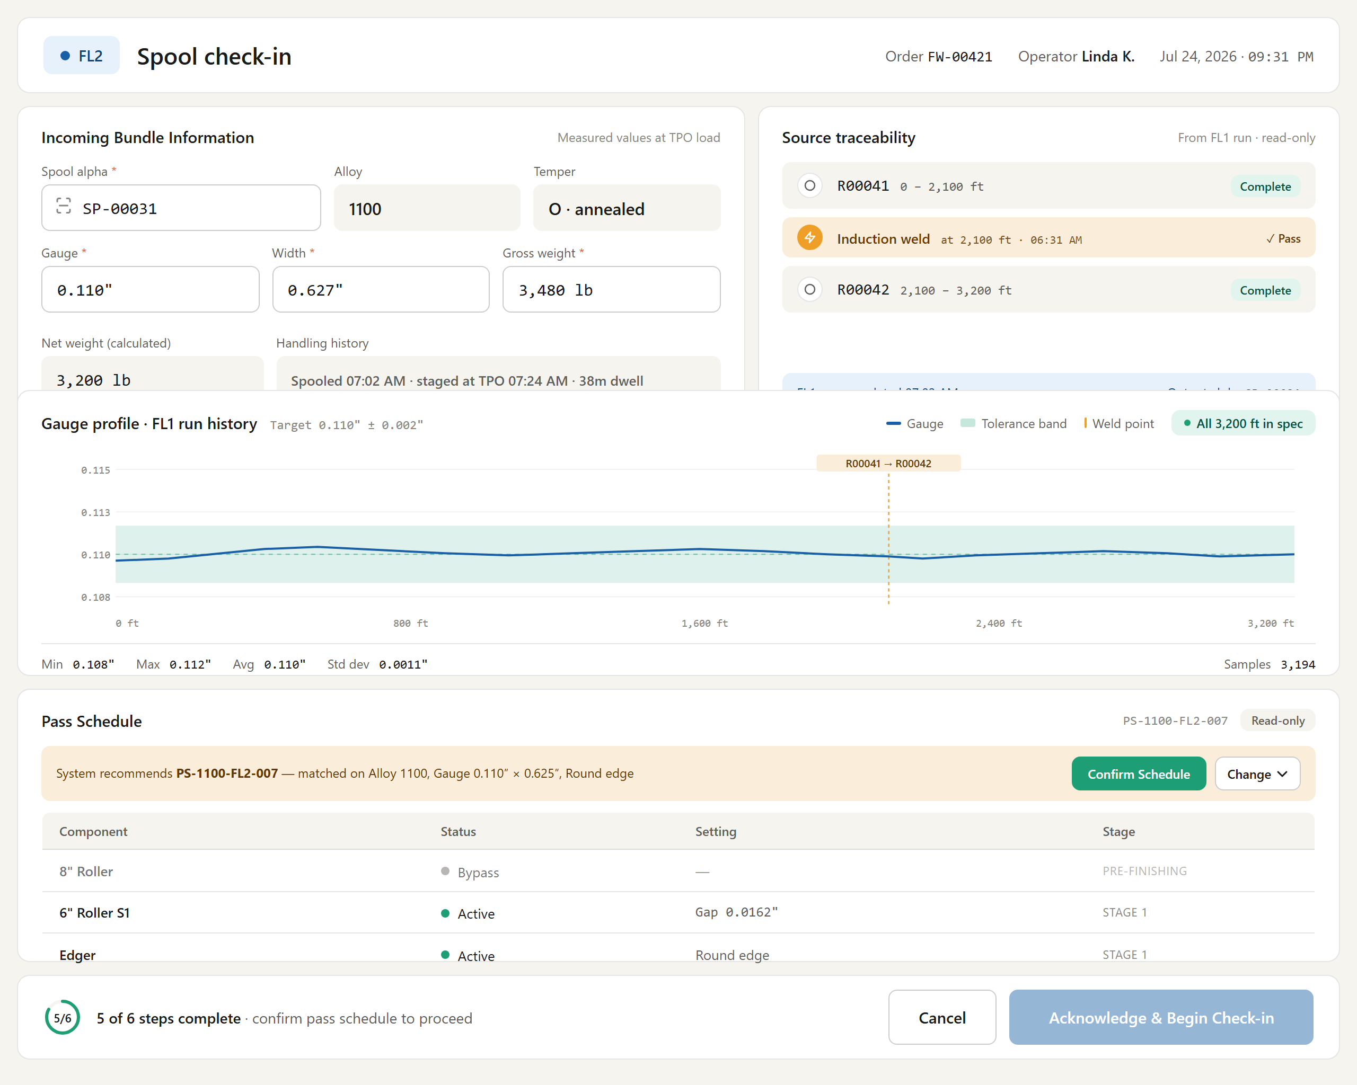
Figure # — Spool Check-In (Dashboard 5) (db05_spool_checkin.png)
*Requirements traced: PRC001–PRC029.*
Feature group — Shopfloor Dashboards.

4.19 Line Status Overview (LST) — Dashboard 1
Description. The Line Status Overview (Dashboard 1) is the persistent master board for the flat-wire floor, presenting all three lines (FL1, FL2, FL3) side by side with live PLC/SCADA readings, order and payoff context, a rolled-up floor-wide alerts panel, and drill-down navigation into the line schematic and SCADA trends. It is used by supervisors and foremen to monitor line state at a glance and act on warning and critical conditions. It matters because it is the always-visible situational anchor that lets the floor catch weld, gauge, fault, and WIP-disposition events before they stop production.
Priority: Must — it is the primary at-a-glance monitoring surface required for Phase-1 go-live floor operations.
Stimulus / Response.
Trigger | System response
Operator opens the master board | Renders all three lines with current status, readings, and active alerts
SignalR live data stream event | Refreshes line readings and alerts in real time
Supervisor selects a drill-down action | Navigates to the Line Schematic or SCADA Trends screen

Functional Requirements.
The Line Status Overview is the persistent master board for the flat wire floor. It presents all three lines side by side with live readings, a rolled-up alert panel, and drill-down navigation into the HMI schematic and SCADA trends. Primary user: Supervisor / Foreman.
- The system shall display all three flat wire lines (FL1, FL2, FL3) concurrently on a single master board. (LST001)
- The system shall present the Line Status Overview as a persistently displayed screen intended to remain always visible on the floor. (LST002)
- The system shall display, per line, a line status of Running, Idle, Setup, Offline, or Fault sourced from the PLC/system. (LST003)
- The system shall display, per active line, the current order identifier and current alpha from the scheduling system. (LST004)
- The system shall display, per line, the alloy and route from the order or item template. (LST005)
- The system shall display, per line, the live line speed in FPM from the PLC live tag. (LST006)
- The system shall display live gauge and width readings from the AGC/gauge stand for FL1 and FL3, and shall leave gauge and width blank for FL2 when idle. (LST007)
- The system shall display the Payoff 1 weight and decrement it as the rod runs off. (LST008)
- The system shall display the Payoff 2 status as Ready or Not Loaded. (LST009)
- The system shall display the run time elapsed since the check-in acknowledgment for each active line. (LST010)
- The system shall display a floor-wide alerts panel driven by the rules engine. (LST011)
- The system shall raise a Warning alert "Prepare weld — Payoff 2 must be ready" when Payoff 1 weight falls below 3,000 lb. (LST012)
- The system shall raise a Warning alert for gauge deviation when the gauge reading is outside the target plus/minus tolerance on FL1 or FL3. (LST013)
- The system shall raise a Critical alert "Component fault — line stopped" when a component PLC fault occurs. (LST014)
- The system shall raise a Warning alert "WIP rejection requires disposition" when an active WIP rejection exists on any line. (LST015)
- The system shall raise a Critical alert "No weld material available" when Payoff 2 is not loaded and Payoff 1 weight is below 2,000 lb. (LST016)
- The system shall provide a per-line "Open HMI" drill-down that navigates to the Line Schematic (Dashboard 13) for that line. (LST017)
- The system shall provide a header "SCADA Trends" action that navigates to the SCADA Multi-Trend Charts (Dashboard 14). (LST018)
- The system shall update all live line readings and alerts in real time via the SignalR data stream. (LST019)

Figure # — Line Status Overview (Dashboard 1) (db01_line_status.png)
*Requirements traced: LST001–LST019.*

4.20 Active Run Monitor + Machine View (ARM) — Dashboard 3
Description. The Active Run Monitor (Dashboard 3) is the FL1/FL3 operator's continuous live view during a production run, presenting real-time gauge and width traces against target and tolerance, machine and component status, payoff monitoring, and a role-specific quick-action bar. A Machine View tab adds a compressed live PLC line schematic alongside the Traces tab. It matters because it is the primary in-run interface for detecting out-of-spec conditions, weld and payoff events, and initiating operator actions on the flat-wire line.
Priority: Must — it is the operator's principal real-time control surface for every active run and is required for Phase-1 go-live.
Stimulus / Response.
Trigger | System response
A production run becomes active | Displays the Active Run Monitor continuously with run context and live traces
SignalR stream delivers new readings | Refreshes traces, status grid, and Machine View schematic in real time
Operator selects the Traces or Machine View tab | Switches panel content and persists the choice to localStorage

Functional Requirements.
The Active Run Monitor is the FL1/FL3 operator's continuous view during a production run. It shows real-time gauge and width traces, machine status, payoff monitoring, and a quick-action bar. A Machine View tab (May 15, 2026 enhancement) provides a compressed live PLC schematic alongside the Traces tab.
- The system shall display the Active Run Monitor continuously during an active production run. (ARM001)
- The system shall display run context in the header: order identifier, alpha, alloy, target gauge, and target width. (ARM002)
- The system shall display a real-time gauge trace against the gauge target and tolerance band. (ARM003)
- The system shall display a real-time width trace against the width target and tolerance band. (ARM004)
- The system shall render a trace line in green when the reading is within target plus/minus tolerance. (ARM005)
- The system shall render a trace line in red and display an alert banner when the reading is outside tolerance. (ARM006)
- The system shall auto-prompt a WIP checkpoint after a configurable number (N) of consecutive out-of-spec readings. (ARM007)
- The system shall display a vertical weld-point marker labelled with the rod alpha at each weld position on the trace. (ARM008)
- The system shall display machine status including line speed and footage counter. (ARM009)
- The system shall display component status for DB1 and DB2 including on/off state and active die diameter. (ARM010)
- The system shall display Payoff 1 and Payoff 2 weight indicators with percent-remaining bars. (ARM011)
- The system shall colour the payoff weight bar green above 50%, amber between 25% and 50%, red below 25% with a prepare-weld alert, and red-flashing below 10% with a weld-now critical alert. (ARM012)
- The system shall present a 6-button FL1 action bar comprising Log Weld Event, Die Change, SPC Checkpoint, Pause Run, WIP Reject, and Complete Run, with no Roll Adjust and no Edger controls. (ARM013)
- The system shall present a 7-button FL3 action bar comprising Log Weld Event, Die Change, Roll Adjust, SPC Checkpoint, Pause Run, WIP Reject, and Complete Run. (ARM014)
- The system shall enable the Check Out Rod action only when the footage counter equals zero. (ARM015)
- The system shall provide a "View Trends" action that navigates to the SCADA Multi-Trend Charts (Dashboard 14) with the active line pre-selected. (ARM016)
- The system shall provide a tab strip offering a Traces tab and a Machine View tab in place of the two trace panels. (ARM017)
- The system shall default to the Traces tab. (ARM018)
- The system shall persist the operator's last-used tab in browser localStorage and restore it on page load. (ARM019)
- The system shall keep the machine status grid visible below the tabs regardless of the active tab. (ARM020)
- The system shall keep the action buttons visible at the bottom regardless of the active tab. (ARM021)
- The system shall render the Machine View tab as a compressed line schematic scaled to the 440px trace area, showing each component's status and primary value only. (ARM022)
- The system shall update the Machine View schematic from the same SignalR stream as the Traces tab. (ARM023)
- The system shall provide an "Open full screen" link in the Machine View tab that opens the Line Schematic (Dashboard 13) for the active line. (ARM024)

Figure # — Active Run Monitor (Dashboard 3) (db03_active_run.png)
*Requirements traced: ARM001–ARM024.*
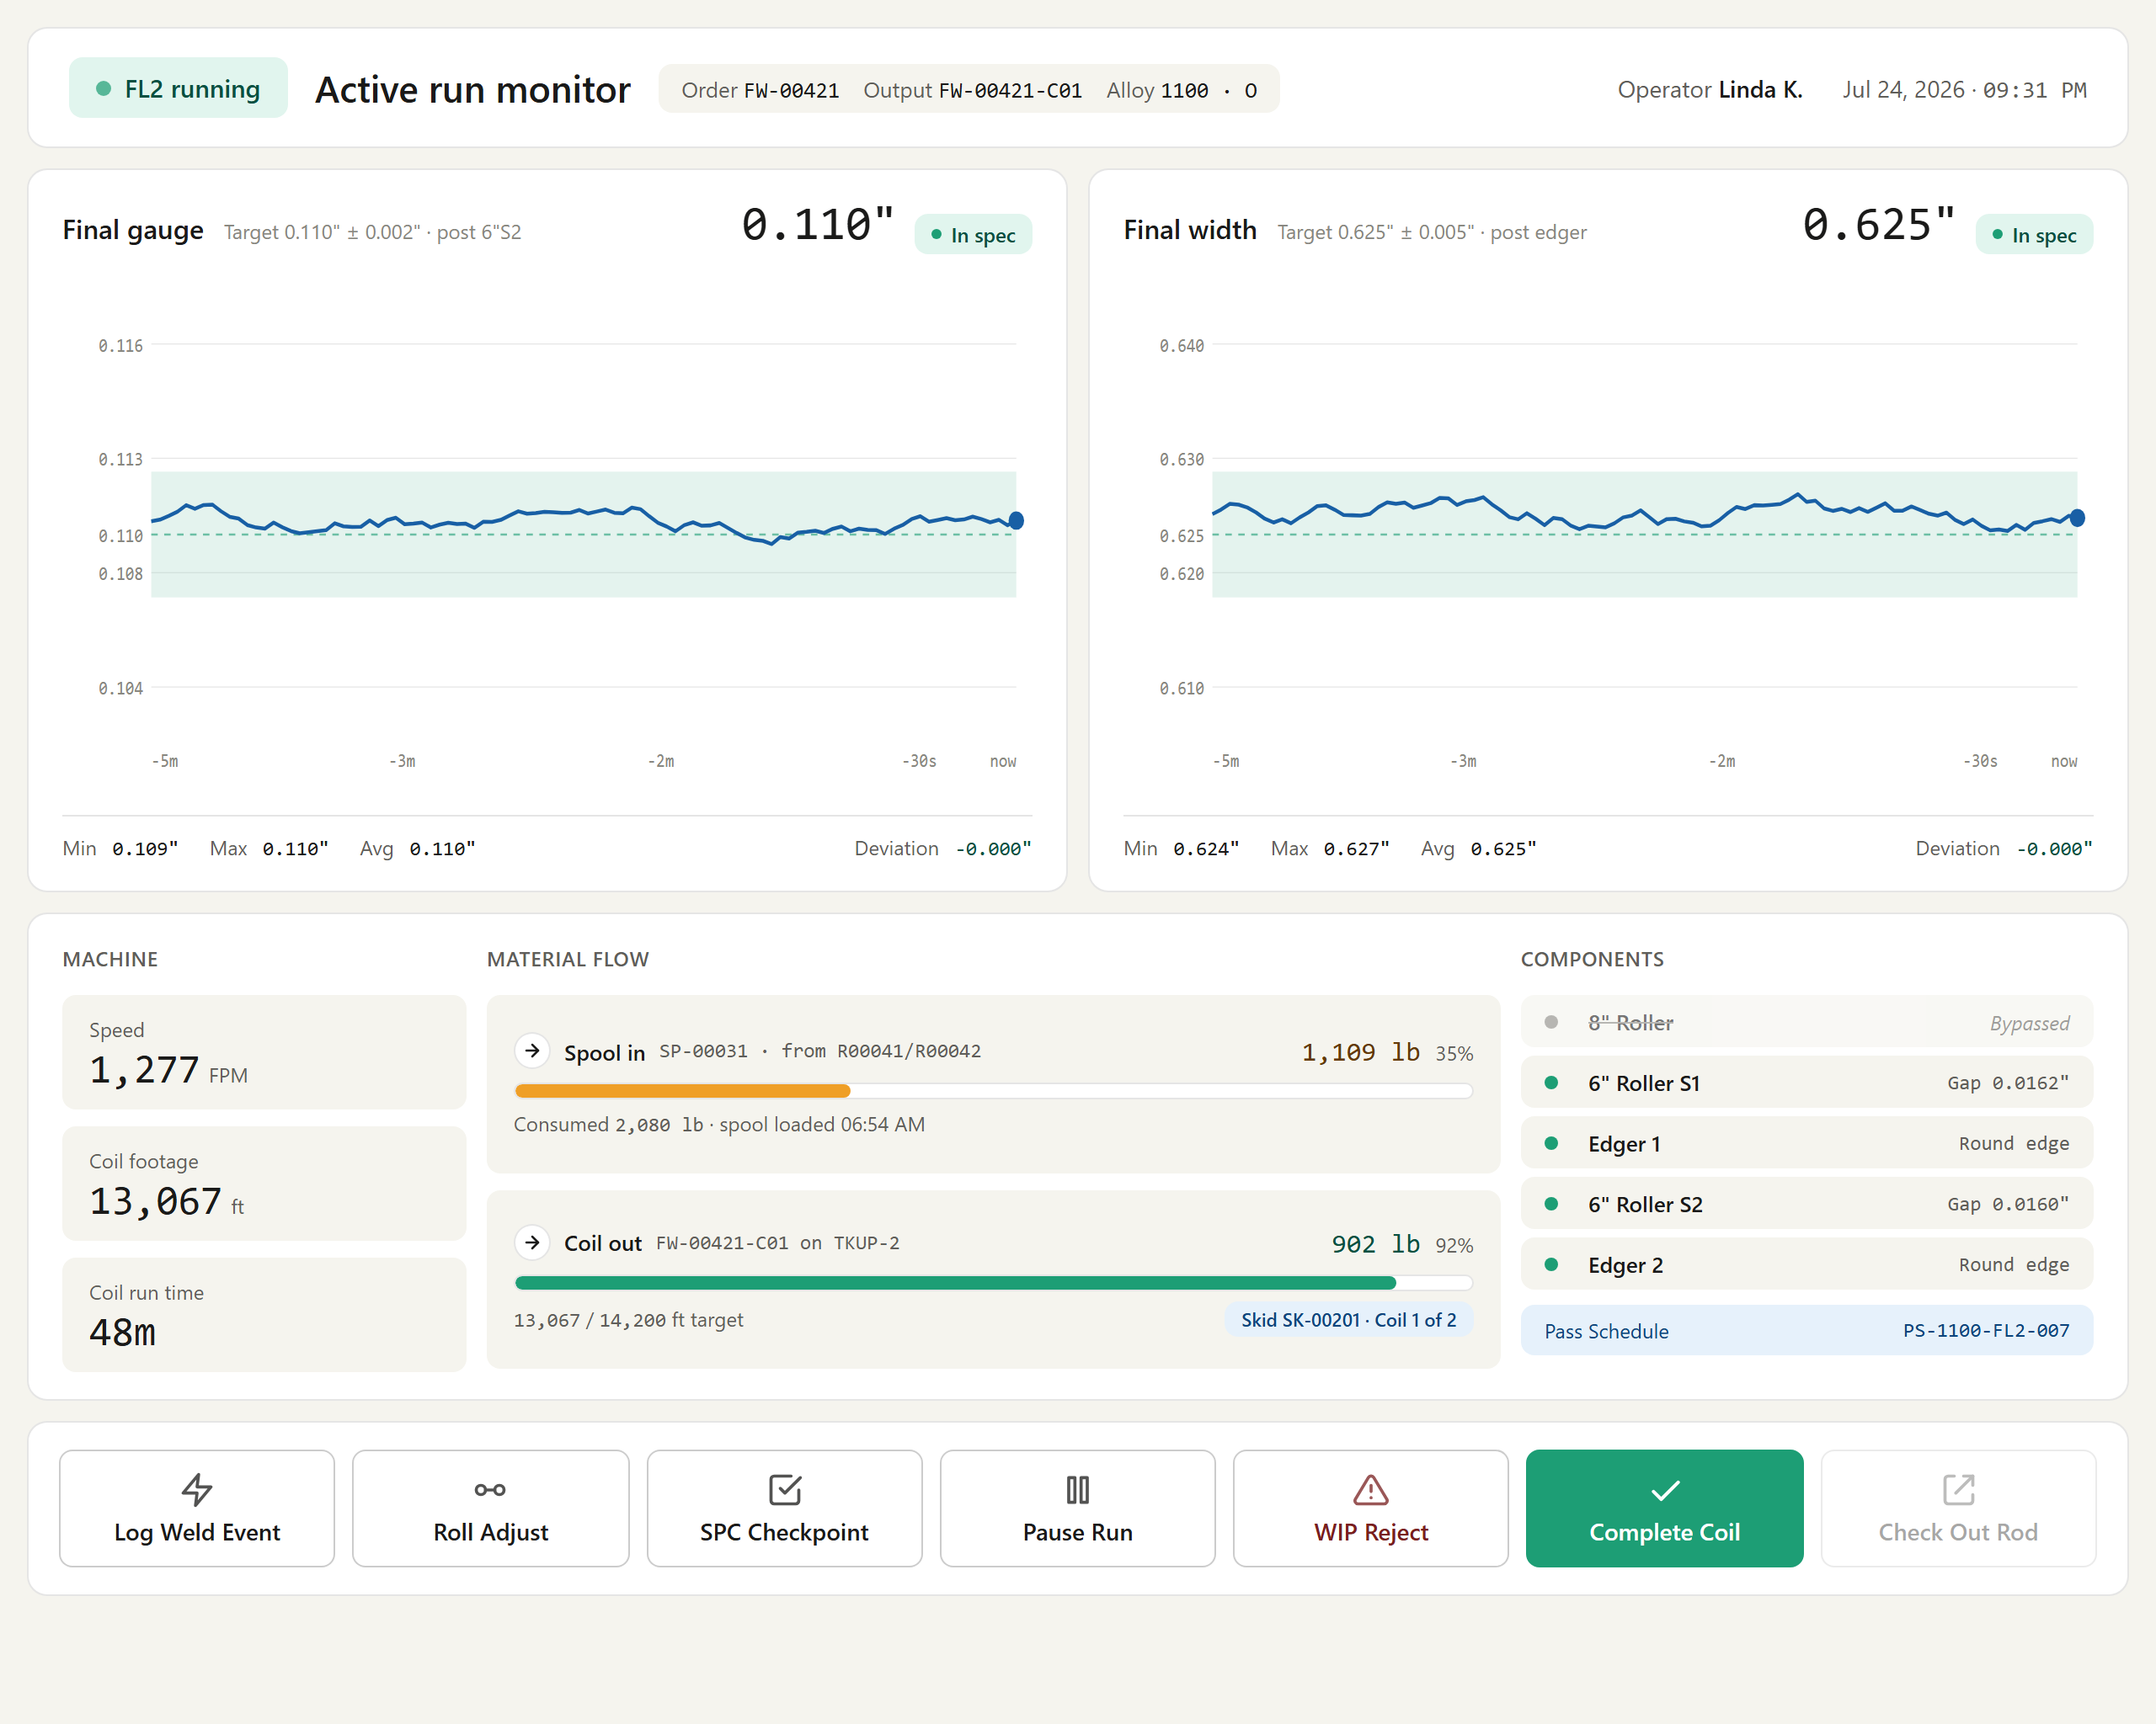
Figure # — Active Run Monitor — FL2 (db03_active_run_fl2.png)
*Requirements traced: ARM001–ARM024.*
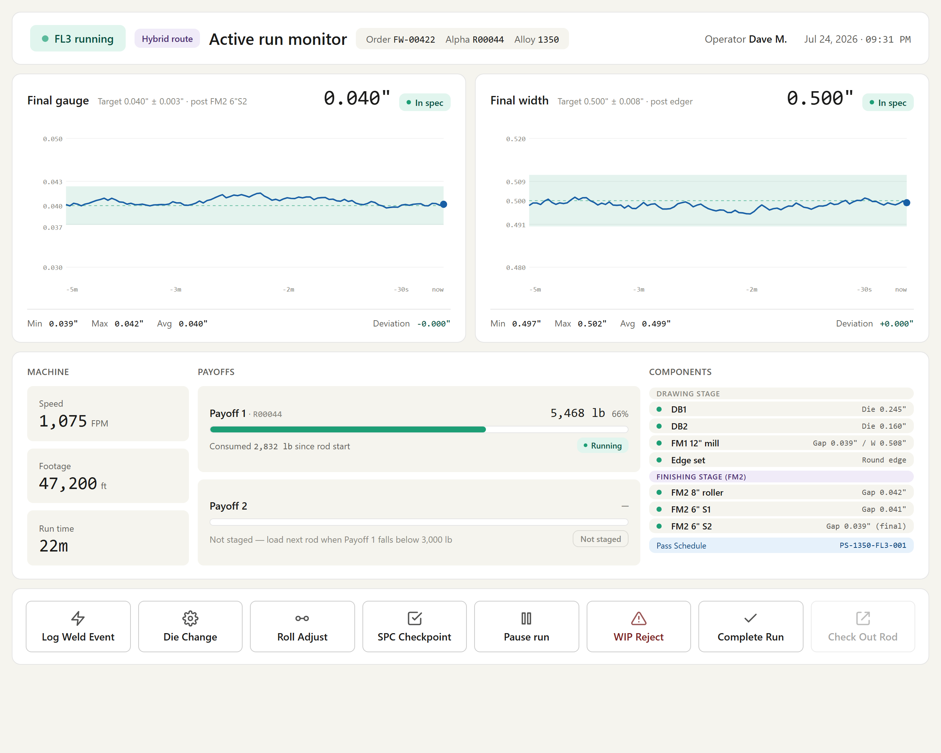
Figure # — Active Run Monitor — FL3 Hybrid (db03_active_run_fl3.png)
*Requirements traced: ARM001–ARM024.*

4.21 Pass Schedule List (PSL) — Dashboard 9A
Description. The Pass Schedule List ("All Schedules", Dashboard 9A) is the index and search view for the entire pass schedule library on the flat-wire line. Operations Managers and Maintenance use it to browse, filter, sort, and open schedules, and to launch creation flows (Enter Manually or Generate from Specs), while all operators may view. It is the primary entry point that governs which schedules drive production, making correct routing and status visibility essential to line throughput.
Priority: Must — schedules cannot be located, activated, or created at go-live without this index, blocking downstream Dashboard 9 operations.
Stimulus / Response.
Trigger / operator action | System response
Operator opens Dashboard 9A | Lists all schedule records with a stats strip of total, Active, Draft, and Inactive counts
User types in search or sets Alloy/Line/Status filters | Applies all criteria simultaneously, highlights active filters amber, and updates counts
User clicks a column header | Sorts ascending, reverses on second click, and marks the active column with a stable sort
User clicks a row or ↗ Open | Opens the schedule in Dashboard 9
Manager clicks "+ New Schedule" | Opens a popup offering Enter Manually or Generate from Specs, then navigates to Dashboard 9 in Draft
No rows match active filters | Shows a centred empty-state while keeping the stats strip at zero counts

Functional Requirements.
The Pass Schedule List ("All Schedules") is the index and search view for the full pass schedule library. It is the entry point for browsing, selecting, and activating schedules and for launching creation flows. Primary users: Operations Manager / Maintenance. (Detailed schedule editing and Generate-from-Specs behaviour is specified in the Pass Schedule functional section.)
- The system shall present an index view listing all pass schedule records. (PSL001)
- The system shall provide a live search that filters rows by matching Schedule ID, Description, and Alloy as the user types, and clears on the × control. (PSL002)
- The system shall provide an Alloy filter dropdown (All / 1100 / 1350 / 3003 / 5052 / 6061). (PSL003)
- The system shall provide a Line filter dropdown (All / FL1 / FL2 / FL3). (PSL004)
- The system shall provide a Status filter dropdown (All / Active / Draft / Inactive). (PSL005)
- The system shall apply the search and all three dropdown filters simultaneously so that displayed rows match all active criteria. (PSL006)
- The system shall display any active (non-"All") filter control with an amber background to signal the list is restricted. (PSL007)
- The system shall display a stats strip showing total, Active, Draft, and Inactive counts, updated dynamically as filters change. (PSL008)
- The system shall display columns for Schedule ID, Description, Alloy, Line, Route, Status, Last Modified, and an Open action. (PSL009)
- The system shall show an "In use: FW-XXXXX" chip in subdued text below the Description when a schedule is linked to an active job. (PSL010)
- The system shall render the FL3 line tag in purple to indicate the Hybrid route. (PSL011)
- The system shall render status badges as Active (green), Draft (purple), and Inactive (grey). (PSL012)
- The system shall support column sorting with a first click sorting ascending, a second click reversing direction, and an arrow indicator marking the active sort column. (PSL013)
- The system shall stable-sort results so that changing a secondary sort criterion does not alter the relative order of equal-value rows. (PSL014)
- The system shall open Dashboard 9 for a schedule when its row or its ↗ Open button is clicked. (PSL015)
- The system shall provide a "+ New Schedule" control that opens a choice popup offering Enter Manually or Generate from Specs. (PSL016)
- The system shall navigate to Dashboard 9 with a blank new schedule (status Draft) when Enter Manually is chosen. (PSL017)
- The system shall provide a "⚡ Generate from Specs" toolbar shortcut that opens the Generate from Specs modal and, on Apply, navigates to Dashboard 9 pre-populated with generated values in Draft status. (PSL018)
- The system shall display a centred empty-state message when no schedules match the active filters, while keeping the stats strip visible showing zero counts. (PSL019)
- The system shall restrict pass schedule creation, generation, and activation actions to the Operations Manager / Maintenance roles while allowing all operators to view schedules. (PSL020)

Figure # — Pass Schedule List (Dashboard 9A) (db09a_schedule_list.png)
*Requirements traced: PSL001–PSL020.*

4.22 Shift Summary (SHS) — Dashboard 10
Description. The Shift Summary (Dashboard 10) consolidates per-machine throughput, quality, weld, downtime, and material status for the flat-wire floor into a single supervisory view, organised as per-machine tabs (FL1, FL2, FL3) plus an All Lines summary. It is the primary screen for the Supervisor / Shift Manager, who uses it to assess line performance, spot exceptions, and hand off between shifts. By surfacing utilisation, SPC pass rates, and downtime reason breakdowns in one place, it drives timely corrective action on the flat-wire line.
Priority: Should — high operational value for shift oversight, but production can continue at go-live without it.
Stimulus / Response.
Trigger | System response
Supervisor opens Dashboard 10 | Loads the summary for the default machine tab, scoped to the current shift window.
Supervisor selects a machine tab (FL1 / FL2 / FL3 / All Lines) | Refreshes KPI tiles, timelines, and metrics for the selected scope.

Functional Requirements.
The Supervisor Shift Summary provides per-machine throughput, quality, weld, downtime, and material status for the flat wire floor. Per the May 21, 2026 revision, the screen is split into per-machine pages (FL1, FL2, FL3) with an All Lines summary; the KPI strip reflects the selected machine. Primary user: Supervisor / Shift Manager.
- The system shall provide a machine tab selector (FL1 / FL2 / FL3 / All Lines) that controls which machine's data is shown. (SHS001)
- The system shall update the KPI tiles (footage, weight out, coils, downtime) to reflect the selected machine. (SHS002)
- The system shall show the selected machine's utilisation timeline for a single machine tab and all three timelines stacked for the All Lines tab. (SHS003)
- The system shall display per-machine footage sourced from that line's footage counter filtered to the shift window. (SHS004)
- The system shall display per-machine weight out as the sum of net weights of coils completed on that line during the shift. (SHS005)
- The system shall display the count of output coils completed on the selected line during the shift. (SHS006)
- The system shall display quality metrics including SPC pass rate, WIP rejection count, and suspended-coil count for the shift window. (SHS007)
- The system shall display weld events per line from the weld event log filtered to the shift. (SHS008)
- The system shall display material status including rod in storage, spools on floor, coils in packing, and WIP held items. (SHS009)
- The system shall calculate line utilisation as run timer time versus available shift hours per line. (SHS010)
- The system shall roll up pause downtime as total pause minutes per line per shift and provide a downtime reason breakdown grouped by pause category (Equipment, Material, Quality, Operational, Safety). (SHS011)
- The system shall flag as an exception any run that resumed without a completed SPC checkpoint following a Gauge drift or Size change die change. (SHS012)
- The system shall provide Export Shift Report and Print actions. (SHS013)
- The system shall provide a View WIP Rejections action. (SHS014)
- The system shall restrict the Shift Summary to the Supervisor / Shift Manager role as its primary screen. (SHS015)
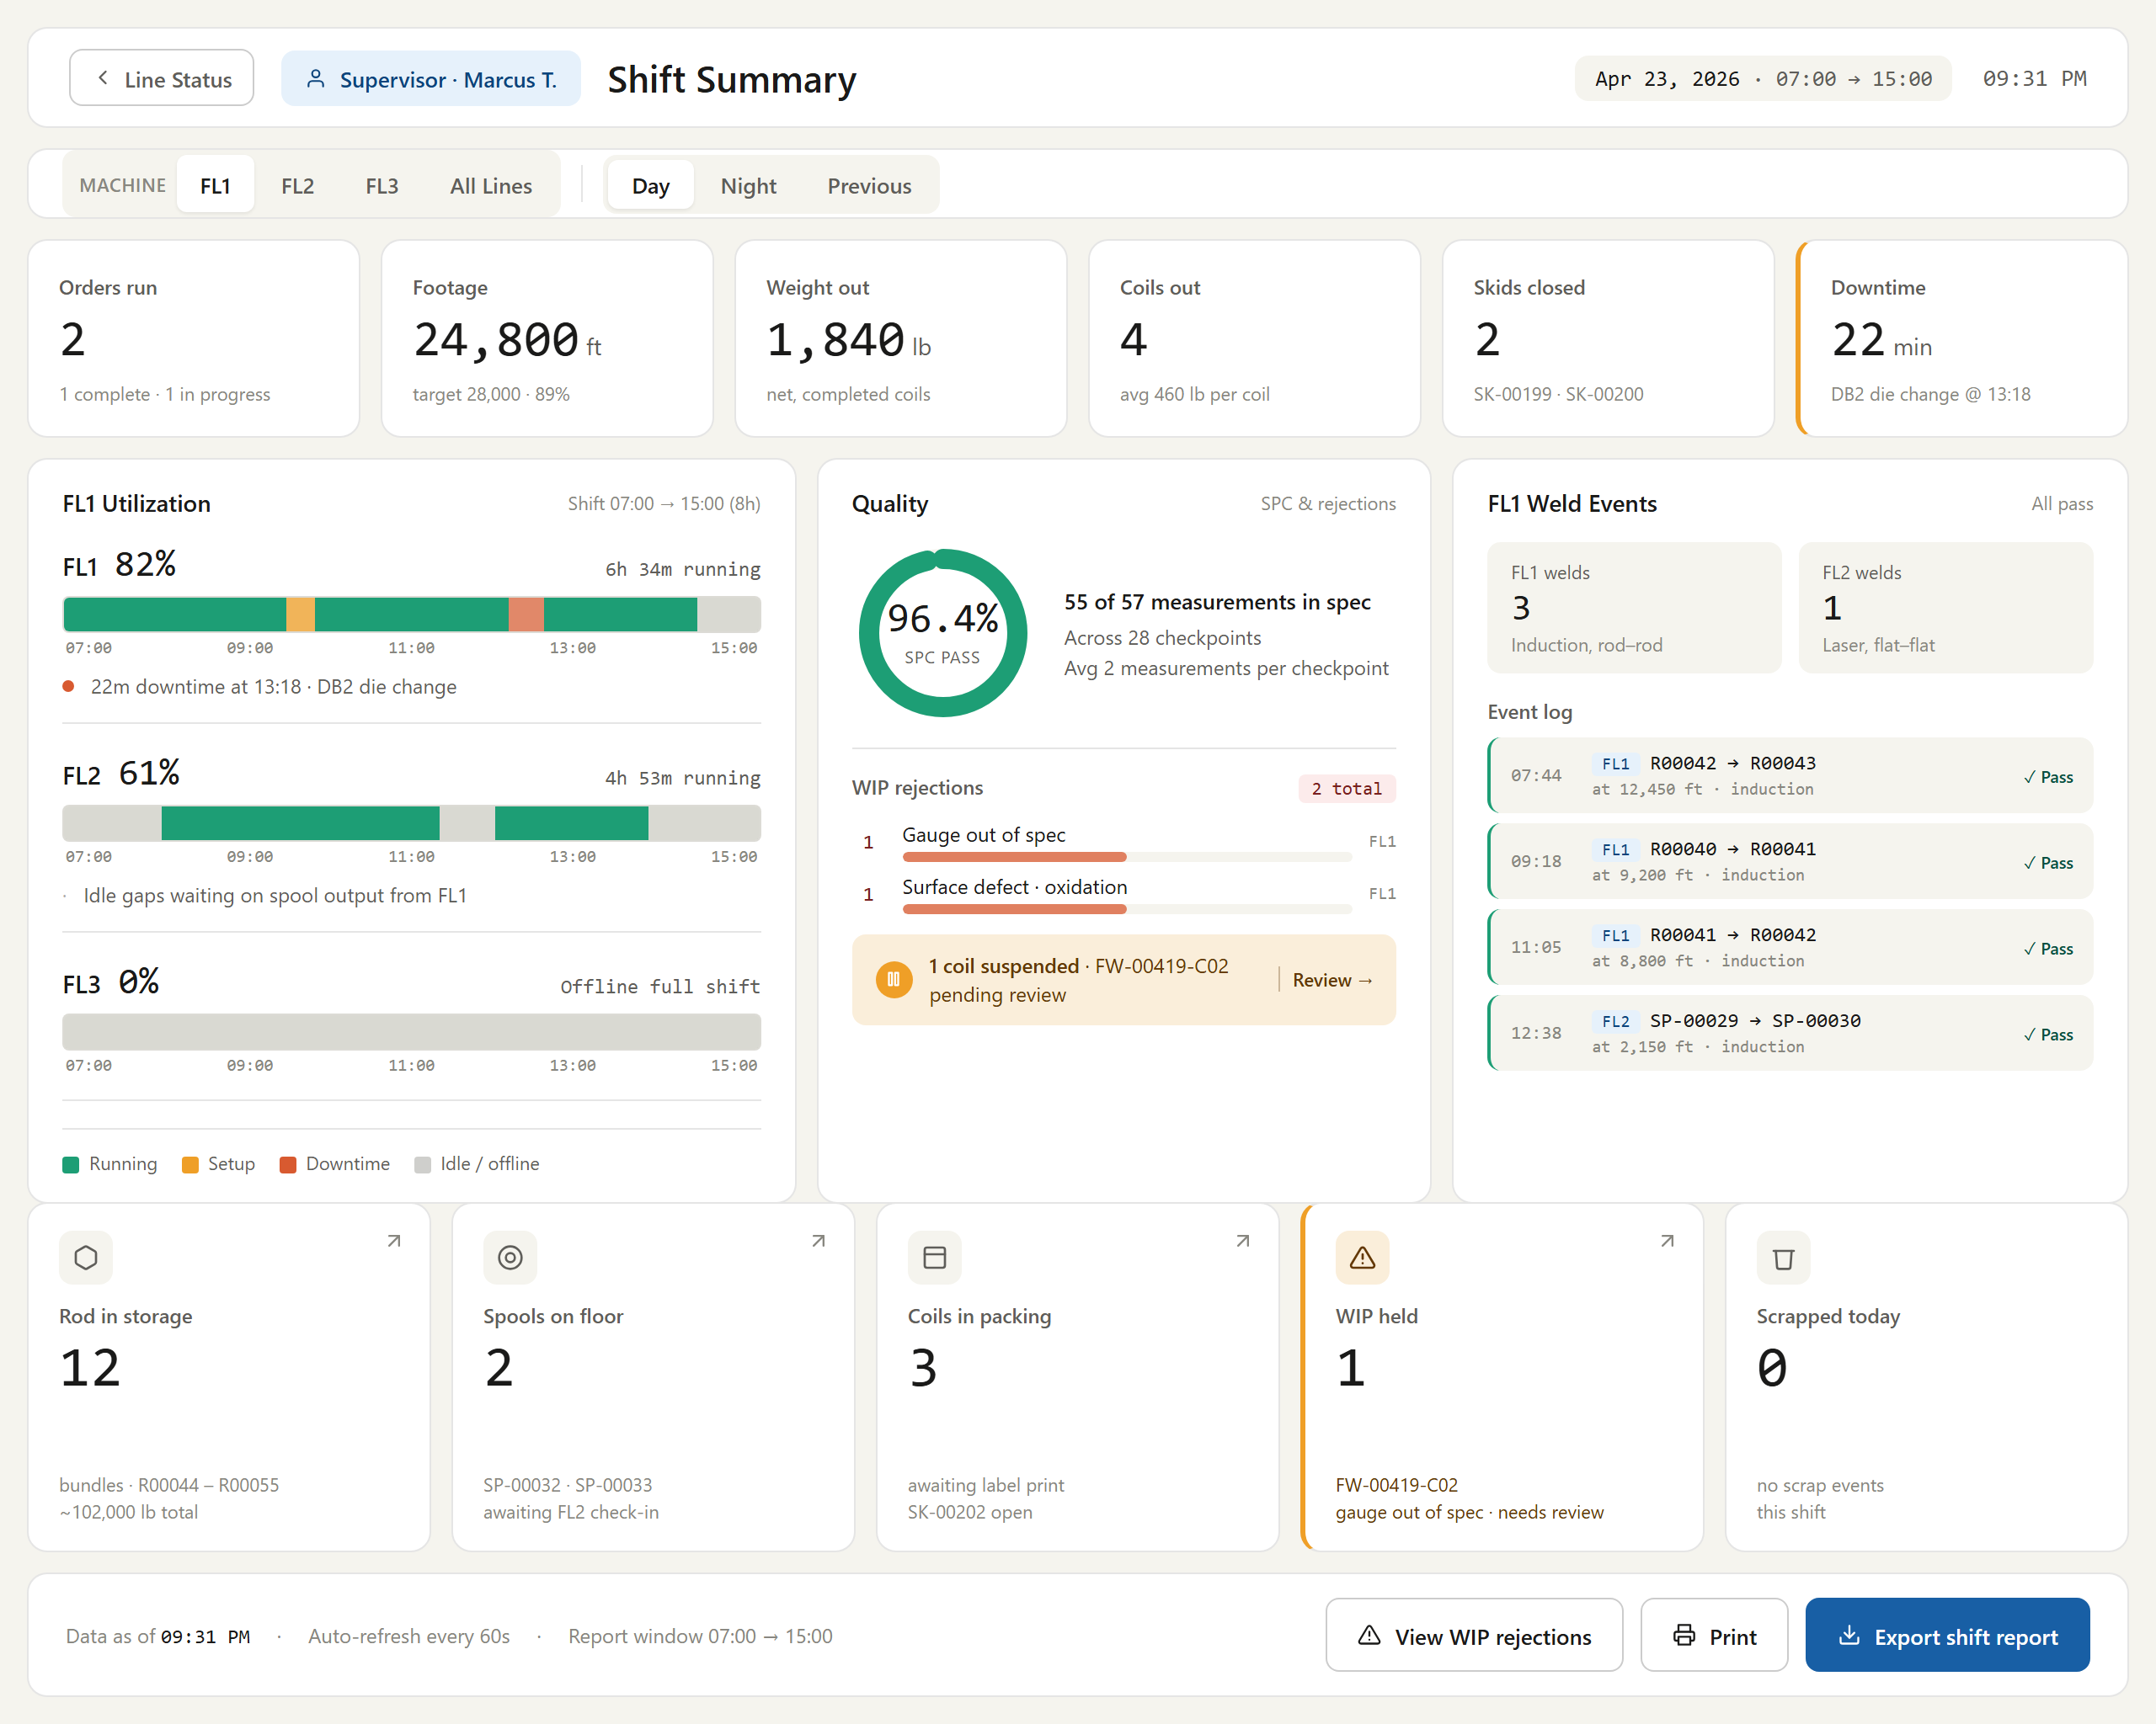
Figure # — Shift Summary (Dashboard 10) (db10_shift_summary.png)
*Requirements traced: SHS001–SHS015.*

4.23 Roll Adjust (RAJ) — Dashboard 11
Description. Roll Adjust (Dashboard 11) lets flat-wire operators log and apply a mid-run roll-gap override to one or more rollers without altering the underlying pass schedule. The change is captured as a run-level record tied to the coil footage position, pushed to the PLC immediately, and backed by a measurement trigger and reason code. It matters because it lets operators correct gauge, width, and roll-wear drift in real time while preserving the master schedule and a full SPC and audit trail.
Priority: Must — mid-run gap correction is essential to holding output tolerances during Phase-1 production and drives live PLC changes.
Stimulus / Response.
Trigger / operator action | System response
Operator opens Roll Adjust for the active run | Displays context strip, adjustment table (edgers/bypassed rollers excluded), and change history
Operator enters measured gauge and width | Records values against footage; shows in-spec/out-of-spec status and deviation
Operator edits a New gap value | Recalculates and colour-codes Delta per keystroke; highlights changed row in amber
Operator selects a reason code | Enables the Apply button
Operator clicks Apply (non-zero deltas) | Writes run-level override, logs each roll change, updates PLC tag and Active Run Monitor, records SPC checkpoint
Operator clicks Apply (all deltas zero) | Labels button "No changes — return to run" and writes no record

Functional Requirements.
The Roll Adjust screen logs and applies a mid-run roll-gap override for one or more rollers without modifying the underlying pass schedule. The override is a run-level record linked to the coil footage position.
- The system shall apply roll-gap changes as a run-level override that never modifies the underlying pass schedule record. (RAJ001)
- The system shall display a context strip with spool/alpha, pass schedule ID, footage at adjustment, output targets with tolerances, and an override-type indicator of "Run-level". (RAJ002)
- The system shall display a roll gap adjustment table with columns for Component, Scheduled gap, Current gap, New gap, and Delta. (RAJ003)
- The system shall allow editing only the New gap column and render Component, Scheduled, Current, and Delta as read-only. (RAJ004)
- The system shall render bypassed rollers as greyed out and read-only with no input. (RAJ005)
- The system shall exclude edgers (edge shape, no gap setting) from the roll gap adjustment table. (RAJ006)
- The system shall auto-calculate Delta as New minus Current on every keystroke and colour-code it (green tightening, red opening, grey no change). (RAJ007)
- The system shall highlight rows with a non-zero delta in amber. (RAJ008)
- The system shall display a measurement trigger panel showing the measured value, target, tolerance, an in-spec/out-of-spec status badge, deviation, and a range bar. (RAJ009)
- The system shall require a reason code chip selection (Gauge drift high, Gauge drift low, Width drift, SPC flag, Roll wear, Post-weld correction, or Operator discretion) before enabling the Apply button. (RAJ010)
- The system shall provide an optional free-text notes field. (RAJ011)
- The system shall display a change history of the last 3 roll adjustments against the active pass schedule with time, operator, roll, change, and reason. (RAJ012)
- The system shall require the measured gauge and measured width to be entered and record them against the footage counter value. (RAJ013)
- The system shall auto-populate operator, timestamp, and footage, and prevent operator edits to them. (RAJ014)
- The system shall, on Apply, write an override record against the active run, spool alpha, and footage position rather than the pass schedule. (RAJ015)
- The system shall log each changed roll gap individually with component name, old value, new value, delta, reason, operator, timestamp, and footage. (RAJ016)
- The system shall update the PLC tag for the adjusted roll gap to the new value immediately on Apply. (RAJ017)
- The system shall reflect the updated current gap in the Active Run Monitor component status panel after Apply. (RAJ018)
- The system shall make the override visible in the pass schedule Overrides history tab. (RAJ019)
- The system shall write the entered measurements to the SPC checkpoint log with type "Roll adjust trigger" so no separate SPC checkpoint entry is required for the same footage position. (RAJ020)
- The system shall, when all deltas are zero, label the Apply button "No changes — return to run" and write no record. (RAJ021)
- The system shall allow FL operators to apply a roll gap override and restrict reverting an override to the Operations Manager role. (RAJ022)
> [OPEN ITEM: Roll Adjust line applicability is inconsistent across sources. The DB11 screen header and access-control table state "FL1 / FL2 Operator" and the wireframe shows FL2, whereas the DB3 quick-action table states Roll Adjust is "FL3 only" and DieChangeAndManagement.md states FL2 (roller-based, no dies) and FL3 (hybrid, FM2 stands) are the lines with roller gaps. FL1 (drawing + FM1 only) is unlikely to expose Roll Adjust. Line eligibility must be confirmed.]
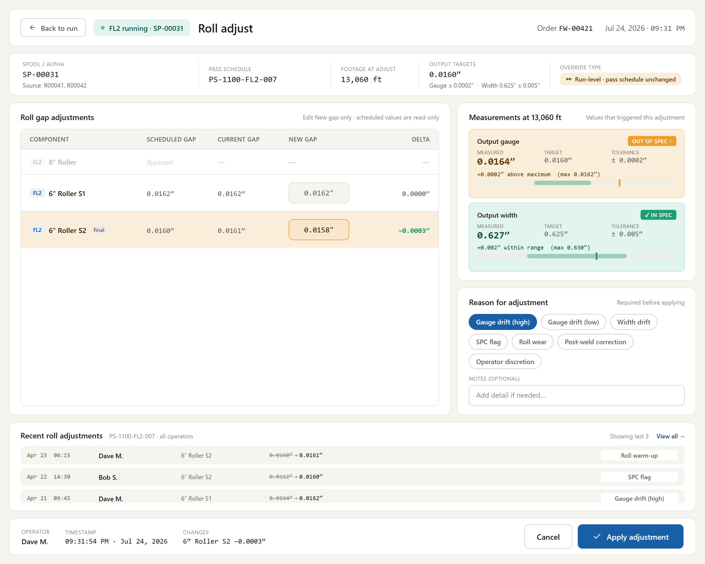
Figure # — Roll Adjust (Dashboard 11) (db11_roll_adjust.png)
*Requirements traced: RAJ001–RAJ022.*

4.24 Die Change (DCH)
Description. The Die Change feature is a mid-run event logger that records drawing-die replacements on lines FL1 and FL3 (FL2 has no drawing dies). Line operators use it to capture the die block changed, outgoing and incoming die identities, the reason for the change, and any resulting quality-hold or SPC actions. It ties each event to the output coil's traceability record at the current footage, making it essential for die-life tracking, quality accountability, and process control on the flat-wire line.
Priority: Must — die changes are routine mid-run events on FL1/FL3, and without traceable capture Phase-1 go-live loses die-life tracking, quality holds, and SPC enforcement.
Stimulus / Response.
Trigger / operator action | System response
Operator opens Die Change mid-run | Pauses the run, shows paused context chip, defaults die block to DB2 and reason to Planned life
Operator selects die block | Updates outgoing die panel and confirm label; auto-fills read-only outgoing fields with coloured life bar
Operator scans incoming die alpha | Looks up and populates incoming die fields, or rejects an unregistered die
Operator selects a reason code | Reveals Quality Hold (Die failure) or SPC checkpoint notice (Gauge drift / Size change)
Operator confirms the change | Writes the immutable event record and routes to Dashboard 3 or SPC Checkpoint, keeping the run paused until SPC passes
Operator cancels | Discards inputs, writes no record, and unpauses the run

Functional Requirements.
The Die Change screen is a mid-run event logger for drawing-die replacement on FL1 and FL3. It captures the die block changed, outgoing/incoming die identities, reason code, and any quality-hold or SPC actions, and ties the event to the output coil's traceability record at the current footage. FL2 has no drawing dies and never needs a die change.
- The system shall provide the Die Change event logger for FL1 and FL3 and shall not provide it for FL2. (DCH001)
- The system shall show the run as paused in the context chip while the Die Change screen is open and require the operator to complete or cancel before resuming production. (DCH002)
- The system shall provide a mutually exclusive die block selector offering DB1, DB2, and Both. (DCH003)
- The system shall pre-select DB2 by default. (DCH004)
- The system shall update the outgoing die panel and the confirm button label when a die block is selected. (DCH005)
- The system shall, when Both is selected, display both outgoing die alphas, clear the incoming die input, and require the operator to scan or enter each new die separately. (DCH006)
- The system shall auto-fill the outgoing die panel as read-only with die alpha, life bar, die size, footage on die, scheduled life, remaining footage, die type, and installed time. (DCH007)
- The system shall colour the outgoing die life bar green below 60%, amber 60–85%, and red above 85%. (DCH008)
- The system shall provide a scan/enter alpha input for the incoming die, pre-focused for a barcode scanner. (DCH009)
- The system shall, on scanning an incoming die alpha, perform a lookup to populate the incoming die fields. (DCH010)
- The system shall provide a New/Reconditioned toggle for the incoming die, defaulting to New. (DCH011)
- The system shall display incoming die fields for size, condition, source, inspection timestamp, die type, and scheduled life. (DCH012)
- The system shall require the incoming die size to match the outgoing die size unless the reason code is Size change. (DCH013)
- The system shall provide five mutually exclusive reason codes: Planned life (default), Gauge drift, Die failure, Size change, and Other. (DCH014)
- The system shall display a red Quality Hold section when the reason is Die failure. (DCH015)
- The system shall provide an editable Hold-from footage (defaulted to the footage the rod started on the die) and a read-only Hold-to footage set to the current footage counter. (DCH016)
- The system shall create a quality hold record against the specified footage range on the output coil when the "Flag WIP for QA hold" toggle is set. (DCH017)
- The system shall display a blue SPC checkpoint notice when the reason is Gauge drift or Size change. (DCH018)
- The system shall provide a "Require SPC on resume" toggle pre-checked ON. (DCH019)
- The system shall, for reason Gauge drift or Size change, route the Confirm action to the SPC Checkpoint screen rather than Dashboard 3, keep the run paused, permit thread mode during SPC measurement, and block return to full production until the SPC checkpoint passes. (DCH020)
- The system shall, for reason Planned life or Die failure, route the Confirm action to Dashboard 3 and resume the run. (DCH021)
- The system shall, on an SPC checkpoint pass, navigate to Dashboard 3 and resume the run, and on an SPC checkpoint fail, present operator disposition options (hold, re-adjust, or re-run SPC). (DCH022)
- The system shall display a read-only audit stamp of operator, server-side timestamp, footage at change, and output coil alpha. (DCH023)
- The system shall, on Cancel, discard all inputs, write no record, and unpause the run. (DCH024)
- The system shall treat a confirmed die change event as immutable, with corrections handled through a separate audit flow. (DCH025)
- The system shall, on Confirm, write the die change event record including die block, outgoing/incoming die alphas and sizes, incoming condition, reason code, footage at change, output alpha, operator, timestamp, quality hold, and SPC-checkpoint-required flag. (DCH026)
- The system shall reject a scanned incoming die that does not exist in the die management inventory and prompt Maintenance to register the die first. (DCH027)
- The system shall write every "Require SPC on resume" toggle-off event to the audit log (user, role, timestamp, die change event ID, reason code) and surface any such run as a flagged exception on the Shift Summary and OEE/Quality dashboards. (DCH028)
> [OPEN ITEM: Override authority for turning OFF "Require SPC on resume" (Q56) is unresolved; Operations Manager minimum is the standing recommendation.]
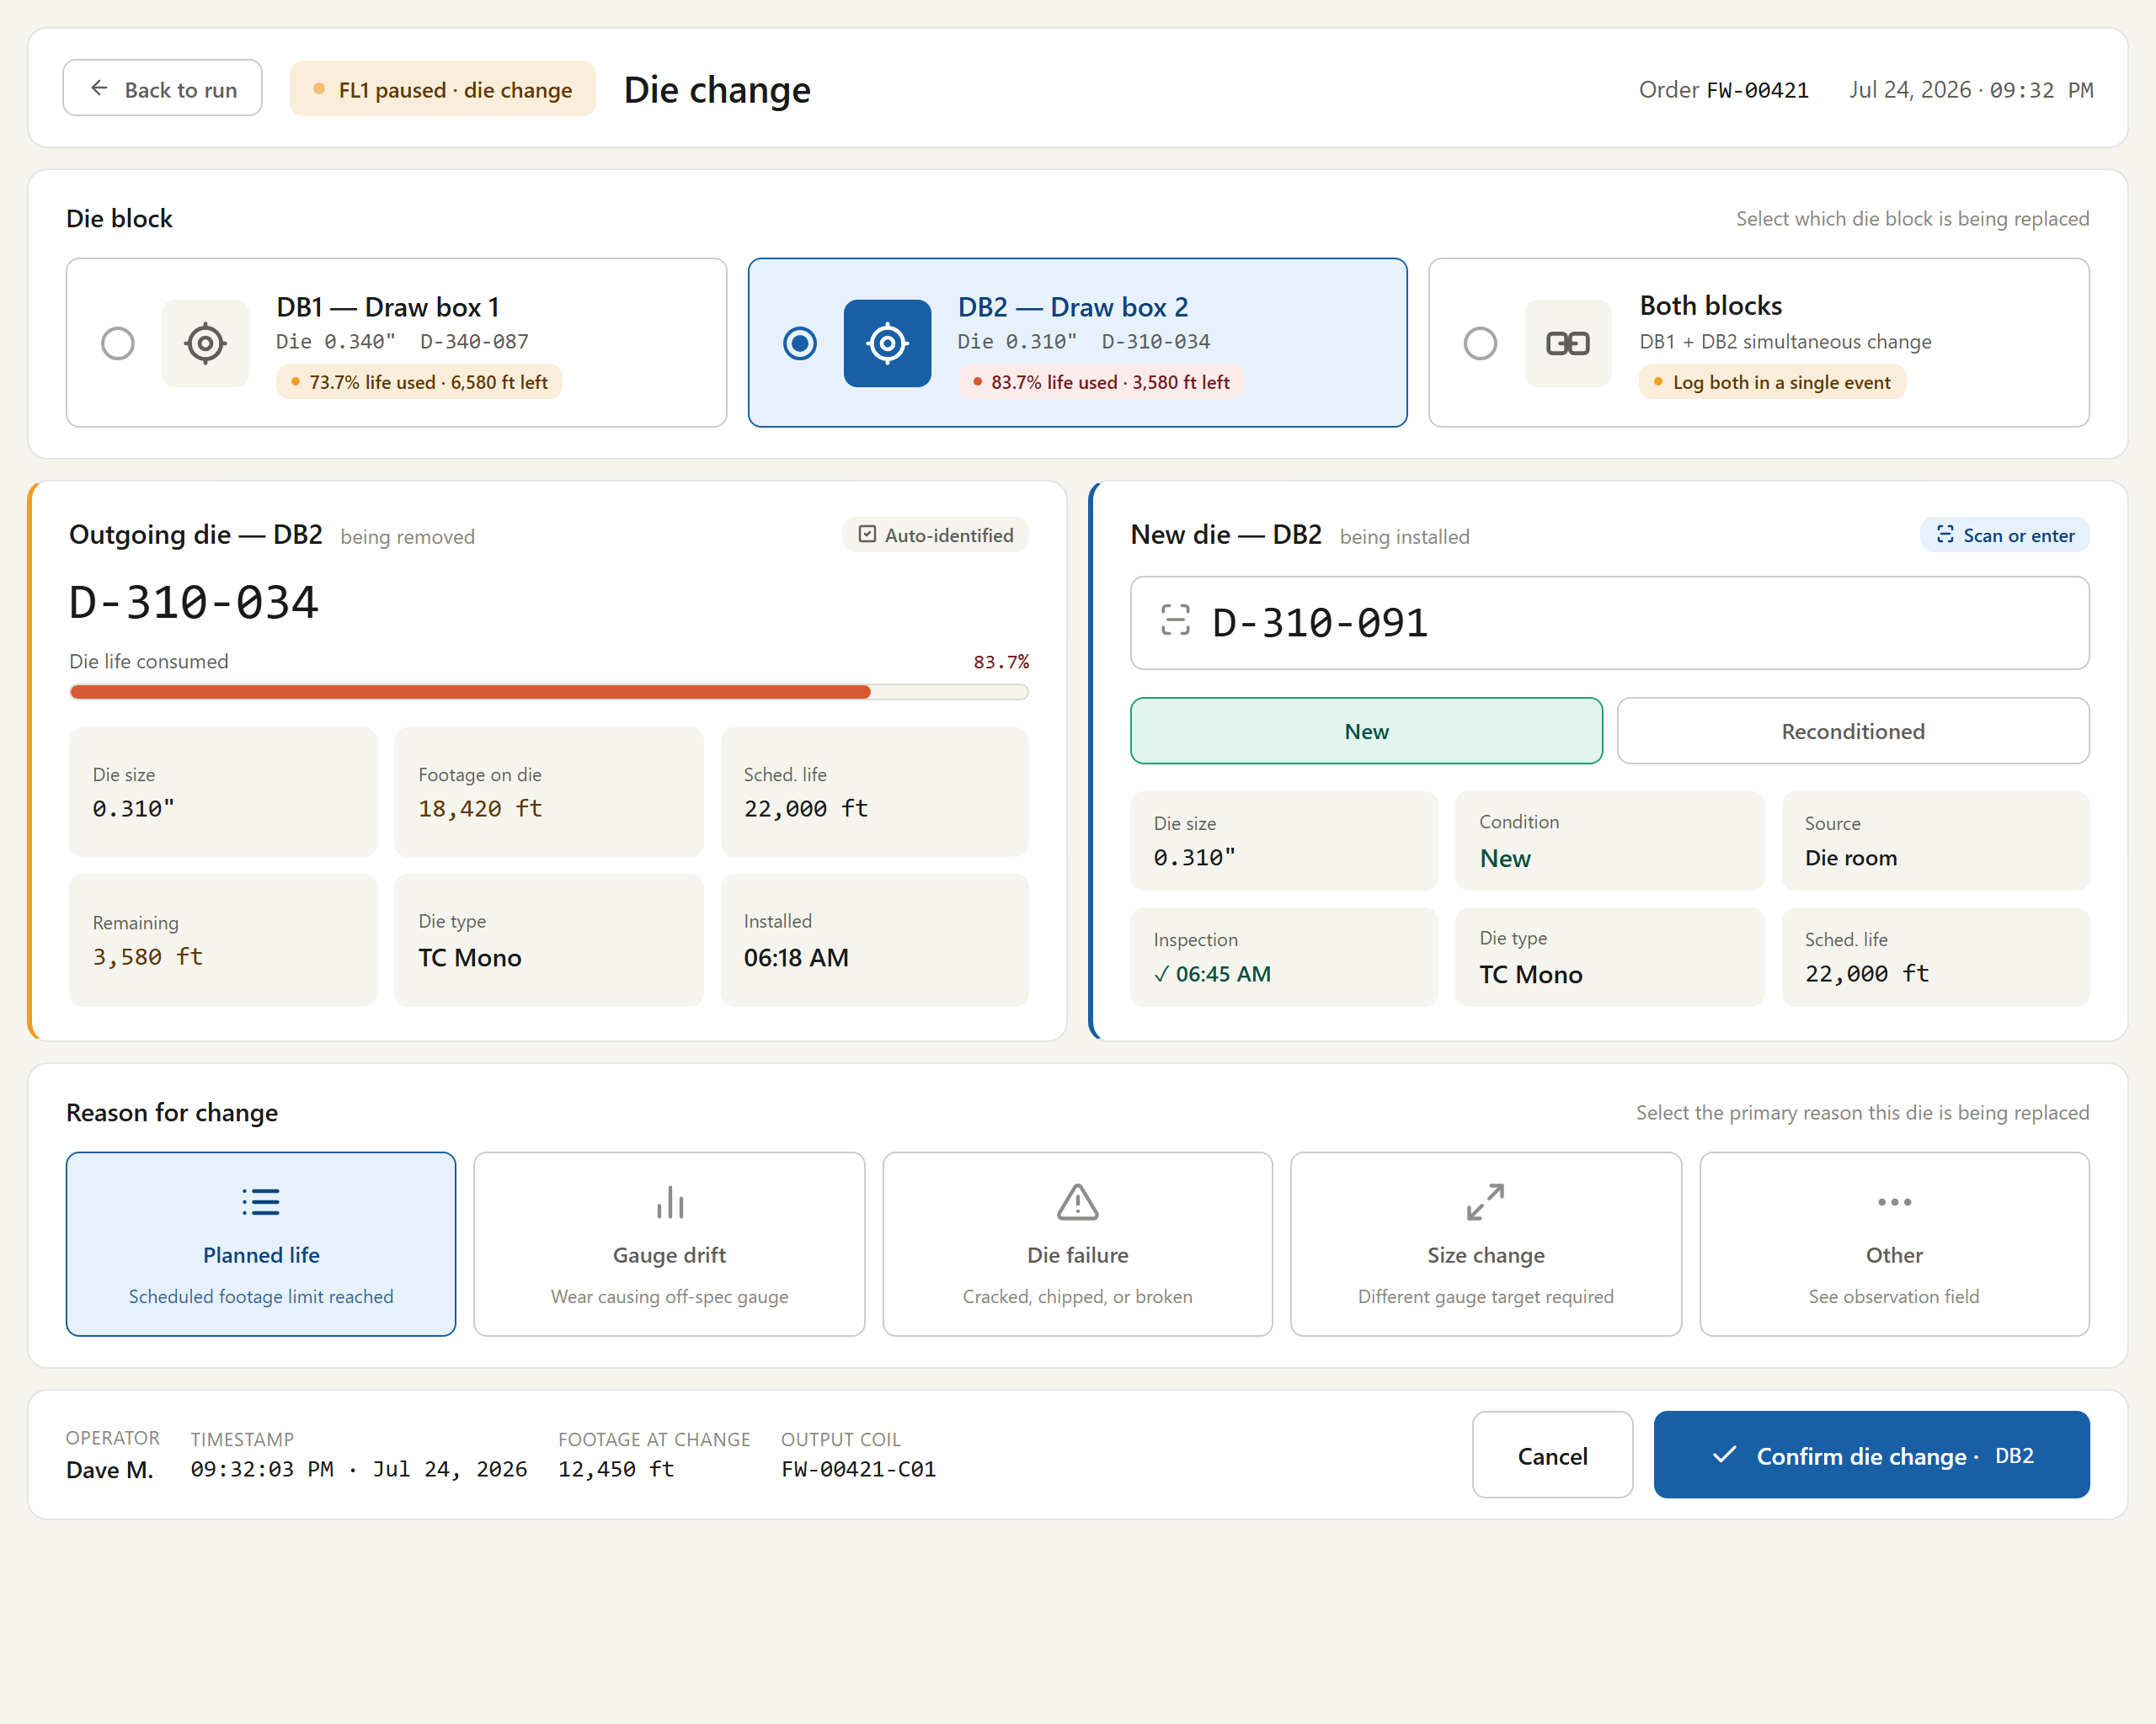
Figure # — Die Change (db_die_change.png)
*Requirements traced: DCH001–DCH028.*

4.25 Die Management (DMG)
Description. Die Management is the maintenance-facing lifecycle manager for the drawing-die inventory on the flat-wire line. Accessed by the Maintenance role from Machines Application → Tooling Inventory, it owns die records, life thresholds, footage counters, and disposition (register, reset, retire). It is the source of truth the Die Change screen reads at runtime for alpha-to-size/type lookup, accumulated footage, and scheduled life, so its accuracy directly governs tooling changeouts and product quality.
Priority: Must — the Die Change screen depends on this inventory as its runtime source of truth, so it must be in place for Phase-1 go-live.
Stimulus / Response.
Trigger / operator action | System response
Maintenance user opens the screen | Loads inventory with stats strip, filter tabs, and line pills; shopfloor dashboards remain excluded
Selects a line pill or filter tab | Narrows inventory list and stat counts to the chosen scope
Selects an inventory row | Populates detail panel with header, life bar, six-field grid, alert banners, actions, and history
Invokes Register / Reset / Edit Threshold / Retire | Applies the action, updates life status and counts, and writes to the Replacement log
Views a die at or above life thresholds | Renders amber (Nearing) or red (Overdue) banners and reclassifies status

Functional Requirements.
The Die Management screen is the maintenance-facing lifecycle manager for the drawing-die inventory. It owns die records, life thresholds, footage counters, and disposition (register/reset/retire) that the Die Change screen reads at runtime. Accessed from the Machines Application → Tooling Inventory tab (Maintenance role); not accessible from the shopfloor dashboards.
- The system shall provide the Die Management inventory manager to the Maintenance role and shall not expose it from the shopfloor dashboards. (DMG001)
- The system shall provide line filter pills (All lines / FL1 / FL3) that narrow both the inventory list and the stats. (DMG002)
- The system shall display a stats strip with Active on line, Overdue for replacement, Nearing end of life, and Spare/ready counts. (DMG003)
- The system shall provide inventory filter tabs (All, Active, Nearing end, Overdue, Spare, Retired) each with a count badge. (DMG004)
- The system shall display inventory rows with columns for Alpha, Block, Size, Line, Status, Life used (bar + percentage), Footage (run/threshold), and Last reset. (DMG005)
- The system shall sort inventory rows Overdue → Nearing → Active → Spare → Retired and render retired rows at reduced opacity. (DMG006)
- The system shall populate the detail panel when an inventory row is selected. (DMG007)
- The system shall display in the detail panel the die header, a life bar, a six-field grid (footage on die, life threshold, remaining, die size, die type, last reset by), status alert banners, action buttons, and a history section. (DMG008)
- The system shall display a red danger banner when a die is Overdue and an amber warning banner when a die is Nearing end of life. (DMG009)
- The system shall provide a Register New Die action that creates a die record with status Spare, capturing alpha, compatible block (DB1/DB2/Both), hole size, die type/material, life threshold, source, condition, inspection date, and optional notes. (DMG010)
- The system shall provide a Reset Counter action that resets footage to zero, supports Reconditioned or New-spare disposition, updates the life threshold when Reconditioned, and writes the event to the Replacement log. (DMG011)
- The system shall provide an Edit Threshold action that changes the footage limit for this die only or all dies of the same type/size, requires a reason, and updates the default threshold for future registrations when applied to all. (DMG012)
- The system shall provide a Retire Die action that permanently retires a die, requires a reason (end of life, physical damage, bore out of tolerance, size discontinued, other), retains the die in history, and excludes it from active and spare counts. (DMG013)
- The system shall disable the Reset Counter, Edit Threshold, and Retire actions for a die that is already retired. (DMG014)
- The system shall provide a history section with a Run history tab (order, line, footage added, date, operator) and a Replacement log tab (install, reset, and retirement events). (DMG015)
- The system shall apply life-status thresholds consistently across the stats strip, filter counts, list badge, inline bar, detail life bar, and alert banners: Active below 65% used, Nearing end 65–79%, Overdue 80% or more, Spare (0 footage, not installed), and Retired. (DMG016)
- The system shall serve as the source of truth consumed by the Die Change screen for die alpha-to-size/type/condition lookup, accumulated footage counter, and scheduled-life threshold. (DMG017)
> [OPEN ITEM: Whether the nearing/overdue life-status boundaries are fixed system constants or configurable per die type (e.g. DB1 roughing vs DB2 finishing) is unresolved.]
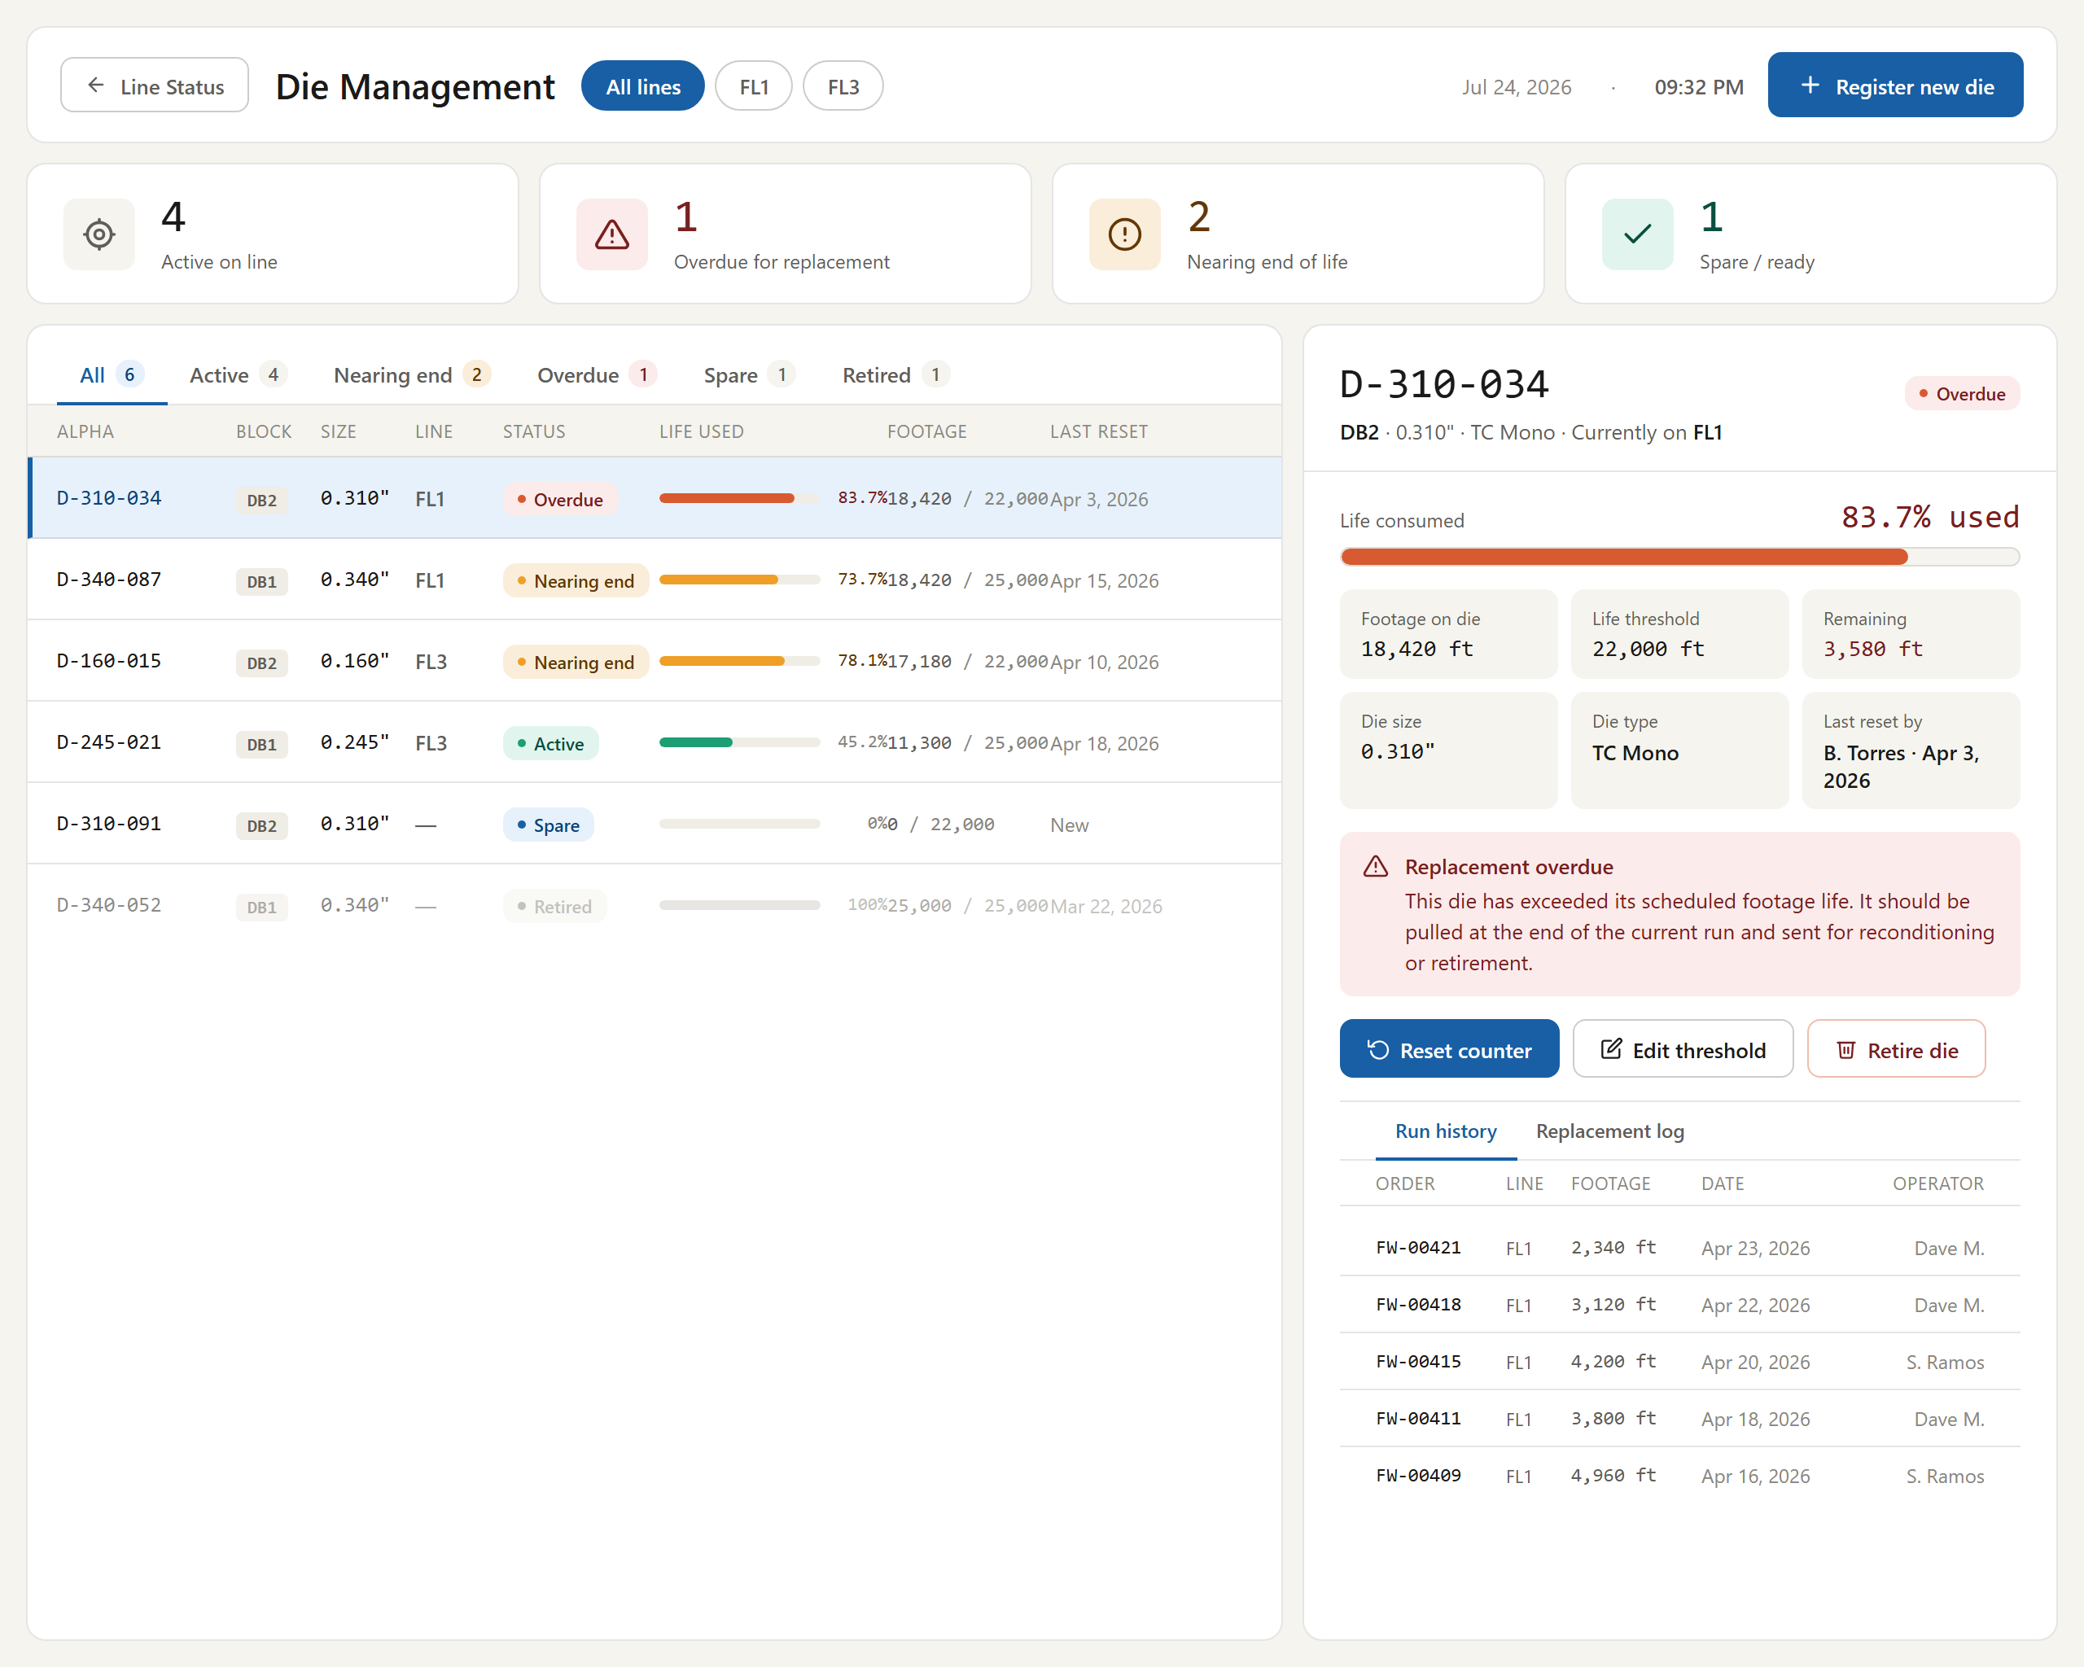
Figure # — Die Management (db_die_management.png)
*Requirements traced: DMG001–DMG017.*

4.26 HMI Schematic (HMI) — Dashboard 13
Description. The HMI Schematic (Dashboard 13) presents a full-screen, route-adaptive SVG of the flat wire line with live PLC data overlaid on every component. Supervisors and operators use it to monitor line state at a glance across FL1, FL2, and FL3 operation, reading per-component status, configured parameters, and live measurements with clear active/bypass/fault indication. It is the primary real-time situational display for the line, making abnormal conditions immediately visible on the shop floor.
Priority: Must — it is the operators' primary live view of line state and is required for Phase-1 go-live monitoring of the flat wire line.
Stimulus / Response.
Trigger | System response
Operator opens Dashboard 13 | Renders the route-adaptive schematic for the active route with current component states.
FlatWireHub SignalR event received | Updates affected component nodes, indicators, and flow animation in place.
Network drop then recovery | Reconnects automatically and restores live schematic updates.

Functional Requirements.
The Line Schematic is a full-screen, route-adaptive SVG of the flat wire line with live PLC data overlaid on every component. It reconfigures for FL1, FL2, or FL3 operation and shows component on/off/bypass indication. Primary users: Supervisor / Operator. Resolves OQ-4 tag mapping via the PLC Tag Mapping table.
- The system shall display a full-screen route-adaptive SVG schematic of the flat wire line with live PLC data overlaid on every component. (HMI001)
- The system shall reconfigure the schematic layout automatically for the active route (FL1 Standalone, FL2 Standalone, or FL3 Hybrid). (HMI002)
- The system shall display, per component node, a status indicator, the configured parameter, and the live measurement per the component node data specification. (HMI003)
- The system shall render each payoff node green when above 25%, amber at or below 25%, and red with pulsing at or below 10%, alongside weight and percent-remaining. (HMI004)
- The system shall render the gauge sensor node green when in-spec and red when out-of-spec, showing the live gauge reading. (HMI005)
- The system shall render the width sensor node green when in-spec and red when out-of-spec, showing the live width reading. (HMI006)
- The system shall render each component green when active, grey when bypassed, and red when in fault. (HMI007)
- The system shall render the FM2-6" S2 stand as non-bypassable (green active or red fault only). (HMI008)
- The system shall animate flow dashes along connector paths when SpeedFPM is greater than zero, stop the animation when paused or idle, show static orange dashes when paused, and static red dashes on fault. (HMI009)
- The system shall show route-appropriate active components and grey out the components inactive for the current route (FL1, FL2, or FL3 variant). (HMI010)
- The system shall dim greyed components to 40% opacity and display a BYPASS or OFFLINE badge in place of parameter values. (HMI011)
- The system shall display a fixed bottom alert bar using the same alert rules as Dashboard 1. (HMI012)
- The system shall display a header showing route selector, line status, order/alpha, live speed, and footage. (HMI013)
- The system shall provide navigation to Line Status (Dashboard 1), Active Run (Dashboard 3, when a run is active), and SCADA Trends (Dashboard 14). (HMI014)
- The system shall drive the schematic from the FlatWireHub SignalR events and reconnect automatically after a network drop. (HMI015)
- The system shall render all interactive elements with a tap target of at least 48px and render all numeric readings in the monospace font. (HMI016)
- The system shall not provide any print action on the HMI schematic. (HMI017)
> [OPEN ITEM: FL1 Edge Set on the HMI schematic conflicts with the May 21, 2026 correction that FL1 has no Edger. HMIAndSCADALayout.md (May 15) still depicts an FL1 EDGE SET node; the FL1 schematic/route variant must be corrected to remove the Edge Set node.]
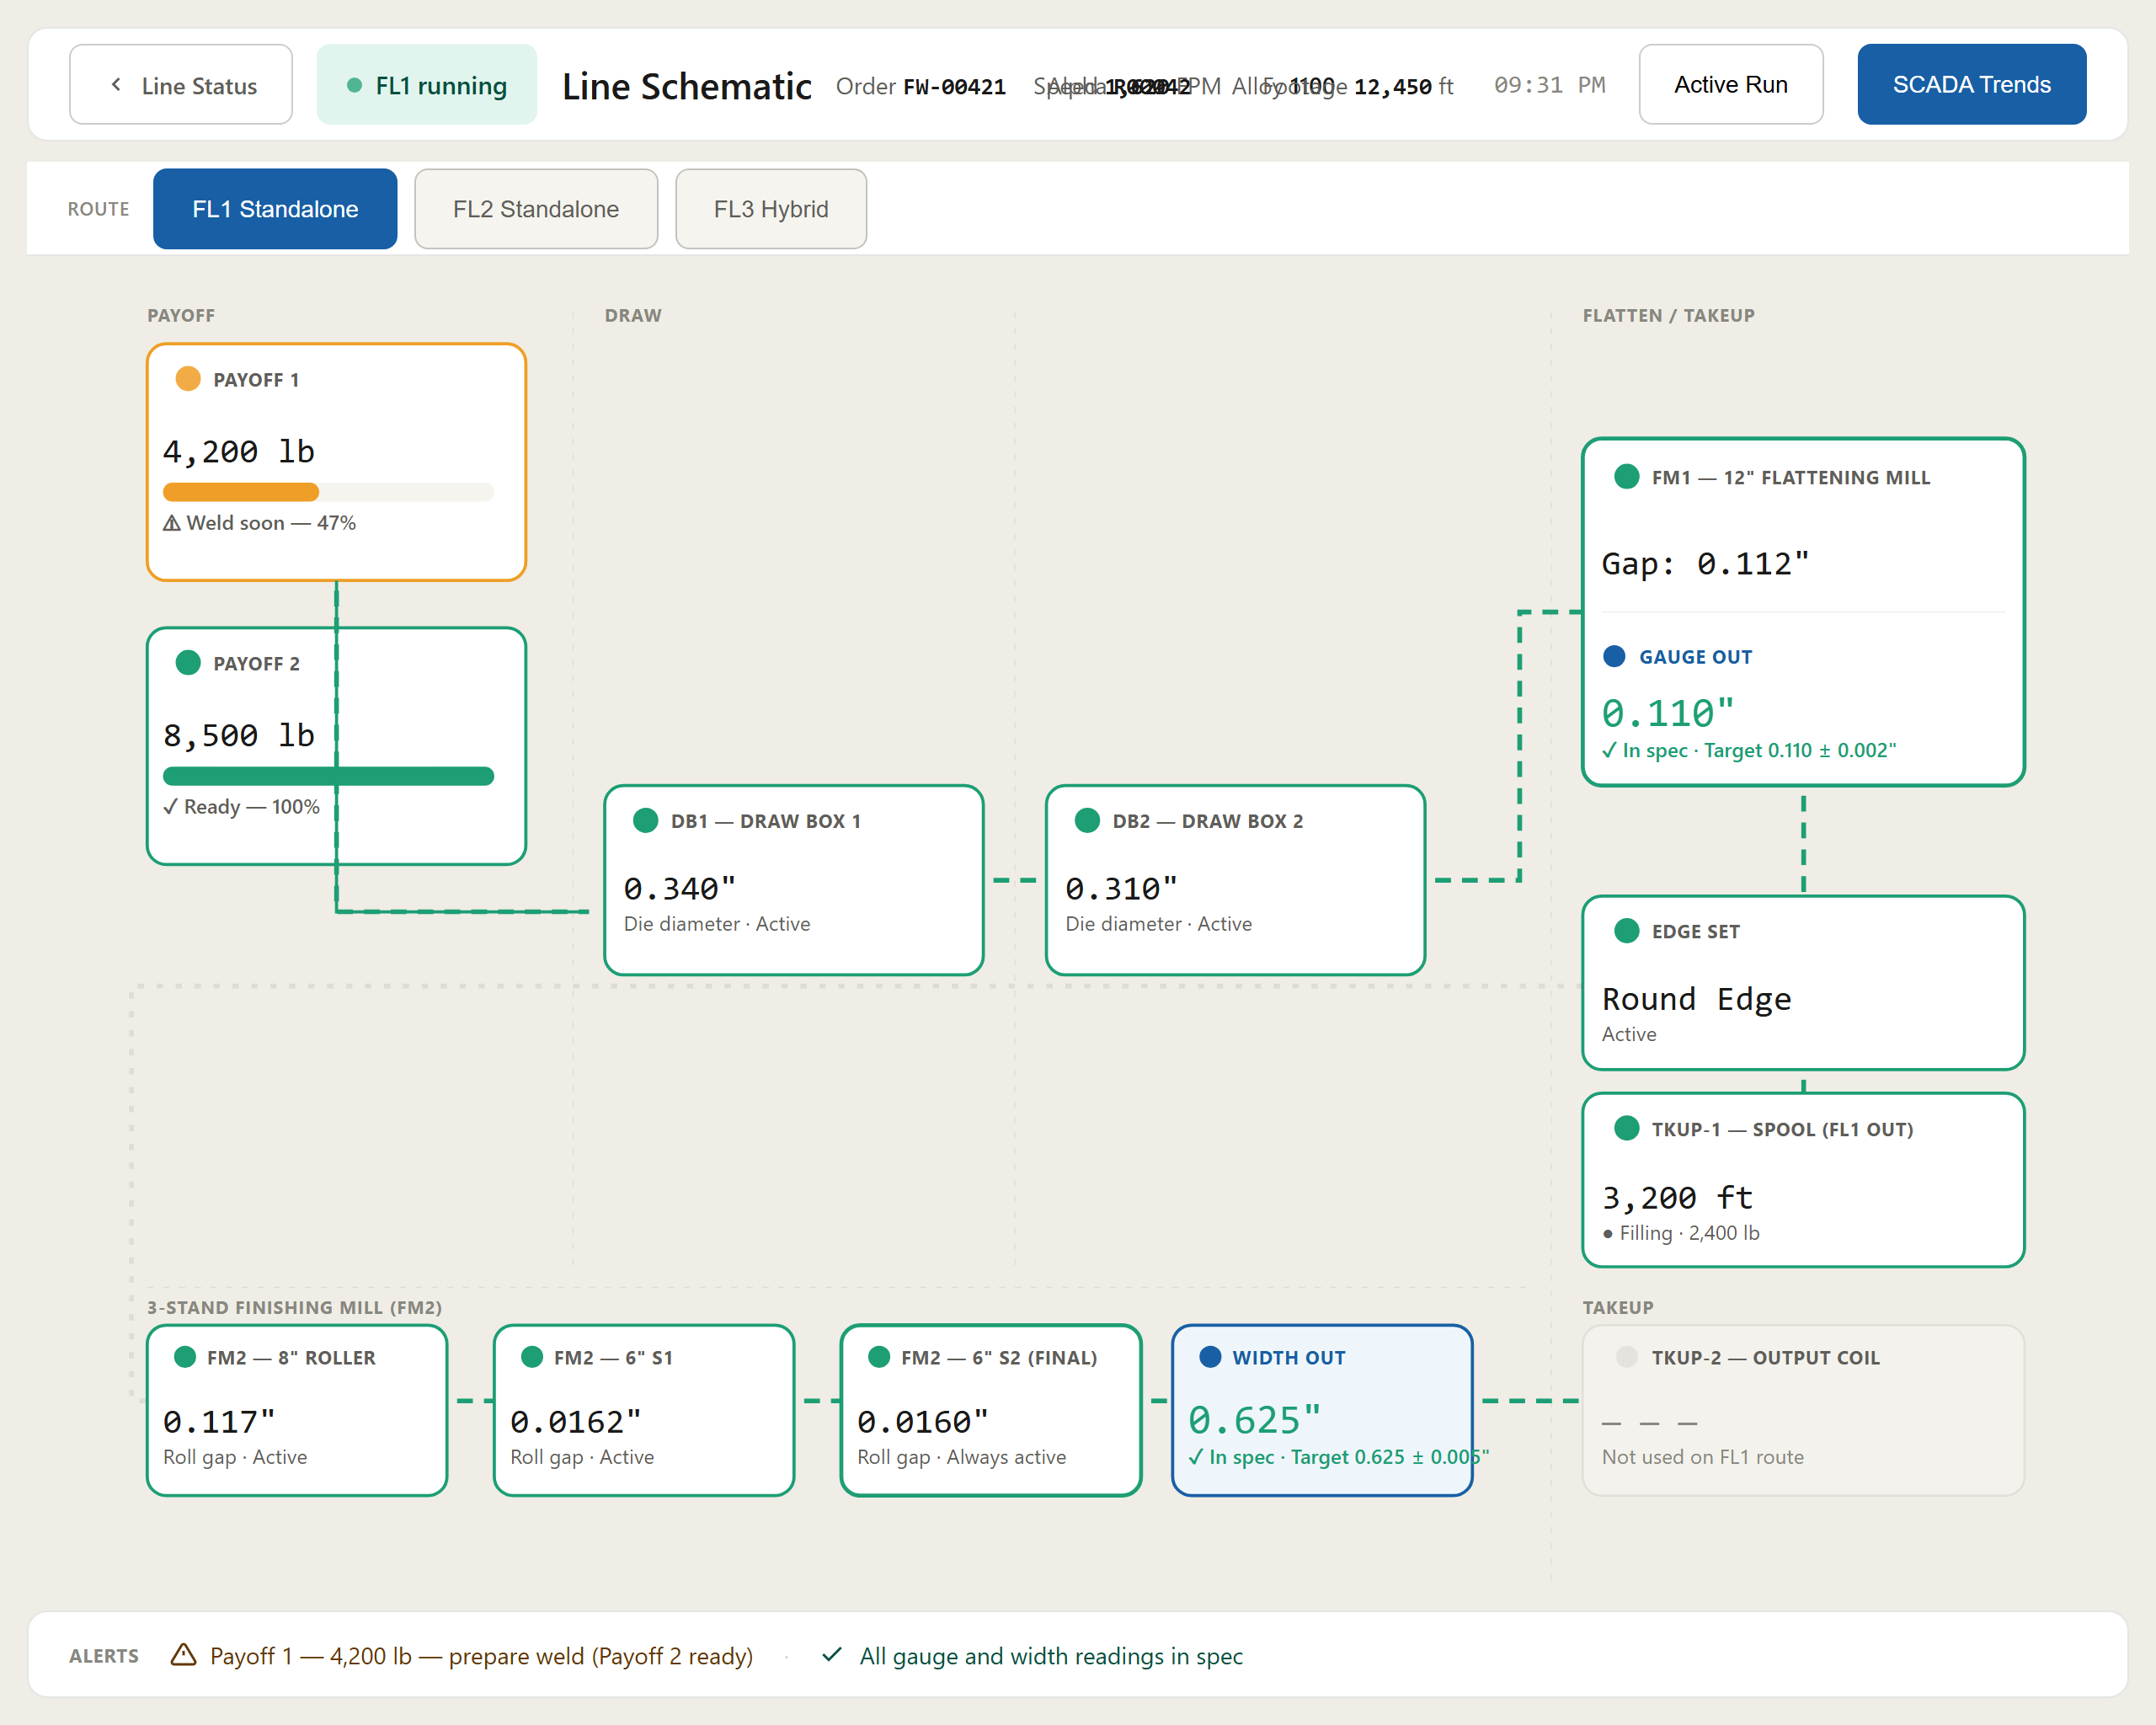
Figure # — HMI Line Schematic (Dashboard 13) (db13_hmi_schematic.png)
*Requirements traced: HMI001–HMI017.*

4.27 SCADA Trends (SCD) — Dashboard 14
Description. The SCADA Trends screen (Dashboard 14) presents multi-pen, real-time time-series charts for gauge, width, speed, and payoff weight, overlaid with SPC control limits, tolerance bands, and a shared event timeline. Operations, Supervisors, and Engineering use it to monitor flat-wire line health, catch out-of-spec drift early, and correlate quality excursions with welds, die changes, and pauses. Configurable time windows and CSV export support both live watch and after-the-fact analysis.
Priority: Should — it materially improves quality visibility and troubleshooting on the flat-wire line, but the line can run and be controlled without it, so it is not strictly required for Phase-1 go-live.
Stimulus / Response.
Trigger | System response
User navigates from Dashboard 1, 3, or 13 and selects a line (FL1/FL2/FL3) | Screen opens and renders all trend charts for the selected line and time window
FlatWireHub SignalR reading arrives | Charts and event markers advance live at the configured update interval
SignalR connection drops | Client reconnects automatically and resumes streaming

Functional Requirements.
The SCADA Multi-Trend Charts screen provides multi-pen time-series trends for gauge, width, speed, and payoff weight with SPC control-limit overlays, a shared event timeline, configurable time windows, and CSV export. Primary users: Operations / Supervisor / Engineering.
- The system shall display multi-pen time-series trend charts for gauge, width, speed, and payoff weight. (SCD001)
- The system shall display the gauge chart with a target centerline, a plus/minus tolerance band, UCL/LCL control lines, and out-of-spec shading. (SCD002)
- The system shall display the width chart using the same visual language as the gauge chart. (SCD003)
- The system shall display the speed chart with a max-speed line from the pass schedule, grey shading over paused periods, and the pause reason shown on hover. (SCD004)
- The system shall display the payoff weight chart with Payoff 1 solid, Payoff 2 dashed, and a 3,000 lb weld-soon threshold line. (SCD005)
- The system shall provide time-window options of 30 min, 1 hr, 4 hr, Shift, and Custom with appropriate x-axis labels. (SCD006)
- The system shall display shared event markers on a synchronized x-axis for weld join, die change, pause start/end, SPC checkpoint, alert raised, alert cleared, and rod checkout, each with its defined symbol, colour, and data source. (SCD007)
- The system shall calculate SPC control limits from the last N measurements (default 25 per run) using X̄-R methodology, deriving UCL (X̄ + 3σ), LCL (X̄ − 3σ), USL (target + tolerance), and LSL (target − tolerance). (SCD008)
- The system shall shade out-of-spec regions red and in-spec regions green at low opacity. (SCD009)
- The system shall export a CSV containing Timestamp, Footage_ft, Gauge_in, Width_in, Speed_FPM, Payoff1_lb, Payoff2_lb, GaugeSpec_in, GaugeTol_in, WidthSpec_in, WidthTol_in, EventType, and EventDetail, with one row per SignalR reading interval. (SCD010)
- The system shall provide a settings panel controlling update interval, SPC sample size, show/hide control limits, chart layout, and dark mode. (SCD011)
- The system shall provide a line selector (FL1 / FL2 / FL3). (SCD012)
- The system shall provide navigation from Dashboard 1, Dashboard 3, and Dashboard 13, and back navigation to Active Run or Line Status. (SCD013)
- The system shall drive the charts from the FlatWireHub SignalR events and reconnect automatically after a network drop. (SCD014)
- The system shall not provide any print action on the SCADA Trends screen. (SCD015)

Figure # — SCADA Trends (Dashboard 14) (db14_scada_trends.png)
*Requirements traced: SCD001–SCD015.*

4.28 OEE (OEE)
Description. The OEE feature provides a read-only dashboard that reports Overall Equipment Effectiveness for each flat-wire line (FL1–FL3) and combined, decomposing it into Availability, Performance, and Quality with factor breakdowns, MTBF/MTTR, Six Big Losses, multi-shift trends, a line comparison table, and ranked loss events. Production supervisors, line leads, and continuous-improvement engineers use it to monitor shift performance against the target and to identify the largest sources of lost throughput. It matters because it turns raw OPC and Planning DB data into an actionable view of where footage is being lost on the flat-wire line.
Priority: Should — high operational value for performance visibility, but not required for the line to run and ship product at Phase-1 go-live.
Stimulus / Response.
Trigger | System response
Operator opens the OEE dashboard | Loads current-shift metrics for all lines from OPC and the Planning DB.
Machine or shift selector changed | Re-renders tiles, panels, and tables for the chosen scope.
Underlying data refreshes | Updates displayed values, thresholds, and charts.

Functional Requirements.
The OEE dashboard presents Availability, Performance, and Quality metrics per machine and combined, with factor breakdowns, MTBF/MTTR, Six Big Losses, a multi-shift trend, a line comparison table, and ranked loss events. Data source: OPC + Planning DB. (Requirements derived from the dashboard_oee.html mockup, the only source available for this screen.)
- The system shall present an Availability / Performance / Quality dashboard with OEE per machine and a combined view. (OEE001)
- The system shall provide a machine detail selector (FL1 / FL2 / FL3). (OEE002)
- The system shall provide a shift selector (Day / Night / Previous). (OEE003)
- The system shall display an OEE strip with one tile per line showing OEE percent, the A·P·Q breakdown, a donut gauge, and a variance-vs-target chip. (OEE004)
- The system shall display an offline line's tile in an offline state with no donut arc. (OEE005)
- The system shall display an MTBF tile with a 7-shift average value and a trend chip. (OEE006)
- The system shall display an MTTR tile with a 7-shift average value and a trend chip. (OEE007)
- The system shall display an OEE breakdown panel with an Availability split (running / planned / unplanned), a Performance bar, a Quality bar, and the OEE result as Availability × Performance × Quality. (OEE008)
- The system shall display a 7-shift OEE trend chart with a target line, colour-coded bars, and a 3-shift moving average. (OEE009)
- The system shall display a Six Big Losses panel categorized by Availability, Performance, and Quality with time lost and estimated footage per loss. (OEE010)
- The system shall display a line comparison table showing Availability, Performance, Quality, Day OEE, Night OEE, and variance versus the 85% target per line. (OEE011)
- The system shall display a Top Loss Events list ranked by duration with loss category and acknowledgment status. (OEE012)
- The system shall apply OEE colour thresholds of green at 85% or above, amber 70–84%, and red below 70%. (OEE013)
- The system shall display offline placeholders for a machine that did not run during the shift. (OEE014)
- The system shall provide Export PDF and Print Report actions. (OEE015)
- The system shall source OEE data from OPC and the Planning DB. (OEE016)
- The system shall use a configurable target OEE, defaulting to 85.0%. (OEE017)
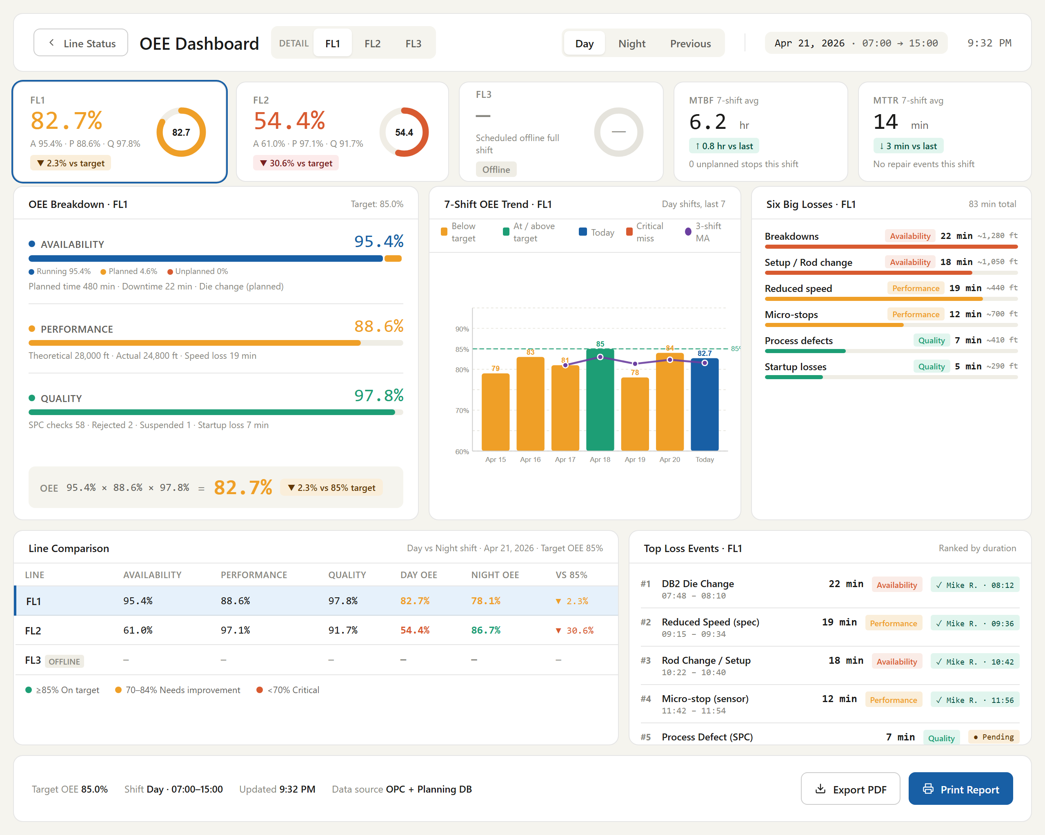
Figure # — OEE Dashboard (db_oee.png)
*Requirements traced: OEE001–OEE017.*

4.29 Pause Run (PRN)
Description. Pause Run gives the line operator a structured way to halt an active flat-wire run, attribute the stoppage to a single reason from a governed taxonomy, and later resume it. Invoked from the action bar on the FL1 and FL3 run monitors, it freezes the footage counter, holds the PLC in an idle state, and separates pause time from productive run time. Accurate reason capture and downtime attribution feed the Shift Summary, making it essential for utilisation reporting and supervisor visibility.
Priority: Must — safe, auditable stoppage and downtime attribution are prerequisites for Phase-1 go-live run monitoring.
Stimulus / Response.
Trigger / operator action | System response
Operator opens the pause dialog from the action bar | Presents reason taxonomy with Confirm Pause disabled
Operator selects one reason and confirms | Freezes footage, holds PLC, starts pause timer, logs reason against run/alpha/footage
Pause takes effect | Sets Dashboard 1 status to PAUSED with reason and switches the action button to Resume Run
Operator selects Resume Run | Shows confirmation with reason and elapsed pause duration, offers resume outcomes
Operator confirms "Yes — resume run" | Restarts timer, restores PLC, returns line to active, closes the pause event

Functional Requirements.
The Pause Run flow provides a structured pause/resume interaction with a reason-code taxonomy and downtime attribution. It is a shared dialog for FL1 and FL3 active run monitors, invoked from the action bar; it freezes footage, holds the PLC, and rolls up into the Shift Summary.
- The system shall require the operator to select exactly one pause reason from the reason taxonomy before a pause can be confirmed. (PRN001)
- The system shall organize pause reasons under the categories Equipment/Mechanical, Material Handling, Quality/Measurement, Operational, Safety, Rod Checkout, and Other. (PRN002)
- The system shall offer the Equipment/Mechanical reasons: Die change (mid-run, no weld), Roll adjustment, Lubrication/coolant, Draw box inspection, and Component inspection (non-fault). (PRN003)
- The system shall offer the Material Handling reasons: Payoff 2 loading/weld preparation, and Downstream blockage (TKUP-2 full / FL2 not ready). (PRN004)
- The system shall offer the Quality/Measurement reasons: Gauge/width investigation, Manual SPC measurement, and Surface inspection. (PRN005)
- The system shall offer the Operational reasons: Operator break, Shift changeover, and Awaiting supervisor instruction. (PRN006)
- The system shall offer the Safety reason: Safety observation (non-fault). (PRN007)
- The system shall provide an "Other" reason and store the operator's notes as the reason text when Other is selected. (PRN008)
- The system shall provide an optional notes field on the pause dialog. (PRN009)
- The system shall keep the Confirm Pause button disabled until a reason is selected. (PRN010)
- The system shall, when the Rod Checkout reason is selected, navigate to the Rod Checkout screen instead of pausing the run. (PRN011)
- The system shall, on pause, pause the run timer and track pause duration separately from productive run time. (PRN012)
- The system shall freeze the footage counter on pause and record the footage position against the run and alpha. (PRN013)
- The system shall log the pause reason code against the run, alpha, and footage position. (PRN014)
- The system shall set the PLC tags to a hold/idle state on pause. (PRN015)
- The system shall change the Dashboard 1 line status from RUNNING to PAUSED with the reason visible to the supervisor. (PRN016)
- The system shall auto-stamp the pause start time and prevent the operator from modifying it. (PRN017)
- The system shall toggle the line badge and pause-timer badge to a paused presentation and change the action button to Resume Run. (PRN018)
- The system shall, on resume, display a confirmation showing the pause reason and elapsed pause duration. (PRN019)
- The system shall offer resume outcomes of "Yes — resume run", "No — log WIP rejection", and "No — continue pause". (PRN020)
- The system shall provide an optional "activity completed during pause" notes field on the resume dialog. (PRN021)
- The system shall keep the Confirm resume button disabled until an outcome is selected. (PRN022)
- The system shall, on "Yes — resume run", restart the run timer, restore the PLC tags, return Dashboard 3 to the active state, and close the pause event with an end time and duration. (PRN023)
- The system shall, on "No — log WIP rejection", close the pause event and open the WIP Rejection screen (Dashboard 8). (PRN024)
- The system shall, on "No — continue pause", dismiss the dialog, leave the line paused, and keep the pause timer running. (PRN025)
- The system shall roll pause events into the Shift Summary as total downtime minutes, a downtime reason breakdown by category, line utilisation, and WIP rejection count. (PRN026)
> [OPEN ITEM: The resume-outcome set conflicts between sources. FlatWireShopfloorDashboards.md specifies four resume outcomes including "No — check out rod (partial run)" opening Rod Checkout Mode B, whereas pause_run.js implements only three resume outcomes and instead exposes Rod Checkout as a pause reason (PRN011). The authoritative behaviour for mid-run rod checkout from the pause/resume flow must be reconciled.]

Figure # — Active Run Monitor (Dashboard 3) (db03_active_run.png)
*Requirements traced: PRN001–PRN026.*

5. Non-Functional Requirements

5.1 Throughput and line speed
(NFR001) The system shall support flat-wire line speeds in the approximate
operating range of 1,800–2,000 FPM, and shall accept per-alloy/gauge speed
ranges as table-driven configuration (PassSchedule.LineSpeedMinFpm /
LineSpeedMaxFpm) since exact ranges are determined by trial (OQ-44).
(NFR002) The system shall accept FL1/FL2/FL3 throughput rates as configurable
inputs to scheduling run-time estimates once available (FL1:FL2 throughput ratio
is approximately 3:1 per OQ-45).

5.2 Data-recording frequency (configurable)
(NFR003) The system shall make the data-recording frequency configurable and
editable by authorized users (Engineering / IT) without a code change.
(NFR004) The system shall default data-recording frequency to **4 feet per
data point for finished product and 20 feet per data point for intermediate
product**, applying the rule: if a subsequent rolling operation exists → 20 ft;
if none → 4 ft; FL2 always records every 4 ft; and in FL3 (hybrid) both FL1 and
FL2 record every 4 ft (FL3 always produces finished product).

5.3 Real-time latency and availability
(NFR005) The system shall deliver live gauge, width, speed, and payoff-weight
readings to dashboards in near-real-time via SignalR push (default update interval
1 second, configurable to 5/10/30 s), with no polling.
(NFR006) The system shall be resilient to shop-floor network drops: SignalR
clients reconnect automatically and re-join their line group, and the Angular PWA
service worker caches the pass schedule and active run state so operator screens
do not go blank mid-run.
(NFR007) The system shall support two simultaneous running dashboard instances
(one per machine) when FL1 and FL2 operate independently, and shall keep the
FlatWire microservice available during PLC commissioning via a
SimulatePLCTagPush mode that logs intended writes without a live PLC connection.

5.4 Security and authentication
(NFR008) The system shall authenticate all access with JWT and shall enforce
role-based authorization for the roles **Operator, Operations Manager,
Maintenance, Supervisor, and Admin**, per the endpoint authorization matrix
(e.g., pass-schedule create/edit restricted to Operations Manager / Maintenance /
Admin; rod receiving restricted to Supervisor / Admin; shift summary restricted to
Operations Manager / Supervisor / Admin).
(NFR009) The system shall require a validated supervisor override for
privileged actions — manual login without punch-in, weld removal/reversal, and
mid-run rod checkout / partial-run disposition — and shall block passive
dismissal of override acknowledgments on the Active Run Monitor.

5.5 Auditability
(NFR010) The system shall log every override, supervisor action, pass-schedule
change, and PLC tag write/clear with who, when, and why (operator/supervisor
ID, timestamp, station/line, old→new value, and reason code or free text), and
shall retain these audit records for quality audit and engineering review.
(NFR011) The system shall capture and timestamp all login/logout events
(manual, auto shift-based, and supervisor-override) with operator ID and station,
consistent with existing slitter functionality and without regression.

5.6 Traceability retention
(NFR012) The system shall retain full weld/coil genealogy (source rod alphas,
weld sequence and footage boundaries, intermediate spool linkage, and finished
coil alpha) for the life of the material record, sufficient to trace any finished
coil back through weld points to supplier heat for welding-wire certificates.
(NFR013) The system shall retain historical R-series rod alphas permanently in
the shared coils table (per FW-020) and shall preserve the pass-schedule
configuration effective at coil creation even if the schedule is subsequently
edited.
> **[OPEN ITEM: SPC control-limit source and published tolerance bands (OQ-38) not
> finalized — UCL/LCL are computed from the last N measurements (default N=25) but
> the governing ASTM/customer tolerance bands per alloy and temper are still
> pending, which also gates meaningful gauge-trace alarms.]**

6. Other Requirements

6.1 Data Requirements
The authoritative source of record for all flat-wire-specific entities is the standalone FlatWire schema (22 tables), owned by the FlatWire .NET 8 microservice and its EF Core DbContext (DM001). The model spans five domains: Lookup/Reference (Stand, Drawer, Edger, SpoolConfiguration), Materials (Rod, Spool), Pass Schedule (PassSchedule, PassScheduleComponent), Runs (FlatWireRun plus its check-in and in-process event tables — RodCheckin, SpoolCheckin, RunPauseEvent, WeldEvent, RollOverride, DieChangeEvent), and Quality/Output (SpcCheckpoint, SpcMeasurement, WipRejection, CoilOutput, CoilTraceability, RodCheckout). FlatWireRun is the central run header (one row per check-in); all in-process events are persisted as its children via RunId, preserving referential integrity (DM005). Alpha-identified entities carry a unique index because those values are the scan and lookup keys throughout the run (DM004).
Named legacy integration points in the shared databases remain in scope for cross-system continuity so that scheduling, planning, reporting, cost, and yield modules continue without regression: coils.coil_status = INFLAT (set at check-in, cleared on checkout, run completion, or WIP rejection), wip_coil_orders, planning_routings/routings.actual_start_date, machines, wip_stations.coilno, and cost_centre_cost (DM002, DM003).
Retention and traceability: the system shall retain full weld/coil genealogy — source rod alphas, weld sequence and footage boundaries, intermediate spool linkage, and finished coil alpha — for the life of the material record, sufficient to trace any coil back to supplier heat for welding-wire certificates (NFR012). Footage ranges in CoilTraceability must be non-overlapping and satisfy FootageFrom < FootageTo (DM010), and the pass-schedule configuration effective at coil creation is preserved even if the schedule is later edited (NFR013, DM011). Detailed table definitions and open data decisions are catalogued in Appendix B and Appendix C; they are not restated here.

6.2 Verification & Acceptance Approach
Each requirement in the Appendix A traceability matrix carries a designated verification method drawn from the four 29148 classes:
- Test — automated and integration tests for API contracts, PLC tag push/clear batches, SPC compliance gating, and weight/footage calculations.
- Demonstration — operator-facing workflows exercised on the shopfloor dashboards (check-in, welding, stop, checkout).
- Inspection — schema constraints, audit-log content, label formats, and configuration-driven values reviewed against specification.
- Analysis — throughput, latency, and yield behaviour evaluated where live trial data is required.
Phase-1 acceptance proceeds in two stages. First, trials on FL1/FL2/FL3 confirm speed ranges, throughput ratios, and data-recording frequencies that the specification leaves table-driven (per OQ-44/OQ-45), using SimulatePLCTagPush mode during PLC commissioning. Acceptance of a requirement requires its verification method to pass against the trial configuration. Second, production acceptance confirms the same requirements against live PLC feeds, end-to-end genealogy, and audit completeness with no regression to legacy scheduling, planning, and reporting.

6.3 Units, Terminology & Conventions
- Units: US customary throughout — weight in pounds (lb), gauge/width/diameter in inches (in), footage in feet (ft), and line speed in feet per minute (FPM). Dimensional values are stored with their unit suffix (e.g., GaugeIn, WeightLb, LineSpeedMinFpm).
- Terminology: flat-wire vocabulary only. The terms *slitting* and *strip* shall not be used; the process is *rolling/flattening*, producing *flat wire* on *spools* and finished *coils*.
- Date/time: ISO-style timestamps (YYYY-MM-DD HH:MM:SS) captured server-side with operator ID and station.
- Identifiers: rods R##### (e.g., R00041); intermediate spools SP-##### (subject to the pending TS-series reconciliation, Appendix B); pass schedules PS-####-<line>-###; runs RUN-####; finished coils FW-#####-C##; and a unique MMS ID per input coil, generated at check-in and closed strictly on material consumption (remaining feet = 0), never on operator action (DM006).

6.4 Data Model & Persistence — Detail (DM)

6.4.1 Architecture Reconciliation — Legacy proddb vs. new FlatWire schema
The v1.x SRS narrative describes persistence in terms of legacy shared tables
(proddb..coils, proddb..spools, a new FlatwireQueue, wip_coil_orders,
planning_routings / routings, coil_status = INFLAT, machines,
wip_stations, cost_centre_cost). In parallel, the design track defined a
standalone, purpose-built FlatWire schema of 22 tables (7 existing tables
updated/renamed + 15 net-new). These two descriptions must be reconciled so
that implementation has a single authoritative data model.
Decision (SRS v2.0):
- The new standalone FlatWire schema is authoritative for all flat-wire-specific
entities — rod/spool lifecycle, pass schedules and their components, runs and
all in-process run events, SPC sessions, WIP rejections, and finished coil
output plus genealogy. All flat-wire application code (the FlatWire .NET 8
microservice and its EF Core DbContext) reads and writes this schema.
- Named legacy integration points are still written for cross-system continuity
so that scheduling, planning, reporting, cost, and yield modules that already
run against the shared databases continue to function without regression. The
legacy writes that remain in scope are:
- coil_status = INFLAT on the shared coils record (set at check-in
acknowledgment; cleared on checkout, run completion, or WIP rejection);
- wip_coil_orders — reqsum entry created if the rod is not already reqsummed;
- planning_routings / routings — actual_start_date updated at check-in;
- machines — three flat-wire entries (FL1, FL2, FL3/Hybrid);
- wip_stations — coilno updated on successful check-in;
- cost_centre_cost — cost-centre entry for the flat-wire lines.
(DM001) The system shall treat the standalone FlatWire schema (22 tables) as
the authoritative source of record for all flat-wire-specific entities.
(DM002) The system shall, at rod/spool check-in acknowledgment, write the
defined legacy integration points (coils.coil_status = INFLAT,
wip_coil_orders reqsum entry, planning_routings/routings.actual_start_date,
wip_stations.coilno) so that existing scheduling, planning, and reporting
modules continue to operate without regression.
(DM003) The system shall clear the legacy coil_status = INFLAT state on rod
checkout, run completion, or WIP rejection, consistent with FW-002.
> [OPEN ITEM: finalize proddb↔FlatWire bridge] — The precise transaction
> boundary, ownership, and synchronization direction between the authoritative
> FlatWire schema and the legacy proddb integration points is not yet fully
> specified (which system is master for each shared column, whether writes are
> synchronous within the check-in transaction or published as an event, and how
> reconciliation/rollback is handled if a legacy write fails after a FlatWire
> write succeeds). This must be resolved before Sprint 1 migration (FW-005/006/007).

6.4.2 Key Table Summary (authoritative FlatWire schema)
The 22-table model groups into five domains: Lookup/Reference (4), Materials (2),
Pass Schedule (2), Runs (8), and Quality/Output (6).
# | Table | Domain | Purpose | Key columns
1 | Stand | Lookup | Rolling-mill finishing stands (FM1, FM2 variants) with gauge/width capacity | Id, Name, LineId, MinGaugeIn/MaxGaugeIn, MinWidthIn/MaxWidthIn, IsActive
2 | Drawer | Lookup | Draw-box die configurations (DB1/DB2); die hole diameter | Id, Name, DiameterIn, MinDiameterIn/MaxDiameterIn, IsActive
3 | Edger | Lookup | Edger tooling sets; edge profile | Id, Name, EdgeType (Round/Square), ToolingSetNo, IsActive
4 | SpoolConfiguration | Lookup | Spool-type dimensional/weight constraints used at check-in validation | Id, Name, MinWeightLb/MaxWeightLb, MinCoreDiameterIn/MaxCoreDiameterIn, MinOuterDiameterIn/MaxOuterDiameterIn
5 | Rod | Materials | Wire-rod (R-series) receiving and lifecycle | Id, Alpha (R00041), Alloy, Temper, DiameterIn, weights, SupplierHeat, Status, Location, ReceivedAt
6 | Spool | Materials | Pre-drawn intermediate spool (FL1 output → FL2/FL3 feed) | Id, Alpha (SP-00021), SpoolTypeId FK, ParentRodAlpha, SourceRunId, LineId, Status, GaugeIn, WidthIn, weights
7 | PassSchedule | Schedule | Pass-schedule header — alloy, line, targets, speed range | ScheduleId (PS-1100-FL1-003, PK), Alloy, LineId, RouteMode, Status, TargetGauge/GaugeTolerance, TargetWidth/WidthTolerance, LineSpeedMin/MaxFpm
8 | PassScheduleComponent | Schedule | Per-component tool config rows (renamed from FlatLineSetup) | Id, PassScheduleId FK, ComponentName, State (Active/Bypass/Skip), ParameterValue, EdgeType, Sequence, StandId/DrawerId/EdgerId
9 | FlatWireRun | Runs | Central run header — one row per check-in | Id, RunId (RUN-0042), LineId, OrderId, PassScheduleId FK, Alloy, RouteMode, Status, StartedAt/CompletedAt, FootageFt, OperatorId
10 | FlatWireRunDetail | Runs | Per-stop / per-sequence detail (renamed from FlatLineProcessing) | Id, RunId FK, StopNo, SequenceNo, PayoffPositionId, FootageFt, gauge/width targets & measurements, OutputOD/OutputID
11 | RodCheckin | Runs | Rod check-in event with inspection + pre-run SPC | Id, RunId FK, RodAlpha FK, PayoffPosition, DiameterMeasuredIn, PassScheduleId, PlcTagsPushed, inspection cols, SpcM1In/SpcM2In/SpcOvalityIn
12 | SpoolCheckin | Runs | FL2/FL3 spool check-in event (mirrors RodCheckin) | Id, RunId FK, SpoolAlpha FK, PayoffPosition, GaugeIn, WidthIn, PassScheduleId, PlcTagsPushed, InspectionSurface
13 | RunPauseEvent | Runs | Pause/resume cycles | Id, RunId FK, PausedAt/ResumedAt, FootageAtPause, ReasonCode/ReasonCategory, Outcome, PauseDurationSeconds
14 | WeldEvent | Runs | Rod-to-rod weld joins during a run | Id, WeldEventId (WLD-002), RunId FK, OutgoingRodAlpha, IncomingRodAlpha, FootagePosition, WeldType, WeldQuality
15 | RollOverride | Runs | Run-level roll-gap / die parameter overrides (does not modify schedule) | Id, OverrideId (OVR-0042), RunId FK, RodAlpha, ComponentName, OldValue/NewValue/Delta, ReasonCode, PlcTagWritten
16 | DieChangeEvent | Runs | Die replacement events; auto-triggers PostDieChange SPC | Id, DieChangeId (DC-0041), RunId FK, DiePosition (DB1/DB2), OldDieSizeIn/NewDieSizeIn, LinkedOverrideId, SpcCheckpointRequired
17 | SpcCheckpoint | Quality | SPC measurement-session header | Id, CheckpointId (SPC-0041), RunId FK, CheckpointType, FootagePosition, AllInSpec
18 | SpcMeasurement | Quality | Individual measurement rows under a checkpoint | Id, CheckpointId FK, Name, TargetValue, ActualValue, InSpec, Deviation
19 | WipRejection | Quality | Material rejection events (run or pre-run) | Id, RejectionId (REJ-0041), RunId FK (nullable), MaterialAlpha, Stage, RejectionGroup/RejectionReason, Disposition, NewMaterialStatus
20 | CoilOutput | Output | Finished output coil records | Id, CoilAlpha (FW-00421-C01), RunId FK, OrderId, weights, FinalGaugeIn/FinalWidthIn, FootageFt, SkidId/SkidStatus, Status
21 | CoilTraceability | Output | Footage-range → source-rod genealogy | Id, CoilAlpha FK, RodAlpha FK, FootageFrom, FootageTo
22 | RodCheckout | Output | Rod removal (Mode A pre-run / Mode B mid-run) | Id, CheckoutId (CO-0041), RunId FK (nullable), RodAlpha, Mode, FootageAtCheckout, RodDisposition, InProcessMaterialDisposition, PlcTagsCleared

(DM004) The system shall persist every alpha-identified entity (Rod.Alpha,
Spool.Alpha, FlatWireRun.RunId, PassSchedule.ScheduleId, CoilOutput.CoilAlpha)
with a unique index, since these values are the scan/lookup keys at check-in and
throughout the run event tables.
(DM005) The system shall record all in-process run events (RodCheckin,
SpoolCheckin, RunPauseEvent, WeldEvent, RollOverride, DieChangeEvent,
SpcCheckpoint, WipRejection, CoilOutput, RodCheckout) as children of
FlatWireRun via RunId, preserving referential integrity to the run header.

6.4.3 Mapping SRS-narrative concepts to persistence

6.4.3.1 MMS ID lifecycle
The SRS narrative requires a unique MMS ID per input coil, generated at
check-in, activated when a welded coil becomes active, and closed strictly on
material consumption (remaining feet = 0) — never on operator action. An output
spool may reference multiple MMS IDs across welded coils.
(DM006) The system shall generate a unique material-tracking identity for each
input coil at check-in time and shall close it based solely on material
consumption (remaining feet reaching zero), independent of operator action.
> **[OPEN ITEM: MMS ID has no column in the schema — define mapping to
> FlatWireRun.RunId or add a column]** — The 22-table model has no explicit
> MmsId column. The check-in event and run lifecycle most closely correspond to
> FlatWireRun.RunId (one row per check-in) plus CoilTraceability/WeldEvent
> for the multi-parent linkage, but the SRS "MMS ID" term is not bound to a
> concrete column. Either (a) map MMS ID onto RunId, or (b) add an MmsId
> column to Rod/RodCheckin/FlatWireRun. Must be decided before FRT/DAT
> implementation.

6.4.3.2 Intermediate spool numbering — TS vs. SP
The SRS narrative numbers intermediate spools TS000001–TS999999 ("Temp
Spool", e.g. TS1..TS6 in the running example, and OUT003/OUT004 state the range
starts TS000001). The authoritative schema uses SP-{5 digits} (e.g.
SP-00021) as the Spool.Alpha format. These two conventions conflict.
(DM007) The system shall assign each intermediate spool a unique,
system-generated identifier that is printed on a high-temperature furnace label
and used for FL2/FL3 check-in traceability.
> **[OPEN ITEM: reconcile intermediate spool numbering — SRS narrative TS######
> vs. schema SP-#####]** — A single canonical format must be chosen. The
> authoritative schema currently defines SP-{5 digits}; the SRS output section
> specifies TS000001–TS999999. Recommend adopting one format across schema,
> label template, and UI; flagged pending Tim O. confirmation.

6.4.3.3 Scrap box identity
Rod pre-check-in and check-in capture an optional Scrap Box reference, with
alloy-based list filtering and carry-forward auto-select logic (same as slitters).
The Stop transaction also references a Scrap Box #.
> [OPEN ITEM: no ScrapBox table defined] — The 22-table model does not define
> a Scrap Box entity, yet scrap-box selection is a first-class field on
> pre-check-in, check-in, and the Stop pop-up. Either reuse the existing slitter
> scrap-box source or define a FlatWire ScrapBox lookup. Must be resolved before
> PCI/STP implementation.

6.4.3.4 Pre-check-in queue (FlatwireQueue)
The SRS narrative introduces a new pre-check-in table FlatwireQueue
(columns Rodno, RodSeqno, Welded) to hold pre-checked-in rods before they
become active, and drives the "Mark as Welded" and weld-visibility behaviour on
the traveler.
> [OPEN ITEM: FlatwireQueue has no counterpart in the model] — The
> authoritative 22-table schema has no pre-check-in queue table. Pre-check-in
> state, the Welded flag, and queue sequencing are only described in the
> narrative. Either add a FlatwireQueue (or equivalent staging) table to the
> FlatWire schema or model the queue via Rod.Status = STAGED + a payoff-position
> attribute. Must be resolved before PCI/WLD implementation.

6.4.3.5 Spool status state machine
Spool.Status supports the lifecycle values RECEIVED, STAGED, INFLAT,
COMPLETE, HOLD, SCRAP. The SRS operational narrative additionally refers to
plan-oriented states (ACTIVE / IN-PLAN / IN-USE / COMPLETED / SCRAPPED).
(DM008) The system shall enforce a defined spool status state machine so that
invalid transitions are prevented (e.g., a COMPLETE/COMPLETED spool cannot be
re-opened for FL2 check-in, and a spool cannot be planned for two orders
simultaneously).
> **[OPEN ITEM: reconcile spool status vocabularies — schema
> (RECEIVED/STAGED/INFLAT/COMPLETE/HOLD/SCRAP) vs. narrative
> (ACTIVE/IN-PLAN/IN-USE/COMPLETED/SCRAPPED); full transition set per OQ-57
> still In Progress]**

6.4.3.6 Weld / coil multi-parent genealogy
(DM009) The system shall maintain end-to-end multi-parent genealogy for every
finished coil, mapping each output footage range back to its contributing source
rod via CoilTraceability (CoilAlpha, RodAlpha, FootageFrom, FootageTo)
and linking rod-to-rod transitions via WeldEvent (OutgoingRodAlpha,
IncomingRodAlpha, FootagePosition).
(DM010) The system shall ensure CoilTraceability footage ranges within a
single coil do not overlap and satisfy FootageFrom < FootageTo, so that
footage attribution to source rods is unambiguous for cert and yield reporting.
(DM011) The system shall associate the acknowledged PassScheduleId (and the
configuration data effective at coil creation) with the CoilOutput record for
technical traceability, even if the pass schedule is later edited (per OQ-54).

6.4.4 Corrected v1 defect
The v1 SRS proddb..spools column list enumerated rodlength twice
(Spoolno, rodno, rodlength, multiple coils (Y/N), spoollength, rodlength).
(DM012) The system shall define the intermediate-spool record with a single
rod-length column (the duplicate rodlength from the v1 proddb..spools list is
removed); the authoritative Spool table supersedes the v1 column list.

Appendix A — Analysis Models
The principal analysis models for this system are: the system context / equipment layout (Figure in §2.1), the end-to-end process flow (§2), the entity-relationship model of the FlatWire schema (§6.4), and the PLC/OPC/SignalR interface map (§3.4–3.5). The screen inventory is catalogued in Appendix E.

Appendix B — Requirement Traceability Matrix
Priority (MoSCoW) and Verification method per requirement group. Identifiers are contiguous within each prefix.
Prefix | Feature | Priority | Verification | Authoritative source | Figure
OL | Login / Logout (OL) | Must | Test | srs / OperationsManager | —
PCI | Pre-Check-In (PCI) | Should | Test | RocCheckin | Rod Check-In (Dashboard 2)
CHK | Check-In (CHK) | Must | Test | RocCheckin / CheckinImplementationPlan | Rod Check-In (Dashboard 2)
WLD | Welding (WLD) | Must | Test | WeldEvent | Weld Event Logger (Dashboard 4)
TRV | Traveler (TRV) | Must | Demonstration | FlatWireShopfloorDashboards | Active Run Monitor (Dashboard 3)
ORD | Order Instructions (ORD) | Must | Demonstration | srs | —
PSM | Pass Schedule Management (PSM) | Must | Test | PassScheduleManagement | Pass Schedule Management (Dashboard 9)
GWT | Gauge Trace & Width Trace (GWT) | Should | Demonstration | SPCCheckpoint / srs | SCADA Trends (Dashboard 14)
SPC | SPC & CPK (SPC) | Must | Test | SPCCheckpoint | SPC Checkpoint (Dashboard 6)
ALT | ITInhibit & Alerts (ALT) | Must | Test | srs / PassScheduleManagement | Line Status Overview (Dashboard 1)
STP | Stop / Pause / Output (STP) | Must | Test | FlatWireShopfloorDashboards | Output Coil Completion (Dashboard 7)
WBK | Wire Break (WBK) | Must | Test | srs | —
PR | Label Printing (PR) | Must | Demonstration | FlatWireEndToEndProcess | Output Coil Completion (Dashboard 7)
FRT | Data Recording (FRT + DAT) | Must | Test | ShopfloorAndRealTimePlan | Active Run Monitor (Dashboard 3)
WRJ | WIP Rejection (WRJ) | Must | Test | FlatWireShopfloorDashboards | WIP Rejection (Dashboard 8)
PKG | Packing & Skid (PKG) | Must | Demonstration | FlatWireEndToEndProcess | Packing Station (Dashboard 7b)
RCO | Rod Checkout (RCO) | Must | Test | RodCheckout | Rod Checkout (Dashboard 12)
PRC | Partial Rod Re-Check-In (PRC) | Should | Test | PartialRodReCheckin | Spool Check-In (Dashboard 5)
LST | Line Status Overview (LST) — Dashboard 1 | Must | Demonstration | FlatWireShopfloorDashboards | Line Status Overview (Dashboard 1)
ARM | Active Run Monitor + Machine View (ARM) — Dashboard 3 | Must | Demonstration | HMIAndSCADALayout | Active Run Monitor (Dashboard 3)
PSL | Pass Schedule List (PSL) — Dashboard 9A | Must | Test | FlatWireShopfloorDashboards | Pass Schedule List (Dashboard 9A)
SHS | Shift Summary (SHS) — Dashboard 10 | Should | Demonstration | FlatWireShopfloorDashboards | Shift Summary (Dashboard 10)
RAJ | Roll Adjust (RAJ) — Dashboard 11 | Must | Test | FlatWireShopfloorDashboards | Roll Adjust (Dashboard 11)
DCH | Die Change (DCH) | Must | Test | DieChangeAndManagement | Die Change
DMG | Die Management (DMG) | Must | Test | DieChangeAndManagement | Die Management
HMI | HMI Schematic (HMI) — Dashboard 13 | Must | Demonstration | HMIAndSCADALayout | HMI Line Schematic (Dashboard 13)
SCD | SCADA Trends (SCD) — Dashboard 14 | Should | Demonstration | HMIAndSCADALayout | SCADA Trends (Dashboard 14)
OEE | OEE (OEE) | Should | Demonstration | dashboard_oee mockup | OEE Dashboard
PRN | Pause Run (PRN) | Must | Test | FlatWireShopfloorDashboards | Active Run Monitor (Dashboard 3)
DM | Data & Persistence | Must | Analysis | Schema/*, FlatWireTables | —
INT | Integration | Must | Analysis | HMIAndSCADALayout / ShopfloorAndRealTimePlan | —
NFR | Non-Functional Requirements | Must | Analysis | consolidated | —

Appendix C — Open Items & TBD Register
Built from FlatWireOpenQuestions.md (59-item register) plus the [OPEN ITEM]
flags raised in this section. "Source" cites the originating document/section.
Item | Description | Decision / Status | Source
Pass-schedule generation | Auto-generate vs. manual central table | Decided — no auto-generation; central Pass Schedule table, manually maintained by Engineering/Maintenance; "Generate from Specs" is an operator-review draft aid only | OQ-1; SRS (Pass Schedule generation); PSM003
SPC force-continue vs. block | Whether an out-of-spec / incomplete SPC blocks the transaction or can be force-continued | Reconciled — final SPC compliance check must pass before transaction completion (Update disabled until SPC done); post-die-change routes to SPC and stays blocked/paused until pass; thread mode allowed pre-SPC (Q56) | SRS (SPC; Stop pop-up); OQ-56
Max finished coil weight | 1,000 lb vs. 1,100 lb TKUP-2 limit | Decided → 1,100 lb (TKUP-2 equipment limit, revised up from 1,000 lb); customer limit set below UA max in orders/quotes; orders split into stops | OQ-32 (Apr 28 / May 4 2026)
MMS ID mapping | MMS ID has no column in the 22-table schema | Open — map to FlatWireRun.RunId or add an MmsId column; decide before FRT/DAT build | This section §1.3.1; SRS (FRT)
TS vs. SP spool numbering | Narrative TS###### vs. schema SP-##### | Open — pick one canonical format across schema, label, UI | This section §1.3.2; SRS OUT003/004 vs. Schema Mapping
Scrap box entity | No ScrapBox table defined | Open — reuse slitter scrap-box source or define FlatWire ScrapBox lookup | This section §1.3.3; SRS (PCI/STP)
FlatwireQueue | Pre-check-in queue has no counterpart in the model | Open — add staging table or model via Rod.Status=STAGED + payoff attribute | This section §1.3.4; FlatWireTables.md
Net-weight formula | Net = Vendor − Gross − Tail; footage×gauge×width for output | Open — footage-to-weight conversion factor per alloy/cross-section (OQ-36) and metallic yield per route (OQ-35) still required | OQ-35, OQ-36; SRS (Weight Calculation)
proddb↔FlatWire bridge | Master/sync boundary between legacy tables and FlatWire schema | Open — finalize before Sprint-1 migration | This section §1.1
TRF logic | Transaction/traceability "TRF logic pending" for SPC finalization | Open — TRF logic not yet defined | SRS (SPC — "TRF logic pending")
ITInhibit trigger finalization | Exact list of set/clear conditions for ITInhibit | Open — reasons list pending | This section §2.4; SRS (ITInhibit and Alerts)
SPC control-limit source | UCL/LCL from last N (default 25); governing tolerance bands | Open — ASTM/customer tolerance bands per alloy/temper pending (OQ-38) | OQ-38; HMIAndSCADALayout (SPC Control Limits)
FL3 scheduling (Q10) | FL3 as single booking vs. simultaneous FL1+FL2 bookings | In Progress — partial: FL3 cannot run if FL1/FL2 have scheduled orders; FL1/FL2/FL3 tracked as separate machines; booking-unit representation still open | OQ-10
Mid-run pass-schedule change / alpha handling | New child alpha vs. amend existing on mid-run change | Decided — five-case rule (same-spec swap & AGC tuning = single alpha; size/edge/new-target = new child alpha) | OQ-27 (May 4 2026)
Pass-schedule override authority | Who may change an active schedule and how logged | Decided — operators read-only except one-for-one same-size die swap; Operations Manager edits; four-step flow with ack + auto SPC | OQ-28 (May 4 2026)
Component failure mid-run | Unplanned bypass handling | Decided — distinct unplanned-bypass event; alpha split; supervisor ack; pre-bypass disposition | OQ-29 (May 4 2026)
Roll-gap validation before run | Manual vs. encoder readback vs. no readback | In Progress — three options open; hard-stop vs. supervisor-override secondary question pending | OQ-30
Coreless coil OD/ID limits | Equipment vs. customer bounds | In Progress — both sources; UA equipment specifics pending | OQ-31
SCADA chart layout owner | Layout + machine tags owner/timeline | Decided — defined as Dashboard 14; PLC tag mapping documented; tags to be confirmed with Tim O. | OQ-4 (May 15 2026)
FL1/FL2 simultaneous operation | Independent concurrent runs | Decided — allowed; separate machines/alphas/check-ins; ~3:1 throughput; FL3 blocks both | OQ-45 (May 4 2026)
Traveler fields per station | Full field list per FL1/FL2/FL3 | Open — ownership/date TBD | OQ-14
FL2 spool check-in identifier | Which identifier scanned at FL2 TPO | Open (relates to TS/SP reconciliation) | OQ-15
Inventory type for rods | Coils-table inventory type for rod entries | Open — affects planning/cost/yield | OQ-18
Mid-run rod checkout authority | Approval level for footage>0 checkout | Decided — supervisor approval required | OQ-48 (May 4 2026)
PLC tag behaviour on checkout | When tags cleared relative to line stop | In Progress — proposed: never send stop, clear only when confirmed stopped, block while running | OQ-49
Partial-run disposition authority | Accept/Hold/Reject authority | Decided — supervisor approves; notification-driven remote approval model | OQ-50 (May 4 2026)
Pass-schedule selection at check-in | No-match path undefined | Open — attribute-based lookup + confirm bar defined; no-match/error path undefined | OQ-51
FL3 hybrid — one or two schedules | Unified vs. two coordinated schedules; hybrid-origin spool validation at FL2 | Open — single unified record implied; FL2 validation of hybrid-origin spools undefined | OQ-52
Pass-schedule ID on coil/cert | Whether schedule data on label/cert | Decided — not on label; logged against coil for technical traceability | OQ-54 (May 4 2026)
Spool alpha continuity | Through anneal / re-pass | Decided — anneal modifies existing alpha (no child); no FL1 re-pass capability | OQ-55 (May 4 2026)
Spool status state machine (Q57) | Full valid-transition set | In Progress — unique IDs + FL1→furnace→cooling→FL2 workflow confirmed; transitions TBD; vocab reconciliation needed | OQ-57; this section §1.3.5
Footage-to-weight conversion | Formula per alloy/cross-section | Open (Critical) — density × area × footage vs. empirical; drives output weight | OQ-36
OD→weight formula for spool | Remaining-weight from OD/ID/width/density | Open — Tim O. to confirm | OQ-58
v1 duplicate rodlength | proddb..spools listed rodlength twice | Fixed — single rod-length column; Spool table supersedes v1 list | This section §1.4; SRS (Database)

Appendix D — Document Cross-Reference Map
Modules out of scope for this section, with their owning document and coverage.
Module (out of scope here) | Owning document | What it covers
Web (Orders / Quotes / IQR / Item Template / Alloys / Vendor) | FlatWireJiraStories.md — Epic FW-E06 (FW-050…FW-055) | Flat-wire flag, Bundle Width, Edge Type, finish-field lock, customer/vendor typing, item-template Type/Shape, alloy material-type splits
Scheduling | FlatWireJiraStories.md — Epic FW-E04 (FW-030, FW-031) | Flattening Lines tab; FL1/FL2/FL3 as schedulable machines; FL3 blocking rule; F operation letter
Planning | FlatWireJiraStories.md — Epic FW-E05 (FW-040…FW-043) | Flat-wire filter; weight-based drop with alpha generation at planning; assign-as-is stock; tabular allocation grid
Reporting | FlatWireJiraStories.md — Epic FW-E09 (FW-090…FW-095) | Flattening Lines report tab; Gauge Trace; Gauge CPK; Coil Pass Detail; SPC-at-FL; Cut Traceability
Receiving (Rod) | FlatWireJiraStories.md — Epic FW-E03 (FW-020…FW-022); TechStackRecommendation (Phase-1 backend-only) | R-series alpha generation; rod receiving web screen; suspend-coil logic adapted for rods (no width rules)
Cost & Yield | FlatWireJiraStories.md — Epic FW-E10 (FW-100…FW-102) | Footage-based weight; weld traceability in yield; Cost Ledger flat-wire configuration; standard times (OQ-5)
Scrap | FlatWireJiraStories.md — Epic FW-E11 (FW-110) | Scrap Box / Scrap Skid outlet selection; banding material (OQ-13); baler dimensions (OQ-7)

*End of Section F.*

Appendix E — Dashboard Reference Gallery
Full-resolution renders of every shopfloor screen. Each is cross-referenced from its feature in Chapter 4.

Figure # — Line Status Overview (Dashboard 1) (db01_line_status.png)
*Requirements traced: see Chapter 4.*

Figure # — Rod Check-In (Dashboard 2) (db02_rod_checkin.png)
*Requirements traced: see Chapter 4.*

Figure # — Rod Check-In — FL3 Hybrid (db02_rod_checkin_fl3.png)
*Requirements traced: see Chapter 4.*

Figure # — Active Run Monitor (Dashboard 3) (db03_active_run.png)
*Requirements traced: see Chapter 4.*

Figure # — Active Run Monitor — FL2 (db03_active_run_fl2.png)
*Requirements traced: see Chapter 4.*

Figure # — Active Run Monitor — FL3 Hybrid (db03_active_run_fl3.png)
*Requirements traced: see Chapter 4.*

Figure # — Weld Event Logger (Dashboard 4) (db04_weld_event.png)
*Requirements traced: see Chapter 4.*

Figure # — Spool Check-In (Dashboard 5) (db05_spool_checkin.png)
*Requirements traced: see Chapter 4.*

Figure # — SPC Checkpoint (Dashboard 6) (db06_spc_checkpoint.png)
*Requirements traced: see Chapter 4.*

Figure # — Output Coil Completion (Dashboard 7) (db07_coil_completion.png)
*Requirements traced: see Chapter 4.*

Figure # — Packing Station (Dashboard 7b) (db07b_packing_station.png)
*Requirements traced: see Chapter 4.*

Figure # — WIP Rejection (Dashboard 8) (db08_wip_rejection.png)
*Requirements traced: see Chapter 4.*

Figure # — Pass Schedule Management (Dashboard 9) (db09_pass_schedule.png)
*Requirements traced: see Chapter 4.*

Figure # — Pass Schedule List (Dashboard 9A) (db09a_schedule_list.png)
*Requirements traced: see Chapter 4.*

Figure # — Shift Summary (Dashboard 10) (db10_shift_summary.png)
*Requirements traced: see Chapter 4.*

Figure # — Roll Adjust (Dashboard 11) (db11_roll_adjust.png)
*Requirements traced: see Chapter 4.*

Figure # — Rod Checkout (Dashboard 12) (db12_rod_checkout.png)
*Requirements traced: see Chapter 4.*

Figure # — HMI Line Schematic (Dashboard 13) (db13_hmi_schematic.png)
*Requirements traced: see Chapter 4.*

Figure # — SCADA Trends (Dashboard 14) (db14_scada_trends.png)
*Requirements traced: see Chapter 4.*

Figure # — Die Change (db_die_change.png)
*Requirements traced: see Chapter 4.*

Figure # — Die Management (db_die_management.png)
*Requirements traced: see Chapter 4.*

Figure # — OEE Dashboard (db_oee.png)
*Requirements traced: see Chapter 4.*

