Software Setup:

- Download Arduino IDE Software: https://www.arduino.cc/en/Main/Software
- Download Code stuff
  - copy and paste this URL into search bar: sparkfun.com/sikcode
  - Copy “SNK Guide Folder” into examples…….
    - You can probably find the “SNK Guide Folder” in your Downloads
    - Start → Programs→ Arduino → Examples
- Download Chinese Drivers:
  - http://www.wch.cn/download/CH341SER_ZIP.html
  - I know. It looks super sketchy. It’s completely safe, just click Download.
- You might need to restart your computer (can’t remember, oops)…….I would do this just to be safe
- Open Arduino and do this:
: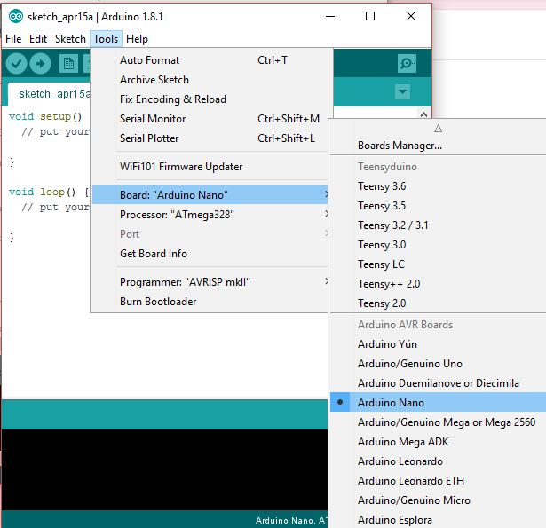

- Plug in the USB cord and Then do this: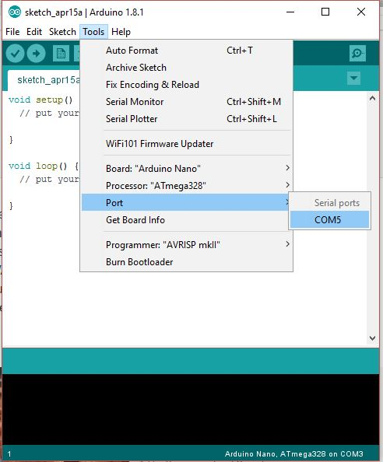
  - *It may say something different like COM3, COM4, etc. That’s normal. Don’t Freak Out!*
- From here you should be all set! Typically after you restart your computer, Arduino likes to go back to default settings. So just redo steps 5 and 6 whenever you restart.
Circuit 1
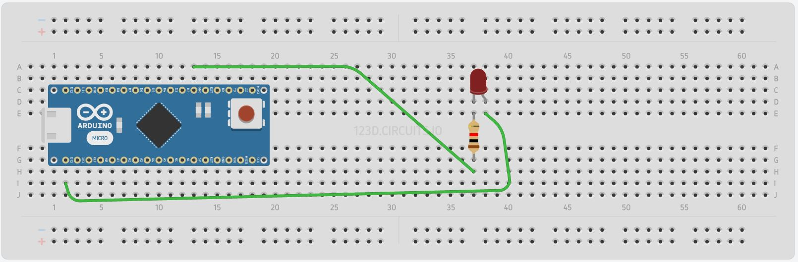
Circuit 1:
What Does it do?:
This circuit creates one blinking LED!

Instructions:
- Place electronic components in positions as shown in the diagram.
  - Since it’s hard to se…..
    - Top Green: GND
    - Bottom Green: D13
- Open the Arduino Software
- Follow the picture and select “Circuit 1”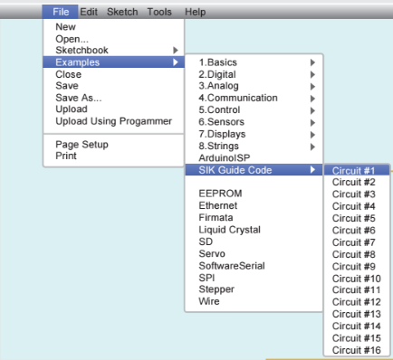
- Click Upload (the right arrow in the corner) to Upload the code to your circuit
- Your Circuit is now complete!

Feel free to adjust the code or change the circuit to experiment with different outcomes!

Circuit 2:
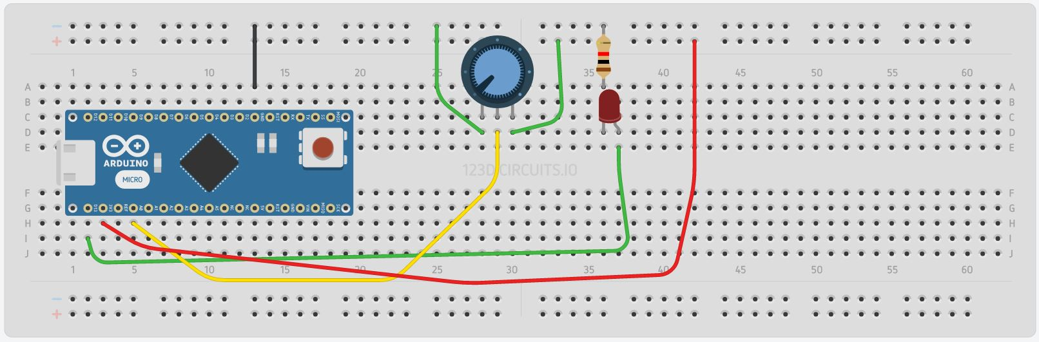\

Circuit 2:
What Does it do?:
This circuit allows you to change the blink speed of one LED!

Instructions:
- Place electronic components in positions as shown in the diagram.
  - Since it’s hard to see:
    - Black: GND
    - Red: 3V
    - Green Bottom: D13
    - Yellow: A0
- Open the Arduino Software
- Follow the picture and select “Circuit 2”
- Click Upload (the right arrow in the corner) to Upload the code to your circuit
- Your Circuit is now complete!

Feel free to adjust the code or change the circuit to experiment with different outcomes!
Circuit 3:
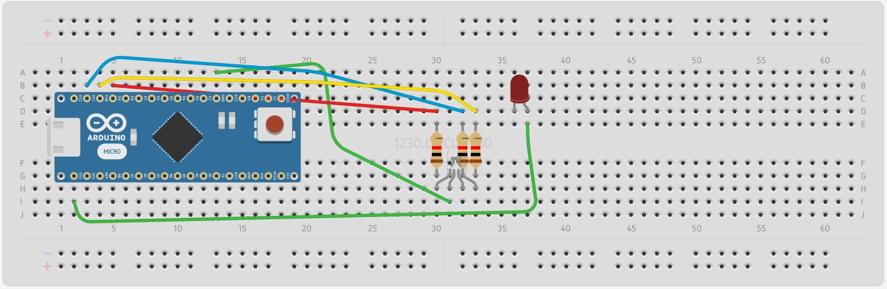
Circuit 3:
What Does it do?:
This circuit uses and RGB LED to create multiple colors!

Instructions:
- Place electronic components in positions as shown in the diagram.
  - Ignore the red LED and wire attached to it. I Forgot to delete that.
  - Since it’s hard to see….
    - Blue: D11
    - Yellow: D10
    - Red: D9
    - Top Green: GND
- Open the Arduino Software
- Follow the picture and select “Circuit 3”
- Click Upload (the right arrow in the corner) to Upload the code to your circuit
- Your Circuit is now complete!

Feel free to adjust the code or change the circuit to experiment with different outcomes!

Circuit 4:
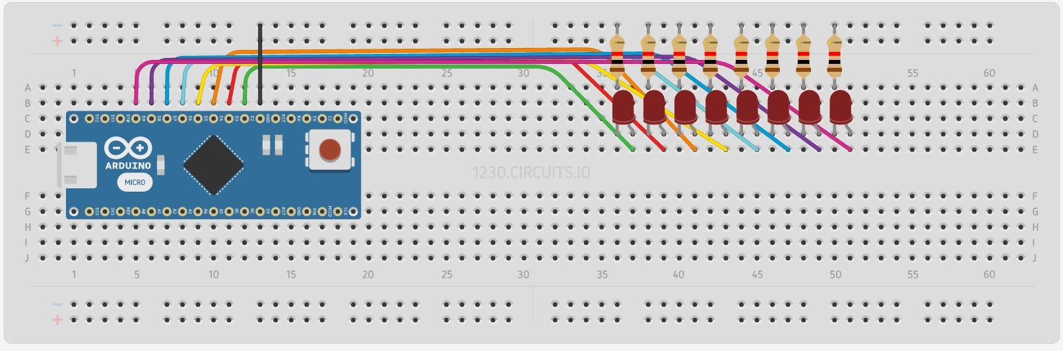
Circuit 4:
What Does it do?:
This circuit creates an array of blinking LEDs

Instructions:
- Place electronic components in positions as shown in the diagram.
  - Since it’s hard to see…..
    - Black GND
    - Green: D2
    - Colors following that will increase in oder (D3, D4, D5, D6, D7, D8, D9)
- Open the Arduino Software
- Follow the picture and select “Circuit 4”
- Click Upload (the right arrow in the corner) to Upload the code to your circuit
- Your Circuit is now complete!

Feel free to adjust the code or change the circuit to experiment with different outcomes!

Making your own Circuit!
Some things to remember:

- Each LED needs one resistor
- Each RGB LED needs 3 resistors
- The Circuit must always connect to ground (negative) and 3v (positive).
- Use the original Circuits as a guide to help construct your own circuits
- If you do not know how to code, ask for help! Someone can assist you to get your circuit functioning as you would like :D

*Below are some Breadboards. Use them to draw out your circuits!*
