**“Mobile Applications Development”**

**course**

**a.y. 2013-2014**

**YOUR_APP_NAME**

**Design[1],[2]**

|  |  |  |
| --- | --- | --- |
| **Team Members[3]** | | |
| **Name** | **Student Number** | **E-mail address** |
|  |  |  |
|  |  |  |
|  |  |  |
|  |  |  |
|  |  |  |

Strategy

# Product Overview

Very brief overview of the app

## Competitors

Identify possible competitors (up to 5-6) and evaluate your app against theirs (a paragraph for each competitor, no more). Here it is fundamental to explicitly show how and why your app is different from the other apps.

# User Research

Describe the NEEDS that you want to fill with your app

Describe the main GOALS your app allows users to achieve

## Personas

Identify the classes of your target users by age, job, life style, etc.(usually an app targets 1-2, 3 classes of users at most)

Define a “persona” for each kind of target user identified in the previous section

Scope

**Features**

Provide a list of the main features of your app.

Specify explicitly the subset of features that you are planning to implement in the final project.

**Scenarios**

Propose a set of scenarios that describe how each “persona” can interact with your app (here it is mandatory to use the same personas you defined in the previous chapter).

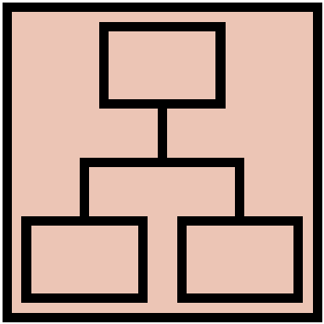Structure

# Navigation model

Navigation model of your app.

Description of its main parts and the relevant choices you made.

# Vocabulary

Provide a well-defined terminology for all the content and tasks you manage in your app.

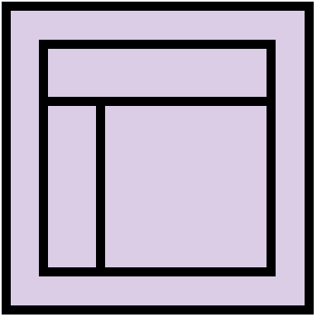Skeleton

Lo-Fi Wireframes of your app. In this phase you have to 1) create your wireframes by hand with paper, pen, colors, etc., and 2) include their scans in this document.

Description of the relevant choices you made about the user interaction and how information flows among views. Here you must also report some alternatives you discarded and motivate your choice.

Surface

Provide an Hi-Fi Wireframes of a single view of your app. Please choose a representative view to show here.

Description of the relevant choices you made about the layout, colors, textures, UI design, user interaction, etc. Here you can use also mockups, prototypes, photos, etc.

1. The max length of this document is 20 pages
2. The structure of this document is fixed, it cannot be changed in any way
3. The team leader is listed as first member in this list