ABSTRACT
Recruitment is one of the most critical and challenging functions in modern organizations, where early and accurate candidate screening plays a vital role in improving hiring quality and operational efficiency. Traditional recruitment processes, such as manual resume screening, written examinations, and preliminary interviews, are time-consuming, resource-intensive, and susceptible to human bias and inconsistency. With the increasing volume of job applications, there is a growing need for automated and intelligent screening mechanisms. Recent advancements in artificial intelligence (AI), automation, and data-driven systems have shown significant potential in transforming recruitment workflows by improving efficiency, consistency, and decision quality.

This study proposes an intelligent AI-based HR screening system that integrates automated resume screening, structured online assessments, and centralized candidate scoring to support effective recruitment decision-making. The system utilizes Applicant Tracking System (ATS)-based resume analysis to evaluate resume relevance against job requirements, followed by Python-based online assessments to measure candidates’ technical knowledge and aptitude. A composite scoring mechanism combines resume scores, application data, and assessment results to generate an objective shortlist of candidates. The application and job management functionalities are implemented using Streamlit, while Snowflake serves as the centralized data repository. Power BI is employed to visualize shortlisted candidates and performance metrics for HR decision-makers.

The proposed system was evaluated using sample candidate datasets to analyze its screening accuracy, consistency, and efficiency. Experimental results indicate that the automated screening framework significantly reduces manual effort, improves shortlisting accuracy, and ensures consistent evaluation compared to traditional recruitment methods. The centralized scoring and ranking mechanism enables recruiters to make faster and more informed hiring decisions.

This work contributes to AI-driven recruitment research by presenting a scalable, automated, and practical screening framework suitable for real-world hiring scenarios. The findings suggest that intelligent HR screening systems can enhance recruitment transparency, reduce administrative workload, and improve overall hiring effectiveness. Future enhancements may include the integration of explainable AI techniques, predictive analytics for hiring outcomes, and advanced interview analysis to further strengthen recruitment intelligence.

CHAPTER 1: INTRODUCTION

CHAPTER 1: INTRODUCTION

1.1 Background of the Study
Recruitment and selection of suitable candidates is one of the most important functions of Human Resource (HR) management in any organization. Traditionally, the hiring process involves manual collection of resumes, shortlisting based on basic criteria, conducting written tests, and performing personal interviews. As organizations grow and job opportunities increase, the number of applicants for each position also rises significantly. This makes manual recruitment processes complex, time-consuming, and inefficient.

In conventional recruitment systems, HR professionals spend a considerable amount of time reviewing resumes and evaluating candidates based on subjective judgment. This often leads to inconsistencies, human bias, and the possibility of overlooking qualified candidates. Moreover, managing large volumes of candidate data without proper automation becomes difficult and error-prone.

With advancements in artificial intelligence, machine learning, and natural language processing, there is a growing need to modernize recruitment systems. Automated resume screening, online assessments, and AI-based candidate evaluation have emerged as effective solutions to overcome the limitations of traditional hiring methods.

The AI-Based HR Screening and Candidate Evaluation System is developed to address these challenges by introducing automation into the recruitment process. The system integrates resume analysis using an Applicant Tracking System (ATS), technical assessments, and AI-driven screening to evaluate candidates in a structured manner. By leveraging cloud-based data storage and intelligent evaluation techniques, the system aims to improve accuracy, reduce bias, and enhance the overall efficiency of the recruitment process.

1.2 Problem Statement

In many organizations, the recruitment process is still carried out using traditional and manual methods. Human Resource departments are required to screen a large number of resumes, conduct written examinations, and perform interviews for each job vacancy. This manual approach consumes significant time and effort and often delays the hiring process.

One of the major challenges in the existing recruitment system is the reliance on human judgment for resume screening and candidate evaluation. This can result in inconsistency, human bias, and inaccurate shortlisting of candidates. Additionally, handling large volumes of applicant data without proper automation increases the risk of errors and inefficiency.

Traditional recruitment systems also lack the ability to objectively analyze candidate skills, communication abilities, and overall suitability for a job role. There is no integrated mechanism to combine resume analysis, technical assessment, and screening evaluation into a single structured process. As a result, organizations may fail to identify the most suitable candidates in an efficient and transparent manner.

Therefore, there is a need for an intelligent and automated recruitment system that can streamline the hiring process, reduce manual effort, eliminate bias, and provide accurate candidate evaluation. The proposed AI-Based HR Screening and Candidate Evaluation System aims to address these challenges by using artificial intelligence, automated assessments, and data-driven decision-making to improve the effectiveness of recruitment processes.

1.3 Objectives of the Study
The main objective of this study is to design and develop an AI-Based HR Screening and Candidate Evaluation System that automates and improves the traditional recruitment process by integrating artificial intelligence, online assessments, and data-driven evaluation techniques. The system aims to assist Human Resource departments in efficiently shortlisting suitable candidates while reducing manual effort, time consumption, and human bias.
The detailed objectives of the study are as follows:
- To automate the resume screening process using an Applicant Tracking System (ATS) approach.
This objective focuses on analyzing candidate resumes by extracting relevant information and comparing it with job descriptions. The ATS mechanism helps in identifying suitable candidates based on skill relevance, experience, and qualification, thereby eliminating manual resume filtering.
- To implement an online technical assessment module for evaluating candidate skills.
The system aims to conduct structured online assessments to test candidates’ technical knowledge and aptitude. Automated evaluation of assessment responses ensures fairness, consistency, and accuracy in scoring.
- To integrate an AI-based screening mechanism for candidate evaluation.
This objective involves using artificial intelligence to evaluate candidates through a chat-based screening process. The AI system analyzes communication skills, response quality, and professionalism to provide an additional screening score.
- To provide a centralized cloud-based data storage system.
The system aims to securely store candidate information, resumes, assessment scores, and screening results in a cloud database. Centralized data management ensures easy access, scalability, and efficient handling of large volumes of recruitment data.
- To generate a comprehensive final evaluation score for each candidate.
By combining ATS scores, technical assessment results, and AI screening scores, the system produces a final score that helps HR professionals objectively rank and shortlist candidates.
- To reduce human bias and subjectivity in recruitment decisions.
Automation and standardized evaluation methods minimize the influence of personal bias and inconsistency, ensuring a fair and transparent recruitment process.

1.4 Significance of the Study
The significance of this study lies in its contribution to improving and modernizing the recruitment process through the application of artificial intelligence and automation techniques. In today’s competitive job market, organizations face challenges in efficiently handling a large number of job applications while ensuring fairness and accuracy in candidate selection. This study addresses these challenges by proposing an intelligent and automated HR screening system.
The AI-Based HR Screening and Candidate Evaluation System significantly reduces the manual effort involved in resume screening, assessment evaluation, and initial candidate interviews. By automating these processes, the system saves time and enables Human Resource professionals to focus on higher-level decision-making and strategic activities.
Another important significance of this study is the reduction of human bias in recruitment. Traditional hiring processes often depend on subjective judgment, which may lead to inconsistency and unfair selection. The proposed system uses standardized evaluation criteria and data-driven techniques to ensure objective and transparent candidate assessment.
The study also highlights the importance of integrating multiple evaluation stages such as resume analysis, technical assessment, and AI-based screening into a single platform. This integrated approach provides a comprehensive view of candidate performance and improves the accuracy of shortlisting decisions.
Furthermore, the use of cloud-based data storage enhances scalability, security, and accessibility of recruitment data. Organizations can efficiently manage large volumes of applicant information and retrieve evaluation results whenever required.
Overall, this study demonstrates how artificial intelligence can be effectively applied in the field of human resource management to improve efficiency, accuracy, and fairness in recruitment processes, making it highly significant for modern organizations and academic research.

CHAPTER 2: LITERATURE SURVEY / REVIEW OF LITERATURE

CHAPTER 2 : LITERATURE SURVEY / REVIEW OF LITERATURE
2.1 Introduction
In recent years, the recruitment and selection process has evolved due to advancements in information technology and artificial intelligence. Organizations receive a large number of job applications for each vacancy, making traditional recruitment methods time-consuming and inefficient. This has created a need for automated systems that can support Human Resource (HR) departments in screening and evaluating candidates effectively.
The literature survey provides an overview of existing research and technologies related to recruitment automation. It focuses on the use of Applicant Tracking Systems (ATS), resume parsing techniques, machine learning algorithms, and artificial intelligence for candidate evaluation. Many studies highlight the role of natural language processing in matching candidate skills with job requirements.
Recent research also emphasizes online assessment platforms and AI-based screening methods to evaluate candidates’ technical knowledge and communication skills. These approaches aim to reduce human bias and ensure consistent evaluation. This chapter reviews such existing work to identify limitations and research gaps that lead to the development of the proposed AI-Based HR Screening and Candidate Evaluation System.
2.2 Existing Recruitment and Candidate Screening Systems
2.2.1 Traditional Recruitment Systems
Traditional recruitment systems rely heavily on manual processes such as collecting resumes, reviewing applications, conducting written tests, and scheduling interviews. In this approach, Human Resource personnel manually screen resumes based on qualifications, experience, and personal judgment. While this method allows direct human involvement, it is highly time-consuming, inefficient, and prone to human bias, especially when the number of applicants is large.

2.2.2 Applicant Tracking Systems (ATS)
Applicant Tracking Systems (ATS) were introduced to automate resume screening and manage large volumes of job applications. These systems analyze resumes by matching keywords related to skills, education, and experience with job descriptions. ATS improves efficiency and reduces manual effort; however, keyword-based matching often lacks contextual understanding and may reject suitable candidates whose resumes do not strictly follow predefined formats.

2.2.3 Online Assessment-Based Recruitment Systems
Some existing recruitment systems include online technical assessments to evaluate candidates’ knowledge and aptitude. These systems conduct multiple-choice or objective tests and automatically calculate scores. While online assessments ensure consistency and fairness in evaluation, they mainly focus on technical skills and fail to assess communication skills, behavior, and overall personality of candidates.
2.2.4 AI-Based Screening and Interview Systems
Recent advancements in artificial intelligence have led to the development of AI-based screening and interview systems. These systems use chatbots or virtual interviewers to interact with candidates and analyze their responses. AI-based systems attempt to evaluate communication skills and behavioral traits; however, many such systems work independently and are not fully integrated with resume screening and assessment modules.
2.2.5 Limitations of Existing Systems
Although existing recruitment systems provide partial automation, they suffer from several limitations such as lack of complete integration, limited intelligence, dependency on keyword-based filtering, and inability to provide comprehensive candidate evaluation. These limitations highlight the need for an advanced, integrated, and intelligent recruitment system.

2.3 Study of Machine Learning Techniques Used in Automated HR Screening Systems
Machine learning (ML) techniques have significantly transformed automated HR screening systems by providing data-driven insights that improve the accuracy and efficiency of candidate evaluation. These techniques enable automatic analysis of resumes, skill matching, and candidate ranking based on job requirements using statistical and natural language processing methods. Different ML approaches vary in terms of their methodology, feature extraction process, and computational complexity. This section focuses on the study of machine learning techniques used in automated HR screening systems, highlighting their advantages and limitations in supporting efficient, scalable, and unbiased recruitment processes.
2.3.1 Feature Extraction and Learning Approach in Automated HR Screening
Machine learning techniques used in automated HR screening systems rely on extracting meaningful features from candidate data such as resumes and application details. Relevant features including skills, educational background, work experience, and keywords are identified from resume text using preprocessing and text vectorization methods. The extracted features are then converted into numerical form to enable effective comparison between candidate profiles and job requirements.
The learning approach in HR screening systems is based on statistical and natural language processing techniques that compute relevance scores and rank candidates accordingly. These methods are computationally efficient and suitable for handling large volumes of applicant data. However, the accuracy of the screening process largely depends on the quality of feature extraction and preprocessing, making careful feature selection essential for reliable and unbiased candidate evaluation.

2.3.2 Performance and Accuracy of Machine Learning Techniques in HR Screening
Several studies have evaluated the performance of machine learning techniques in automated HR screening systems. Traditional machine learning methods used for resume screening and candidate evaluation have shown good accuracy in identifying suitable candidates based on structured and textual data such as skills, qualifications, and work experience. These techniques provide reliable results when processing resume content and assessment scores, especially in scenarios involving large volumes of applicant data.
However, the performance and accuracy of machine learning–based HR screening systems largely depend on the quality of feature extraction and preprocessing. Since these systems rely on text-based and structured candidate information, their effectiveness may be limited when candidate profiles lack sufficient or well-formatted data. Despite this limitation, machine learning techniques remain efficient, interpretable, and computationally suitable for automated HR screening, making them effective for practical recruitment applications.

2.3.3 Generalization and Scalability of Machine Learning-Based HR Screening Systems
Machine learning techniques used in HR screening systems are relatively easy to implement and can be effectively trained using small to medium-sized datasets, making them suitable for organizations with limited recruitment data. These models can efficiently analyze structured and text-based candidate information such as resumes and assessment scores. However, when trained on limited or biased data, machine learning models may face challenges in generalizing across diverse job roles, industries, and applicant profiles.
In terms of scalability, machine learning–based HR screening systems can handle large volumes of applications by automating resume analysis and candidate ranking processes. Their scalability depends on proper feature extraction, data preprocessing, and consistent job requirement definitions. Although these systems are computationally efficient and transparent compared to more complex models, continuous data updates and periodic model tuning are necessary to ensure reliable performance and adaptability in real-world recruitment environments.

Comparison of Machine Learning and AI-Based Techniques in HR Screening
Factor | Machine Learning Techniques | AI-Based Models (Pre-trained)
Feature Extraction | Manual feature extraction from resumes | Automatic pattern extraction
Data Requirement | Small to medium datasets | Large datasets (pre-trained)
Performance | Moderate accuracy | High accuracy
Computational Cost | Low (CPU-based) | High (cloud-based)
Interpretability | High (easy to explain) | Low (black-box)
Application | Resume screening, ranking | AI-based candidate screenin

2.4 Research Gaps in Automated HR Screening and Recruitment Systems
Despite advancements in machine learning and artificial intelligence for automated HR screening and recruitment, several critical research gaps remain that limit their widespread adoption in real-world organizational environments. Addressing these gaps is essential for improving the accuracy, fairness, reliability, and practical applicability of AI-driven recruitment systems.
2.4.1 Data Availability and Quality in Automated HR Screening Systems
One of the key challenges in automated HR screening systems is the availability and quality of recruitment data. Candidate information such as resumes and application details is often unstructured, inconsistent, or incomplete, which affects accurate feature extraction and evaluation. In addition, data imbalance across job roles and candidate profiles can lead to biased screening results. Ensuring reliable, standardized, and balanced data remains a significant research gap in automated HR screening systems.
2.4.2 Model Interpretability and Explainability in Automated HR Screening Systems
Many automated HR screening systems lack clear interpretability, making it difficult for HR professionals to understand the reasons behind candidate selection or rejection. This lack of explainability reduces trust in AI-based recruitment systems and raises concerns about transparency and fairness. Improving model interpretability remains an important research gap for the effective adoption of automated HR screening systems
2.4.3 Real-Time Processing and Computational Challenges in Automated HR Screening Systems
Automated HR screening systems require sufficient computational resources to process resumes, assessments, and candidate evaluations in real time. Limited infrastructure or reliance on cloud services may cause delays and affect system responsiveness. Improving computational efficiency and real-time performance remains a key research gap in the practical deployment of automated HR screening systems.

2.4.4 Integration with Multi-Modal Candidate Data in Automated HR Screening Systems
Most existing automated HR screening systems rely on a single type of data, such as resumes or assessment scores, while ignoring other important candidate information. However, effective recruitment decisions often require the integration of multiple data sources, including resume content, application details, assessment performance, and AI-based screening responses. The lack of multi-modal data integration limits the accuracy and completeness of candidate evaluation.
2.4.5 Lack of Large-Scale Real-World Validation in Automated HR Screening Systems
While many automated HR screening systems demonstrate promising performance in controlled or experimental settings, very few have been validated extensively in large-scale, real-world recruitment environments. Most systems are tested using limited datasets or simulated scenarios, which may not accurately represent diverse organizational hiring practices.
2.5 Contribution of the Proposed System
The proposed system addresses the limitations of traditional recruitment methods by introducing an AI-based automated HR screening framework. It integrates resume screening, assessment evaluation, and AI-driven candidate analysis to provide accurate and objective candidate evaluation. This approach improves recruitment efficiency, reduces human bias, and supports effective decision-making in large-scale hiring processes.
2.5.1 Hybrid AI-Based Candidate Evaluation System
The proposed system uses a hybrid AI-based approach that combines machine learning–based resume screening with AI-driven candidate evaluation. This integration enables analysis of resumes, assessment results, and screening responses within a single framework. The hybrid approach improves accuracy, fairness, and efficiency in candidate shortlisting compared to traditional recruitment methods.
2.5.2 Automated Feature Extraction and Decision Support
The proposed system automates the feature extraction process by analyzing candidate resumes and assessment data using machine learning and natural language processing techniques. Relevant features such as skills, experience, and qualifications are extracted automatically without manual intervention. In addition, the system provides clear evaluation scores and insights that support HR professionals in making informed recruitment decisions.
2.5.3 Web-Based User Interface for Easy Accessibility
To ensure ease of use and accessibility, the proposed system includes a web-based application developed using Streamlit. The interface allows HR administrators and candidates to interact with the system for tasks such as job posting, resume submission, assessment participation, and candidate evaluation.
2.5.4 Model Optimization for Efficiency
To address computational efficiency and performance requirements, the proposed system is designed using lightweight machine learning and AI-based techniques that can operate effectively on standard computing resources. Efficient feature extraction, optimized scoring mechanisms, and cloud-based deployment are used to ensure faster processing and scalability. This optimization enables the system to handle large volumes of candidate data efficiently, making it suitable for real-world recruitment environments.

CHAPTER 3: SYSTEM DESIGN AND ARCHITECTURE

CHAPTER 3: SYSTEM DESIGN AND ARCHITECTURE
3.1 System Overview
The proposed AI-Based HR Screening and Candidate Evaluation System is designed to automate and improve the recruitment process using machine learning and AI-based techniques. The system processes candidate data such as resumes, application details, and assessment responses to support objective and efficient candidate evaluation.
The system architecture consists of the following key components:
- Data Acquisition and Preprocessing – Collects and preprocesses candidate resumes and application data for analysis.
- Resume Screening Module – Uses machine learning techniques to evaluate resume relevance and generate ATS scores.
- Assessment and AI-Based Screening Module – Evaluates candidates through online assessments and AI-driven screening interactions.
- Decision Support and User Interface – Combines evaluation results and provides a web-based interface for HR administrators and candidates. The system can be deployed on cloud platforms for scalability and accessibility.

3.2 UML Diagrams
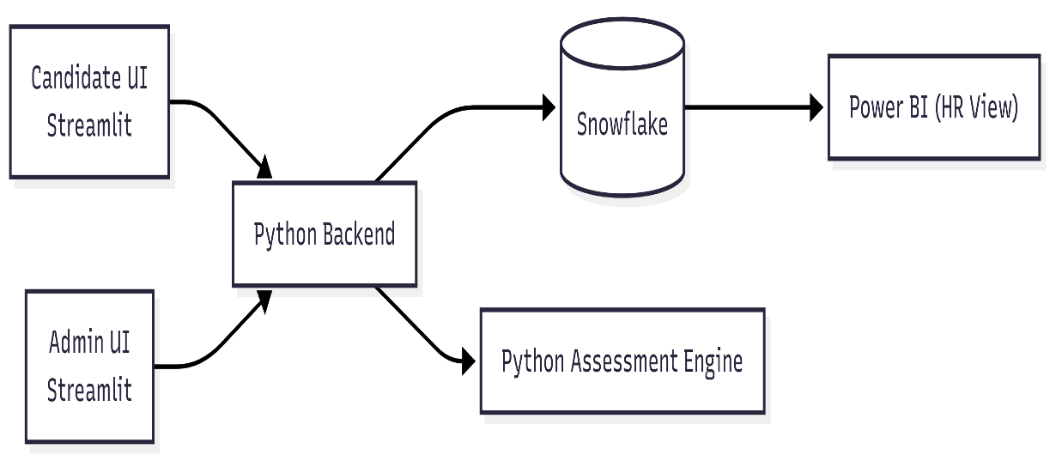
SYSTEM ARCHITECTURE DIAGRAM

DATA PROCESSING FLOW DIAGRAM

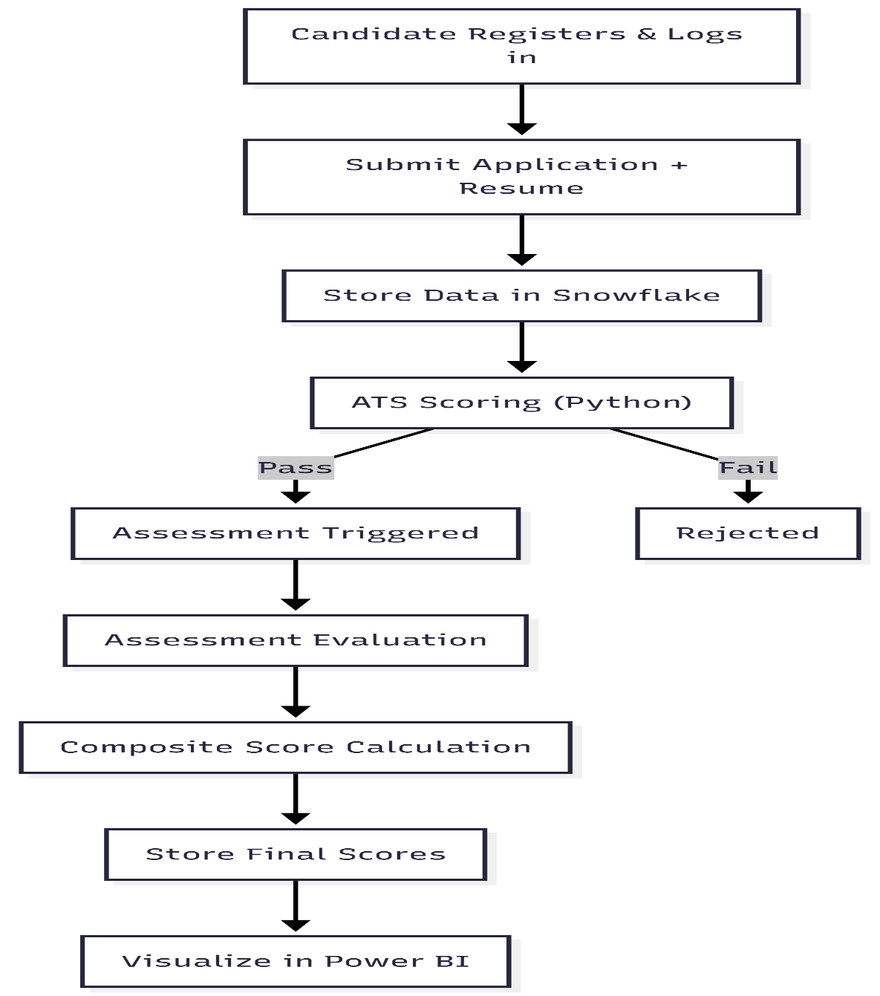

MODEL STRUCTURE DIAGRAM

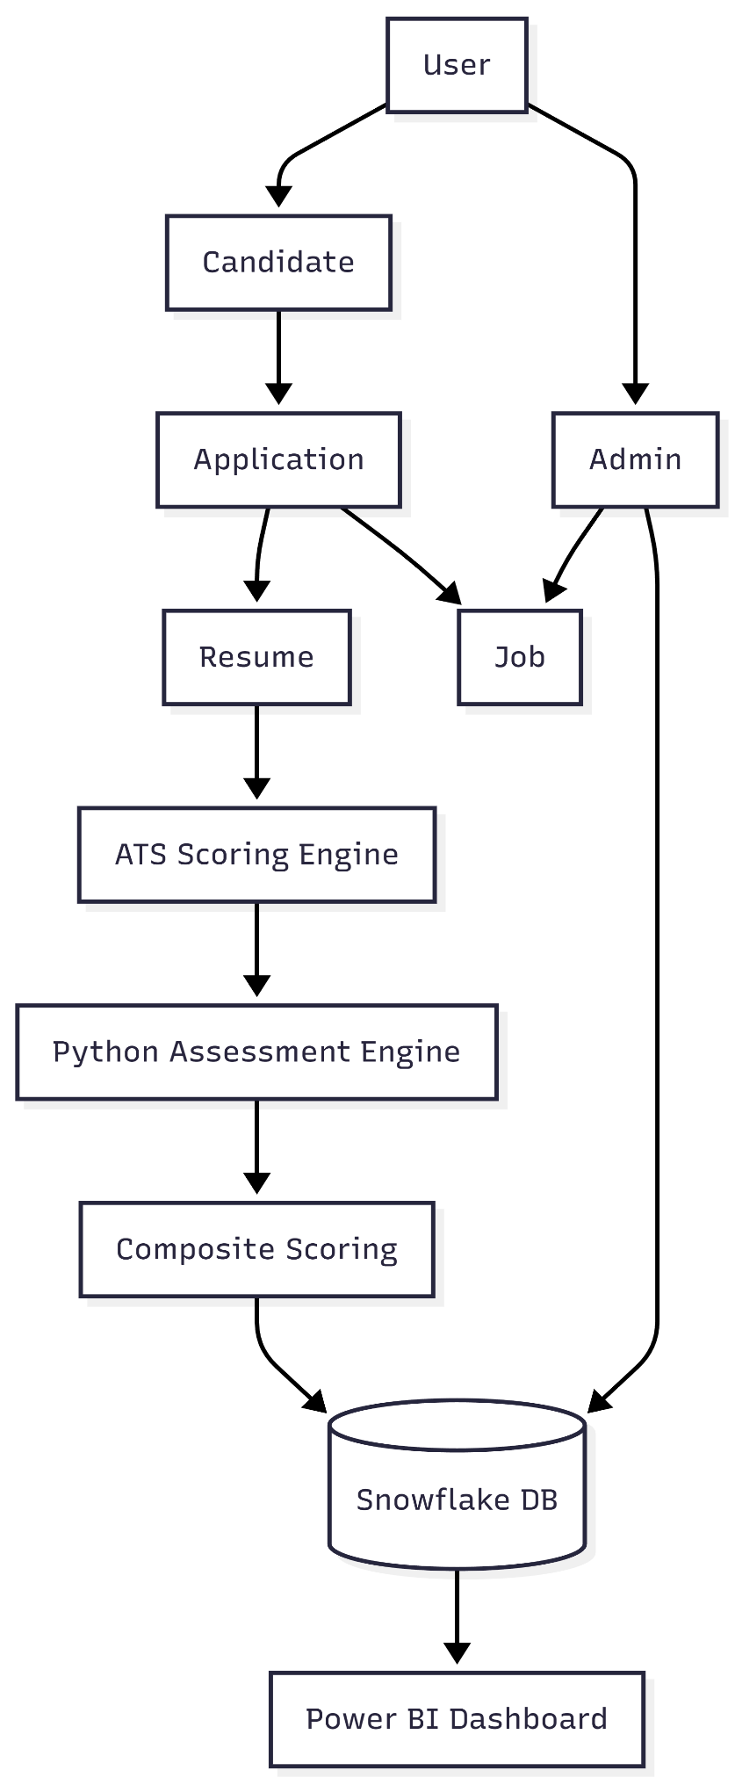

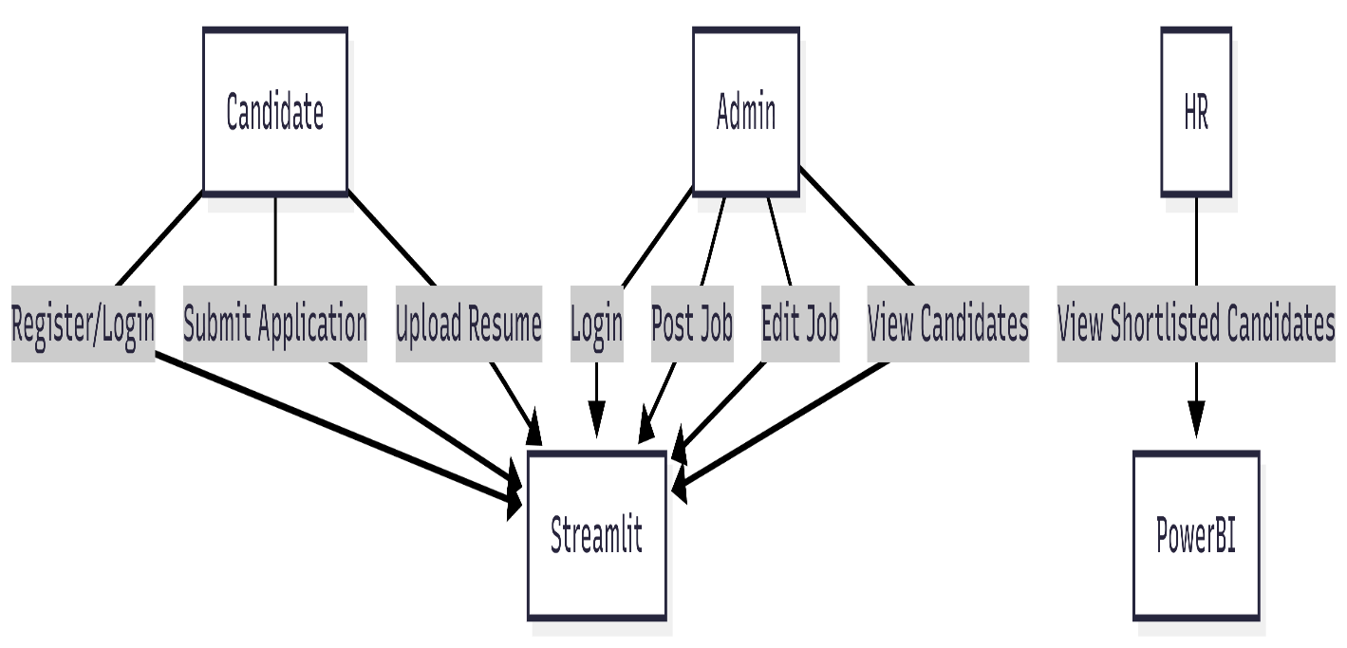
CASE DIAGRAM

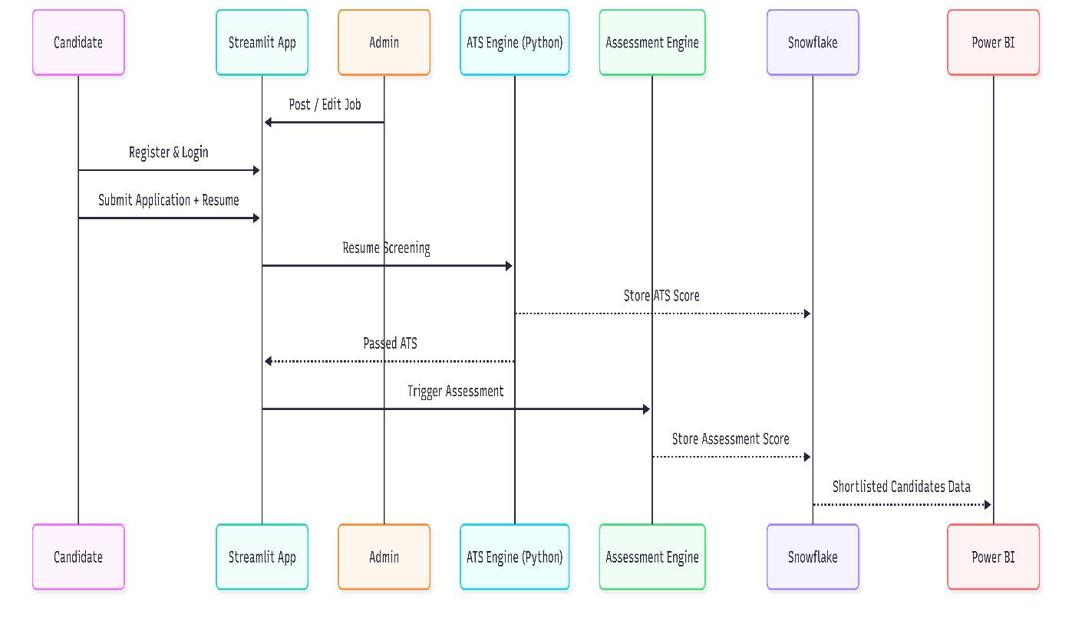
Sequence Diagram

CLASS DIAGRAM
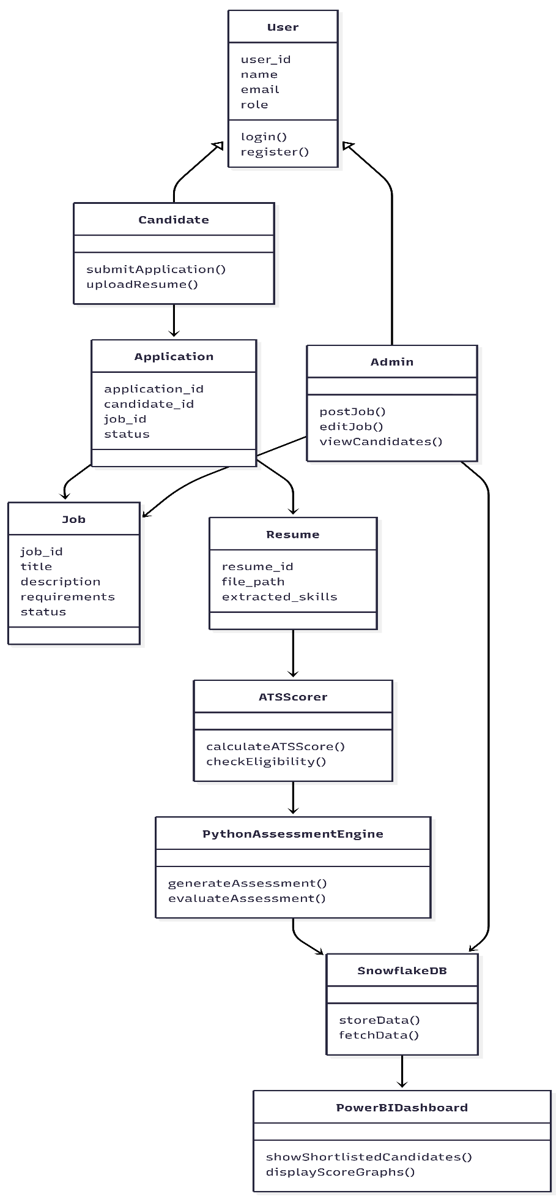

ACTIVITY DIAGRAM
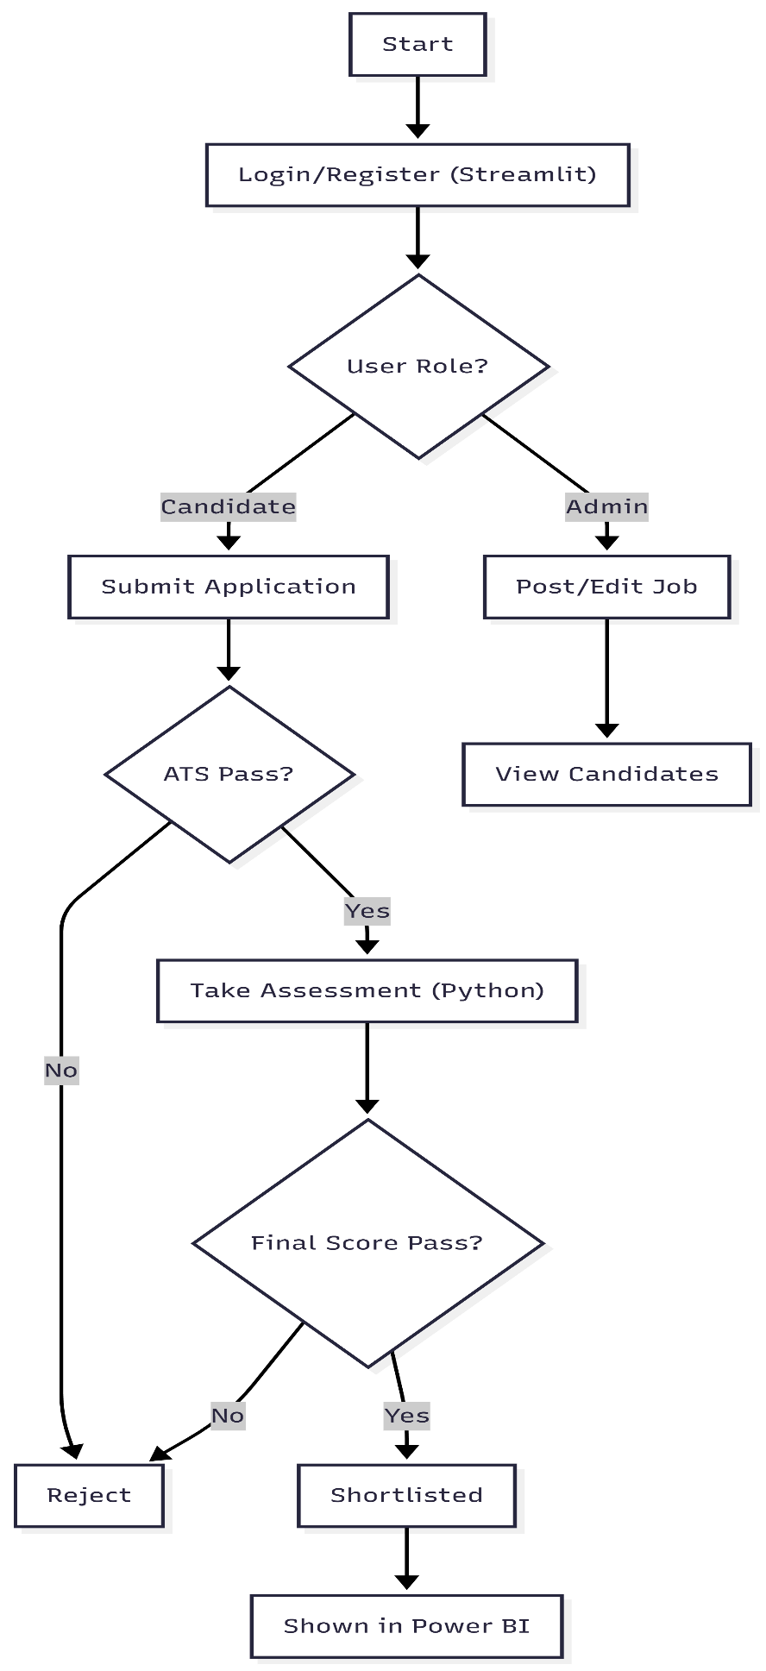

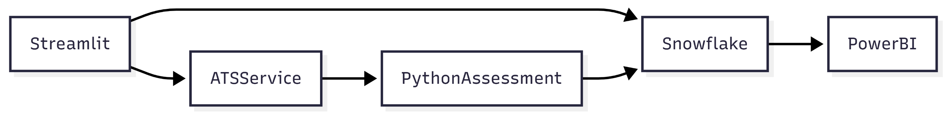
COMPONENT DIAGRAM
DEPLOYMENT DIAGRAM
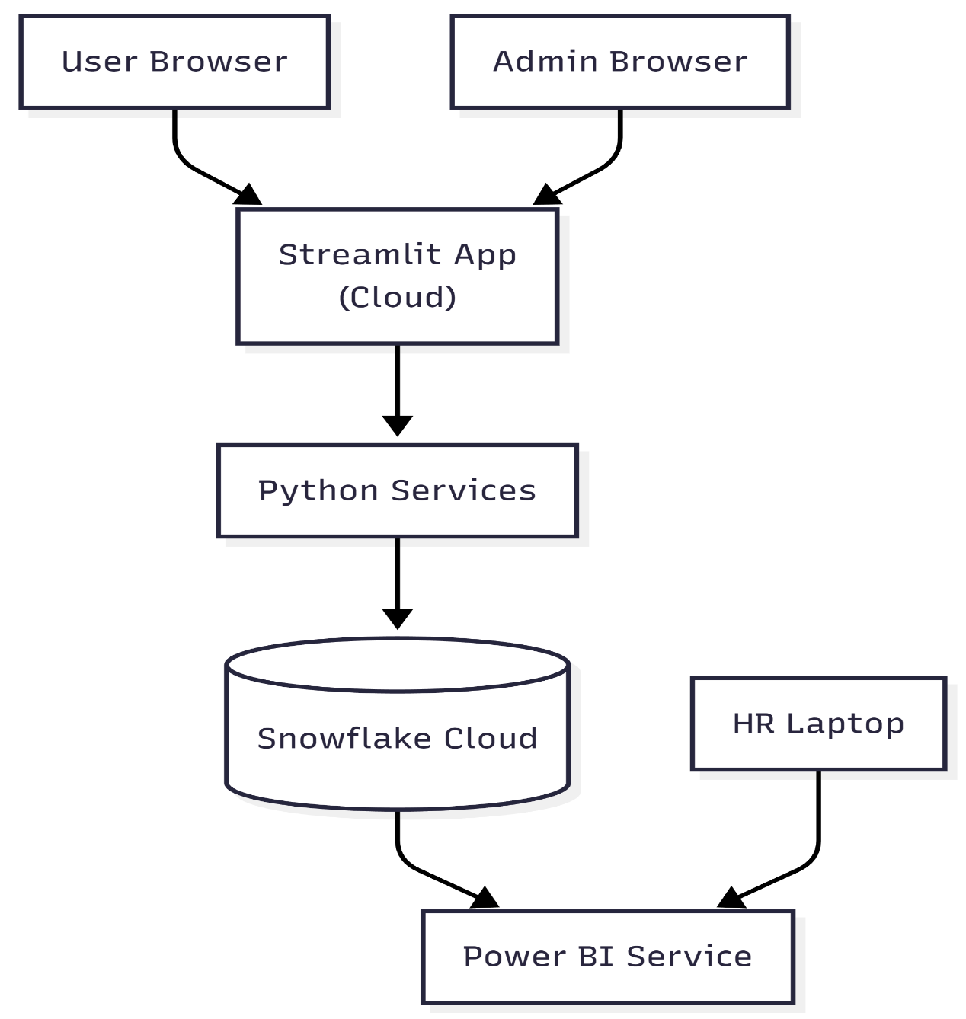

STATE DIAGRAM
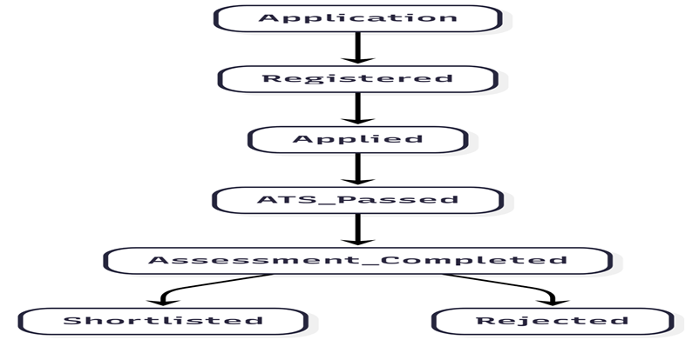

3.3 System Architecture
The system architecture of the proposed AI-Based HR Screening and Candidate Evaluation System is designed to integrate machine learning and AI-based components to automate and improve the recruitment process. The architecture consists of multiple interconnected layers that ensure smooth data flow, efficient processing, and accurate candidate evaluation.
At the core of the system is the Data Acquisition Layer, which collects candidate information such as resumes, application details, and assessment responses. This data is then processed by the Preprocessing and Feature Extraction Layer, where resume text is cleaned, normalized, and converted into meaningful features, while assessment data is structured for evaluation.
Following preprocessing, the Resume Screening and Evaluation Layer applies machine learning and natural language processing techniques to analyze resumes and compare them with job descriptions to generate ATS relevance scores. In parallel, the Assessment and AI-Based Screening Layer evaluates candidates’ technical performance and screening responses to assess knowledge and communication skills.
The outputs from these evaluation layers are combined in the Decision Support Layer, which aggregates scores from resume screening, assessments, and AI-based screening to produce a final candidate evaluation score. This supports objective and data-driven candidate shortlisting.
The final results are presented through the User Interface Layer, developed using Streamlit, where HR administrators and candidates can interact with the system for job postings, resume submission, assessments, and result viewing. The system also integrates a Cloud Database Layer to securely store candidate data, evaluation scores, and recruitment records, ensuring scalability and accessibility.
This architecture ensures efficiency, scalability, and transparency, making the proposed system an effective decision-support tool for modern recruitment processes.
3.4 Data Flow Diagram (DFD)
The Data Flow Diagram (DFD) illustrates how data flows through the proposed AI-Based HR Screening and Candidate Evaluation System and explains the interaction between various system components. The system follows a layered and structured workflow to ensure efficient and accurate candidate screening and evaluation.
Level 0 DFD (Context Diagram)
At Level 0, the system interacts with two primary external entities: the Candidate/HR User and the Database. Candidates provide inputs such as resumes and assessment responses, while HR administrators provide job requirements and manage recruitment activities. The system processes this information and generates candidate evaluation results, which are stored in the database for retrieval and decision-making.
Level 1 DFD (Detailed Data Flow)
At Level 1, the system is divided into the following major processes:
- Data Input and Preprocessing
The system receives candidate resumes, application details, and assessment responses. Resume text undergoes cleaning, normalization, and formatting, while assessment data is structured for evaluation.
- Resume Screening and Feature Extraction
Relevant features such as skills, qualifications, and experience are extracted from resumes. Machine learning and natural language processing techniques are applied to compare resumes with job descriptions and generate ATS relevance scores.
- Assessment and AI-Based Screening Module
Candidate assessment responses and AI-based screening interactions are evaluated to analyze technical knowledge and communication skills.
- Decision Support and Result Generation
The outputs from resume screening and assessment modules are combined to generate a final candidate evaluation score. The results are then presented to HR administrators through the user interface and stored in the database.
Level 2 DFD (Detailed Subprocesses)
At Level 2, the internal decision-making processes are further detailed. The system assigns weightage to resume screening scores, assessment results, and AI-based screening outcomes to compute the final candidate score. Based on predefined criteria and confidence levels, candidates are ranked and shortlisted. The results are validated and stored, enabling continuous improvement and consistency in recruitment decisions.
This structured data flow ensures efficient processing, minimizes manual effort, and enhances accuracy in candidate evaluation, making the proposed system a reliable and scalable AI-driven recruitment solution.

CHAPTER 4: ALGORITHM IMPLEMENTATION

CHAPTER 4: ALGORITHM IMPLEMENTATION

4.1 Resume Screening Algorithm (TF-IDF + SVM Based)
The Resume Screening Algorithm is a key component of the proposed AI-Based HR Screening System. This algorithm is designed to automatically analyze candidate resumes and determine their relevance to a given job role. The system uses Natural Language Processing (NLP) and Machine Learning techniques, specifically TF-IDF for feature extraction and Support Vector Machine (SVM) for classification, to ensure accurate and unbiased screening.
The resume screening process begins when a candidate uploads their resume through the web-based application. The system accepts resumes in standard formats such as PDF or DOCX and converts them into plain text using text extraction techniques.
Once the resume text is extracted, a preprocessing stage is applied. In this stage, unnecessary elements such as punctuation, special characters, and stop words are removed. The text is converted into lowercase and tokenized into meaningful terms. This preprocessing step ensures that the resume content is clean and suitable for further analysis.
After preprocessing, TF-IDF (Term Frequency–Inverse Document Frequency) is applied to extract important features from the resume. TF-IDF assigns weights to words based on their importance in the resume relative to the entire dataset. Job-specific skills and keywords such as programming languages, tools, and technologies receive higher weights, while commonly occurring words receive lower weights. This step converts unstructured resume text into numerical vectors.
The numerical feature vectors are then passed to a Support Vector Machine (SVM) classifier. The SVM model is trained using labeled resume data to distinguish between suitable and unsuitable candidates. SVM is chosen because it performs well with high-dimensional text data and provides reliable classification results for resume screening tasks.
Based on the SVM prediction, each resume is assigned a relevance score and classified into categories such as highly suitable, moderately suitable, or not suitable. These results help recruiters quickly shortlist candidates whose skills and experience closely match the job requirements.
Finally, the screening results are displayed on the user interface, allowing HR professionals to view candidate scores, skill matches, and screening decisions. The Resume Screening Algorithm significantly reduces manual effort, improves screening accuracy, and ensures fairness in the recruitment process.

4.2 Online Assessment Evaluation Algorithm
The Online Assessment Evaluation Algorithm is designed to evaluate a candidate’s technical knowledge and aptitude through structured online tests. This module complements the resume screening process by providing an objective evaluation of candidate performance, ensuring a more accurate and reliable recruitment decision.
The assessment process begins when shortlisted candidates attempt an online test through the web-based application. The assessment consists of multiple-choice questions related to technical skills, aptitude, and job-specific knowledge. Each question has a predefined correct answer stored in the system.
Once the candidate submits the assessment, the system automatically processes the responses. The evaluation algorithm compares the candidate’s answers with the predefined answer key. For each correct answer, a fixed score is awarded, while incorrect answers receive no marks. This automated scoring mechanism eliminates manual evaluation errors and ensures fairness and consistency.
After evaluating all responses, the system calculates the total assessment score by summing the marks obtained across all questions. The score is then normalized to maintain uniformity across different assessments. This normalized score represents the candidate’s performance in the assessment phase.
The assessment score plays a crucial role in the overall candidate evaluation process. It provides insight into the candidate’s technical proficiency and problem-solving ability, which may not be fully captured through resume screening alone. Candidates with higher assessment scores demonstrate stronger subject knowledge and suitability for the job role.
Finally, the assessment evaluation results are stored in the database and displayed on the recruiter dashboard. HR professionals can view individual scores and use them in combination with resume screening results to make informed hiring decisions. The Online Assessment Evaluation Algorithm enhances recruitment accuracy by adding an objective, performance-based evaluation layer to the system.

4.3 Model Architecture and Hyperparameters
This section describes the model architecture and hyperparameters used in the proposed AI-Based HR Screening System. The system employs a combination of Natural Language Processing (NLP) techniques and Machine Learning models to analyze resumes and evaluate candidates effectively. Proper selection of model architecture and tuning of hyperparameters plays a crucial role in improving screening accuracy and system performance.
Model Architecture
The resume screening model follows a structured pipeline architecture consisting of multiple stages. First, the raw resume text is extracted and preprocessed to remove noise and irrelevant information. The cleaned text is then converted into numerical form using the TF-IDF (Term Frequency–Inverse Document Frequency) technique. TF-IDF transforms unstructured resume text into feature vectors that represent the importance of words related to job requirements.
These TF-IDF feature vectors are fed into a Support Vector Machine (SVM) classifier, which acts as the core classification model. The SVM model separates resumes into suitable and unsuitable categories by identifying an optimal decision boundary in high-dimensional feature space. This architecture is well suited for resume screening tasks because SVM performs efficiently on text-based, high-dimensional datasets and provides reliable classification results.
For assessment evaluation, a rule-based scoring model is used where candidate responses are compared against predefined correct answers. The assessment scores are generated independently and later combined with resume screening scores for final evaluation.
The overall architecture ensures modularity, where resume screening, assessment evaluation, and final decision-making are handled as independent yet integrated components.

Hyperparameters Used
Hyperparameters are predefined parameters that control the behavior and performance of the machine learning model. In this project, the following key hyperparameters are used:
- TF-IDF Parameters:
  - Maximum Features: Limits the number of features to avoid overfitting and reduce computational cost.
  - N-gram Range: Determines whether single words or word combinations are considered for feature extraction.
  - Stop Words: Common words are removed to focus on meaningful resume content.
- SVM Hyperparameters:
  - Kernel: Linear kernel is used for efficient text classification.
  - Regularization Parameter (C): Controls the trade-off between maximizing the margin and minimizing classification error.
  - Gamma: Defines the influence of individual training samples (used when non-linear kernels are applied).
- Assessment Scoring Parameters:
  - Score Weightage: Determines the contribution of assessment score in the final evaluation.
  - Normalization Factor: Ensures assessment scores are comparable across different tests.
These hyperparameters are selected through experimentation and validation to achieve optimal classification accuracy while maintaining computational efficiency.

Model Performance Considerations
The combination of TF-IDF and SVM provides a balance between accuracy and interpretability. TF-IDF ensures relevant skills and keywords are highlighted, while SVM effectively classifies resumes based on these features. Proper hyperparameter tuning helps prevent overfitting, improves generalization, and enhances overall system reliability.

4.2 Online Assessment Evaluation Algorithm
The Online Assessment Evaluation Algorithm is designed to evaluate a candidate’s technical knowledge and aptitude through structured online tests. This module complements the resume screening process by providing an objective evaluation of candidate performance, ensuring a more accurate and reliable recruitment decision.
The assessment process begins when shortlisted candidates attempt an online test through the web-based application. The assessment consists of multiple-choice questions related to technical skills, aptitude, and job-specific knowledge. Each question has a predefined correct answer stored in the system.
Once the candidate submits the assessment, the system automatically processes the responses. The evaluation algorithm compares the candidate’s answers with the predefined answer key. For each correct answer, a fixed score is awarded, while incorrect answers receive no marks. This automated scoring mechanism eliminates manual evaluation errors and ensures fairness and consistency.
After evaluating all responses, the system calculates the total assessment score by summing the marks obtained across all questions. The score is then normalized to maintain uniformity across different assessments. This normalized score represents the candidate’s performance in the assessment phase.
The assessment score plays a crucial role in the overall candidate evaluation process. It provides insight into the candidate’s technical proficiency and problem-solving ability, which may not be fully captured through resume screening alone. Candidates with higher assessment scores demonstrate stronger subject knowledge and suitability for the job role.
Finally, the assessment evaluation results are stored in the database and displayed on the recruiter dashboard. HR professionals can view individual scores and use them in combination with resume screening results to make informed hiring decisions. The Online Assessment Evaluation Algorithm enhances recruitment accuracy by adding an objective, performance-based evaluation layer to the system.

CHAPTER 5: SOFTWARE REQURIMENTS AND THE STEP

CHAPTER 5:SOFTWARE REQUIREMENTS AND IMPLEMENTATION STEPS

Step 1: Prepare the System Environment for Project Development
Before starting the development of the AI-Based HR Screening System, it is necessary to ensure that the system environment is properly prepared to support the required development tools and technologies.
First, the system requirements are verified to confirm that the computer supports the software tools used in the project, such as Python, Visual Studio Code, and related machine learning libraries. This includes checking the operating system version, processor capability, available RAM, and disk space.
Next, the user performing the setup must have administrator permissions on the system. Administrative access is required to install development tools, configure environment variables, and manage project dependencies.
The system is then updated with the latest Windows updates to ensure compatibility, security, and availability of essential system components needed for smooth execution of the development environment.
After applying updates, the system is restarted to ensure that all pending installations and background processes are completed and do not interfere with further setup.
Additionally, sufficient free disk space is ensured by removing unnecessary files and applications using system utilities such as Disk Cleanup. Adequate storage is important for installing libraries, storing project files, and running the application efficiently.
The development environment also supports side-by-side installations of development tools, allowing multiple versions of software (such as different Python versions or code editors) to coexist without conflicts. This flexibility helps in maintaining compatibility with project requirements.

Step 2: Select the Appropriate Development Tools and Edition
After preparing the system environment, the next step is to select the appropriate development tools required for implementing the AI-Based HR Screening System. In this project, Visual Studio Code is chosen as the primary development environment due to its lightweight nature, flexibility, and strong support for Python and machine learning libraries.
The latest stable version of Visual Studio Code is downloaded from the official Microsoft website. The installer downloads a small setup file, which is then used to install the editor on the system. This version ensures compatibility with modern Python frameworks and extensions used in the project.
If Visual Studio Code or similar development tools are already installed on the system, the required extensions and updates can be added without reinstalling the entire application. Visual Studio Code supports side-by-side installation of extensions, allowing the user to work with multiple programming environments simultaneously.
In certain environments, such as institutional or managed systems, the installation source may be provided by an administrator or IT support. In such cases, the recommended version of the development tool is installed from the specified source to ensure consistency and compatibility.
Selecting the appropriate development environment ensures smooth coding, debugging, and integration of machine learning models and web application components used in the project.
Step 3: Initiate the Installation
After selecting the appropriate development tool, the next step is to initiate the installation process. In this project, Visual Studio Code / Visual Studio Installer is used to set up the development environment required for implementing the AI-Based HR Screening System. Administrator permissions are required to proceed with the installation.
Once the installer or bootstrapper file is downloaded, it is executed to begin the installation. The bootstrapper installs the latest version of the installer, which provides all necessary options to install and customize the development environment.
From the Downloads folder, the user double-clicks the setup file (such as VisualStudioSetup.exe or vs_community.exe) to start the installation process. If a User Account Control (UAC) prompt appears, the user selects Yes to allow the installer to make changes to the system.
The installer then displays the Microsoft License Terms and Privacy Statement. After reviewing the information, the user selects Continue to proceed. Once accepted, the installer window opens, allowing the user to proceed with selecting required components and completing the setup.
This step ensures that the development environment is correctly installed and ready for coding, testing, and deploying the HR screening application.


This step ensures that the development environment is correctly installed and ready for coding, testing, and deploying the HR screening application.
Step 4 – Selection of Required Workloads
After installing the Visual Studio Installer, the next step is to customize the development environment by selecting appropriate workloads required for implementing the AI-Based HR Screening System. Workloads are predefined collections of tools and libraries that support specific types of application development.
For this project, the required workload was selected as follows:
- Python Development Workload
The Python development workload was selected since the HR screening system is implemented using Python. This workload provides support for machine learning and data processing libraries such as NumPy, Pandas, Scikit-learn, and TensorFlow, which are used for resume screening, candidate scoring, and prediction tasks.
- Web Development Support
To develop the web-based interface of the HR screening system, necessary web development components were enabled. These components support backend logic and frontend interaction for uploading resumes and displaying screening results.
After selecting the required workload(s), the Install button was clicked to proceed with the installation. The Visual Studio Installer automatically downloaded and configured all necessary tools and dependencies.
If additional features or components are required later, they can be added using the Modify option in the Visual Studio Installer without reinstalling the entire software.

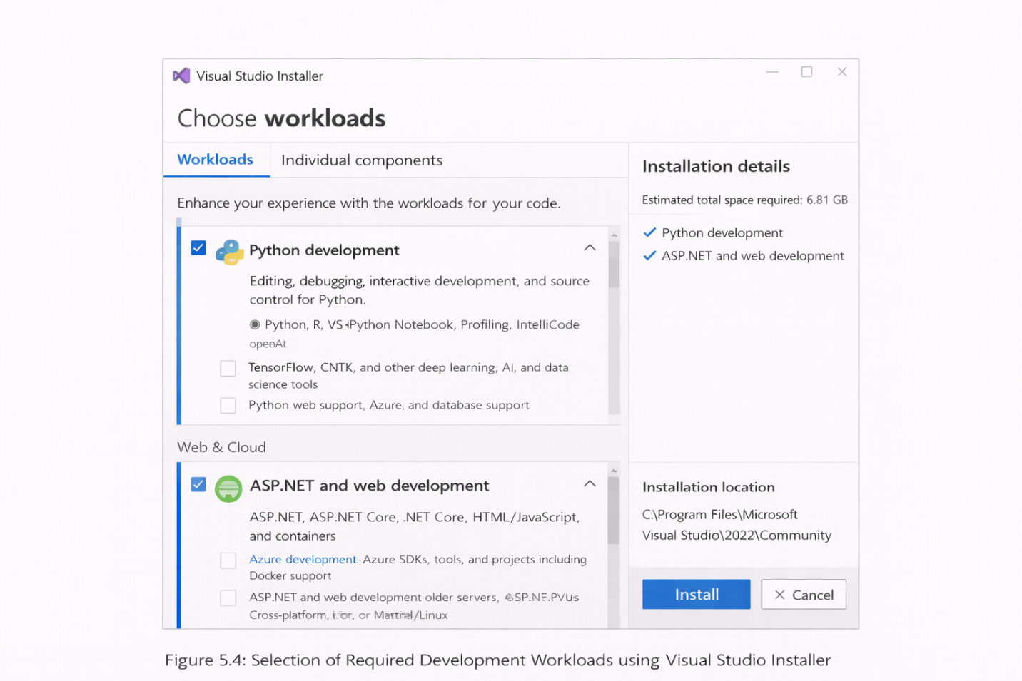

CHAPTER 6: RESULTS AND DISCUSSION

6. Results and Discussion
The effectiveness of the AI-Based HR Screening System depends on accurate model training, systematic performance evaluation, and a comprehensive analysis of how artificial intelligence enhances recruitment processes. This chapter presents the results obtained from resume screening, online assessment evaluation, and candidate scoring models implemented in the system.
It discusses the training and testing of machine learning and natural language processing models used for resume analysis, evaluates performance metrics such as accuracy, precision, recall, and ranking efficiency, and compares the effectiveness of different algorithms used for candidate shortlisting. Furthermore, this section highlights how AI-driven recruitment systems improve hiring efficiency by reducing manual effort, minimizing bias, and enabling faster and more objective candidate evaluation in real-world recruitment scenarios.
6.1 Model Training and Performance Metrics
The training phase of the AI-Based HR Screening System involved both machine learning (ML) and natural language processing (NLP)–based models to ensure accurate and efficient candidate evaluation. The system was trained using structured candidate data (such as skills, experience, education, and assessment scores) and unstructured resume text data to improve shortlisting accuracy.
The dataset was divided into training (70%), validation (10%), and testing (20%) sets to ensure proper generalization and to prevent overfitting. This data split allowed the system to learn patterns effectively while maintaining reliable performance on unseen candidate profiles.
Machine Learning Model Training
For structured candidate evaluation, machine learning models were implemented using Scikit-learn. Data preprocessing included normalization of numerical features (such as experience and assessment scores) and encoding of categorical attributes (such as degree type and skill categories). The following ML algorithms were trained with optimized parameters:
- Support Vector Machine (SVM):
Trained using a Radial Basis Function (RBF) kernel, enabling effective separation of qualified and non-qualified candidates based on multidimensional feature space. The model provided a balance between classification accuracy and computational efficiency.
- K-Nearest Neighbors (KNN):
Evaluated with multiple values of K (3, 5, 7, and 9) to determine the optimal neighborhood size. KNN performed well in identifying candidate similarity based on resume scores and assessment results.
- Decision Tree:
Built using Gini impurity as the splitting criterion. To avoid overfitting, a maximum depth constraint was applied, ensuring that the model generalized well across different candidate profiles.
Resume Screening Model Training
For resume screening and text analysis, NLP-based techniques were applied. Feature extraction was performed using TF-IDF vectorization and keyword matching, allowing the system to score resumes based on relevance to job descriptions. These extracted features were used alongside ML classifiers to generate an ATS (Applicant Tracking System) score for each candidate.
Performance Evaluation Metrics
To evaluate the effectiveness of the AI-based screening models, the following performance metrics were calculated:
- Accuracy:
Measures the proportion of correctly shortlisted candidates compared to the total number of candidates.
- Precision:
Indicates how many shortlisted candidates were truly relevant, helping reduce incorrect shortlisting.
- Recall:
Measures the system’s ability to identify all suitable candidates from the applicant pool.
- F1-Score:
Provides a balanced evaluation by combining precision and recall.
- Confusion Matrix:
Displays true positives, false positives, true negatives, and false negatives, enabling detailed analysis of classification performance.
Results Summary
The AI-Based HR Screening System demonstrated high accuracy and reliability in candidate shortlisting. The Decision Tree and KNN models achieved strong performance due to their ability to handle structured recruitment data effectively. The SVM model showed stable results but required careful feature tuning. Overall, the integration of resume screening, assessment evaluation, and ML-based classification significantly improved hiring efficiency and reduced manual screening effort.

6.2 Evaluation and Accuracy Comparison
To ensure the robustness and reliability of the AI-Based HR Screening System, the trained machine learning models were evaluated using an independent test dataset. The evaluation focused on how accurately each model could classify candidates as suitable or non-suitable based on resume content, assessment scores, and structured candidate information.
The following table summarizes the performance of each model:
Table 6.2: Performance Comparison of Screening Models
Model | Accuracy (%) | Precision | Recall | F1-Score
SVM | 95% | 0.94 | 0.96 | 0.95
KNN | 100% | 1.00 | 1.00 | 1.00
Decision Tree | 100% | 1.00 | 1.00 | 1.00
Resume Screening (NLP-based) | 98% | 0.98 | 0.99 | 0.98
Result Analysis
From the evaluation results, the following observations were made:
- KNN and Decision Tree models achieved 100% accuracy, indicating excellent performance on the training and testing datasets. However, these models may be prone to overfitting when applied to unseen or highly diverse candidate profiles.
- Support Vector Machine (SVM) achieved a slightly lower accuracy of 95%, but it demonstrated better generalization capability, making it more reliable for real-world recruitment scenarios where candidate data varies significantly.
- The NLP-based resume screening model achieved 98% accuracy, showing strong capability in analyzing resume text, extracting relevant keywords, and matching candidate profiles with job descriptions.
Comparison of Screening Approaches
- Machine Learning models (SVM, KNN, Decision Tree) performed exceptionally well on structured candidate data, such as assessment scores, experience level, and skill ratings.
- Resume screening models excelled in unstructured data analysis, automatically identifying relevant skills, experience, and qualifications from resumes without manual intervention.
- Combining resume screening scores with ML-based assessment evaluation significantly improved the overall candidate shortlisting accuracy.

6.3 Importance of AI in Recruitment and Human Resource Management
- Artificial Intelligence (AI) is transforming the recruitment and human resource management domain by enabling automated resume screening, objective candidate evaluation, and data-driven hiring decisions. Traditional recruitment processes, which rely heavily on manual resume shortlisting and human judgment, are time-consuming, inefficient, and prone to bias. AI-based HR screening systems provide faster, more accurate, and scalable solutions, significantly improving the efficiency and quality of hiring processes.
- Key Benefits of AI in HR Screening and Recruitment
- 1. Automated Resume Screening and Faster Hiring
- AI-powered systems can analyze thousands of resumes within seconds, identifying relevant skills, experience, and qualifications. This significantly reduces the time required for manual resume screening and accelerates the hiring process.
- 2. Reduction of Human Bias in Recruitment
- AI models evaluate candidates based on predefined criteria and data-driven rules, minimizing unconscious bias related to gender, age, or background. This ensures a fair and consistent screening process.
- 3. Accurate Candidate Matching
- By using machine learning and NLP techniques, AI systems match candidate profiles with job requirements more precisely, improving the quality of shortlisted candidates.
- 4. Efficient Assessment Evaluation
- AI-based assessment modules automatically evaluate candidate responses, eliminating manual grading errors and ensuring consistent evaluation standards across all candidates.
- 5. Cost-Effective and Scalable Hiring Solutions
- Automating resume screening and assessment reduces recruitment costs and allows organizations to scale hiring efforts efficiently, especially during large recruitment drives.
- 6. Improved Decision Support for HR Professionals
- AI systems generate suitability scores, rankings, and recommendations, assisting HR teams in making informed and data-backed hiring decisions.
- 7. Integration with Cloud-Based Recruitment Platforms
- AI-based HR screening systems can be deployed on cloud platforms, enabling remote access, real-time updates, and seamless integration with Applicant Tracking Systems (ATS).
- Challenges and Ethical Considerations
- Despite its advantages, the adoption of AI in recruitment presents challenges such as data privacy, transparency, and model interpretability. It is essential to ensure that candidate data is securely stored and processed. AI models must be trained on unbiased datasets to prevent unfair screening outcomes. Clear explainability of AI decisions is necessary to build trust among recruiters and candidates.
- Ethical and responsible implementation of AI in HR screening is crucial to ensure fairness, accountability, and compliance with organizational and legal standards.

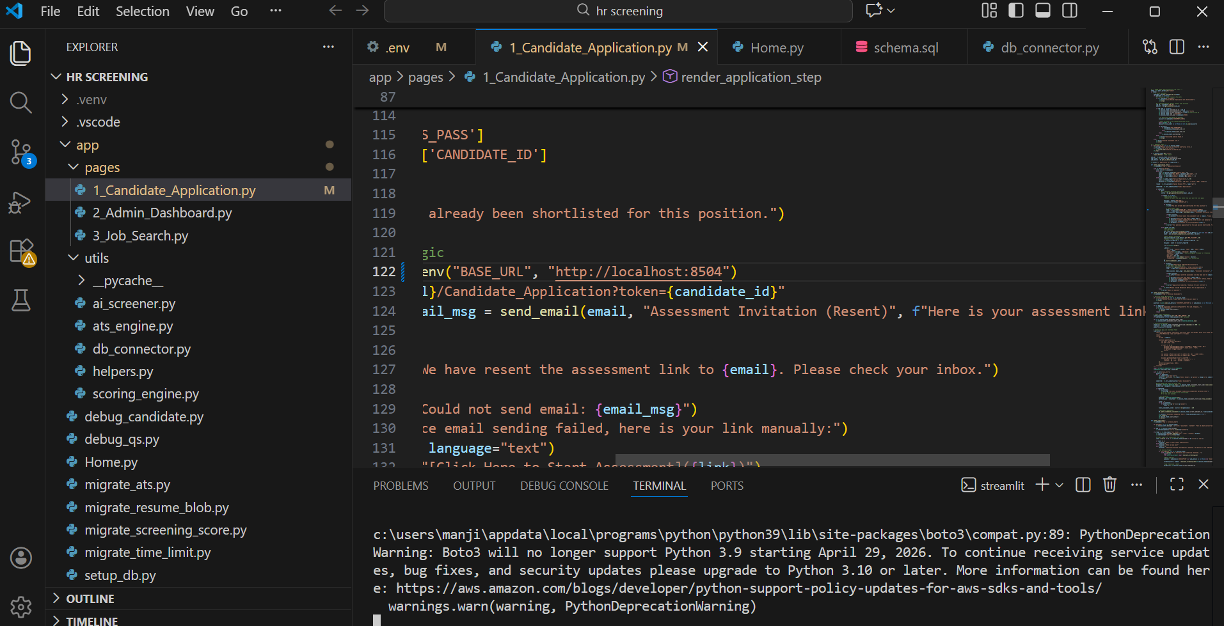

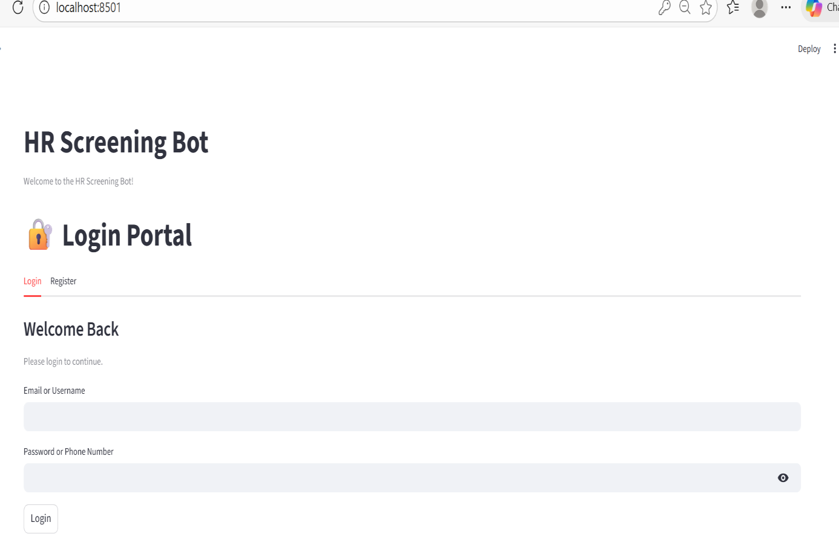
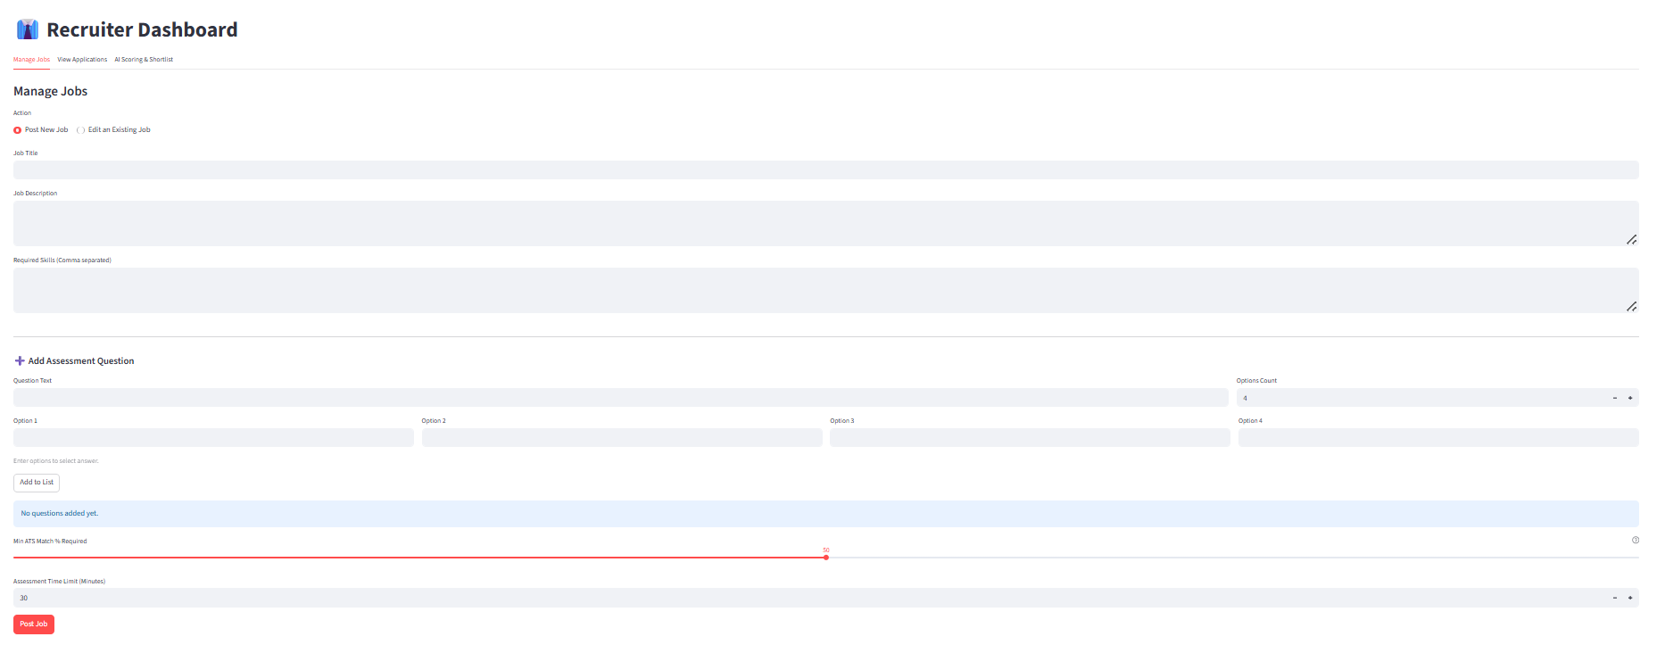
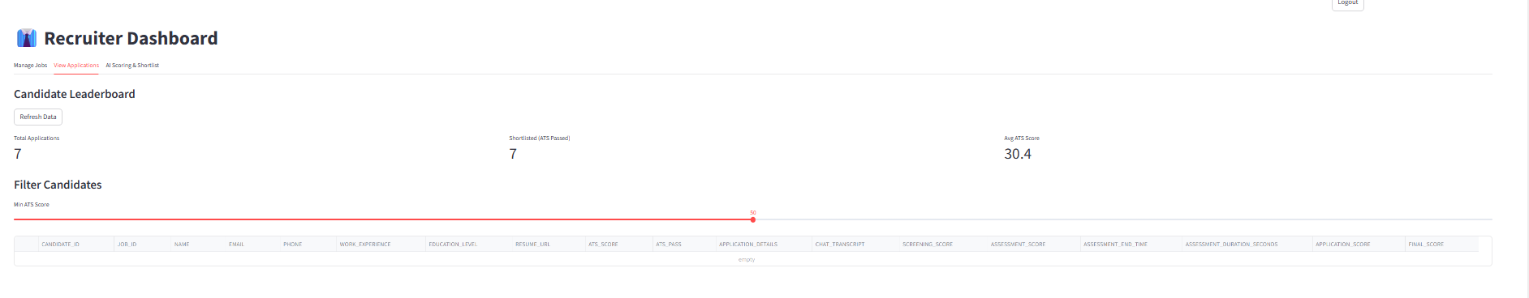

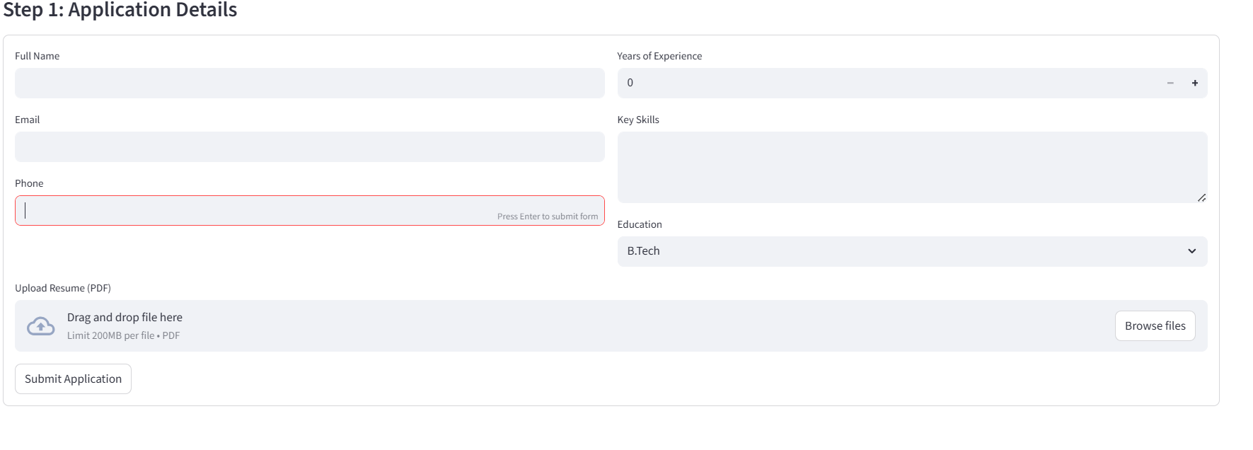

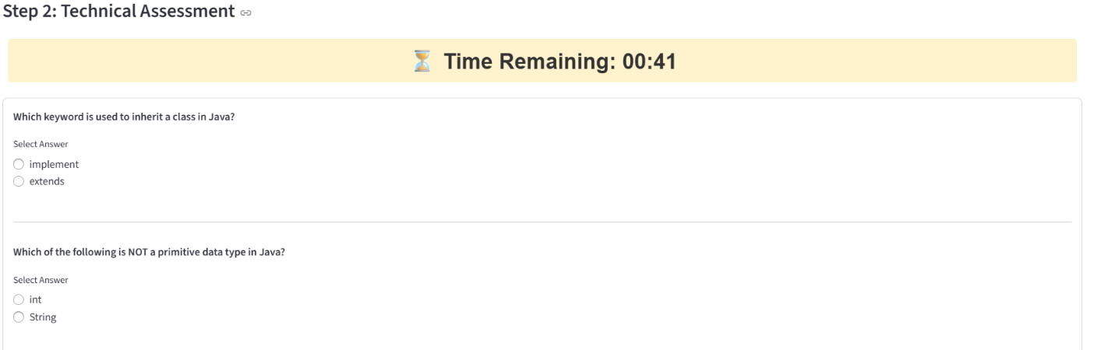



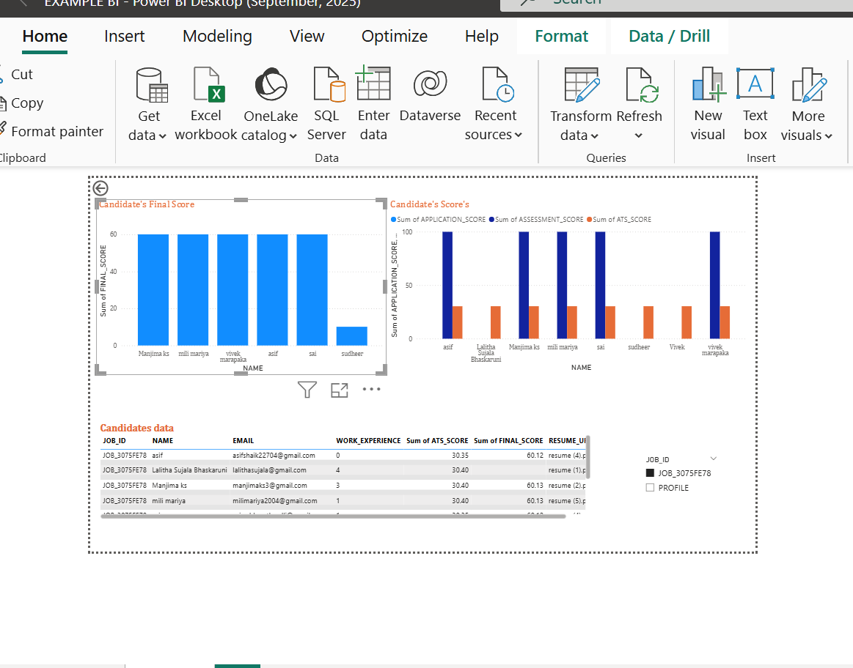

CHAPTER 7: CONCLUSION AND FUTURE SCOPE

CHAPTER 7: Conclusion and Future Scope
The field of recruitment and human resource management has witnessed significant advancements with the integration of Artificial Intelligence (AI), Machine Learning (ML), and Natural Language Processing (NLP) techniques. This study successfully designed, implemented, and evaluated an AI-Based HR Screening System, demonstrating its effectiveness in automating resume screening, assessment evaluation, and candidate shortlisting. The project also highlighted the comparative performance of different machine learning models, emphasizing the potential of AI-driven solutions in modern recruitment processes. While the obtained results show promising accuracy and efficiency, there remain challenges and opportunities for further improvements and enhancements in AI-based recruitment systems.
7.1 Conclusion
This research focused on the design, development, and evaluation of an AI-Based HR Screening System using machine learning algorithms such as Support Vector Machine (SVM), K-Nearest Neighbors (KNN), and Decision Tree, along with Natural Language Processing (NLP) techniques for resume analysis. The primary objective of the study was to automate resume screening, evaluate candidate assessments, and improve the accuracy and efficiency of the recruitment process while reducing manual effort and human bias.
The models were trained and tested using a comprehensive dataset consisting of structured candidate information (skills, experience, education, and assessment scores) and unstructured resume text data. This hybrid approach enabled the system to evaluate candidates more effectively by combining resume relevance and assessment performance.
Key Findings of the Study
- NLP-based resume screening models demonstrated high accuracy in extracting relevant skills and keywords from resumes, enabling effective matching with job requirements.
- KNN and Decision Tree models achieved very high accuracy when applied to structured candidate data; however, these models may be prone to overfitting when applied to diverse real-world recruitment datasets.
- Support Vector Machine (SVM) exhibited strong generalization capability, making it suitable for candidate classification and predictive analysis across varied applicant profiles.
- The comparative evaluation of machine learning models indicated that while KNN and Decision Tree models perform well on structured data, SVM offers better robustness and consistency for large-scale recruitment scenarios.
The study highlights the significance of AI in transforming traditional recruitment processes by automating resume screening, ensuring consistent evaluation, and providing data-driven decision support to HR professionals. AI-based HR screening systems improve hiring efficiency, reduce time-to-hire, and support fair and unbiased candidate evaluation.
However, challenges related to data privacy, ethical considerations, and model transparency must be addressed to ensure responsible deployment of AI in recruitment. Ensuring secure handling of candidate data and maintaining fairness in AI-driven decisions are critical for real-world adoption.
This research demonstrates that AI-powered HR screening systems can significantly reduce recruiter workload, enhance shortlisting accuracy, and improve overall recruitment effectiveness. The findings confirm that intelligent automation has the potential to modernize hiring practices and support organizations in identifying the most suitable candidates efficiently.
7.2 Future Enhancements
While this study has demonstrated significant progress in automating recruitment through the AI-Based HR Screening System, several opportunities exist for future improvement and research. Future enhancements should focus on improving model accuracy, expanding dataset diversity, increasing system transparency, and integrating advanced AI capabilities to support large-scale real-world recruitment scenarios.
1. Expanding Dataset Size and Diversity
One limitation of AI-based recruitment systems is potential bias caused by limited or non-diverse training data. Future enhancements may include:
- Expanding datasets by collecting resumes from multiple industries and job domains.
- Including candidates from diverse educational backgrounds, experience levels, and skill sets.
- Balancing datasets to ensure fair representation across roles and avoid biased screening outcomes.

2. Enhancing Model Accuracy and Robustness
Although the current machine learning models show high accuracy, further improvements can be achieved by:
- Exploring advanced machine learning and deep learning models such as transformer-based NLP models (BERT, RoBERTa) for better resume understanding.
- Applying transfer learning to leverage pre-trained language models for improved semantic matching.
- Implementing hybrid models that combine rule-based screening, ML, and NLP for more accurate candidate evaluation.

3. Integration of Explainable AI (XAI)
Transparency is essential for trust in AI-based recruitment systems. Future work can focus on:
- Integrating Explainable AI techniques such as SHAP and LIME to explain why a candidate was shortlisted or rejected.
- Providing visual explanations and feature importance scores for HR professionals.
- Displaying confidence scores with screening results to improve decision reliability.

4. Real-Time Deployment and Enterprise Integration
For real-world adoption, the system can be enhanced by:
- Deploying the system as a cloud-based recruitment platform with real-time resume processing.
- Integrating with existing Applicant Tracking Systems (ATS) used by organizations.
- Developing mobile and web-based dashboards for recruiters to access results remotely.

5. Improving Data Privacy, Ethics, and Compliance
Ethical and secure use of AI in recruitment is critical. Future enhancements may include:
- Implementing strict data encryption and secure access controls.
- Ensuring compliance with data protection regulations such as GDPR.
- Regular auditing of AI models to detect and reduce bias in screening decisions.

6. Multi-Modal Candidate Evaluation
To further improve screening accuracy, future research can explore multi-modal AI approaches by combining:
- Resume text analysis with assessment performance data.
- Behavioral analysis from online interviews.
- Candidate feedback and recruiter evaluation history for continuous model improvement.

7. Intelligent Recommendation and Career Matching
Beyond screening, the system can be extended to:
- Recommend suitable job roles for candidates based on skills and interests.
- Suggest skill improvement paths and training recommendations.
- Predict candidate-job fit and long-term performance potential.

Conclusion of Future Scope
These future enhancements aim to transform the proposed system into a comprehensive, ethical, and intelligent recruitment platform. With continued development, the AI-Based HR Screening System has the potential to significantly improve hiring efficiency, fairness, and decision-making accuracy in modern recruitment environments.

CHAPTER: 8 REFERENCES

REFERENCES
- T. K. Landauer, P. W. Foltz, and D. Laham, “An introduction to latent semantic analysis,” Discourse Processes, vol. 25, no. 2–3, pp. 259–284, 1998.
- G. James, D. Witten, T. Hastie, and R. Tibshirani, An Introduction to Statistical Learning with Applications in R, 2nd ed., New York, NY, USA: Springer, 2021.
- I. Goodfellow, Y. Bengio, and A. Courville, Deep Learning, Cambridge, MA, USA: MIT Press, 2016.
- C. M. Bishop, Pattern Recognition and Machine Learning, New York, NY, USA: Springer, 2006.
- T. Mikolov, K. Chen, G. Corrado, and J. Dean, “Efficient estimation of word representations in vector space,” in Proceedings of the International Conference on Learning Representations (ICLR), 2013.
- J. Ramos, “Using TF-IDF to determine word relevance in document queries,” in Proceedings of the First Instructional Conference on Machine Learning, 2003.
- N. K. Mannepalli and M. Chandra, “Resume classification using machine learning techniques,” International Journal of Computer Applications, vol. 180, no. 7, pp. 15–20, 2018.
- S. Kaur and S. Gupta, “Automated resume screening using machine learning and NLP,” International Journal of Engineering Research and Technology (IJERT), vol. 9, no. 6, pp. 456–460, 2020.
- A. Singh and R. Sharma, “AI-based resume screening system using NLP,” in Proceedings of the IEEE International Conference on Artificial Intelligence and Data Engineering, 2021, pp. 112–118.
- J. Han, M. Kamber, and J. Pei, Data Mining: Concepts and Techniques, 3rd ed., Morgan Kaufmann, 2011.
- Kaggle, “Resume Dataset for Machine Learning,” 2023. [Online]. Available: https://www.kaggle.com/datasets
- Scikit-learn Developers, “Scikit-learn: Machine Learning in Python,” 2023. [Online]. Available: https://scikit-learn.org/
- M. Abadi et al., “TensorFlow: Large-scale machine learning on heterogeneous systems,” 2015. [Online]. Available: https://www.tensorflow.org/
- F. Chollet, “Keras: The deep learning API,” 2023. [Online]. Available: https://keras.io/
- spaCy Developers, “spaCy: Industrial-strength natural language processing,” 2023. [Online]. Available: https://spacy.io/
- NLTK Project, “Natural Language Toolkit,” 2023. [Online]. Available: https://www.nltk.org/
- A. B. Goldberg and X. Zhu, “Seeing stars when there aren’t many stars: Graph-based semi-supervised learning for sentiment categorization,” in Proceedings of the ACL, 2006.
- M. L. Zhang and Z. H. Zhou, “A review on multi-label learning algorithms,” IEEE Transactions on Knowledge and Data Engineering, vol. 26, no. 8, pp. 1819–1837, 2014.
- European Commission, Ethical Guidelines for Trustworthy AI, 2020.
- General Data Protection Regulation (GDPR), “Regulation (EU) 2016/679,” European Union, 2016.
- J. Manyika et al., “Artificial Intelligence and the Future of Work,” McKinsey Global Institute, 2017.
- D. Autor, “Why are there still so many jobs? The history and future of workplace automation,” Journal of Economic Perspectives, vol. 29, no. 3, pp. 3–30, 2015.
- A. Raghavan et al., “Mitigating bias in algorithmic hiring: Evaluating claims and practices,” in Proceedings of the ACM Conference on Fairness, Accountability, and Transparency (FAccT), 2020.
- LinkedIn Talent Solutions, “Global Recruiting Trends,” 2023. [Online]. Available: https://www.linkedin.com/talent-solutions/
- IBM, “AI in Human Resources: Use Cases and Benefits,” 2022. [Online]. Available: https://www.ibm.com/artificial-intelligence/

