# MRAKOMĚR 4.1

MRAKOMĚR is a cloud coverage sensor especially suitable for protection of maintenance free telescopes against rain and snow. The MRAKOMĚR can directly command cupola or other telescope housing for closing whether the MRAKOMĚR detects cloudy sky or telescope control computer can use the MRAKOMĚR for measurement of direct coverage of the sky by clouds.

## Measuring principle

The MRAKOMĚR measures IR radiation of the Earth reflected from clouds.

There are some other values witch have to be considered together with temperature of the sky/clouds. There is IR radiation of the near Earth surface air and IR radiation of a cupola of MRAKOMĚR. This radiation has to be subtracted from the sky radiation.

## Technical realization

There is a thermopile sensor directed to zenith. This sensor integrates radiation over the 120° of the ski. Clear view to the ski is important because any terrestrial objects can cause IR radiation.

The thermopile sensor at MRAKOMĚR is covered by small and thin HDPE cupola which protects the senor itself against atmospheric events. The HDPE material has good transparency in IR and it is hydrophobic. In case of big humidity there is heating necessary against water wapour condensation. As solution for this problem (condensate water is resolved as cloudy) there is a 2W heating resistor inside the MRAKOMĚR. This heating can melt accidental ice or snow too.

MRAKOM ER is connected to a telescope computer over USB interface board where is standard RS232 port emulation. The interface board contain a optocoupler which can generate a logical signal for command a telescope copula. This signal is galvanicaly isolated from other wiring and it is activated at cloudy conditions or if the telescope control computer does not send periodical measurement requests (if computer hangs for some reason).

Sensor and interface board can be connected together with cable up to 100m long. Electronics of the MRAKOMĚR which is protected against overvoltage.

## Communication protocol

When MRAKOMĚR is plugged to the computer it communicates by speed 2400 baud, 8 bits, 1 stop bit, without parity. Approximately every second the MRAKOMĚR transmits a message such as:

$M4.1 15539 1193 -3 -33 -181 20 0 *43

Where is:

M4.1 version and revision (4.1)

15539 number of current measurement (0 to 65535)

1193 temperature inside the MRAKOMĚR‘s case (11.93°C)

-3 temperature of the sky zone 1 (-0.03 °C)

-33 temperature of the sky zone 2 (-0.33°C)

-181 ambient temperature (-1.81°C)

20 time to stop heating (20s)

0 time to close the cupola (cupola is closed)

43 checksum of characters between $ and * (XOR)

You can send these commands to the MRAKOMĚR:

h turn on heating for 20s

c open the cupola for 20s

x open cupola and turn on heating for 20s

l close cupola

i show version and some help (only if cupola is closed)

r turn on periodical measurement approximately every second

s proceed one single measurement

u upgrade MRAKOMĚR’s firmware

a turn to automatic mode

After sending some request for measurement you have to wait minimally one second for response. There is some time needed for proceeding of measurement.

## Mounting recommendations

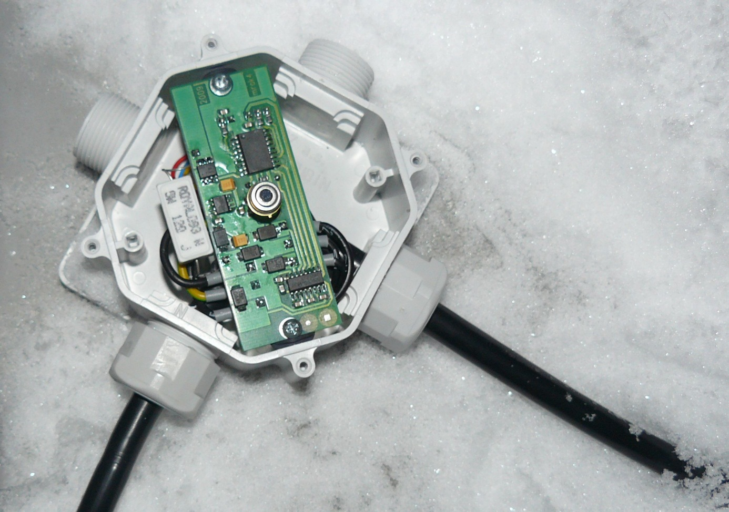

Zone 1

Zone 2

To the Temperature Sensor

To the Computer