# MRAKOMĚR 4.1

MRAKOMĚR is a cloud coverage sensor especially suitable for protection of maintenance free telescopes against rain and snow. The MRAKOMĚR can directly command a cupola or other telescope housing for closing whether the MRAKOMĚR detects cloudy sky. Or a telescope control computer can use the MRAKOMĚR for measurement of coverage the sky by clouds.

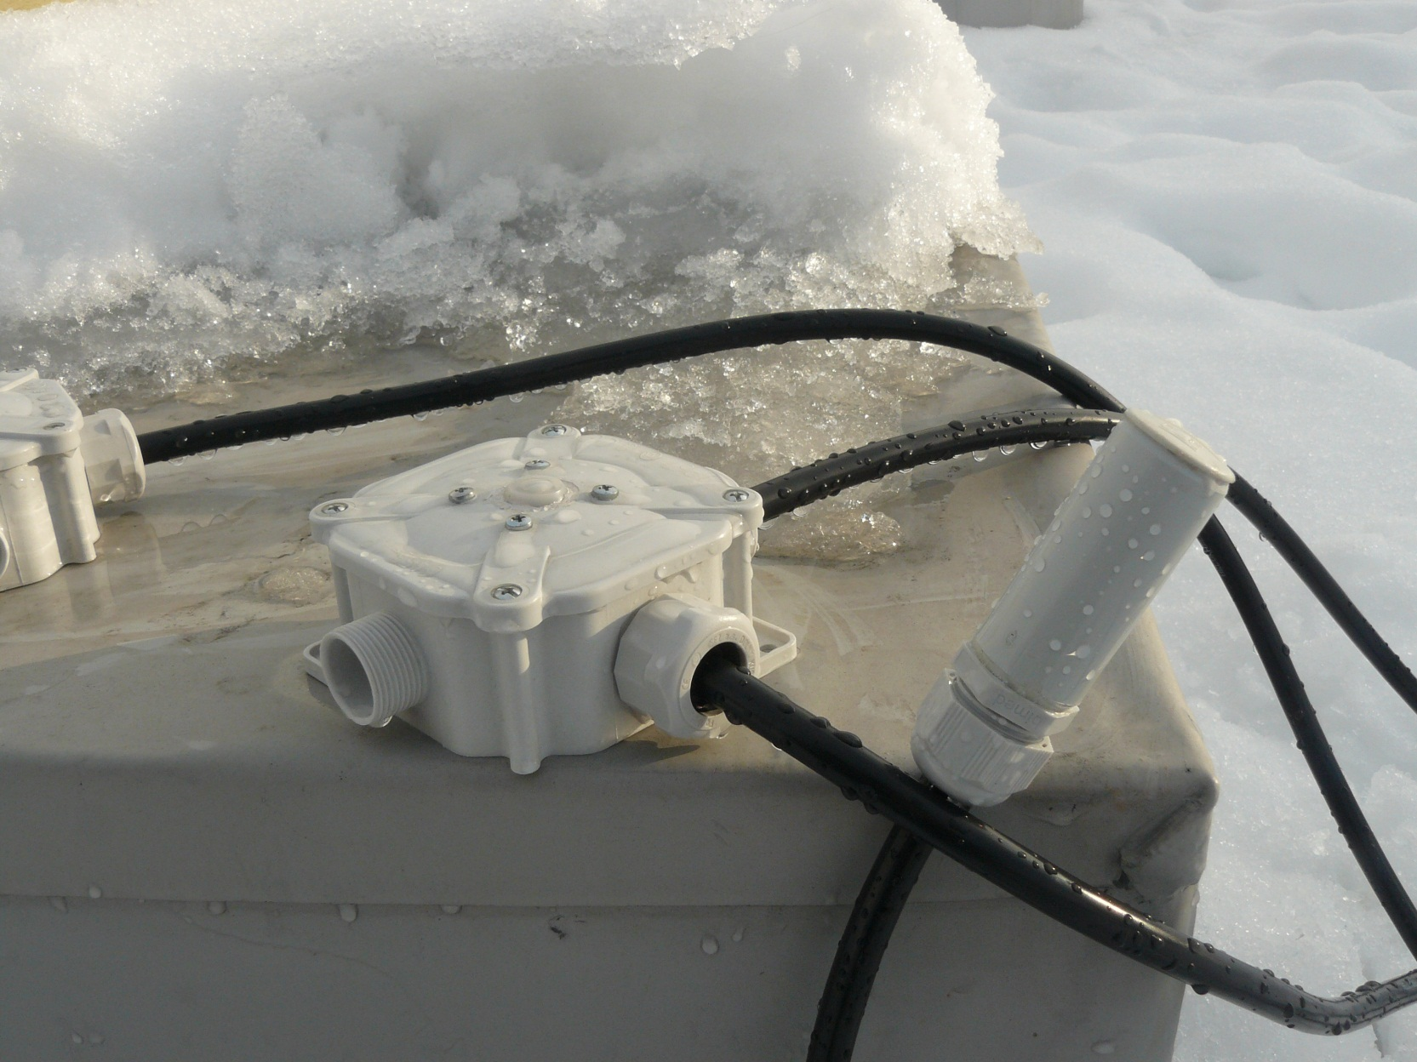

## Measuring principle

The MRAKOMĚR measures IR radiation of the Earth reflected from clouds.

There are some other values witch have to be considered together with temperature of the sky/clouds. There is IR radiation of the near Earth surface air and IR radiation of a cupola of MRAKOMĚR. This parasite IR radiation has to be subtracted from the sky/clouds radiation.

## Technical realization

There is a thermopile sensor directed to zenith. This sensor integrates radiation over the 120° of the ski. Clear view to the ski is important because any terrestrial objects can cause parasite IR radiation.

In fact two zones are measured by the thermopile sensor each with approximately 90° FOV.

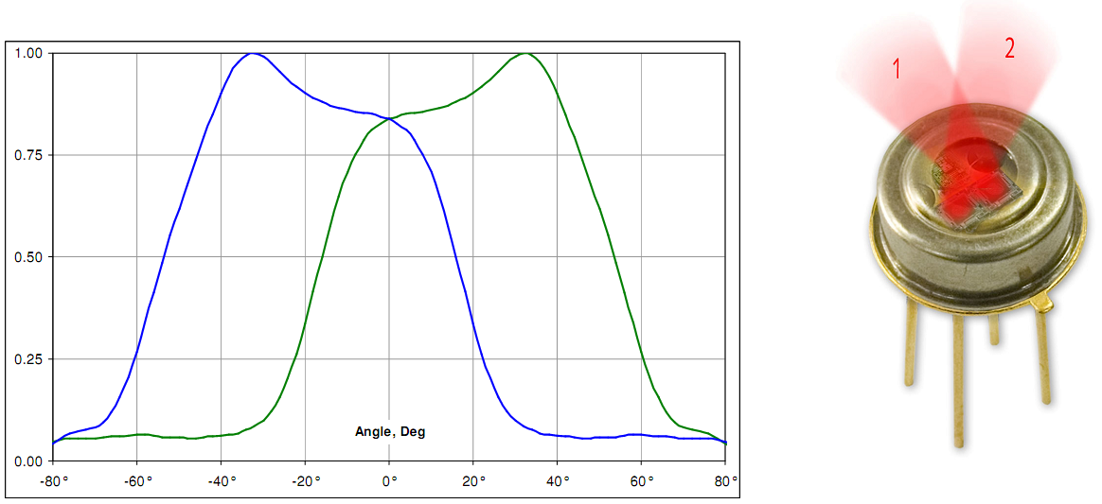

The thermopile sensor inside the MRAKOMĚR is covered by small and thin HDPE cupola which protects the senor itself against atmospheric events. The HDPE material has good transparency in IR and it is hydrophobic. In case of big humidity there is 2W heating resistor inside the MRAKOMĚR. This heating is necessary against water vapor condensation on the sensor. This heating can melt accidental ice or snow as well.

MRAKOMĚR is connected to a telescope computer over an USB Interface Board where is a standard RS232C interface emulation. The Interface Board contains an optocoupler which can generate a logical signal for commands a telescope copula. This signal is galvanic isolated from the other wiring and it is activated at cloudy conditions or if the telescope control computer does not send periodical measurement requests (if computer hangs for some reason).

The Sensor Board and the Interface Board can be connected together with cable up to 100 m long. Electronics in the MRAKOMĚR is partially protected against overvoltage at this cabling.

## Communication

When MRAKOMĚR is plugged to the computer it communicates by speed 2400 baud, 8 bits, 1 stop bit, without parity (2400 8N1). If cables are proper connected and drivers in the computer are installed a green LED starts blinking for a while.

First after power on the MRAKOMĚR waits for a firmware update approximately one minute. You can skip this by sending some command or you can wait for a start of sending some measurement.

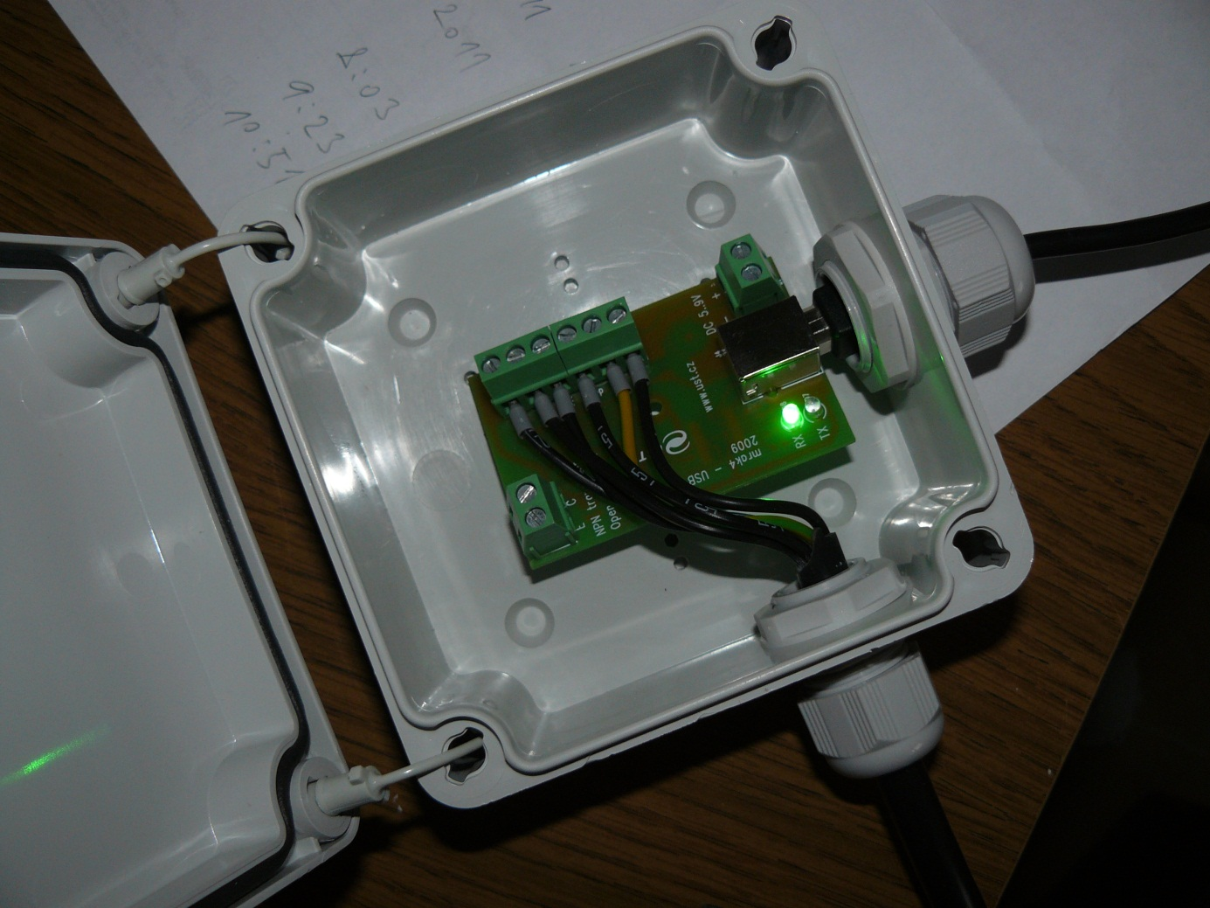

To the computer’s USB port

Green LED  
Data OUT from the MRAKOMĚR

Cupola controlling signal

Red LED  
Data IN to the MRAKOMĚR

To the MRAKOMĚR

Optional power source

Approximately every second the MRAKOMĚR transmits a message such as:

$M4.1 15539 1193 -3 -33 -181 20 0 *43

Where meaning is:

M4.1 version and revision (4.1)

15539 sequential number of current measurement (from 0 to 65535 and again)

1193 temperature inside the MRAKOMĚR‘s case (11.93°C)

-3 temperature of the sky Zone 1 (-0.03 °C)

-33 temperature of the sky Zone 2 (-0.33°C)

-181 ambient temperature (-1.81°C)

20 time to stop heating (20s)

0 time to close the cupola (cupola is closed)

43 checksum of characters between $ and * (XOR)

You can send these **commands** to the MRAKOMĚR:

|  |  |
| --- | --- |
| h | turn on heating for 20s |
| c | open the cupola for 20s |
| x | open cupola and turn on heating for 20s |
| l | close cupola |
| i | show version of firmware and some short help (only if cupola is closed) |
| r | turn on periodical measurement approximately every second |
| s | proceed one single measurement |
| u | upgrade MRAKOMĚR’s firmware |
| a | turn to automatic mode |

*You have to wait* ***minimally one second*** *for response after sending some request for measurement. There is some time needed for processing of measurement.*

## Mounting recommendations

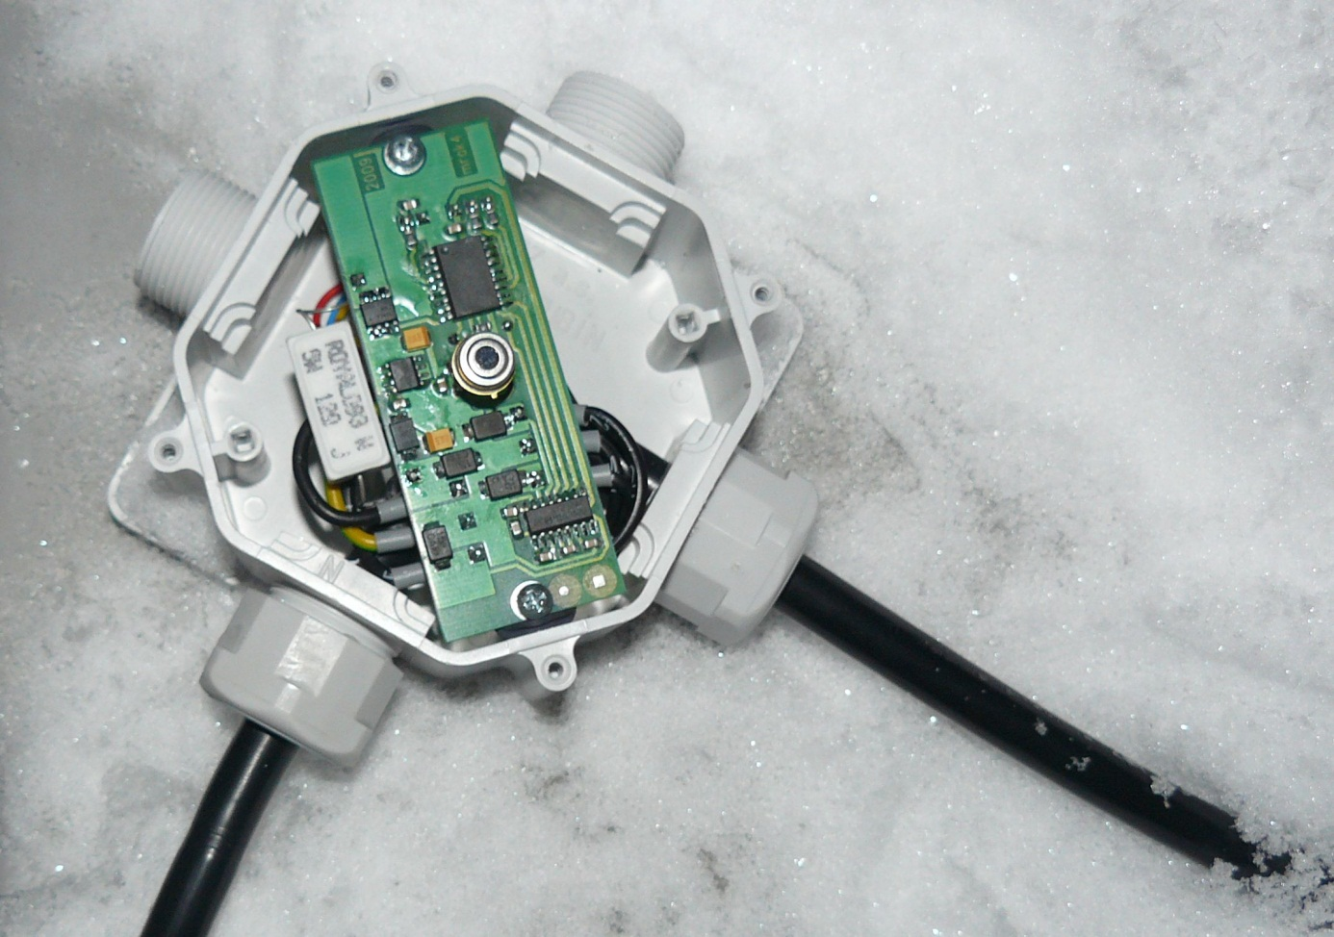

Zone 1

Zone 2

To the Temperature Sensor

To the Computer

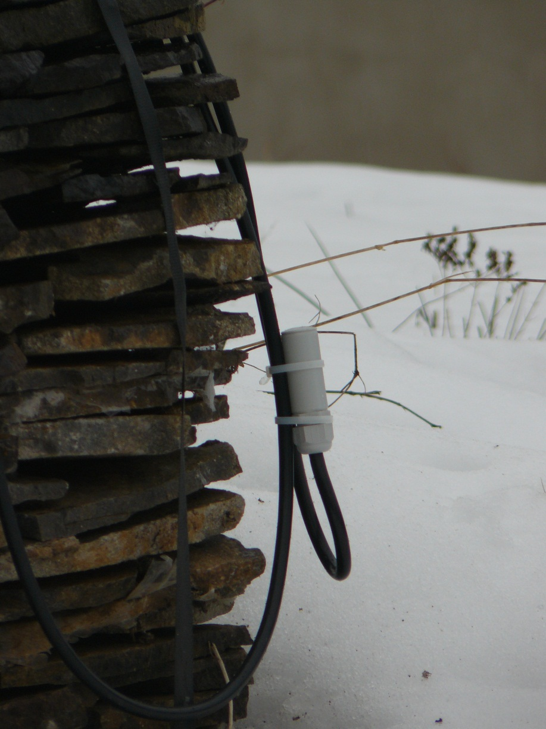

This side up

Mount at the north side

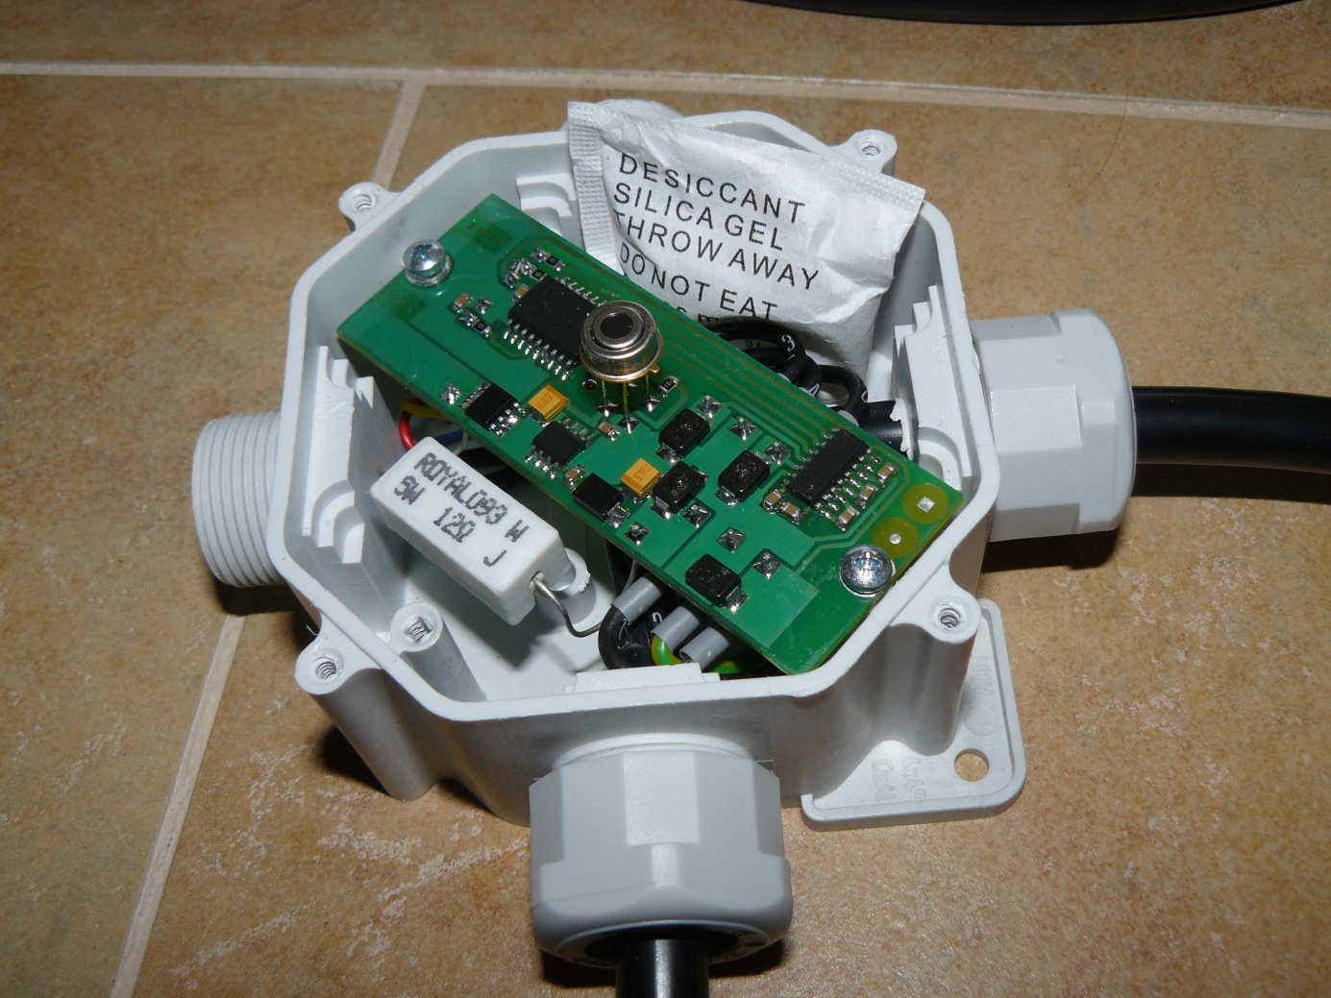

SILICAGEL

There is a bag with Silicagel inside the MRAKOMĚR. If you open the MRAKOMĚR’s case, please do not throw away this but reactivate the Silicagel. You have to bake (but do not eat :) this at 150 °C at least 45 minutes.

## Communication cable connection

|  |  |  |
| --- | --- | --- |
| **Sensor board** |  | **Interface board** |
| 3 | RX | 2 |
| 2 | TX | 3 |
| 5 | DOME | 5 |
| 1 | +U | 1 |
| 4 | GND data | 4 |
| Green Yellow | GND Power | Green Yellow |

## External thermometer cable connection

