Mrakoměr 3

([mrakomjer] - “Clouds Meter” ver. 3)
Ing. Martin Kákona, kakl@i.cz, 2008
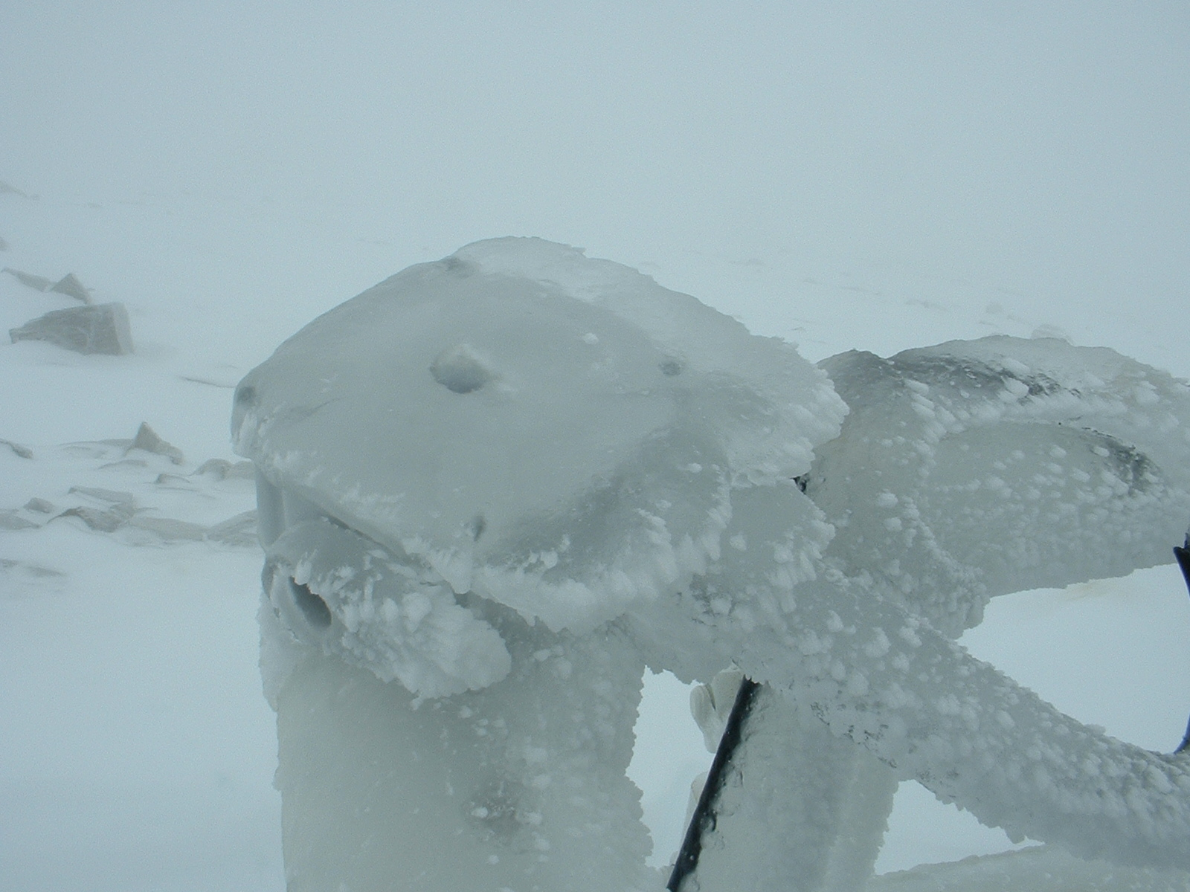

Abstract:
This paper describes an electronics sensor which can be used for protection of robotics telescopes against rain and snow.
Introduction
It is very important to protect optics and other sensitive parts of robotics telescopes against rain and snow. Protection system has to be autonomous as robotics telescope itself. For instance a telescope dome has to be closed automatically before rain or snow.
A telescope control computer needs some sensor for detecting or better predicting bad weather. Such sensor is described below.
Principles
The principle of the described sensor is based on detection of clouds. Respective amount of water in atmosphere is measured. As shown by many, some correlation between cloudy/clear sky and temperature of the sky exists.
An infrared radiation of the sky is measured by a thermopile sensor (http://www.melexis.com/Assets/IR_sensor_thermometer_MLX90614_Datasheet_5152.aspx) at 10μm. This sensor looks statically to zenith with FOV about 90°. Average temperature of the sky is measured. The cloudy sky has bigger temperature then clear sky.
It has to be considered that the thermopile sensor does not measure absolute temperature of the sky but temperature flow between its body and sky. When the body has a high temperature, the temperature noise is bigger too. The electronics inside the sensor is trying to reduce noise and compute the sky temperature. Finally some temperature threshold should be given for closing the telescope dome.
The sensor electronics and sensor itself is protected against water by HDPE cupola. The cupola’s material is well infrared transparent and naturally hydrophobic. Drops of water tend to slide down from cupola. This reduces time when the sensor is able to detect clear sky after rain.
The sensor is connected with a telescope and dome control computer by RS232C interface. A simple message is transmitted when the control computer asks Mrakoměr:
#333 24.7 -3.3 0
The firs number is number of measurement, the second number is an ambient temperature (the temperature inside the Mrakoměr’s cupola), the third number is a sky temperature and the last number is status (whether is an internal heating on/off).
The control computer (for the dome and telescope) makes decision from ambient and sky temperature and open/close the dome.
Results
The device has not moveable mechanical parts. Due to this the sensor is very durable.
The temperature thresholds for opening/closing the telescope dome have to be setting up for each peace of the sensor and climatic environment. There are some reasons for this:
- The cupola manufacturing is not perfect. The thickness of cupola is probably varying piece by piece.
- The digital signal processing inside the sensor is not absolute linear. For different outside temperatures (and temperature noise) should be setting up different dome opening threshold.
- The temperature of HDPE cupola has influence to the measurement. This temperature is not measured precisely. Only temperature of the thermopile sensor is measured and this temperature has relation to the cupola’s temperature.
Last predicted problem is degradation of the HDPE cupola by Sun’s ultraviolet radiation. We estimate about 5 years of operation before the sensor’s cupola replacement.
Discussion
Mrakoměr is an “Open Hardware” project. You can see complete schematics, PCBs and firmware source code in SVN repository at http://www.mlab.cz/WebSVN/listing.php?repname=MLAB&path=%2FDesigns%2FMRAKOMER3%2F#_Designs_MRAKOMER3_ . You can build this hardware and experiment with this and possibly improve this. May be you can be interested in an old one or future versions of the Mrakoměr (Mrakomer 2 or Mrakomer 4) in the same SVN repository (http://www.mlab.cz/WebSVN/listing.php?repname=MLAB&path=%2FDesigns%2F#_Designs_). If you want to cooperate in development of the Mrakoměr please contact me (mailto:kakl@i.cz). Necessary parts for Mrakoměr 3 or full assembled devices you can order by friendly firm UST (http://www.ust.cz/shop/product_info.php/cPath/2/products_id/59).
I have done only few experiments with Mrakoměr because I have not stable telescope site for an automatic optical data acquisition near my home. I’ll appreciate some cooperation with this problem. Instead of this the Mrakoměr devices are successfully used by robotics telescopes BART, BOOTES and Watcher with RTS2 control system (http://rts2.org). Please consult results with my friends around the RTS2 (http://sourceforge.net/project/memberlist.php?group_id=151217).
A new goal for next generation of Mrakoměr (Mrakomer 4) is to develop a fail-safe device which will be fault-tolerant against failure of sensor or telescope control system.

