Configuring the GPS using u-center v. 8.27 on MS Windows
Windows 10 note: System downloads and installs a driver using Windows Sensor API. The driver will not work (UBX messages are not decoded).
I have reverted to the COM driver using instructions at: https://www.u-blox.com/sites/default/files/USBDriverWindowsSelectionGuide_%28UBX-15022403%29.pdf (Install without Internet, then connect, let it update to Sensor API, revert in control panel driver settings.)

Viev - Configuration View (ctrl + F9)

RATE - Measurement period 100 ms
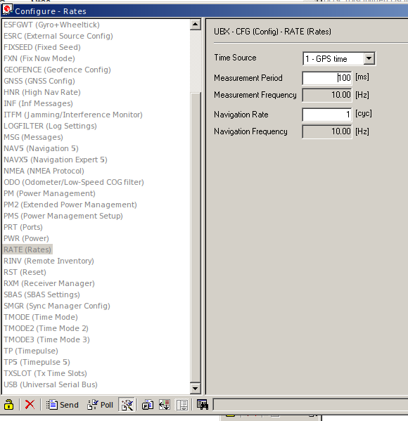

Viev - Message View (F9)

NMEA - Disable Child Messages

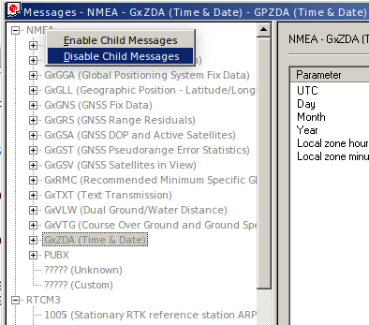

UBX - TIM - TM2 - Enable Message
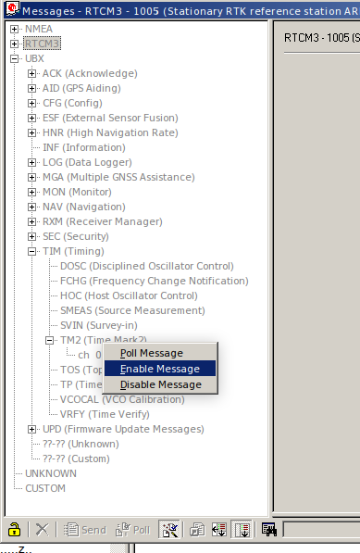

A nakonec je zřejmě potřeba to uložit do flash paměti, sic to nepřežije přehození na druhý počítač.

Test it with u-Center
After reverting to the COM driver, polling works and UBX messages are visible in Packet Console.

