Project3 - Chord

**1.What is working :**

**The structure of the program:**

In our program , we defined two kinds of actors, chord actor and node actor, to implement the creation of Chord Network . And we set the identifier m to 16**.**

Chord Actor :

We define one chord actor to create a array of node actors . The chord actor is responsible for initializing the node actors , accounting the times of request and statistic sum hops to get the average hops that have to be traversed to request a message. When the chord actor receive all the nodes’ responses , the system is down.

Node Actor :

Node actors can be seen as the nodes of the chord network . They will initialize their IDs and finger-tables including intervals and successors . Node actors will choose a random number as the message to find from the Chord Network by using the chord algorithm. When they get the message from someone node , they will response to the Chord Actor and report the sum hops they used .

T**he Implementation of algorithm:**

We use the similar algorithm of the Chord paper to implement the network join and routing .

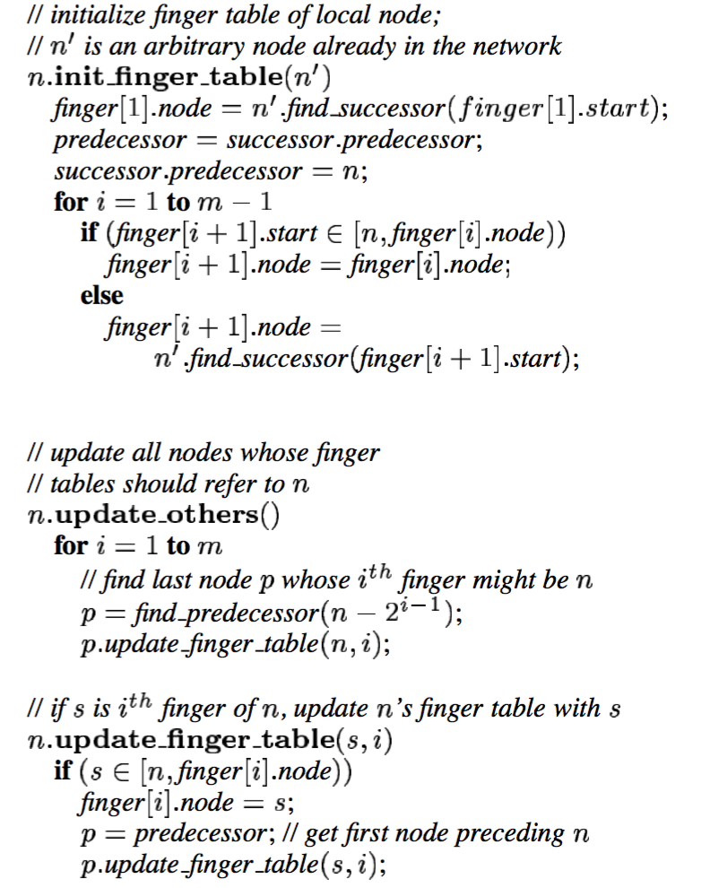

T**he results of program:**

1. To clearly get the message’s routing information , we just use 3 nodes in the chord system and just send the request one time .

The result is like this:

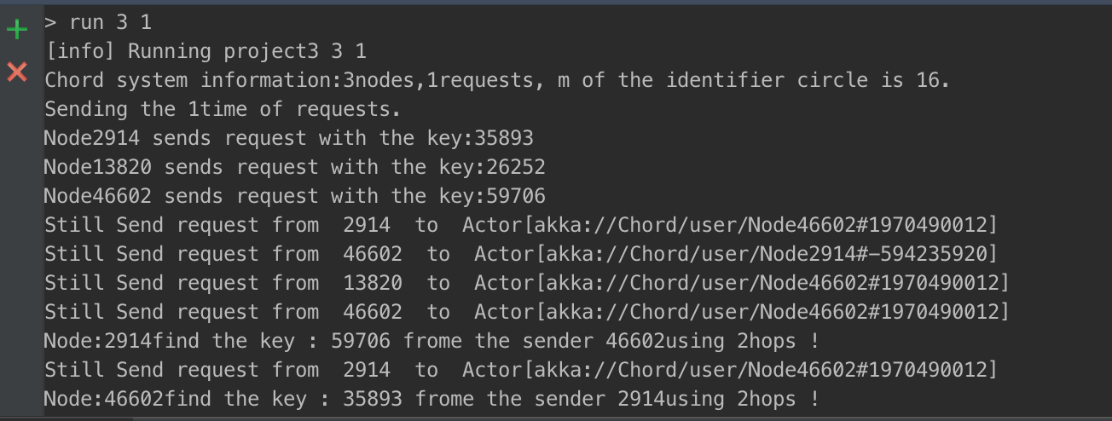

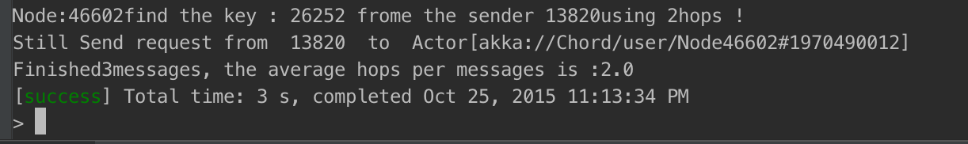

We can see that :

Node 2914 find the key:35893 from 2914 to 46602 to 13820, using 2 hops.

Node 13820 find the key:26252 from 13820 to 46602 to 2914, using 2 hops.

Node 46602 find the key:59706 from 2914 to 46602 to 13820, using 2 hops.

And the average hops per message is 2

1. When the nodes increase to 200 and the requests are 5 , the result is like that:

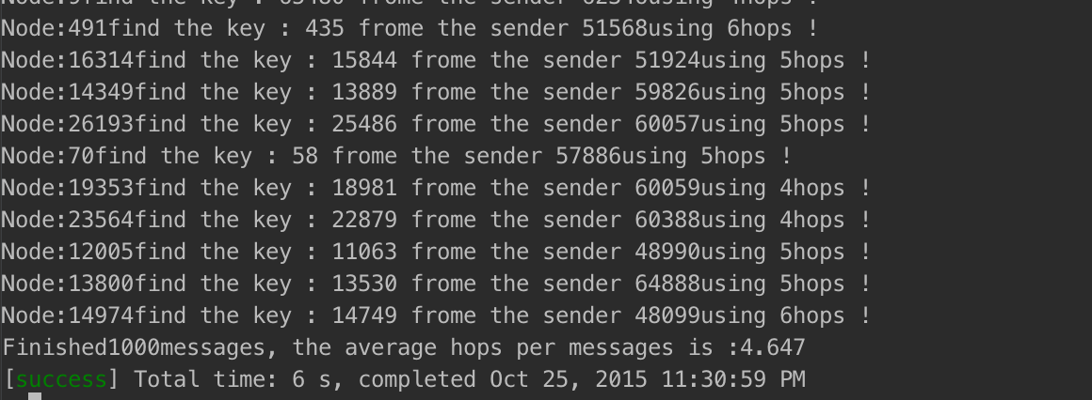

To finish the total 200*5 messages , the average hops per message is :4.67

**2. Largest Network to deal with:**

Maximum number of nodes for Chord System:

We tried the number nodes from 5 to 5000 with 5 requests, all the nodes can get the messages. When the numbers of nudes come to 10000 even more, it takes too much time to finish the program, we did not see the results . What’s more, if there are more message needed to be sent, it will cost much more time.