Project2 - Gossip Simulator

**1.What is working :**

**The creation of topology:**

**Line Topology:** The nodes are arranged in a Line and each actor has two neighbors except the first and last one. Such as “1 ,2 ,3 ,4, 5, 6 ” . Node 3 has the neighbors of “2 ” and “3”.

**Full Topology**: An node can talk to any other node and all the other nodes are its neighbors.

**3D Grid Topology**: Nodes are arranged in 3D Grid form. We use the square root of the numbers of nodes to get the neighbors of the node. Such as “1,2,3,4,,,,,,13,14,15,16” , Node 7 has the neighbors of “ 3”,”11”,”6”,”8”. If the given number of nodes is not perfect square, we increase that value to the nearest Perfect Square.

**Imperfect 3D Grid Topology**: It is similar to the 3D-Grid. In addition to that, the node has an extra neighbor and it is selected from the rest of the nodes randomly.

T**he Implementation of algorithm:**

**Gossip:**

A node randomly selected his neighbor to send the message and when his neighbor gets the message , it will also choose its own neighbors to send the message ,when a node get 10 messages , it finishes the job.

**Push Sum:**

A node(i) upon receiving its message stores S(i) and W(i) value and Selects any of its random neighbor(j) and sends the message. Upon receiving the message, the node(j) should add received pair of its values to its corresponding Values (S(i) + S(j)) and (W(i) + W(j)). This node again selects it’s random neighbor and sends half the value of above sum to that random node. This process has to be done Recursively. If an nodes ratio (S/W) did not change more than 10^ (-10) in 3 Consecutive rounds, then node terminates. The Terminated node doesn’t transmit any message hereafter even after receiving messages from any node.

**2. Largest Network to deal with:**

Maximum number of nodes for which Gossip Algorithm Converged:

**Gossip Algorithm:**

We tried the number nodes from 10 to 10000 in 3 minutes , they all works well .

When the numbers of nudes come to 500000, it takes too much time to finish the program ,we did not see the results .

**Push-Sum Algorithm:**

We tried the number nodes from 10 to 5000 in 3 minutes , they all works well .

When the numbers of nudes come to 10000, it takes too much time to finish the program ,we did not see the results .

**Reports of program results:**

The following are the graphs plotted for the input size and time for convergence.

Gossip Simulator

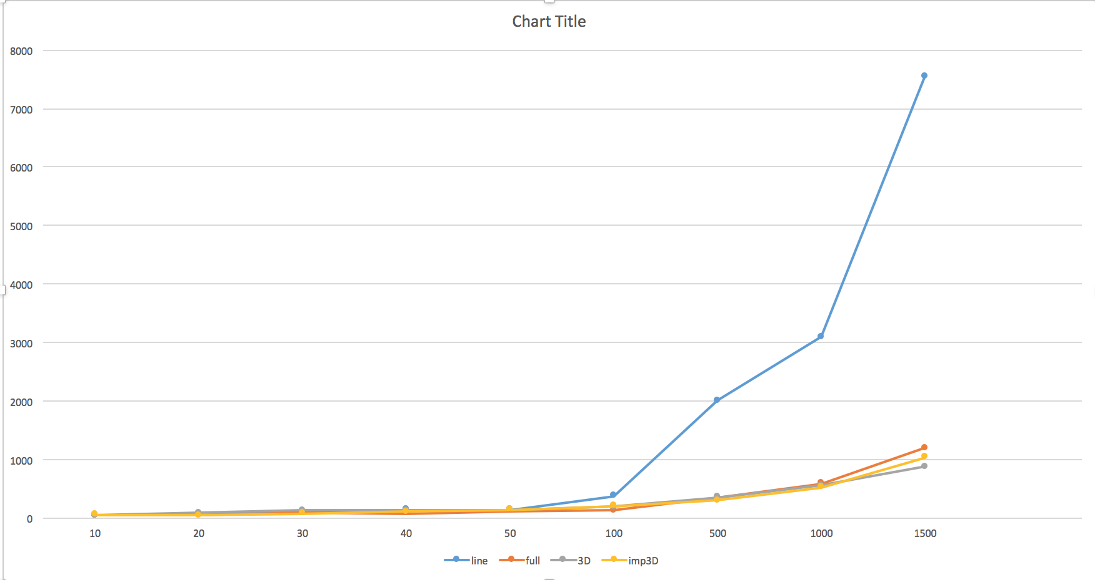

Push-Sum Simulator

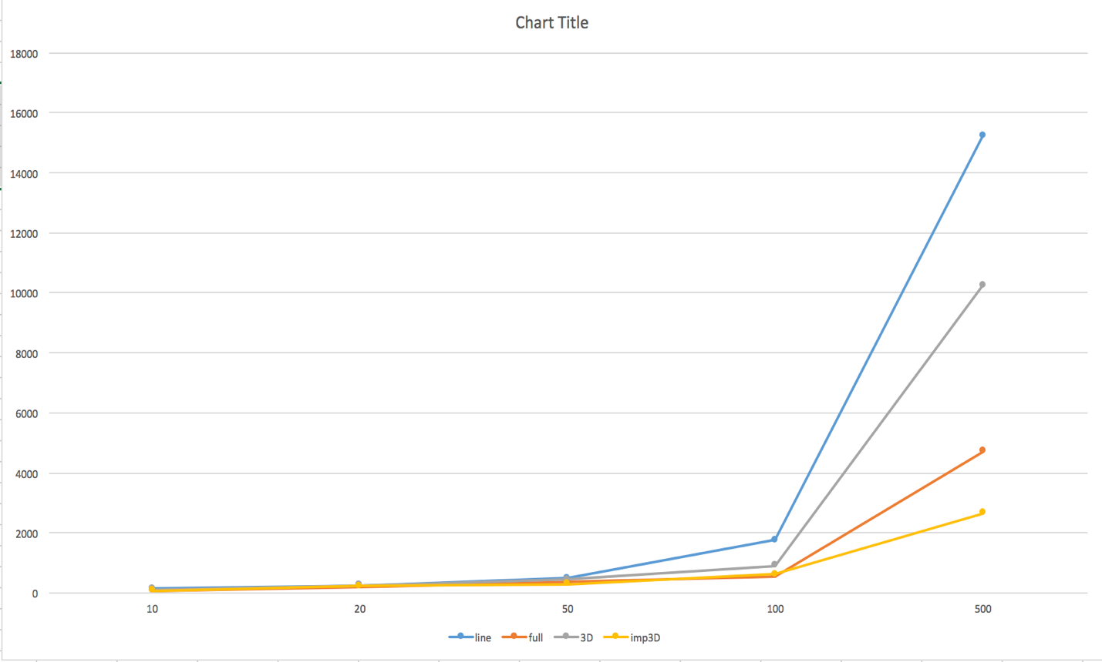

From the graphs we get some views:

1. Push-sum and Gossip are all observed to take more time for convergence as the number of input nodes increased.

2. Push-Sum algorithm will normally take more time for convergence than Gossip algorithm with the same topology especially when there are more than 100 nodes in the network.

3. The order of the convergence time as the input nodes goes high for Gossip algorithm is:

Line > Full > 3D Grid> Imp 3D Grid

4. The order of the convergence time as the input nodes goes high for Push-Sum algorithm is :

Line > 3D Grid > Full > Imp3D Grid

**Maximum number of nodes for which Gossip Algorithm Converged:**

**Gossip Algorithm:**

We tried the number nodes from 10 to 10000 in 3 minutes , they all works well .

When the numbers of nudes come to 500000, it takes too much time to finish the program ,we did not see the results .

**Push-Sum Algorithm:**

We tried the number nodes from 10 to 5000 in 3 minutes , they all works well .

When the numbers of nudes come to 10000, it takes too much time to finish the program ,we did not see the results .