**Taller 1. Fundamentos en Biología Computacional -2019**[**¶**](http://localhost:8888/notebooks/Documents/Taller1Daniela.ipynb#Taller-1.-Fundamentos-en-Biolog%C3%ADa-Computacional--2019)

"1." Abrir una cuenta en Data Camp [https://www.datacamp.com](https://www.datacamp.com/) , suscribirse en "learning Python"

"2." Hacer un Notebook en Jupyter con el registro de actividad. Tómele un pantallazo al usuario que creo y subalo al notebook (1 punto)

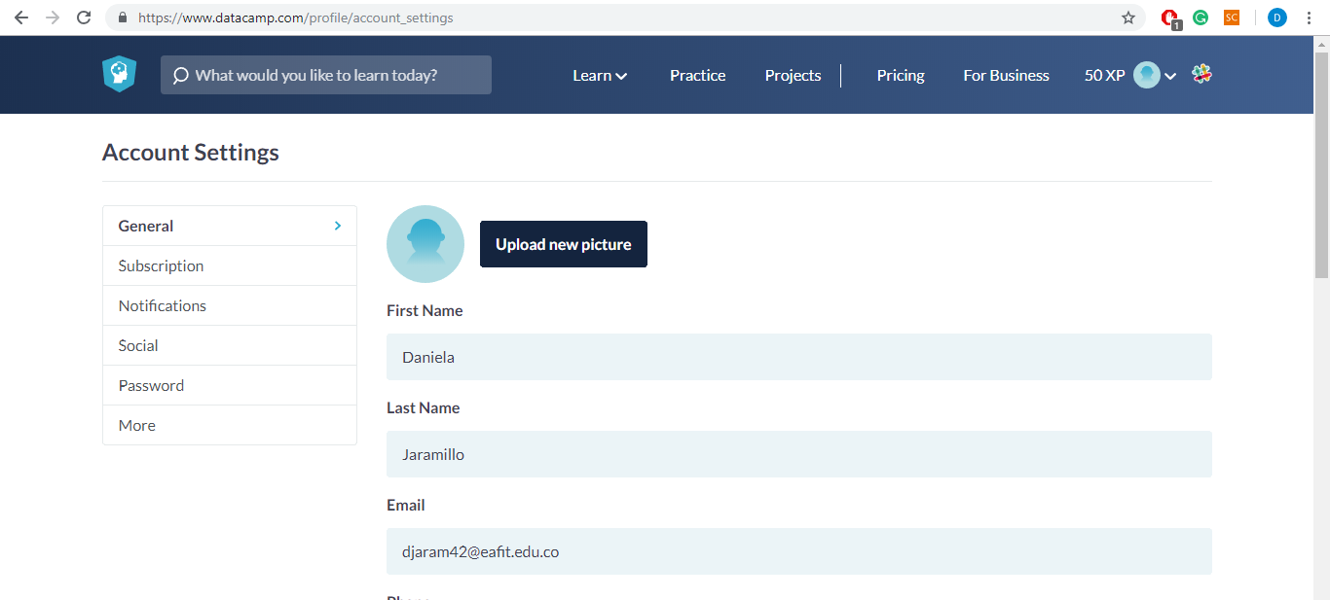"3." Completar el curso de Python al 100% y suber pantallazo del progreso al notebook (2 Puntos)

![title]

"4." Realizar 3 ejercicios de Rosalind y sibir el pantallazo de los tres ejercicios (1 Punto)

In [1]:



*##Problem ACGT Count*

​

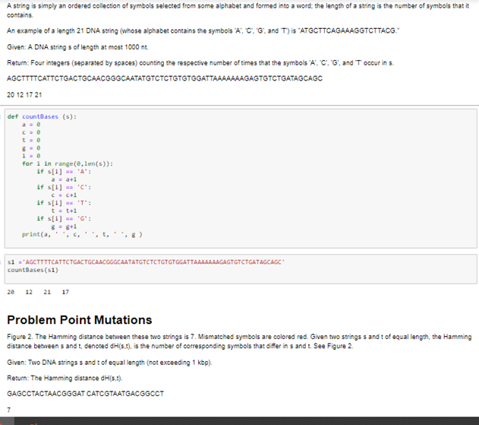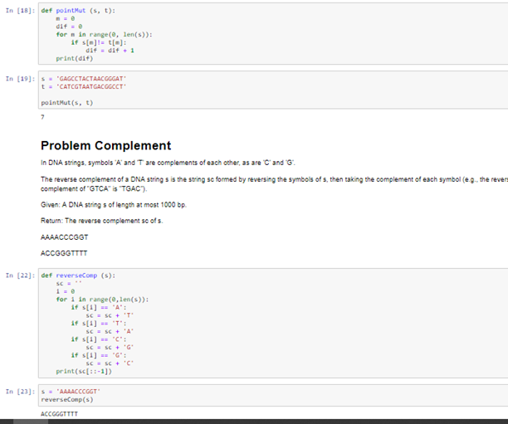"5." Realizar un ejercicio de cada nivel de "Warmup-1 y Logic-1" de <https://codingbat.com/python> y subir el código en el notebook.

In [ ]:



*#We have a loud talking parrot. The "hour" parameter is the current hour time in the range 0..23. We are in trouble if the parrot is talking and the hour is before 7 or after 20. Return True if we are in trouble.*

​

​

parrot_trouble(**True**, 6) → **True**

parrot_trouble(**True**, 7) → **False**

parrot_trouble(**False**, 6) → **False**

**def** parrot_trouble(talking, hour):

**if** talking:

**if** (hour **<** 7 **or** hour **>** 20):

**return** **True**

**return** **False**

In [ ]:



*#The squirrels in Palo Alto spend most of the day playing. In particular, they play if the temperature is between 60 and 90 (inclusive). Unless it is summer, then the upper limit is 100 instead of 90. Given an int temperature and a boolean is_summer, return True if the squirrels play and False otherwise.*

​

​

squirrel_play(70, **False**) → **True**

squirrel_play(95, **False**) → **False**

squirrel_play(95, **True**) → **True**

**def** squirrel_play(temp, is_summer):

**if** is_summer:

**if** temp**>=**60 **and** temp**<=**100:

**return** **True**

**else**:

**return** **False**

**if** **not**(is_summer):

**if** temp**>=**60 **and** temp**<=**90:

**return** **True**

**else**:

**return** **False**

In [ ]:



*#Given a string name, e.g. "Bob", return a greeting of the form "Hello Bob!".*

​

​

hello_name('Bob') → 'Hello Bob!'

hello_name('Alice') → 'Hello Alice!'

hello_name('X') → 'Hello X!'

​

**def** hello_name(name):

**return** "Hello " **+** name **+** "!"

In [ ]:



*#Given an array of ints length 3, return a new array with the elements in reverse order, so {1, 2, 3} becomes {3, 2, 1}.*

​

​

reverse3([1, 2, 3]) → [3, 2, 1]

reverse3([5, 11, 9]) → [9, 11, 5]

reverse3([7, 0, 0]) → [0, 0, 7]

​

**def** reverse3(nums):

**return** [nums[2], nums[1], nums[0]]

​

"6." Enviar el notebook de jupyter completo a la carpeta del github del curso