Taller 1. Fundamentos en Biología Computacional -2019¶
"1." Abrir una cuenta en Data Camp https://www.datacamp.com , suscribirse en "learning Python"
"2." Hacer un Notebook en Jupyter con el registro de actividad. Tómele un pantallazo al usuario que creo y subalo al notebook (1 punto)
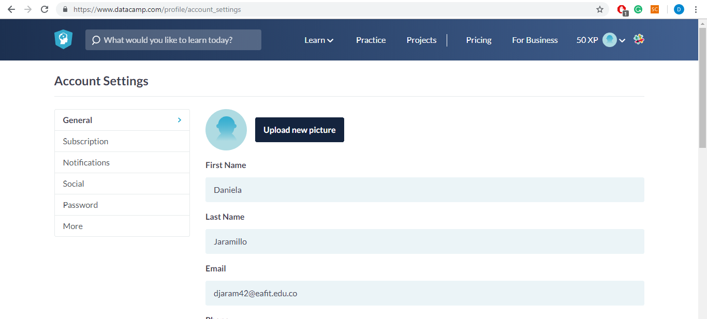"3." Completar el curso de Python al 100% y suber pantallazo del progreso al notebook (2 Puntos)
![title]
"4." Realizar 3 ejercicios de Rosalind y sibir el pantallazo de los tres ejercicios (1 Punto)
In [1]:
##Problem ACGT Count
​
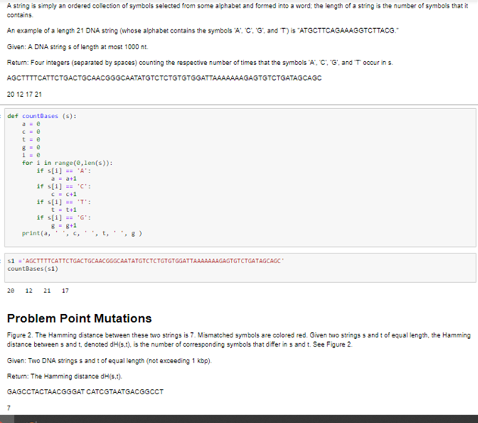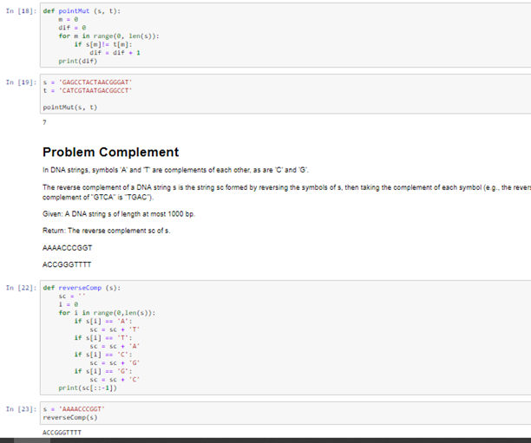"5." Realizar un ejercicio de cada nivel de "Warmup-1 y Logic-1" de https://codingbat.com/python y subir el código en el notebook.
In [ ]:
#We have a loud talking parrot. The "hour" parameter is the current hour time in the range 0..23. We are in trouble if the parrot is talking and the hour is before 7 or after 20. Return True if we are in trouble.
​
​
parrot_trouble(True, 6) → True
parrot_trouble(True, 7) → False
parrot_trouble(False, 6) → False
def parrot_trouble(talking, hour):
if talking:
if (hour < 7 or hour > 20):
return True
return False
In [ ]:
#The squirrels in Palo Alto spend most of the day playing. In particular, they play if the temperature is between 60 and 90 (inclusive). Unless it is summer, then the upper limit is 100 instead of 90. Given an int temperature and a boolean is_summer, return True if the squirrels play and False otherwise.
​
​
squirrel_play(70, False) → True
squirrel_play(95, False) → False
squirrel_play(95, True) → True
def squirrel_play(temp, is_summer):
if is_summer:
if temp>=60 and temp<=100:
return True
else:
return False

if not(is_summer):
if temp>=60 and temp<=90:
return True
else:
return False
In [ ]:
#Given a string name, e.g. "Bob", return a greeting of the form "Hello Bob!".
​
​
hello_name('Bob') → 'Hello Bob!'
hello_name('Alice') → 'Hello Alice!'
hello_name('X') → 'Hello X!'
​
def hello_name(name):
return "Hello " + name + "!"

In [ ]:
#Given an array of ints length 3, return a new array with the elements in reverse order, so {1, 2, 3} becomes {3, 2, 1}.
​
​
reverse3([1, 2, 3]) → [3, 2, 1]
reverse3([5, 11, 9]) → [9, 11, 5]
reverse3([7, 0, 0]) → [0, 0, 7]
​
def reverse3(nums):
return [nums[2], nums[1], nums[0]]
​
"6." Enviar el notebook de jupyter completo a la carpeta del github del curso

