**Sub: Build and Release Management**

**Experiment – 3**

**Aim : Making Junit test case file for java project, Basically ,unit test file.**

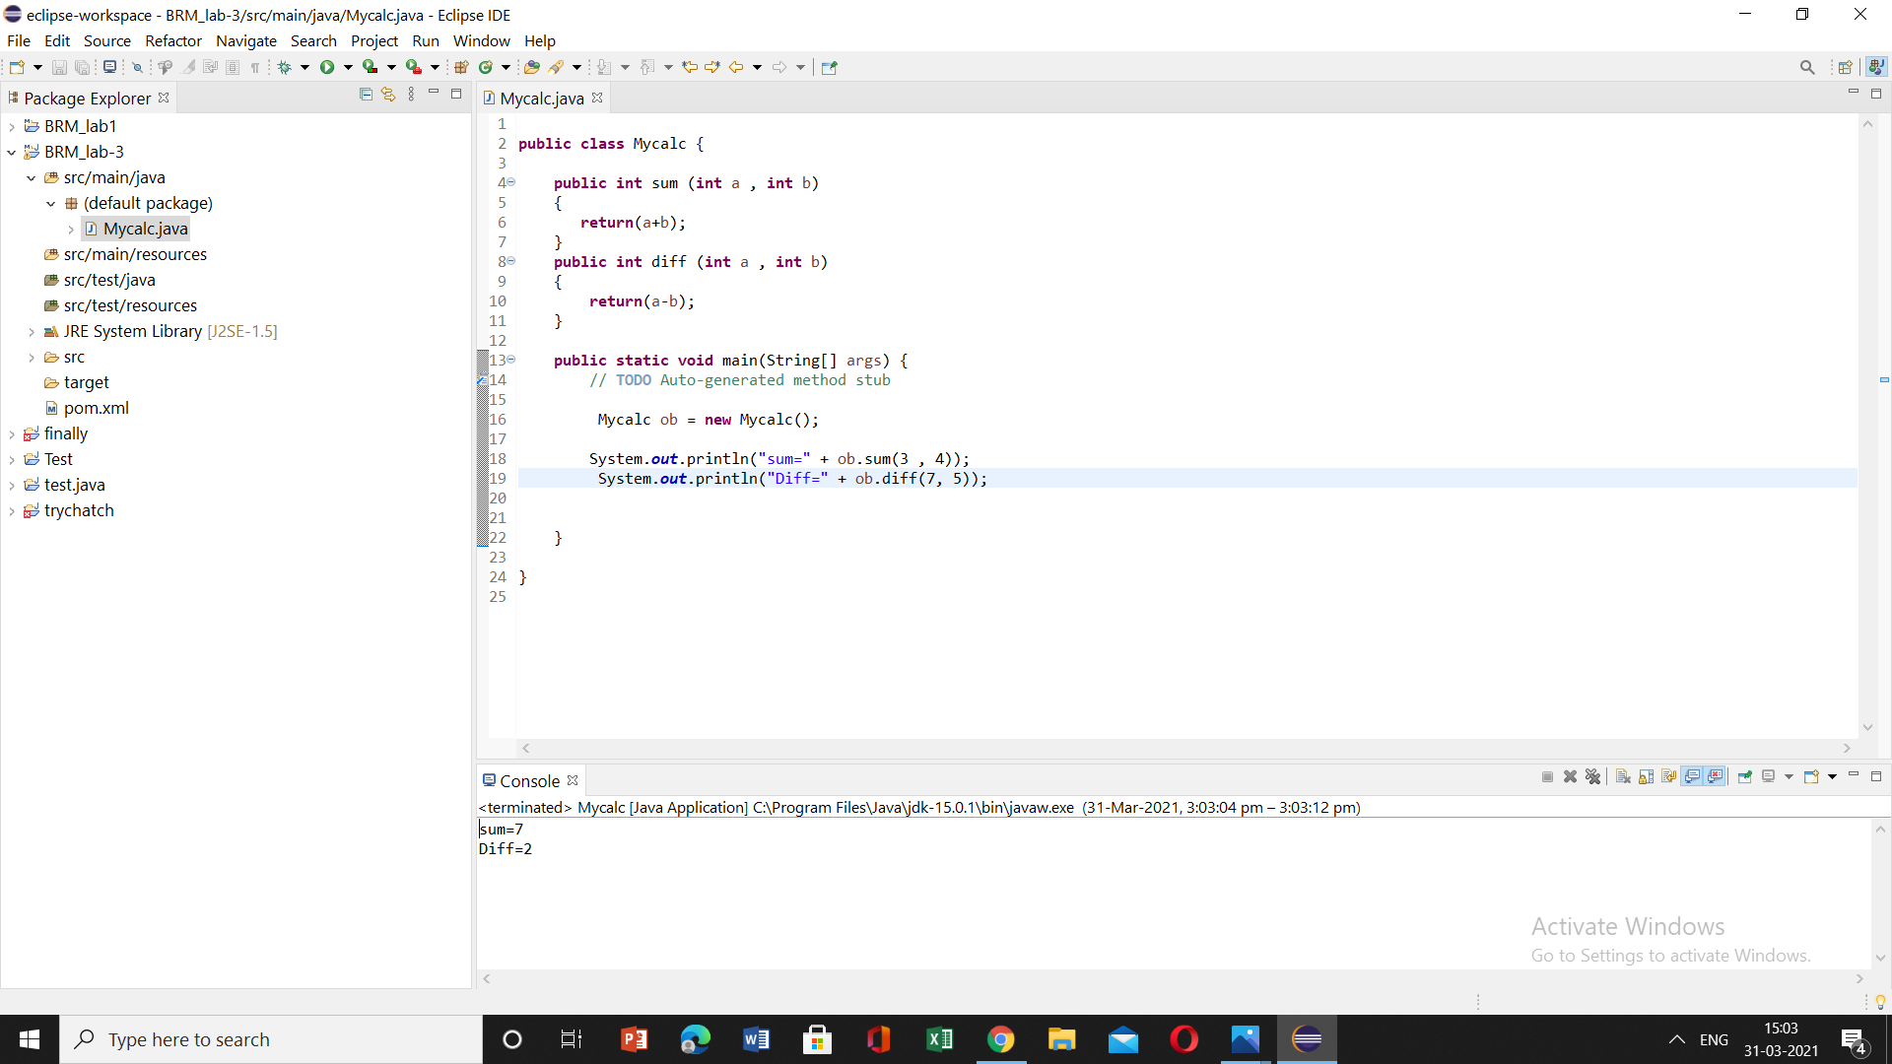

**Junit test:**

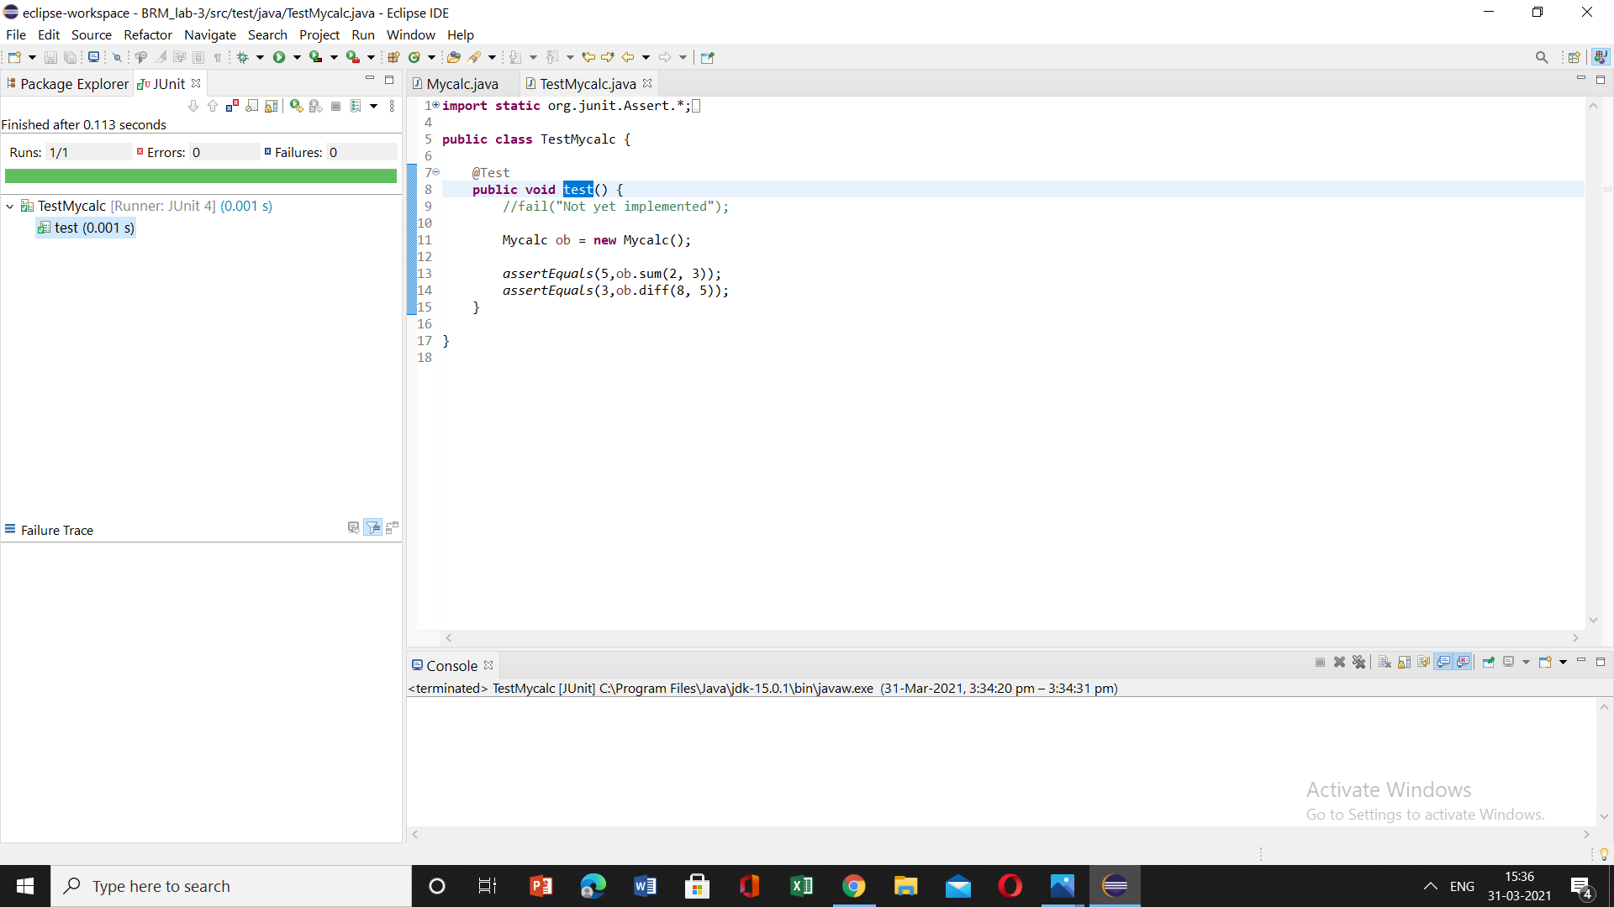

**Run test:**

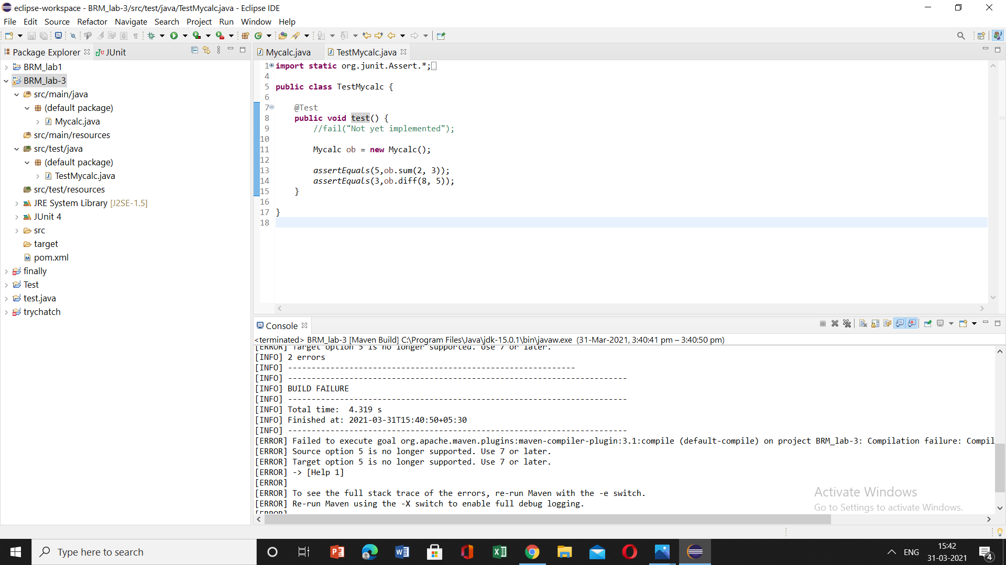

**Run Clean :**

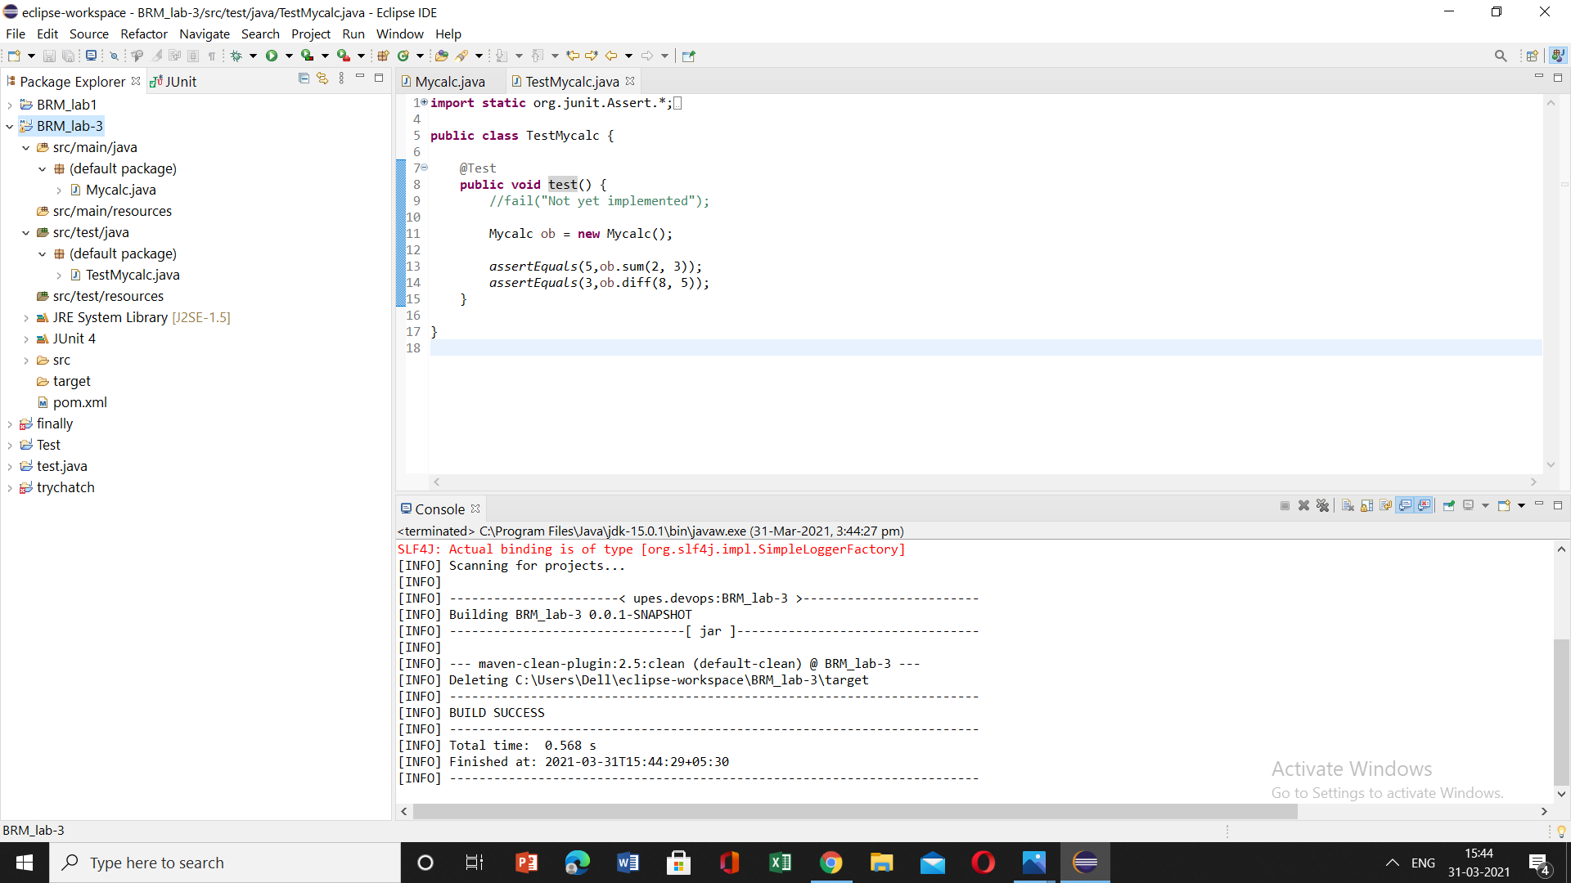

**Adding depencencey:**

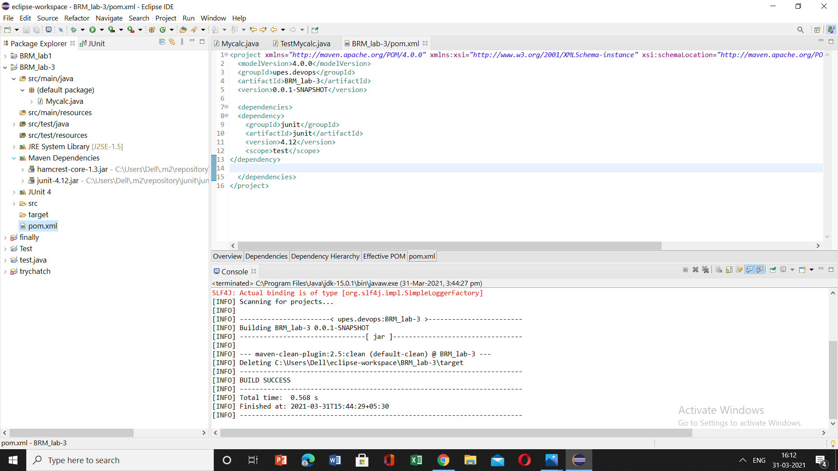

**Run test:**

