**LAB 2**

**NAME: SAUBHAGYA DIXIT**

**R171218089**

**500067088**

**DEVOPS: BUILD AND RELEASE MANAGEMENT LAB**

**Q1. Write a program in java to find sum of two numbers and test this unit with JUnit tool.**

**Step1** : Write a program in java to find sum of two numbers

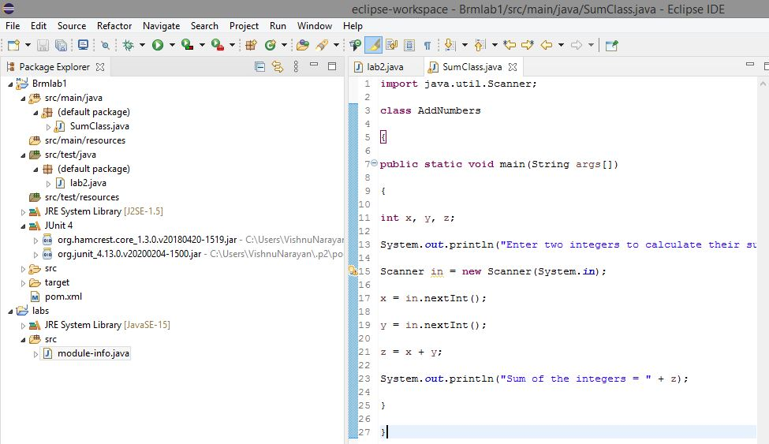

**Step2**: creating a test case for assertion of logic through **Junit test case**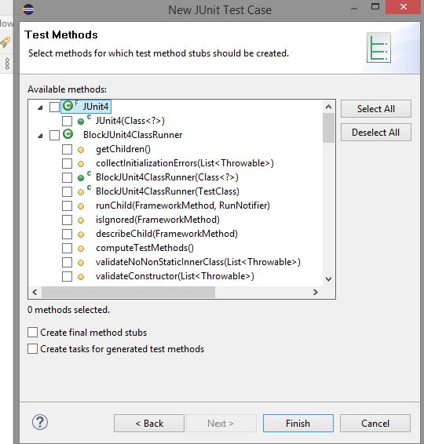

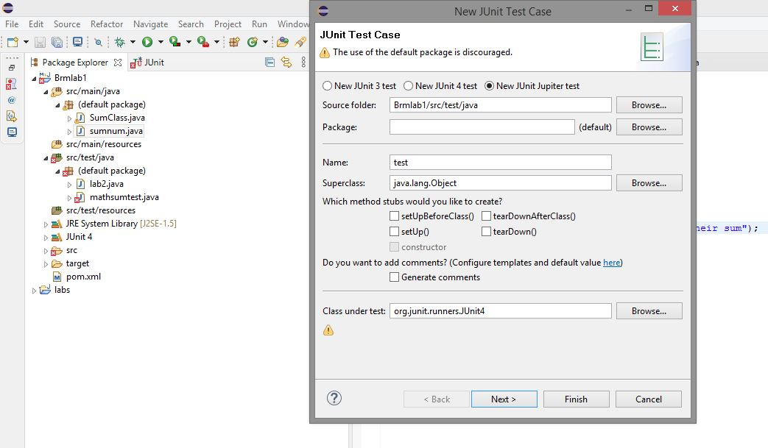

**Step3**: verifying the test case in the original logic code 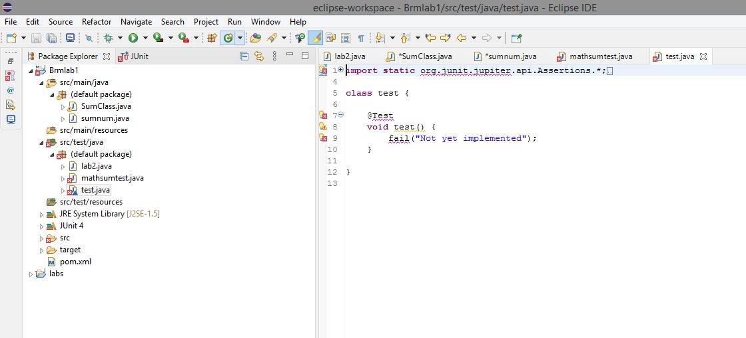

**STEP4**: Assertion errors found during formation of case test to be rectified.

