**Build and Release Management lab**

**Submitted by**

**Name – Aditya Raj**

**Roll No – R171219002**

**SAP – 500076748**

Date – 21-01-2021

Lab-1

Aim – Creating a Maven project and running the following goals – Clean, Compile and Build

Creating maven project

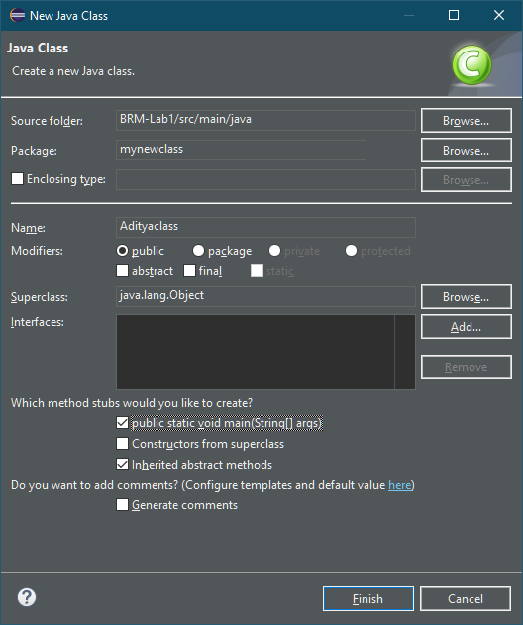

Adding class to the project

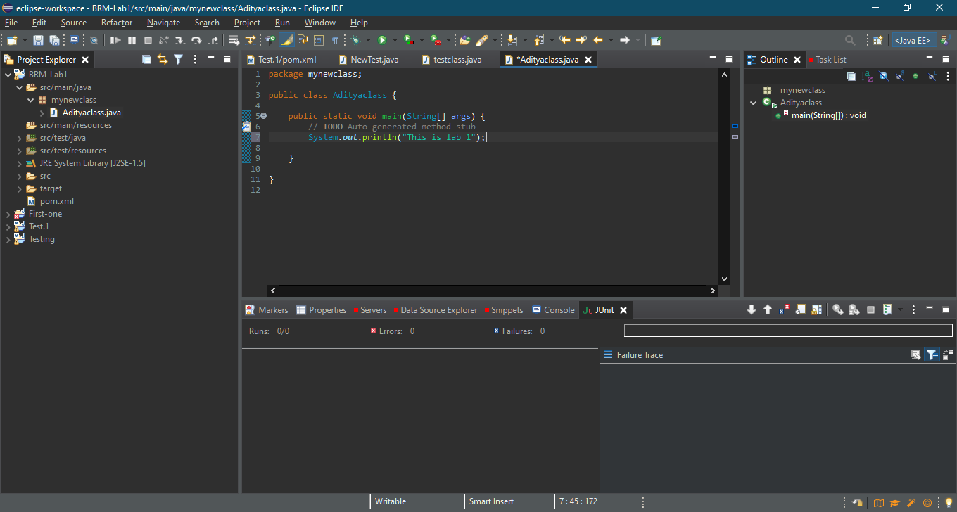

CLEAN

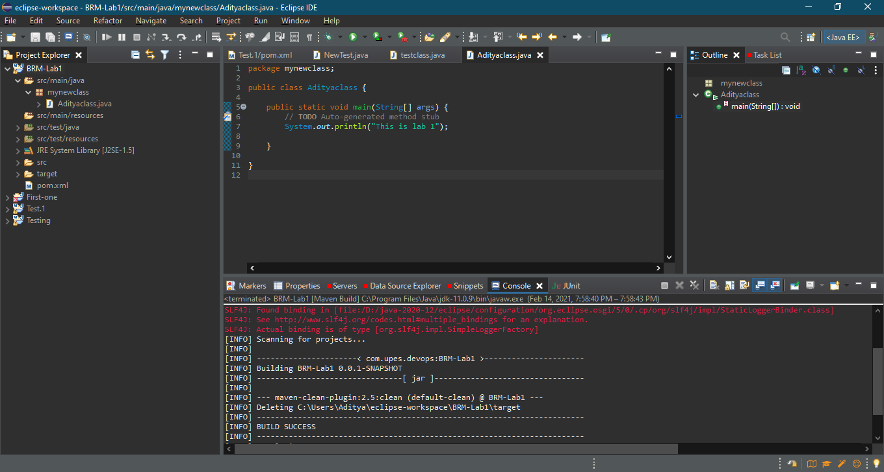

COMPILE

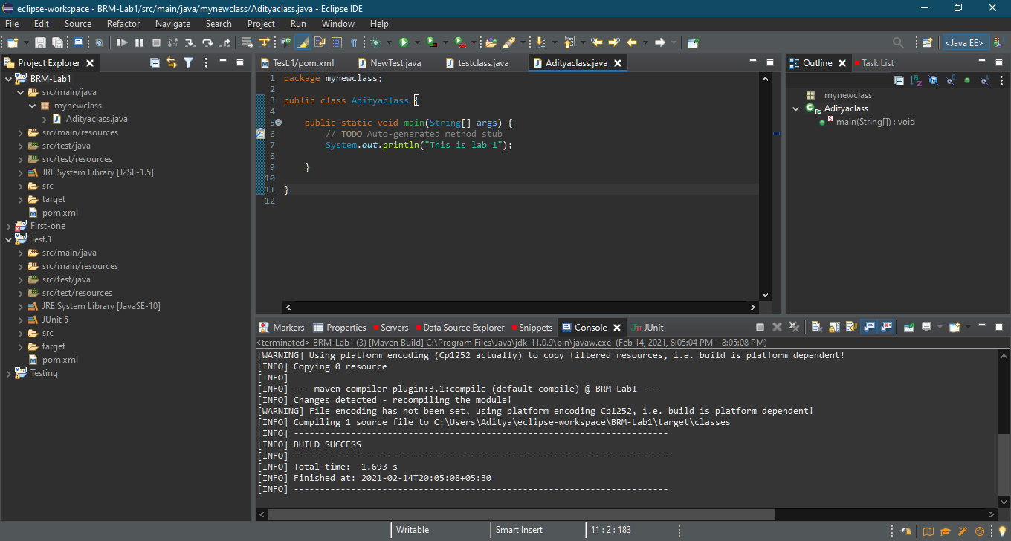

BUILD

