**Build and Release Management lab**

**Submitted by**

**Name – Aditya Raj**

**Roll No – R171219002**

**SAP – 500076748**

Date – 28-01-2021

Lab-2

Aim – Adding a maven project and linking it with Jenkins then building that file

* Creating a maven project

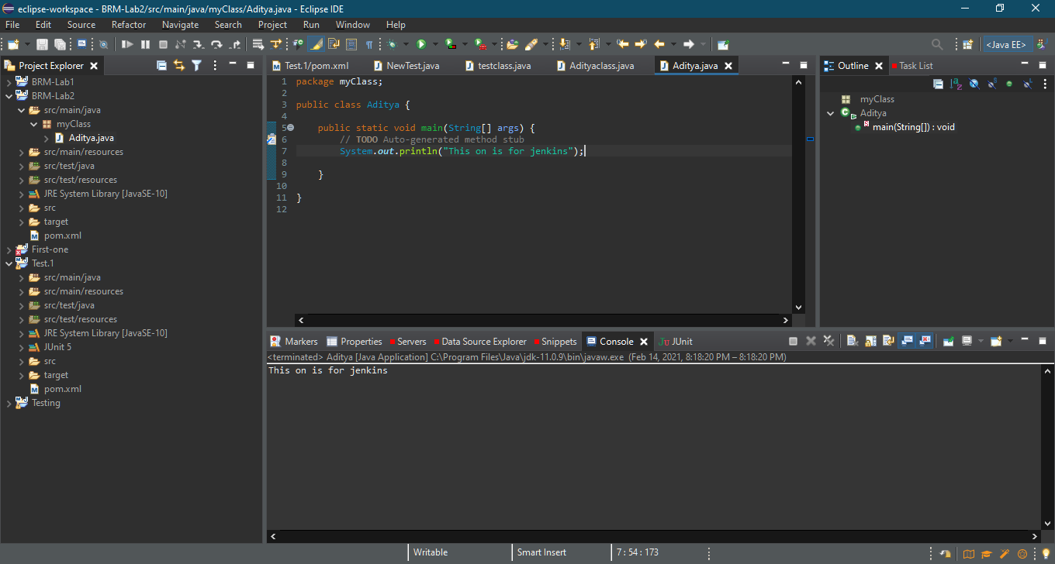

* Configure it with specified Git repository

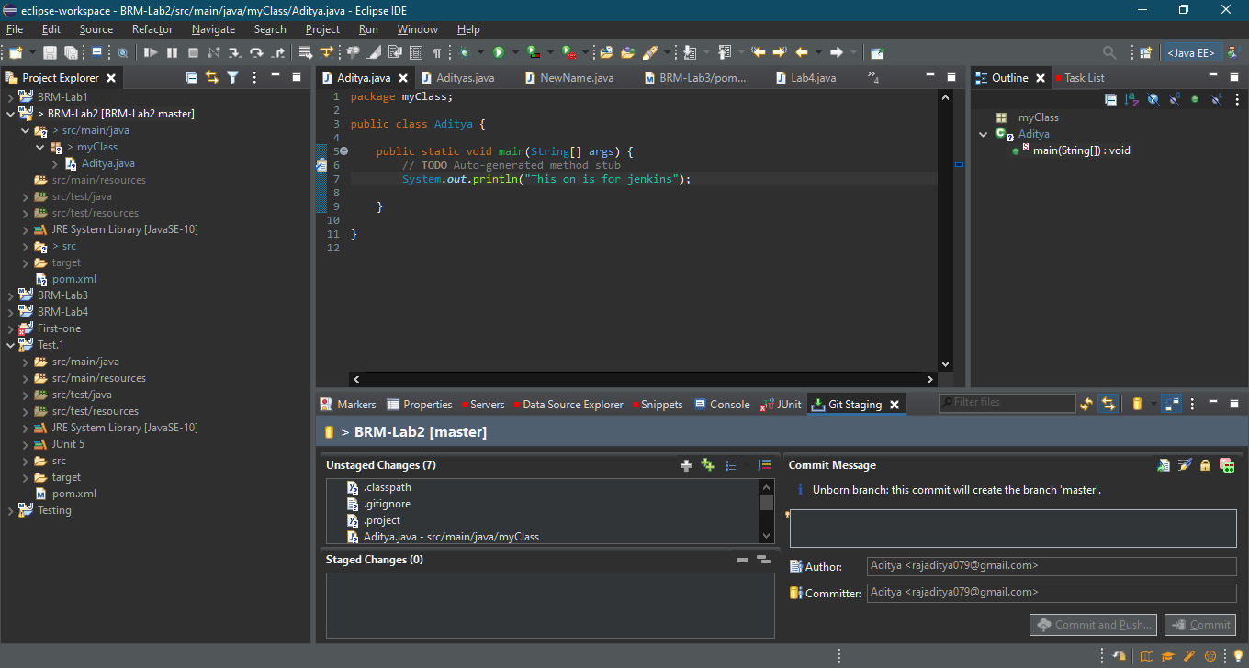

* Moving to staging area and adding comment

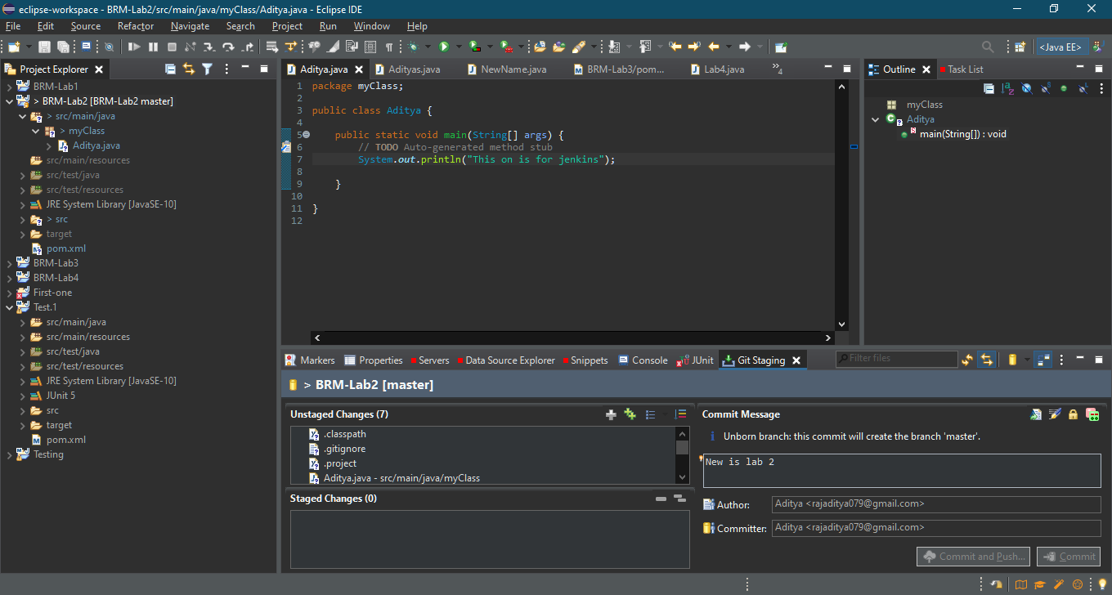

* Github repo created

