**Build and Release Management lab**

**Submitted by**

**Name – Aditya Raj**

**Roll No – R171219002**

**SAP – 500076748**

Date – 04-02-2021

Lab-3

Aim – Making Junit test case file

* Creating maven project

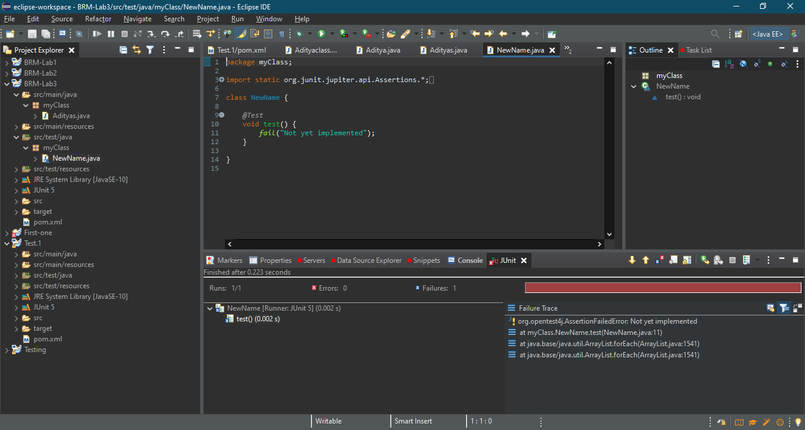

* Adding latest dependencies

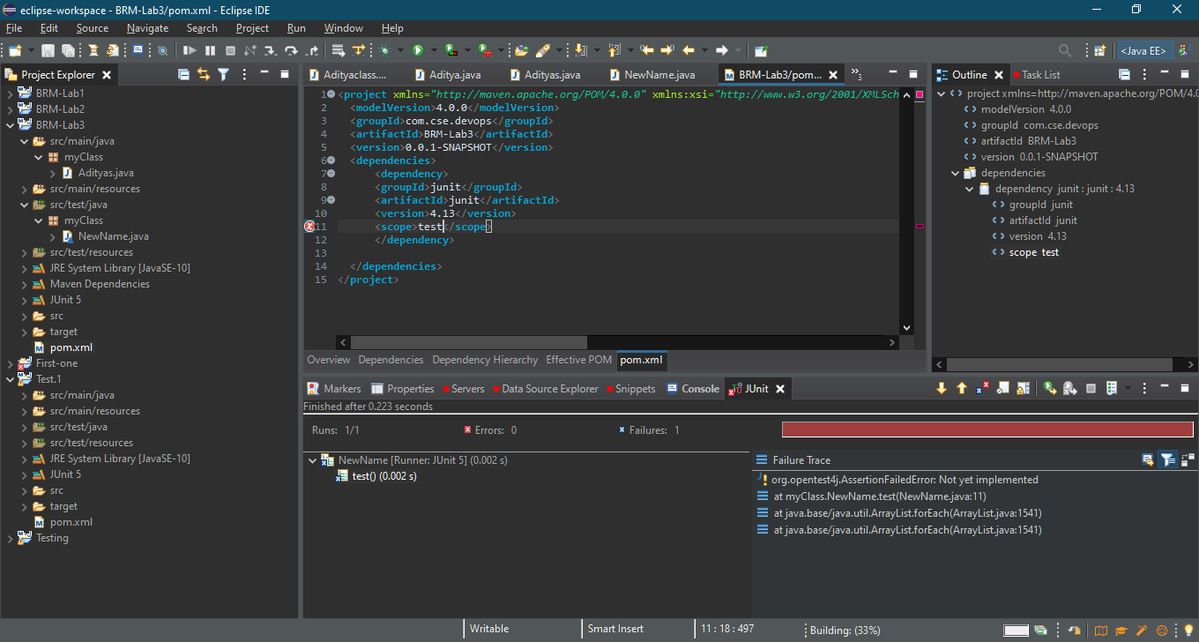

* Running the project

