**Build and Release Management lab**

**Submitted by**

**Name – Aditya Raj**

**Roll No – R171219002**

**SAP – 500076748**

Date – 11-02-2021

Lab-4

Aim – Doing all work from lab1 to 3 in one

* Creating a maven project

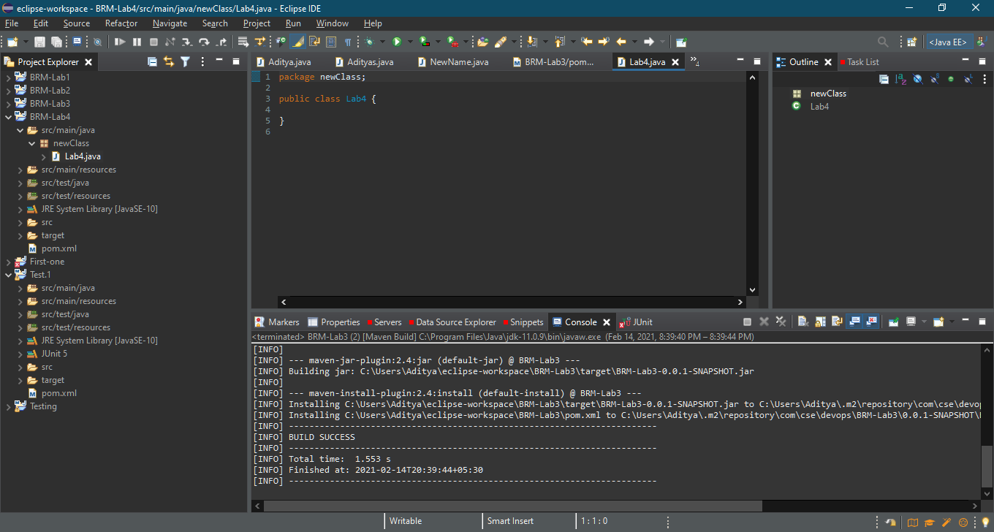

* Configure it with specified Git repository

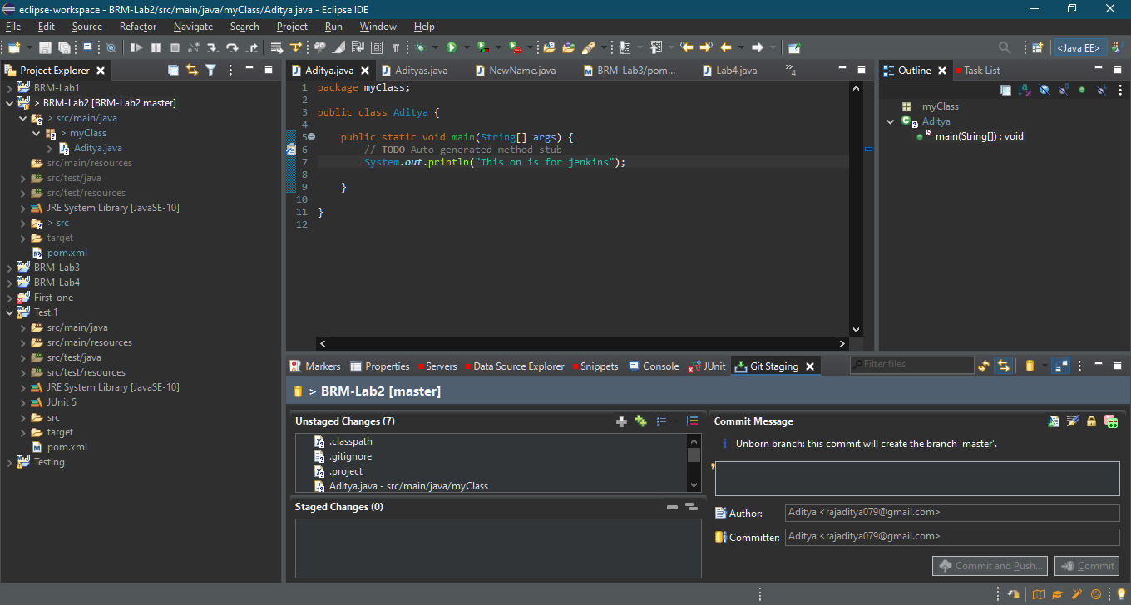

* Moving to staging area and adding comment

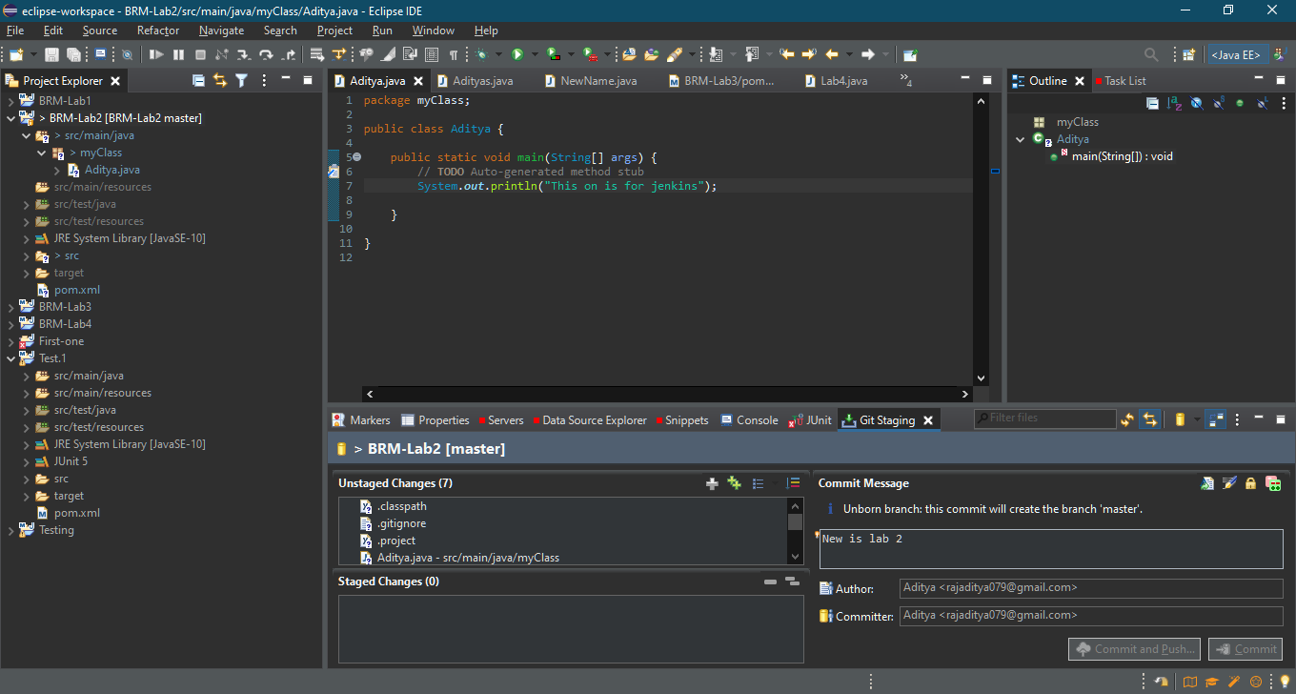

* Github repo created

