**Build and Release Management lab**

**Submitted by**

**Name – Aditya Raj**

**Roll No – R171219002**

**SAP – 500076748**

Date – 25-02-2021

Lab-5

Aim – Making Site

Pom.xml

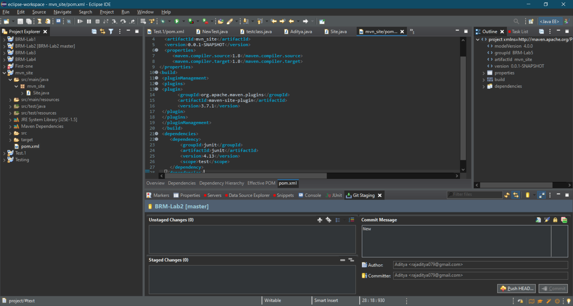

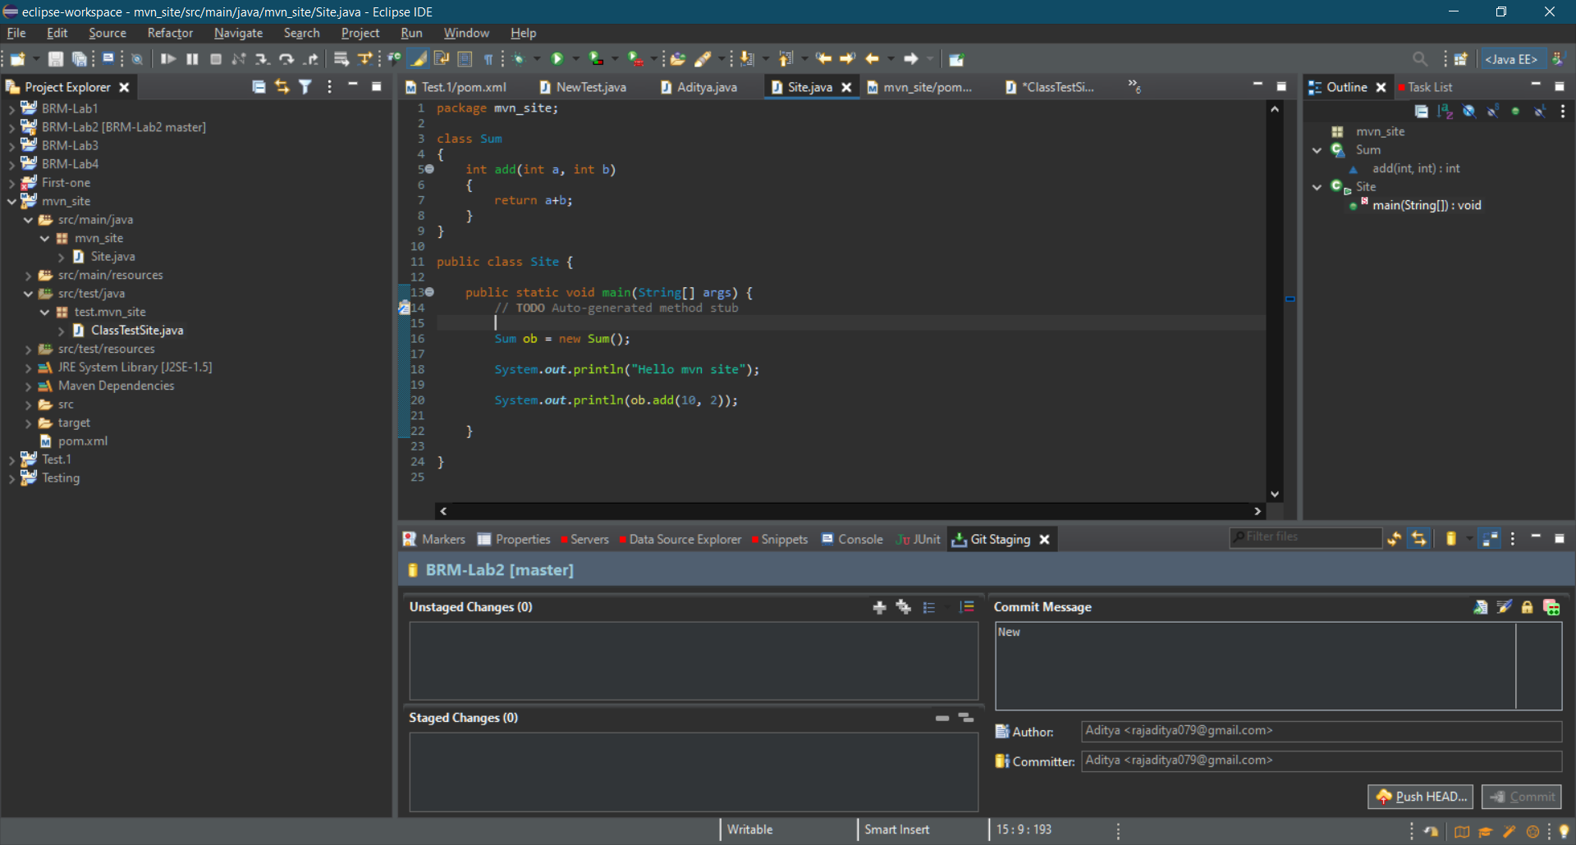

Goal = install

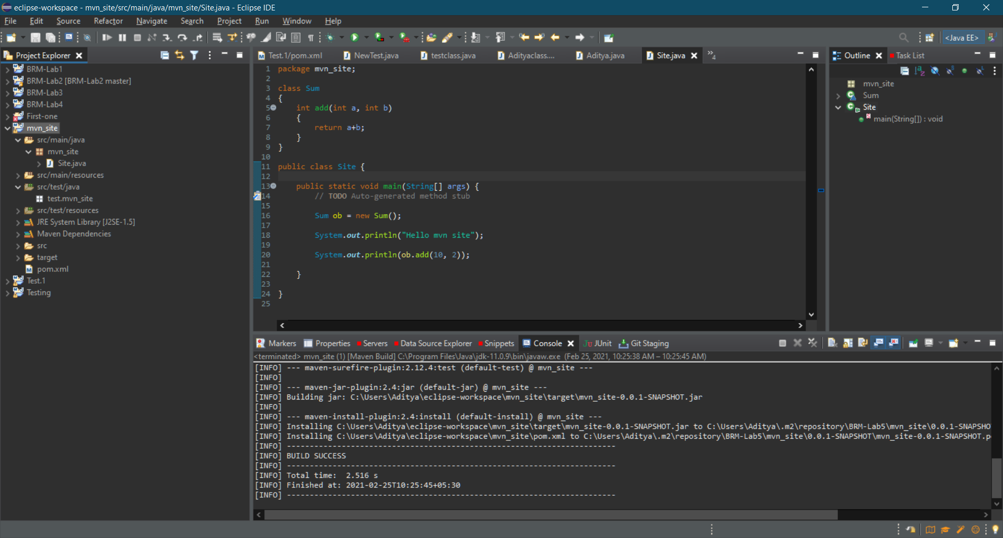

Goal = site

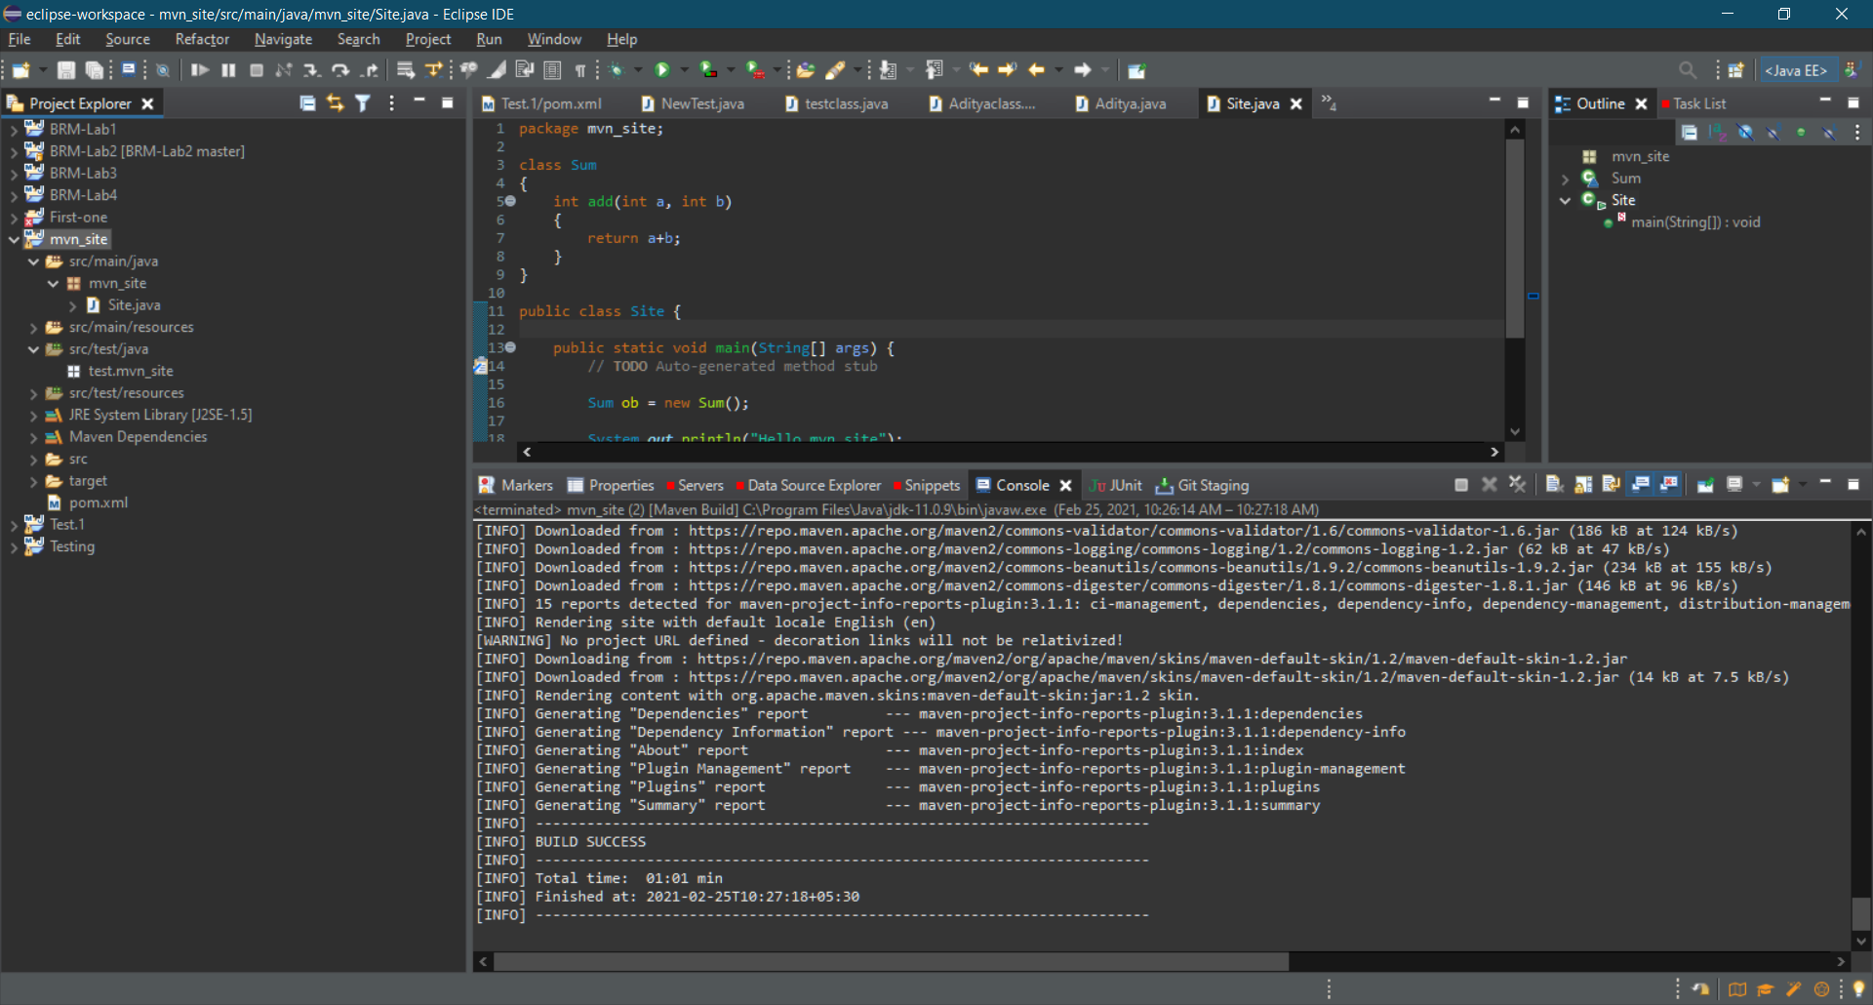

File are created in site folder

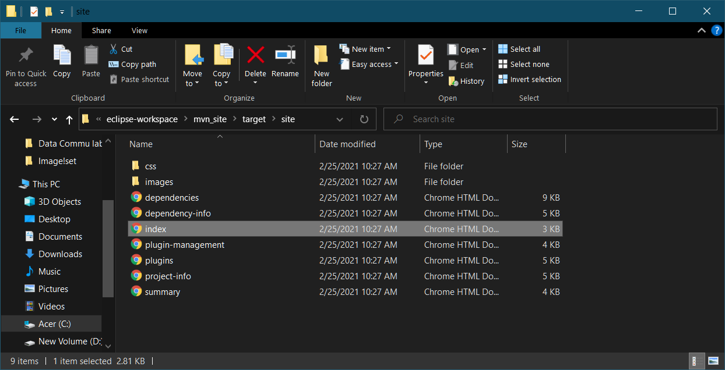

Index.html

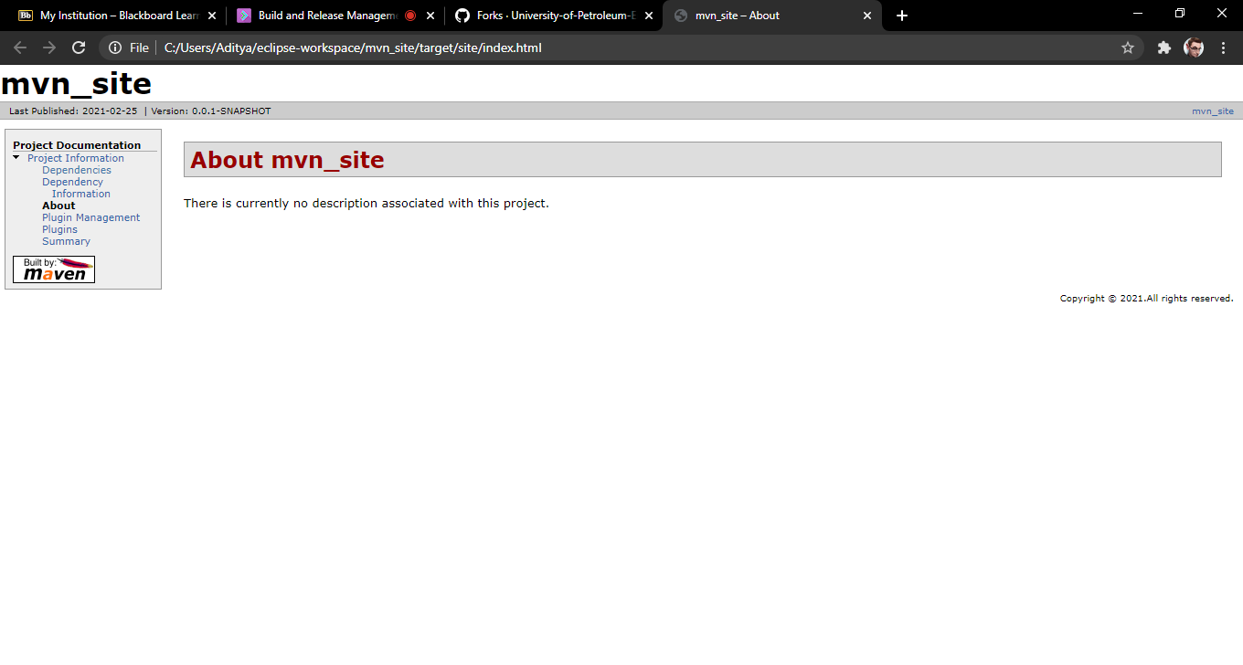

Dependencies.html

