BRM LAB-9

SELENIUM

PHAGUN JAIN

Creating project in selenium

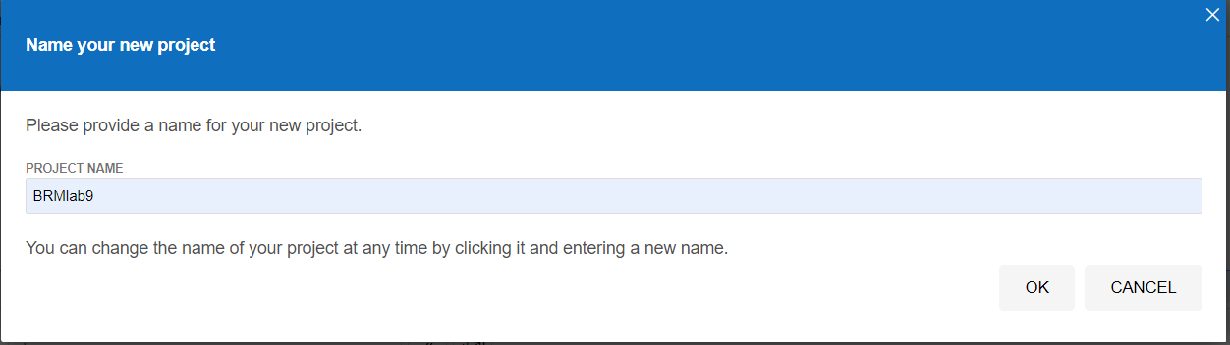

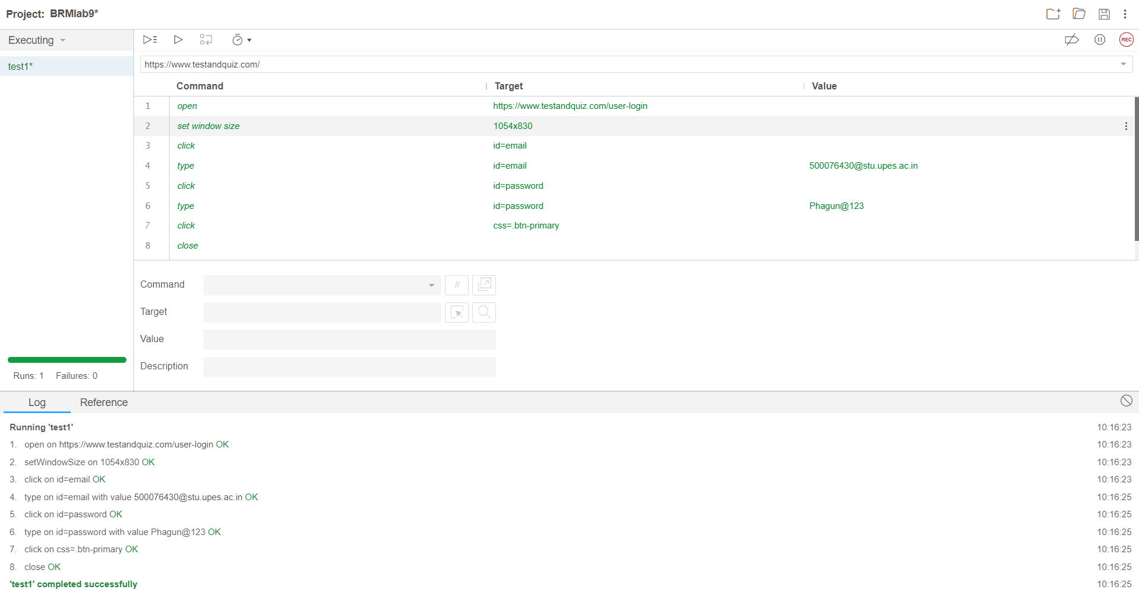commands and successful execution

save project

