Build And Release Management Lab

Experiment-3

Making Junit test case file for Java Prog. Basically, unit test file .Run the prog. Bottom right corner shows that no error recorded test passed, if failed it will show at that bar.

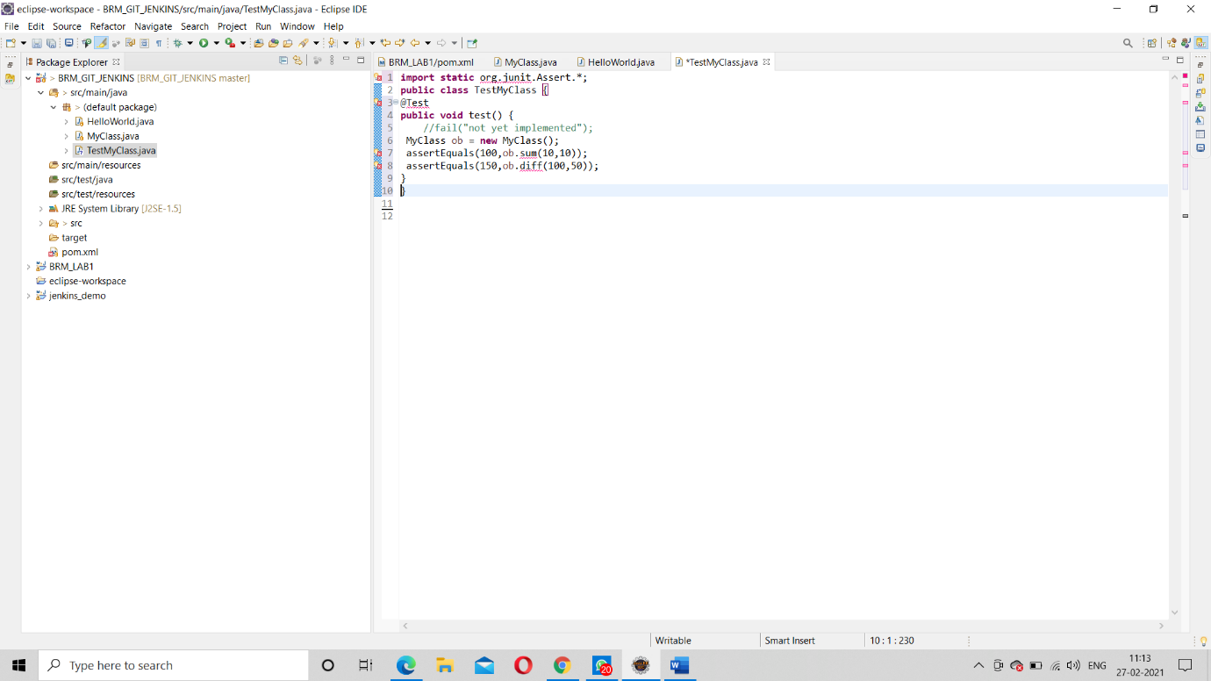

Creating a Java prog, for unit test, on Junit

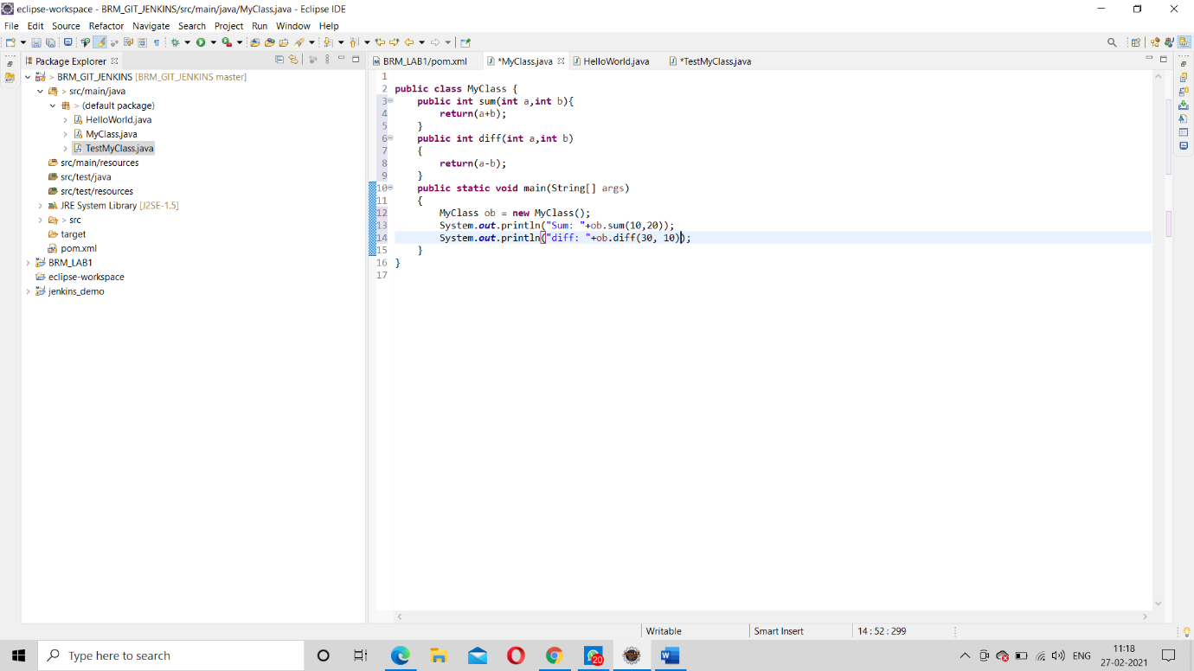

Adding latest dependency from web, on pom.xml file for the unit test case. Started from 6 line to 13 line (which will later add a maven dependencies tab on side bar) .This added dependency help to build the maven project, basically the test phase.

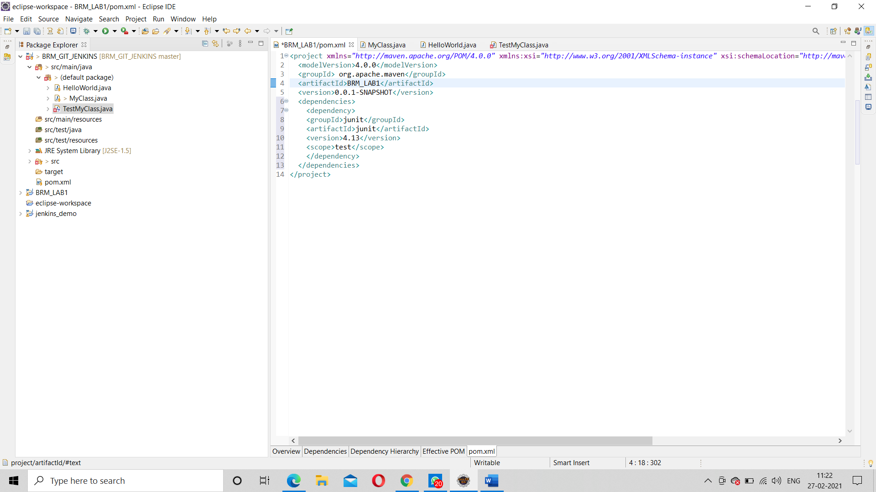

Run the project, set goal “test”.

