**Name : Tanmay Kanwar**

**Branch : CS DevOps 3rd Sem**

**Sap id : 500076341**

**Roll No. : R171219038**

**Build and Release Management Lab-1**

**Aim :** 1. Create a java project using Maven

2. Run the following goals on this project • Clean • Compile • Install

3. Adding external jar file

**Procedure:**

Step1: Go to file -> new -> project

Step2: Select maven project and click next

Step3: Select the checkbox which says “Create a simple project” and click next

Step4: Enter group ID and Artifact ID and click on “Finish” You will see that your project is created

Step5: Right click on your project -> New -> Class

Step6: Enter your classname and click on “Finish”

Step7: Write the code

**FOR CLEAN:**

Step 1: Right click the project name -> Run as -> Maven Build…

Step 2: In the goals section, write clean and click on “Run”

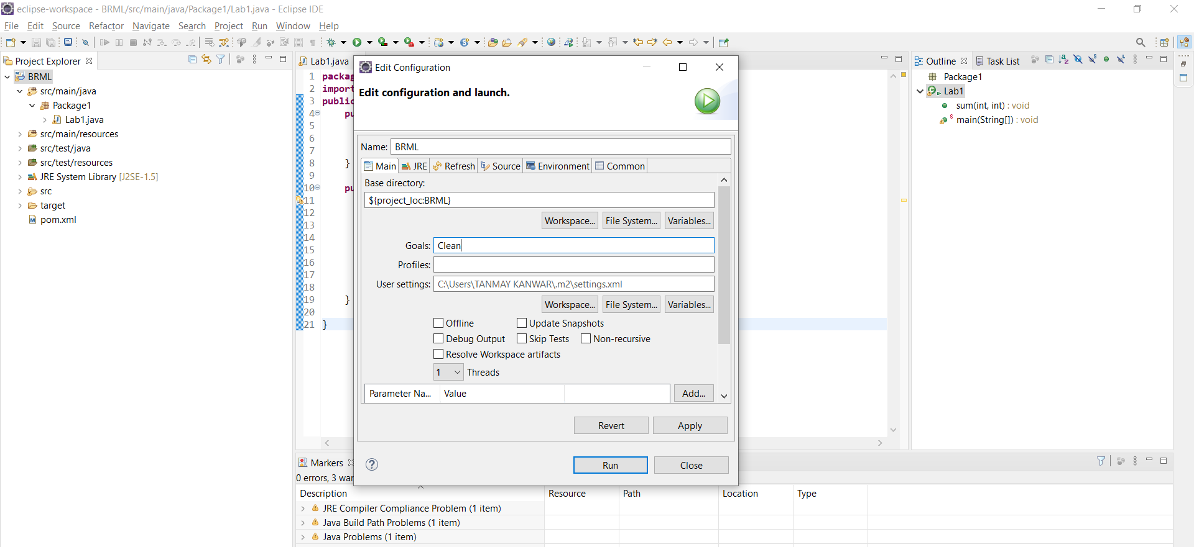

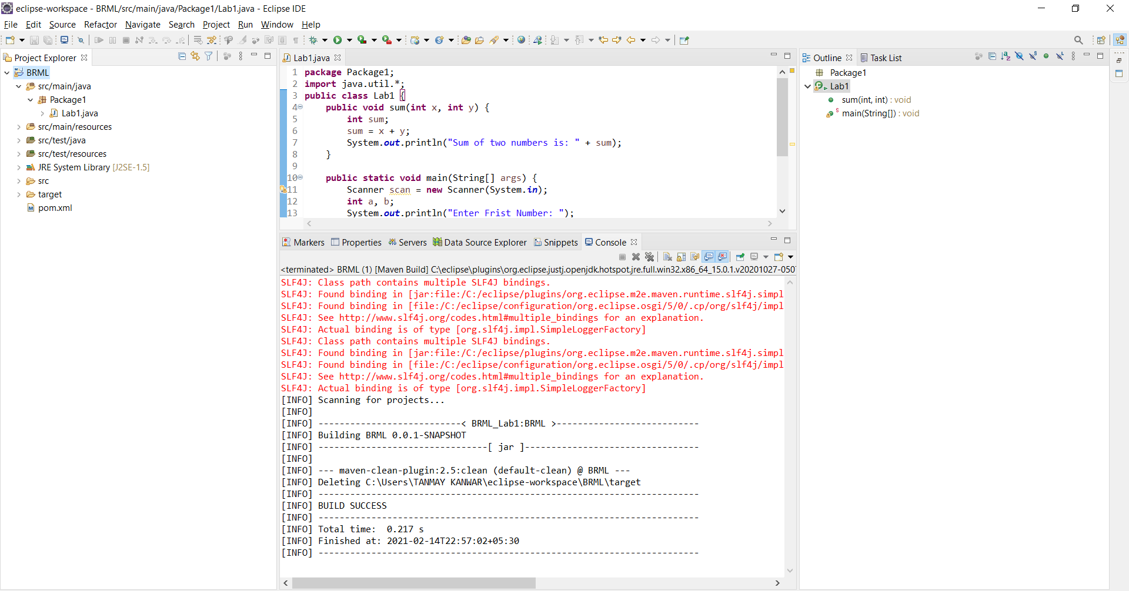

**FOR COMPILE:**

Step 1: Right click the project name -> Run as -> Maven Build…

Step 2: In the goals section, write compile and click on “Run”

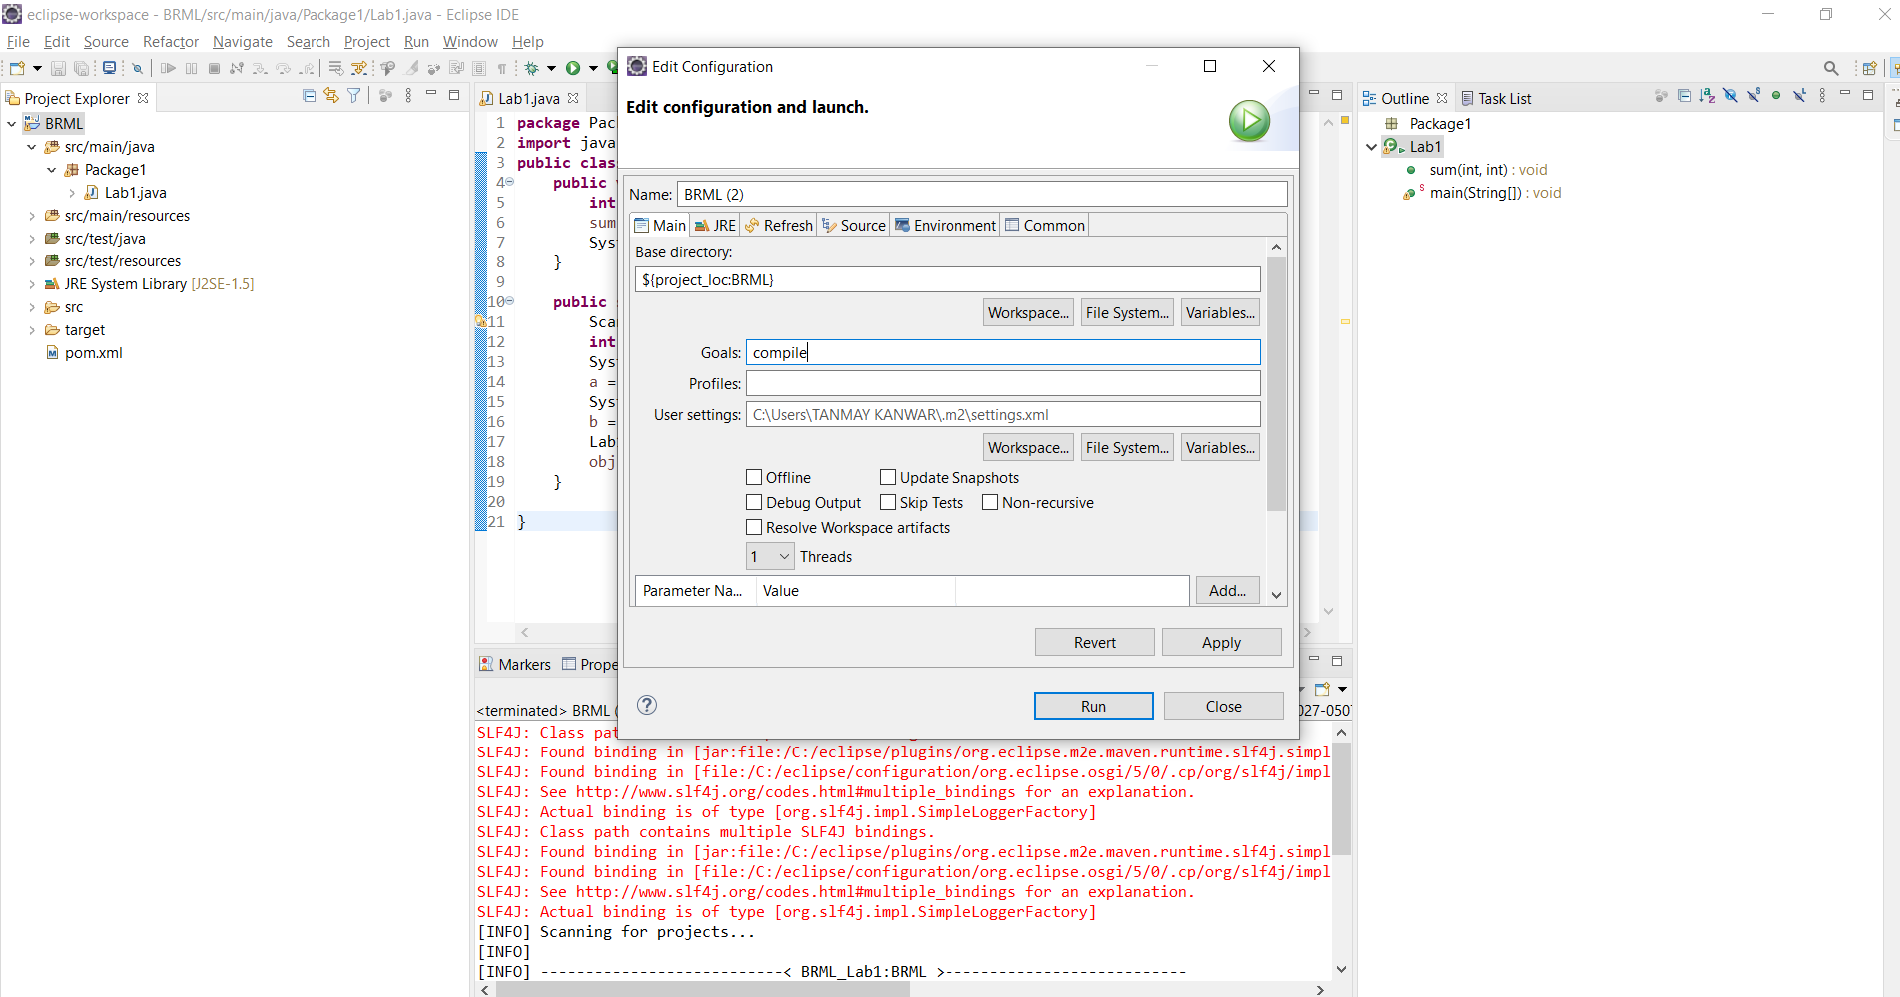

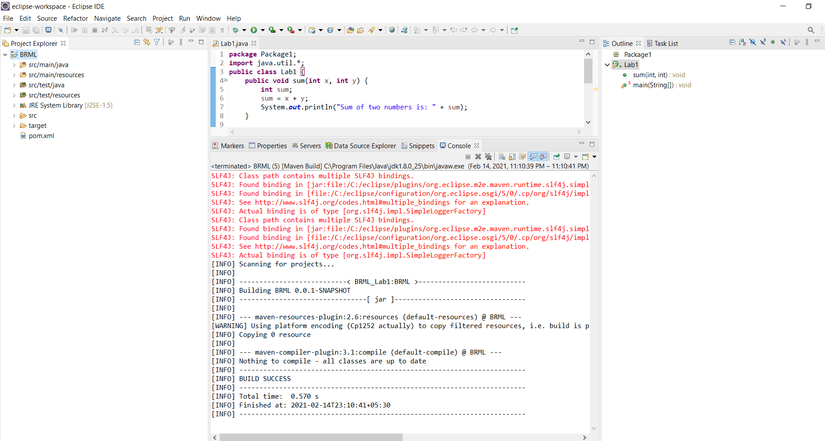

**FOR INSTALL:**

Step 1: Right click the project name -> Run as -> Maven Build…

Step 2: In the goals section, write install and click on “Run”

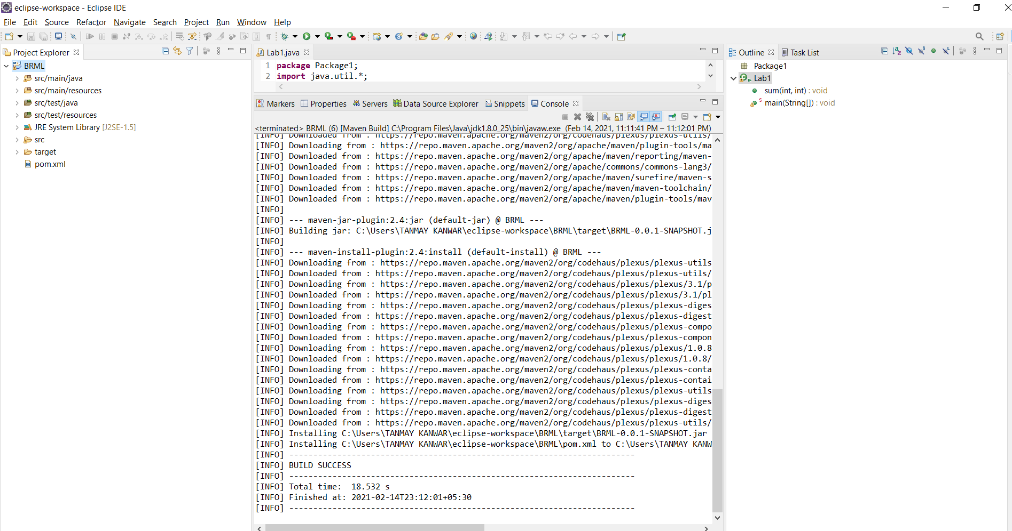

Adding external .jar file to existing java file

