**Name : Tanmay Kanwar**

**Branch : CS DevOps 3rd Sem**

**Sap id : 500076341**

**Roll No. : R171219038**

**Batch : 2**

**Build and Release Management Lab-6**

**Aim:** Create a simple Maven Project using CLI.

1. Command to check Maven Version

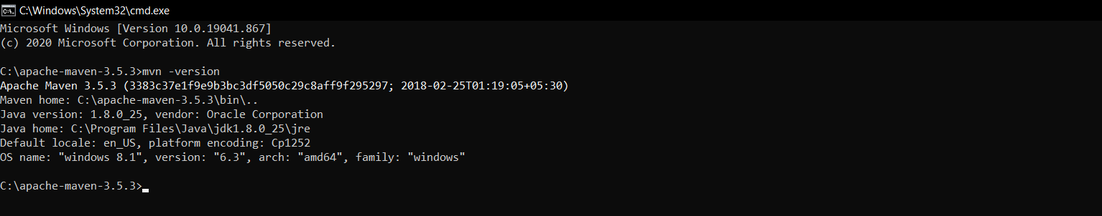

1. Command to create a Maven Project

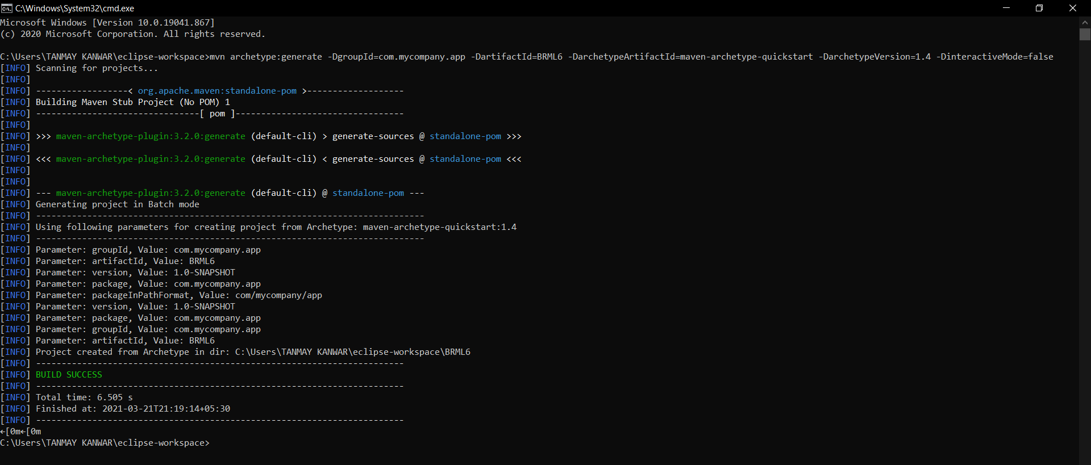

1. Pom.xml File

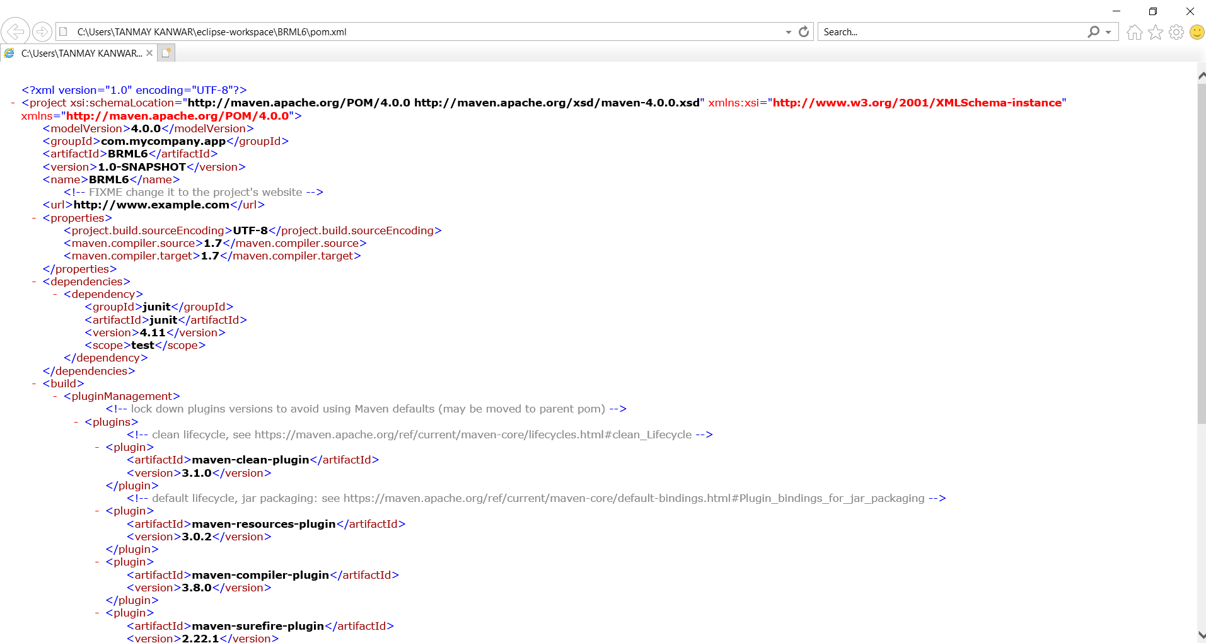

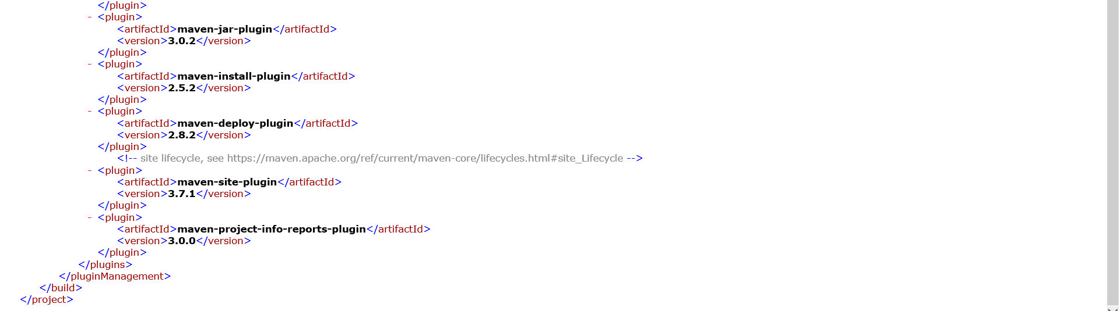

4. Command to run ‘package’ goal

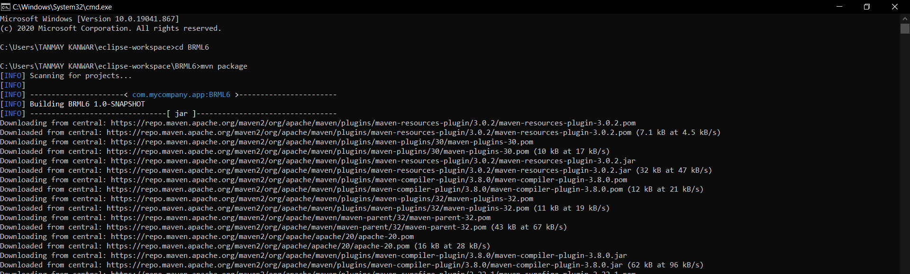

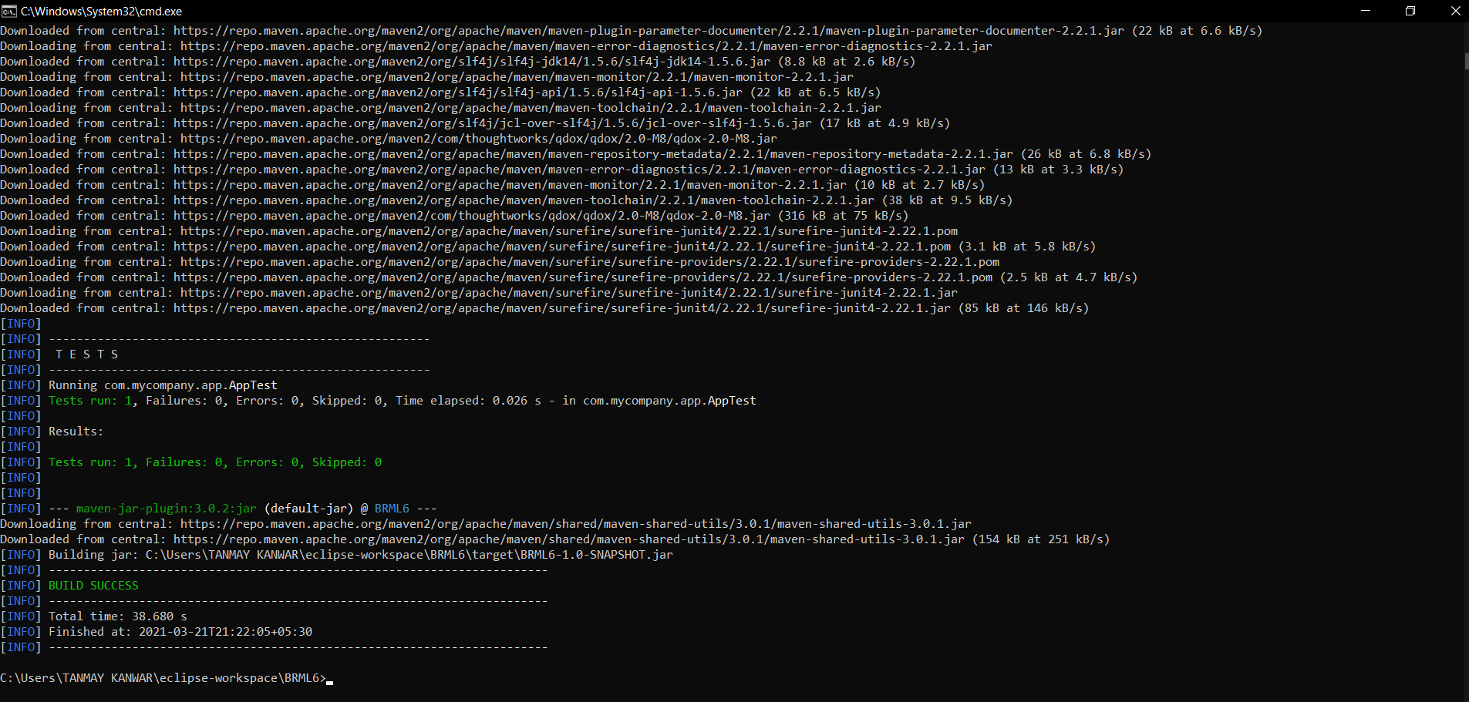

5.Testing of newly compiled and packaged jar file



6.Command to generate Site

